Search for Radionuclide Information for Particular radionuclide Entity in RDCdb
n the “RDC Search” section, users can search the full-text content of the RDCdb database to identify relevant RDC entries by entering keywords such as RDC drug names, target names, ligand names, linker names, radionuclide names, chelator names, and other related terms.
To perform a search, users simply enter a keyword in the main search box and submit the query. The search results page will display comprehensive information on all RDC drugs directly associated with the search term, including the RDC name, drug development stage, drug type, ligand name, linker name, chelator name, radionuclide name, and detailed links to the corresponding target information.
In order to facilitate a more customized input query, the wild characters of "?" are also supported.
(1) If search "68Ga", find a single API entry which is named "68Ga";
(2)If search "68", find a single API entry which is named "68Ga”.
(3)If search “Ga” or “Gallium”,find a single API entry which is named "68Ga”.
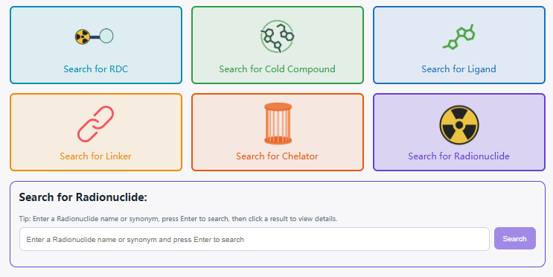

Using Gallium-68 as an example, the “General Information of This Radionuclide” section presents the basic information of the Radionuclide, including its Radionuclide ID, name, synonyms, Radionuclide_half_life, Radionuclide-emission, Radionuclide_energy.

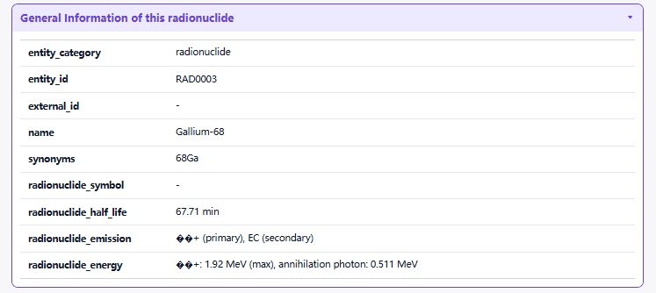

The "Related RDCs" section is about Each Radionuclide Conjugate Related to This Radionuclide, which displays the radionuclide drug conjugates (RDCs) associated with this Radionuclide. Clicking each button will redirect users to the corresponding detail page for that radionuclide drug conjugate (RDC).
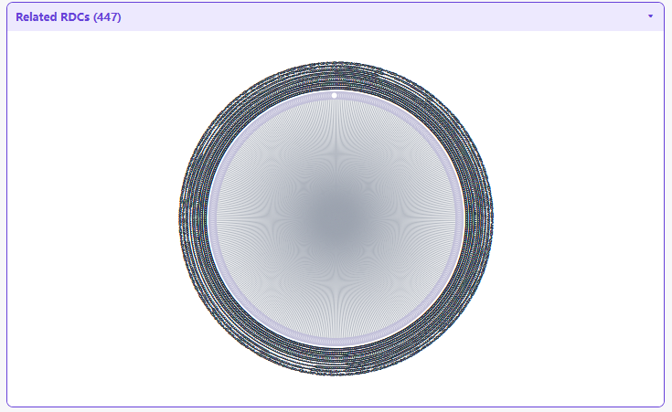
The "Complete List of RDCs Associated with This Radionuclide" section systematically displays the RDCs bound to this ligand. The list presents different types of RDCs along with their structural component information. Users can browse the different RDCs as a whole or click the RDC information to quickly navigate to the corresponding RDC activity page.

