Project Report

Qualification Name | Professional Diploma in Data Science
Module Name | WSQ -Data Modelling and Visualization (SF)

Student name |  | Assessor name
Koh Chun Yao
Date issued | Completion date |  | Submitted on
Project title

Learner declaration
I certify that the work submitted for this assignment is my own and research sources are fully acknowledged.

Student signature: Date:

Index
- Project background 2
- Project Objectives 2
- Project Specifications 4
- Project Tasks 4

Document Version History

Version  Number | Effective Date of release |  | Details | Author
1.0 | 24 June 2023 | Initial Creation |  | Kishan
2.0 | 15 November 2024 | Format Change |  | Ismayil Siyad

- Project Background

<Explain the Project in your own words in 15 – 20 lines>

- Project Objective

<List down the top 5 objectives of the project>

- Project Specifications

<List and give brief of the technical tools used in the project >
< Explain approaches to execute the project>

- Project Tasks
4A. Activity 1
Please include screenshots  and explanations in the provided space below.
- Screenshots of Tables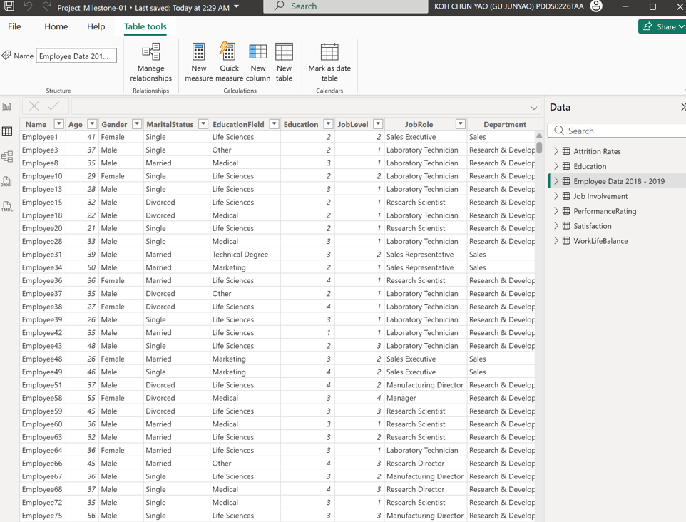
- Data Cleaning
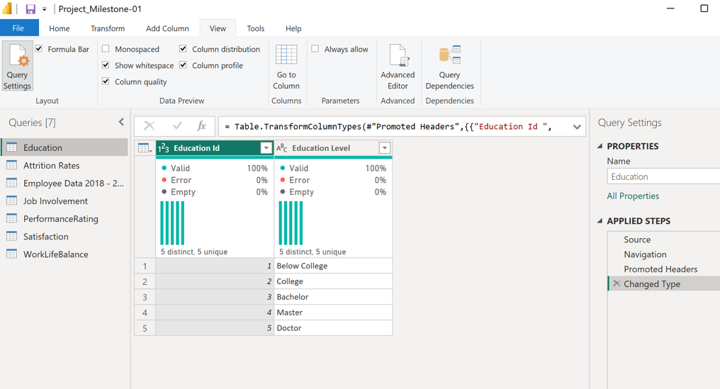
- Data Transformations Applied
- 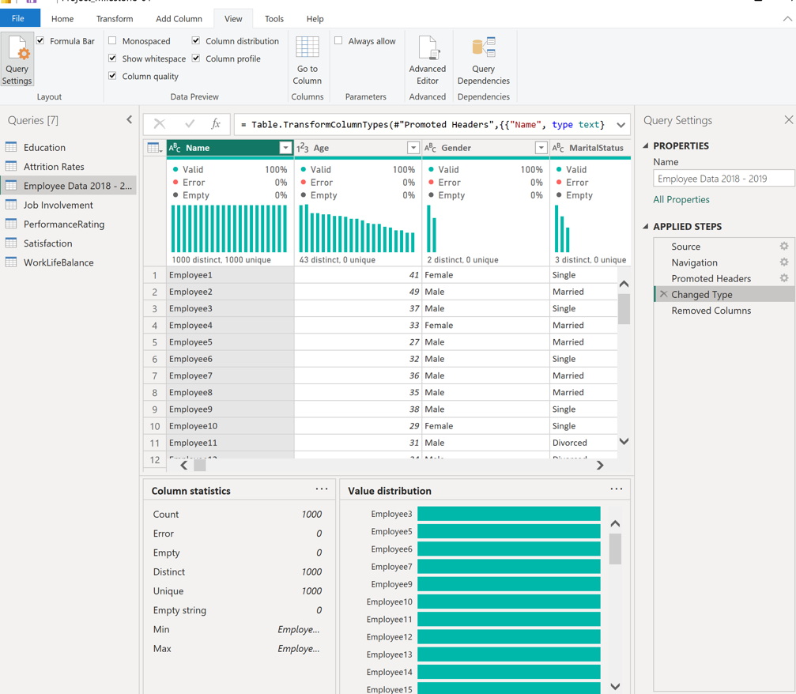
- Created Columns and Measures
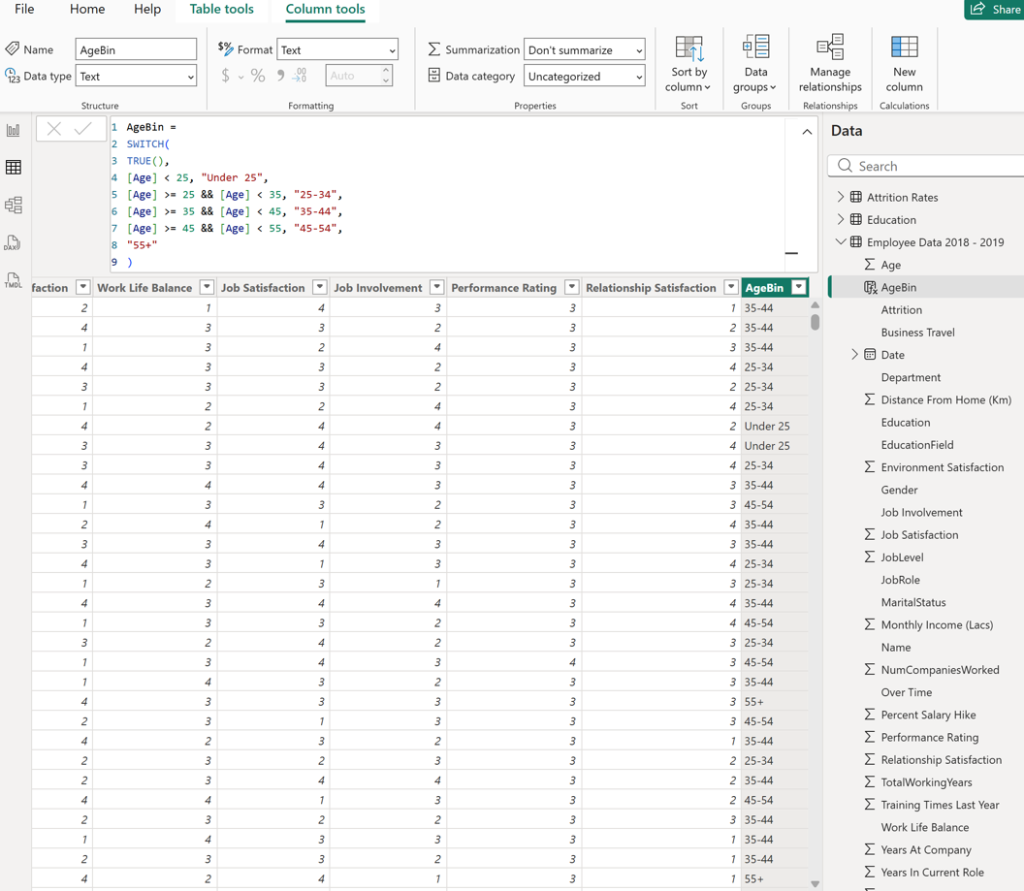

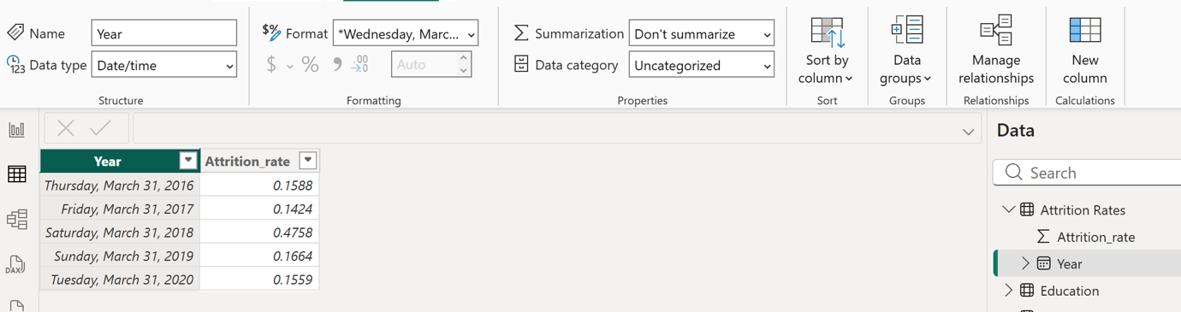
4B Activity 2
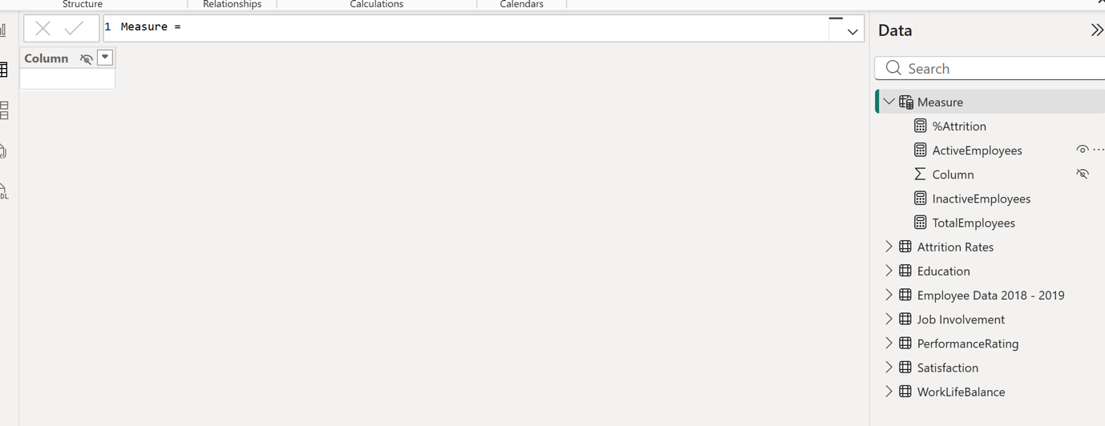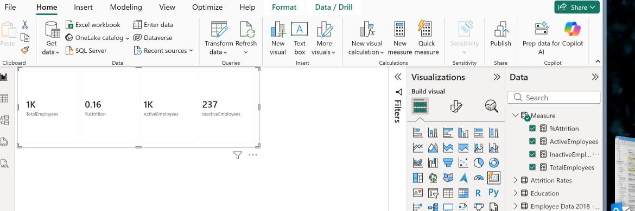
Please include screenshots and explanations in the provided space below.
- Data Model
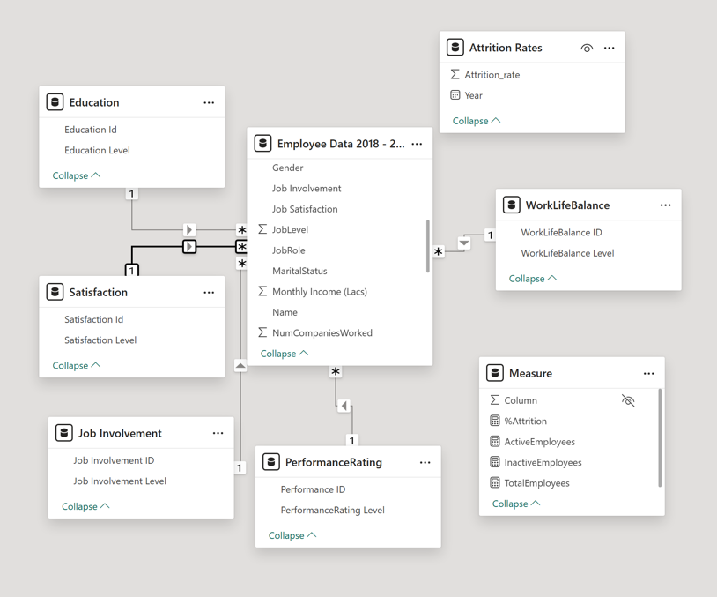
- Data Relationships
All supporting tables were linked to the Employee Data fact table using many-to-one relationships with single-direction filtering, ensuring a proper star schema structure.

- Created Hierarchies
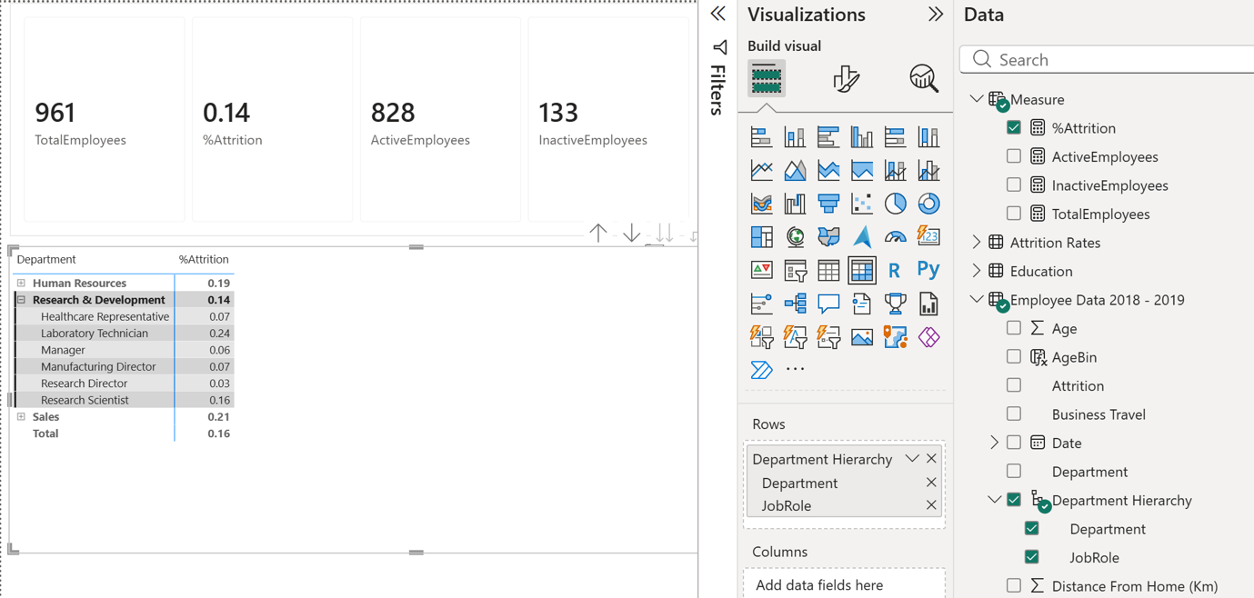
4C Activity 3

Please include screenshots and explanations in the provided space below.
- KPI Cards
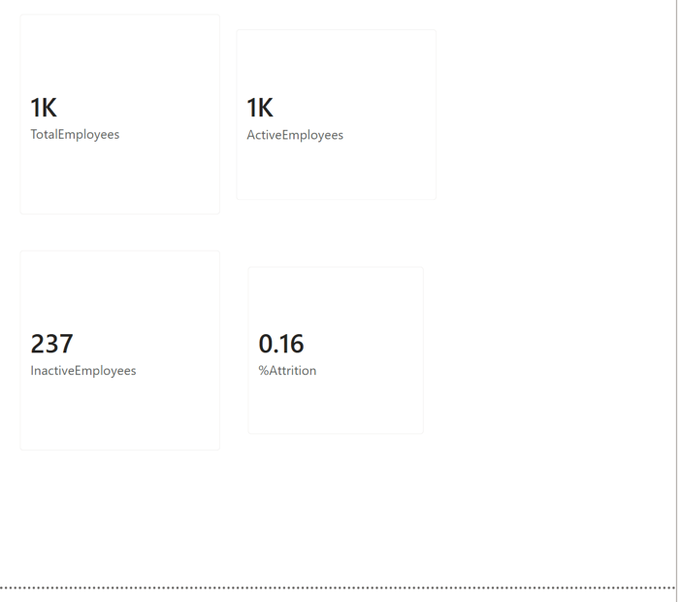
- Bar Chart
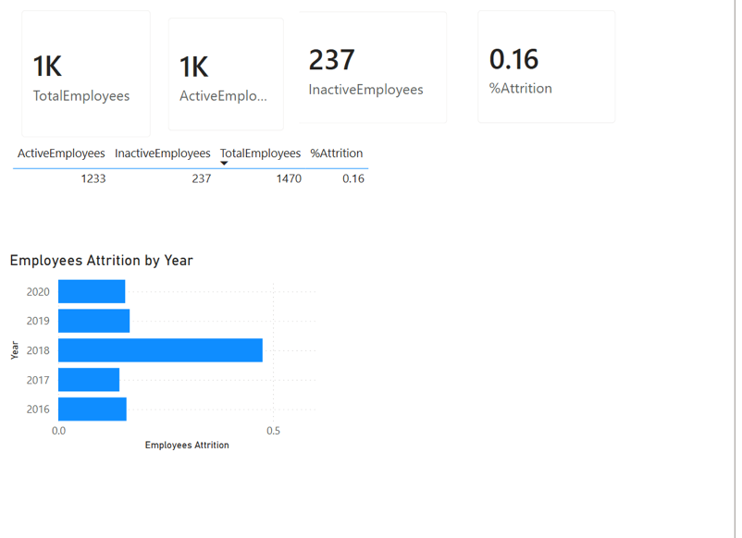
- Stacked Bar Chart
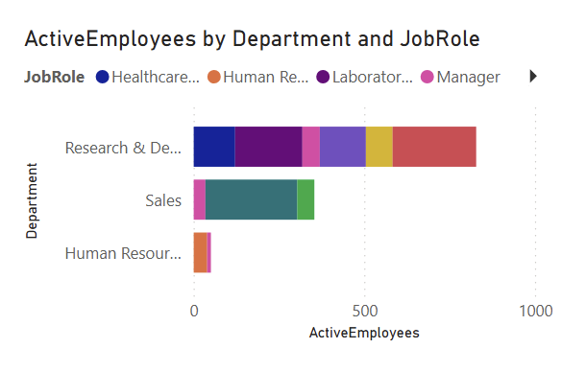
4D. Activity 4
Please include screenshots and explanations in the provided space below.
- KPI Cards for Demographics Page.
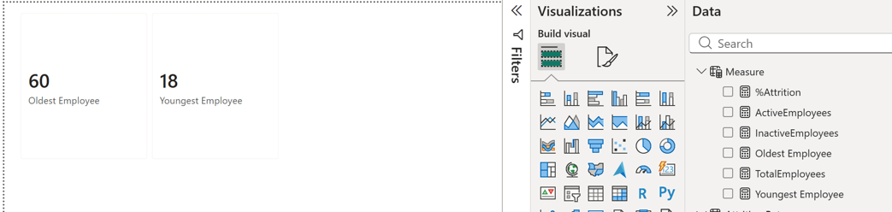
- Bar Chart.
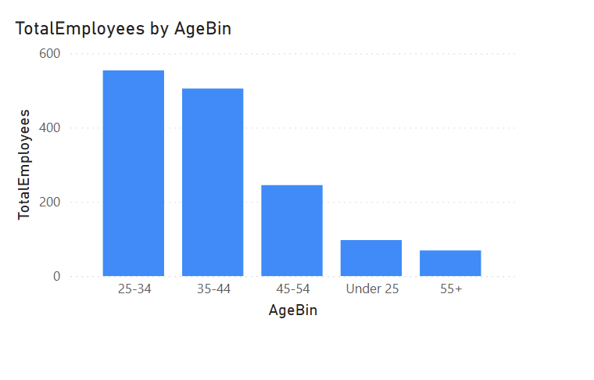
- Pie Chart.
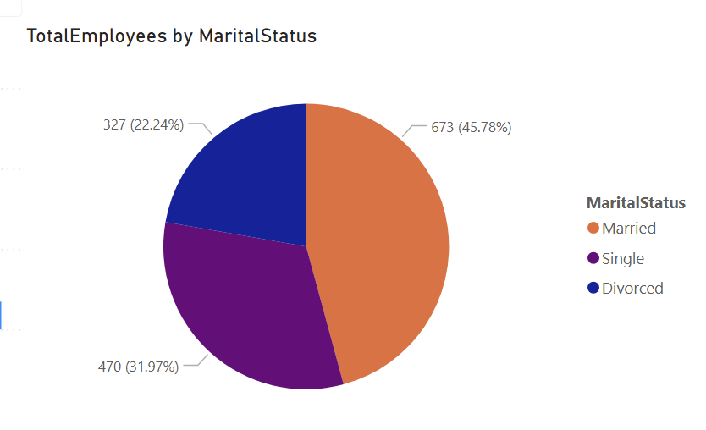
- Combined Chart.
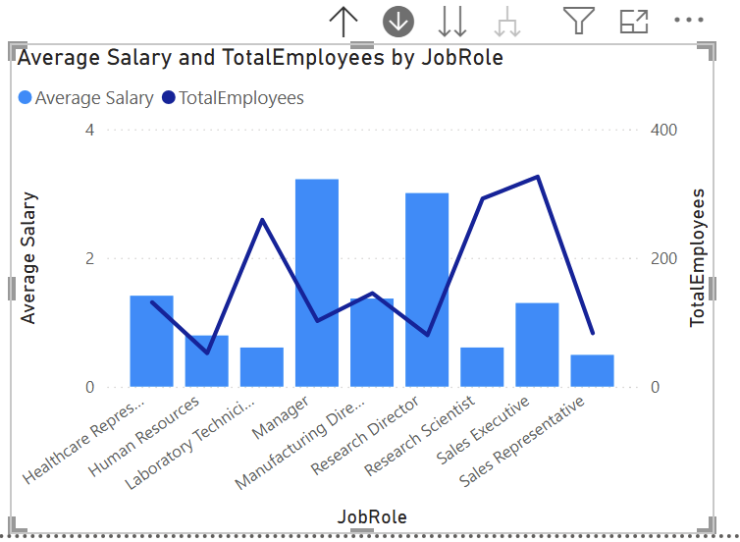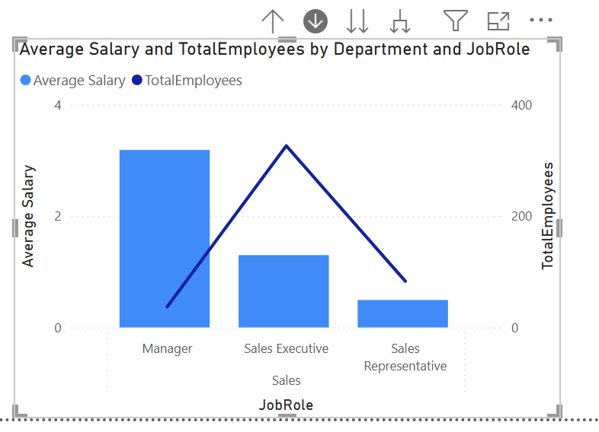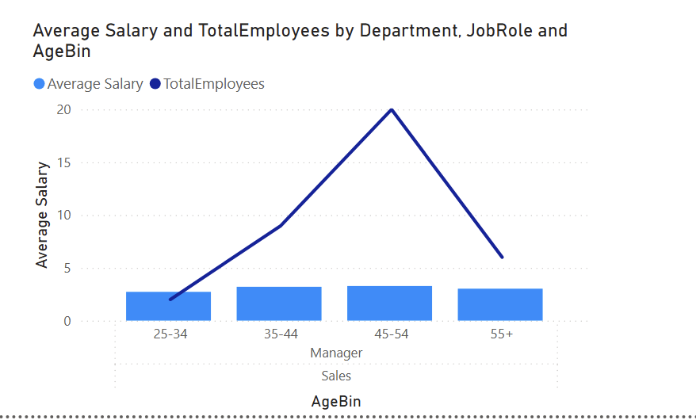

4E. Activity 5
Please include screenshots and explanations in the provided space below.
- Filter Slicers.
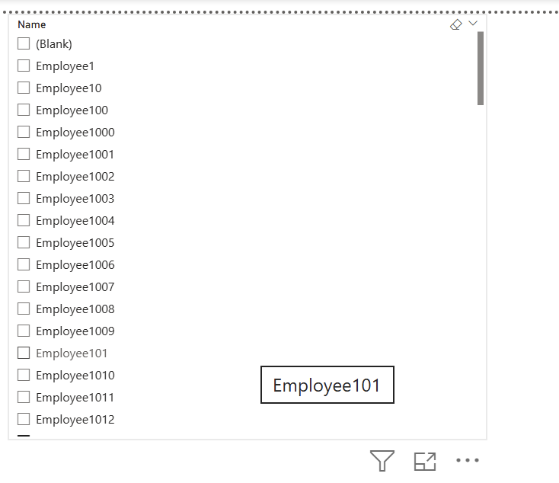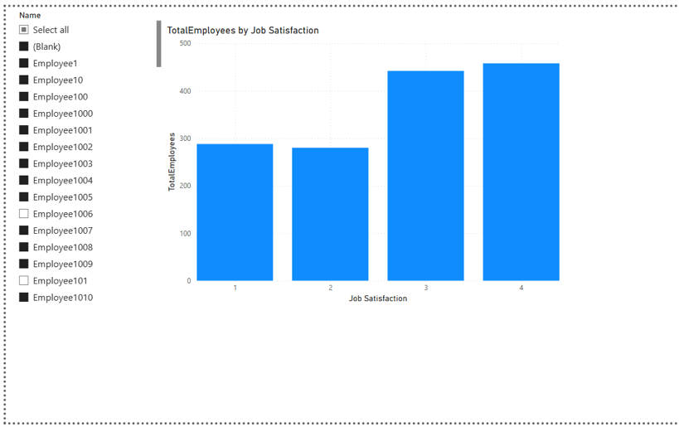
- Bar Chart
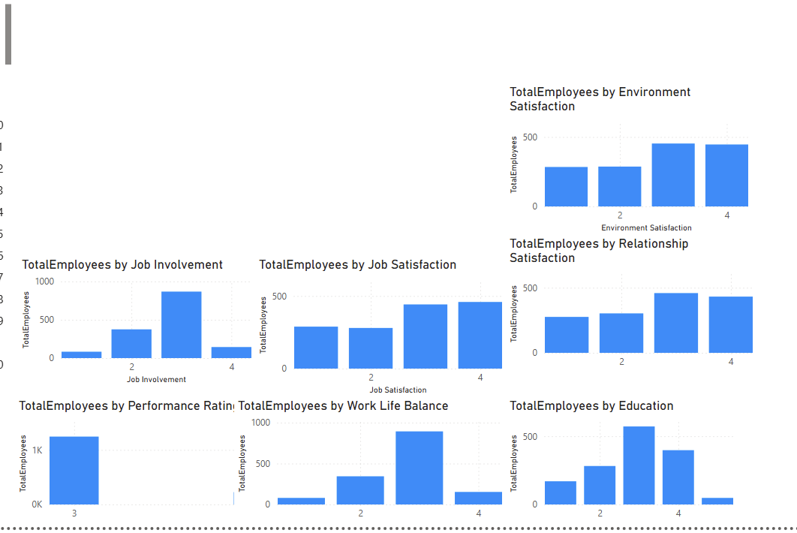
- Gauges
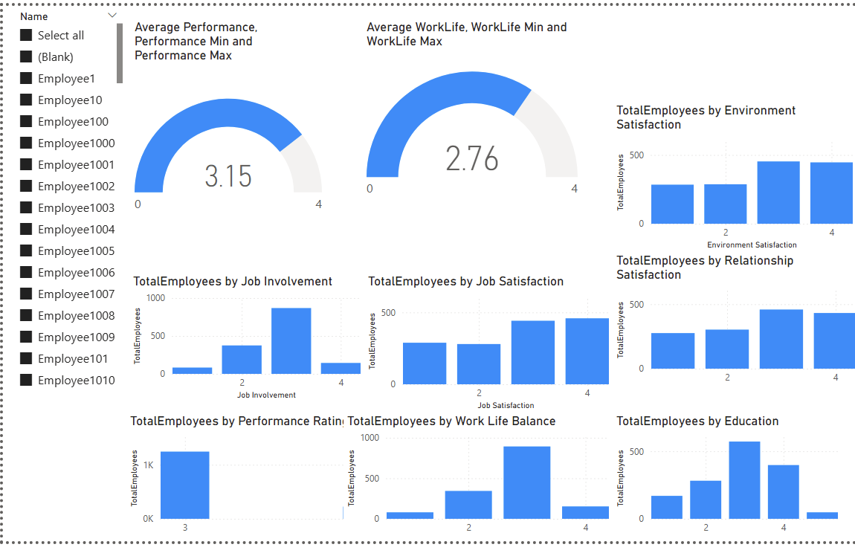
- Line and Bar Charts for Attrition Page

