Evan Cruz

B00320293

Assignment 2

CSCI4171

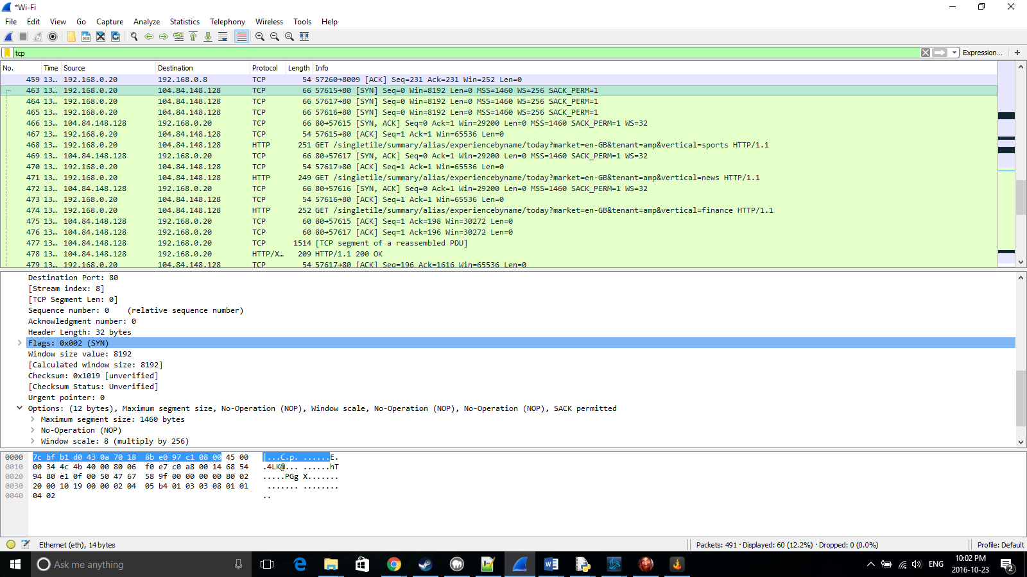

The TCP segment contains

The 16 bit source port number: 57615

The 16 bit destination port: 80

The 32 bit sequence number: 0

The 32 bit acknowledgement: 0

The length of the header: 32 bytes

Contains the flag SYN

The 16 bit window size: 8192

The 16 bit checksum : 0x1019

The 16 bit urgent pointer: 0

12 bytes of options:

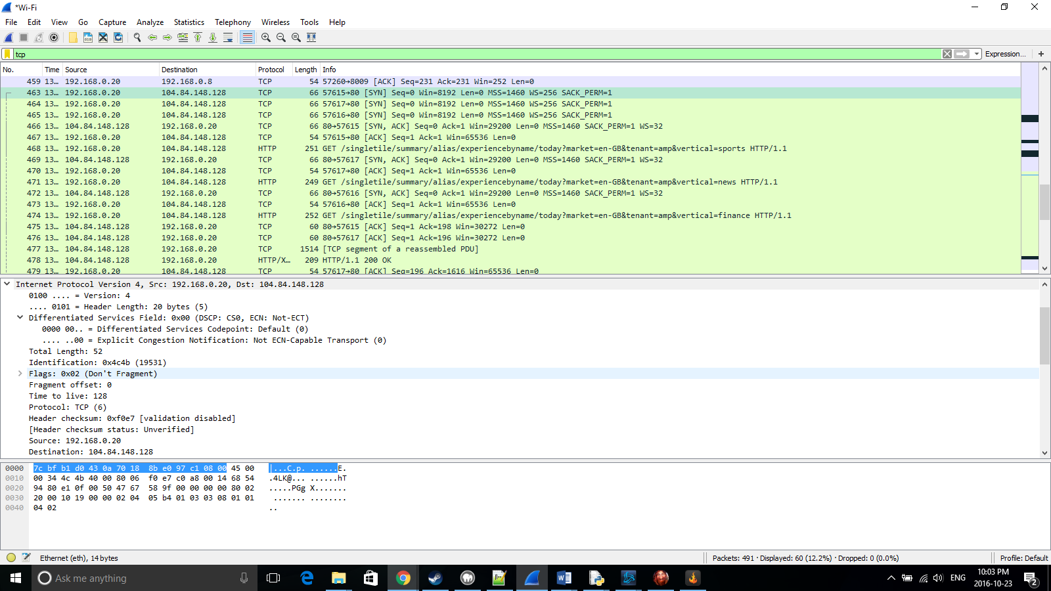

The IP datagram contains

The IP version: 0100 (IPv4)

Header Length: 20 bytes

Type of Service/ Differentiated Services Field: DSCP: CS0, Not ECN cable transport.

Total length: 52 bits

Fragment ID:0x4c4b (19531)

Flags: Don’t fragment

Fragment offset: 0

Time to live: 128

Protocol:TCP(6)

Header checksum: 0xf0e7

Source address: 192.168.0.28

Dest address:104.84.148.128

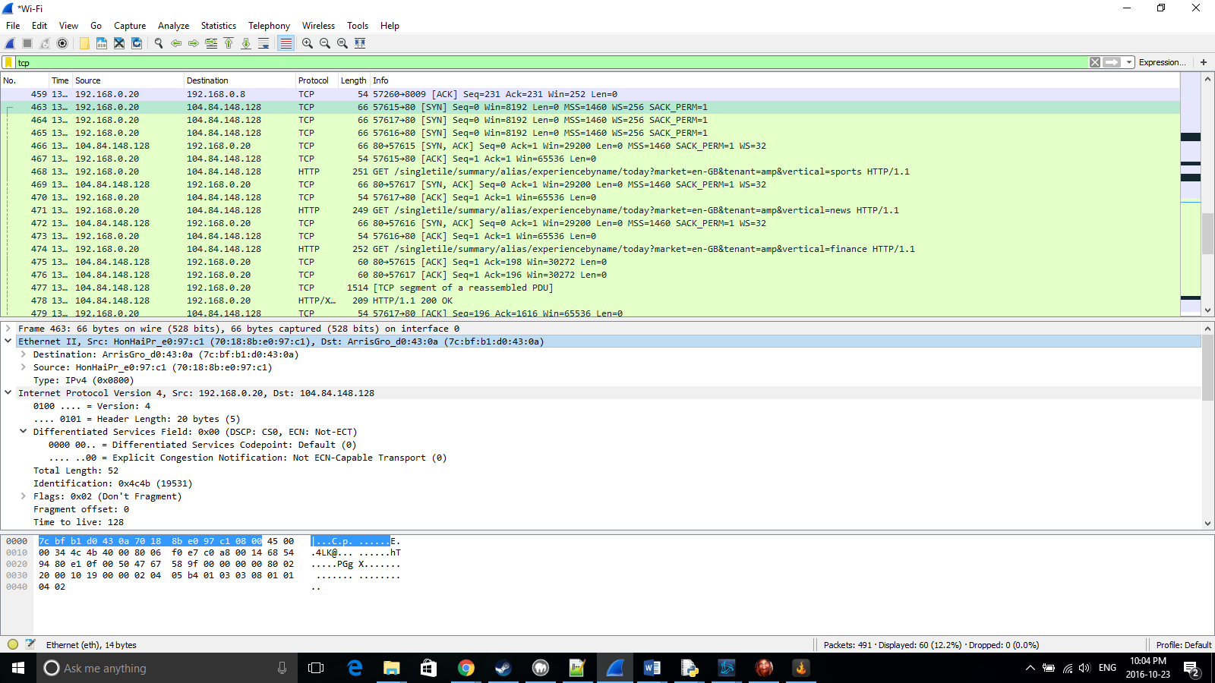

The Ethernet Frame contains

Preamble(not shown): 7 bytes of alternating 1’s and 0’s

Strat frame delimiter(not shown): 10101011

Destination MAC: ArrisGro_d0:43:0a (7c:bf:b1:d0:43:0a)

Source MAC: HonHaiPr_e0:97:c1 (70:18:8b:e0:97:c1)

Type: IPv4 (0x0800)

Frame check sequence(not shown): 32 bit CRC remainder

2.

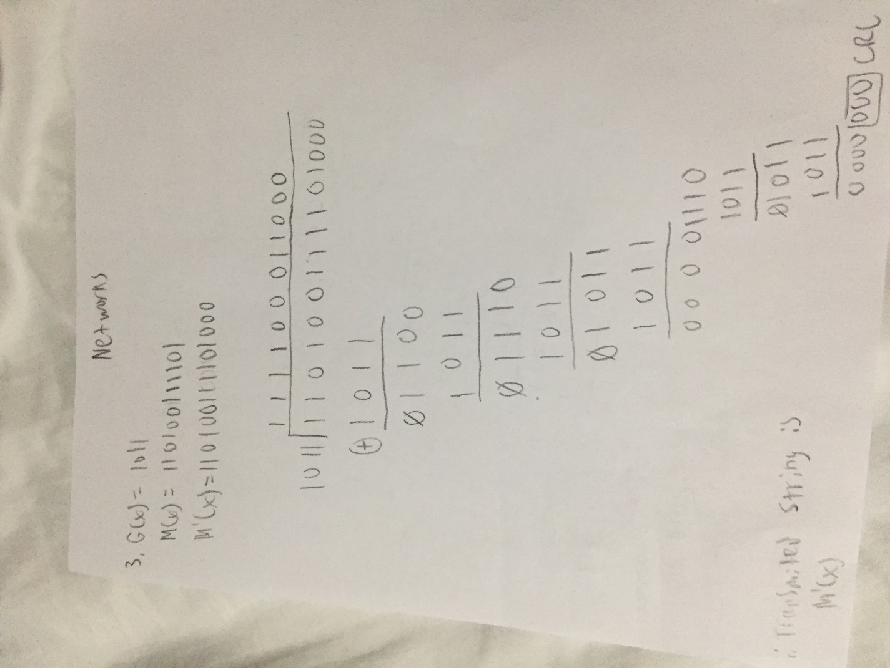

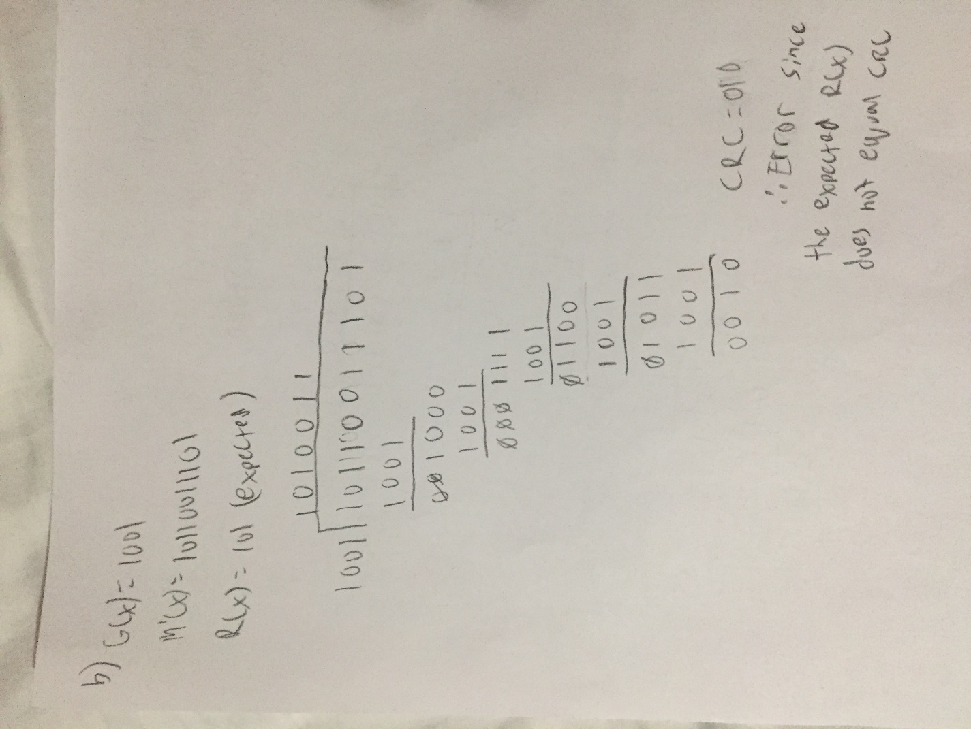

3.

|  |  |  |
| --- | --- | --- |
| Burst error length | Number of frames | Number of frames where error was detected |
| < 32 | 1000 | 999 |
| = 32 | 1000 | 1000 |
| > 32 | 1000 | 1000 |

--------------------------------------------------------------------------------------------------

Q2 Reader is reader.py

Q3 is crcprotocol.py

Q2 also has pictures of my work but if that is not valid I can scan them at Dal