**Observations**

1. Treatments with the drug Capomulin had the most favorable response.

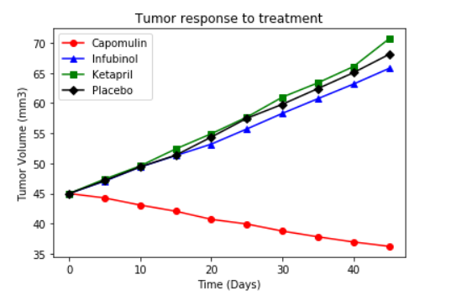

1. Capomulin also had the lease amount of Metastatic spread during the 45 day treatment.

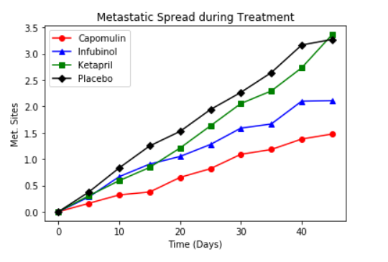

1. Mice treated with Capomulin also had the highest survival rate during the treatment period.

