**Observations**

Based on observed data Charter schools perform 21% better when it comes to overall passing rates

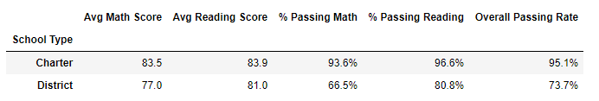

There is a significant drop-off in performance with schools with large populations (>2,000 Students)

