A Scheduling and Duty Management System with AI Application in Absence Handling

A Research
Presented to the Faculty of
College of Computer Studies
Global Reciprocal Colleges
Caloocan City

In Partial Fulfillment of the Requirements for the Degree
Bachelor of Science in Information Technology

Prepared by:
Acop, Nel Laurice T.
Cahulugan, Ranzie Kirth O.
Cruz, Ashley Eunice V.
Regacho, Christian Mark G.

Mrs. Ann Camile M. Maupay Adviser

November 2026

APPROVAL SHEET
This research entitled “A Scheduling and Duty Management System with AI Application in Absence Handling,” prepared and submitted by ACOP, NEL LAURICE T, CAHULUGAN, RANZIE KIRTH O, CRUZ, ASHLEY EUNICE V., AND REGACHO, CHRISTIAN MARK G. in partial fulfillment of the requirements for the subject CAPSTONE 1 and 2: Capstone Project and Research, has been examined for oral examination.
MRS. ANN CAMILE M. MAUPAY
Capstone Project Adviser
PANEL OF EXAMINERS
Approved by the Committee for Oral Defense on ______, with a grade of _____ on____.

____________________
Chair, Panelist

______________________ ____________________
Panelist Panelist

Accepted and approved in partial fulfillment of the requirements for the degree of
Bachelor of Science in Information Technology.

MR. DOMINGO V. TANAEL, MAT-ITEd
Program Head, College of Computer Studies

DR. WILMA CARIDAD C. TOLENTINO
OIC-Dean, Academic Department

ACKNOWLEDGEMENT

The completion of this study would not have been possible without the guidance, assistance, and encouragement of the individuals and the institution to whom the researchers wish to express their sincerest gratitude.
Above all, to our Almighty God, for the wisdom, strength, good health, and perseverance He bestowed upon the researchers throughout the conduct of this study. Every insight gained and every obstacle overcome in the course of this work is owed first to Him.
To Mr. Eduardo S. Rodrigo, our professor in Capstone Project 1, for laying the foundation of this study. His guidance in shaping the research problem, refining the objectives, and setting the direction of the project gave the researchers the clarity and discipline with which this work began.
To Mrs. Ann Camile M. Maupay, our professor in Capstone Project 2, for her patient supervision throughout the development, testing, and documentation of the system. Her corrections, suggestions, and insistence on quality guided the researchers in bringing this study to its completion.
To Mr. Romark Cacho, our Technical Adviser, for generously sharing his technical knowledge, guidance, and expertise throughout the development of the system. His assistance in addressing technical concerns, providing recommendations, and helping the researchers overcome challenges during the implementation of the system greatly contributed to the improvement and completion of this study.
To Mrs. Necifora O. Cahulugan, for her invaluable assistance in facilitating the researchers' interview with the agency's administration. Her willingness to help open that door made the data gathering of this study possible.
To Mr. Sammy P. Dulay, the administrator of Kaizen Security Agency Corp., for generously giving his time to be interviewed, for sharing with the researchers the realities of the agency's manual scheduling process, and for testing the developed system and providing the feedback that guided its improvement. His participation shaped this study from its requirements to its final evaluation.
To the administrators, head guards, and security personnel of Kaizen Security Agency Corp., and to the IT experts who took part in the evaluation of the system, for their time and for the honest assessments that gave this study its findings.
Finally, we extend our heartfelt appreciation to our families and friends for their unwavering support, encouragement, and understanding throughout the conduct of this study. Their belief in the researchers sustained this work through every stage of its development.

DEDICATION

First and foremost, to our Almighty God, the source of all wisdom, strength, and understanding. For the guidance He gave us in every decision, the perseverance He granted us in every difficulty, and the grace that carried this study from its first page to its last, we offer this work back to Him.
To our beloved parents and families, who gave us far more than support. For the sacrifices made quietly on our behalf, for the encouragement offered on the days when this study felt heavier than we could carry, and for the unconditional love and patience that never once ran short, this work is as much theirs as it is ours.
To our school, Global Reciprocal Colleges, and to our professors in Capstone Project 1 and Capstone Project 2 and to our adviser, who gave us not only the knowledge and discipline required to undertake a study of this scope, but also the standards by which we learned to measure our own work. The formation we received within its halls made this study possible.
And to everyone who became part of this journey, through their encouragement, help, and understanding, we extend our deepest gratitude. This study reflects not only the completion of an academic requirement, but also the lessons, sacrifices, challenges, and growth we experienced along the way.

CERTIFICATE OF ORIGINALITY

This is to certify that this research paper, entitled “A Scheduling and Duty Management System with AI Application in Absence Handling”, prepared and submitted by Acop, Nel Laurice T, Cahulugan, Ranzie Kirth O., Cruz, Ashley Eunice V., Regacho, Christian Mark G., in partial fulfillment of the requirements for the subject CAPSTONE 1 and 2: Capstone Project and Research, is the product of the researchers’ collective ideas, derived from the data gathered, with the guidance of the professionals who helped construct this research.
It does not contain any material previously published or written by another person, nor any material to a substantial extent entitled “A Scheduling and Duty Management System with AI Application in Absence Handling”, except where due acknowledgement is made in the paper. Any contribution made to the research by others is explicitly acknowledged.
I further certify that the signatures appearing herein are genuine and that the work and ideas presented in this study are the original work of the researchers, developed under the supervision of their adviser, Mrs. Ann Camile M. Maupay.

Signed this 9th day of August in the year of our Lord, 2026


Acop, Nel Laurice T.


Cahulugan, Ranzie Kirth O.


Cruz, Ashley Eunice V.

Regacho, Christian Mark O.

Mrs. Ann Camile M. Maupay.
Adviser

CETIFICATE OF GRAMMARIAN

This is to certify that the undersigned has reviewed and gone through all the contents of the study entitled " A Scheduling and Duty Management System with AI Application in Absence Handling" by Acop, Nel Laurice T, Cahulugan, Ranzie Kirth O., Cruz, Ashley Eunice V., Regacho, Christian Mark G., have aligned with the set of structural rules that govern the composition of sentences, phrases, and words in the English Language and all punctuation marks, formatting, and spacing for its intended use. All of its parts have been checked, proofread, and edited, and are aligned with the formal and proper English linguistic rules.
Signed ---- in the year of our Lord, 2026.

ABSTRACT

Title: | A Scheduling and Duty Management System with AI Application in Absence Handling
Researcher: | Acop, Nel Laurice T.  Cahulugan, Ranzie Kirth O.  Cruz, Ashley Eunice V.  Regacho, Chrstian Mark G.
Degree: | Bachelor of Science in Information Technology
Institution: | Global Reciprocal Colleges
Year: | 2026
Adviser | Mrs. Ann Camile M. Maupay
Keywords: | Security Personnel Scheduling, Duty Management System, AI-Assisted Absence Handling, Bi-Weekly Scheduling, Reliever Recommendation, ISO/IEC 25010

This study aimed to develop a Scheduling and Duty Management System with AI Application in Absence Handling among Security Personnel at Light Rail Transit for Kaizen Security Agency Corp. to improve the efficiency and accuracy of security personnel scheduling and absence management. The study addressed challenges associated with manual scheduling, including the preparation of bi-weekly duty schedules, monitoring of personnel availability, assignment of rest days, and the identification of suitable relievers when personnel are absent.
The study followed the Rapid Application Development (RAD) model. The system was developed using Python with FastAPI for the backend services, Supabase PostgreSQL for database management, and Flutter for the web, desktop, and mobile applications. The system was designed for administrators, head guards, and security personnel and was evaluated by five (5) IT experts and 211 end users from Kaizen Security Agency Corp.
The system provides bi-weekly schedule generation based on station requirements, shift assignments, personnel availability, rest days, preferred stations, and reliever assignments. It also includes absence handling with an AI-assisted recommendation feature that helps identify suitable replacement personnel based on predefined scheduling rules and personnel information. Other features include schedule viewing, duty assignment management, dashboard monitoring, and reporting.
The ISO/IEC 25010-based questionnaire evaluation resulted in overall ratings of 4.79 from the five IT experts and 4.74 from the 211 end users, both interpreted as Highly Acceptable. A supplementary assessment maps the documented AI-related tests to selected ISO/IEC 25059:2023 quality characteristics and identifies behaviors requiring further observation. The findings indicate that the developed system provides an organized approach to managing security personnel schedules and handling absences while assisting administrators in making replacement assignments.

TABLE OF CONTENTS
PRELIMINARIES Page
Title Page………………………………………………………………………………. i

CHAPTER I – The Problem and Its Background
1.1 Project Context …….…………………………………………………..…… 5
1.2 Objective of the study…………………………………………………….... 6
1.3 Scope and Delimitations of the Study…..………………………….……….. 7
1.4 Significance of the Study...…………………………………………………. 13
1.5 Operational Definition of Terms...………………………………....……..... 14

CHAPTER II - Review of Related Literature and Studies
2.1 Review of Related :Literature
Local Literature…………………………………………………….…... 18
Foreign Literature………………………………………………….…… 21
2.2 Review of Related :Studies
Local Studies …………………………………………………......……. 26
Foreign Studies………………………………………..……….…….… 30
2.3 Synthesis of the Review of Related Literature and Studies………………... 34

CHAPTER III – METHODOLOGY AND RESEARCH DESIGN
3.1 Research/Development Method and Design……………………………….…… 36
3.2 Conceptual Framework …………………………………………………… 39
Input Process Output Diagram ……………………………………………… 39
3.3 Software and Hardware Requirements………...…………………………..… 40
3.4 System Analysis and Design……..…………...……………………………… 46
Context Diagram …………...….………………………………………. 47
Data Flow Diagram ………………………………………………….... 50
Entity Relationship Diagram ……………….……………………….… 66
Use Case Diagram ..………………………………..……..…………… 69
Data Dictionary…...………………………………..……..…………… 71
3.5 Gantt Chart…………………………………………………………..……… 90
3.6. Roles and Responsibilities…………………………………………..……… 91
3.7 Evaluation Procedure………………………………………………..……… 93
3.8 Ethical Standards and Consideration………………………………..……… 100

CHAPTER IV – RESULTS AND DISCUSSIONS
4.1 Development and Testing….……..…………...……………………………… 104
Unit and Integration Testing……..……...….………………………………. 104
AI Quality Assessment (ISO/IEC 25059) …………………………………… 109
User Acceptance Testing………………………...……………………….... 118
4.2 Evaluation Results………….……..…………...…………………………… 129
Data Interpretation……..……...............….………………………………. 129

CHAPTER V – SUMMARY, CONCLUSIONS AND RECOMMENDATIONS
5.1. Summary of Findings…..………………………………..…………..…… 132
5.2Conclusions………...…………………………………………..……..…… 136
5.3 Recommendations………………………………………………..…..…… 138
REFERENCES…………………………………………………..…….……... 141
APPENDICES…………………………………………………..…..……...… 149
Appendix A Permit to Conduct the Study..……...….…………………...… 149
Appendix B Letter for Interview………………………………………….... 150
Appendix C Evaluation Instrument……....……...….…………………...… 152
Appendix D User Manual……...…………………………………………... 157
CURRICULUM VITAE………..………………………………..…...……...… 202

LIST OF TABLES

Table 1 Hardware Requirements Scheduling and Duty Management System……..…... 41
Table 2 Software Requirements for Scheduling and Duty Management System ……… 42
Table 3 Users Table ………………………………………………………………..…... 71
Table 4 Auth Accounts Table ……………….……………………………………..…... 72
Table 5 Employees Table …………………………………………………………..…... 73
Table 6 Stations Table ……………………………………………………………..…... 74
Table 7 Counters Table ……………………………….…….……………………..…... 75
Table 8 Rotation Cycles Table ………………...…………..….…………………..…... 75
Table 9 Station Rotation Assignments Table…………………….…………….…..…... 76
Table 10 Special Assignments Table ……...………………………………..……..…... 77
Table 11 Schedules Table…………………...…………………...…………….…..…... 78
Table 12 Duty Assignment Table …………………………………………..……..…... 79
Table 13 Attendance Reports Table ……………….………………………….…..…... 80
Table 14 Absence Requests Table …………………………………………..……..…... 81
Table 15 Special Requests Table …………………………………...………….…..…... 83
Table 16 Leave Requests Table ……………………………………………..……..…... 84
Table 17 Cover Offers Table ….…………………..………….………………………... 86
Table 18 Replacements Table ………………………………….…………..……..……. 87
Table 19 Employee Notifications Table ……………………………………..……..…... 88
Table 20 AI Suggestions Table ….……………....………….…………………..……... 89
Table 21 Roles and Responsibilities of the Researchers …………………..……..……. 91
Table 22 ISO 25010 Guideline ….……………....………….…………………..……... 94
Table 23 Likert Scale ………………………………….…………………..……..……. 98
Table 24 Unit and Integration Testing for Web Application ….………………..…….. 104
Table 24A AI Quality Assessment Based on Testing and Observation …… 110
Table 25 Unit and Integration Testing for Mobile Application ……………..……..…. 111
Table 26 System Processing and Response Times……………..…………………..…. 117
Table 27 Software Evaluation of Functional Suitability Criterion by IT Expert …….. 119
Table 28 Software Evaluation of Functional Suitability Criterion …………………… 121
Table 29 Software Evaluation of Performance Efficiency Criterion ….……….……... 122
Table 30 Software Evaluation of Reliability Criterion ……….……….…..……..…… 123
Table 31 Software Evaluation of Compatibility Criterion ……………………..…….. 124
Table 32 Software Evaluation of Usability Criterion …….………….…..…..………. 126
Table 33 Software Evaluation of Maintainability Criterion ……...…………………... 127
Table 34 Software Evaluation Summary — End Users …………………..……..……. 128

LIST OF FIGURES

Figure 1 RAD Methodology Diagram ….……………....….…………………..……... 36
Figure 2 Input-Process-Output …………………….……………….…….……..……. 39
Figure 3 Context Diagram of the Existing System ….……………….………..……... 47
Figure 4 Context Diagram of the Proposed System .……………….…….……..……. 48
Figure 5 DFD Level 1, Proposed System ….……………....….………..……..……... 50
Figure 6 DFD Level 2, Security Personnel Management ………….…….……..……. 57
Figure 7 DFD Level 2, Schedule Management ….………………..…………..……... 59
Figure 8 : DFD Level 2, AI Absence Handling …………………….…….……..……. 61
Figure 9 Activity Diagram for Registering Security Personnel Account ….………..... 64
Figure 10 Activity Diagram for AI Absence Handling ……………………..…..……. 65
Figure 11 Entity Relationship Diagram (ERD)….……………… ……………..……... 66
Figure 12 Use Case Diagram ……………………….……………….…….……..……. 69
Figure 13 Gantt Chart of Activities …………….….……………….…….……..……. 91

CHAPTER I
THE PROBLEM AND ITS BACKGROUND

1.1 Project Context

Workforce scheduling in security operations is a complex process that involves balancing shift requirements, personnel availability, and organizational policies. When not properly managed, it can result in missed shifts, excessive overtime, and employee dissatisfaction, which may negatively affect operations, reduce morale, and lead to financial losses (Hughes, 2024). Many organizations still rely on traditional methods such as spreadsheets, phone calls, and printed schedules; however, these approaches often lead to errors, miscommunication, delays, increased administrative workload, and difficulty in tracking real-time updates. These challenges emphasize the need for more efficient and automated systems to improve personnel scheduling and management. Additionally, unexpected absences due to illness, emergencies, or lack of commitment create sudden staffing gaps, requiring administrators to spend significant time manually adjusting schedules and finding replacements (Dhamrait, 2025).
Advancements in information technology have introduced new solutions to improve workforce scheduling. Artificial Intelligence (AI), in particular, has shown significant potential in optimizing scheduling processes by analyzing multiple variables such as employee availability, workload distribution, and operational requirements. AI-driven scheduling systems can automate complex scheduling tasks, reduce human error, and support better decision-making (Kupunarapu, 2022).
1.2 Objectives of the Study
General Objective:
The primary objective of this study is to develop A Scheduling and Duty Management System with AI Application in Absence Handling for Kaizen Security Agency Corp, which manages security personnel assigned to Light Rail Transit (LRT) stations. The proposed system aims to improve the efficiency of scheduling processes, provide convenient access to duty assignments, and assist administrators in handling employee absences through an AIbased recommendation feature.
Specific Objectives:
1. Design a scheduling system that organizes and balances the workload of security personnel through an automated schedule generation feature that follows each station's required number of personnel and assigned posts per shift, observes rest days, and distributes personnel across stations every rotation cycle.
2. Develop an AI-based absence handling feature that recommends suitable reliever personnel based on availability, current schedule or day-off status, shift and post eligibility, and workload distribution, by screening candidates through system-defined scheduling rules and ranking the qualified candidates with the assistance of artificial intelligence.
3. Test the system to reduce delays in assigning replacement personnel and minimize extended working hours of on-duty security guards.
4. Evaluate the developed web and mobile-based Scheduling and Duty Management System in terms of accessibility, timeliness, and usability of schedule information for administrators and security personnel.
1.3 Scope and Delimitations of the Study

Scope of the Study
This study focuses on the development of a Scheduling and Duty Management System with AI Application in Absence Handling intended for security personnel assigned to Light Rail Transit (LRT) stations under Kaizen Security Agency Corp. The proposed system is developed using Flutter for cross-platform accessibility, providing a desktop and web-based application for administrators and a mobile application for security personnel, while a Python (FastAPI) web service hosted on a cloud platform handles the scheduling logic and a Supabase (PostgreSQL) database is utilized for secure data storage and centralized data access. Artificial intelligence is integrated through the Google Gemini API, which assists in ranking replacement candidates during absence handling. The system aims to improve the process of managing duty schedules, monitoring personnel assignments, and assisting administrators in handling employee absences efficiently
- User authentication features: allow authorized users to log in and log out securely using credentials stored in encrypted (hashed) form, which cannot be retrieved and can only be reset by an administrator. It implements role-based access control with three roles — administrators, who manage schedules and system data; head guards, who monitor and report the attendance of personnel in their station; and security personnel, who view their assigned schedules and duty information.
- Station and post configuration: allows administrators to register stations and define, per shift, the required number of personnel and the named post assigned to each slot, together with the duty hours of each post. This configuration determines how many personnel the system deploys to a station and serves as the basis of schedule generation.
- Automated schedule generation: the system generates bi-weekly (15-day) duty schedules based on the configured station requirements, assigning regular personnel to their fixed station and shift with scheduled rest days, assigning relievers to cover those rest days, and reassigning personnel to different stations every rotation cycle while considering their preferred stations. Personnel may only be deployed to stations within their own group or an immediately adjacent group. When the available personnel are not enough to fill a requirement, the system does not stop the process; instead, it produces the best possible schedule and records the staffing problem as a note for the administrator to review.
- Scheduling management: the system enables administrators to create, edit, delete, publish, and manage bi-weekly duty schedules of security personnel assigned to various stations. Security personnel are able to view their assigned shifts and schedule details through the system only after a schedule has been published.
- Schedule viewing interface: displays generated and published schedules by station, period, and shift, showing each personnel's date, duty hours, and assigned post, with color-coded indicators for duty status such as rest days, absences, and covered duties, to make schedule monitoring easier for administrators
- Search and filter functions: that allow administrators to search for security personnel by name and filter schedules and records by station, date, shift, and scheduling period. This feature supports efficient schedule management and quick access to relevant information.
- Reporting and archiving functions: allow administrators to generate duty schedule reports per station and per period and leave reports for the year, view historical and past schedules, and export or print reports in PDF format on the agency's letterhead with configurable signatories for documentation purposes.
- Mobile application for security personnel: through the mobile application, security personnel can view their assigned bi-weekly schedules, shift details such as date, duty hours, station and assigned post, and access their past schedules. Personnel may also file emergency absence requests before their duty begins, file leave requests, request specific day-offs for periods that are not yet scheduled, and indicate their availability to cover duties on their rest days.
- Report Absence of Security Personnel: through the mobile application, the head guard can view the assigned bi-weekly schedule, past schedules, shift details such as date, time and station, view the daily roster of their station, and submit an attendance report per shift identifying the personnel who are present and absent. The day head guard files the morning and afternoon shifts while the night head guard files the night shift, and each shift may only be submitted once.
- Dashboard interface: provides an overview of important scheduling information. The dashboard displays the total number of security personnel, schedule summaries, and daily absence, on-duty, and availability statistics to assist administrators in monitoring operations.
- Absence handling module: Artificial Intelligence (AI) is integrated into the system to assist administrators in identifying suitable replacements for absent security personnel. The system first applies its scheduling rules to remove candidates who are unavailable, already scheduled on that date, also reported absent, or not qualified for the shift or post, then scores the remaining candidates according to station familiarity, personnel type, workload, and declared availability. The AI reviews this screened list and recommends the most suitable replacement with an explanation, and the ranked candidates are presented to the administrator, who makes the final decision. Duties assigned on short notice are automatically adjusted to give the assigned personnel reasonable travel and preparation time, and replacements can no longer be assigned once the duty has already ended.
- Leave management module: allows security personnel to file leave requests and administrators to record and approve them, with the system enforcing the allowed duration per leave type, the required filing lead time, the yearly limit, and the waiting period between leaves. Approved leaves automatically exclude the personnel from schedule generation for the covered dates.
- In-app notification module: informs security personnel and head guards of schedule updates, decisions on their requests, and duty assignments given to them as replacements, and informs administrators of newly submitted reports and requests.
The software evaluation uses the existing ISO/IEC 25010-based questionnaire. The AI-assisted absence-handling feature is additionally examined through documented testing and observation guided by selected ISO/IEC 25059:2023 quality characteristics: functional correctness, robustness, transparency, and user controllability. This supplementary assessment uses the researchers’ test records and does not require a separate respondent questionnaire. Its conclusions are limited to the characteristics and test conditions supported by recorded evidence.

Delimitations
This study is limited in terms of system features and implementation. The proposed system does not include SMS or email notification functionality due to the need for third-party API integration, which involves additional system configuration, security considerations, and possible subscription or usage-based costs that are beyond the resources and scope of the study. Moreover, implementing such features would increase the complexity of the system by requiring more advanced backend services for real-time message handling. Instead, the system utilizes in-app notifications within the mobile application to inform users of schedule updates. The focus of the study is to develop an efficient scheduling and absence handling system rather than a full-scale communication platform.
The system also does not include biometric, location-based, or automated time-in and time-out recording. Attendance is established through the attendance report submitted by the head guard of each station, and the system does not compute payroll, salaries, or overtime pay. The artificial intelligence component is advisory in nature; it recommends and ranks replacement candidates, but the final assignment is always confirmed by the administrator, and the system remains fully functional using its rule-based ranking when the AI service is unavailable. The mobile application is deployed for Android devices, while the administrative application is deployed for Windows desktop and web browsers. Finally, the study covers only the security personnel of Kaizen Security Agency Corp. assigned to Light Rail Transit (LRT) stations.

1.4 Significance of the Study

Administrators The system will provide administrators with a centralized platform for managing duty schedules and assigning security guards to different stations. It will also assist them in handling employee absences by generating AI-based recommendations for suitable replacement personnel, reducing the time and effort required for manual schedule adjustments

Future Researchers. This study may serve as a reference for future researchers who plan to develop similar systems related to personnel scheduling, duty management, or AI-assisted decision support in other organizations or industries

Kaizen Security Agency Corporation. The proposed system will help improve the efficiency and organization of managing security personnel schedules across various LRT stations. By automating the scheduling process and integrating an AI-assisted absence handling feature, the organization can minimize scheduling conflicts, ensure continuous station security, and enhance operational efficiency.

Researchers. The researchers will gain valuable knowledge and experience in developing a real-world information system that integrates scheduling management and artificial intelligence concepts. The study will also enhance their technical skills in system development using modern technologies such as Flutter, FastAPI, Supabase, and AI integration..

Security Personnel. Security guards will benefit from easier access to their duty schedules and assigned station locations through the system. This will allow them to conveniently check their weekly assignments, reducing confusion and improving communication regarding duty responsibilities. Additionally, the system enables faster identification of replacement personnel in cases of absence, helping to prevent unnecessary extension of working hours and reducing fatigue among security staff.

1.5 Operational Definition of Terms

Absence Handling refers to a system feature that records when a scheduled security personnel member is unavailable for duty and suggests suitable relievers based on availability, schedule, shift and post eligibility, and workload, for the administrator's approval.
Administrator (Manager) refers to authorized personnel responsible for managing the scheduling system, creating and updating the duty schedules, assigning security guards to stations, and handling absence reports within the system.
Artificial Intelligence refers to the language model service integrated into the system that reviews the list of qualified replacement candidates prepared by the system and recommends the most suitable replacement security guard, together with the reason for the recommendation, when an absence occurs.
Bi-weekly Schedule refers to the work schedule generated by the system that covers a 15-day assignment of security personnel per station, covering the 1st to the 15th and the 16th to the last day of the month.
Cover Offer refers to a declaration submitted by a security personnel indicating their willingness to be assigned duty on a rest day, which raises their ranking among replacement candidates.
Duty refers to the assignment, responsibility, or task given to a security personnel as displayed and managed within the scheduling system.
FastAPI refers to the Python web framework used to build the backend service of the system, which contains the schedule generation logic and provides data to the web and mobile applications.
Flutter refers to the development framework used to build the cross-platform mobile and web application of the proposed system.
Head Guard refers to the security personnel assigned to supervise a station on a twelve-hour duty and who submits the attendance report of the personnel deployed in that station.
Leave refers to an approved absence covering a range of dates during which the security personnel is excluded from schedule generation.
Post refers to the specific station area or responsibility assigned to a security personnel within a shift, such as platform, roving, or head guard, each with its own duty hours.
Preparation Window refers to the automatic adjustment of duty hours applied when a replacement is assigned on short notice, giving the assigned personnel time to travel and report for duty.
Reliever refers to a security personnel whose function is to cover the rest days of regular personnel and who may be suggested by the system to temporarily replace an absent guard based on availability and workload balance
Rotation Cycle refers to the monthly redistribution of security personnel across stations, which considers their preferred stations while keeping a number of familiar personnel in each station.
Scheduling System refers to the developed web, desktop, and mobile application that automates the creation, management, and distribution of security personnel duty schedules.
Security Personnel is a security guard and user of the mobile application who is assigned to LRT stations and can view their schedules and receive updates regarding their duties.
Station Group refers to the division of the LRT stations into three groups along the line, which limits the deployment of security personnel to their own group or an immediately adjacent group.
Supabase refers to the cloud database service used in the system for storing employee records, stations, schedules, requests, and user credentials accessed by the web and mobile applications.

CHAPTER II
REVIEW OF RELATED LITERATURE AND STUDIES

2.1 Related Literature
Local Literature
According to Andaya (2025), artificial intelligence adoption in Philippine digital governance shows strong potential but remains limited in research and implementation. The review explored possible AI applications, highlighting benefits such as improved decision-making and reduced administrative workload. However, challenges such as data quality, privacy concerns, and limited resources continue to affect adoption. The study recommends policy development and capacity-building strategies for responsible AI implementation.
According to Amil (2024), the integration of artificial intelligence in Philippine public administration offers opportunities for improvement but also presents legal and regulatory challenges. This reviewed existing literature and found that current laws are not fully equipped to handle rapid AI adoption. Issues such as data privacy, limited awareness, and resource constraints were identified as key barriers. The study recommends strengthening legal frameworks and ethical standards for responsible AI use.
Aytona et al. (2022) explained that workforce planning is important in addressing staffing shortages and uneven workload distribution in Philippine health institutions. This emphasized that workload-based allocation helps ensure employees are assigned duties according to their capacity and the needs of the service. It also noted that poor staffing practices may lead to overwork and lower quality of service. Overall, the findings highlight the importance of proper planning and scheduling in maintaining a balanced and efficient workforce.
According to Bautista and Del Prado (2025), the adoption of artificial intelligence in Philippine organizations is closely associated with better productivity and smoother operations. This found that AI helps automate repetitive tasks and supports faster, more accurate decision-making. However, it also pointed out that not all organizations benefit equally since some employees are still not fully prepared to use AI tools. This shows that AI works best when it is matched with proper workforce management and readiness.
According to Concepcion et al. (2024), work-life balance and career satisfaction among employees in a Philippine local government unit are strongly influenced by organizational practices. This found that employees with better work-life balance tend to have higher job satisfaction and engagement. It also highlighted that flexible scheduling, fair workload distribution, and supportive management improve employee morale and reduce turnover. This emphasizes the importance of effective scheduling systems in enhancing employee well-being and organizational performance.
According to Denoso et al. (2023), disbursement procedures in public institutions in the Philippines are often affected by bureaucratic structures, manual processes, and employee-related factors, which can lead to inefficiencies and delays in service delivery. Complex approval processes, extensive documentation requirements, and outdated systems contribute to operational challenges and reduced client satisfaction. Employee competence and behavior also play a significant role in influencing the effectiveness of administrative processes. This highlights the need for improved systems, streamlined procedures, and better workforce management to enhance efficiency and overall service quality in public organizations.
According to Jimenez (2025), artificial intelligence is now being used more often in administrative tasks in Philippine organizations, especially in documentation, scheduling, and workload management. This found that AI helps reduce manual work and makes daily operations more efficient. However, it also noted that employees need proper training so they can fully adapt to these new tools. This suggests that AI is most effective when it is properly implemented and supported by user readiness.
According to Marcos et al. (2025), artificial intelligence has significant potential to improve structural health monitoring by addressing limitations in traditional monitoring systems such as delayed damage detection and data inefficiency. The review examined various machine learning and deep learning models used for anomaly detection, predictive maintenance, and structural analysis. Findings showed that AI-integrated systems improve accuracy, enable early fault detection, and enhance real-time monitoring capabilities for complex infrastructures like bridges and buildings. The study concludes that AI plays a vital role in advancing automated and intelligent structural monitoring systems, leading to improved safety and reduced maintenance costs.
According to Pareja (2025), digital transformation in Philippine government operations improves efficiency, transparency, and citizen satisfaction, with artificial intelligence further enhancing these processes. The paper reviewed policies, journal articles, and government documents to analyze AI applications in areas such as HR management and public services. It found that although digitalization is still developing, AI strategies and government support are already present. The study emphasizes that AI tools, including intelligent scheduling systems, have strong potential to improve public service delivery.
According to Zabala (2023), artificial intelligence adoption in Philippine local government units was examined using a mixed-methods approach involving surveys, interviews, and discussions. This found that while AI is recognized for improving efficiency and decision-making, its implementation remains uneven due to infrastructure and organizational limitations. Employees acknowledged its benefits but faced challenges in adoption. The study emphasizes the need for policy support and capacity building to expand AI use in government operations.
Foreign Literature
According to Bositkhanova and Dadaboyev (2025), artificial intelligence plays a significant role in improving workforce planning by enhancing efficiency, decision-making, and strategic human resource management. Their review of multiple studies showed that AI can support organizations through better employee engagement, reduced turnover, and more objective planning processes. However, challenges such as data privacy and organizational readiness must also be considered. This suggests that AI is a valuable tool in modern workforce systems but requires proper implementation to maximize its benefits.
According to Dhamrait (2025), security companies operate within a high-demand and high-liability industry where effective scheduling plays a critical role in ensuring both organizational success and public safety. Inefficient scheduling practices may result in several operational risks, including ser vice disruptions, compliance violations, increased labor costs, and employee burnout. These challenges highlight the importance of implementing effective workforce scheduling strategies in security organizations. Failure to address such scheduling issues may negatively affect a company’s operational efficiency, financial stability, reputation, and its ability to maintain long-term client relationships.
According to Egasmara et al. (2025), artificial intelligence enhances workforce planning by improving predictive accuracy, resource allocation, and organizational flexibility. Their systematic review identified key areas such as scheduling, demand forecasting, and employee retention where AI provides significant benefits. However, the study also noted concerns related to employee well-being, job security, and ethical issues. These findings highlight that AI not only improves operational efficiency but also impacts organizational and human factors.
According to Hughes (2024), security guard scheduling is a critical factor in ensuring operational efficiency and maintaining employee satisfaction. Challenges such as overstaffing, absences, overtime, regulatory compliance, and shift management make scheduling a complex and time-consuming task for supervisors and administrative staff. Workforce scheduling software can help address these issues by streamlining processes, reducing un-necessary overtime, integrating management systems, and providing data that supports bet-ter decision-making and employee retention. These findings are particularly relevant to the present study, as implementing an AI-driven scheduling and duty management system can automate absence tracking, optimize shift assignments, and enhance overall efficiency in managing security personnel.
According to Itu (2025), industrial scheduling has become increasingly complex in the digital era, requiring advanced methods such as artificial intelligence, reinforcement learning, and hybrid optimization techniques. These approaches improve adaptability, scalability, and robustness in scheduling systems, especially in uncertain and dynamic environments. The study emphasized that AI-driven scheduling is essential for achieving efficiency and competitiveness in modern industries.
According to Kupunarapu (2022), the use of artificial intelligence–driven labor scheduling significantly benefits goods rail operations. Effective shift planning helps reduce labor costs, ensures that the appropriate personnel are available when needed, and automatically monitors work hours and legal restrictions, thereby improving regulatory compliance. Furthermore, artificial intelligence technologies such as predictive analytics, optimization tools, and machine learning can enhance the automation of complex scheduling processes. These technologies help minimize human error and improve decision-making in workforce management.
According to Oladele (2024), artificial intelligence can significantly improve employee scheduling by analyzing historical data, employee availability, and workload demand to generate efficient work schedules. AI-driven predictive scheduling reduces understaffing and overstaffing, promotes schedule fairness, and increases employee satisfaction and productivity by providing balanced and consistent work assignments. This study is particularly relevant to the present research, as it illustrates how AI can automate complex scheduling tasks and enhance workforce management. Likewise, the proposed study aims to develop a scheduling and duty management system with AI to optimize employee schedules and manage absences more effectively.
According to Ono and Okeagu (2025), high-mix low-volume (HMLV) manufacturing environments experience complex scheduling challenges due to product variety, frequent changeovers, unpredictable demand, and disruptions such as rush orders and machine failures. The review highlights that traditional scheduling methods, including fixed rules and mathematical programming, are often insufficient under uncertainty and real-time constraints. The study synthesizes artificial intelligence–based scheduling approaches such as machine learning, reinforcement learning, and hybrid optimization methods that improve adaptability and decision-making in dynamic production environments. It also explains that multi-agent systems and digital twin technologies enhance coordination, scalability, and simulation-based validation of schedules.
According to Sanjalawe et al. (2025), efficient scheduling is essential in complex and dynamic environments, and artificial intelligence techniques can optimize task allocation, resource utilization, and workload distribution. The study highlighted that AI-based scheduling improves system performance by reducing delays and balancing workloads effectively. However, it also emphasized challenges such as high computational requirements and potential bias in decision-making. This indicates that while AI enhances scheduling systems, careful design and monitoring are necessary.
According to Tanner (2025), project schedule management is a crucial process that ensures tasks are properly planned, organized, and completed within a specific timeline. The discussion explains that effective scheduling helps teams coordinate activities, allocate resources efficiently, and monitor progress throughout a project’s lifecycle. It also highlights that poor scheduling can lead to delays, inefficiencies, and increased project costs. The article emphasizes the importance of using structured scheduling methods and tools to improve productivity, communication, and overall project success. This suggests that proper schedule management is essential in maintaining workflow efficiency and meeting organizational goals.
2.2 Related Studies
Local Studies
According to Ampuan and Delena (2022), a web-based appointment scheduling system was developed for a university office in the Philippines. The researchers observed that relying on manual processes often resulted in long waiting times and unorganized scheduling. With the implementation of the system, users were able to set appointments more easily and services became more efficient. The study shows that using a scheduling system can greatly improve time management and overall service quality.
According to Ana Rose Abucejo et al. (2026), a Digital Barangay Office Scheduling System was introduced to manage appointments, rescheduling, and real-time availability using AI chat assistance. The system addressed issues such as long waiting times, scheduling conflicts, and administrative workload. The study emphasized that integrating artificial intelligence improves user experience and system efficiency in public service scheduling.
According to Bulawat and Peña (2025), an automated scheduling system was developed to address common problems in manual scheduling at NEUST Papaya Off-Campus, such as overlapping classes, delays in administration, and inefficient allocation of rooms and faculty. The study followed the Analysis, Design, and Development phases of the ADDIE model to create a user-centered prototype system. The system was designed to automatically detect scheduling conflicts, synchronize class schedules, and generate organized room and faculty assignments. Initial testing showed that the system reduced manual workload, improved scheduling accuracy, and allowed flexibility based on institutional requirements, demonstrating its potential for supporting digital transformation in academic scheduling.
According to Carawana et al. (2025), a web-based scheduling system was developed to improve the efficiency and security of timetable generation by using a genetic algorithm for automatic schedule optimization. The system addresses issues in manual scheduling by generating conflict-free schedules based on constraints such as user availability and resource capacity. It also integrates facial recognition technology to ensure secure user authentication. The study found that the system significantly reduced scheduling time and achieved high performance in usability, accuracy, and security, with strong facial recognition accuracy. Overall, the study shows that combining optimization algorithms with biometric security can improve scheduling efficiency and system reliability.
According to Cutamora et al. (2025), this study addresses the inefficiencies of manual resource scheduling at Agusan National High School, such as frequent scheduling conflicts and communication gaps in Computer Laboratory (ComLab) usage. A web-based scheduling system using a Greedy Algorithm was developed to maximize laboratory allocation and improve timetable management for Grade 11 ICT students while also supporting reservation requests for Non-ICT teachers. The system includes automated request processing and conflict detection to improve scheduling efficiency. Usability testing resulted in a SUS score of 73.5, indicating good usability and showing that the system effectively improves resource management and reduces scheduling conflicts.
According to Distor and Khaltar (2023), artificial intelligence adoption in a Philippine local government unit was examined using the Technology Acceptance Model and UTAUT framework. The study found that government officials showed moderate to high acceptance of AI, with positive attitudes toward its integration in operations. It also highlighted that ICT infrastructure readiness and personnel attitudes are key factors influencing successful AI implementation. This suggests that organizational readiness plays an important role in adopting AI systems in government.
According to Rheylord Vincent Dizon et al. (2025), a web-based management system was developed that integrates scheduling algorithms and descriptive analytics. The system addressed common issues in manual scheduling, such as inefficiency, inaccurate data, and lack of real-time updates. The findings revealed that automated scheduling systems significantly improve operational efficiency and decision-making in organizations, supporting the need for digital solutions in managing schedules and resources.
According to Kyle Dave Reyes et al. (2025), a faculty management system utilizing machine learning for adaptive scheduling was developed. The system analyzed historical data, including faculty availability and course demand, to generate conflict-free schedules. The results demonstrated that AI-based scheduling can reduce conflicts and improve flexibility compared to traditional manual methods.
According to Ranoco et al. (2022), a digital tracking and scheduling system was developed to manage the dry docking of Philippine-flagged vessels. The study identified that the absence of a proper system causes difficulties in monitoring schedules, especially with limited shipyard capacity and urgent appointments. The proposed system improves coordination, planning, and scheduling efficiency by organizing vessel maintenance timelines. As a result, the system helps reduce delays and enhances overall operations in the maritime industry.
According to Jhunievieve Soriano et al. (2021), an integrated employee scheduling model was developed that considers real-world factors such as employee demand, working conditions, and individual preferences. The study utilized advanced techniques such as the Analytic Hierarchy Process and optimization algorithms to generate efficient schedules. The results showed that combining multiple constraints leads to more realistic and effective scheduling solutions. This highlights the importance of intelligent systems in improving workforce scheduling accuracy and efficiency.
According to Diane Nicole Soriao et al. (2025), scheduling practices in the Quezon City Parole and Probation Office were analyzed and found to rely mostly on reactive planning rather than structured scheduling. This resulted in inefficiencies, workload imbalance, and reduced productivity. The study recommended adopting digital scheduling tools to improve time management and organizational performance.
Foreign Studies
According to Biot, Tabbuso, and Marechal (2025), artificial intelligence can be effectively applied in hospital scheduling to improve the organization and allocation of resources. The study presented a simple and reproducible AI-based model designed to optimize scheduling processes in healthcare environments. It emphasized that traditional scheduling systems often face inefficiencies, while AI-driven approaches can enhance accuracy, reduce administrative workload, and improve overall operational performance. The findings suggest that AI-based scheduling systems can be adapted in various real-world settings to support better decision-making and resource management.
According to Chiou et al. (2021), this study developed a real-time automatic scheduling and control system for PET patients to address inefficiencies and errors in manual scheduling. The system uses wearable sensors to automatically schedule tasks, update timelines, and allocate resources such as beds in real time. Results from simulations using patient data showed that the system reduced examination time and minimized scheduling errors compared to manual methods. This demonstrates that automated scheduling systems can improve efficiency, reduce staff workload, and enhance overall service management.
According to Denizhan et al. (2025), the use of artificial intelligence in workforce scheduling significantly improves efficiency and adaptability. Their study introduced an AI-based framework using Genetic Algorithms, Monte Carlo Simulation, and Taguchi methods to optimize scheduling in manufacturing environments. The results demonstrated reduced task completion time and improved resource utilization compared to traditional scheduling methods.
According to Gabriel et al. (2022), designing AI-based workforce planning systems requires not only technical solutions but also a socio-technical approach that considers human factors and organizational processes. The study emphasized the importance of integrating stakeholder input, data analysis, and system modeling to develop effective AI solutions. This shows that successful scheduling systems must balance both human and technological components.
According to Muhammed Abdullah Gencer et al. (2024), security personnel scheduling in metro systems can be improved by incorporating employee preferences into assignment decisions. The study focused on the Ankara metro, where a goal programming model was used to allocate 751 personnel across multiple stations while considering operational requirements and individual preferences. Data were collected through a survey in which personnel ranked their preferred work locations. The results showed that a significant portion of employees were assigned to one of their top preferred stations, while maintaining a balanced distribution of staff across all lines. The findings suggest that integrating personnel preferences into scheduling models can improve fairness and efficiency, addressing limitations in traditional scheduling approaches.
According to Reddy et al. (2024), an IoT-driven system was developed to automate bus schedule management by replacing manual data collection processes. The system uses a camera module to scan QR codes for vehicle identification and record entry and exit times, while RFID technology tracks student attendance during transportation. All collected data is stored and synchronized through cloud-based systems for real-time monitoring and record management. The findings show that the system improves accuracy, efficiency, and safety in transportation monitoring compared to manual methods.
According to Renggli et al. (2025), integrating employee preferences into AI-driven scheduling systems improves fairness and job satisfaction. The study used data-driven models to balance organizational requirements with worker preferences, resulting in more equitable schedule distribution. The results showed reduced employee turnover and increased trust in scheduling systems. This indicates that AI can enhance both operational efficiency and employee well-being in workforce management.
Sarkar (2022) proposed a dynamic nurse scheduling approach using a hybrid optimization algorithm. Unlike static scheduling, the proposed approach considers scheduling on a week-by-week basis according to the number of available nurses. This is relevant to your study because an employee absence can change the number of available personnel, requiring the schedule to be adjusted dynamically.
According to Talirongan et al. (2024), an allocation and scheduling system for emission testing was developed to address inefficiencies in manual, on-site appointment booking. The system allows vehicle owners to schedule appointments online based on realtime availability and uses Optical Character Recognition (OCR) technology to extract and verify vehicle document information for authentication purposes. The study found that the system improved scheduling convenience, reduced fraudulent bookings, and provided a user-friendly interface for clients. Evaluation results also showed acceptable performance in terms of response time and functionality, demonstrating that automated scheduling systems can enhance service efficiency and accessibility.
Zupančič and Panov (2024) investigated whether historical employee absence and attendance information could be used with machine-learning methods to predict future absenteeism. Their study used time-and-attendance data, employee demographic information, and historical absence patterns. The researchers evaluated machine-learning methods for predicting sick leave and vacation leave over different time periods. This study is directly relevant to the proposed research because historical attendance and absence information can potentially be used as an input for an AI-assisted absence-handling component.

2.3 Synthesis of the Review of Related Literature and Studies
This section synthesizes the reviewed literature and studies related to scheduling systems, duty management, and the application of artificial intelligence in workforce scheduling. The reviewed studies consistently show that traditional scheduling methods are often inefficient, time-consuming, and prone to human error, particularly in environments that require continuous staffing such as security operations. As a result, many researchers have explored automated and AI-driven scheduling systems to improve efficiency, balance workloads, and reduce administrative burden through the use of optimization techniques, predictive analytics, and data-driven decision-making.
Although existing studies demonstrate the effectiveness of AI in scheduling and workforce management, most of these systems primarily focus on general schedule generation, workforce optimization, and performance monitoring. They often do not fully address real-time absence handling, particularly the intelligent and automated selection of replacement personnel during unexpected absences. In many cases, absence management is still handled manually or through simple rule-based systems, which may lead to delays in identifying suitable replacements and disruptions in operations.
In response to this gap, the proposed study introduces a Scheduling and Duty Management System with AI Application in Absence Handling that extends beyond traditional scheduling functions. The system integrates an AI-based mechanism that analyzes personnel availability, workload distribution, and scheduling constraints to automatically recommend the most suitable replacement personnel when absences occur. By addressing the missing component of intelligent absence handling, the proposed system enhances existing solutions by improving response time, ensuring continuous operations, and reducing workload imbalance among security personnel.

CHAPTER III
METHODOLOGY

3.1 Research Methodology
This chapter details the software development methodology chosen for the project. Selecting the correct approach is vital for successful software delivery, as it equips the team with a structured framework. This organization ultimately guides the efficient and effective designing and developing the Scheduling and Duty Management with AI Application in Absence Handling System.
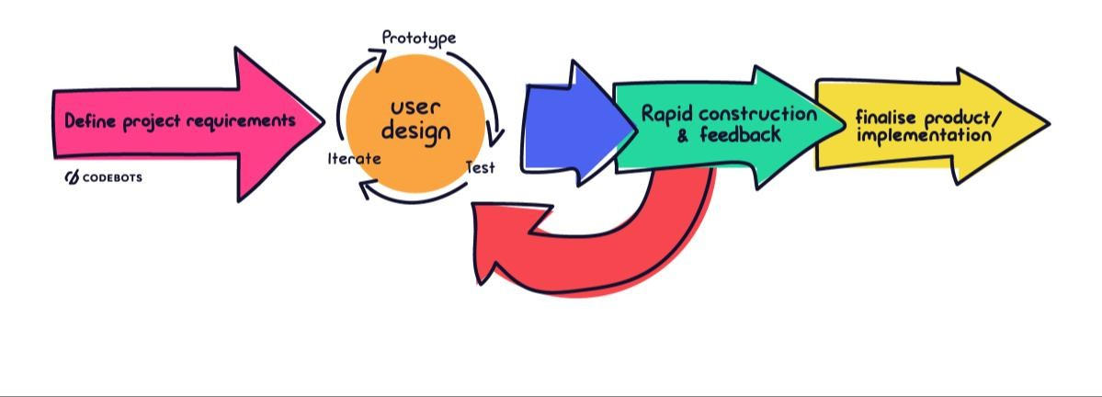

Figure 1: RAD Methodology Diagram

Figure 1 illustrates Rapid Application Development (RAD) methodology as the foundational guide for developing our system. Unlike traditional sequential models, RAD is an agile, iterative approach that prioritizes rapid prototyping and continuous user feedback over extensive upfront planning. By integrating frequent testing and refinement cycles into the development process, this methodology allows the development team to quickly adapt to evolving requirements or constraints. Ultimately, adopting the RAD framework ensures a highly flexible and efficient development lifecycle, guaranteeing that the final system accurately reflects and fulfills end-user expectations.
Phases of Development
Phase 1: Project Requirements
In this stage, the researchers established the project’s goals, boundaries, and specifications. Essential stakeholders worked together to shape the overall system concept, detail the intended capabilities, and rank tasks in order of importance, which culminated in a comprehensive system backlog. The requirements gathered in this phase are expressed as the context diagram in Section 3.4 and the data flow diagrams in Section 3.5.
Phase 2: User Design
During this stage, the developers worked hand-in-hand with the stakeholders to map out the system’s architecture and visual design. This process included developing prototypes, workflow charts, and technical schematics that establish both how the system will look and how it will operate. The outputs of this phase are the decomposed data flow diagrams, the activity diagrams, the entity relationship diagram, and the use case diagram presented in Sections 3.5 to 3.8.
Phase 3: Rapid Construction
During the rapid construction phase, the researchers developed a working prototype of the system. The developers used Flutter for cross-platform front-end development, Python with the FastAPI framework for the backend logic, and the Google Gemini API to implement the AI-assisted absence handling feature. The team built the core functionality that generates automated bi-weekly duty schedules and integrated the AI-assisted replacement ranking for absent personnel. The team collaborated through iterative coding cycles, conducted user feedback sessions, and performed regular component testing. By the end of this phase, a functional prototype had been delivered, demonstrating both the automated scheduling capability and the AI-assisted absence management feature for stakeholder evaluation.
Phase 4: Testing and Deployment
During the testing and deployment phase, the researchers conducted integration testing to ensure correct communication between the client application, the web service, and the AI component. The AI-assisted replacement feature was reviewed for fairness: because every hard eligibility rule is applied by the system before the model is consulted, and because the payload carries job attributes and identifiers only, the candidates presented to the administrator remain the same qualified set whether or not the AI answers. Administrators, head guards, and security personnel participated in user acceptance testing, providing feedback on system usability and schedule accuracy. Upon successful validation, the web service was deployed to the Render cloud platform with the records held in a Supabase (PostgreSQL) database, and the client application was distributed as a Windows installer and an Android application package for controlled real-world evaluation. Following deployment, the team monitored the system and provided maintenance support to address emerging issues and to incorporate user feedback for future enhancements.
3.2 Conceptual Framework
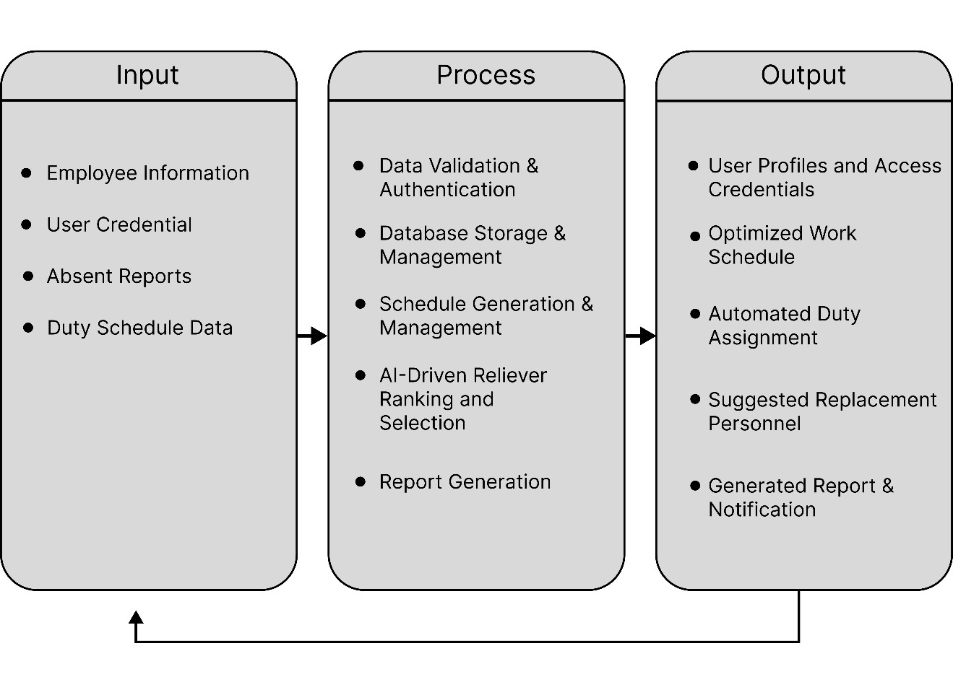
Figure 2 Input-Process-Output
Figure 2 illustrates the overall structure and flow of the proposed Scheduling and Duty Management System with AI Application in Absence Handling. The input stage consists of essential data such as employee profiles, duty sched-ules, user credentials, and absence records, which serve as the basis for system operations. These inputs are processed through various system components, including data validation, authentication, database management, and schedule generation. The AI component plays a key role in identifying suitable replacement personnel when absences occur by evaluating available staff based on relevant criteria. The output stage represents the results produced by the system after processing the inputs, which include creation of employee accounts, optimized work schedules, automated duty assignments, suggested replacement personnel, generated reports, and notifications. These outputs aim to support administrators in managing workforce scheduling more efficiently while ensuring continuity of operations. Overall, the IPO model demonstrates how the integration of scheduling management and artificial intelligence enhances decision-making, minimizes manual intervention, and improves the accuracy and responsiveness of duty allocation within the system.
3.3 Software and Hardware Requirements
The hardware and software specifications listed below outline the minimum and recommended requirements to operate the Scheduling and Duty Management System with AI Application in Absence Handling for Kaizen Security Agency Corp. efficiently. These components ensure that the system performs reliably across the agency's twenty-five deployment stations, supporting real-time schedule synchronization, AI-assisted candidate ranking for absence handling, duty and attendance report generation, and secure storage of personnel and scheduling records. The requirements cover the administrator workstations, the mobile devices used by security personnel and head guards in the field, and the cloud-hosted resources that power the web service and database.
Table 1. Hardware Requirements for Scheduling and Duty Management System
Component | Minimum Requirements | Recommended Requirements
Development Workstation | 64-bit dual-core 2.0 GHz, 8 GB RAM, 40 GB free storage, 1366×768 display, Windows 10 (64-bit), internet connection, USB port and cable | 64-bit quad-core 2.5 GHz+ (with hardware virtualization), 16 GB RAM, 60 GB free SSD, 1920×1080 display, Windows 11 (64-bit), broadband connection, physical Android device for testing
Administrator Workstation | 64-bit dual-core 1.8 GHz, 4 GB RAM, 200 MB free storage, 1366×768 display, keyboard and mouse, stable internet connection | 64-bit quad-core 2.0 GHz+, 8 GB RAM, 1 GB free SSD, 1920×1080 display, keyboard and mouse, broadband (5 Mbps+), printer
Mobile Device (Guards / Head Guards) | Android 7.0, quad-core 1.4 GHz, 2 GB RAM, 200 MB free storage, 5.0" 720×1280 display, mobile data or Wi-Fi | Android 10+, octa-core 1.8 GHz+, 4 GB RAM, 500 MB free storage, 6.0" 1080×2340 display, stable mobile data
Hosted Application Server | Shared CPU, 512 MB memory, Linux container (free plan) | Upgradable to paid tier of same platform
Hosted Database | Managed PostgreSQL, 500 MB storage (free plan) | Upgradable to paid tier of same platform
Network (All Clients) | Continuous internet connectivity on every client | Continuous internet connectivity on every client

The hardware and software specifications listed below outline the minimum and recommended requirements to operate the Scheduling and Duty Management System with AI Application in Absence Handling for Kaizen Security Agency Corp. efficiently. These components ensure that the system performs reliably across the agency’s twenty-five deployment stations, supporting schedule distribution, AI-assisted candidate ranking for absence handling, duty and attendance report generation, and secure storage of personnel and scheduling records. The requirements cover the administrator workstations, the mobile devices used by security personnel and head guards in the field, and the cloud-hosted resources that run the web service and the database.
Table 2. Software Requirements for Scheduling and Duty Management System
Component | Software / Technology | Purpose
Administrator — Desktop | Windows 10 (64-bit, v1809+) or Windows 11 | Installed via setup file (~17 MB, expands to ~39 MB); 64-bit (x64) only; no additional runtime required
Administrator — Web | Google Chrome or Microsoft Edge | Same application served in browser; alternative to desktop installation
Security Personnel / Head Guard | Android 7.0+ (API 24+) | Installed via APK (~63 MB); interface presented depends on the signed-in account role
Client Framework | Flutter SDK / Dart SDK | Cross-platform framework for the administrator desktop, web, and mobile applications
Mobile Build Toolchain | Android SDK / JDK / Gradle / Kotlin / Android Gradle Plugin | Compilation, packaging, and emulator support for the Android build
Desktop Build Toolchain | Visual Studio 2022 (C++ workload) / CMake | MSVC v143 compiler and Windows 10/11 SDK for the Windows desktop build
Web Service | Python / FastAPI / Uvicorn / Pydantic / Starlette | Backend API framework, ASGI server, and request/response validation
Database | PostgreSQL (managed by Supabase) | Backend API framework, ASGI server, and request/response validation
Database & Security Libraries | psycopg / bcrypt / python-dotenv / cryptography / truststore | PostgreSQL driver and connection pool; credential hashing; env config; transport security; OS certificate store
AI Service | Google Gemini API | Ranks replacement candidates during absence handling; optional — falls back to rule-based ranking if the API key is absent, quota is exhausted, request times out, or answer is unreadable
AI Client Libraries | google-genai / google-auth / httpx / requests / tzdata | Gemini client, credential handling, HTTP transport, and Philippine timezone data for duty-time decisions
Flutter Client Libraries | http / shared_preferences / pdf / printing / flutter_launcher_icons / cupertino_icons / flutter_lints | API calls, session storage, report generation and printing, launcher icons, supplementary icons, and static analysis
Development & Deployment Tools | Visual Studio Code / Git / Android Studio / Inno Setup / Google Chrome | Code editor, version control, Android SDK manager and emulator, Windows installer compiler, and web test target
External Hosting & Repository | Render (web service) / GitHub (private repository) | Cloud hosting with HTTPS and health checks; source control and deployment trigger

The software requirements encompass the complete technology stack used to develop, deploy, and operate the system. End users are not required to compile, configure, or install any development tools; administrators receive the application through a Windows installer or access it via a web browser, while security personnel and head guards install the Android application package directly on their devices. The AI service is integrated as an optional enhancement—if the Google Gemini API is unavailable, the system continues to function using its built-in rule-based ranking, ensuring uninterrupted absence handling. All client–server and server–database communications are encrypted, and the dependency versions are pinned to guarantee consistent behavior across development, testing, and production environments.
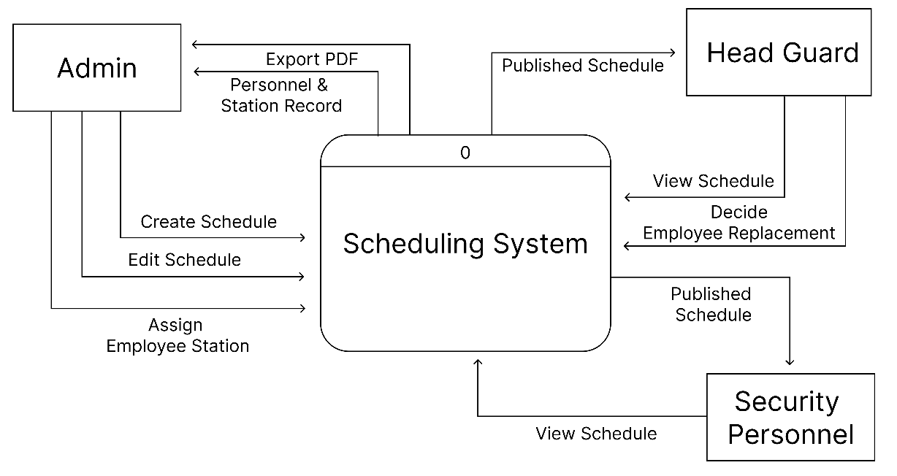
3.4 System Analysis and Design
Context Diagram
Figure 3 Context Diagram of the Existing System
Figure 3 shows how the same duty information moves once the proposed system is in place. The administrator works from a single console: personnel and station records are maintained there, each guard is assigned to a station, and the duty schedule is created in the system and edited there whenever an entry has to change, with the system returning the current personnel and station record so every change can be checked against what is on file. Once the schedule is settled it is published, and that published copy is what the head guards and the security personnel open on their own devices, so a change reaches the people concerned as soon as it is saved rather than when a new printout is delivered. Head guards view the schedule for the stations they supervise and, when a guard fails to report, decide the replacement within the system, so the cover is recorded against the duty instead of being arranged over the telephone and written in afterwards. Printed output is still available, but only as an exported PDF drawn from the same record the guards are reading, so the printout is now a copy of the schedule rather than the schedule itself. Read against Figure 4, the diagram shows the three weaknesses answered: the schedule is held in one shared record instead of in files and printouts, absences are resolved through a decision the system captures instead of a series of telephone calls, and every role reads from the same data instead of reconciling separate copies by hand.
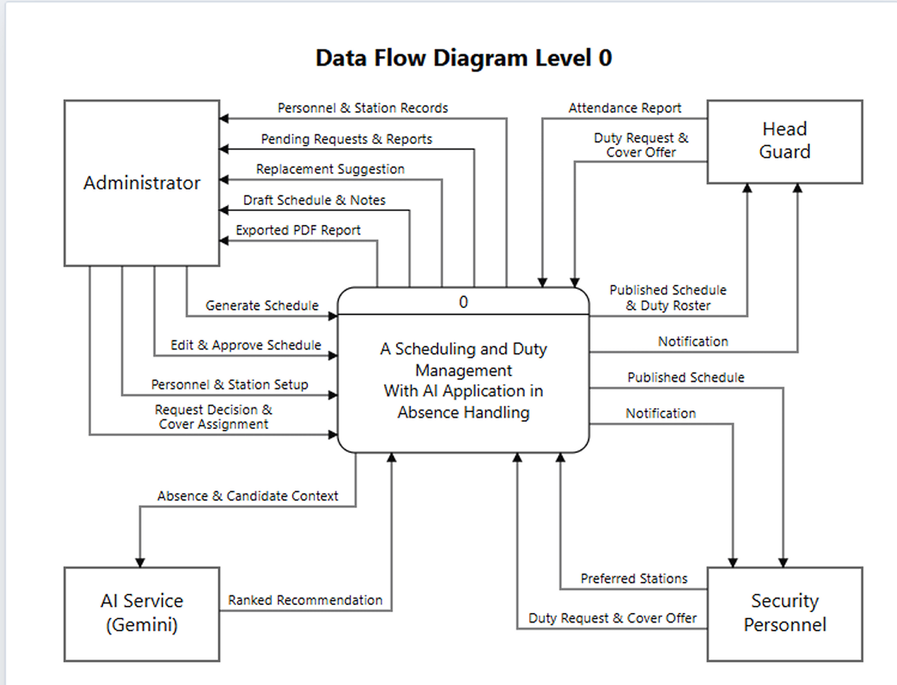
Figure 4 : Context Diagram of the Proposed System
Figure 4 is for the development of A Scheduling and Duty Management with AI Application in Absence Handling illustrates the overall flow of information between the system and the entities that interact with it. It shows how personnel setup, schedule generation, duty requests, and AI-assisted absence handling work in the system.
The process begins with the administrator, who registers each security personnel into the system and configures the stations, including the number of posts required per shift. Upon registration, the system automatically generates an account for the security personnel, and on first log-in the personnel confirm their preferred stations, which the system later uses in placing them on duty. The administrator then generates a bi-weekly schedule, and the system returns it as a draft together with notes describing any station left short-handed. The administrator may edit individual assignments before approving and publishing the schedule. Only a published schedule is released to the mobile application, where security personnel view their own bi-weekly duty and head guards additionally view the daily duty roster of their station.
Through the mobile application, security personnel and head guards file duty requests absence, leave, and special assignment requests — and may also offer their availability to cover a shift on a rest day. Head guards are further responsible for filing the attendance report of the shifts their own duty covers, which is how an absence is recorded in the system. The system forwards all pending requests and attendance reports to the administrator for a decision, and every decision made, along with every newly published schedule, is returned to the concerned personnel as a notification.
In the event of an absence, the system filters the workforce for personnel who are eligible to take the vacant post and ranks them. The shortlist, together with the details of the absence, is sent to the AI service, which returns a recommendation and the reasons behind it. The ranking is presented to the administrator, who remains the one to approve or change the assignment; should the AI service be unavailable, the rule-based ranking is presented on its own. The administrator may also export the schedule and leave records as a PDF report.
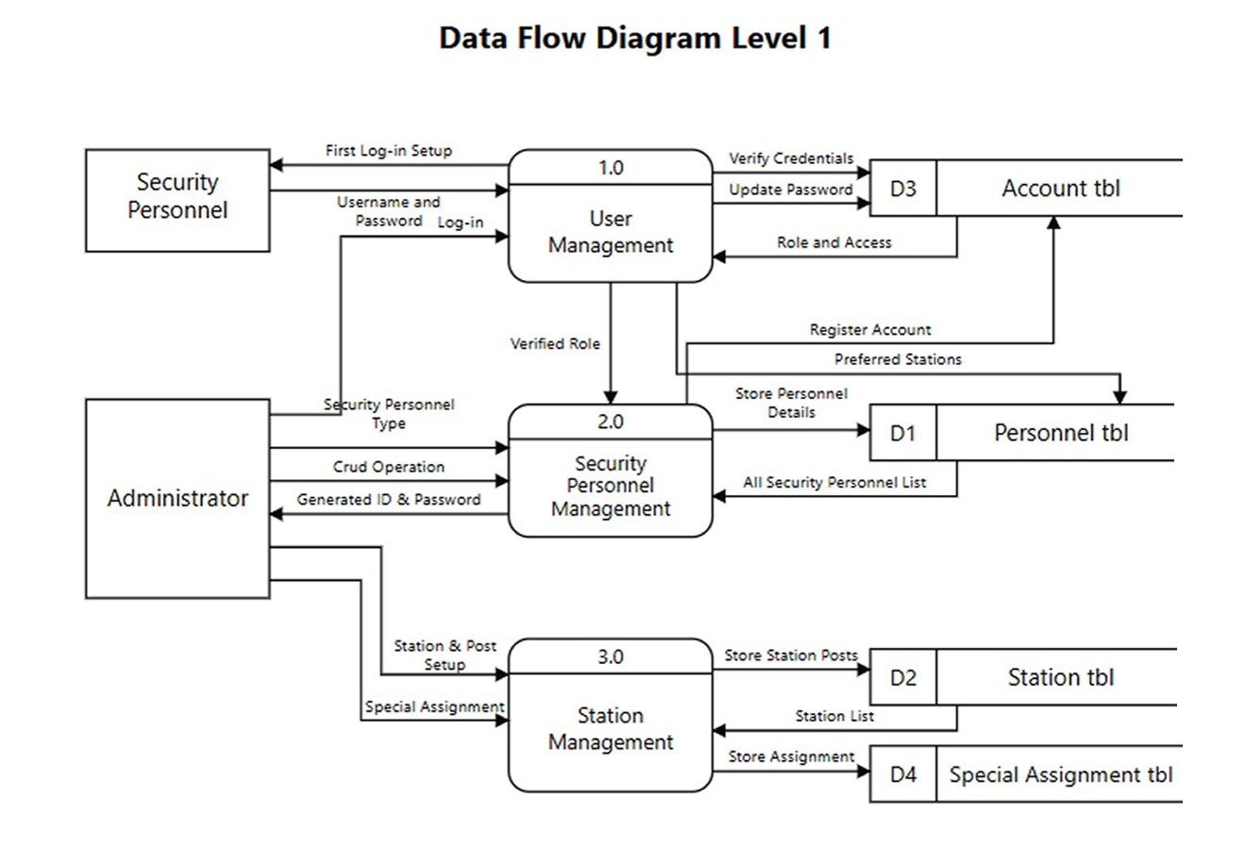
Data Flow Diagram

Figure 5 : DFD Level 1, Proposed System
Figure 5 elaborates the detailed process within the A Scheduling and Duty Management System with AI Application in Absence Handling. The diagram breaks down the system into seven processes: User Management, Security Personnel Management, Station Management, Schedule Management, Duty Request Management, Reporting, and AI Absence Handling.
The User Management feature checks whether the person logging in is an administrator, a regular guard, a reliever, or a head guard, and controls what each of them can see and do in the system. Credentials are kept in their own account store and the password itself is never held in readable form. On their first log-in, security personnel are required to replace the auto-generated password they were issued and to confirm their preferred stations, which the system saves to their personnel record and later uses when placing them on duty. There is also a mobile application made just for security personnel and head guards, where they can view their assigned schedules and keep track of their shifts from anywhere.
Security Personnel Management lets the administrator add new security personnel to the system. When an administrator creates a new personnel account, the system automatically generates a security personnel ID and a temporary password and returns them to the administrator to hand over. Here the administrator can add new personnel, set their type as regular, reliever, or head guard, view profiles, update information, and deactivate accounts.
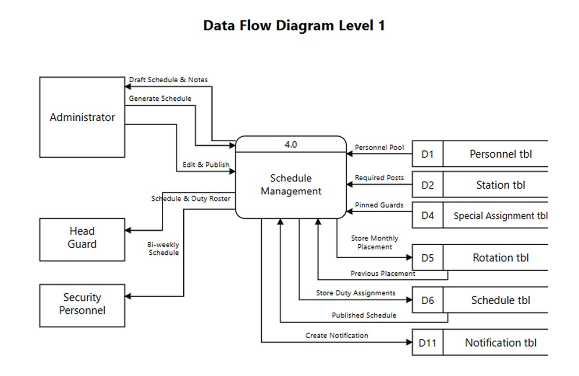
Station Management is where the administrator defines the stations themselves. Each station is configured per shift: how many guards the morning, afternoon, and night shift each require, and the name of the post every one of them will stand. This setup is what the schedule generator reads to know how many people a station needs, so a change made here changes the next schedule. The administrator can also pin a specific guard to a station for one rotation cycle, which the system keeps as a special assignment.

Figure 5 : DFD Level 1 Continuation
Figure 5 elaborates the Schedule Management creates the bi-weekly work schedules for security personnel automatically. Generation reads three things before it places anybody: the pool of personnel eligible for the station, the number of posts each shift requires, and any guard the administrator has pinned there for the cycle. It also reads the previous month's placement, so the monthly rotation moves people to new stations without emptying any of them, and it writes the new placement back for the month after.
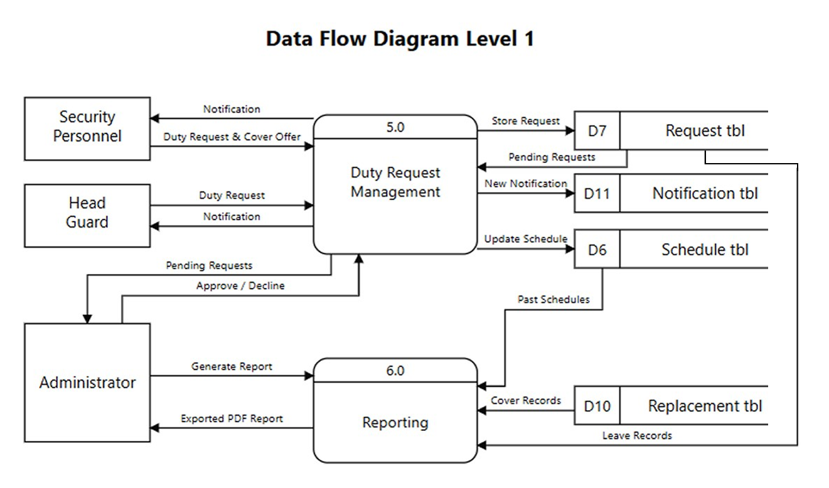
What comes out first is a draft. Each schedule clearly shows which station the personnel will work in, the post they will stand, and the specific dates and times of their shifts; alongside it the system files notes naming any station left short-handed, so a shortage is reported to the administrator instead of the generation simply failing. Before the schedule goes live, the administrator can review it and make changes if needed. Only the administrator can publish and finalize a schedule. Once published, security personnel can see their official bi-weekly duty in the mobile application, and head guards additionally see the daily duty roster of their own station.

Figure 5 : DFD Level 1 Continuation
Figure 5 elaborates Duty Request Management handles everything the personnel file from the mobile application: absence requests, leave requests, special assignment requests, and offers to cover a shift on a rest day. Both security personnel and head guards can file them. Each request is stored and forwarded to the administrator, who is the only one who can approve or decline it. An approved request updates the schedule — a granted leave clears the duties that fall inside it — and a notification of the decision is created for the personnel concerned.
Reporting allows the administrator to export the schedule and the leave records as PDF files for printing or sharing. The schedule report is drawn from the stored bi-weekly schedules together with the record of who covered each absence, so a past period can be reviewed exactly as it was worked. Past schedules are never deleted, so the administrator can look back at previous periods whenever old shift details need to be checked or a dispute settled.
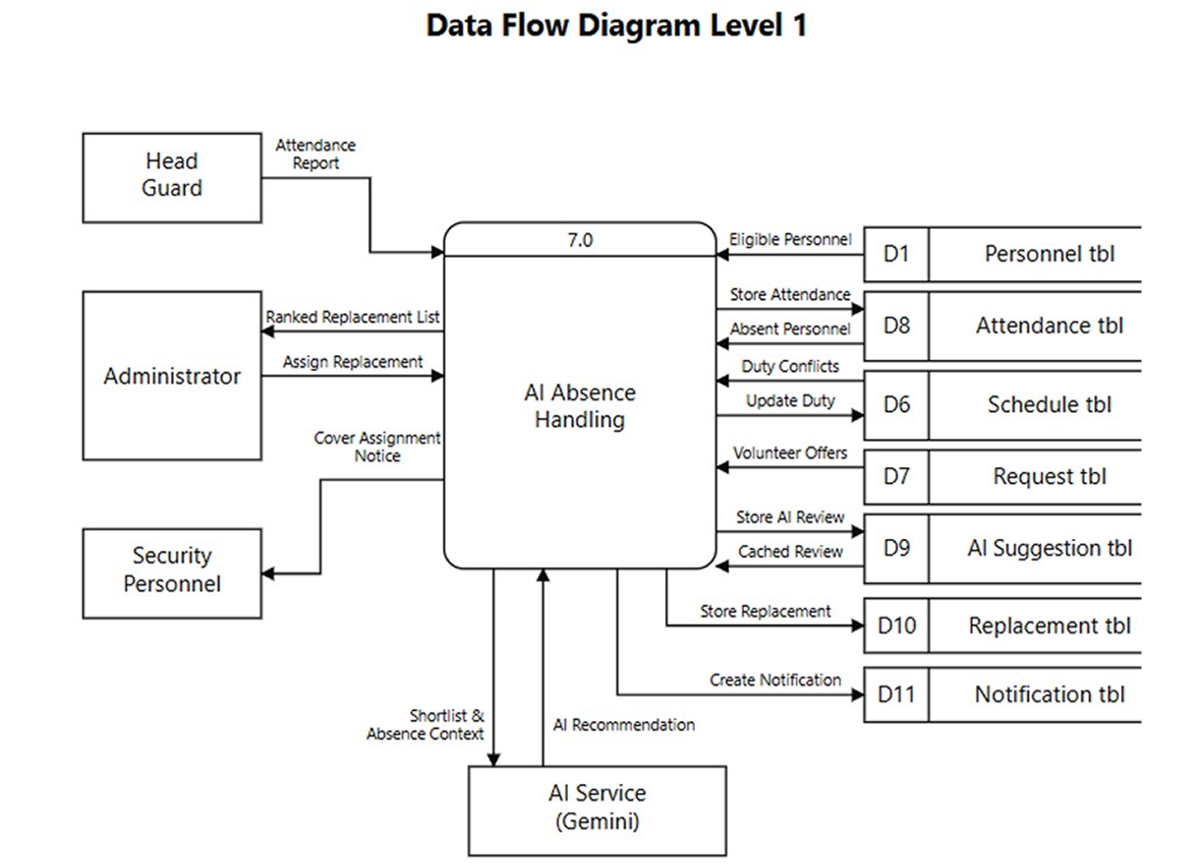

Figure 5 : DFD Level 1, Continuation
Figure 5 elaborates the AI Absence Handling is the process that fills a post left empty. It begins with the head guard, who files the attendance report for the shifts their own duty covers; that report is what records an absence in the system.
The system applies the hard rules itself before the AI is consulted, because those rules are scheduling law and are not open to interpretation. A candidate is dropped if they are already on duty at that time, if they are absent themselves that day, or if they are not eligible for the post — relievers are never posted to the night shift, and a head guard post can only be filled by a head guard. Whoever survives is scored on how familiar they are with the station, how well their type fits the post, and how light their workload for the period has been, so a guard who has already worked most of the period ranks below one who has not. A guard who volunteered to cover that date is boosted and always sorts above those who did not.
Only the survivors are sent to the AI service, with the context of the absence, and only the top of the ranking is sent. The AI re-ranks that shortlist and returns the reason behind its choice, which the system stores so the same absence is never charged to the service twice and so the recommendation can be traced afterwards. The administrator sees the ranking with the AI's recommendation at the top, can open each candidate's profile to see their contact details and call them, and remains the only one who can give the final approval. If the AI service is unavailable, the rule-based ranking is shown on its own and the process continues.
Once a replacement is assigned, the system rewrites that duty in the schedule to show the new arrangement, records who covered the absence, and notifies the guard who is taking the post.
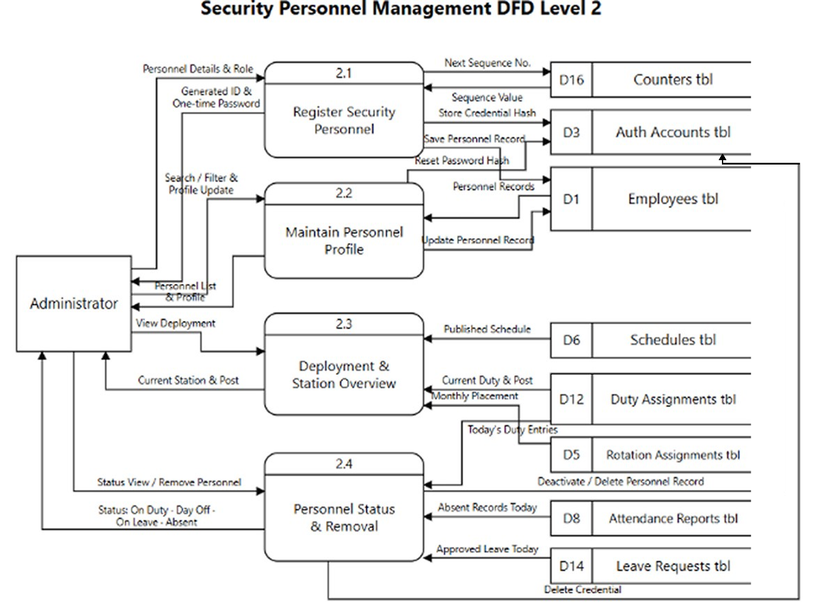
Figure 6 : DFD Level 2, Security Personnel Management
Figure 6 shows the four processes an administrator works through to bring a guard into the system and keep their record current: registration, profile maintenance, deployment lookup, and status.
- Register Security Personnel (Process 2.1):The administrator enters the guard's name, mobile number, email and role — regular, reliever, or head guard — and picks the stations they prefer. The system draws the next value from the counter, builds a personnel ID and a one-time password from it, stores the bcrypt hash in the credential table, and saves the record. The password is shown to the administrator once, to hand over; it is never readable again, only reset. The record is flagged so the guard must change that password and confirm their preferred stations before they reach their dashboard.
- Maintain Personnel Profile (Process 2.2): The administrator searches and filters the roster by type, opens a profile, and edits contact details or role. Resetting a password issues a new temporary one and writes its hash to the credential table the employee record itself only ever holds a mask. This process is also the source the AI reads from: the attributes it ranks a candidate on are the ones kept here.
- Deployment & Station Overview (Process 2.3): The guard is actually posted is read, not typed. The system resolves it from the published schedule for the current period, falling back to the monthly rotation placement and only then to the permanent posting on the record. The same lookup drives the headcount shown per station.
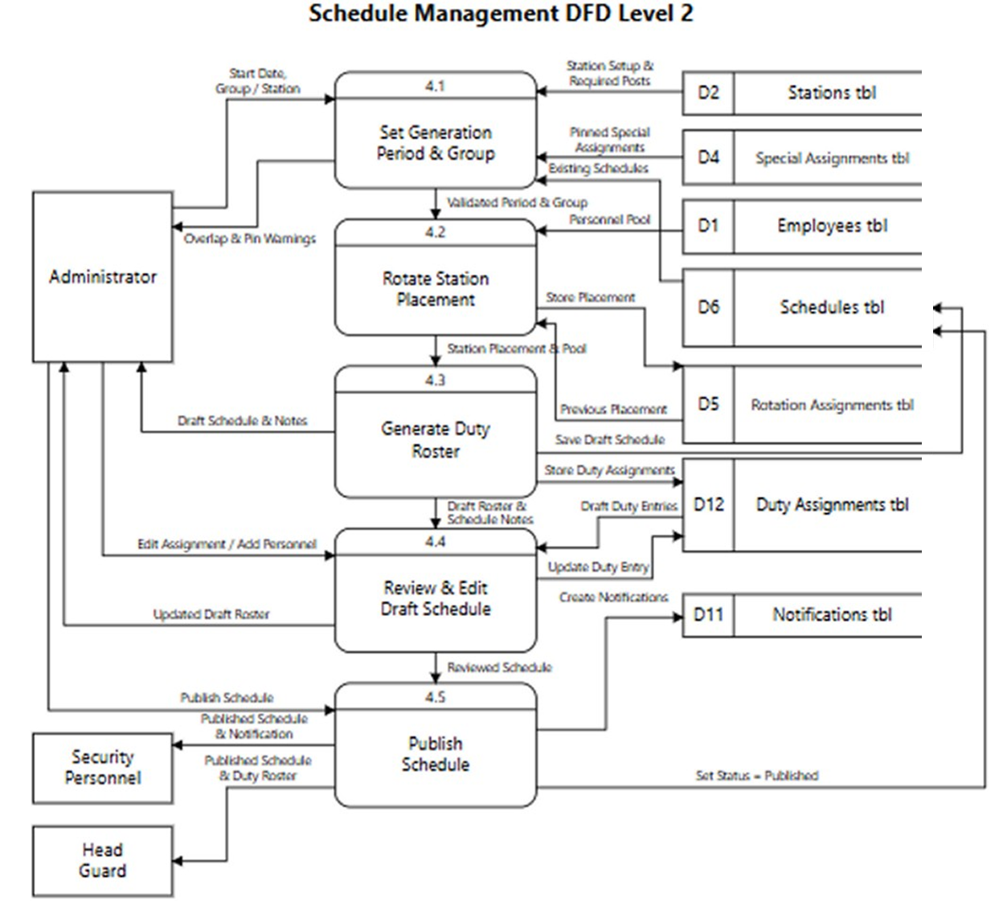
- Personnel Status & Removal (Process 2.4): Status is derived at the moment it is asked for, never stored as a flag: on duty when there is a duty entry for today, day off when the guard is in a schedule with no entry today, on leave when an approved leave covers today, absent when today's attendance report marks them so, and unassigned when no schedule holds them at all. From here the administrator can also deactivate a guard or delete the record, which removes the login with it.

Figure 7 : DFD Level 2, Schedule Management

Figure 7 decomposes the process the whole system is built around: turning a station setup and a group of guards into a published fifteen-day duty roster.
- Set Generation Period & Group (Process 4.1): The administrator picks a start date and a station group, or a single station. Before anything is generated the system refuses two situations by name: a group that already holds a schedule overlapping those dates, and a special assignment that would leave a guard rostered at two stations at once. Both come back as warnings that say which station and which period, not as a generic failure.
- Rotate Station Placement (Process 4.2): The monthly rotation places regulars and head guards across the group's stations for the cycle, weighing each guard's preferred stations against where they were last cycle. The result is stored as the cycle's placement and is what makes "assigned station" a starting point rather than a permanent posting.
- Generate Duty Roster (Process 4.3): Placement in hand, the generator fills every required post for every shift on each of the fifteen days, binds relievers to the regulars they cover, and honours pinned special assignments. Generation never fails on short staffing: an uncovered post is written as a schedule note naming the station, shift and reason, and the draft is saved unpublished with its duty entries.
- Review & Edit Draft Schedule (Process 4.4): The administrator reads the draft alongside its notes, swaps a guard on a post, or adds and removes personnel. Each edit rewrites the affected duty entries and is checked against the same conflict rules the generator used.
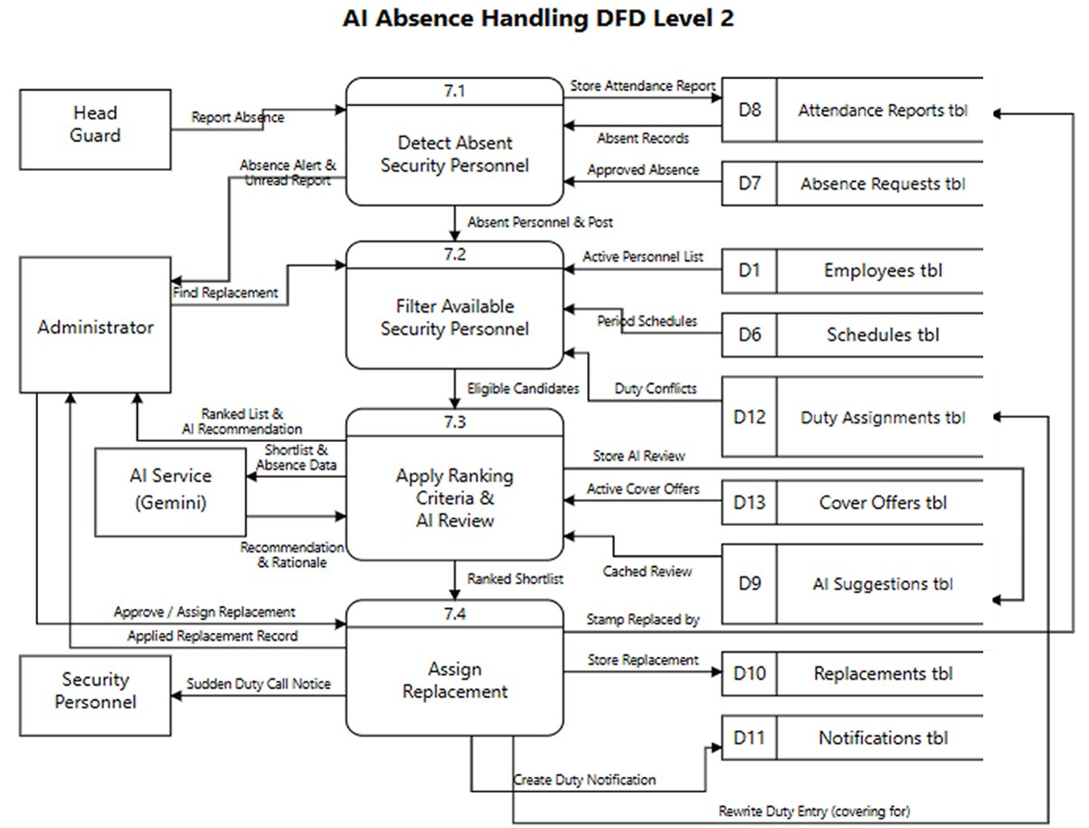
Publish Schedule (Process 4.5): Publishing flips the schedule's status and is the moment the roster becomes visible to guards and head guards in the app. Notifications go out to the personnel affected.

Figure 8 : DFD Level 2, AI Absence Handling

Figure 8 shows what happens between a head guard marking someone absent and a replacement standing the post. The division of labour is the point: rules decide who may cover, and only then does the AI rank the survivors.
- Detect Absent Security Personnel (Process 7.1): The head guard files the attendance report for their own shift — the day head guard files Morning and Afternoon, the night head guard files Night — marking each guard present or absent. The report is stored unread, which is what raises it on the administrator's notifications. An absence the guard filed in advance and the administrator approved reaches this process the same way.
- Filter Available Security Personnel (Process 7.2): Every hard rule is applied here, by code, not by the model. Out go the absent guard themselves, anyone inactive, anyone already on duty somewhere that date, anyone else reported absent that day, and anyone the post's own rules exclude: relievers never cover nights, a night post needs a night regular, a head-guard post needs a head guard. This process also fixes the cover window — the instant the post times out, past which no replacement can be assigned at all, because there is no duty left to stand
- Apply Ranking Criteria & AI Review (Process 7.3): What survives is scored 0–100 on station familiarity, type match, and how light the guard's load is this period; a colleague who volunteered to cover that date is boosted and sorts above everyone else. The shortlist then goes to Gemini with the absence reason and each candidate's recent cover load, and the model returns a recommendation, a confidence, a rationale and a runner-up. The answer is stored against the absence with a fingerprint of the shortlist, so re-opening the screen re-uses it and a changed shortlist forces a fresh review. If the AI is unavailable the ranked list still renders — the screen never waits on it.
- Assign Replacement (Process 7.4): The administrator calls the guard, and on agreement applies the cover. That single action rewrites the duty entry to show who is covering for whom, stamps the attendance record "replaced by", writes an audit record of the substitution, notifies the chosen guard that their schedule changed, and marks the stored AI review with who was actually assigned — which is the only honest measure of whether the recommendation was any good. Past the cover window the assignment is refused.
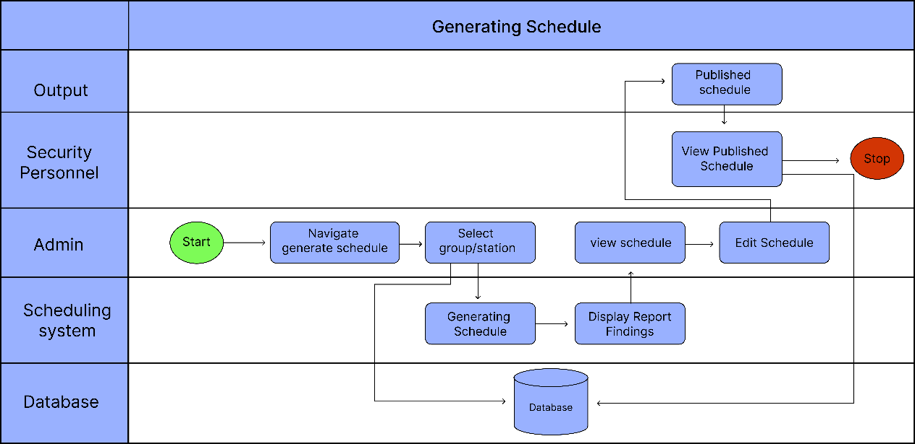
Activity Diagram

Figure 9 : Activity Diagram for Registering Security Personnel Account
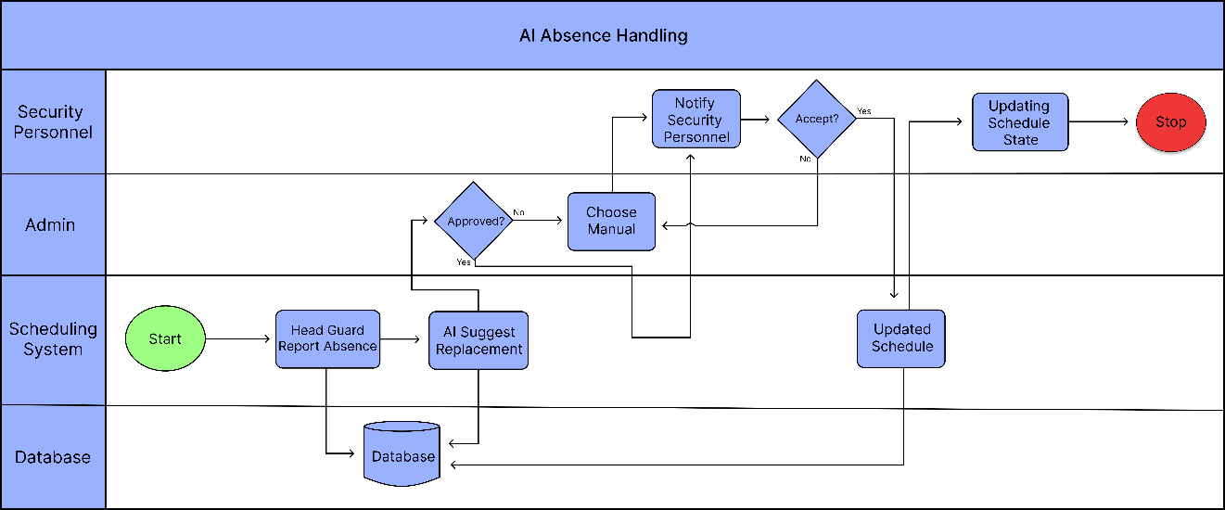
Figure 9 illustrates the step-by-step process for security personnel registration and system access. To begin the process, the administrator enters the security personnel 's personal information into the system, including their full name, email address, and contact number. Also input which station the security personnel assign and lastly the status which tells if the security personnel is regular employee or reliever. Once the registration is successful, the system automatically generates a unique Security Personnel ID and a temporary password. The security personnel will use these credentials to log into the system for the first time. After logging in, the security personnel set a new password and select preferred station and after that they can access their personalized dashboard. This area shows their bi-weekly work schedule, the specific station where they are assigned, and their designated shift type—such as morning, afternoon, or night shift. This streamlined registration process ensures that the system has all the necessary data to manage duties and handle absences effectively using AI.

Figure 10 : Activity Diagram for AI Absence Handling
Figure 10 provides a detailed look at how the system manages scheduling and handles unexpected absences using AI. The process begins when the system generates a standard bi-weekly schedule for all security personnels. If the AI detects an absence, it immediately searches for a suitable replacement and suggests a candidate to fill the shift. The administrator then reviews this suggestion and can either accept the AI's choice or manually select different security personnel. Once a replacement is identified, the system will display the security personnel details and send a notification to that security personnel or admin can call that personnel to request their availability. If the security personnel agree to take over the duty, the administrator confirms the selection, and the system automatically updates the schedule to reflect the change. This ensures that the station remains fully staffed without the need for a long, manual search for replacements.
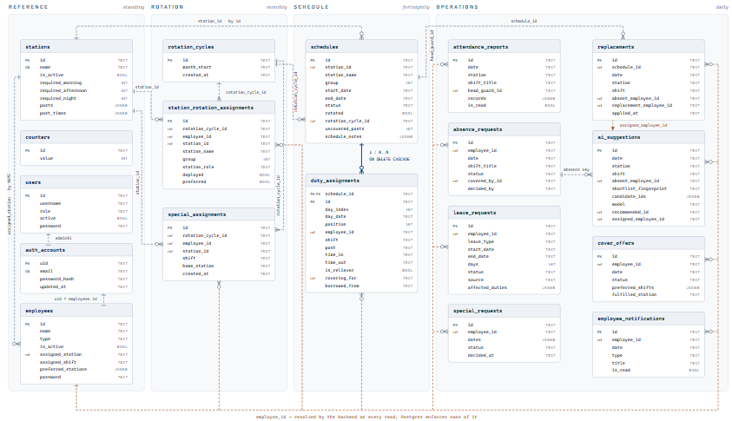
3.4.4 Entity Relationship Diagram
Figure 11 : Entity Relationship Diagram (ERD)

Figure 11 illustrates how all eighteen database tables are interconnected to efficiently manage security personnel deployment, duty scheduling, attendance monitoring, leave and absence handling, AI-driven replacement recommendations, and system notifications. The tables are organized according to how frequently they are written, progressing from standing reference data, to a monthly station rotation, to a fortnightly duty schedule, and finally to the daily operational records filed against it.
Reference data is maintained through the stations and employees tables. The stations table stores each guard post location together with its staffing requirements, which are configured separately for the morning, afternoon, and night shifts, and the named posts that must be filled in each. The employees table stores personnel details and classifies each guard as regular, reliever, or head guard, while retaining their permanent station assignment and preferred stations. System access is managed through the users table, which holds administrator accounts with role-based permissions, and the auth_accounts table, which stores hashed credentials separately from personnel records so that passwords are never exposed through employee data. The counters table supplies the sequential identifiers issued to new employees and stations.
Monthly deployment is governed by the rotation_cycles table, which represents one rotation period, and the station_rotation_assignments table, which records the station and group to which each guard is assigned for that cycle. Exceptions to the rotation are stored in the special_assignments table, which holds guards temporarily posted away from their assigned station for a single shift.
The system centers on the schedules table, which records all work duties. Each row represents a fifteen-day roster for a single station and carries its publication status, its rotation cycle, and any staffing gaps reported during generation. Every schedule expands into the duty_assignments table, which records the individual duty of each guard for each day, specifying the assigned post, shift, and working hours, and identifying whether the guard is serving as a reliever or covering for an absent colleague.
Attendance tracking is handled by the attendance_reports table, which records the daily attendance of personnel as filed by the head guard on duty for each station and shift. Absences and time-off are managed through the absence_requests, leave_requests, and special_requests tables, which store the filing, its supporting details, and the administrator's decision, with the leave_requests table additionally enforcing the day limits and cooldown period applied to each leave type. The cover_offers table records guards who volunteer to cover duties on a given date, together with the shifts and stations they are willing to accept. In cases of absence, the ai_suggestions table stores AI-generated replacement recommendations, linking the absent security personnel, the candidates considered, and the suggested replacement to support decision-making, and later records the replacement the administrator actually assigned. The applied decision is preserved in the replacements table, which links the absent personnel, the replacement, and the affected schedule for future reference and auditing purposes. Lastly, system communication is facilitated through the employee_notifications table, which manages alerts and messages sent to personnel regarding schedules, updates, and system activities.
The relationships shown in the figure are of two kinds. Only one is enforced by the database itself, the constraint between the schedules and duty_assignments tables, which guarantees that deleting a schedule also removes the duties belonging to it. All remaining relationships are logical joins resolved by the system when data is retrieved, most notably the employee identifier carried by eleven separate tables.
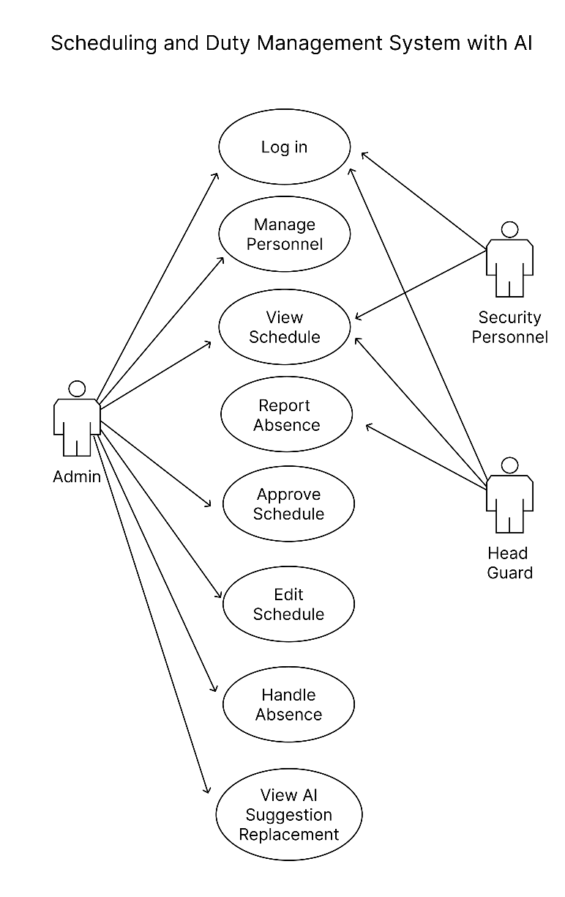
Use Case Diagram
Figure 12 : Use Case Diagram
Figure 12 illustrates the complete functional architecture of the Scheduling and Duty Management System with AI, encompassing three primary actors: the Admin, Security Personnel, and the Head Guard. The Admin serves as the central authority, holding the broadest set of privileges across the system. Upon logging in, the Admin can manage personnel by registering new security staff accounts — entering basic employee information and assigning station locations — after which the system automatically generates a unique Employee ID and temporary password sent directly to the new employee. The Admin also configures station assignments and employee time preferences, which feeds into the automated scheduling engine that generates optimized bi-weekly duty rosters. Before any schedule becomes active, the Admin reviews and officially approves it, maintaining full control over all staffing decisions. When absences arise, the Admin handles them by reviewing AI-generated replacement recommendations produced by the AI SmartReplace module, editing the schedule accordingly, and finalizing substitutions. At the close of each operational day, the system automatically compiles station-specific and overall summary reports including total personnel headcount and accumulated coverage hours which the Admin uses for official submission to the head department agency.
Security Personnel access the system through a secure login using their assigned Employee ID and password, allowing them to view their current duty assignments, upcoming bi-weekly schedules, designated station, shift times, special instructions, and historical work records. The Head Guard, on the other hand, logs in to monitor both their own schedule and the duty rosters of personnel under their supervision. Their primary function is reporting absences by verifying station attendance and submitting absence reports when a scheduled employee fails to report for duty. This triggers the AI SmartReplace module, which analyzes factors such as employee proximity, workload distribution, availability, and performance history to generate a curated list of replacement candidates with detailed profiles, enabling the Admin to directly contact and confirm a suitable substitute. Once accepted, the system automatically updates the master schedule in real time, ensuring continuous station coverage and accurate records across the entire security operation.

Data Dictionary Table

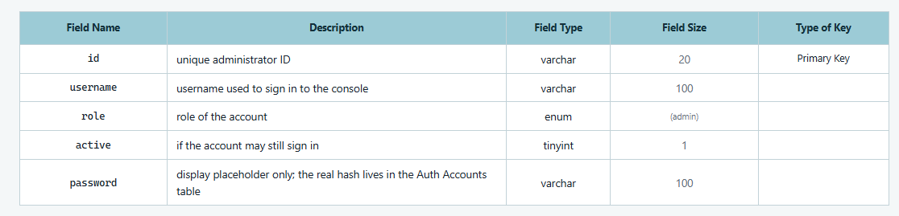
Table 3 Users Table

Table 3 illustrate the administrator accounts that are permitted to operate the web-based management console, and serves as the storage location for the identities under which the system is administered. The security guards themselves are not recorded here, as their own accounts are maintained separately. This table displays several essential fields, including a unique identification number assigned to the administrator, the username used to sign in to the console, and the role held by the account, which is presently limited to that of an administrator. It further includes a status indicator that specifies whether the account remains permitted to sign in. Lastly, the table carries a password field, which serves only as a display placeholder, as the actual encrypted credential is stored in the Auth Accounts Table.

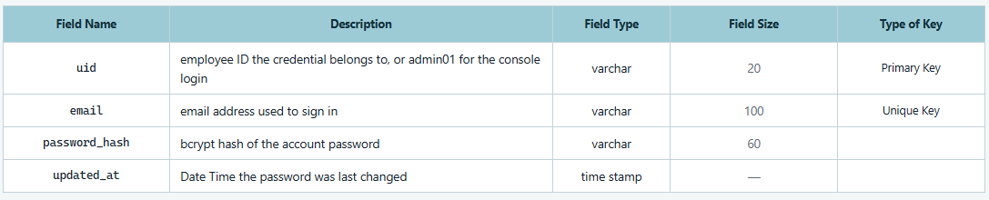
Table 4 Auth Accounts Table

Table 4 illustrate the dedicated storage location for the sign-in credentials of every employee, as well as those of the administrator. It is deliberately kept apart from the Employee Table so that an encrypted password can never be disclosed through an employee record. This table displays several essential fields, including the unique identifier of the account, which corresponds either to the employee number of a guard or to the designated administrator account, together with the email address used to sign in. It also contains the encrypted form of the password, produced through the bcrypt hashing algorithm, so that the password itself is never stored in a readable form. Lastly, the table records the date and time at which the password was last changed.

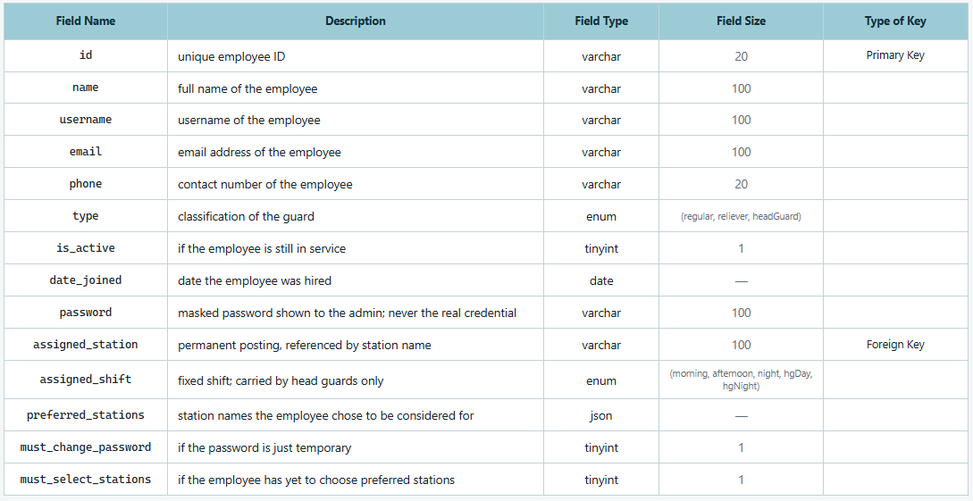
Table 5 Employees Table

Table 5 illustrate the comprehensive details regarding employee information, which serves as the primary storage location for data used in the creation of employee accounts. This table displays several essential fields, including a unique identification number, the full name of the employee, the username and email address under which the employee is identified, and the contact number at which the employee may be reached. Additionally, it includes a classification that specifies whether the employee holds a regular position, serves as a reliever, or serves as a head guard, together with a status indicator showing whether the employee remains in active service and the date on which the employee was hired. The table further records the permanent station to which the employee is posted, the fixed shift the employee is assigned to hold, which is carried by head guards alone, and the list of stations the employee has selected as preferred postings. Lastly, it carries a password field, which displays only a masked value to the administrator and never the actual credential, together with two indicators specifying whether the password issued to the employee is still temporary and whether the employee has yet to choose their preferred stations.

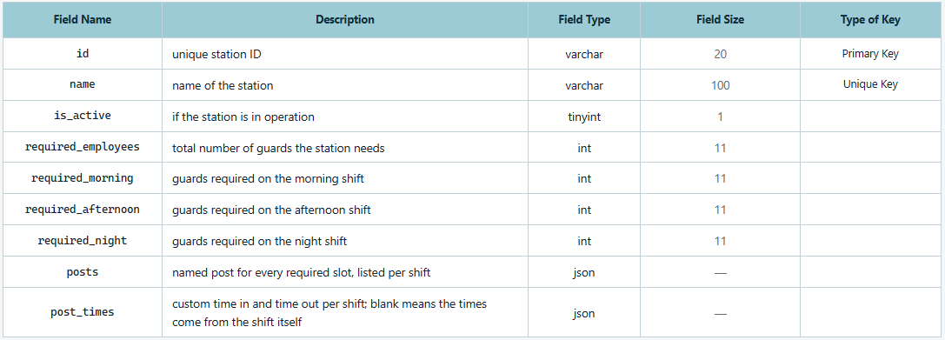
Table 6 Stations Table

Table 6 illustrate the record of every guarded station and of the manpower each one requires, and it is this configuration that governs the generation of duty schedules. This table displays several essential fields, including a unique identification number for the station, the name by which the station is known, and a status indicator showing whether the station is presently in operation. It further specifies the total number of guards the station requires, together with the number required separately for the morning shift, the afternoon shift, and the night shift. Lastly, the table records the named post corresponding to every required slot, listed per shift, as well as the custom time in and time out observed at those posts, which, when left blank, indicates that the standard hours of the shift itself are to be followed.

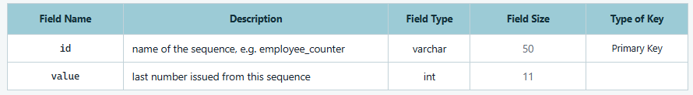
Table 7 Counters Table

Table 7 illustrate the running sequences from which the system issues new identification numbers, thereby ensuring that no generated identifier is ever repeated. This table displays two essential fields, namely the name of the sequence being maintained, such as the sequence reserved for employee numbers, and the last number that was issued from that sequence.

Table 8 Rotation Cycles Table
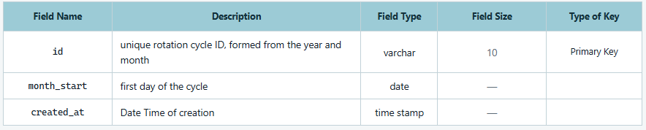
Table 8 illustrates the records one entry for every monthly rotation period, and serves to group together all of the station postings that belong to that period. This table displays several essential fields, including a unique identification number for the cycle, which is formed from the year and the month it covers, and the first day on which the cycle takes effect. Lastly, the table records the date and time when the cycle was originally created.

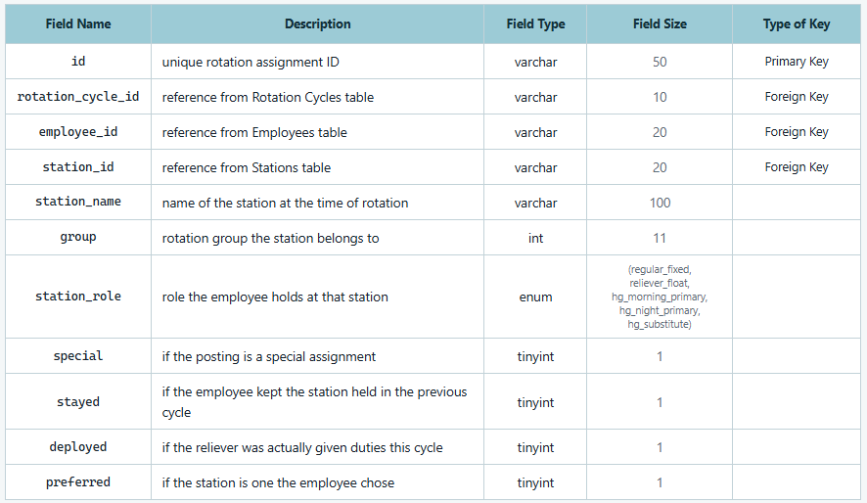
Table 9 Station Rotation Assignments Table

Table 9 illustrates the records the station to which each employee is posted for a given rotation cycle, and therefore constitutes the outcome of every rotation the system performs. This table displays several essential fields, including a unique identification number for the assignment, a reference to the rotation cycle in which it was made, a reference to the employee concerned, and a reference to the station, together with the name that station carried at the time of the rotation. It further records the rotation group to which the station belongs and the role the employee holds at that station, which distinguishes a regular guard occupying a fixed post, a reliever available to float, a head guard serving as the primary for the morning or for the night, and a head guard serving as a substitute. Lastly, the table includes four indicators specifying whether the posting was made as a special assignment, whether the employee retained the station held in the preceding cycle, whether a reliever was in fact given duties during the cycle, and whether the station is one the employee had selected as preferred.

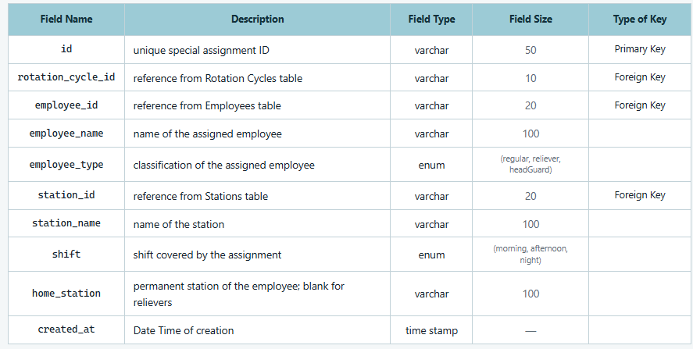
Table 10 Special Assignments Table

Table 10 contains the postings made by hand by the administrator, outside the ordinary rotation, for a particular station and shift. This table displays several essential fields, including a unique identification number for the assignment, a reference to the rotation cycle in which it falls, and a reference to the employee concerned, together with that employee's name and classification. It further records a reference to the station, the name of that station, and the shift the assignment covers, as well as the permanent station of the employee, which is left blank in the case of relievers, as they hold no permanent posting. Lastly, the table records the date and time when the assignment was originally created.

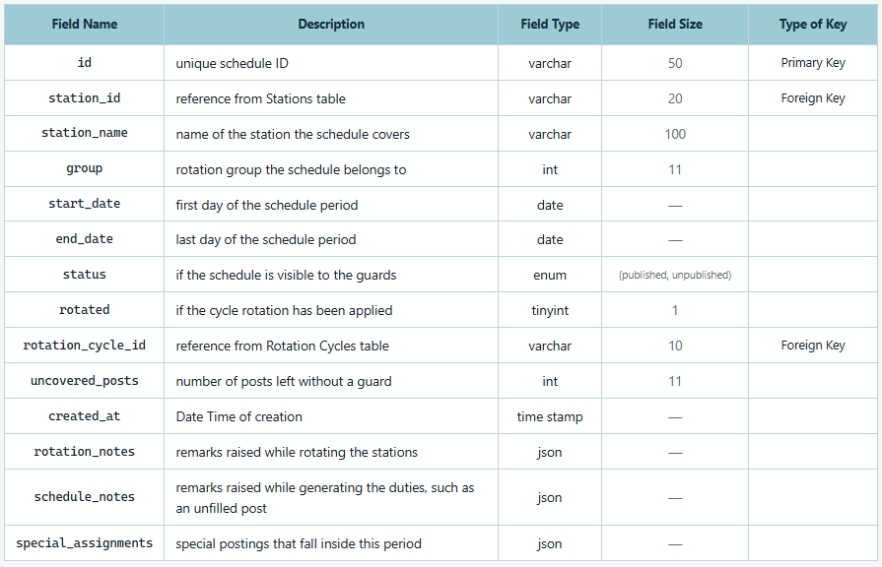
Table 11 Schedules Table

Table 11 illustrates the ifteen-day duty schedule for one station, and serves as the parent record under which the individual duties are stored. This table displays several essential fields, including a unique identification number for the schedule, a reference to the station it covers together with the name of that station, and the rotation group to which the schedule belongs. It further records the first and the last day of the period covered, a status indicator specifying whether the schedule has been published and is therefore visible to the guards, an indicator showing whether the rotation for the cycle has already been applied, a reference to the rotation cycle concerned, and the number of posts that were left without a guard. The table likewise stores the remarks raised while the stations were being rotated and the remarks raised while the duties were being generated, such as a post that could not be filled, together with the special postings that fall within the period. Lastly, the table records the date and time when the schedule was originally created.

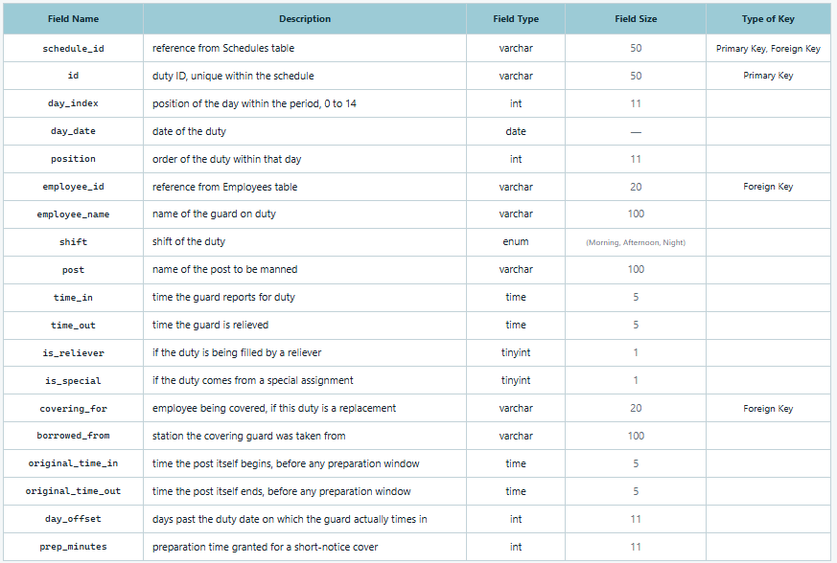
Table 12 Duty Assignments Table

Table 12 illustrates the records one guard, on one post, on one day, and its rows are the individual entries of which a schedule is composed. This table displays several essential fields, including a reference to the schedule the duty belongs to and a duty identification number that is unique within that schedule, the two of which together identify the record. It further records the position of the day within the fifteen-day period, numbered from zero to fourteen, the calendar date of the duty, and the order of the duty within that day, as well as a reference to the employee on duty together with their name, the shift being served, the name of the post to be manned, and the time in and time out observed by the guard. The table also carries two indicators specifying whether the duty is being filled by a reliever and whether it arises from a special assignment. Lastly, in the case of a duty taken over as a cover, the table records the employee being covered for, the station from which the covering guard was drawn, the time in and time out of the post as it ordinarily runs before any preparation window is applied, the number of days past the duty date on which the guard actually times in, and the preparation time granted for a cover arranged at short notice.
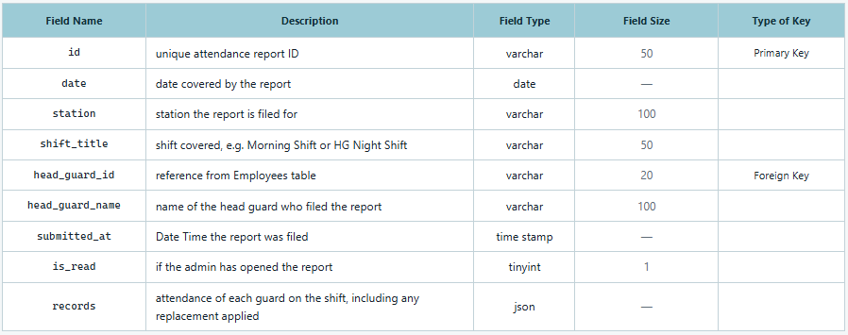
Table 13 Attendance Reports Table

Table 13 illustrates the reports filed by head guards concerning the guards who reported for a given shift. A head guard on day duty files for the morning and the afternoon, whereas a head guard on night duty files for the night alone. This table displays several essential fields, including a unique identification number for the report, the date it covers, the station for which it is filed, and the shift concerned, expressed as it appears to the head guard, such as the Morning Shift or the Head Guard Night Shift. It further records a reference to the head guard who filed the report together with their name, the date and time at which the report was submitted, and an indicator specifying whether the administrator has already opened it. Lastly, the table stores the attendance of each guard on the shift, including any replacement that was applied in the course of that shift.

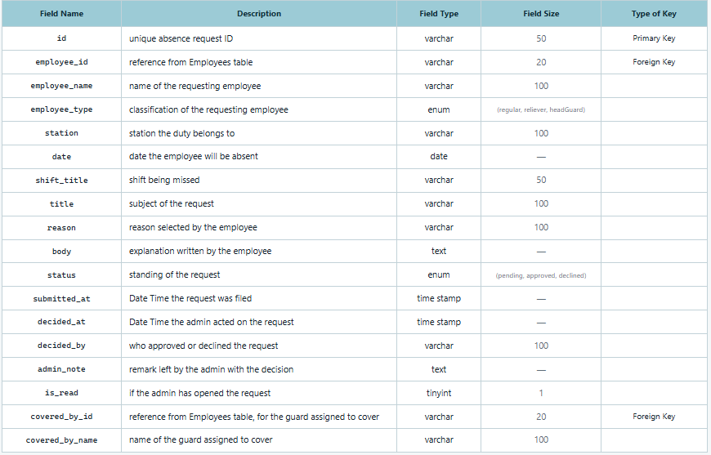
Table 14 Absence Requests Table

Table 14 illustrates the notices submitted by employees who are unable to report for a single duty. This table displays several essential fields, including a unique identification number for the request, a reference to the requesting employee together with their name and classification, and the station to which the duty belongs. It further records the date on which the employee will be absent and the shift being missed, as well as the subject of the request, the reason selected by the employee, and the explanation written in their own words. The table likewise records the standing of the request, being pending, approved, or declined, the date and time at which it was filed, the date and time at which the administrator acted upon it, the identity of the person who approved or declined it, any remark left with that decision, and an indicator specifying whether the administrator has already opened the request. Lastly, where a cover has been arranged, the table records a reference to the guard assigned to take the duty, together with that guard's name.

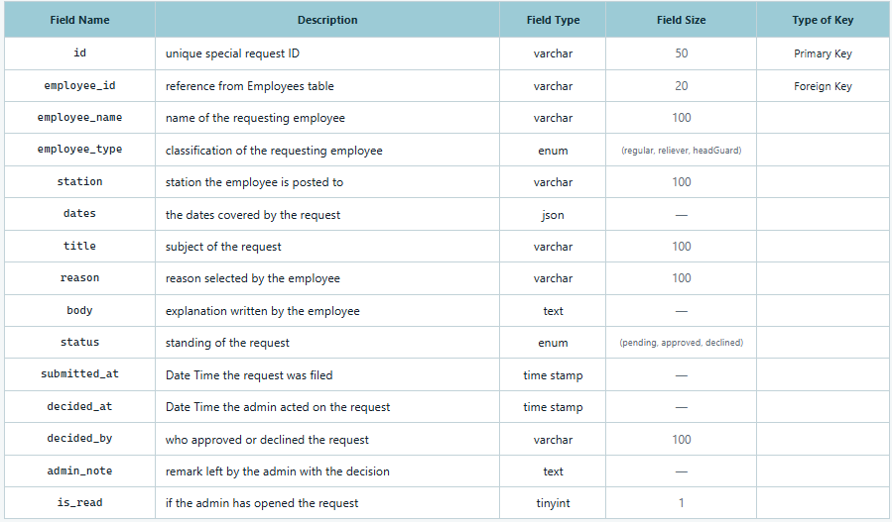
Table 15 Special Requests Table

Table 15 illustrates the requests submitted by employees that concern several dates at once, rather than a single duty. This table displays several essential fields, including a unique identification number for the request, a reference to the requesting employee together with their name and classification, the station to which the employee is posted, and the several dates the request covers. It further records the subject of the request, the reason selected by the employee, and the explanation written in their own words. Lastly, the table records the standing of the request, being pending, approved, or declined, the date and time at which it was filed, the date and time at which the administrator acted upon it, the identity of the person who approved or declined it, any remark left with that decision, and an indicator specifying whether the administrator has already opened the request.

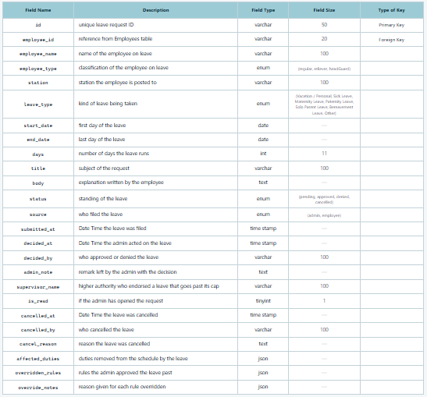
Table 16 Leave Requests Table

Table 16 illustrates the records of extended leave, whether filed by the employee through the mobile application or entered on their behalf by the administrator, with each kind of leave carrying its own maximum number of days. This table displays several essential fields, including a unique identification number for the request, a reference to the employee concerned together with their name and classification, the station to which that employee is posted, and the kind of leave being taken, which may be vacation or personal leave, sick leave, maternity leave, paternity leave, solo parent leave, bereavement leave, or a leave of another kind. It further records the first and the last day of the leave, the number of days it runs, the subject of the request, and the explanation written by the employee, together with the standing of the leave, being pending, approved, denied, or cancelled, and an indication of whether it was filed by the administrator or by the employee. The table likewise records the date and time at which the leave was filed, the date and time at which the administrator acted upon it, the identity of the person who approved or denied it, any remark left with that decision, the name of the higher authority who endorsed a leave granted beyond its permitted maximum, and an indicator specifying whether the administrator has already opened the request. Where a leave is withdrawn, it records the date and time of the cancellation, the person who cancelled it, and the reason given. Lastly, the table stores the duties that were removed from the schedule in consequence of the leave, the rules the administrator approved the leave in spite of, and the reason given for each rule so overridden.

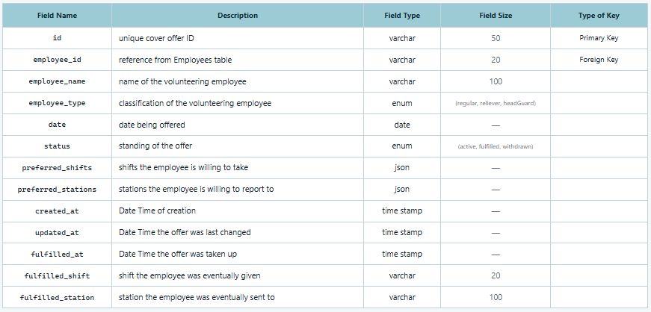
Table 17 Cover Offers Table

Table 17 illustrates the the offers of employees who volunteer to take an open duty on a given date, from which the administrator may draw when a guard is absent. This table displays several essential fields, including a unique identification number for the offer, a reference to the volunteering employee together with their name and classification, the date being offered, and the standing of the offer, which may be active, fulfilled, or withdrawn. It further records the shifts the employee is willing to take and the stations to which the employee is willing to report. The table also records the date and time when the offer was originally created and the date and time when it was last changed. Lastly, where an offer has been taken up, the table records the date and time at which it was taken up, together with the shift the employee was eventually given and the station to which the employee was eventually sent.

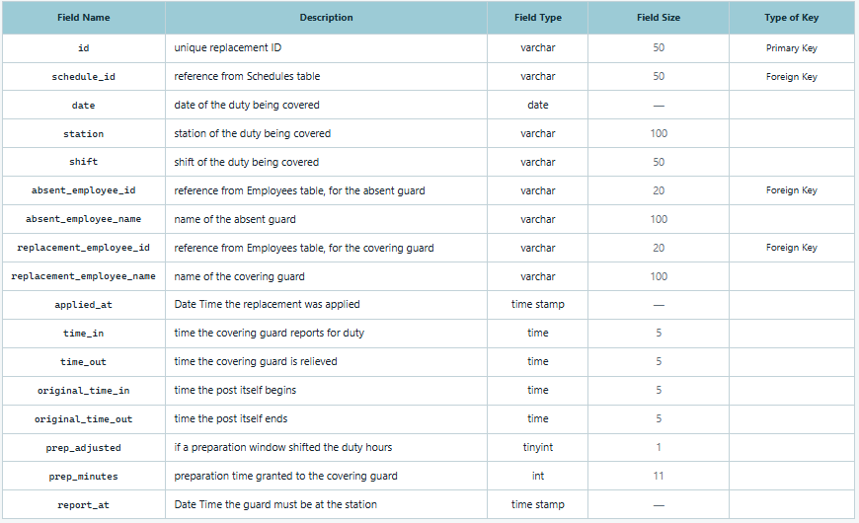
Table 18 Replacements Table

Table 18 illustrates the record of every cover that has in fact been applied to a duty. As a guard assigned at short notice is granted a preparation window, the hours that guard is required to stand may differ from the hours the post ordinarily runs, and both are therefore preserved. This table displays several essential fields, including a unique identification number for the replacement, a reference to the schedule in which it was made, and the date, the station, and the shift of the duty being covered. It further records a reference to the absent guard together with their name, a reference to the covering guard together with their name, and the date and time at which the replacement was applied. The table likewise records the time in and time out observed by the covering guard, the time in and time out of the post as it ordinarily runs, an indicator specifying whether a preparation window shifted those hours, and the preparation time granted. Lastly, the table records the date and time at which the covering guard is required to be present at the station.

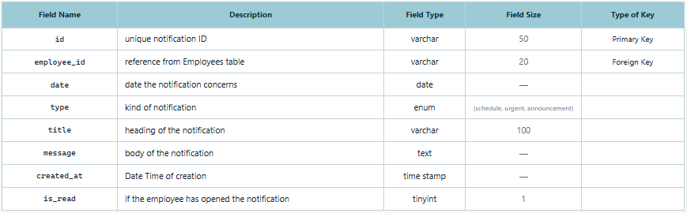
Table 19 Employee Notifications Table

Table 19 illustrates the messages delivered to a guard through the mobile application. This table displays several essential fields, including a unique identification number for the notification, a reference to the employee to whom it is addressed, and the date to which it pertains, together with the kind of notification, which may concern a schedule, an urgent matter, or a general announcement. It further records the heading of the notification and the body of the message it carries. Lastly, the table records the date and time when the notification was originally created and an indicator specifying whether the employee has already opened it.

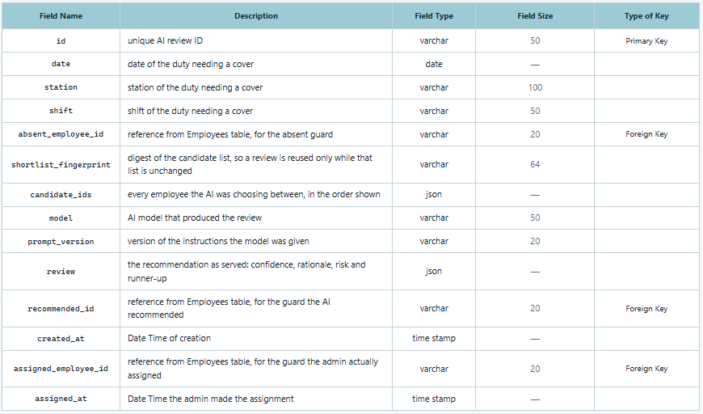
Table 20 AI Suggestions Table

Table 20 illustrates the record of each review performed by the artificial intelligence in respect of a single absence, preserving the candidates it was shown, the recommendation it returned, and the guard the administrator ultimately assigned. This table displays several essential fields, including a unique identification number for the review, the date, the station, and the shift of the duty requiring a cover, and a reference to the absent guard. It further records a digest of the candidate list, by which a stored review is reused only for so long as that list remains unchanged, together with every employee the artificial intelligence was choosing between, listed in the order in which they were presented, the model that produced the review, and the version of the instructions the model was given. The table likewise stores the recommendation as it was served, comprising the confidence expressed, the rationale given, the risk noted, and the runner-up identified, along with a reference to the guard that was recommended. Lastly, the table records the date and time when the review was created, a reference to the guard the administrator in fact assigned, and the date and time at which that assignment was made.
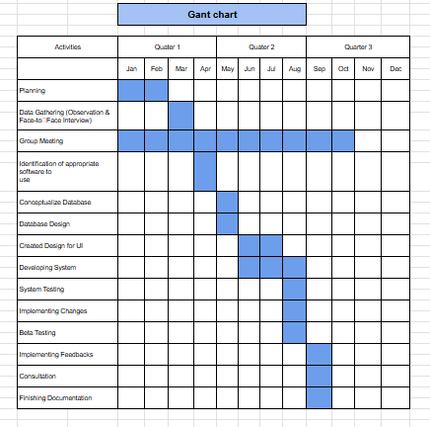
3.5 Gantt Chart
Figure 13 Gantt Chart of Activities
Figure 13 presents the Gantt chart of activities, which maps the timeline of the study's development across three quarters of the year. The project began with Planning in January and February, followed by Data Gathering through observation and face-to-face interviews in March, and the Identification of Appropriate Software to be used in April, closing out the first quarter. The second quarter covered the technical groundwork of the system: Conceptualizing and Designing the Database in May, Creating the Design for the User Interface in June and July, Developing the System from July to August, and System Testing in August. The third quarter was devoted to refinement and validation, consisting of Implementing Changes and Beta Testing in September, then Implementing Feedback, Consultation, and Finishing the Documentation in October. Running parallel to all of these is the Group Meeting activity, which extends from January to October, indicating that the researchers convened continuously throughout the entire duration of the project rather than at isolated intervals. The chart therefore illustrates a sequential yet overlapping workflow, where each phase builds on the output of the one before it while regular consultation and collaboration sustain the project from conception to completion.
3.6 Roles and Responsibilities
Table 21 Roles and Responsibilities of the Researchers
Member | Designation | Core Responsibilities
  Ashley Eunice V. Cruz | Project Leader /Documentation Lead/Lead System Tester | Serves as the primary coordinator and decision-maker for all research activities. Oversees the preparation, organization, and maintenance of all project documentation, including research papers, system manuals, and technical reports. Leads the system testing phase to ensure functionality, reliability, and adherence to project objectives. Monitors project progress and ensures timely completion of deliverables.
  Ranzie Kirth O. Cahulugan | Full-Stack Developer | Responsible for the design and implementation of the system's front-end user interface. Develops and manages the back-end architecture, including server-side logic, database management, and API integration. Ensures seamless integration between the front-end and back-end components. Implements system features and functionalities in accordance with the research requirements.
  Christian Mark G. Regacho | Quality Assurance Tester/Documentation Contributor | Worked on the preparation and development of Chapter 2 by gathering, reviewing, and organizing related literature and studies with the other members of the group. Participated in system testing to verify the functionality and proper operation of the developed system, confirming that there is no significant errors or issues observed during testing.
  Nel Laurice T. Acop | Documentation Assistant | Assisted in the preparation and organization of Chapter 2 by gathering, reviewing, and organizing related literature and studies. Helped with the formatting and structuring of the chapter to ensure proper presentation of the research content..

3.7 Evaluation Procedure
The evaluation uses two complementary sources of evidence. The ISO/IEC 25010-based questionnaire provides respondent ratings of software quality and acceptability. A supplementary technical assessment uses selected characteristics from ISO/IEC 25059:2023 to interpret documented testing and observation of the AI-assisted absence-handling feature. ISO/IEC 25059 provides a quality model for AI systems (International Organization for Standardization [ISO] & International Electrotechnical Commission [IEC], 2023); the specific observation criteria are defined for this project.
Table 22 presents the six software quality criteria used in the existing ISO/IEC 25010-based respondent evaluation. The supplementary AI assessment is described separately under AI Testing and Observation.

Table 22 ISO 25010 Guideline
Evaluation  Criteria | Description

Functional Suitability | Ensures that the system's functions, such as automated scheduling, duty management, and absence handling, completely and correctly address the users' requirements.
Performance  Efficiency | Focuses on the system's ability to maintain appropriate response times and resource utilization during normal and peak operations.
Compatibility | Evaluates the system's ability to interact and exchange data with other systems, platforms, or environments when required..
Reliability | Evaluates the system's ability to maintain consistent performance and recover appropriately from failures or errors.
Usability | Evaluates whether the system provides an intuitive interface that is easy to learn, understand, and use, resulting in user satisfaction.
Maintainability | Evaluates whether the system is modular, analyzable, and modifiable, allowing efficient updates, bug fixes, and future enhancements.

Evaluation Design
The study employed a descriptive-quantitative approach for the respondent evaluation. Following the Rapid Application Development model, the developed system was evaluated through an ISO/IEC 25010-based instrument covering six selected characteristics: Functional Suitability, Performance Efficiency, Compatibility, Reliability, Usability, and Maintainability. The additional ISO/IEC 25059 assessment organizes existing AI-related test findings and further observations by quality characteristic. It does not introduce another respondent survey or replace the existing software-quality evaluation.

Respondents of the Study
The questionnaire respondents consisted of two groups: five (5) IT experts and 211 end users. The IT experts evaluated technical aspects of the developed system, while the end users comprised administrators, head guards, and security personnel of Kaizen Security Agency Corp. Both groups used the existing ISO/IEC 25010-based evaluation instrument. The supplementary ISO/IEC 25059 assessment uses test cases and researcher observations; it does not add another respondent group.

Evaluation Instrument
The researchers used a structured Evaluation Rating Scale delivered through Google Forms. The questionnaire was adapted from the ISO/IEC 25010 software quality model and used statements suitable for the study’s respondents. It remains the instrument for the respondent evaluation.

AI Testing and Observation
The supplementary AI assessment maps documented test results to four selected ISO/IEC 25059:2023 quality characteristics. Functional correctness is examined by checking whether replacement candidates satisfy the independently verified availability, schedule, shift, and post requirements. Robustness is examined through the workflow’s behavior when the AI service fails or the candidate information changes. Transparency is examined by checking whether the recommendation’s explanation agrees with the supplied records and whether AI advice can be distinguished from rule-based fallback. User controllability is examined by checking whether the administrator can confirm, reject, or change a recommendation before assignment.
For each assessed case, the researchers record the test condition, expected behavior, actual behavior, and supporting screenshot or log, together with the observer, test date, and system version. The record identifies whether the AI response was live, simulated, cached, or unavailable. Existing test records may be used when their conditions and outcomes can be traced. Where an observation is missing, the corresponding behavior is marked Not assessed until supporting evidence is recorded. The observation record is completed by the researchers and is not distributed as another questionnaire.
The findings are compared with the expected behavior and reported descriptively. A criterion is marked Met only when supported by the recorded observation, and Not met when the actual behavior differs from the expected result. These are study-specific reporting labels. Simulated AI failures support findings about validation and fallback behavior; they do not establish the quality of live model recommendations. The assessment covers the selected characteristics and observed scenarios rather than full conformity with ISO/IEC 25059.
Likert Scale
The questionnaire used the following five-point Likert scale to rate the acceptability of each item. This scale applies to the respondent evaluation; it is not used to score the ISO/IEC 25059 test observations.

Table 23 Likert Scale

Scale | Range | Interpretation
5 | 4.21 – 5.00 | Highly Acceptable
4 | 3.41 – 4.20 | Acceptable
3 | 2.61 – 3.40 | Neutral
2 | 1.81 – 2.60 | Unacceptable
1 | 1.00 – 1.80 | Totally Unacceptable

The questionnaire means summarize respondent ratings of the six software quality characteristics and the overall acceptability of the Scheduling and Duty Management System.

Data Analysis Method
The results of the study will be analyzed using the Weighted Mean method. This statistical technique will be used to evaluate responses gathered from surveys or questionnaires by assigning corresponding weights to each response. The weighted mean will help determine the overall average rating of each criterion, such as system usability, efficiency, and user satisfaction. The formula for the weighted mean is determine the overall average rating of each criterion, such as system usability, efficiency, and user satisfaction. The formula for the weighted mean is:
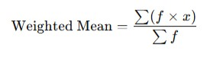
Where:
- f = frequency of response
- x = Weighted Mean
- ∑(𝑓 ∙ 𝑥)= Sum of the products of the frequency and the weight
This method allows for a more accurate interpretation of data by considering the significance of each response.
The ISO/IEC 25059 observations are analyzed separately by comparing the expected and actual behavior for each test case. The discussion identifies which quality characteristic is supported, the evidence used, and any limitation or observation still required. These findings are not combined with the questionnaire means, and no additional Likert rating or overall ISO/IEC 25059 score is calculated.
3.8 Ethical Standards and Consideration
The study involves a working agency, its personnel records, and an artificial intelligence service operated by a third party. The researchers therefore observed the following standards throughout the conduct of the study and in the design of the system itself.
- Permission and informed consent. Permission to conduct the study was sought from Kaizen Security Agency Corp. before any data was collected. The purpose, scope, and intended use of the study were explained to the security supervisor prior to the interview, and the session was recorded only after consent had been given. The same explanation was given to every respondent of the evaluation.
- Voluntary participation. Participation in the interview and in the evaluation was voluntary. Respondents were free to decline any question and to withdraw at any point without consequence to their employment or standing in the agency.
- Confidentiality and anonymity. The personnel records used in developing and testing the system are the property of the agency and were used solely for that purpose. Responses to the evaluation instrument are reported in aggregate, and no individual respondent is identified in the manuscript. Illustrations and screenshots presented in the study show only what is necessary to demonstrate a feature.
- Compliance with the Data Privacy Act. The handling of personal information in this study observes Republic Act No. 10173, the Data Privacy Act of 2012. Only the data necessary to operate the system is collected — name, contact details, classification, and duty history — and it is used only for scheduling and duty management, which is the purpose for which it was given.
- Security of credentials. Passwords are never stored or displayed in readable form. Each credential is stored as a bcrypt hash in a table kept separate from the personnel records, and an administrator may reset a password but cannot read one. Access to the system is controlled by role, so that each user sees only the information their role requires.
- Data minimization in the AI feature. Only the shortlist of candidates who have already passed the system’s eligibility rules is submitted to the AI service, and the payload carries job-related attributes and identifiers only — never names, contact details, or any other personal information. The stored review keeps the identifiers and the reasoning so that a recommendation can be traced afterwards.
- Human accountability for decisions. The artificial intelligence is advisory. It re-ranks a list the system has already screened, and it neither adds a candidate nor assigns a duty. The administrator makes the final assignment, and the system records who was in fact assigned alongside what the model recommended, so that the recommendation and the decision remain distinguishable. Where the AI is unavailable, the rule-based ranking is presented on its own and the process continues unchanged.
- Fairness in the ranking. The criteria on which candidates are scored — station familiarity, personnel type, workload for the period, and declared availability to cover — are job-related and are applied uniformly. Personal characteristics unrelated to duty play no part in the screening or the scoring.
- Integrity of records. Past schedules, attendance reports, and applied replacements are retained rather than deleted, so that a past period can be reviewed as it was actually worked and a dispute settled on the record.
- Academic honesty. All literature, tools, and third-party libraries used in the study are duly cited and acknowledged. The results reported in Chapter IV are presented as they were obtained, without alteration.

CHAPTER IV
RESULTS AND DISCUSSIONS

This chapter presents the development, testing, and evaluation of the Scheduling and Duty Management System with AI Application in Absence Handling for Kaizen Security Agency Corp. It reports unit and integration tests, response-time measurements, and the ISO/IEC 25010-based ratings of IT experts and end users. A supplementary assessment maps the documented AI-related behavior to selected ISO/IEC 25059:2023 quality characteristics. The interpretation distinguishes tested behavior from features that require further recorded observation.
4.1 Development and Testing
Unit and Integration Testing
Table 24 Unit and Integration Testing for Web Application
Test Case ID | Component/Module | Test Condition | Expected Behavior | Actual Result | Status
Web Application
TC001 | Authentication | Administrator logs in with valid credentials and attempts login with incorrect password | Valid login grants access to the administrator interface; invalid login is refused with no session created | Access granted for valid credentials; access refused for invalid credentials | Passed
TC002 | Station Configuration | A station is registered with required personnel and named posts per shift; station is renamed and per-post duty windows are edited | Configuration is saved, employee records update correctly, and duty windows re-stagger with the nine-hour rule enforced | Configuration saved; records updated; duty windows re-staggered correctly; nine-hour rule enforced | Passed
TC003 | Schedule Generation | A 15-day period is generated from station configuration and checked for conflicts and rest-day compliance | Daily coverage meets required headcount; no double bookings; rest days observed; shortfalls flagged | Coverage matched requirements; no double bookings; rest days observed; shortfalls flagged | Passed
TC004 | Rotation Cycle | Two consecutive rotation cycles are generated | Personnel redistribute across stations; preferred-station shares stay within target; familiar personnel retained | Personnel moved between cycles; shares within target; familiar personnel retained | Passed
TC005 | Special Assignment | A guard is pinned to a station at or beyond its required number; pinned assignments that clash with existing schedules are handled | Pinned assignment is honoured with surplus noted; clashing assignments are blocked and resolved through regeneration | Pinned assignment honoured; surplus reported; clashes blocked and resolved | Passed
TC006 | Schedule Management | A populated schedule is published; empty schedules are prevented from publishing | Published schedule becomes visible to recipients with notifications; empty schedules are skipped and reported | Schedule published with notifications delivered; empty schedules skipped | Passed
TC007 | Absence Handling | An absence is reported; candidates are screened and ranked by AI or rule-based fallback | Ineligible candidates removed; survivors scored on familiarity, type, workload, and availability; AI fallback works when unavailable | Ineligible candidates removed; survivors scored correctly; rule-based ranking survived all AI failure paths | Passed
TC008 | Leave Management | Leave requests are filed against type caps, lead time, yearly limits, and cooldown rules | All four rules enforced; approved leave excludes guard from generation | All rules enforced; approved leave excluded guard; pending leave scheduled normally | Passed
TC009 | Dashboard & Notifications | Dashboard analytics are computed and notifications screen is opened with pending items | Personnel totals and daily statistics are correct; pending counts populate across all tabs | Analytics values correct; all pending counts populated | Passed
Legend:
Passed — System successfully responded to different scenarios
Failed — System did not respond to different scenarios
AI Quality Assessment Based on ISO/IEC 25059:2023
The AI-assisted absence-handling feature was examined by mapping the existing test findings and documented behavior to selected ISO/IEC 25059:2023 quality characteristics. Table 24A identifies the available evidence and the limits of each interpretation. It uses the current paper’s reported results and does not treat an implemented feature as proof that every related quality requirement has been tested.
Table 24A. AI Quality Assessment Based on Testing and Observation
Quality characteristic | Behavior documented in the paper | Evidence and interpretation
Functional correctness | Ineligible candidates were excluded and the remaining replacement candidates were scored using the scheduling criteria. | Table 24, TC007 reports the screening and scoring result. It supports correctness of the tested rule-based screening; it does not establish that the AI selects the best eligible guard.
Robustness | The rule-based ranking remained available under the AI failure conditions tested. | Table 24, TC007 and Section 5.1 report fallback behavior. This supports continuity of the replacement workflow in those conditions. The test logs should identify the individual failure cases.
Transparency | The system provides explanatory reasoning with its replacement recommendation. | Sections 1.3 and 5.1 describe this feature. Table 24 does not separately report whether live explanations agree with the source records. Explanation accuracy therefore remains Not assessed in this supplementary mapping.
User controllability | The administrator confirms the final replacement assignment. | Sections 1.3 and 3.8 describe administrator control. Table 24 does not separately record rejecting a recommendation, selecting an alternative, or cancelling an assignment. These interaction outcomes remain Not assessed in this mapping.
The documented screening and fallback results provide evidence for specific aspects of functional correctness and robustness within the tested workflow. Explanation accuracy and the administrator’s rejection, alternative-selection, and cancellation actions require separate observation records before a test finding can be reported. These observations can be collected during system testing without administering another questionnaire. The findings do not establish that AI ranking is superior to rule-based ranking or that the system conforms to all requirements of ISO/IEC 25059.
Table 25 Unit and Integration Testing for Mobile Application
Test Case ID | Component/Module | Test Condition | Expected Behavior | Actual Result | Status
Mobile Application
TC001 | Authentication | Security Personnel and Head Guard log in with issued credentials; user changes password from mobile app | Access granted with role-based interface loaded; new password takes effect on next login | Security Personnel and Head Guard interfaces loaded correctly; password change reflected on next login | Passed
TC002 | Schedule Viewing | Guard opens assigned bi-weekly schedule and past schedule periods; duty window and stagger ladder are rendered | Dates, duty hours, station, and post displayed for each duty; archived periods accessible; stagger ladder and duty window rendered | Current and past schedules displayed correctly; duty windows and stagger ladders rendered accurately across all entries | Passed
TC003 | Duty Status | Guard opens application at various times relative to duty hours; Today's Duty card renders at phone width | Duty status computed correctly from server clock; card renders in all statuses without overflow | Current and past schedules displayed correctly; duty windows and stagger ladders rendered accurately across all entries | Passed
TC004 | Absence Request | Guard files emergency absence before duty begins; attempts to file after duty has ended | Guard declares availability to cover a rest-day duty; receives short-notice cover assignment | Emergency absence filed successfully; late filing blocked with clear reason provided | Passed
TC005 | Leave Request | Guard files leave request that breaches a rule; guard files valid leave request | Breach refused with named rule; valid request accepted and appears as pending | All rule violations correctly identified and explained; valid requests accepted and tracked as pending | Passed
TC006 | Day-off Request | Guard requests specific day off for a period not yet scheduled | Request filed against the correct period | All rule violations correctly identified and explained; valid requests accepted and tracked as pending | Passed
TC007 | Cover Availability & Assignment | Guard declares availability to cover a rest-day duty; receives short-notice cover assignment | Cover offer recorded and boosts replacement ranking; notification states station, post, adjusted hours, and report time | Cover availability recorded; ranking updated; notifications delivered with complete duty details | Passed
TC008 | Station Overview | Head Guard opens daily roster of assigned station | Personnel on duty for the shift listed with assigned posts | Daily roster displayed with all on-duty personnel and their assigned posts | Passed
TC009 | Attendance Reporting | Day and Night Head Guards file attendance reports; duplicate submissions are attempted | Day scope covers morning and afternoon; night scope covers night shift only; duplicate submissions prevented | Day reports filed for morning and afternoon shifts; night reports filed for night shift only; duplicate submissions blocked | Passed
TC0010 | Notifications | Schedule is published while guard is logged in; decision is made on filed request | Notification received and opens published schedule; guard notified of request decision | Schedule notifications delivered and navigable; request decision notifications received promptly | Passed
Legend:
Passed — System successfully responded to different scenarios
Failed — System did not respond to different scenarios
Response Time Testing
Table 26 shows the documented response time testing results of the developed Scheduling and Duty Management System with AI Application in Absence Handling. The evaluation covers schedule generation, retrieval of system records, and initial access after an idle period. Schedule-generation measurements represent computation time, while record-retrieval measurements represent the time taken by the deployed service to respond to requests.
Table 26. System Processing and Response Times
System Operation | Reported Time | Description
Generate a 15-day schedule for one station | 1.7 ms | Median computation time for one station’s schedule.
Generate a 15-day schedule for one station—slowest run | 3.2 ms | Highest computation time recorded across 25 runs.
Generate schedules for all 25 stations | 0.04 s | Computation time for generating 7,700 duty assignments.
Retrieve the station list | 0.73 s | Service response for retrieving station records.
Retrieve absence requests | 0.69 s | Service response for retrieving submitted absence requests.
Retrieve the complete personnel roster | 1.18 s | Service response for retrieving 573 personnel records.
Retrieve all schedules and duty assignments | 3.23 s | Service response for retrieving the complete schedule dataset.
Access the service after an idle period | 23.71 s | First-request response time, including the cloud service’s startup delay.

Legend
Very Fast - 0–2 seconds
Fast - More than 2–4 seconds
Slightly Fast - More than 4–6 seconds
Slow - More than 6–8 seconds
Very Slow - More than 8 seconds
No response received - N/A
User Acceptance Testing
Evaluation by IT Experts
Following the ISO/IEC 25010 software quality model, an evaluation was carried out on the Scheduling and Duty Management System with AI Application in Absence Handling. The study involved five (5) IT expert respondents, selected for their background in software development and systems administration. The evaluation focused on Functional Suitability, Reliability, Performance Efficiency, Usability, Compatibility, and Maintainability. Each criterion was measured using a 5-point Likert scale, providing insights into the system’s effectiveness, accuracy, and adaptability.
Table 27. Software Evaluation of Functional Suitability Criterion by IT Expert
Criterion | Overall Rating | Interpretation
Functional Suitability | 4.87 | Highly Acceptable
Performance Efficiency |  | Highly Acceptable
  4.53
Compatibility | 4.73 | Highly Acceptable
Reliability | 4.80 | Highly Acceptable
Usability | 4.93 | Highly Acceptable
Maintainability | 4.87 | Highly Acceptable
Overall System Rating : 4.79 |  | Highly Acceptable

Table 27 presents the ISO/IEC 25010 software evaluation results for the system as rated by the IT expert panel. The system obtained an Overall System Rating of 4.79, interpreted as Highly Acceptable, with every criterion falling within that range. Usability rated highest at 4.93, followed by Functional Suitability and Maintainability at 4.87 each. Performance Efficiency rated lowest at 4.53. The experts’ Maintainability rating is the more technically grounded of the two panels’ assessments of that criterion, since it was made against the modularity of the architecture and the organization of the source code rather than against the clarity of the system’s outward behaviour; at 4.87 it exceeds the end users’ 4.67 for the same criterion, indicating that closer inspection of the implementation did not weaken confidence in its maintainability.

Evaluation by End Users
The end-user evaluation involved 211 respondents comprising Admin, Head Guards,
and Security Personnel of Kaizen Security Agency Corp. The evaluation procedure
followed the same ISO 25010 framework.
Criterion | Sub- Criterion | Rating | Interpretation
 | Admin: The web dashboard provides complete employee, station, and schedule management functions needed for my administrative tasks. | 5.00 | Highly Acceptable
FUNCTIONAL SUITABILITY | Head Guard: The mobile app allows me to report attendance and view my station overview effectively. | 4.92 | Highly Acceptable
 | Security: The mobile app provides all necessary functions for viewing my duty schedule and submitting requests. | 4.84 | Highly Acceptable
 | Overall Rating | 4.92 | Highly Acceptable
Table 28. Software Evaluation of Functional Suitability Criterion

Table 28 presents the evaluation of the system against the Functional Suitability criterion, which measures whether the system provides the functions its users require to do their work. The criterion obtained an overall rating of 4.92, interpreted as Highly Acceptable, and was the highest-rated of the six criteria. All three roles rated their own interface at 4.84 or above, with no role reporting a missing function on which its work depends. The result is consistent with the coverage demonstrated in Section 4.2: the administrator’s dashboard carries station configuration, generation, publication and absence handling in one place, while the mobile application carries schedule viewing, request filing, cover availability and — for head guards — attendance reporting.
Table 29. Software Evaluation of Performance Efficiency Criterion
Criterion | Sub- Criterion | Rating | Interpretation
 | Admin: The web dashboard loads and responds quickly during schedule generation | 5.00 | Highly Acceptable
PERFORMANCE EFFICIENCY | Head Guard: The mobile app performs smoothly when reporting attendance and checking schedules during my shift. |  | Highly Acceptable
  4.32
 | Security: The mobile app loads my duty schedule quickly and runs without lag on my smartphone. | 4.45 | Highly Acceptable
 | Overall Rating | 4.59 | Highly Acceptable

Table 29 presents the evaluation of the Performance Efficiency criterion, which measures the responsiveness of the system under ordinary use. The criterion obtained an overall rating of 4.59, interpreted as Highly Acceptable, and was the lowest-rated of the six. The Head Guard sub-criterion returned 4.32, the lowest single figure in the evaluation, and the Security Personnel sub-criterion 4.45. The pattern is explicable: both are mobile figures gathered from personnel using the application on their own handsets over mobile data at station level, whereas the administrator’s rating reflects a desktop browser on an office connection. Responsiveness on the guard’s own device, rather than the correctness of what the system returns, is therefore the aspect of the system with the clearest room for improvement.
Table 30. Software Evaluation of Reliability Criterion
Criterion | Sub- Criterion | Rating | Interpretation
 | All: The system is consistently available whenever I need to access schedules or submit reports. | 4.71 | Highly Acceptable
RELIABILITY | All: The system handles errors and connection issues without crashing or losing my data. | 4.49 | Highly Acceptable
 | All: The generated schedules and attendance data are accurate and dependable for daily operations. | 4.66 | Highly Acceptable
 | Overall Rating | 4.62 | Highly Acceptable

Table 30 presents the evaluation of the Reliability criterion, which measures availability, tolerance of failure, and dependability of the data the system produces. The criterion obtained an overall rating of 4.62, interpreted as Highly Acceptable. Availability rated 4.71 and the dependability of generated schedules and attendance records 4.66, while error and connection handling rated 4.49 — the lowest item within the criterion. Read alongside Performance Efficiency, the two lowest figures in the whole evaluation both concern behaviour under a poor connection rather than the correctness of the roster itself, which respondents rated highly.

Table 31. Software Evaluation of Compatibility Criterion
Criterion | Sub- Criterion | Rating | Interpretation
 | Admin: The web dashboard works properly on my computer/browser and displays consistent data across sessions. |  | Highly Acceptable
  5.00
COMPATIBILITY | Head Guard: The mobile app works properly on my smartphone and syncs attendance data correctly with the Admin dashboard. | 4.84 | Highly Acceptable
 | Security: The mobile app works properly on my smartphone and shows consistent schedule data with the Admin's records. | 4.73 | Highly Acceptable
 | Overall Rating | 4.86 | Highly Acceptable

Table 31 presents the evaluation of the Compatibility criterion, which measures whether the system runs correctly across the devices in use and whether the record it shows is the same record everywhere. The criterion obtained an overall rating of 4.86, interpreted as Highly Acceptable, and was the second highest of the six. The head guards’ 4.84 is the more informative figure, since their sub-criterion asks specifically whether attendance submitted from the station arrives correctly at the administrator’s dashboard. Taken with the security personnel’s 4.73 on schedule consistency, the result supports the claim made in Section 4.2 that the administrator’s view and the guard’s view are drawn from a single published record.
Table 32. Software Evaluation of Usability Criterion
Criterion | Sub- Criterion | Rating | Interpretation
 | Admin: The web dashboard is easy to learn and use for managing employees, stations, schedules, and handling attendance reports. | 5.00 | Highly Acceptable
USABILITY | Head Guard: The mobile app is easy to use for reporting attendance and checking my station overview. | 4.72 | Highly Acceptable
 | Security: The mobile app is easy to learn and use for checking my duty schedule and submitting requests. | 4.69 | Highly Acceptable
 | Overall Rating | 4.80 | Highly Acceptable

Table 32 presents the evaluation of the Usability criterion, which measures how readily users learn and operate the system. The criterion obtained an overall rating of 4.80, interpreted as Highly Acceptable. The figure carries particular weight for this study because the respondents are deployed security personnel rather than office staff, and because the system replaced a process in which a guard’s own schedule reached them as a distributed file. That personnel aged 41 and above make up 158 of the 217 respondents, and that this group returned no lower a rating than the younger cohort, indicates the interface did not present a barrier to the majority of the workforce it was built for.

Table 33. Software Evaluation of Maintainability Criterion
Criterion | Sub- Criterion | Rating | Interpretation
 | All: The system's design appears well-structured and organized, suggesting it can be maintained and improved in the future. | 4.63 | Highly Acceptable
MAINTAINABILITY | All: Errors or issues in the system can be identified and explained clearly when reported to the development team. | 4.63 | Highly Acceptable
 | All: The system documentation and  structure support future maintenance and  new user training. | 4.74 | Highly Acceptable
 | Overall Rating | 4.67 | Highly Acceptable

Table 33 presents the evaluation of the Maintainability criterion, which measures how readily the system can be corrected, extended, and taught to new users. The criterion obtained an overall rating of 4.67, interpreted as Highly Acceptable, with the documentation and training item rating highest at 4.74. The end users’ reading of this criterion is necessarily an outside one: they judge maintainability from the clarity of the system’s behaviour and from the response they receive when they report a problem, not from the source code. The IT expert panel’s rating of the same criterion, presented in Section 4.4.1, is therefore the more technically grounded of the two and should be read as the primary evidence for maintainability.

Table 34. Software Evaluation Summary — End Users
Criterion | Overall Rating | Interpretation
Functional Suitability | 4.92 | Highly Acceptable
Performance Efficiency | 4.59 | Highly Acceptable
Compatibility |  | Highly Acceptable
  4.86
Reliability | 4.62 | Highly Acceptable
Usability | 4.80 | Highly Acceptable
Maintainability |  | Highly Acceptable
  4.67
Overall System Rating : 4.74 |  | Highly Acceptable

Table 34 presents the summary of the end-user software evaluation results. The system obtained an Overall System Rating of 4.74, interpreted as Highly Acceptable. All six criteria fell within the Highly Acceptable range, with Functional Suitability highest at 4.92 and Performance Efficiency lowest at 4.59 — a spread of 0.33 across the whole instrument. No criterion, and no individual sub-criterion, fell below 4.32.

4.2 Evaluation Result
Data Interpretation
Responses to each sub-criterion were recorded on a 5-point Likert scale, where 5 denotes Highly Acceptable, 4 Acceptable, 3 Neutral, 2 Unacceptable, and 1 Totally Unacceptable. The rating shown for each sub-criterion is the arithmetic mean of the responses to that statement. The Overall Rating for each criterion is the mean of its sub-criterion ratings, and the Overall System Rating is the mean of the six criterion ratings. Means were computed to two decimal places and interpreted against the following ranges:

Scale | Range | Interpretation
5 | 4.21 – 5.00 | Highly Acceptable
4 | 3.41 – 4.20 | Acceptable
3 | 2.61 – 3.40 | Neutral
2 | 1.81 – 2.60 | Unacceptable
1 | 1.00 – 1.80 | Totally Unacceptable

The sub-criteria under Functional Suitability, Performance Efficiency, Compatibility and Usability are worded separately for each role, the Overall Rating for those four criteria weights the three roles equally rather than by the number of respondents in each. The sub-criteria under Reliability and Maintainability are common to all respondents and are averaged across the full sample. Weighting the four role-split criteria by respondent count instead yields an end-user Overall System Rating of 4.67, which falls in the same interpretation band; the finding is therefore not sensitive to the choice of weighting. The IT expert instrument raises no such question: all eighteen of its sub-criteria were answered by all five respondents, so each criterion is the unweighted mean of three statements across the whole panel. The combined rating in Table 4.9 weights the two panels equally, on the ground that they measured different things rather than the same thing at different sample sizes.

CHAPTER V
SUMMARY, CONCLUSIONS AND RECOMMENDATIONS

5.1 Summary of Findings
The study successfully developed an Automated Scheduling and Duty Management System for Kaizen Security Agency Corp. to replace its manual, spreadsheet-based process. The system was developed as three integrated components: a Python (FastAPI) web service for scheduling logic, a Supabase (PostgreSQL) database for records, and a Flutter application for administrators (Windows desktop and web) and for head guards and security personnel (Android). Developed under the Rapid Application Development model, all fifteen modules defined in the project scope were completed, tested, and deployed.
Firstly, the system generates complete bi-weekly schedules for all twenty-five stations directly from station configuration. Generation is demand-driven: administrators declare per shift the required personnel count, assigned posts, and duty hours, and the system deploys exactly as configured. Verification confirmed that daily coverage matched required headcounts per shift and post, no guard was double-booked, rest days were observed, primary head guards totaled 156 hours over 15 days, relievers remained within bounded duty ranges, and no reliever was assigned to night shift. A complete 15-day schedule for a station of nineteen posts was generated in a median of 1.7 milliseconds, with all twenty-five stations (7,700 duty assignments) completed in 0.04 seconds. Rotation redistributed personnel between cycles while remaining reproducible, with preferred-station placement maintained at intended shares and familiar personnel retained at each station. The system completes generation even when personnel are insufficient, producing the best possible roster and recording shortfalls as reviewable notes rather than aborting.

Secondly, the system automates screening, scoring, ranking, and notification of replacement candidates. Upon absence reporting, scheduling rules eliminate candidates who are unavailable, already on duty, also absent, or ineligible for the shift or post. Remaining candidates are scored on station familiarity, personnel type, workload, and declared availability, then passed to the language model for re-ranking with explanatory reasoning. The administrator confirms the final assignment. The rule-based ranking remained functional across all tested AI failure paths—no API key, feature disabled, quota exhausted, network timeout, and malformed response—ensuring system utility does not depend on third-party service availability. The AI feature cost is bounded by absence count, with one model request per absence and cached results. Two temporal rules were added during testing: the expired-post refusal prevents replacement for shifts already finished, and the preparation window adjusts short-notice duty hours for travel and preparation time, with notifications stating both adjusted and original hours.

The supplementary ISO/IEC 25059 mapping identified reported evidence for candidate screening and preservation of the rule-based ranking during the tested AI failures. These findings support specific aspects of functional correctness and robustness. The paper describes explanatory reasoning and administrator confirmation, but separate observations are still needed to establish explanation accuracy and the outcomes of rejecting, changing, or cancelling a recommendation. These remaining checks are part of system testing rather than a new respondent evaluation.
Thirdly, the unbounded telephone-based replacement process was eliminated. Under the manual process, absences were communicated by telephone or failure to appear; administrators reviewed spreadsheets, decided from memory whom to call, and telephoned candidates sequentially, with each refusal restarting the search. The system enables head guards to file attendance reports directly, delivers them to the administrator dashboard immediately, pre-screens ineligible candidates, presents qualified candidates already ranked and explained, and prioritizes guards who declared cover offers for rest days. The administrator confirms rather than negotiates assignments. Extended working hours end when the replacement arrives, not when assigned. The preparation window ensures assigned reporting times are reachable, and the expired-post refusal prevents assignment to shifts already ended. Notifications contain complete duty information—station, post, adjusted duty hours, and reporting time—eliminating verbal relay.

Fourthly, one record serves three clients: the administrator application (Windows desktop and web) and the mobile application (Android) access the same data through one web service with role-based access. Guards access assigned bi-weekly schedules, past schedules, and duty details directly on their devices without requesting files or visiting offices. Information reaches recipients upon change rather than at next file distribution. Duty status is computed against the server clock in Manila time, ensuring displayed information reflects the current moment. Schedules are presented through station, period, and shift views with color-coded indicators for rest days, absences, and covered duties. Personnel are searchable by name, with records filterable by station, date, shift, and period. Duty reports per station and per period, along with yearly leave reports, are exportable to PDF on agency letterhead with configurable signatories.

Lastly. the system was verified by 284 automated unit checks across twelve harnesses covering generation, placement, rotation, leave, replacement, special assignment, station rename, server clock, and AI modules, all of which passed. Integration testing used a golden-file contract test over fifty-eight read endpoints; all endpoints answered, none were added or lost, and no read fields disappeared. System testing against the deployed cloud service returned HTTP 200 for every requested endpoint, serving 573 personnel records, 25 stations, and 25 schedules over HTTPS. Eleven defects were logged during development; ten are resolved and one remains open—a cosmetic 2.6-pixel tab bar overflow at window widths of 1280 pixels and below, affecting no data or scheduling decisions.

In conclusion, the system has proven to be a complete, efficient, and reliable platform that automates scheduling generation, strengthens absence handling through AI-assisted ranking, reduces administrative delay, and ensures timely information delivery to all personnel, making it fit for operational use at Kaizen Security Agency Corp.
5.2 Conclusion
As the development of the Scheduling and Duty Management System with AI Application in Absence Handling, the project has demonstrated its effectiveness in improving security personnel operations at Kaizen Security Agency Corp. through automation and the integration of demand-driven schedule generation, AI-assisted replacement ranking, and real-time notification mechanisms. The system provides automated bi-weekly roster generation, intelligent absence handling with rule-based fallback, and timely duty information delivery across desktop, web, and mobile platforms, thereby supporting efficient workforce management, reduced administrative delay, and continuous station coverage.
- The manual preparation of bi-weekly duty schedules is not a problem of effort but of arithmetic, and the arithmetic is now performed by the system. The challenges administrators encountered in organising and balancing workload — differing requirements per station and per shift, rest days that must be honoured, relievers who must cover them, and a rotation that must move personnel without disregarding their preferences — are all consequences of holding many constraints in the head at once while filling a spreadsheet. The study concludes that when the station configuration itself is made the input to generation, a complete and rule-compliant 15-day roster for twenty-five stations is produced in a fraction of a second, and the administrator’s remaining work is to review it rather than to construct it. The first specific objective was therefore attained.
- A scheduling system is trustworthy not because it always fills every post, but because it never hides an empty one. The study concludes that the decision to complete generation and record shortfalls as reviewable notes, rather than to abort when personnel are insufficient, is what makes the generated schedule usable in an agency that is periodically short of guards. An unexplained hole in a roster is a defect; a reported one is information the administrator needs before the day of duty. This conclusion is offered as a design principle for scheduling systems generally, not only for this one.
- The delay in handling absences was caused by the search and the negotiation, not by the decision, and it is the search and the negotiation that the system removes. The study concludes that separating a rule-based screening stage from an AI ranking stage answers the second and third objectives together: the rules guarantee that no ineligible candidate ever reaches the administrator, and the AI orders the survivors and explains the order. The administrator’s task becomes a confirmation rather than an open-ended sequence of telephone calls, and because guards may declare in advance their willingness to cover a rest day, the refusal loop is removed for those who have volunteered.
- The advisory placement of AI allows the replacement workflow to retain its rule-based candidate ranking when the AI service cannot provide usable advice. The reported tests support this fallback behavior under the conditions examined. The ISO/IEC 25059 mapping therefore supports conclusions about the documented screening and fallback behavior, while further observations are needed for explanation accuracy and administrator control. The study does not establish that AI always improves the ranking or that the observed behaviors demonstrate full conformity with the standard.
- Reducing the extension of an on-duty guard’s shift is a problem of reachability, not of assignment speed. The study concludes that assigning a replacement quickly accomplishes nothing if the reporting time given cannot be met, and that the preparation window — an automatic adjustment of duty hours for travel and preparation, with both the adjusted hours and the post’s own hours stated in the notification — is the mechanism by which the third objective is actually served. The corresponding refusal to assign a replacement to a post whose duty has already ended closes the same problem from the other direction.
5.3 Recommendation
Based on the outcomes and insights from the capstone project, the following recommendations are offered to further improve the system’s performance, efficiency, and impact:
1. Formalize Administrative Protocols and Data Integrity
Establish clear procedures requiring administrators to rename stations only through the Edit Station function, review generation notes before publishing, and confirm all AI recommendations. Provide head guards with orientation on attendance report scope rules to prevent submission errors.
2. Resolve Technical Defects and Infrastructure Limitations
Close the outstanding Notifications tab layout defect at narrow window widths, provision a dedicated staging database for write-path test suites, and eliminate the web service cold start through scheduled keep-warm requests or a non-idling hosting tier.
3. Expand Notification Channels and Platform Reach
Add SMS or email notifications to reach personnel for short-notice covers when the application is not open. Extend mobile support to iOS and implement offline schedule caching for guards on duty without data connectivity.
4. Enhance System Intelligence and Maintain Test Contracts
Analyze recorded administrator decisions against AI recommendations to examine usefulness and refine rule-based scoring weights. Maintain the golden-file contract test by running it before every release and documenting endpoint differences. Complete the remaining ISO/IEC 25059 observations by comparing live explanations with the underlying records and recording the administrator’s rejection, alternative-selection, and cancellation actions. Retain the test conditions, actual outcomes, screenshots or logs, and system version as evidence, and repeat relevant checks after changes to the model, prompt, rules, or interface.
5. Guide Future Research on Long-Term and Cross-Domain Impact
Future Researcher should evaluate longitudinal effects on absenteeism, overtime, and personnel satisfaction over months of live operation. Compare AI and rule-based rankings under live conditions, test demand-driven scheduling in other industries, and examine ethical perceptions of AI-assisted workforce assignment.

REFERENCES
Foreign Literature
Bositkhanova, N., Dadaboyev S. M. U. (2025). Revolutionaizing workforce planning: the strategic role of AI in HR strategy, discover global society, 3, 100.
Dhamrait, G. (2025). Security guard scheduling: Challenges, solutions, and best practices. International Journal of Security Management, 9(1), 55–68.
Egasmara, F., Rahayu, A., Wibowo, L. A., Rofaida, R., Sofia, A., & Fauziyah, A. (2025). Workforce planning optimization utilising AI to improve firm performance: A systematic literature review using VOSviewer. Journal of Work-Applied Management, 17(1), 1–13.
Hughes, L. (2024). Security guard scheduling: Avoid common problems and schedule more efficiently. Journal of Workforce Management Systems, 11(2), 78–89.
Itu, A. (2025). Industrial scheduling in the digital era: Challenges, state-of-the-art methods, and deep learning perspectives. Applied Sciences, 15(19), 10823.
Kupunarapu, S. (2022). AI-driven crew scheduling and workforce management for improved railroad efficiency. Journal of Transportation Technologies, 13(3), 112–125.
Oladele, T. (2024). The impact of AI-driven predictive scheduling on employee engagement and customer satisfaction. International Journal of Artificial Intelligence in Management, 12(1), 34–45.
Ono, C. G. & Okeagu, F. N. (2025). AI-Powered Scheduling in High-Mix, Low-Volume (HMLV) Manufacturing: An Appraisal of the Challenges, Approaches, and Future Directions. Journal of Education, Science and Engineering, 2(1), 176–199.
Sanjalawe, Y., Al-E’mari, S., Fraihat, S., & Makhadmeh, S. (2025). AI-driven job scheduling in cloud computing: A comprehensive review. Artificial Intelligence Review, 58, 197.
Tanner, R. (2025, December 22). Project schedule management explained: Planning, tracking, and delivering. Lark.Concepcion, B. J. W., Cruz, L. B. O., Chavez, A. L. A., Briones, J. P., & Abante, M. V.
Local Literature
Andaya, Eduardo. (2025). An Exploration of Implementing Artificial Intelligence and Machine Learning in Digital Governance in the Philippines. 1. 78–94.

Amil, Alinor C. (2024). Integration of Artificial Intelligence (AI) in Philippine Public Administration: Legal and Regulatory Frameworks, Challenges, and Strategies, International Journal of Multidisciplinary Research & Reviews, 3(3), pp. 82-88
Aytona, M. G., Politico, M. R., McManus, L., Ronquillo, K., & Okech, M. (2022). Determining staffing standards for primary care services using workload indicators of staffing needs in the Philippines. Human resources for health, 19(Suppl 1), 129.
Bautista, Rowinner & Prado, Monica. (2025). The Influence of Artificial Intelligence Adoption and Workforce Digital Readiness on Organizational Growth. International Journal of Multidisciplinary Applied Business and Education Research, 6(10), 5051–5061.
Concepcion et al. (2024). Employees’ Work-Life Balance and Career Contentment in a Philippine Local Government Unit. Applied Quantitative Analysis, 4(2), 146–159.
Denoso, R., Briones, R., Espinosa, M., & Briones, J. (2023). Disbursement procedure challenges of a public medical institution in the Philippines. SSRN Electronic Journal.
Jimenez, M. (2025). Leveraging Artificial Intelligence (AI) for Administrative Assistance Workloads: An Appreciative Inquiry. Journal of Interdisciplinary Perspectives, 4(1), 216– 226.
Marcos, C. J. L., Mediavillo, R. L., Querijero, G. G., Soriano, R. M. B., & Dionisio, K. G.
C. (2025). Integration of artificial intelligence in structural health monitoring of Philippine infrastructures: A framework. In Proceedings of SPIE 14064, Second International Conference on Communication, Information, and Digital Technologies (CIDT 2025) (Article 1406440).
P. Pareja, H. (2025). Artificial Intelligence as A Driver of Digital Government Transformation: Applications and Trends in Government Operations in the Philippines. Policy & Governance Review, 9(3), 302–317.
Zabala, C. (2023). Exploring the applicability of artificial intelligence in local government units (LGUs) in Zamboanga Peninsula (Region IX), Philippines. SSRN Electronic Journal.
Foreign Studies
Biot, C., Tabbuso, T., & Marechal, Y. (2025, January 13). Artificial intelligence for hospital scheduling: A simple, reproducible, and effective model. Cureus, 18(1), e101412.
Chou, B.-Y., Lin, K.-J., & Dong, Y.-X. (2021). A real-time, automatic, and dynamic scheduling and control system for PET patients based on wearable sensors. Sensors, 21, 1104.
Denizhan, M., et al. (2025). Intelligent workforce scheduling in manufacturing: An integrat-ed optimization framework using genetic algorithm, Monte Carlo simulation, and Taguchi method. Computers & Industrial Engineering, 180, 108–120.
Gencer, M. A., Alakas, H. M., Pinarbasi, M., & Eren, T. (2024). Railway security personnel scheduling problem considering personnel preferences. Journal of Transportation Security, 17, Article 14.
Gabriel, S., Bentler, D., Grote, E.-M., Junker, C., Meyer zu Wendischhoff, D., Bansmann, M., Latos, B., Hobscheidt, D., Kühn, A., & Dumitrescu, R. (2022). Requirements analysis for an intelligent workforce planning system: A socio-technical approach to design AIbased systems. Procedia CIRP, 109, 431–436.
Vasudevareddy, T., Reddy, A., Prasanna, S., Shiva, S., Meghana, S., & Reddy, T. S. (2024). An IoT-driven solution for automated bus schedule management. Proceedings of the 2024 5th International Conference on Smart Electronics and Communication (ICOSEC).
Renggli, F. J., Gerlach, M., Bierl, J. S., Golz, C., & Sariyar, M. (2025). Integrating nurse preferences into AI-based scheduling systems: Qualitative study. JMIR Formative Research, 9, e67747.
Sarkar, P. (2022). Sea lion attacking-based deer hunting optimization algorithm for dynamic nurse scheduling in health care sector contribution of hybrid algorithm in cloud. Concurrency and Computation: Practice and Experience.
Talirongan, F. J. B., Talirongan, H., Caroro, R. A., Paredes, R. K., Largo, K., & Dico, J. C. (2024). Allocation and scheduling system of emission testing using optical character recognition. International Journal of Applied Science and Research, 7(5), 39–47.
Zupančič, P., & Panov, P. (2024). Predicting employee absence from historical absence profiles with machine learning. Applied Sciences, 14(16), 7037.
Local Studies
Ampuan, A. D., & Delena, R. D. (2021). An implementation and evaluation of a web-based appointment system for the Mindanao State University – Main Campus. Journal of Information Systems and Informatics, 4(4), 922–937.
Abucejo, A. R., Bilangel, J. V., Dantes, R., Marbella, K., Molina, C. K., & Laynesa, M. J. (2025). Local government unit 3: Digital barangay office scheduling system (real-time availability, rescheduling, reporting and department selection with AI chat assistance). Ascendens Asia Singapore – Bestlink College of the Philippines Journal of Multidisciplinary Research, 7(1).
Bulawat, A. C., & Peña, C. B. (2025). Development of an automated scheduling system for NEUST Papaya off-campus: A partial ADDIE model approach. Global Scientific Journal, 13(4).
Carawana, A. G., Agoylo, J. C. Jr., Delos Reyes, C. R. P., Manligas, K. M., & Oraño, D.
L. (2025). Web-based scheduling system using genetic algorithm with facial recognition. Journal of Computer Sciences and Informatics, 2(3), 182–190.
Cutamora, J. M. F., Niog, G. R., Pino, A. L., & Amistoso, N. (2025). A web-based scheduling system for resource management in secondary education leveraging greedy algorithm. International Exchange and Innovation Conference on Engineering and Sciences, 11, 1663–1671.
Dizon, R. V., De Guzman, J. J., Cuyos, M. R., Tacuyo, J., Maglapuz, S. J., & Azur, R. (2025). A web-based management system utilizing descriptive analytics and scheduling algorithms for SJOE Pet Supply. International Journal of Research and Innovation in Applied Science, 10(10), 709–721.
Distor, C. B., Khaltar, O., & Moon, M. J. (2021). Adoption of artificial intelligence (AI) in local governments: An exploratory study on the attitudes and perceptions of Carmona’s government officials in the Philippines. Journal of Public Affairs and Development, 8, 33–65.
Reyes, K. D., Estacio, D., Matilla, E. M., Directo, C. C., Rañola, R., & Hosena, K. (2025).
SMS 4: Faculty management system with adaptive scheduling using machine learning.
Ascendens Asia Singapore – Bestlink College of the Philippines Journal of Multidisciplinary Research, 7(1).
Ranoco, J. C. U., Zamora, D. M. V., & Espina, R. C. (2022). MaDox: A digital tracking and scheduling system for the dry docking of Philippine-flagged vessels. Innovatus: A Journal on Computing Technology Innovations, 5(2).
Soriano, J., Jalao, E.R., & Martinez, I.A. (2020). Integrated employee scheduling with known employee demand, including breaks, overtime, and employee preferences. Journal of Industrial Engineering and Management, 13(3), 451-463.
Soriao, D. N., Felices, T. G., Lao, E. M., Palmes, J., Rodolfo, N., & Embile, K. J. B. (2025). Scheduling and calendar management of Quezon City Parole and Probation Office: An assessment. Ascendens Asia Singapore – Bestlink College of the Philippines Journal of Multidisciplinary Research, 7(1).
Evaluation Standard
International Organization for Standardization, & International Electrotechnical Commission. (2023). Software engineering — Systems and software Quality Requirements and Evaluation (SQuaRE) — Quality model for AI systems (ISO/IEC Standard No. 25059:2023). https://www.iso.org/standard/80655.html

APPENDICES
APPENDIX A
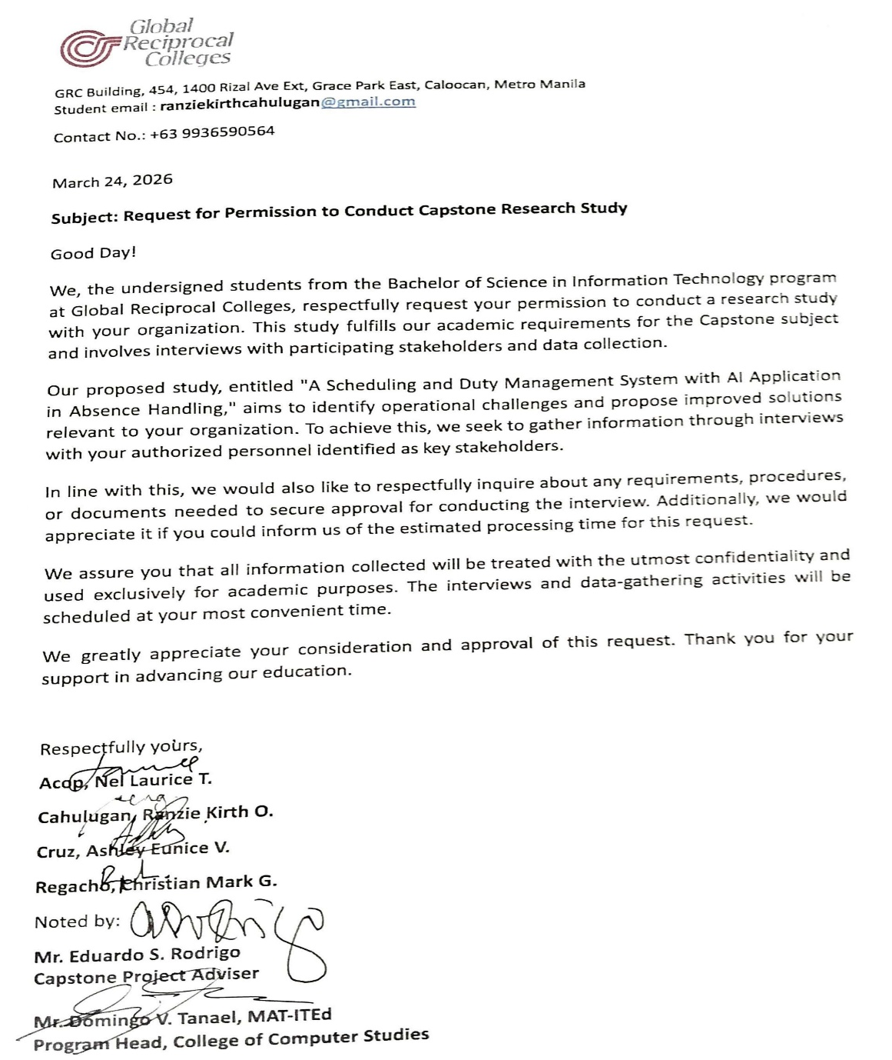
Permit to Conduct the Study

APPENDIX B
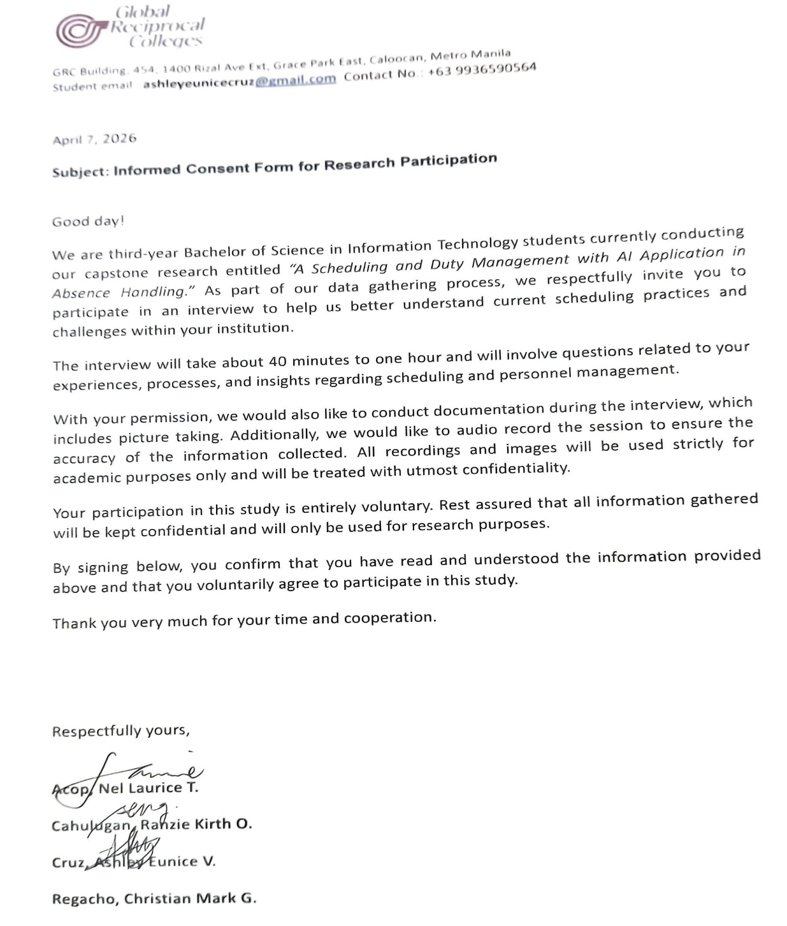
Letter for Interview

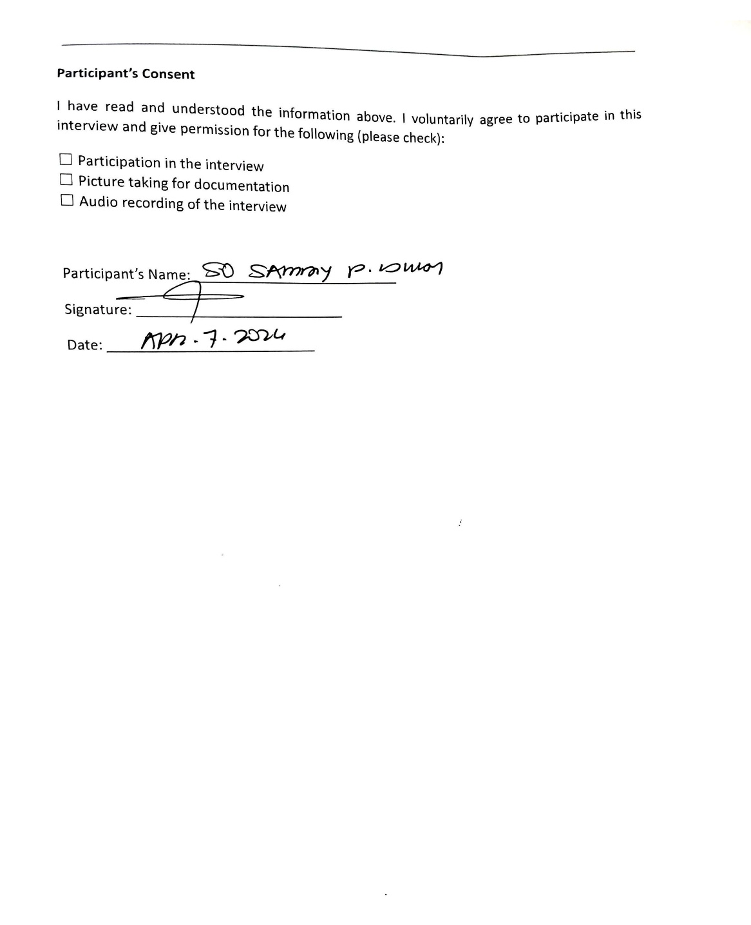

APPENDIX C
Evaluation Instrument
Evaluation Instrument for A Scheduling and Duty Management System with AI Application in Absence Handling
Respondent Name: _________________________________________
Respondent Role: _________________________________________

Instructions: Please evaluate each statement based on your experience using the developed system. Select the rating that best represents your assessment of the system. Use the following scale:
5 – Highly Acceptable
4 – Acceptable
3 – Neutral
2 – Unacceptable
1 – Totally Unacceptable

INDICATORS |  | RATING
- FUNCTIONAL SUITABILITY |  | 5 | 4 | 3 | 2 | 1
1 | Admin: The web dashboard provides complete employee, station, and schedule management functions needed for my administrative tasks.
2 | Head Guard: The mobile app allows me to report attendance and view my station overview effectively.
3 | Head Guard: The mobile app allows me to report attendance and view my station overview effectively.
- PERFORMANCE EFFICIENCY |  | 5 | 4 | 3 | 2 | 1
1 | Admin: The web dashboard loads and responds quickly during schedule generation
2 | Head Guard: The mobile app performs smoothly when reporting attendance and checking schedules during my shift.
3 | Security: The mobile app loads my duty schedule quickly and runs without lag on my smartphone.
- RELIABILITY |  | 5 | 4 | 3 | 2 | 1
1 | All: The system is consistently available whenever I need to access schedules or submit reports.
2 | All: The system handles errors and connection issues without crashing or losing my data.
3 | All: The AI-generated schedules and attendance data are accurate and dependable for daily operations
- COMPATIBILITY |  | 5 | 4 | 3 | 2 | 1
1 | Admin: The web dashboard works properly on my computer/browser and displays consistent data across sessions.
2 | Head Guard: The mobile app works properly on my smartphone and syncs attendance data correctly with the Admin dashboard.
3 | Security: The mobile app works properly on my smartphone and shows consistent schedule data with the Admin's records.
- USABILITY |  | 5 | 4 | 3 | 2 | 1
1 | Admin: The web dashboard is easy to learn and use for managing employees, stations, schedules, and handling attendance reports.
2 | Head Guard: The mobile app is easy to use for reporting attendance and checking my station overview.
3 | Security: The mobile app is easy to learn and use for checking my duty schedule and submitting requests.
- MAINTABILITY |  | 5 | 4 | 3 | 2 | 1
1 | All: The system's design appears well-structured and organized, suggesting it can be maintained and improved in the future.
2 | All: Errors or issues in the system can be identified and explained clearly when reported to the development team.
3 | All: The system documentation and  structure support future maintenance and new user training.

APPENDIX D
USER MANUAL

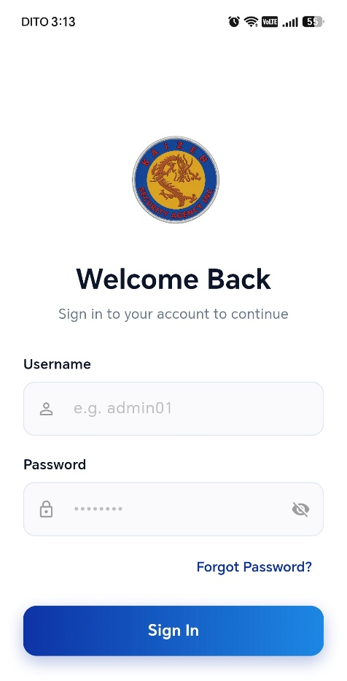
Logging In

- Open Sched - the desktop app on the administrator's computer, or the mobile app on a guard's phone.
- Enter the username and password issued to you when your account was registered.
- Select Log In. Sched opens the workspace for your role: Administrator, Head Guard, or Security Guard.

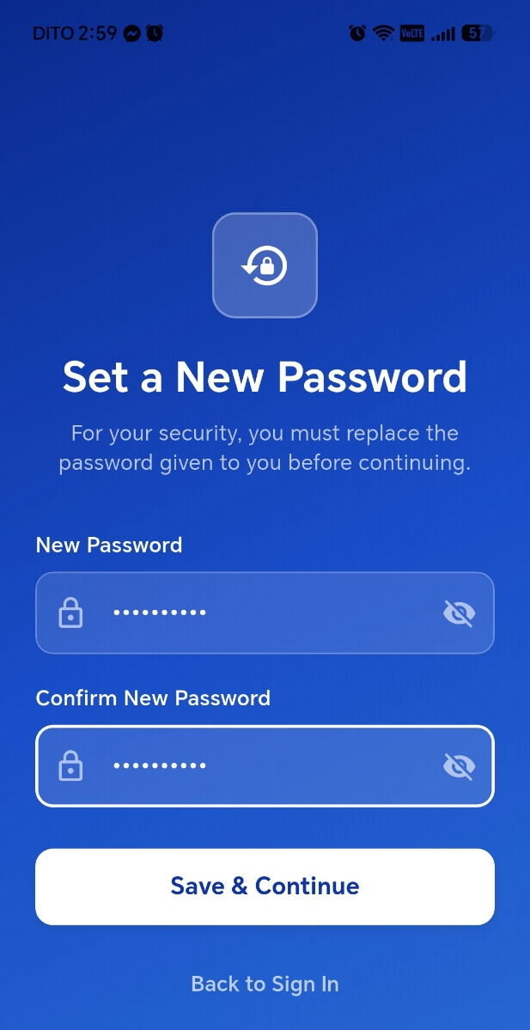
Changing Your Password on First Login

- Log in using the password the administrator gave you. Sched goes straight to the password change screen — this step cannot be skipped.
- Enter a new password of at least 8 characters, then re-enter it to confirm.
- Save. A guard continues to station selection; an administrator lands on the dashboard.
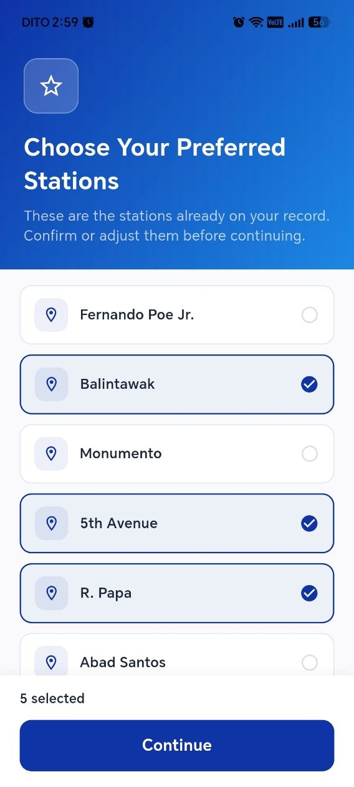
Choosing Your Station on First Login

- After the password change, Sched shows the list of stations.
- Select the station you are permanently posted to.
- Confirm. Your dashboard opens.

Administrator
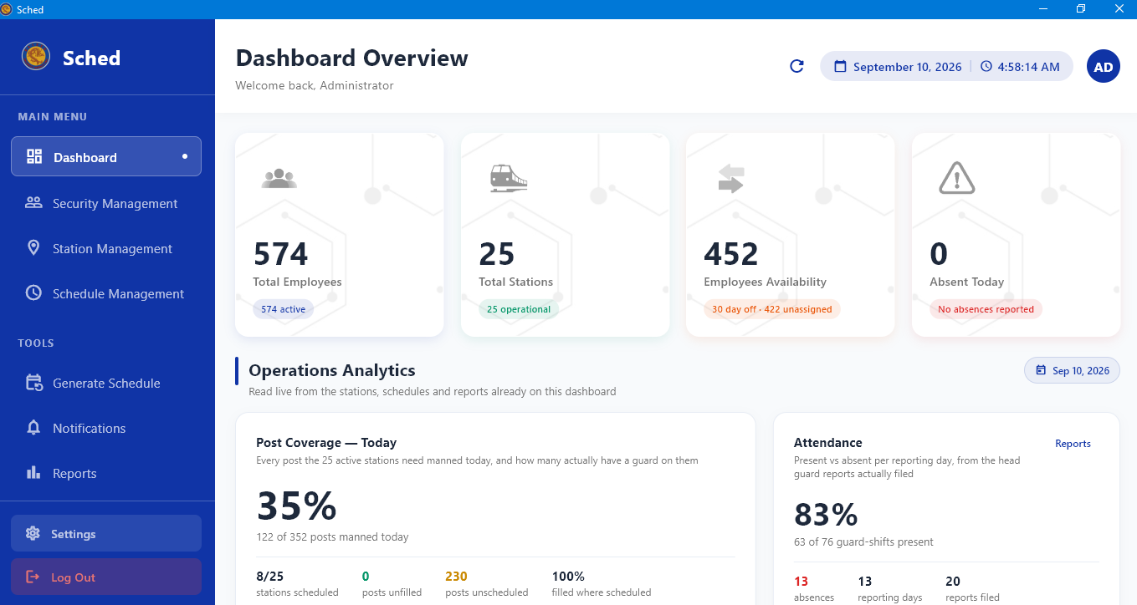
Reading the Dashboard
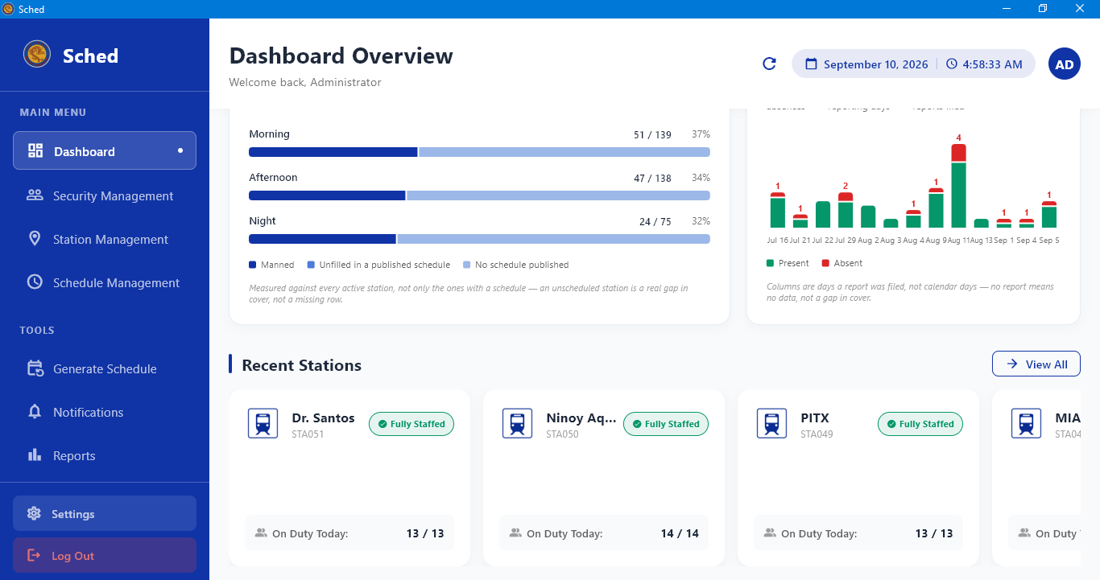

- Select Dashboard in the sidebar.
- Read the summary cards across the top for today's headcount — personnel on duty, available, and absent.
- Use the duty card to see who is posted right now; the clock follows the server's Manila time, not the computer's clock.
- Select any summary card to open the full list behind it.

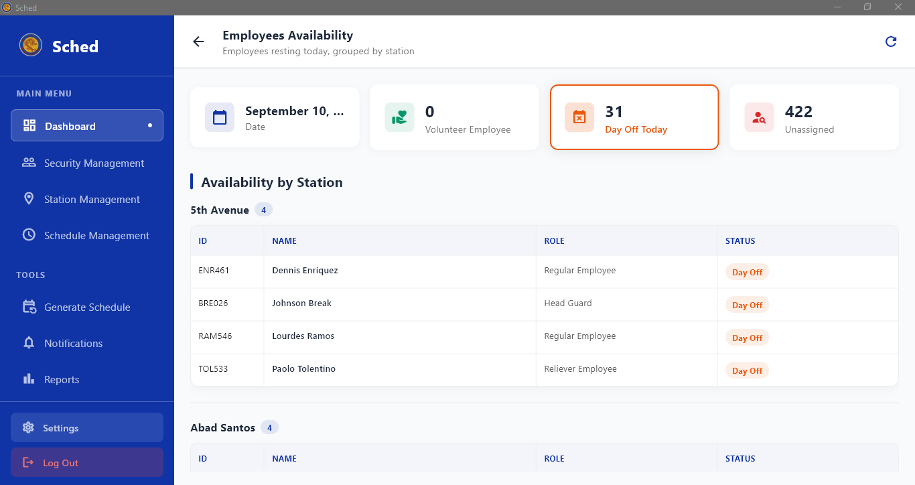
Viewing Available Personnel

- From the dashboard, open the Available summary card.
- Review the list of guards who are not on duty, not absent, and not on leave for the selected day.
- Select a name to open that employee's record.

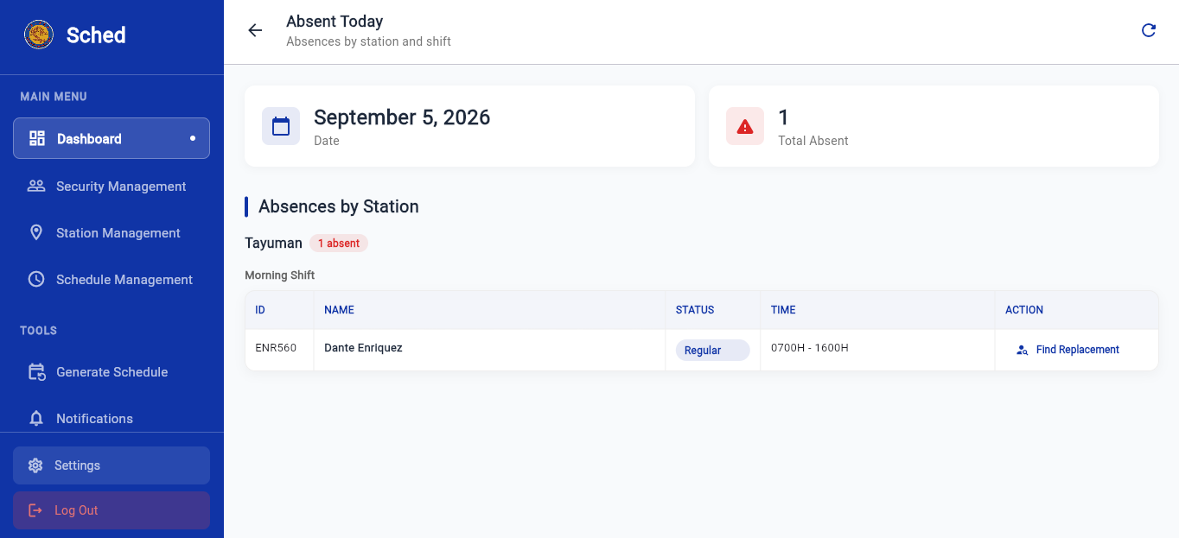
Reviewing Absent Personnel

- From the dashboard, open the Absent summary card.
- Review each absent guard, the station and shift they were assigned to, and whether a replacement has been found.
- Note any post left uncovered that is what Procedure 1.04 fixes.

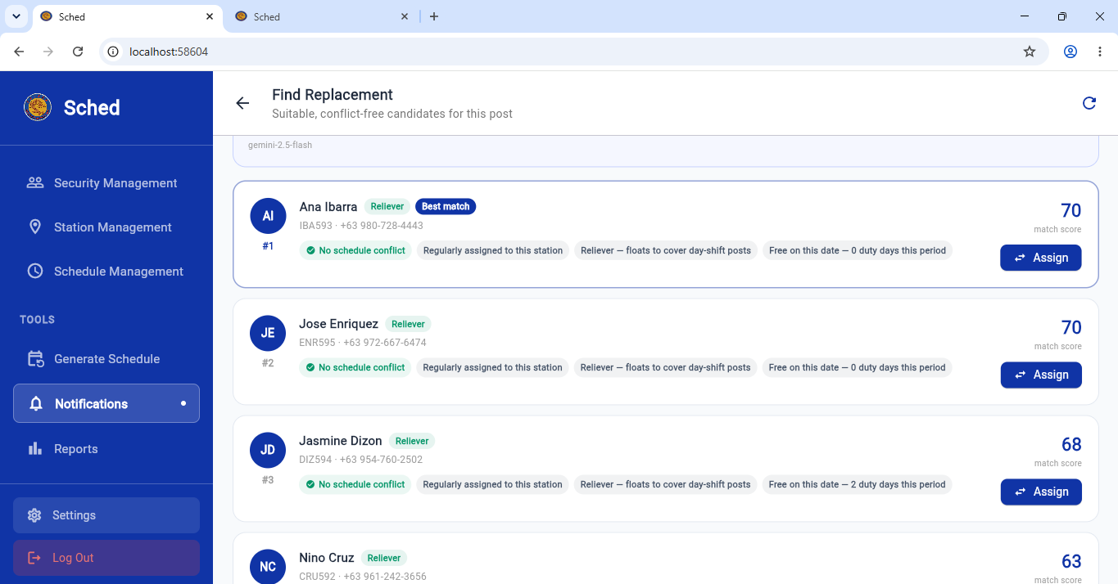
Finding a Replacement for an Absent Guard
- From the absent list — or from the prompt Sched shows when a guard is marked absent — select Find Replacement.
- Review the candidates. Sched has already filtered out anyone ineligible and ranked the rest by suitability for that post and shift.
- Select the guard you want and confirm the assignment.
- The replacement is notified in their app, and the schedule for that day updates.

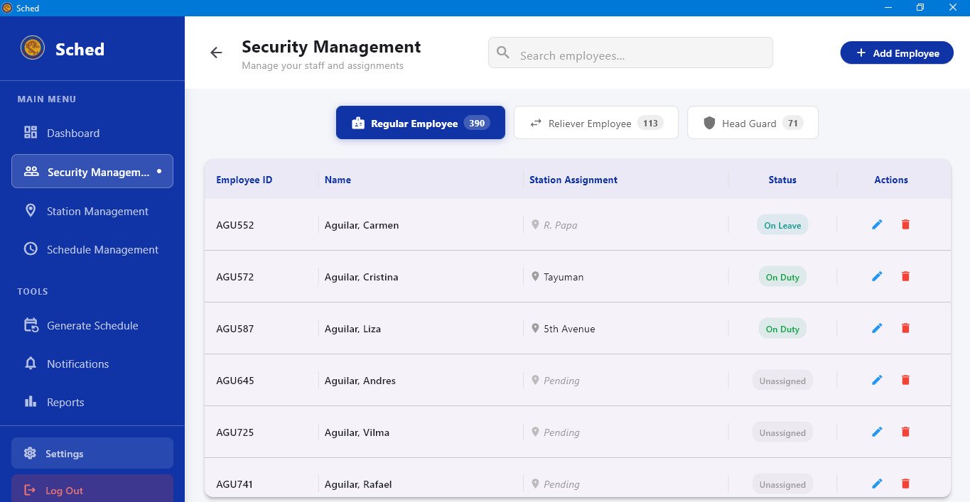
Registering an Employee

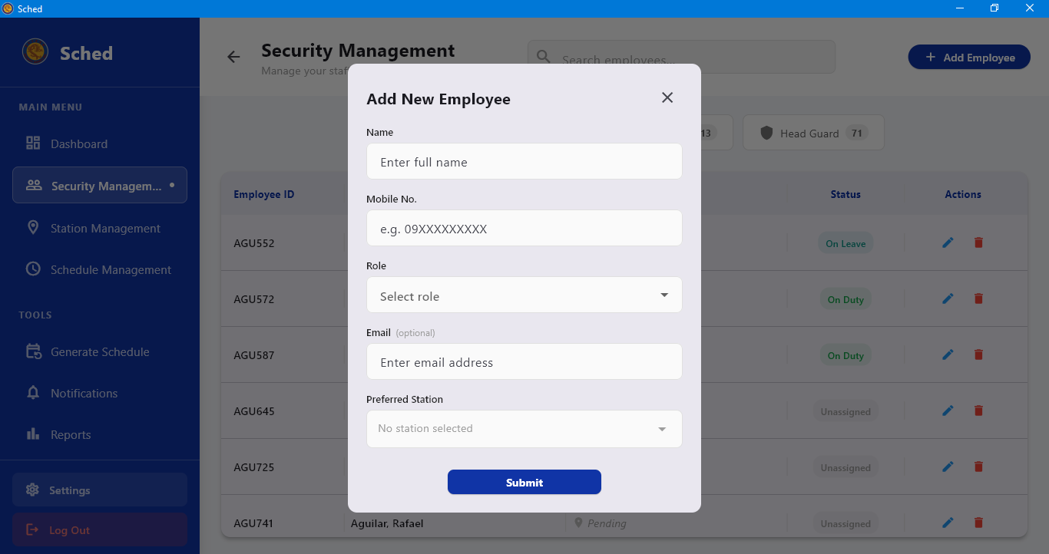
- Select Security Management in the sidebar, then Add Employee.
- Enter the employee's Name and Mobile No.
- Choose the Role: Regular Employee, Reliever Employee, or Head Guard.
- Enter an Email if there is one — this field is optional.
- Select the Preferred Station(s) the employee should normally be posted to. You may leave this empty if they have no preference.
- Select Done to register the employee.

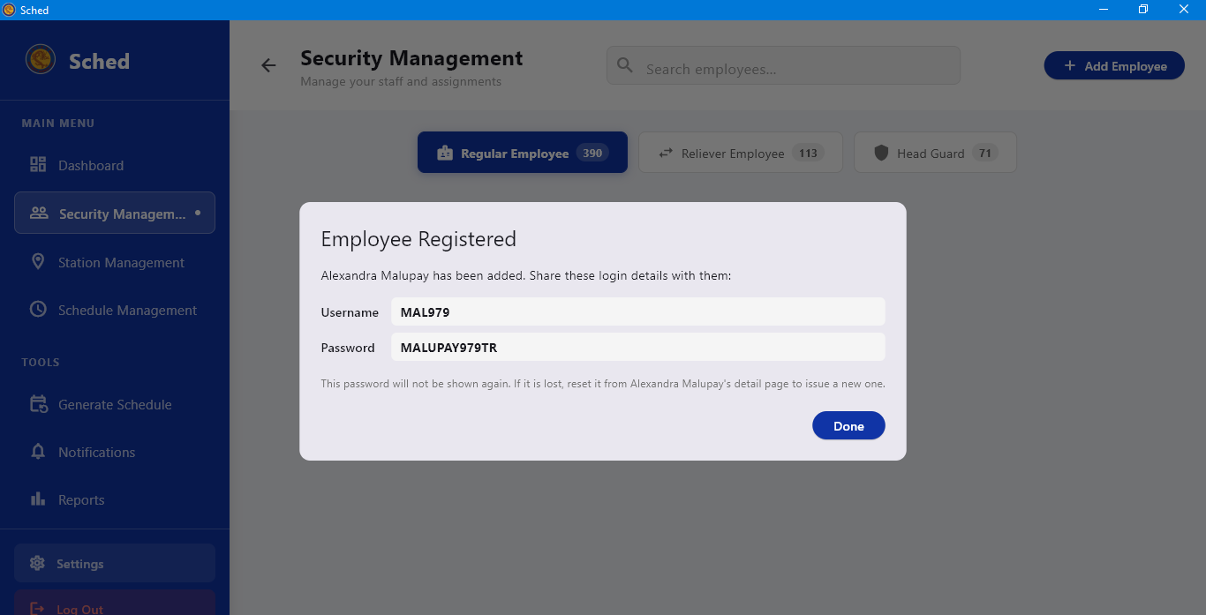
Handing Over the Login Details
- After registration, Sched shows the Employee Registered dialog with the new username and password.
- Write down or copy both, and give them to the employee.
- Select Done.
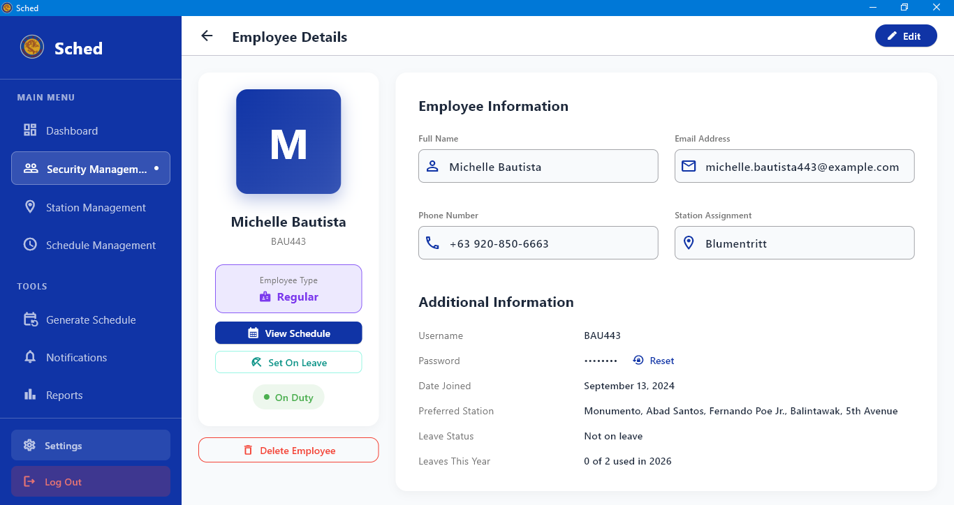
Opening an Employee Record
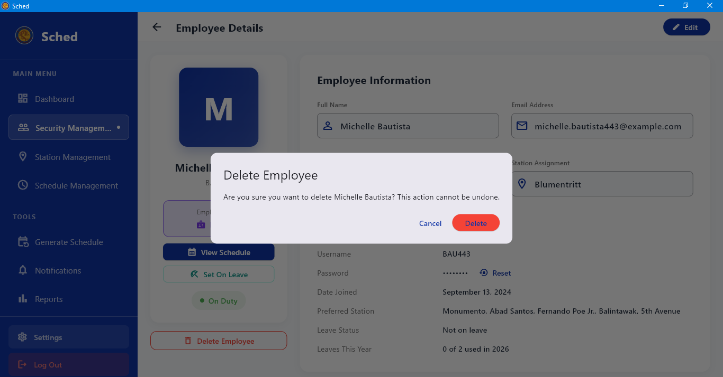
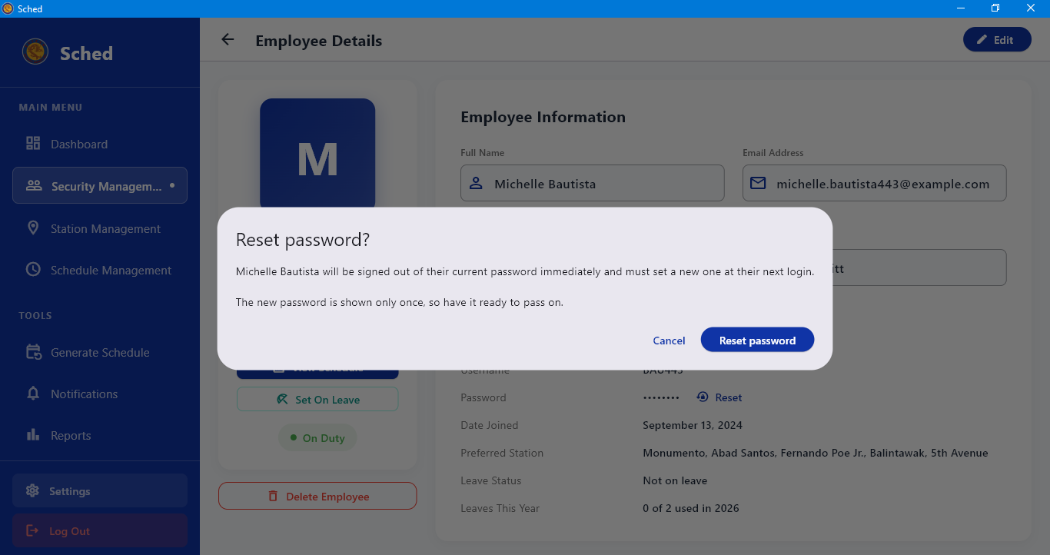

- Open Security Management.
- Find the employee using the search box or by browsing the role groups — Regular, Reliever, and Head Guard are color-coded.
- Select the employee's row to open the employee detail page.
- From the employee detail page, you can perform the following actions:
  - Reset Password: Select Reset beside the password field, then confirm by selecting Reset on the Reset password? prompt. Sched will display the new password once in the New password dialog. Provide the new password to the employee, then select Done.
  - Delete Employee: Select Delete Employee, review the confirmation prompt, then select Delete to remove the employee.

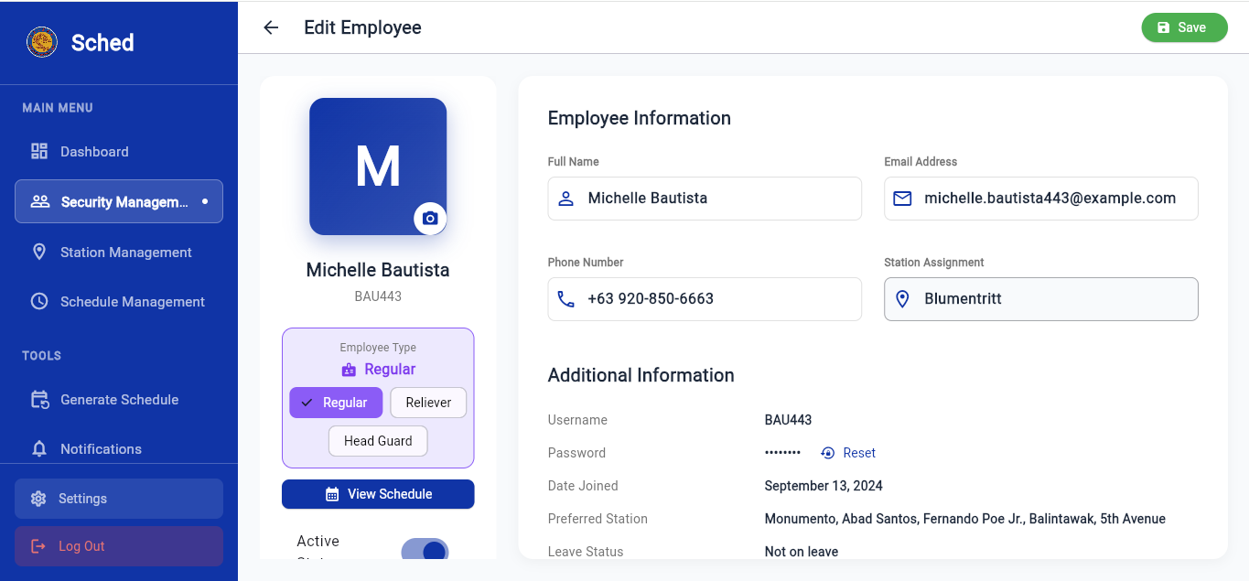
Editing Employee Information
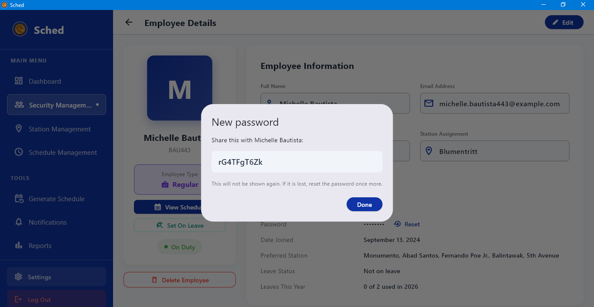
- Open the employee's detail page
- Select Edit.
- Update the details that changed — name, mobile number, email, role, or preferred station.
- Select Save. Sched confirms with "Employee updated successfully".

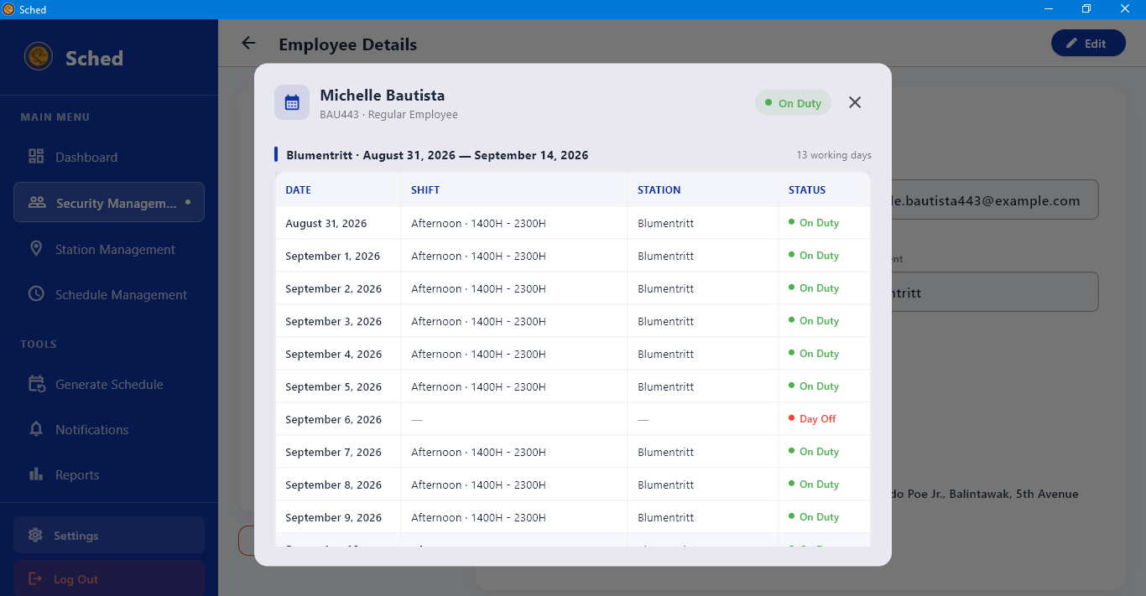
Viewing an Employee's Schedule

- Open the employee's detail page.
- Select View Schedule.
- Review their duties for the period — dates, shifts, stations, and posts, including any cover duties they picked up.
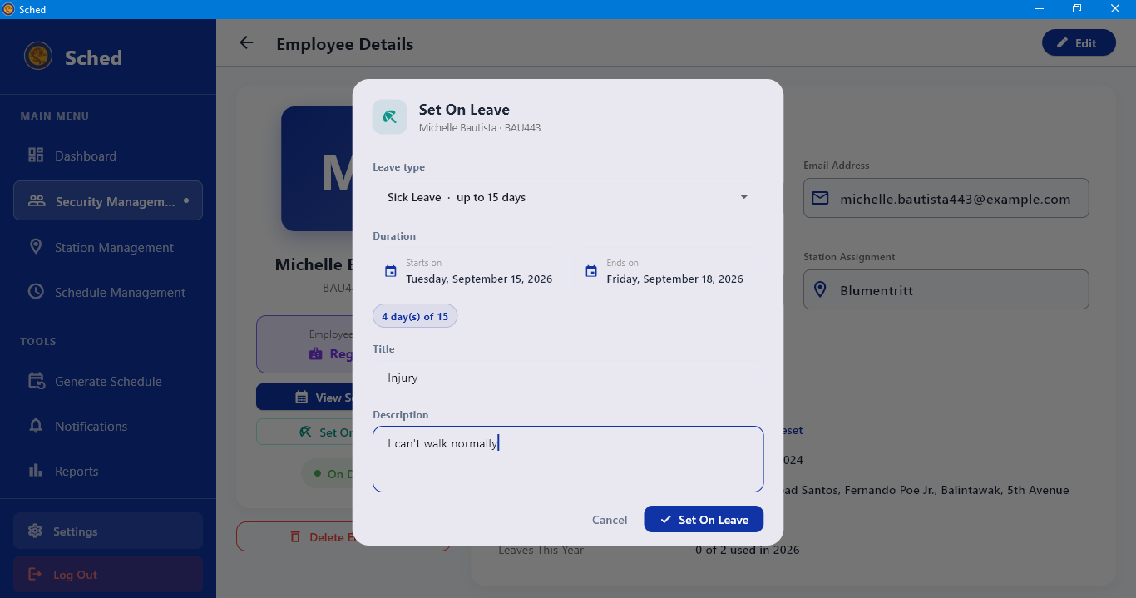
Setting an Employee On Leave

- Open the employee's detail page.
- Select Set On Leave.
- Choose the leave type and the start and end dates.
- Confirm. The employee is excluded from scheduling for those dates.
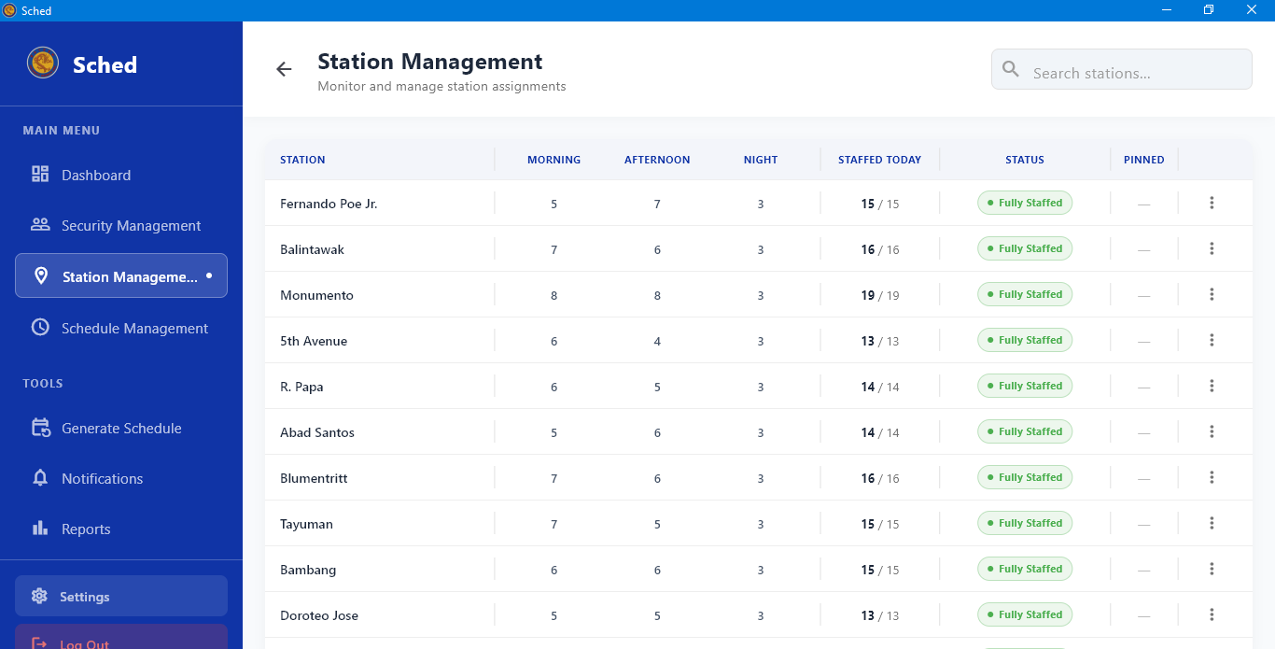
Setting the Posts for Each Shift
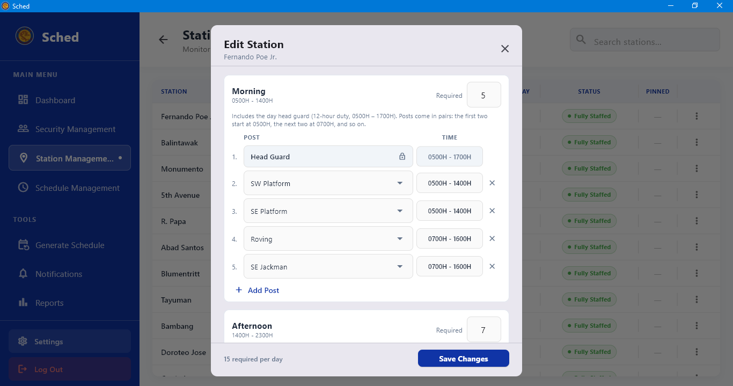
- In the station dialog, work down the shift cards one at a time.
- Select Add Post to add a slot to that shift; repeat until the number of slots matches the manning required.
- Select a slot to name it — type the post name and select Set.
- Clear the footer warning that reads "N post(s) unnamed" before saving, so every slot has a name guards will recognise.
- Save the station.

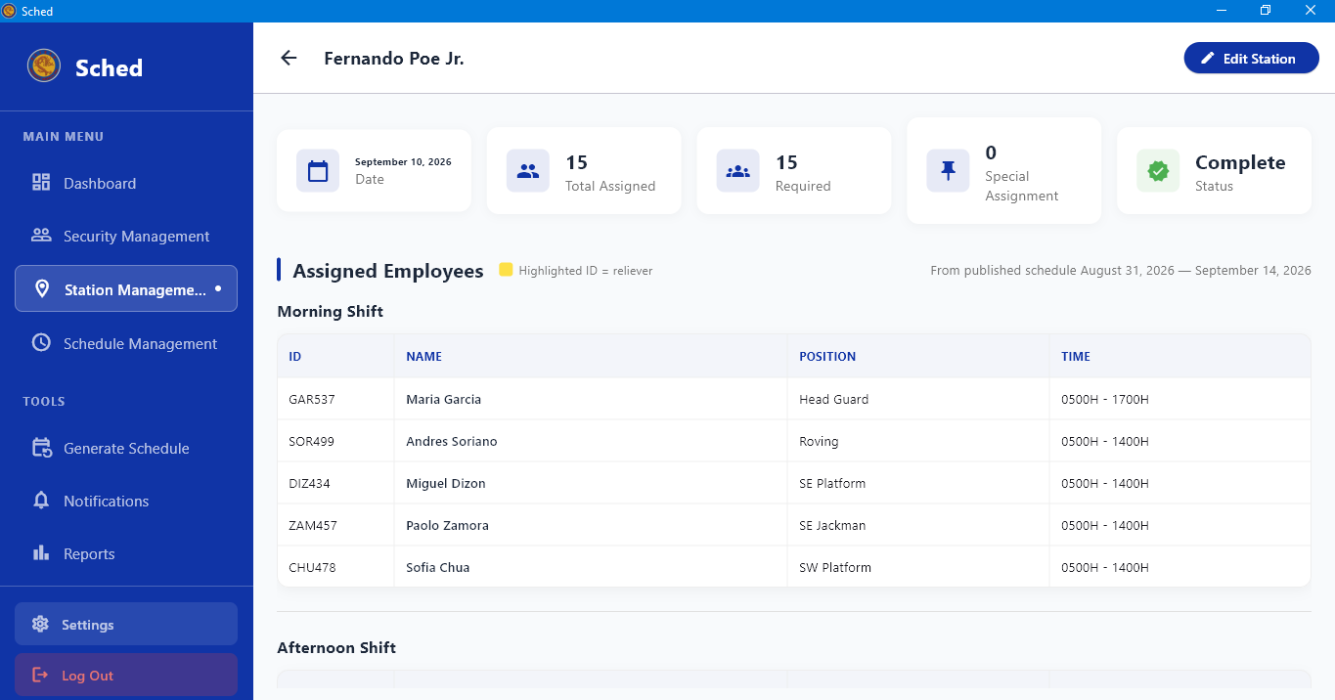
Reviewing a Station's Roster

- Open Station Management and select the station.
- Review the posts per shift and the personnel currently attached to the station.
- Compare the required number against the roster to spot a station that is short-handed before you generate.
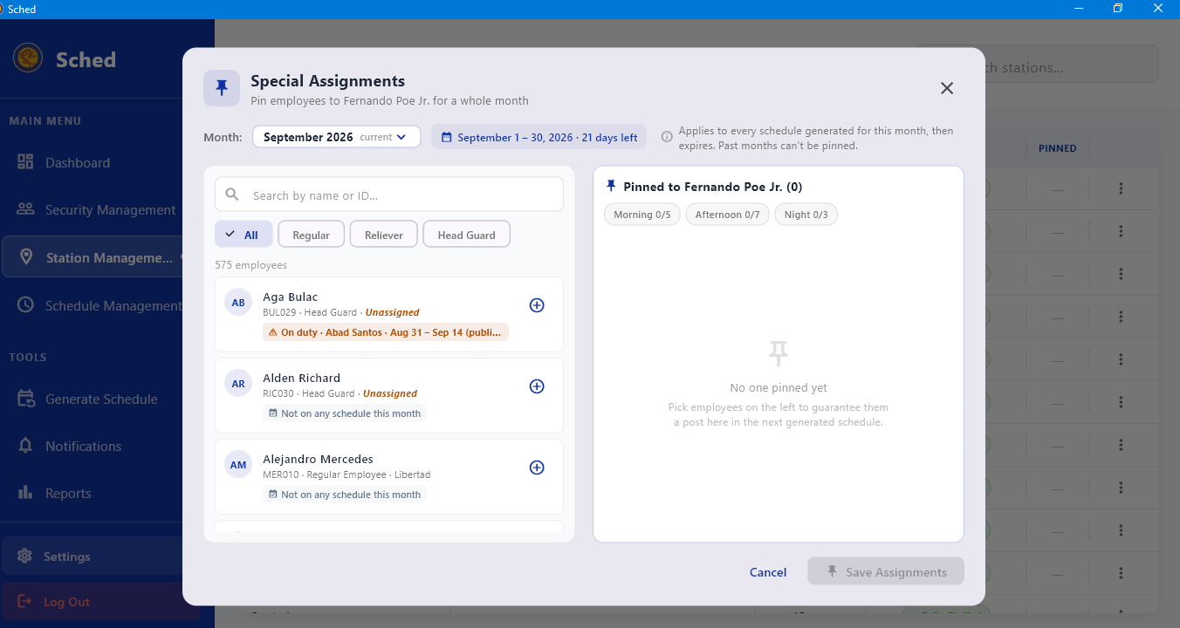
Creating a Special Assignment

- Open Station Management and open the row menu for the station.
- Select Special Assignments.
- Add the assignment — the guard, the dates, and the shift it covers.
- Save. The assignment is respected when schedules are generated for that period.

Viewing Schedules by Period

- Select Schedule Management in the sidebar.
- Choose the period you want to look at.
- Review the schedules listed for that period, and which of them are published.

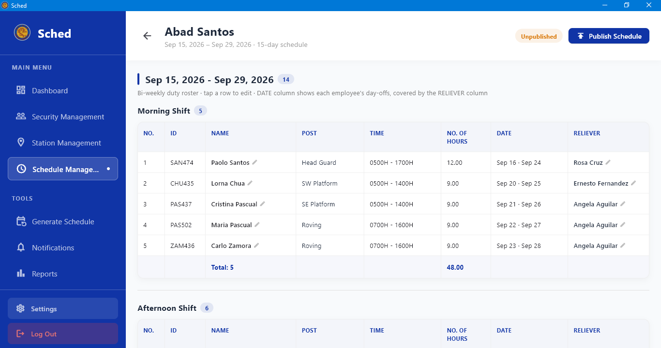
Opening a Schedule's Details

- From the schedule list, select the schedule.
- Review the assignments day by day — station, shift, post, and the guard filling it.
- Check any generation notes attached to the schedule

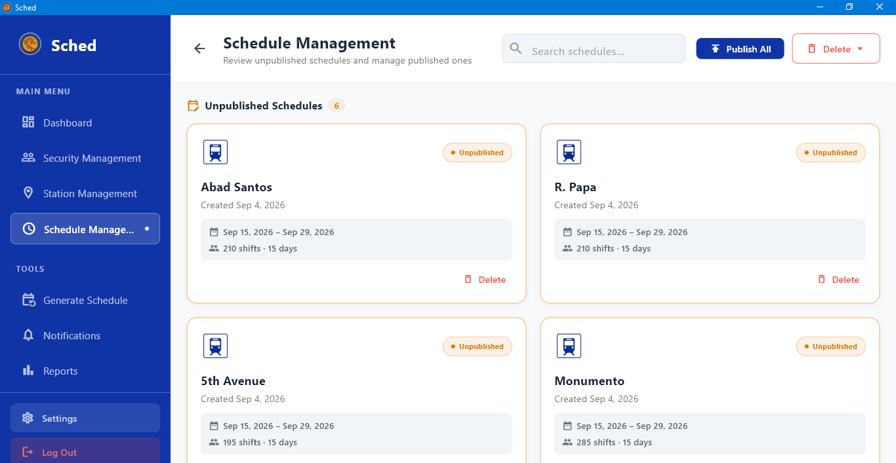
Publishing Schedules
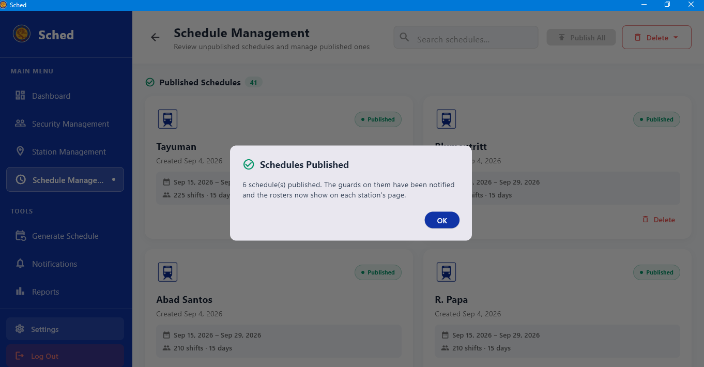
- Open Schedule Management and select the period.
- Review the schedules you are about to release.
- Select Publish All.
- Once published, guards can see their duties in the mobile app.
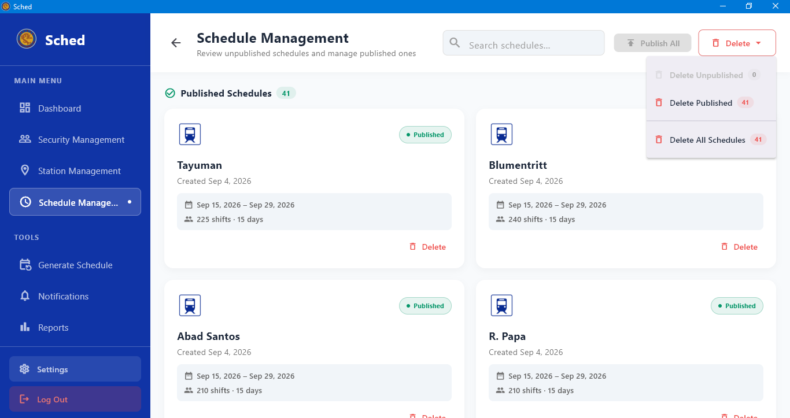
Deleting a Schedule
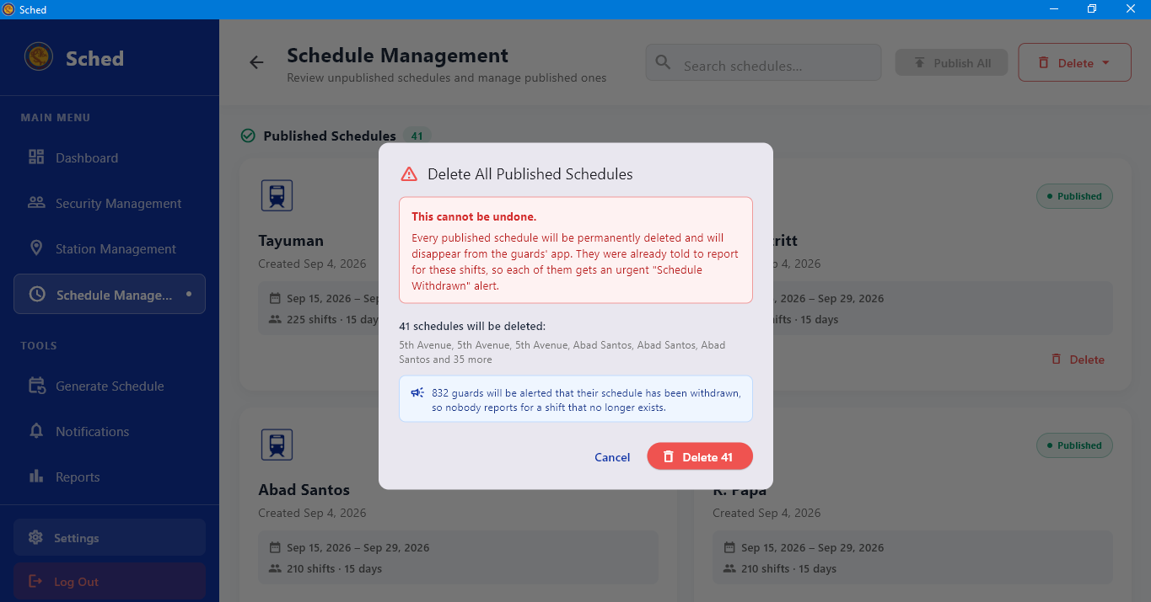
- Open Schedule Management and select the period.
- Select the schedule, or tick several to remove them together.
- Select Delete and confirm on the Delete Schedule prompt.

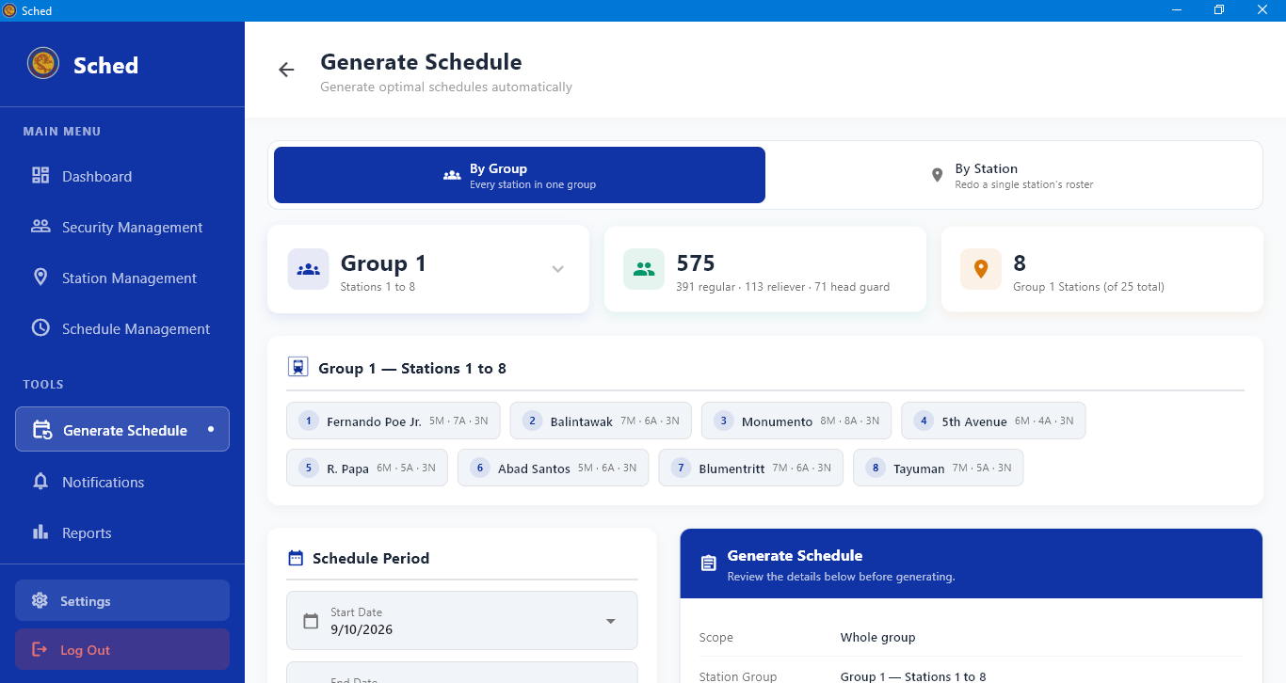
Choosing What to Generate For
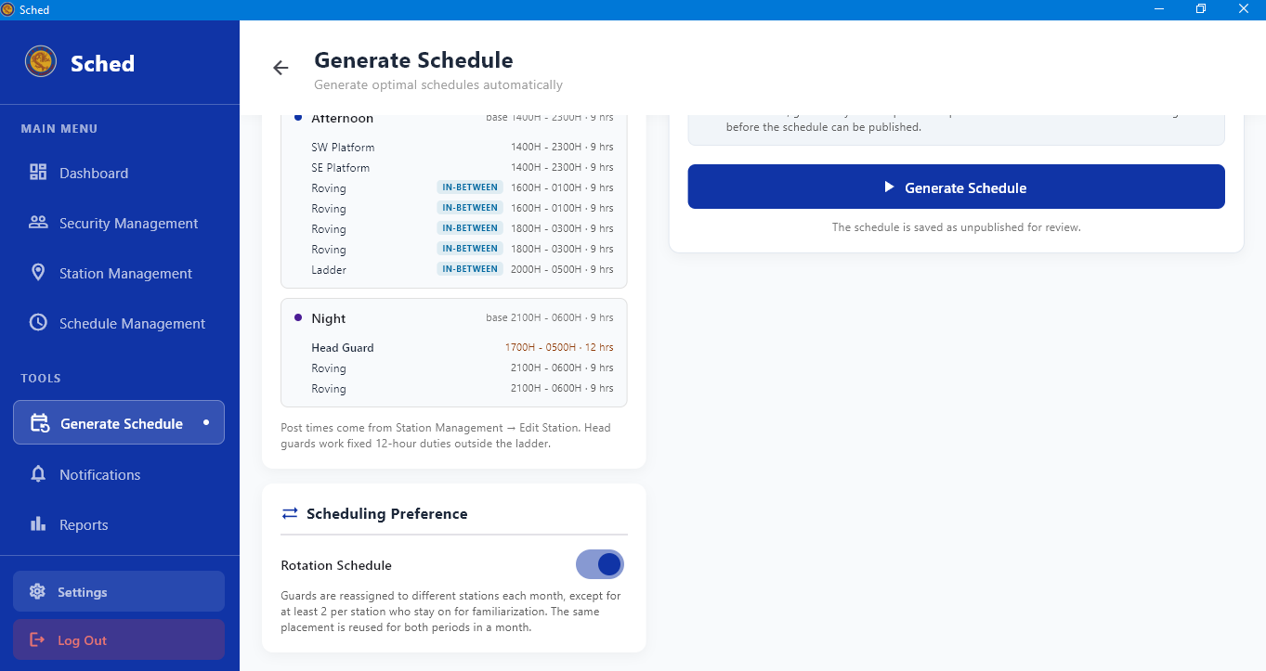
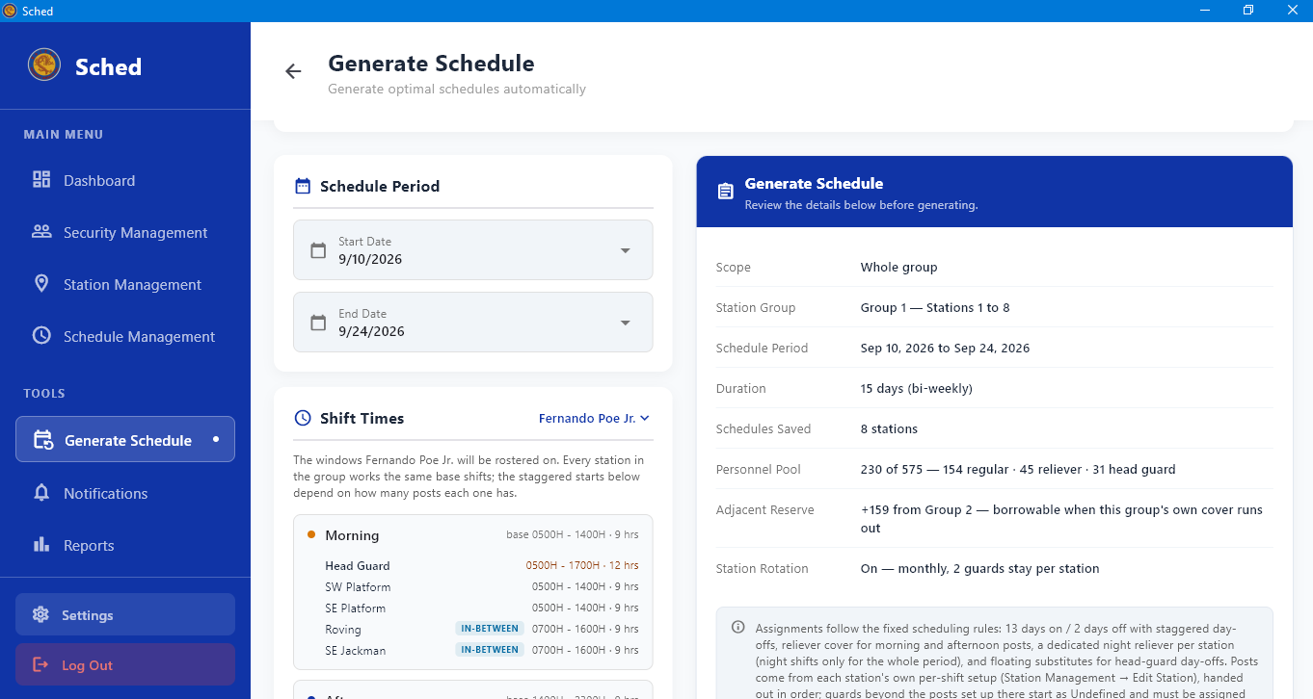

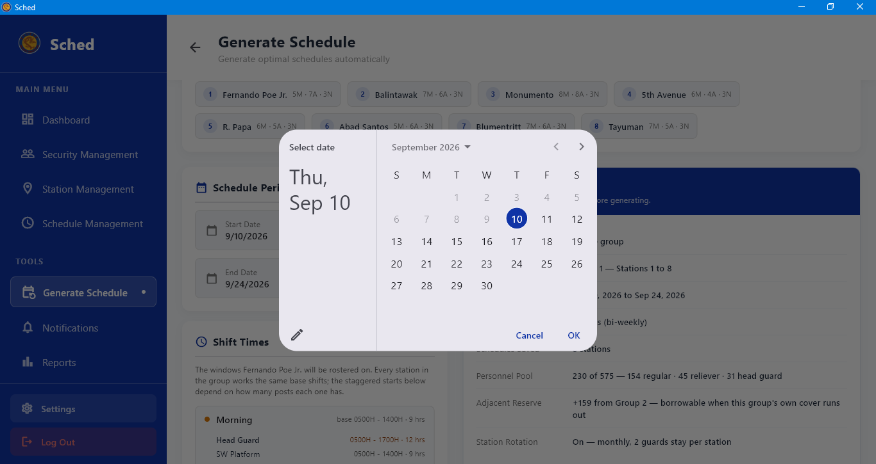
- Select Generate Schedule in the sidebar.
- Choose the target: By Group to cover every station in one group, or a single station on its own.
- Select the station group — each group covers a range of stations, shown beside its name.
- Set the Start Date, check the period length. If it does not match the required number of days, the generate button reads "Fix Schedule Period First" until you correct it.
- Click the generate schedule button.

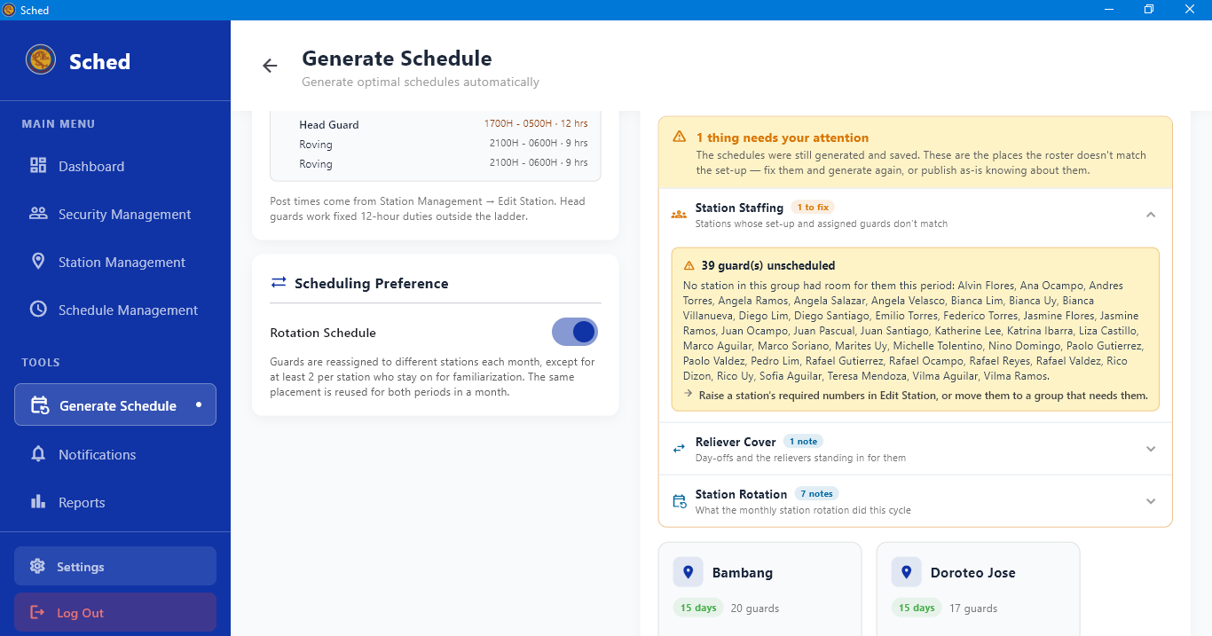
Reviewing the AI Review

- Open the AI review panel shown with the generated preview.
- Read the summary of how the period was staffed and any issues it flags.
- Treat it as a second opinion — the assignments come from the scheduling rules, not from the review.
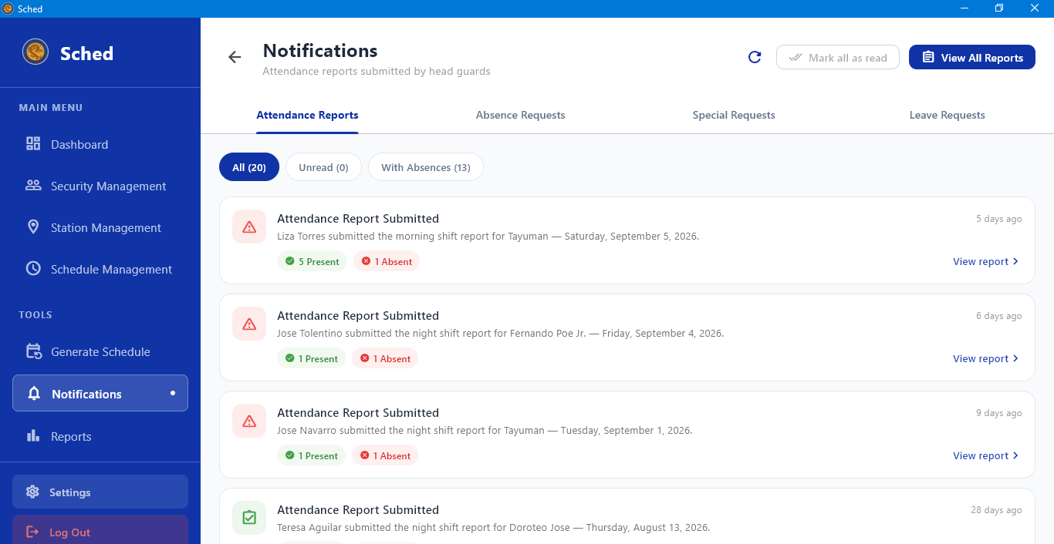
Reviewing Submitted Attendance Reports
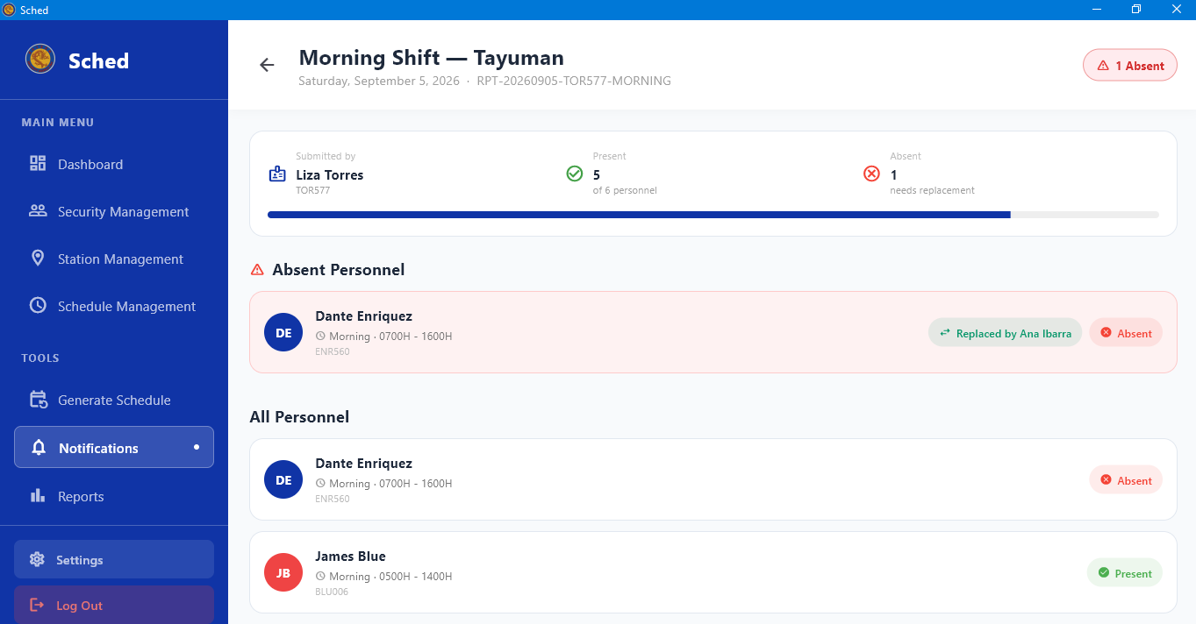
- Select Notifications in the sidebar and open the Attendance Reports tab.
- Select a report to see the head guard who filed it, the station and shift, and who was marked present or absent.
- Act on anyone marked absent — see Procedure 1.04 to cover their post.

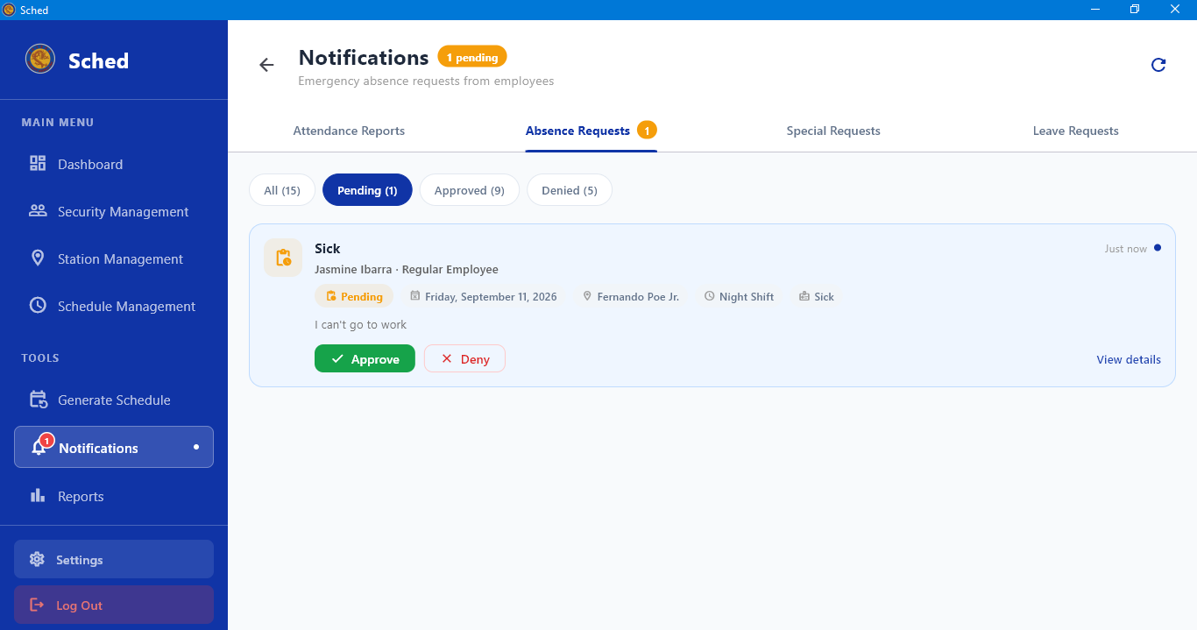
Acting on an Absence Request
- Open Notifications and select the Absence Requests tab.
- Open the request to read the duty affected, the guard's reason, and the details they gave.
- Approve or decline it.
- If you approve, cover the vacated post
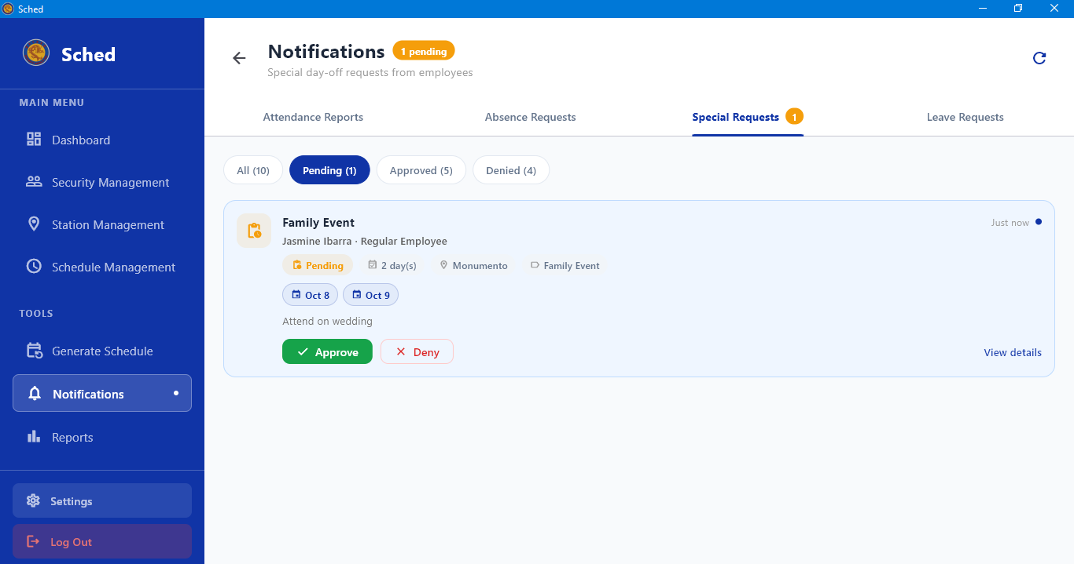
Acting on a Special Request
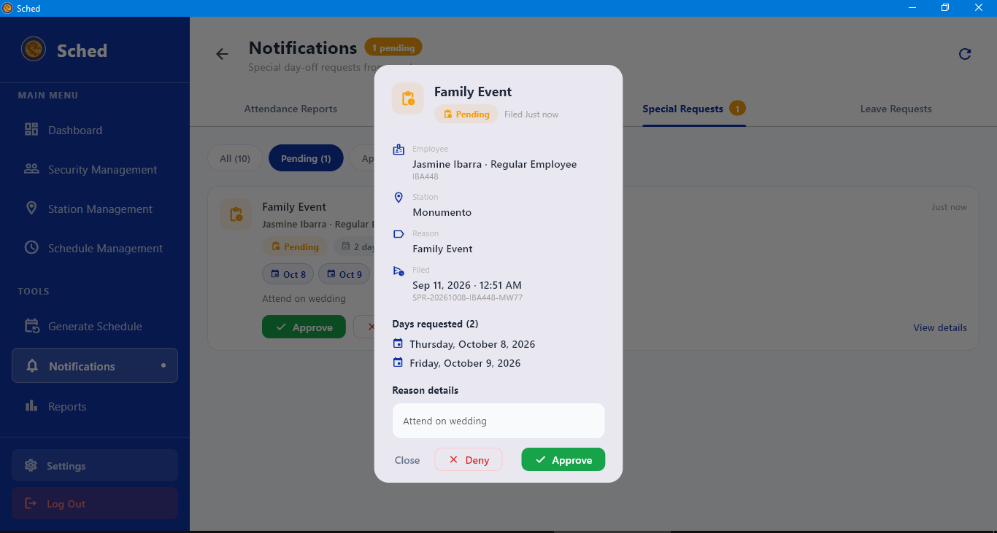
- Open Notifications and select the Special Requests tab.
- Open the request to see the days off the guard is asking for and the reason.
- Approve or decline. An approved request is respected when the schedule for those dates is generated.

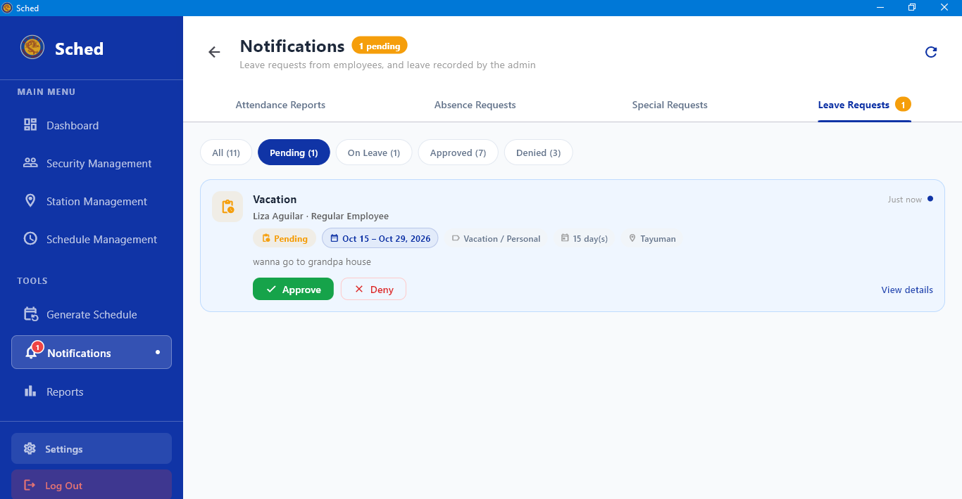
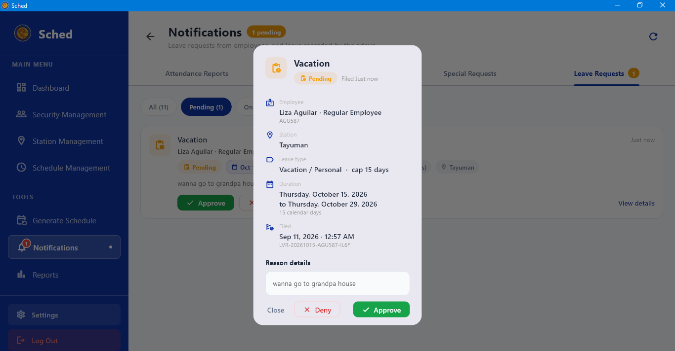
Acting on a Special Request

- Open Notifications and select the Special Requests tab.
- Open the request to see the days off the guard is asking for and the reason.
- Approve or decline. An approved request is respected when the schedule for those dates is generated.
Acting on a Leave Request
- Open Notifications and select the Leave Requests tab.
- Open the request to see the leave type, title, description, and dates.
- Approve or decline it. Approved leave keeps the guard out of scheduling for those dates.
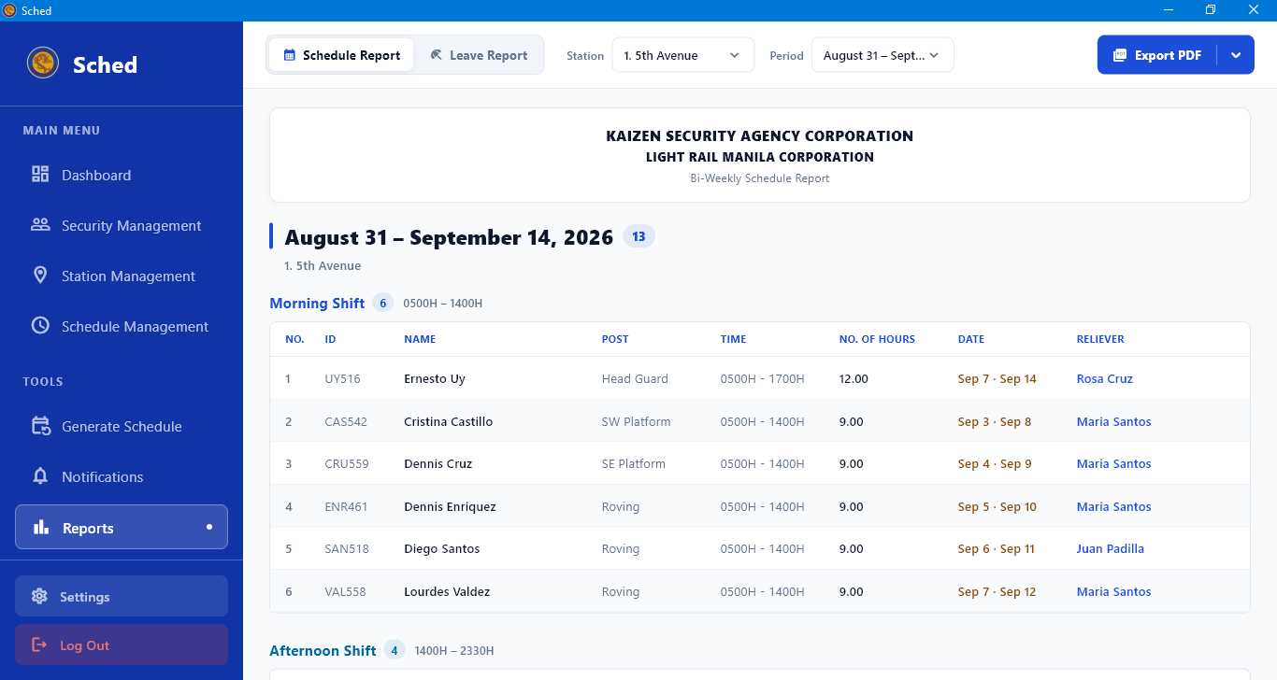
Viewing Schedule Records

- Select Reports in the sidebar.
- Set the period and, if you want to narrow it, the station.
- Review attendance across the period — present and absent counts, and the reports behind them.

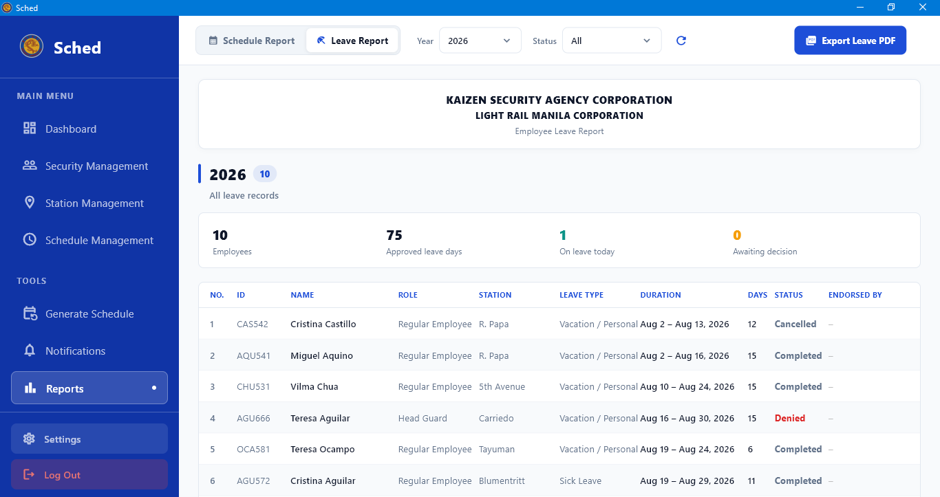
Viewing Leave Records

- Open Reports and switch to the leave records view.
- Review leave taken across the period — who, what type, and for how long.
- Use this to check a guard's remaining entitlement before approving a new request.
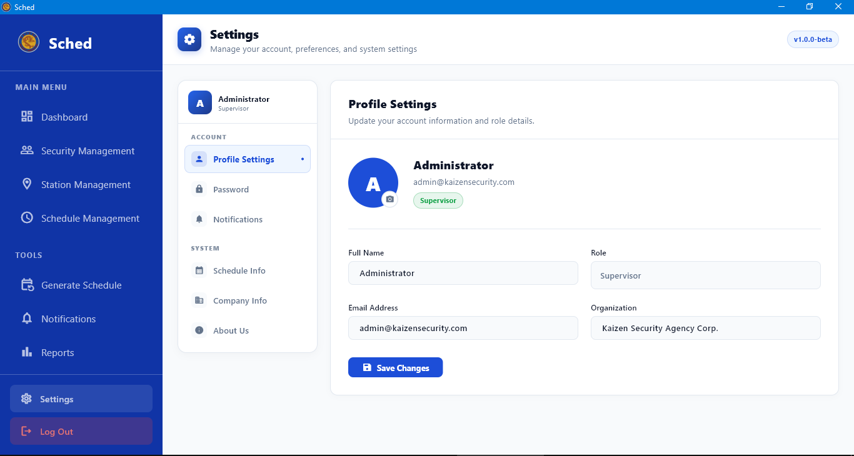
Settings
- Select Settings at the bottom of the sidebar.
- From the Settings menu, select the appropriate option:
- Profile Settings: Update your account information, then select Save Changes.
- Notification Settings: Turn Allow Notifications on to receive alerts for absences and reliever assignments, or turn it off to silence notifications.
- Schedule Configuration: Under Shift Configuration, review the shift times used by Generate Schedule, including the head guard shifts. Select Add Shift to create another shift. Under Security Positions, maintain the list of positions available when naming security posts.

Security Personnel
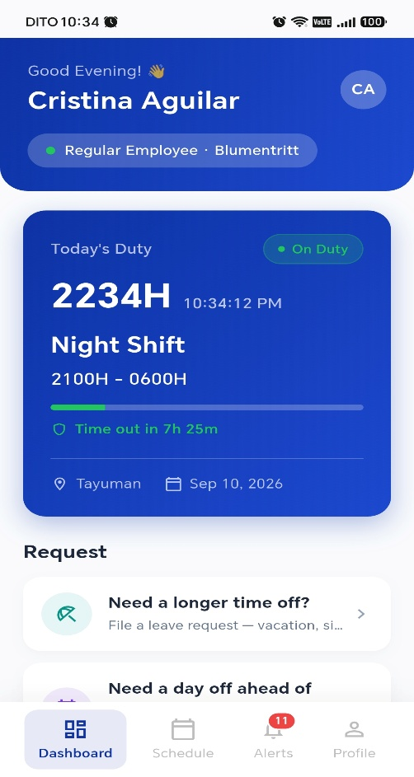
Reading Your Dashboard
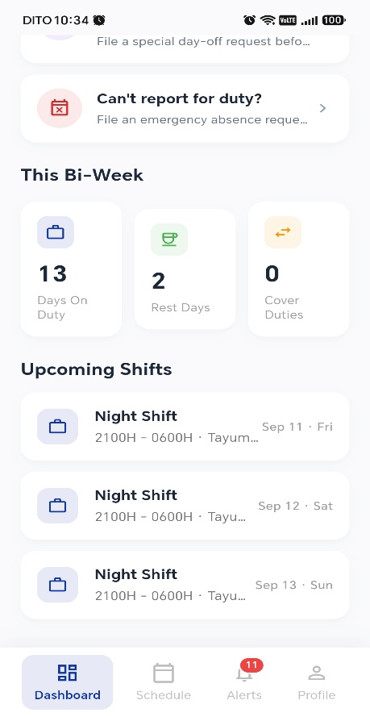
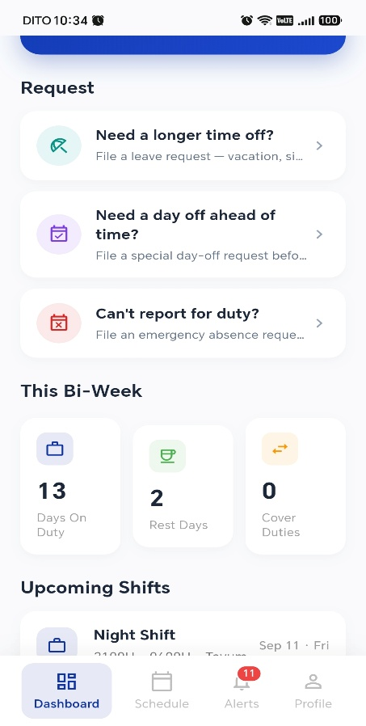
- Open the Dashboard tab.
- Check the duty card at the top for what you are on today — station, post, and shift times.
- Read the three counters for the period: Days On Duty, Rest Days, and Cover Duties.

Viewing Your Schedule
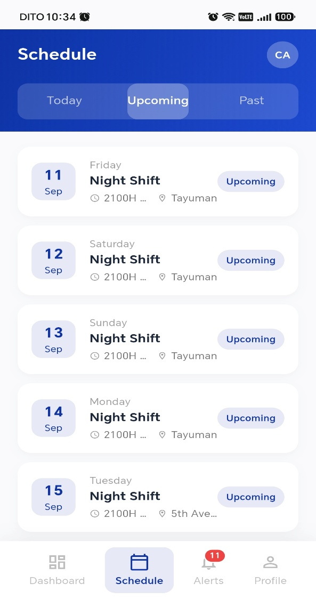
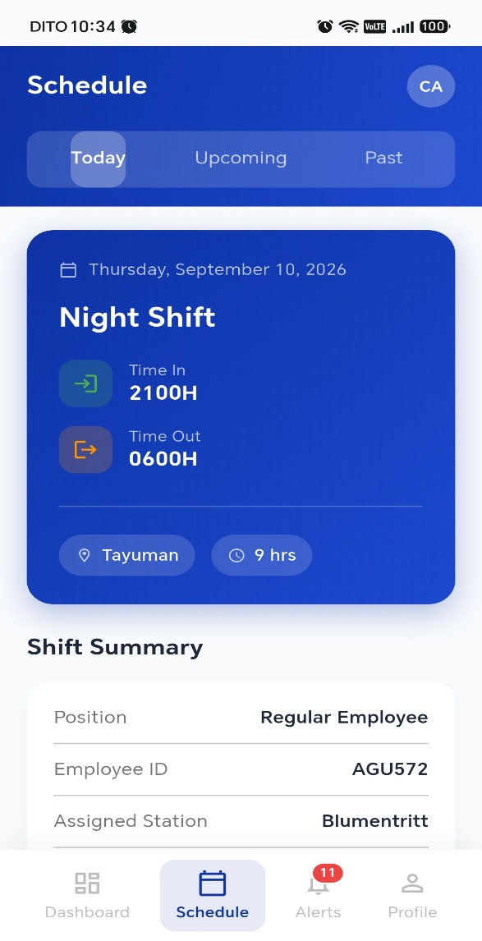

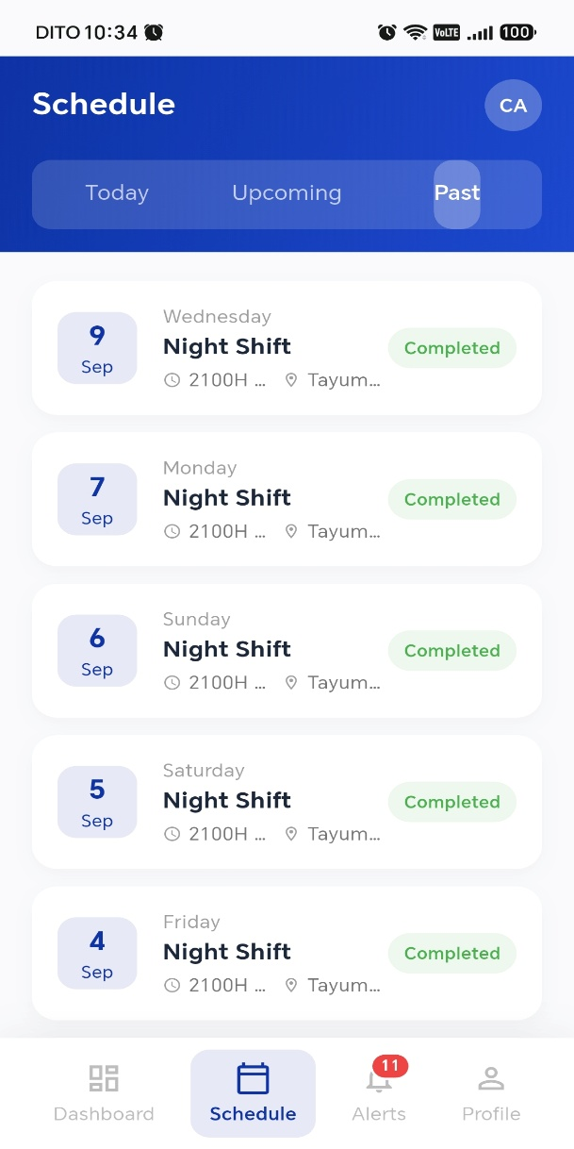
- Open the Schedule tab.
- Review your duties for the period — the date, shift, station, and post for each.
- Select a duty to see its full details.

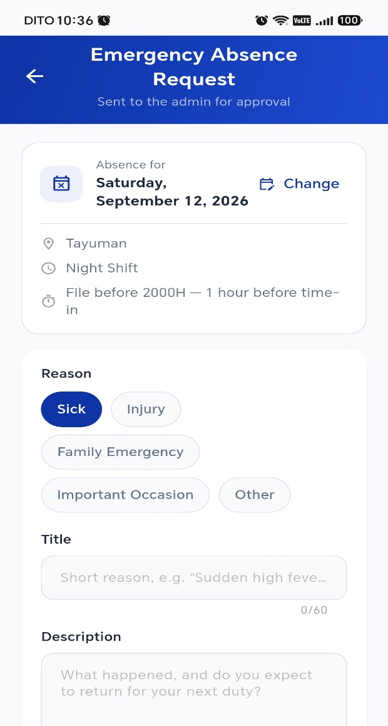
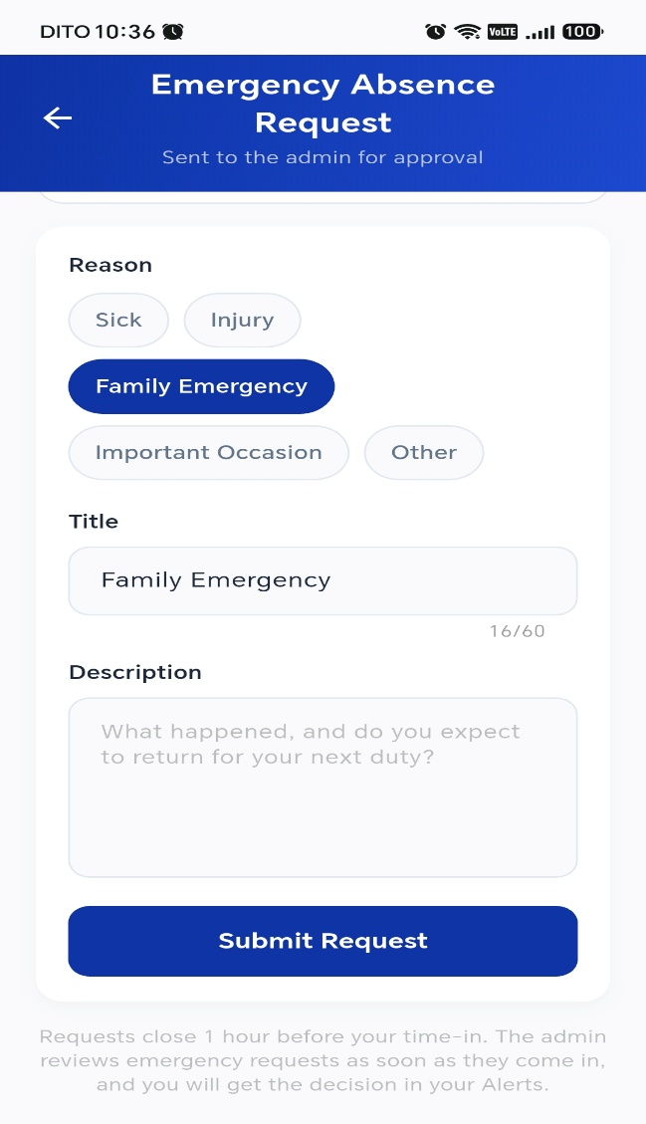
Filing an Absence Request

- From the dashboard, open the absence request card.
- Select Pick an upcoming duty and choose the duty you will miss. Use Change if you picked the wrong one.
- Enter a short reason — for example, "Sudden high fever".
- Add the details: what happened, and whether you expect to return for your next duty.
- Submit. The request goes to the administrator, and you will see the outcome in your Alerts tab.

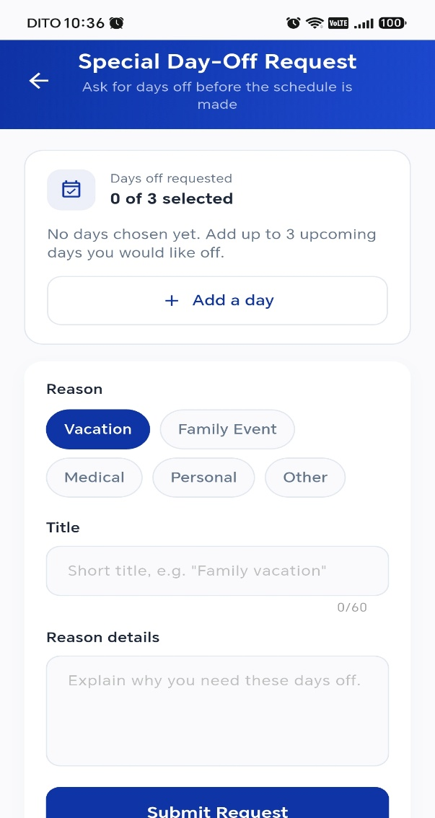
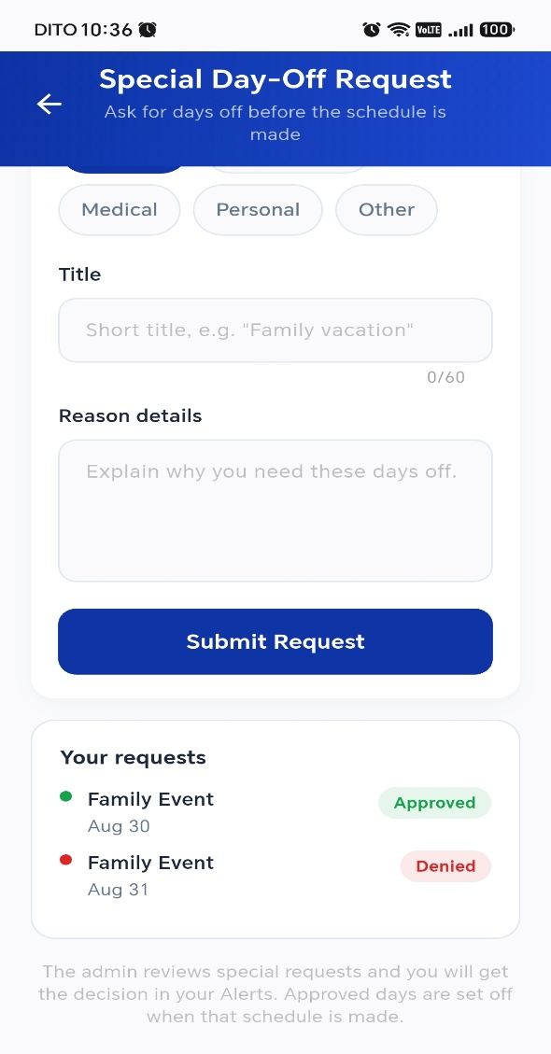
Requesting Days Off

- From the dashboard, open the special request card.
- Choose the days off you are requesting.
- Give your reason and submit.
- An approved request is taken into account when the schedule for those dates is generated — so file it before the period is generated, not after.

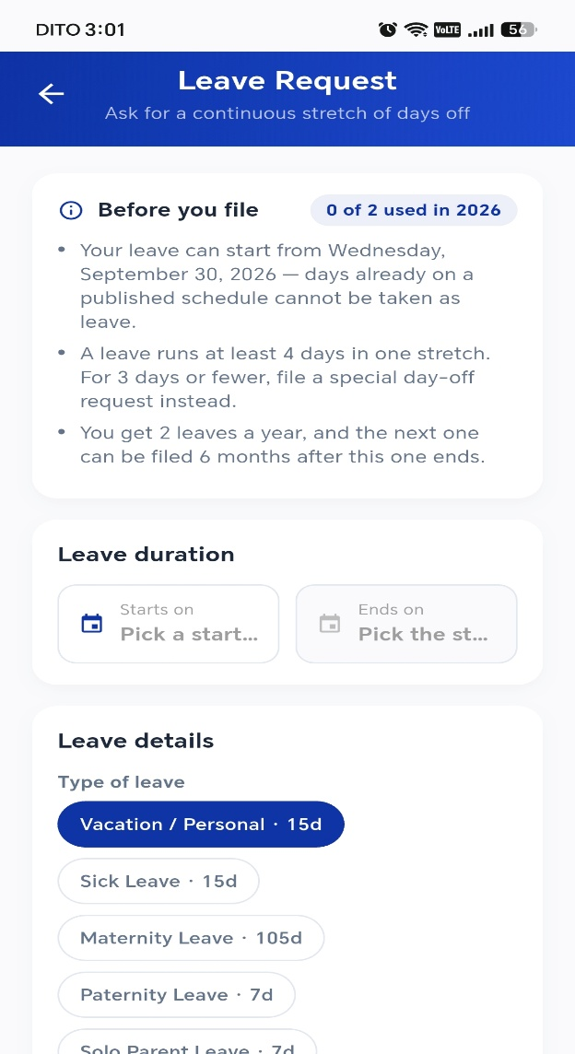
Filing a Leave Request

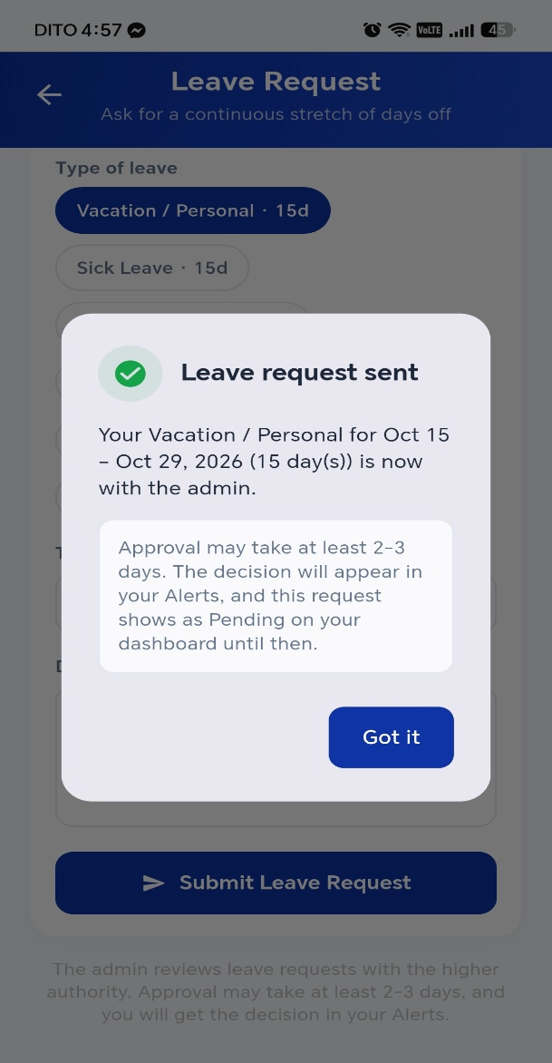
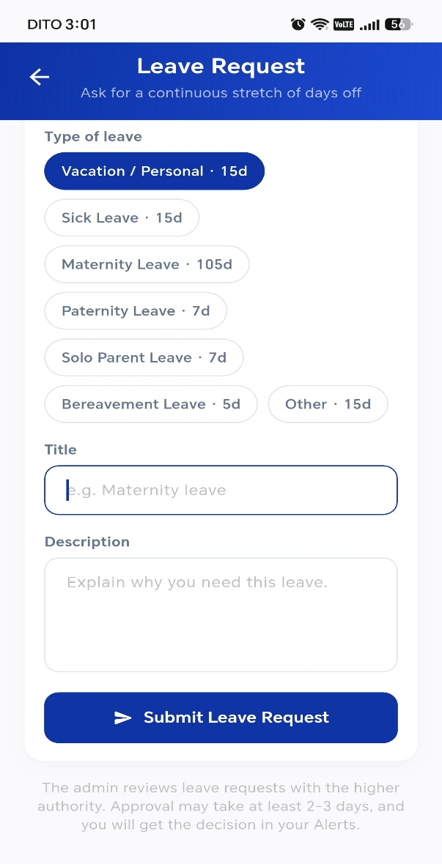
- From the dashboard, open the leave request card.
- Choose the Type of leave. Sched shows how many days that type allows.
- Enter a Title and a Description, and set the dates.
- Submit. Track the outcome in your Alerts tab.

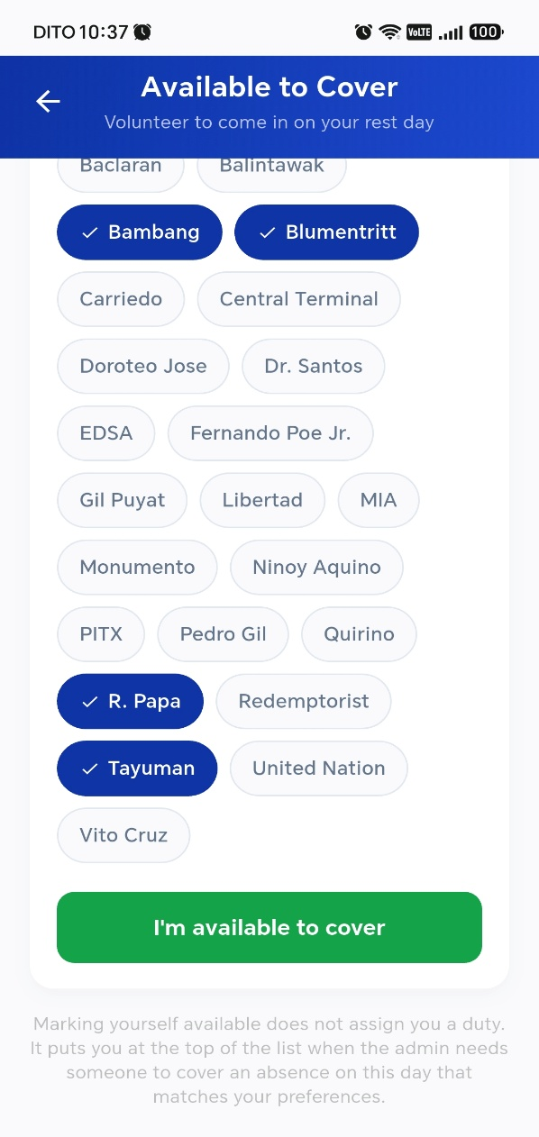
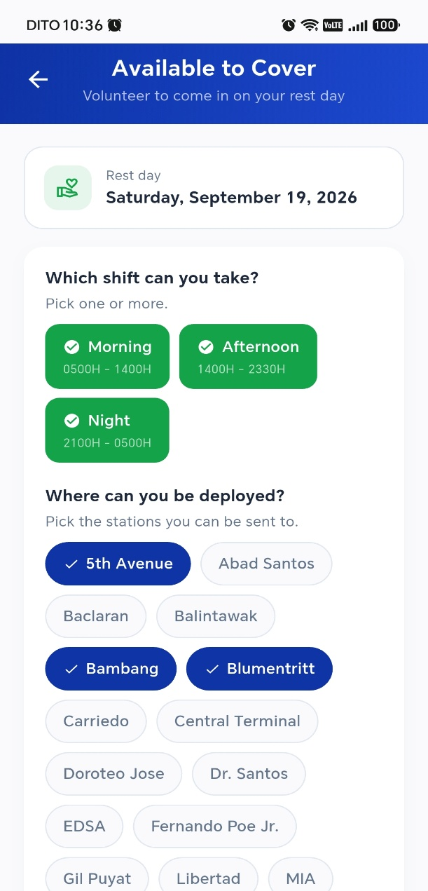
Volunteering to Cover a Duty

- Open the Schedule tab and select a rest day.
- Open the cover availability screen for that day.
- Confirm that you are available. Your name now appears to the administrator when they look for a replacement.
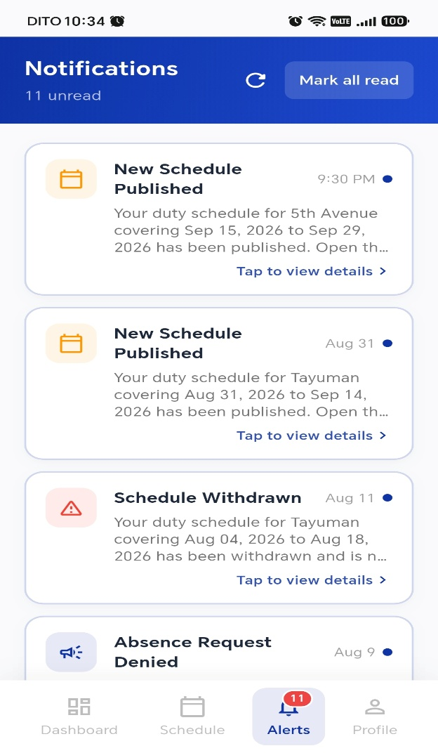
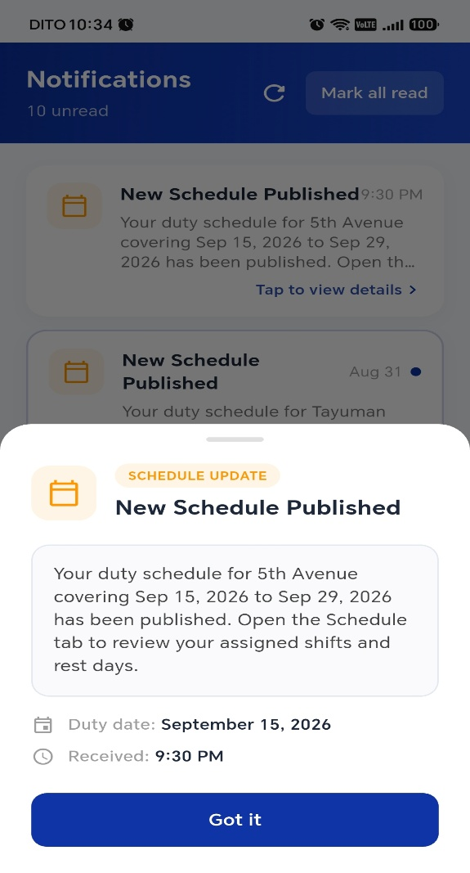
Checking Your Alerts

- Open the Alerts tab.
- Read your notifications — request outcomes, cover assignments, and schedule changes.
- Select an alert to open the duty or request it refers to.

Viewing Your Profile
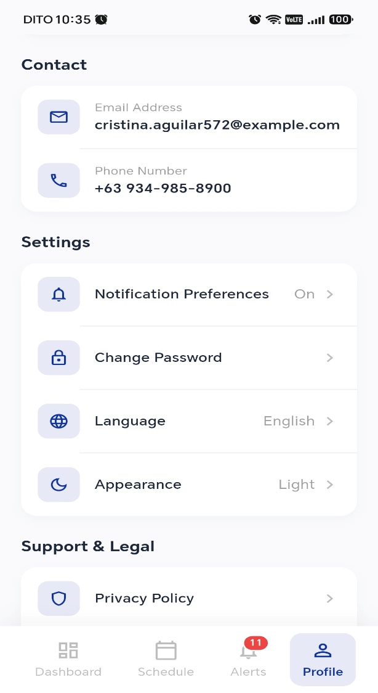
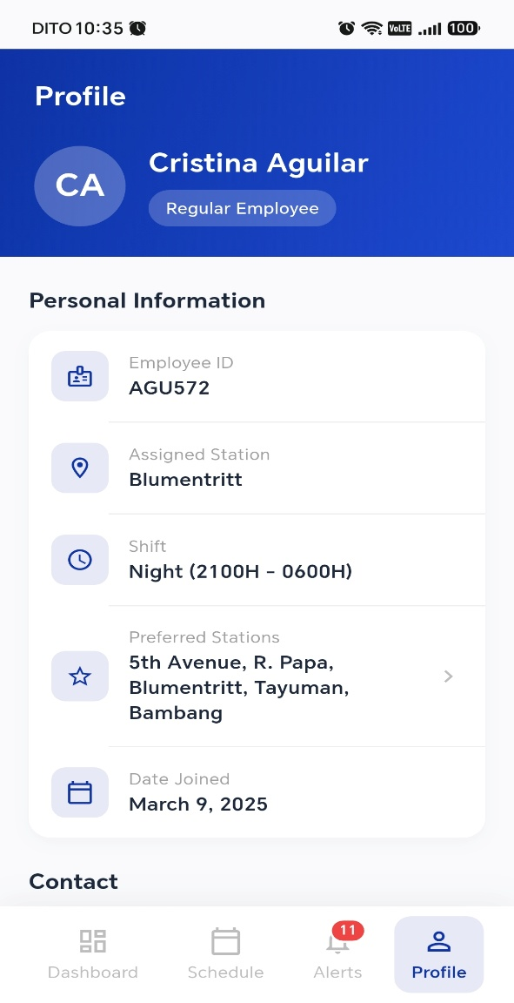

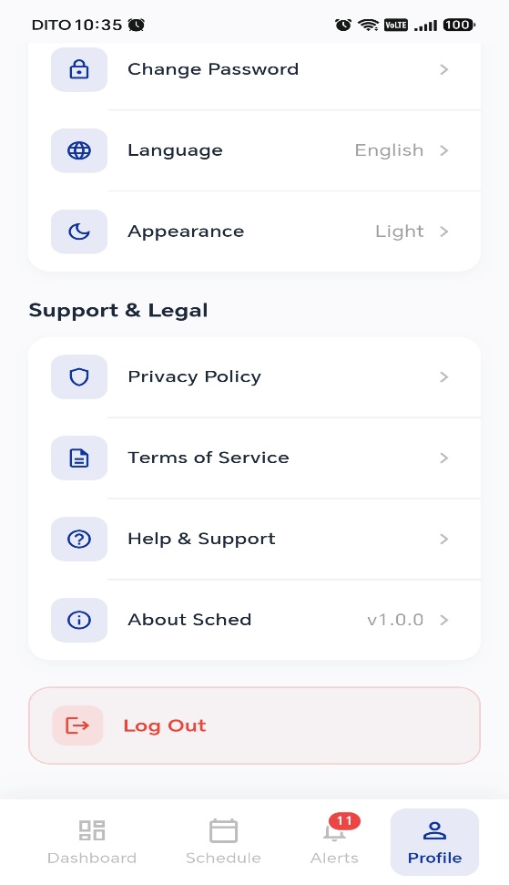
- Open the Profile tab.
- Check your details — name, role, and permanent station.
- From here you can change your password (Procedure 0.04) or log out (Procedure 0.05).

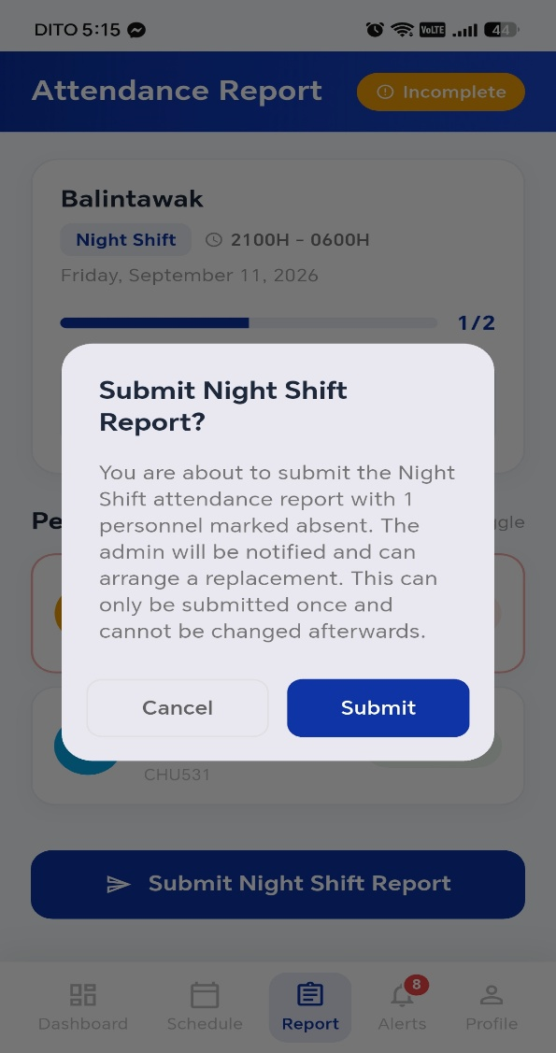
Filing the Attendance Report for Head Guard
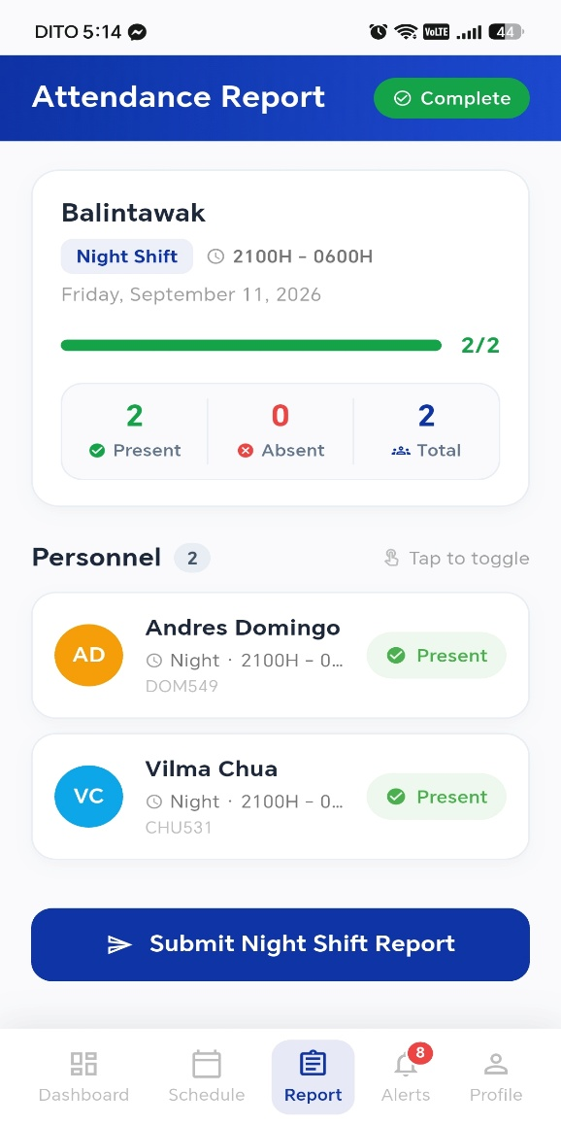
- Open the Report tab.
- Select the shift you are filing for.
- Go down the list and mark anyone who did not report by tapping their row — a guard is Present by default and toggles to Absent.
- Check the Present, Absent, and Total counts at the bottom against what you see on the ground.
- Select Submit [shift] Report and confirm on the prompt.

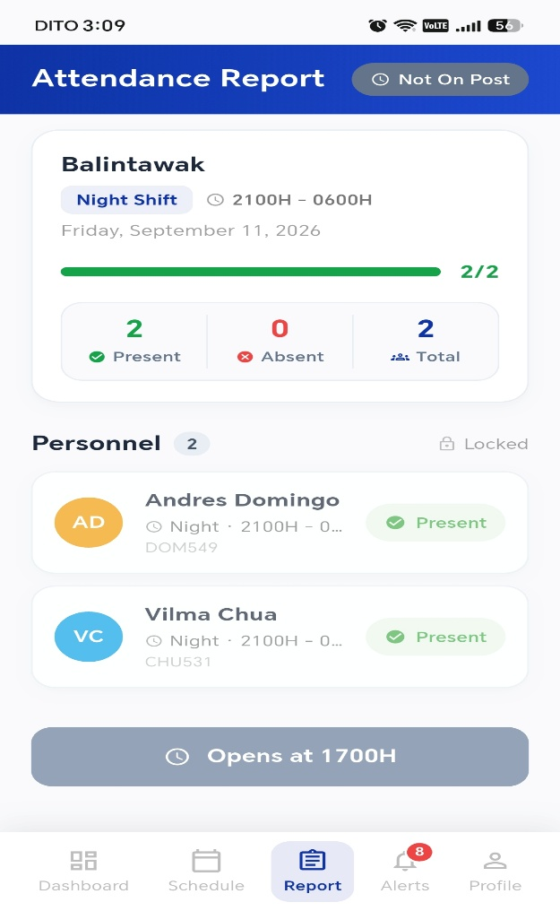
When the Submit Button Is Locked

The button tells you why it is disabled. Match the label to the cause:
What the button says | What it means
[Shift] Report Submitted | You already filed this shift. A shift can only be reported once — tell the administrator if something needs correcting.
Disabled — off duty | You are not on duty for this shift. Only the head guard on post files the report.
Disabled — outside the duty window | It is too early or too late. File the report during the shift itself.


CURRICULUM VITAE



