Question 1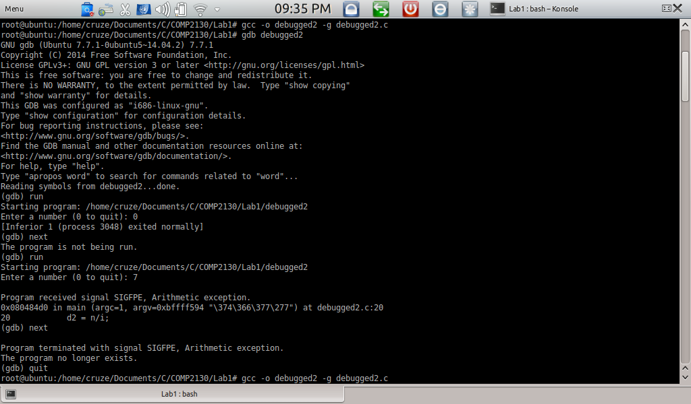

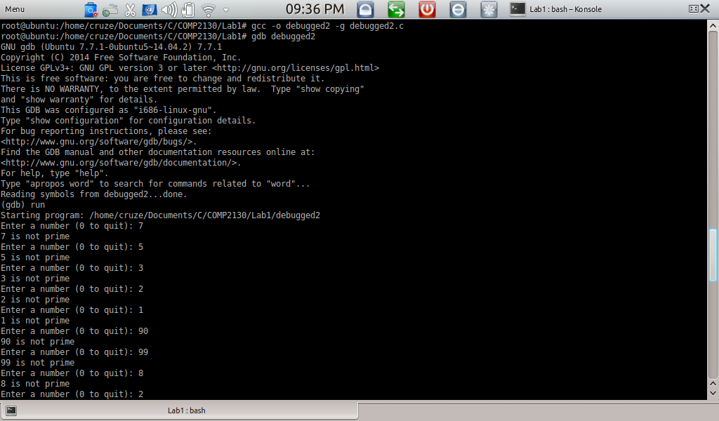

The error in the debugger appeared on line 20: Arithmetic error

Uppon further checking, it was found that the iteration for the program was trying to divide by zero

Commands:

gcc -o debugged2 -g debugged2.c

gdb debugged2

break

run

display

next

quit

Question 4

Output: 9

