Game Guide

1. Press Start to begin

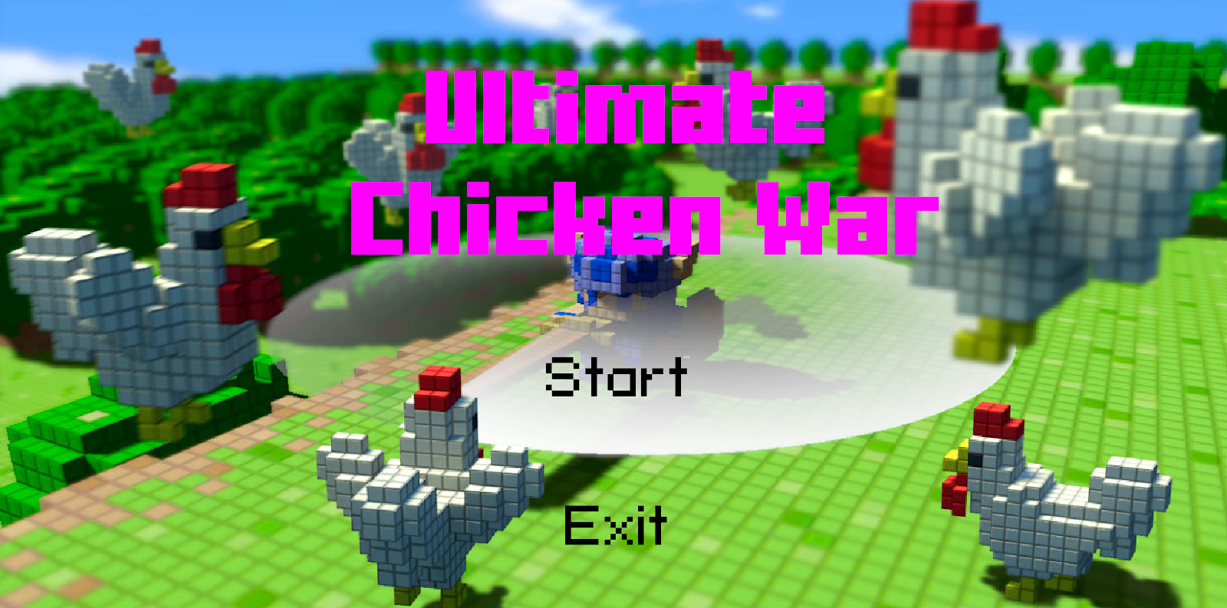

1. Type in player 1 ‘s name

Enter to complete

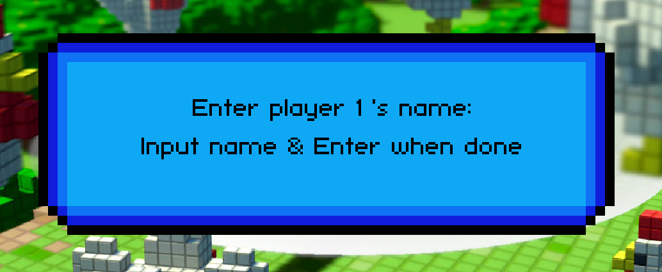

1. Type in player 2 ‘s name

Enter to complete

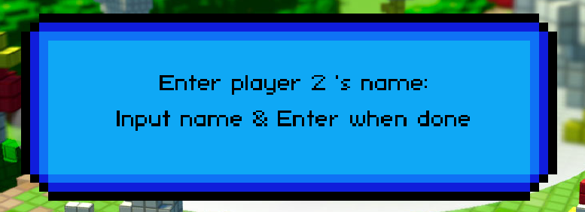

1. Game start

Player 1 has 3 white chicken and Player 2 has 3 black chicken.

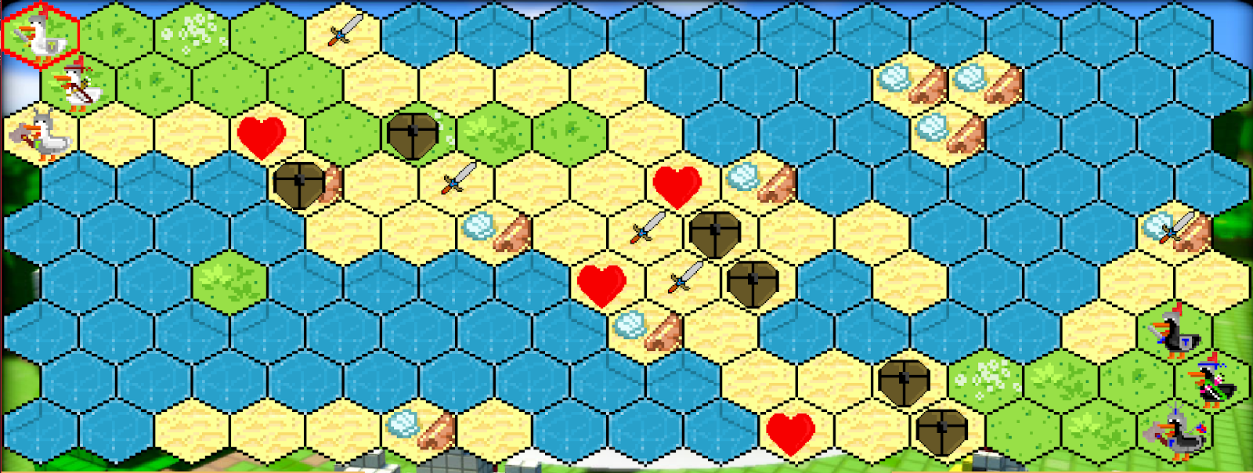Map will random automatically like:

**Rules**

Each player will take turn to move 1 of their chickens, starting with player 1. The red hexagon surrounding the tile will indicate which chicken is allowed to move, which is also indicated as the stats line turn red in the table. As the player moves the mouse across the map, a blue hexagon will show that the chicken is allowed to move or attack there, which is dependent on the chicken’s range.

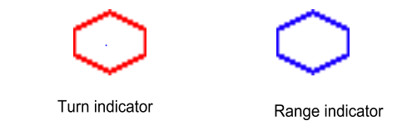

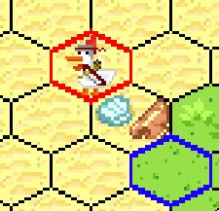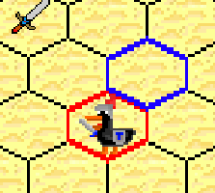

**Chicken stats table**

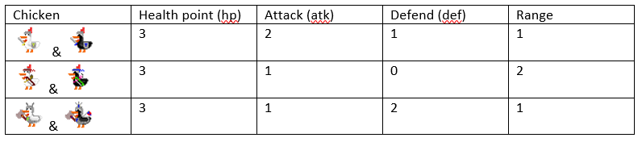

These stats will update continuously; you can see changes through stats table below the playground:

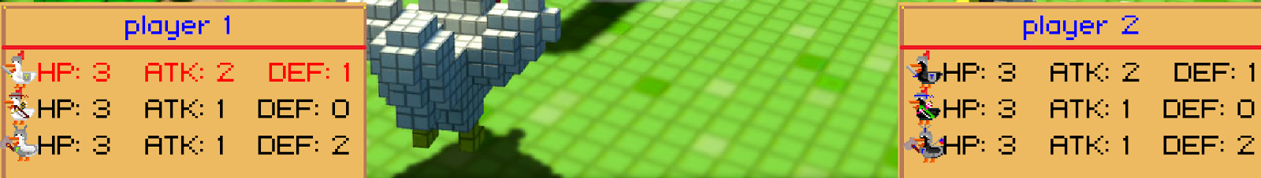

**Attack**

When you click on another chicken, one popup will display between 2 stats table

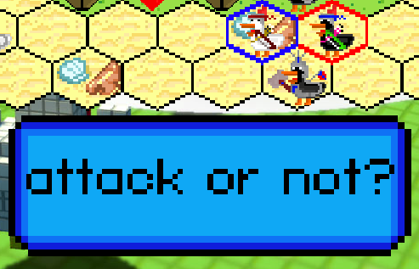

Click on the attack text if you want to attack and not if you don’t want to do so.

***Opponent’s HP = Opponent’s HP + Opponent’s DEF – Your ATK***

***Opponent’s DEF = Opponent’s DEF – Your ATK (if its DEF is greater than your ATK)***

There is one way to increase your Stats: Pick Item

**Item**

Each kind of Item will give you a bonus stat point when you pick it up (click on it)

 +1 HP

 +1 DEF

+1 ATK



**Win Condition**

When one player killed all enemy’s chickens, he will count as Victory and the Win box popup with his name on it.