Stock Data Display

Display Functions
show_table <- function(df, rows = 5) {
knitr::kable(tail(df, rows), row.names = FALSE, digits = 2)
}
plot_price <- function(df, symbol, n = 20) {
ma <- TTR::SMA(df$Close, n = min(n, nrow(df)))
plot(df$Date, df$Close, type = "l", xlab = "Date", ylab = "Close price",
main = paste(symbol, "closing price"))
lines(df$Date, ma, col = "blue", lwd = 2)
legend("topleft", legend = c("Close", paste(n, "day moving average")),
col = c("black", "blue"), lty = 1, bty = "n")
}
plot_volume <- function(df, symbol) {
plot(df$Date, df$Volume, type = "h", xlab = "Date", ylab = "Volume",
main = paste(symbol, "trading volume"))
}

Load Data
stocks <- load_stock_data("portfolio.txt")
if (length(stocks) == 0) stop("No stock data loaded. Check your internet connection.")
names(stocks)
## [1] "RY.TO" "TD.TO" "SHOP.TO" "ENB.TO"

Summary Statistics
stats <- lapply(stocks, calculate_statistics)
knitr::kable(summary_table(stats), digits = 2)
Symbol | Mean | Median | Mode | SD | Latest_MA
RY.TO | 261.51 | 264.50 | 288.21 | 27.20 | 279.68
TD.TO | 152.47 | 156.60 | 130.18 | 17.37 | 170.43
SHOP.TO | 182.15 | 173.68 | 180.62 | 28.48 | 236.72
ENB.TO | 72.18 | 72.35 | 73.30 | 4.70 | 66.96

Stock Details
for (s in names(stocks)) {
cat("\n\n### ", s, "\n\n")
print(show_table(stocks[[s]]))
cat("\n\n")
plot_price(stocks[[s]], s)
plot_volume(stocks[[s]], s)
}

RY.TO
Date | Open | High | Low | Close | Volume | Adjusted
2026-10-23 | 281.87 | 282.10 | 278.43 | 281.77 | 2975600 | 280.01
2026-10-26 | 281.01 | 284.59 | 280.75 | 284.26 | 4747400 | 284.26
2026-10-27 | 284.81 | 286.00 | 282.38 | 285.46 | 7599600 | 285.46
2026-10-28 | 285.25 | 286.49 | 283.82 | 286.41 | 5184100 | 286.41
2026-10-29 | 288.47 | 291.17 | 287.37 | 288.21 | 3675000 | 288.21
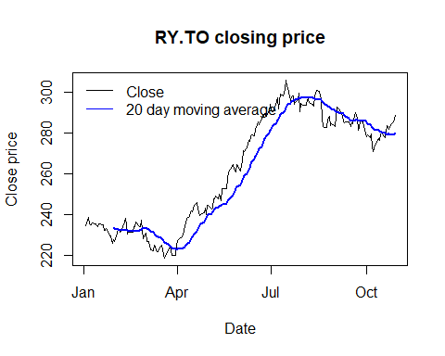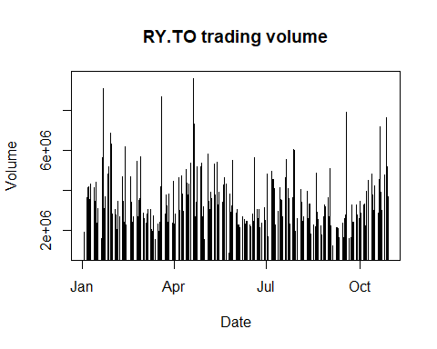

TD.TO
Date | Open | High | Low | Close | Volume | Adjusted
2026-10-23 | 174.00 | 174.89 | 172.00 | 174.47 | 3656600 | 174.47
2026-10-26 | 175.25 | 176.85 | 175.06 | 175.76 | 7579700 | 175.76
2026-10-27 | 176.35 | 177.00 | 174.30 | 176.57 | 4641000 | 176.57
2026-10-28 | 176.80 | 177.30 | 175.77 | 176.89 | 4423500 | 176.89
2026-10-29 | 177.45 | 178.95 | 177.10 | 178.13 | 4819600 | 178.13
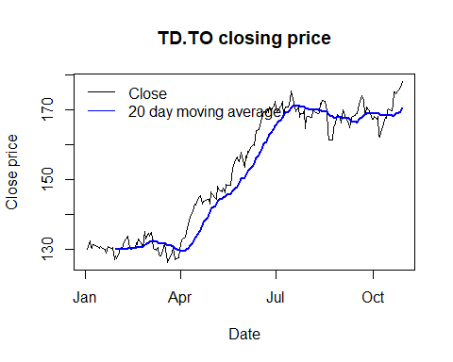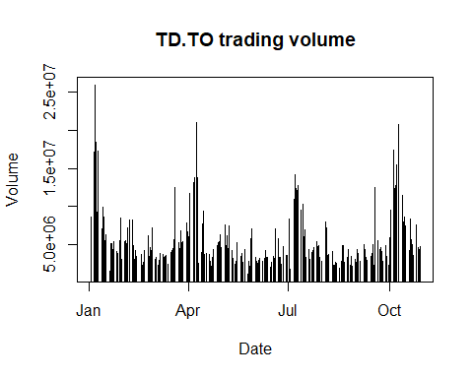

SHOP.TO
Date | Open | High | Low | Close | Volume | Adjusted
2026-10-23 | 233.12 | 238.10 | 232.29 | 236.24 | 1434700 | 236.24
2026-10-26 | 237.34 | 240.84 | 235.34 | 235.93 | 1445600 | 235.93
2026-10-27 | 236.59 | 239.12 | 229.58 | 232.93 | 904000 | 232.93
2026-10-28 | 232.94 | 237.65 | 231.26 | 235.47 | 1188000 | 235.47
2026-10-29 | 232.75 | 235.91 | 227.63 | 233.70 | 876400 | 233.70
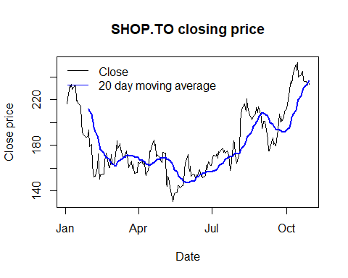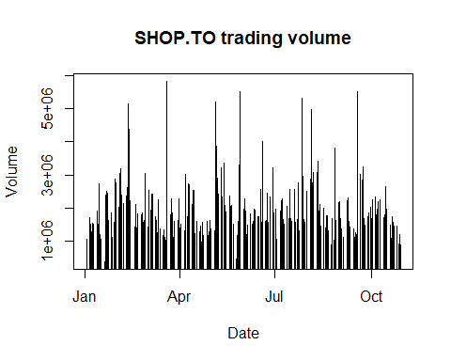

ENB.TO
Date | Open | High | Low | Close | Volume | Adjusted
2026-10-23 | 67.33 | 67.61 | 67.13 | 67.37 | 4551900 | 67.37
2026-10-26 | 67.14 | 67.72 | 67.13 | 67.65 | 10641200 | 67.65
2026-10-27 | 67.60 | 68.05 | 67.44 | 68.01 | 9636700 | 68.01
2026-10-28 | 68.12 | 68.66 | 67.81 | 67.89 | 8132100 | 67.89
2026-10-29 | 68.41 | 69.14 | 68.41 | 68.90 | 4052500 | 68.90


