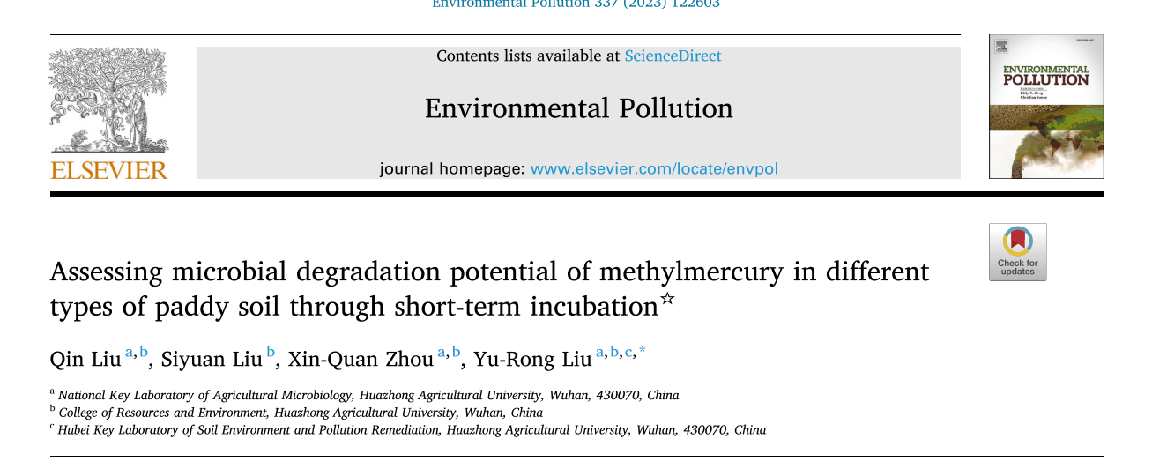

分颜色散点图#

#install.packages('ggplot2')

setwd('C:/Users/22971/Desktop')

library(ggplot2);library(reshape2)

############## ARGsCountAb ##########################################????????

M<-read.csv("Eh.csv",header=1)

#拟合

#r1<-glm(ReAb~log(Count,10),family=gaussian,ARGsCountAb);summary(r1)

p1<-lm(X~Y,M);summary(p1)#R2 =0.103, P = 0.01031

p2<-lm(X~poly(Y,2),M);summary(p2)#R2 = 0.08661, P = 0.03721

#r2<-glm(AbAb~log(Count,10),family=gaussian,ARGsCountAb);summary(r2)

#作图

p1<-ggplot(M,aes(x=X,y=Y))+labs(x="SOC (g/kg)",y="Microbial degradation of MeHg (%)")

p1+geom_point(aes(col=Site),alpha=1,size=5)+

theme(axis.text=element_text(size=20,color='black'),axis.title=element_text(size=24),axis.ticks=element_line(size=1,color='black'),axis.ticks.length=unit(0.3,"cm"),

legend.text=element_text(size=20),legend.title=element_text(size=24),legend.key=element_rect(fill='white'),

title=element_text(size=20),panel.border=element_rect(fill='transparent',color='black',size=1.5),panel.background=element_rect(fill='white'))+

#M$type <-factor(M$type,levels=c('WC', 'PJ', 'DL', 'NJ', 'WH', 'JJ', 'YY', 'JA', 'GZ'))

scale_color_manual(values=c('WC'="#005991",'PJ'="#00B0F0",'NJ'="#F8EE5C",'WH'="#F8CB5C",'JJ'="#DB8E0C",'YY'="#F5521F",'JA'="#E26D32",'GZ'="#7C2828"))+#赋予颜色+

geom_smooth(method="lm",color="black",formula=y~x,size=1.5)

