import turtleturtle.setup(1300,800,0,0)turtle.penup()turtle.fd(-250)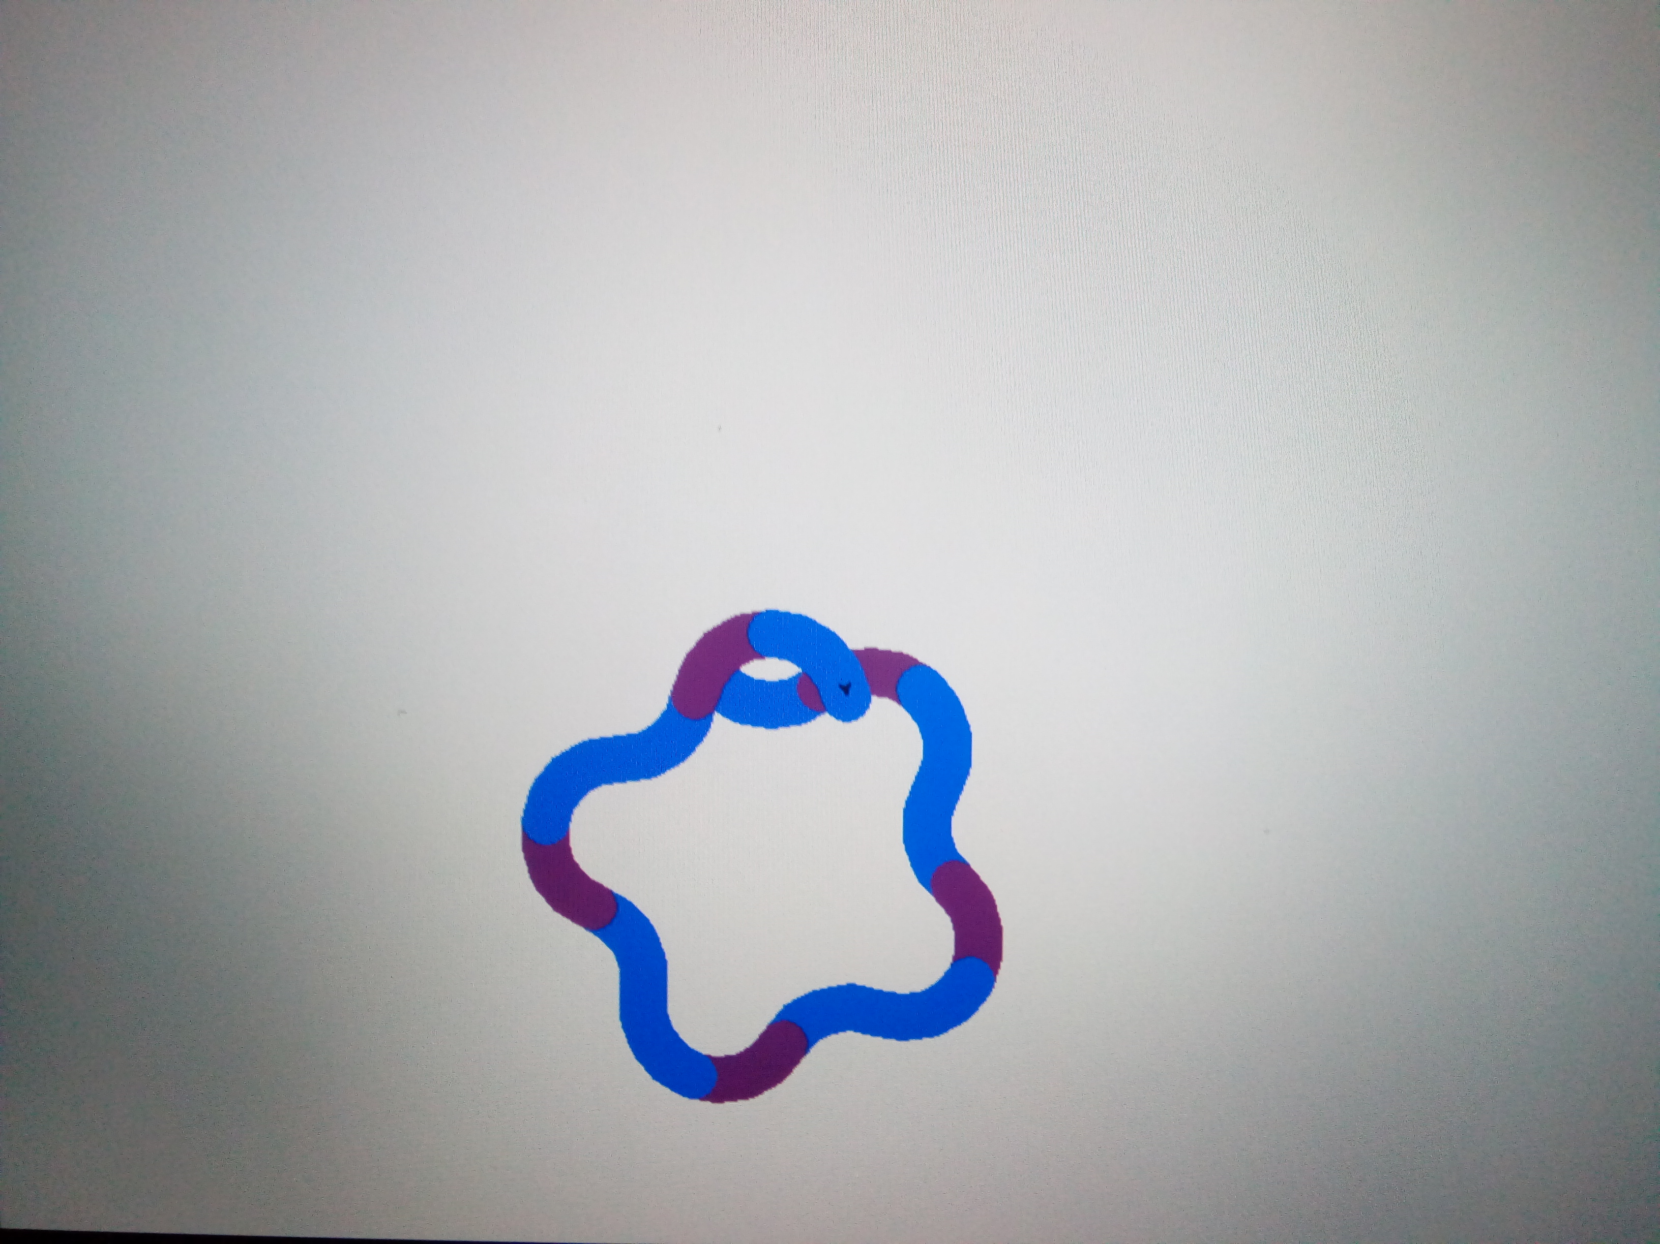turtle.pendown()turtle.pensize(25)turtle.pencolor("blue")turtle.seth(-40)for i in range(5):

turtle.circle(40,80)

turtle.pencolor("purple")

turtle.circle(-40,80)

turtle.pencolor("blue")

turtle.circle(-40,80)

circle(40,40)

turtle.pencolor("black")

fd(40)

turtle.circle(16,160)

turtle.pensize(36)

fd(40\*2/3)