
SN_GUI

USER MANUAL
Version 28 June 2012

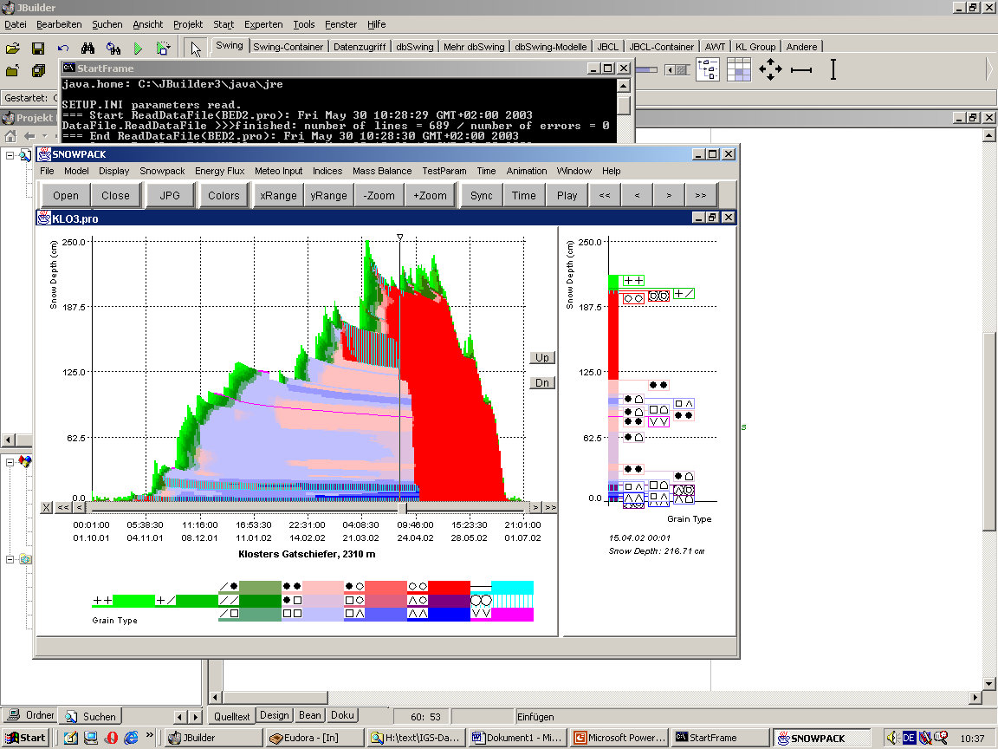

Charles Fierz

© WSL Snow and Avalanche Research SLF
Flüelastrasse 11, CH-7260 Davos-Dorf, Switzerland
http://www.slf.ch
General User Agreement

1. SN_GUI is a program developed by the WSL Snow and Avalanche Research SLF. The functions of the program are described in this manual.

2. The program and the manual are protected by copyright. All rights are reserved to the SLF.

3. The SLF gives the user a non-exclusive, non-transferable, and temporally unlimited right of usage.

4. Transfer or concession of the usufruct or exploitation rights to a third party is prohibited.

6. Any liability for damages occurring in relation to the use of SN_GUI, (in particular resulting damages, unrealised economies, lost profits etc. as well as commercialisation) is impossible.

CONTENTS

1. Introduction
1.1 General Remarks
1.2 Technical Notes

2. Installation
2.1 Installation Process
2.2 File System Review

3. Operation of the SN_GUI
3.1 The Start Frame
3.2 Visualization of the Output of SNOWPACK
3.2.1 Split Frames
3.2.2 The Menu Bar
3.2.2.1 The File Menu
3.2.2.2 The Model Menu
3.2.2.3 The Display Menu
3.2.2.4 The Parameter Menu
3.2.2.5 The Time Menu
3.2.2.6 The Animation Menu
3.2.2.7 The Window Menu
3.2.2.8 The Help Menu
3.2.3 The Speed Bar
3.3 Full Version versus Reduced Parameter Set

Appendix: A: Known Bugs
1. Introduction

  - General Remarks

The general acceptance and practical applicability of scientific software depends to a high degree upon the ease of operation and the availability of an excellent, up-to-date and accurate visualization of the numerical output. The Swiss Federal Institute for Snow and Avalanche Research (SLF) developed a graphical user interface for snowpack modelling (SN_GUI) designed to meet high quality standards. The software is specifically meant to accompany the Swiss snow cover model SNOWPACK but could also be used for other snow cover models. This manual is to provide to the user of SN_GUI all information he needs in order to work efficiently with SN_GUI.
The following conventions are followed throughout this manual:
- File and directory names are printed in bold.
- <Button names> used in dialog frames are listed within square brackets.
- Names of menus are listed in italics.
Since SN_GUI was tailor-made for the operation of the SLF model SNOWPACK. The next section contains a installation hints (Section 2) followed by a discussion of the principal features of the software (Section 3).

NOTE:
This manual is derived from the former SNOWPACK_WIN manual that described both model and visualization. With the new C++ version of SNOWPACK, the two software packages are distinct and only the documentation pertaining to SN_GUI is retained below.

  - Technical Notes

SN_GUI is based upon the object-oriented and platform-independent programming language Java, meaning that the program execution in different operation system environments (Windows, LINUX, Solaris, etc.) is possible. The source code of the current version (around 700 KB in size), consists of 50 Java classes and more than 300 methods (= subroutines). It was compiled with the aid of the JBuilder software, using Swing libraries to create some special graphical effects.

2. Installation

2.1 Installation Process

The SN_GUI software package can be installed in any directory along with the subdirectories DATA, and SETUP. The whole structure, including the files residing in the mentioned directories is described in the following section (2.2).
Currently no specific batch or script files exist to process the installation of SN_GUI. The user simply installs the SN_GUI package through copying a clone of the original file system onto a computer accessible by him. This file system may be available for a specific user at a number of different locations and media. This can for instance be a CD, or the SN_GUI package could be transferred to the user as a zipped email attachment.
When operating the SN_GUI on UNIX systems, one has always to make sure that through the copy process the original capitalization of the letters of the file names does not change.
The SN_GUI package can in theory be placed at any position of the user’s directory system provided DATA and SETUP remain subdirectories of the directory where the SN_GUI package is installed.

2.2 Using SN_GUI

SN_GUI.bat or SN_GUI.sh is used to launch the SN_GUI user interface. STN_1.pro and STN_1.met provided in the subdirectory DATA are demo files to start learning using the visualization tool (see section 3.2).
All files installed are necessary for the operation of SN_GUI, except for those residing in the DATA subdirectory. This directory was implemented for the convenience of the user to hold snowpack output files (*.pro and *.met).
With few exceptions, no manual changes of the files included in the SN_GUI package should be processed by the user. SETUP.INI contains the most essential setup parameters of SN_GUI. Advanced users might want to alter SETUP.INI as well as the default parameter settings in the files PARDATA.INI and PARDATA203.INI located in SETUP (see Section 3.2.2.4).

NOTE:
Additional sets of configuration files are contained in the subdirectories of SETUP. These sets allow to display other parameter sets of model outputs, for example, Snat also includes the visualization of the natural stability index. This, however, also requires using the SN_GUI-Snat.jar executable stored in bin. The remaining sets correspond to very specific applications, for example, the opera set works best for files obtained from runs performed in operational mode. To use these alternate sets, the user needs to edit SETUP.INI and change the IniFilePath from ./SETUP/ to ./SETUP/Snat/, for example.
3. Operation of the SN_GUI

3.1 The Start Frame

SN_GUI provides graphical tools facilitating the operation of SNOWPACK. After starting the SN_GUI, the user is confronted with the following start frame:
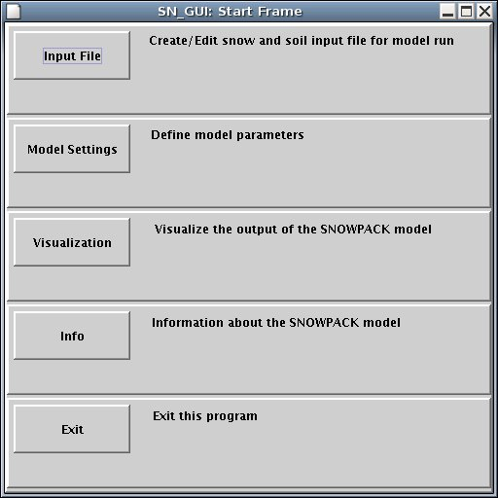
Figure 4: Start frame of the SN_GUI, giving the user access to various subsystems.
Activating the buttons has the following effects:
The buttons <Input File> and <Model Settings> are now obsolete. See the SNOWPACK and MeteoIO documentations to learn how to create input and configuration files.
<Visualization> switches to the SNOWPACK visualization frame (Section 3.2).
<Info> indicates SN_GUI version.
<Exit> quits the SN_GUI.

3.2 Visualization of the Output of SNOWPACK

The visualization module of the SN_GUI package was designed to make the results of the SNOWPACK calculations easily and comprehensively accessible to a wide range of users. The visualization frame has a menu bar at the top from which the individual menu items (various functions for data management plus graphical adjustment tools, see Section 3.2.2) can be chosen. Underneath is a tool bar, which allows accelerated access to some of the menu items (Section 3.2.3). At the bottom of the visualization frame is a status bar which is not fully functional.
The visualization is started by clicking the <Visualization>-button in the start frame (Section 4.1). The visualization frame can enclose one or more split frames (see Section 3.2.1).

3.2.1 Split Frames
The data calculated for a certain station and related to a specific parameter are displayed in form of split frames (see Figures 7, 8, 9, 10). The left side of such a frame always represents a time series and contains a bar that can be moved horizontally to specific dates. This is done by dragging a slider or by mouse-clicking interactive scroll buttons that are attached to the frame. The data referring to the currently marked date are visualized in the right part of the split frame. The vertical separation line between the left and the right part of split frames can be moved, dragging it with the mouse cursor (not recommended on a regular base, since this action may still produce errors).
Currently more than 50 parameters can be visualized by means of the SN_GUI (see Table 1).
A number of split frames can be displayed concurrently in the visualization frame and arranged in various ways (see Section 3.2.2.7).

The following buttons are attached to split frames:
<X>: Clicking on this removes all the buttons of the split frame, including the slider. The buttons can be reinserted via the menu item Display /Slider + Buttons (see Section 3.2.2.3).
<<: Moves the slider to the beginning of the displayed time range (see Section 3.2.2.5) or to the time range preceding the currently displayed one.
<: Moves the slider to the data record preceding the current one.
>: Moves the slider to the data record following the current one.
>>: Moves the slider to the end of the displayed time range or to the time range following the currently displayed one.
(The buttons <<, <, >, >> are also available on the speed bar, see Section 3.2.3).
<Up>: equivalent to Display/Y-Interval Up (see Section 3.2.2.3)
<Dn>: equivalent to Display/Y-Interval Down (see Section 3.2.2.3)
There are two main types of data and thus split frames:
- Scalar data (resident in files with the extension *.met). This type of parameter (e.g. the surface temperature of snow) is not related to individual layers of the snowpack. The left side of the split frame is a line graph, while the right-hand side gives the numerical value of the displayed parameter for the selected date. Depending on the parameter, and where useful, a number of line graphs can be displayed concurrently, for instance to compare modelled and measured data, indices or wind data from different altitudes (see Figure 7).
- Vector data (resident in files with the extension *.pro). This attribute refers to layer parameters such as the simulated vertical profile of the size of snow grains. For such data, the left part of the split frame describes the time evolution of the layered snowpack, and the right-hand graph gives a single-time vertical profile of the active parameter. The latter is usually a simple line-graph (see Figure 8), but for some parameters more sophisticated graphs are provided.
The right-hand side of Figure 9 for example gives a vertical profile of the grain form, based upon internationally recognized symbols. Melted and refrozen grain forms are marked by vertical hatching. Figure 10 provides information about the stability calculated by the SNOWPACK model. In the right-hand side of the split frame, the arrows mark the altitudes at which three stability parameters reach a minimum value. The numerical values (stability minimum, plus the altitude) are listed at the bottom.

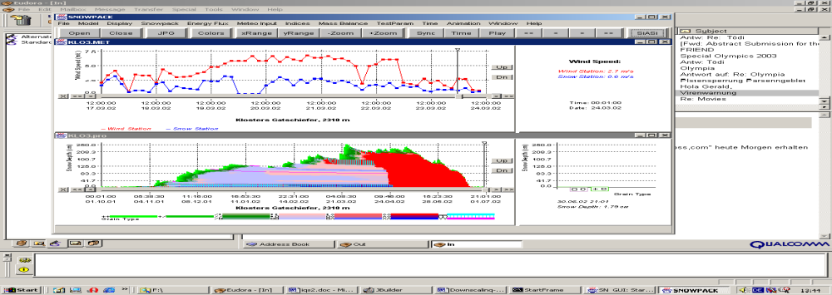
Figure 7: Split frame for the visualization of scalar data. Several parameters can be displayed concurrently within the same frame in different colours, in this example the wind data at two different altitudes, related to the station Klosters Gatschiefer (the upper curve gives the data for the higher sensor). The right-hand graph reveals the numerical values for the displayed parameters for the date marked by the slider position in the left part of the split frame.

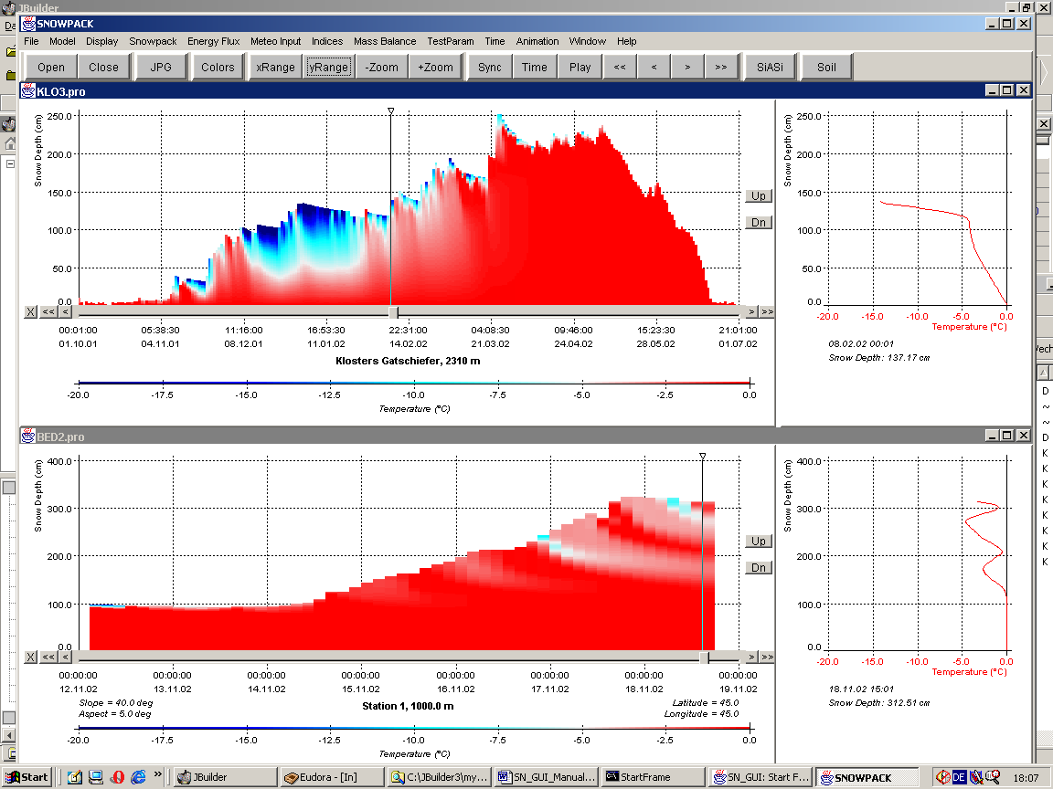
Figure 8: Split frame for the visualization of vector data (displayed parameter: snow temperature)

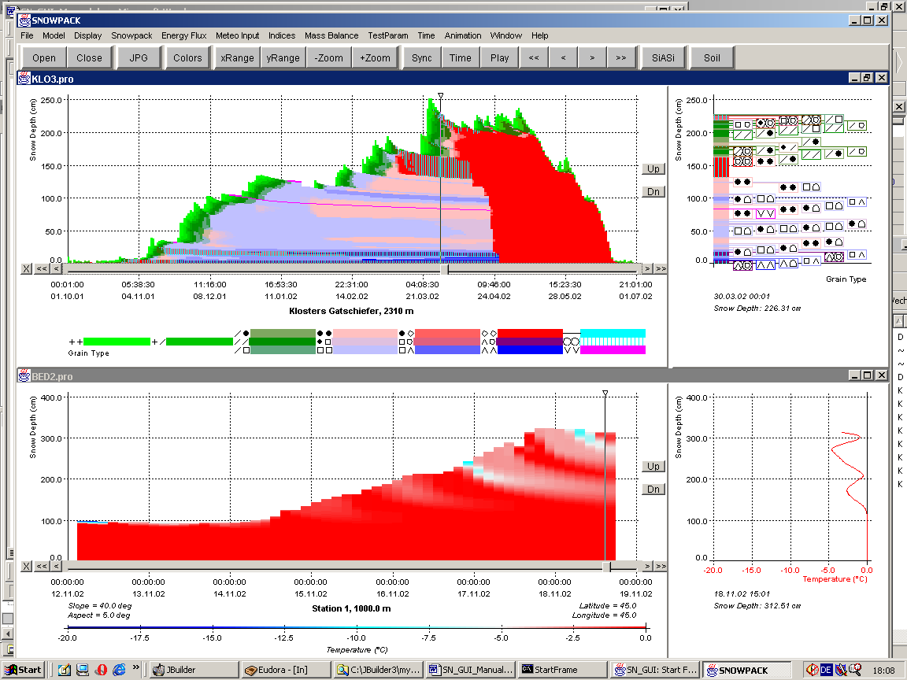
Figure 9: Split frame for the visualization of vector data (displayed parameter: grain type)

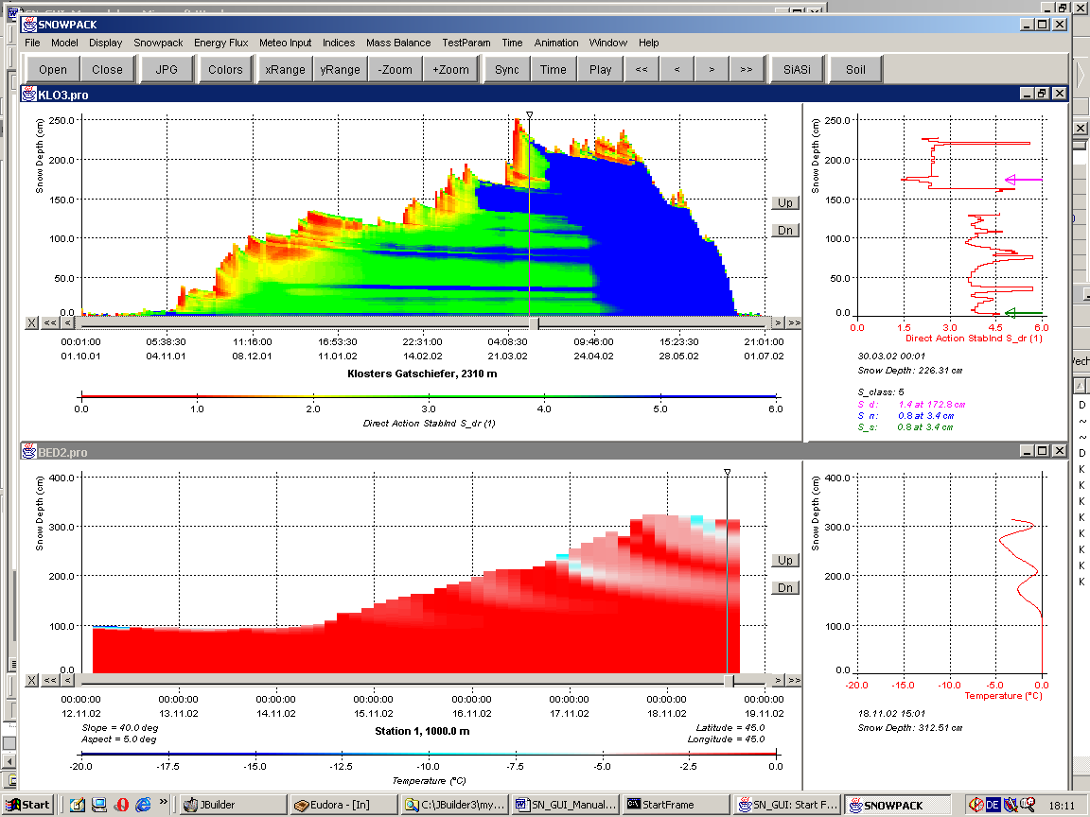
Figure 10: Split frame for the visualization of vector data (displayed parameter: direct action stability index)

3.2.2 The Menu Bar
In the following, the functionality of the menu items accessible by the menu bar is described in detail.
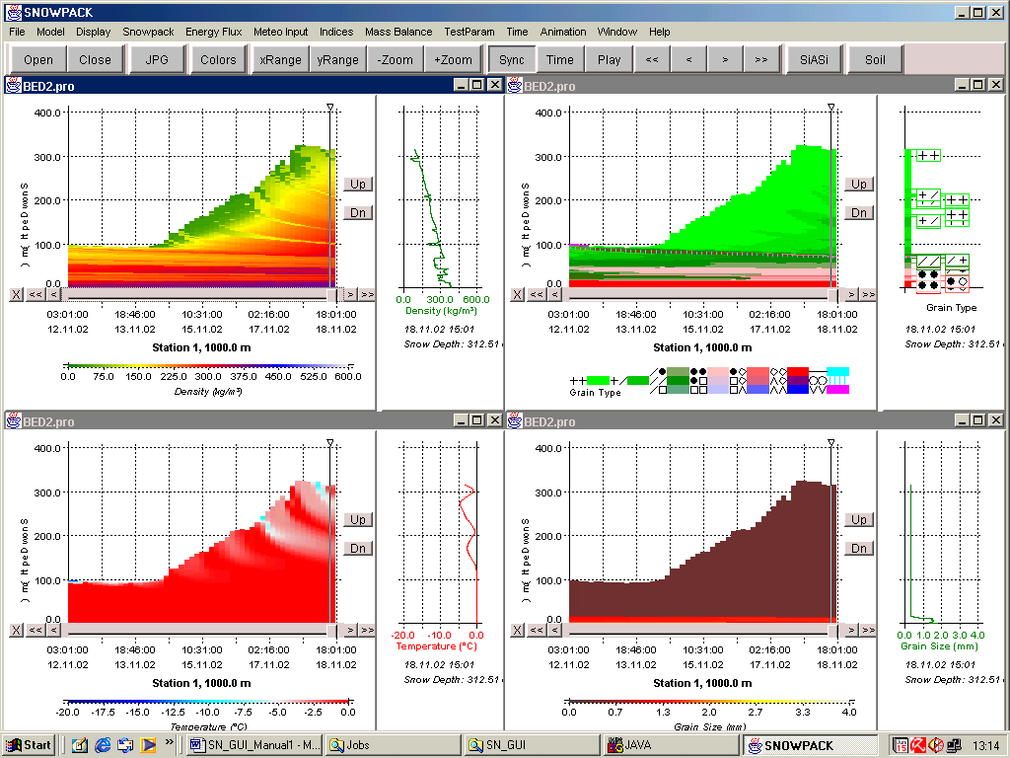

3.2.2.1 The File Menu
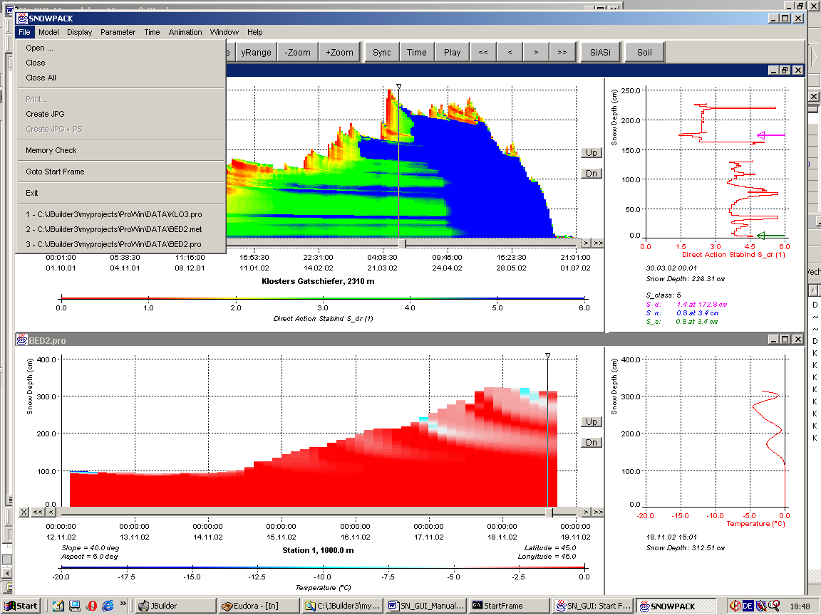
Menu File/Open:
Selecting Open, a file selection box pops up whose appearance depends on the operation system. Two types of data file (compare Section 3.2.1), both produced by SNOWPACK and residing in any accessible directory, can be chosen:
- *.pro-files: contain vector data
- *.met-files: related to scalar data
After selecting a file, its content is loaded into the memory, including a format check of the data. Detected errors may be visible in a background console window provided by the operation system. Once the data loading has finished successfully, a split frame related to the selected file appears, filling up the visualization frame and being set active. *.met and *.pro files contain valuable information about the station (Lat, Long etc as well as the depths of temperature sensors) .Now a wealth of display options is accessible by clicking the desired menu items (most of these are not selectable if no split frames are open). A default parameter is displayed which is snow temperature (for *.pro-files) or air temperature (for *.met-files). This parameter can be exchanged by another one at any time by choosing any items from the Parameter menu (see Section 3.2.2.4).
If the file is opened for the first time during a SN_GUI session, its name is appended to the list of menu items of the File menu (Section 3.2.2.1).
Other occasions where files are loaded, are after:
- clicking on recently opened files (menu File/Recently Opened Filename), or
- choosing a parameter (menu Parameter) related to a *.met-file if a *.pro-file is open (and vice versa)

Menu File/Close:
The currently active split frame is closed. If it was the last one open, a number of menu items will become inaccessible.

Menu File/Close All:
All open split frames are closed. A number of menu items will become inaccessible.

Menu File/Print:
Currently not usable.

Menu File/Create JPG:
This menu allows the creation of *.jpg images of the visualization frame which can be printed by a variety of programs. Clicking Create JPG leads to the emergence of a file selection box which is dependent on the used operation system. Here the name and the directory of the *.jpg-file to be created can be stated. The default name is SN_GUI.jpg. After selecting a name, all open split frames are arranged in a side-a-side-mode (see Section 3.2.2.7), and thereafter the *.jpg-file is created, including the whole visualization frame except for the menu bar (Section 3.2.2) and the speed bar (Section 3.2.3). A message window informs about the successful construction of the file.

Menu File/Create JPG+PS:
Not implemented.

Menu File/Memory Check:

When a Java program such as the SN_GUI is executed, the Java Virtual Machine occupies a certain amount of memory (“total memory”). The “free memory” is this “total memory” minus the memory the program actually needs to run. The total memory is automatically adjusted from time to time, so unpredictable fluctuations of it (and also of the free memory) are not uncommon.
Clicking on Memory Check, both the total and the free memory of the Java Virtual Machine are listed in a message box.

Menu File/Goto Start Frame
Clicking this menu item results in the emergence of the start frame (see Section 3.1).

Menu File/Exit:
Termination of the SN_GUI.

Menu File/Recently Opened Filename:
“Recently Opened File” stands for any path/file name.
The name of any file that is loaded for the first time during a SN_GUI session, is appended to the list of menu items of the File menu. It remains there, until the SN_GUI program is terminated.
Clicking on any of the appended filenames causes the construction of a new split frame related to that file.

3.2.2.2 The Model Menu
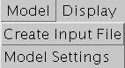

These functions are now obsolete. See the SNOWPACK and MeteoIO documentations to learn how to create input and configuration files.
3.2.2.3 The Display Menu
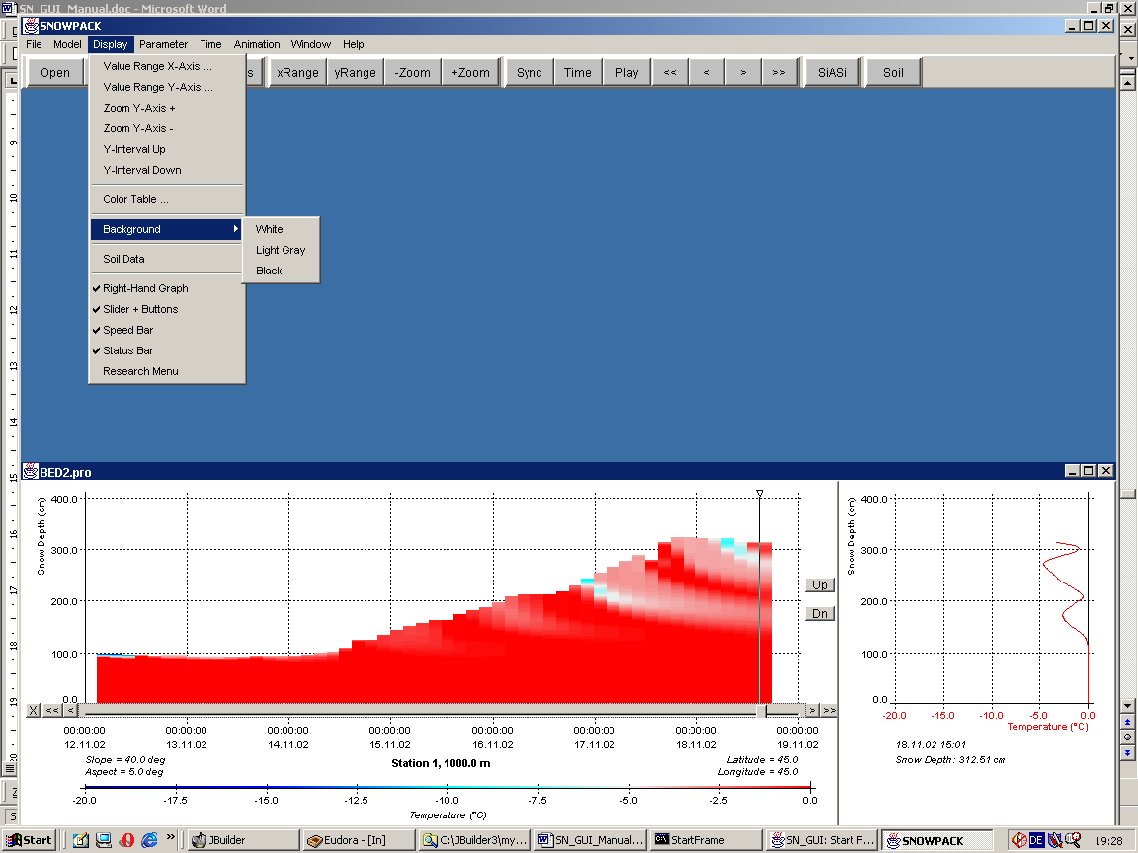

Menu Display/Value Range X-Axis:
This menu item is just available for split frames displaying vector data (*.pro-files; see Section 3.2.1). When clicked, a dialog window pops up (see Figure 11), allowing the scaling of the x-axis of the right-hand graph. The minimum (“Start Value”) and maximum (“End Value”) displayed parameter value can be reset. The number of vertical lines structuring the right-hand graph (“Partition Lines”) can also be adjusted.
Having changed some of the values in the edit boxes, the <OK> button has to be pressed in order to transfer the changes to the active split frame or to all open split frames if the synchronization mode (Section 3.2.2.5) is on. Format errors will be communicated to the user and may be corrected. Clicking <Cancel> exits the dialog frame without implementing the proposed changes in the split frame.
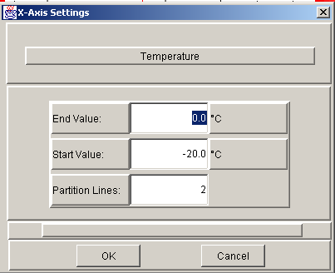
Figure 11: Dialog window to change the settings of the x-axis in the right part of a split frame
Menu Display/Value Range Y-Axis:
When clicked, a dialog frame very similar to that displayed in Figure 11 pops up, allowing the simultaneous scaling of the y-axis in the left-and and right-hand side of the split frame. The minimum (“Start Value”) and maximum (“End Value”) displayed parameter value can be reset. The number of horizontal “Partition Lines” can also be adjusted.
Having changed some of the values in the edit boxes, the <OK> button has to be pressed in order to transfer the changes to the split frame. Format errors will be communicated to the user and may be corrected. Clicking <Cancel> exits the dialog frame without implementing the proposed changes in the split frame.

Menu Display/Zoom Y-Axis +:
50%-zoom of the displayed y-axis range.

Menu Display/Zoom Y-Axis -:
200%-zoom of the displayed y-axis range.

Menu Display/Y-Interval Up:
Changes start and end value of the y-axis. While the y-axis range remains the same, the new start value is the old end value. Thus an “upward scrolling” through the data is possible by the multiple usage of this function. One application of this function is to scroll through the layers of the snowpack (with a constant layer depth).

Menu Display/Y-Interval Down:
Changes start and end value of the y-axis. While the y-axis range remains the same, the new end value is the old start value. Thus a “downward scrolling” through the data is possible by the multiple usage of this function, for instance from the upper layers of the snowpack to the lower ones (with a constant layer depth).

Menu Display/Colour Table:

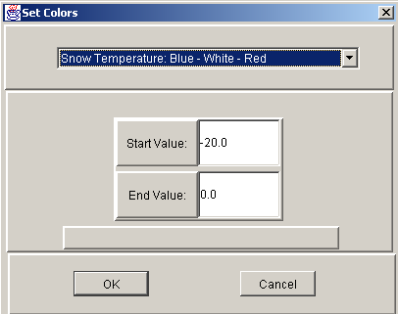
Figure 12: Colour dialog window
This menu item is available for split frames related to vector data only (*.pro-files; see Section 3.2.1), but not for the display of grain type. Clicking it, the colour dialog window appears which contains several edit-boxes related to the colour display. When a split frame emerges for the first time, it does so using default colour settings related to the displayed parameter (read from the file PARDATA.INI). The colour dialog window allows the adjustment of these default values. In the upper part of the dialog window it can be chosen among a variety of colour palettes, and in the center “Start Value” and “End Value” for the colour range are given. The numerical values in these text fields refer to the parameter and unit listed in the currently active frame.
Clicking <OK> adjusts the colours of the active split frame according to the changed settings. <Cancel> exits the frame without any actions.
Example: If the colour palette “Blue – Green – Yellow –Red” is chosen, “Start Value” is –10 and “End Value” is 0, and the active split frame is related to temperature, any snow layers with a temperature of –20, -15 and –10 degrees will be painted in blue, green tones will be used for –7 degrees, yellow ones for –3 degrees and red ones for zero degree.

Menu Display/Background:
A background colour can be chosen. Choices are White, Light Gray and Black.

Menu Display/Soil Data:
If this menu is checked, soil data (if calculated and available for a specific parameter) will be included in the display.

Menu Display/Right-Hand Graph :
If the menu is checked, the right-hand graph is displayed.

Menu Display/Slider + Buttons:
If the menu is checked, slider and control buttons (see Section 3.2.1) are displayed in the split frames.

Menu Display/Speed Bar:
If the menu is checked, the speed bar (see Section 3.2.3) is visible.

Menu Display/Status Bar:
If the menu is checked, the status bar is visible. The status bar is situated at the bottom of the visualization frame and is not yet fully functional.

Menu Display/Research Menu:
This menu item allows to switch back and forth between the parameter choices of a reduced parameter set and the full version (see 4.5). If the checkmark is visible in front of Research Menu, the extended parameter set of the full version is on display.

3.2.2.4 The <Parameter> Menu
After the start of the SN_GUI an extended set of parameter menus and submenus is available, listed in the file PARMENU1.INI, residing in the SETUP directory. See Table 1 for a review of the parameters that can currently be visualized by the SN_GUI.

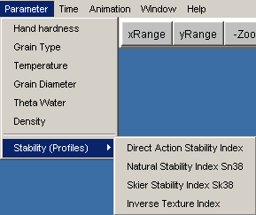

During runtime it can be switched back and forth between the parameter choices of the reduced and the full version, clicking the menu item Display/Research Menu.
A mouse-click on any of the available parameters has the consequence that either an adequate file and a new split frame are being opened, or that one of the open split frames (if possible the active one) is used for the visualization of the new parameter.
If it is wished to display a new parameter in any case in a separate split frame (thus two parameters related to the same data set can be displayed concurrently), the relevant file should be opened another time, clicking Menu File/Open or Menu File/Recently Opened Filename, followed by the choice of a display parameter from the parameter menu.
Advanced users can customize the files PARDATA.INI and /or PARDATA203.INI, focussing on the sections describing the properties of “Profile Parameters” (in PARDATA.INI) and “Time Series Parameters” (in PARDATA203.INI). Thus self-designed parameters can be displayed by means of the SN_GUI. Both files have a detailed syntax description in their header.

context | SN_GUI parameter
energy | snow temperature*, temperature gradient, conductivity, absorbed shortwave radiation
stresses and strains | overburden stress, viscosity, viscous deformation rate
density and volumetric contents | density*; volumetric content of ice, water*, air, void
microstructure | dendricity, sphericity, bond size, grain size*, optical equivalent grain size, grain type* (including surface hoar and refrozen layers), coordination number
energy flux | sensible and latent heat exchange, rain energy, soil heat fluxes, long wave radiation (incoming, outgoing, net), short wave radiation (incoming, outgoing, net, surface albedo, radiation on slopes, direct), energy balance
station data input | temperature (of air, at the snow surface, within the snowpack for fixed levels, in the ground), relative humidity, wind speed and direction, rain rate, snow depth
indices | hoar index, drift index, new snow (24 hours, 3-day sum), hand hardness*, inverse texture index*, vector stability indices (deformation*, skier stability*), scalar stability indices (stability index, depth stability index), classifications (profile type, stability)
mass balance | Snow water equivalent, erosion, runoff, sublimation, evaporation
parameter testing | dummy parameters** for any number of vector and a limited number of scalar data
Table 1: Review of the parameters that can currently be visualized by the SN_GUI. Where applicable, not only snow, but also soil layer data can be visualized.
(*) All listed parameters are available in the full version, but only the items marked by the star (*) can be accessed by the reduced parameter version.
(**) The properties of dummy parameters, such as menu names, default colour scales and value ranges, can be defined by the individual user. The output routines must also be adapted accordingly in Queries.c.

3.2.2.5 The Time Menu
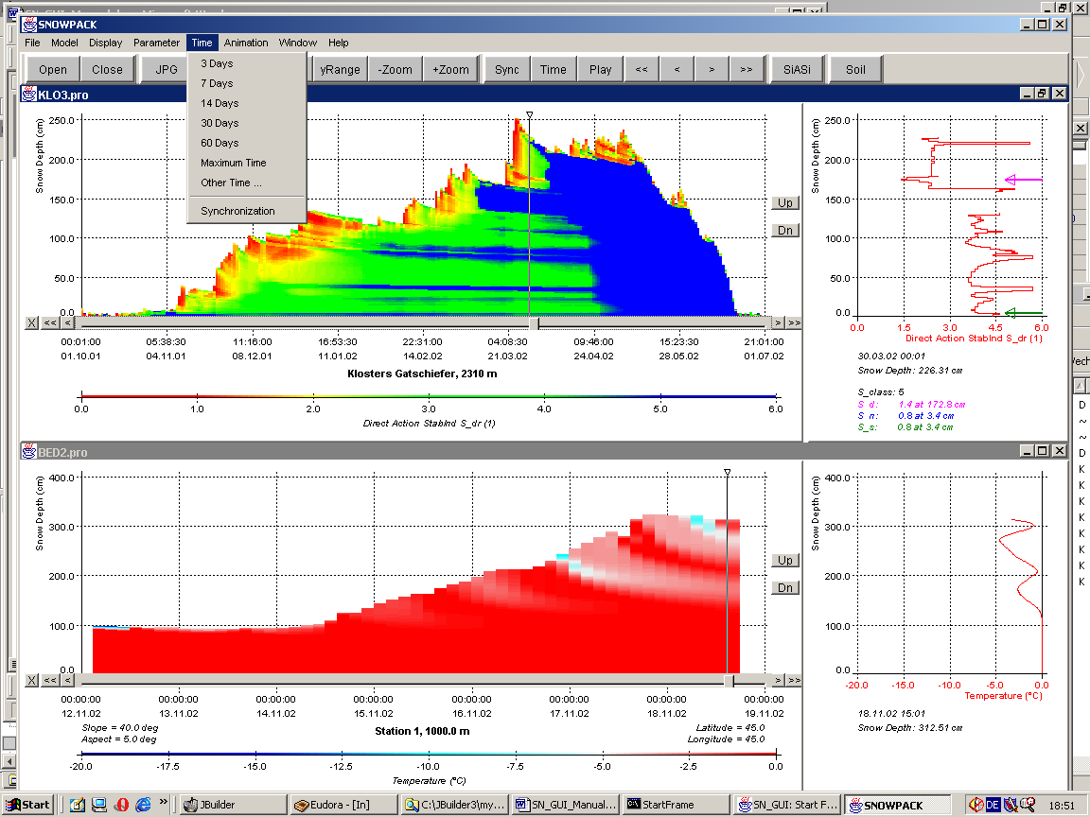

The choice of any item of the first part of the Time menu changes the time range of the loaded data set displayed on the x-axis of the left side of the split frame, see Section 3.2.1. Generally, if possible, the new end time of the displayed time range will be set to the currently active time marked by the slider position.
Scrolling in time through the file is possible, for instance moving back week by week. For this, the buttons <<, <, >, >> (see Section 3.2.1, 3.2.3) have to be used.

Menu Time/3 Days, 7 Days, 14 Days, 30 Days and 60 Days: Clicking this item changes the displayed time range to 3, 7, 14, 30 or 60 days.

Menu Time/Maximum Time: The maximum time range available for the currently chosen parameter (depending on the input file) will be displayed in the left part of the split frame.
Menu Time/Other Time:
When clicking this menu item, a user window pops up (see Figure 13) which allows the display of any time ranges for which adequate data are available in the input file.
Start and end time (year, month, day, hour) of the data display period can be entered in the relevant edit boxes. <OK> implements the changes in the split frame, and clicking <Cancel> exits the time dialog window without further actions.
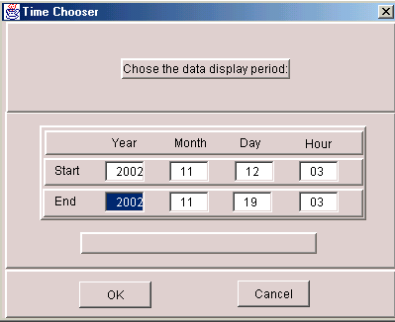
Figure 13: User window to state the start and end time of the time range to display

Menu Time/Synchronization:
Clicking this menu item allows the user to alternately activate or deactivate the synchronization mode. If the synchronization mode is on, a number of menu functions is simultaneously applied upon all open split frames, including:
- Zoom functions and scaling of the y-axis (see Section 3.2.2.3)
- Displayed time range
- Movement of the slider position through mouse dragging or through clicking specific buttons (<, <<, >, >>), see section 3.2.1
When activating the synchronization mode, the following actions are processed automatically:
- First it is checked if all open split frames refer to the same data set. This is supposed to be the case if all the file names appearing in the title bars of the open split frames are equal (apart from the extension, which is either *.pro or *.met). If the file names are not equal, the synchronization mode cannot be established, and an error message appears. Advanced users can restrict the file name check to a selectable number of characters at the start of the file name, setting the parameter “SynLetters” in SETUP.INI to a value other than 0.
- The time ranges displayed in the left part of all split frames are adjusted to display the maximum time range possible, and the slider button is moved to the last data record.
- The open split frames are arranged in a side-a-side mode (see Section 3.2.2.7).
The synchronization mode is deactivated if the names of newly loaded files are not in agreement with those of open split frames.
When starting SN_GUI, the synchronization mode is by default deactivated.

3.2.2.6 The Animation Menu
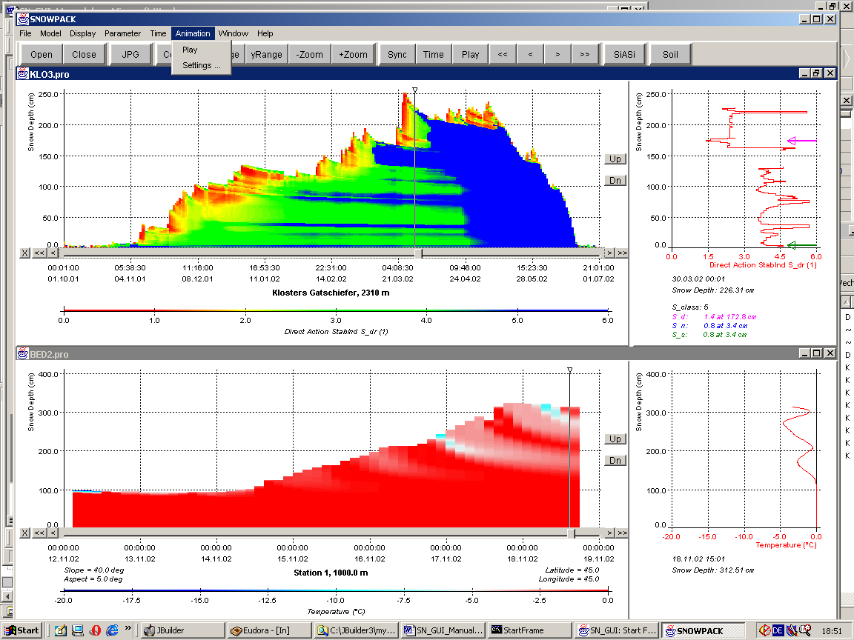
The Animation menu allows the user to automatically time-lapse through the data set calculated by the SNOWPACK model.

Menu Animation/Play:
Clicking on Play initiates the animation using the currently active animation settings listed in the Settings dialog window (see Figure 14).

Menu Animation/Settings:
Clicking on this menu item leads to the display of the animation dialog window. Start and end time of the animation (Year, Month, Day, Hour) can be adjusted. As a default, the animation end time is set to the end of the currently displayed time range. The default start time is set in a way that around 30 time steps are included in the “movie”.
The animation speed can be set on a scale between 1 (very slow) and 5 (very fast). Absolute values of the animation speed depend on specifics of the computer upon which the SN_GUI is operated.

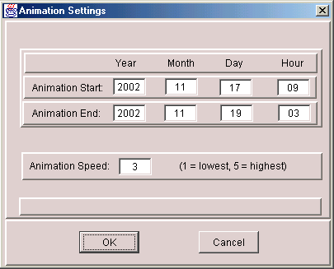
Figure 14: Animation dialog window

3.2.2.7 The Window Menu
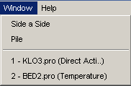

A number of split frames can be displayed simultaneously within the boundaries of the main visualization frame of the SN_GUI, either in a side-a-side mode or in form of a pile of overlapping frames. This allows among other things an easy comparison of different model parameters at a specific location or the confrontation of the SNOWPACK output for different stations.

Menu Window/Side a Side:
New split frames created by using File/Open generally cover the whole area of the visualization frame, and any other previously opened frames remain in the background. Clicking Side a Side displays all currently open split frames concurrently on the screen. If more than three split frames are present, two columns are used for the display. An example of the side-a-side display mode is given in Figure 15.
The mode is also utilized whenever the synchronization mode is on (see menu Time/Synchronization).

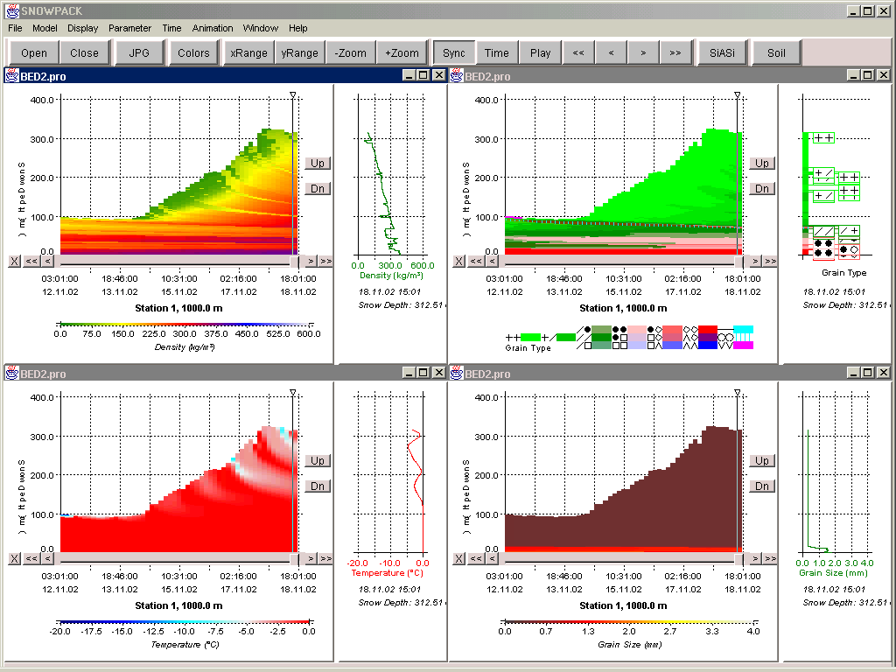
Figure 15 : Example of split frames arranged in the side-a-side mode
Menu Window/Pile:
Activating this menu item arranges all open split frames in the form of a staple (Figure 16). All frame title bars can be spotted, but the frames overlap each other and are, except for the topmost frame, not completely visible. The synchronization (see Section 3.2.2.5) is not usable if the split frames are arranged in this mode.

Menu Window/Split Frame:
At the end of the Window menu a list of menu items is appended referring to the currently open split frames. Clicking on any of these items is the suggested method to maximize frames.
“Split Frame” has for example the following form: ‘1 - BED2.pro (Temperature)’. The name of the file from which the active split frame is derived, is given (e.g. BED2.pro). The name of the active parameter (e.g. Temperature) is listed in brackets. Numbers in front of the file names indicate the chronology of the open split frames, with the most recently opened frame referring to number 1.

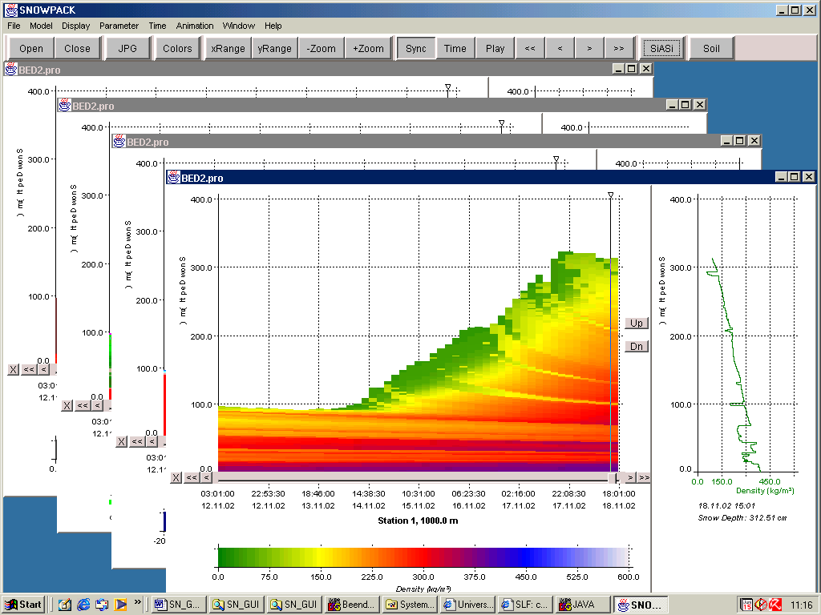
Figure 16 : Example of split frames, arranged in the pile mode

3.2.2.8 The Help Menu
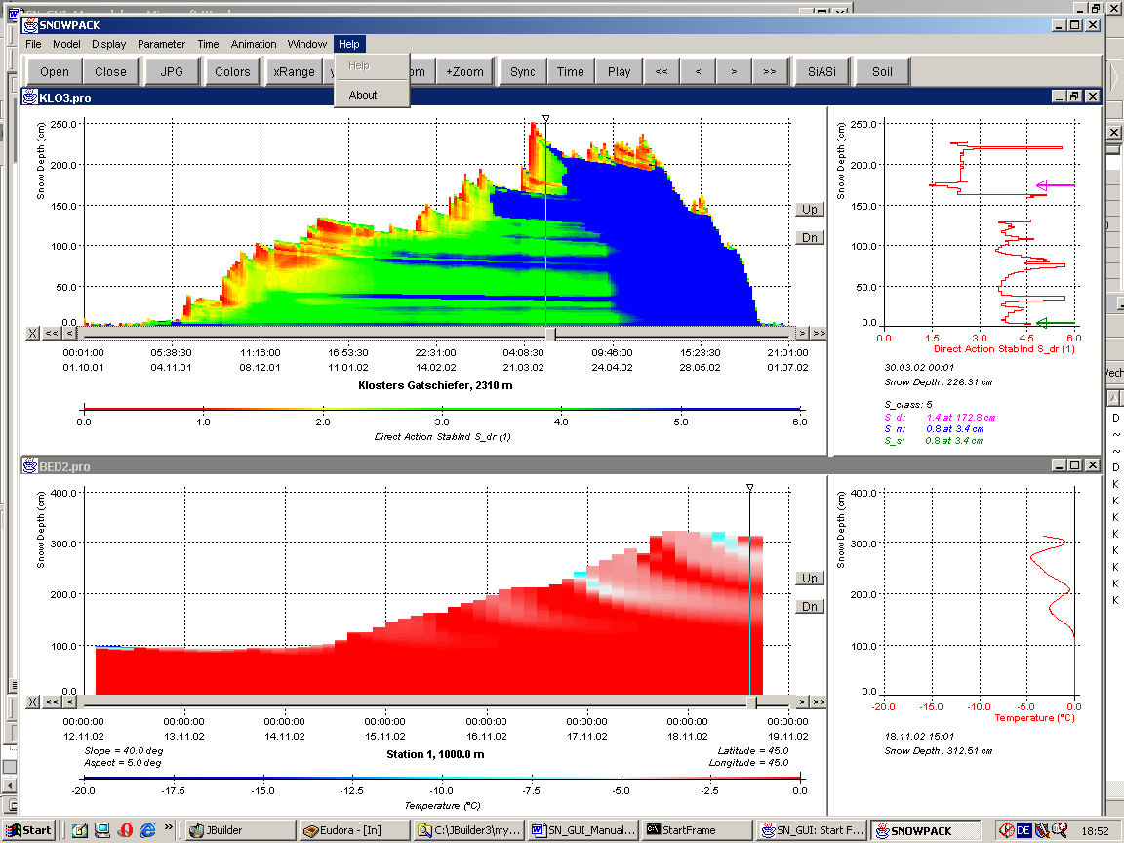

Menu Help/Help:
Not implemented.

Menu Help/About:
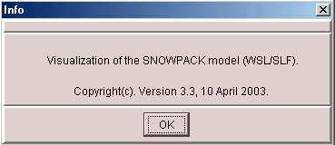
Figure 17: Help/About information window

Some information about the running version of SN_GUI is given (version number and date).

3.2.3 The Speed Bar
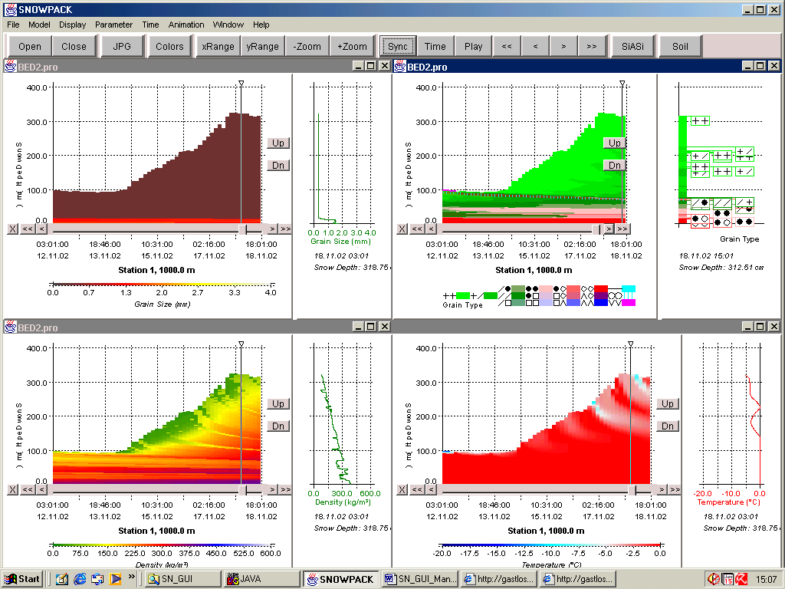
speed bar

Button of the Speed Bar | Menu access | Section of this manual describing the function
<Open> | File/Open | 3.2.2.1
<Close> | File/Close | 3.2.2.1
<JPG> | File/Create JPG | 3.2.2.1
<Colours> | Display/Colour Table | 3.2.2.3
<xRange> | Display/Value Range X-Axis | 3.2.2.3
<yRange> | Display/Value Range Y-Axis | 3.2.2.3
<-Zoom> | Display/Zoom Y-Axis + | 3.2.2.3
<+Zoom> | Display/Zoom Y-Axis - | 3.2.2.3
<Sync> | Time/Synchronization | 3.2.2.5
<Time> | Time/Other Time | 3.2.2.5
<Play> | Animation/Play | 3.2.2.6
<SiASi> | Window/Side a Side | 3.2.2.7
<Soil> | Display/Soil Data | 3.2.2.3
Table 2: Review of connections between menu items and buttons of the speed bar

The speed bar is located below the menu bar. It can be switched on and off by clicking the menu Display/Speed Bar. The buttons containing the arrows (<, <<, >>, >) work the same way as their equivalents inside the split frames (see Section 3.2.1). The rest of the buttons has the same functionality as specific menu items accessible through the menu bar. For details see the Table 2.

3.3 Full Version versus Reduced Parameter Set
When starting the SN_GUI, some principal settings are read from the file SETUP.INI. The first lines of this file determine if the program is operated in the full or in the reduced mode. If the first is the case, the start frame (see Section 3.1) appears, otherwise the contents of the file StartFile (resident in the SETUP directory) is read. This may look similar to the following:

[StartFile]
; Name: file name to be used in reduced startup (4 windows constructed)
Name=./DATA/BED2.pro

;This terminates SN_GUI:
;Name=exit

The string after “Name=” gives the name of the file providing the data for the initial visualization frame. Four split frames referring to different parameters are constructed (similar to Figure 15), using synchronization and the side-a-side mode.
The full and the reduced version are related to different sets of parameters. Using Display/Research Menu (see Section 3.2.2.3), it can be switched back and forth between the two parameter choices.

Appendix A: Known Bugs

Below is an incomplete list of known program bugs of the SN_GUI. Beside these, some additional ones may occur, sometimes depending on the used JRE version (Java Runtime Environment).

- Desktop management/Sizing of frames
A number of problems may occur when using the buttons for frame minimization and maximization in the upper right corner of the split frames. It is preferable to use Window/Split Frame for maximizing frames and Window/Side a Side for rearrangement once some frames were maximized. Possible errors that can occur when using minimization/maximization:
- Minimization: after minimization no active frames remain, and applying many of the menu functions (such as zooming) does not show any visible effects
- Maximization: The maximized split frames have the attached control objects (buttons and slider bar) at a wrong place. Display/Slider + Buttons can be used to remove these objects.
- After maximizing split frames using Window/Split Frame and returning to the side-a-side mode clicking Window/Side a Side, any inactive frames clicked will maximize when clicked. Again, control objects may emerge at the wrong place.
- Closing all windows: Problems occur when using File/Close All after maximizing any of the open split frames.
- Split frame divider: When dragging the vertical line separating the left from the right part of split frames, the size of the slider bar underneath the x-axis of the left graph remains the same as before.
- Start screen: In some cases the start screen was observed to “freeze” on the minimization of the visualization or of other frames.

- Synchronization
- Split frame divider: Synchronization problems occur when dragging the vertical line separating the left from the right part of split frames.
- Data gaps: If a number of split frames are displayed simultaneously in the synchronization mode, and the individual frames contain data gaps at differing times, a movement over the gaps using either the slider or the key buttons (see Section 3.2.1) may result in synchronization errors.

- Slider movement/Marker
In the left part of the split frame, a vertical line (“marker”) is connected to the slider button (can be dragged by the user, attached to the slider bar underneath the x-axis). This marks the date for which data details are displayed in the right part of the split frame. The following errors may emerge in this context:
- Marker: Repainting of the split frame is automatically done after processing many of the menu options or clicking on the title bar of the frame. If after repainting the slider is moved through mouse-dragging, the original marker line remains on the screen (although the new one is drawn correctly). It can only be removed by processing another operation related to repainting.
- Data gaps: If data gaps exist and the marker is moved over these from left to right, the data record immediately after the gap (to the right of it) is sometimes skipped, depending on parameters such as the number of missing records (odd or even).

- Data loading
- File choser box: If File/Open is clicked when open split frames exist, during the presence of the file choser box the expressions “ParameterError” and “UnitError” may appear inside the open frames. They disappear as soon as the file chooser box is closed again.
- Missing default parameter: If a new data file is loaded with missing data for the default parameter (generally temperature), a correct error message appears, but an inactive split frame is constructed. This causes an error message (NullPointerException) when other files are tried to be opened afterwards.
- Case error: If two open split frames exist, one related to a *.pro and the other to a *.met-file (see Section 3.2.1), and if the *.pro-file is active and a *.met-parameter is clicked (and vice versa), sometimes a new file is read instead of using the data already residing in memory. The already open split frame might not be recognized as usable, since some problems in the file name recognition may exist (upper/lower case error).
- Slider missing: If new data files are loaded while the synchronization mode is active, the new split frames do not contain a movable slider.

- Errors/shortcomings specific to SN_GUI installations under Unix:
- Size of buttons (e.g. <OK>, < Cancel>) sometimes too small
- Titles of split frames only appear if mouse is moved over them
- File chooser box: In contrast to Windows installations, the most recently used working directory is not remembered by the operation system.
- Mouse movements may cause error messages in the background console window (these should not be paid attention to)
- Tool tip text missing: No explanation text appears when the mouse cursor is positioned over a button

- Status bar:
Most of the messages to be displayed at the bottom of the visualization frame are not drawn in a reliable way.

- Time resolution:
Sawtooth-like graphs can emerge in the left-hand part of split frames (for *.pro-files only), if the time difference between any two adjacent data records of the file is not constant.

- Screen resolution
The SN_GUI was developed on a PC with a screen resolution of 1024 x 768 pixel and just sporadically tested for other resolutions. Using screens set to a lower resolution than this might cause parts of the included windows and user interfaces to be inaccessible.

