CryoSkills Sensor Kit

# System-level schematic

Solar Panel

Regulator

Battery

QWIIC (I2C) Sensors

Analogue Temp. Sensor

Micro-controller

(i.e. Feather M0 Adalogger)

SD Card

Wireless

Modem

Antenna

Weatherproof housing

Solar Regulator

Realtime clock

# Subsystems

## Power (Battery & Solar)

The power supply for the sensor kit is composed of a 12V lead-acid battery and a 12V 5W solar panel, connected to the battery through a EP Solar 5a charge controller.

|  |  |
| --- | --- |
| Item | URL |
| 12V 1.2Ahr lead-acid battery | <https://uk.rs-online.com/web/p/lead-acid-batteries/1501558?gb=s> |
| 12V 5W solar panel | <https://www.sunstore.co.uk/product/12v-5w-monocrystalline-solar-panel/> |
| EP Solar 5a Charge Controller | <https://www.sunstore.co.uk/product/ep-solar-5a-charge-controller-with-usb-output/> |

Table - Power system components

The solar charge controller has a maximum rated battery current of 5A and maximum PV (panel) input of 30V. The mounting hole sizes are M4.5 (assumption of mm) and terminal sizes are 2.5mm2 which require wire diameter of less than 1.784mm (AWG of 14 or greater). The charger user manual recommends that cables should satisfy 3.5A/mm2 current density – AWG 14 can therefore accommodate 5.25A.

The battery terminals are tabs with width 4.75mm and length 6.35mm, hence a 5mm spade connector with AWG 14-16 crimp terminal is sufficient.

Finding it hard to find appropriate 4.75mm tabs in red/blue or red/black with matched 2.5mm2 CSA – go with blue which has 2.5mm2 max CSA.

|  |  |  |  |
| --- | --- | --- | --- |
| Component | Details | Supplier | Order Code |
| Red 16AWG Cable | 100m | Farnell / SW | [1204343](https://uk.farnell.com/lapp-kabel/4520041/wire-h07v-k-red-1-5mm-100m/dp/1204343) |
| Black 16AWG Cable | 100m | Farnell / SW | [1204340](https://uk.farnell.com/lapp-kabel/4520011/wire-100m-1-5mm2-copper-black/dp/1204340) |
| Red Crimp Terminal | 4.8mm(W), 12A, 16-14AWG | Farnell / SW | [3384774](https://uk.farnell.com/pro-power/stfdd1-187-8/female-push-on-red-12a-4-8-x-0/dp/3384774) |
| Blue Crimp Terminal | 4.8mm(W), 16A, 16-14AWG | Farnell / SW | [3384777](https://uk.farnell.com/pro-power/stfdd2-187-8/female-push-on-blue-16a-4-8-x/dp/3384777) |
| Red Ferrule | 16 AWG 10mm | Farnell / SW | [3383565](https://uk.farnell.com/pro-power/pet1515/german-single-ferrule-1-50mm-red/dp/3383565) |
| Black Ferrule | 16 AWG 10mm | Farnell / SW | [4161844](https://uk.farnell.com/pro-power/pp01538/french-single-ferrule-1-50mm-black/dp/4161844) |
| Fuse Holder | 16 AWG, Red, 5x15mm Fuse, | RS Pro / SW | [849-5594](https://uk.rs-online.com/web/p/fuse-holders/8495594) |
| 1A Fuse | 5x15mm | - | - |

Alternatively, consider using automotive blade style fuse holder & fuse – need to check options. Ideally should satisfy current rating <5A and AWG 16 gauge cable.

These place a requirement on the screw terminals used on the sensor kit PCB – they must be able to accept 1.5mm2 CSA ferrules.

### Battery Capacity

The battery capacity is calculated for an on period of 2s and a sleep period of 58s, resulting in a total measurement interval of 60s. For a 24 hour period, this would yield 1440 measurements.

The average current consumed is calculated as

$$\overline{I}=\left(I_{sleep}t_{sleep}+I_{peak}t_{peak}\right)/T_{period}$$

Hence for the values given in Table 2, the average current is 4.76mA at 3V3 and 6mA at 12V (solar charger). Hence the power consumed is 15.7mW (load) and 72mW (self consumption) or a total of 87.7mW. Over a period of 24hours, this requires 2.1Wh of energy. Assuming the battery is derated by 50% due to cold weather, the actual energy requirement is 4.2Wh, which at 12V equates to a battery capacity of 0.35Ah. A 12V 1.2Ah battery specified should be sufficient to run the sensor for the 24-hour period.

|  |  |  |  |
| --- | --- | --- | --- |
| Component | Sleep Current (mA)  @ 3V3 Vcc | Peak Current (mA)  @ 3V3 Vcc | Time-enabled per cycle (s) |
| Adafruit Feather M0 | 2 | 20 | 2 |
| Wireless module | 0.001 (sleep mode) | 120 | 1 |
| I2C atmospheric sensor | 0.0000002 | 0.000714 | 1 |
| PT1000 temp. sensor | 0.000002 | 0.210 | 1 |
| DSB1820 temp.sensor | 0.00000075 | 1.5 | 1 |
| I2C light sensor | 0.000005 | 0.220 | 1 |
| Charge controller | <6 (@12V) | <6 @(12V) | Always-on |
|  | ~8 | ~150 |  |

Table - Current consumption based on subsystems

### Solar Charge Controller

Wiring of the solar charge controller is given by the (terrible [user manual](https://www.sunstore.co.uk/wp-content/uploads/2017/02/LS-EU%20Manual.pdf) supplied) diagram in Figure 1.

Figure - EP Solar 5a Charge Controller wiring diagram

.

### INA3221 Power Meter

The Texas Instrument [INA3221](https://www.ti.com/product/INA3221) integrates a high-side ADC which can be used as a power meter. To integrate with the sensor kit, using the three available channels we can assess power from the solar panel, battery power (charge or discharge) and the power draw of the load.

**Note:** The rated open circuit voltage of the panel is 21.9V so this is within the maximum input voltage however it is perhaps prudent to add some voltage protection at the panel input in-case an alternative panel is used?

Appropriate current sense resistors need to be selected for each of the channels. The shunt voltage limits for the INA3221 are ±163.8mV and the maximum input voltage at any port is 26V.

We assume the peak current into the sensor kit will be on the order of 0.2A (rounded up from 0.15A peak consumption during radio transmission). With a 0.2 Ohm resistor, this equates to a shunt potential difference of 40mV (30mV) which uses approximately 10% of the full-scale voltage range.

The maximum charge current for the RS Pro lead-acid battery is listed as 0.36A, hence with the same 0.2 Ohm resistor as above, we yield a potential difference of 72 mV.

This appears to be a reasonable value to use across the application – the everythingpi.co.uk evaluation board uses 0.1 Ohm, which I assume is to accommodate for slightly higher average load currents.

A provisional wiring diagram for integrating the INA3221 power meter into the sensor kit is shown in Figure 2. This results in a total of 6x screw terminals being present on the sensor kit board, one each for the solar panel and battery and then an additional to wire the load to the solar controller. An external 6-way connector (i.e. 2x 5-way Wago?) is also necessary to provide a common ground for the panel, battery, charge controller and load.

HellermanTyton 8-way splice for 1mm2 to 2.5mm2 common splice (RS Stock No. 124-2530).

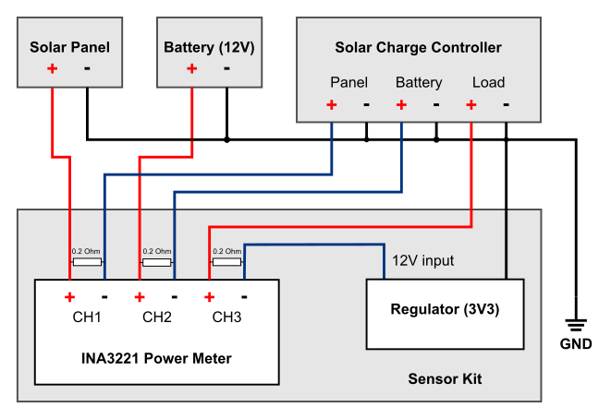

Figure - Wiring diagram for sensor kit using INA3221 power meter with solar panel, 12V battery and solar charge controller.

### Linear (LDO) vs Buck Voltage Regulator

If there is a sufficient pin-for-pin replacement (3-pin 100mil, Vin-GND-Vout) for the Multicomp Pro drop-in MP-K78L03-500R3 DC/DC regulator then participants can have the choice/compare the performance of linear vs. buck boost regulated instrument using data from the INA3221. The higher efficiency DC/DC converter should draw less current from the 12V supply and hence less power.

## Microcontroller and Datalogger

[Section]

### I2C Address Table

To avoid clashes of I2C addresses, [] lists the address for devices being considered or actively used in the sensor kit design.

|  |  |  |  |  |
| --- | --- | --- | --- | --- |
| Part No. | Description | Address | Programmable | Used in design |
| INA3221 | Power Meter | 0x40-0x43 | Yes (A0 pin) | Yes |
| PCF48574 | 8-bit I/O expander | 0x40-0x4E | Yes (A0-2 pins) | No |
|  |  |  |  |  |
|  |  |  |  |  |

## Analogue Temperature Sensor

[Section]

## Digital Temperature Sensor

[Section]

## I2C Peripheral Sensor

[Section]

## Wireless Modem

[Section]

## Weatherproof Housing

[Section]

## Installation and Mounting

[Section]

# Firmware

[Section]