

FootHub(Database Project)

By Anirban Ghosh Argha

CSE 3110:Database Systems Laboratory

Introduction:

Football is more than simply a sport; it's a universal phenomenon that connects individuals from various backgrounds and geographical locations. There is a plethora of data hiding behind every thrilling game and incredible goal, just waiting to be discovered and examined. By providing a comprehensive platform for football enthusiasts, experts, and organisations to access, manage, and derive insights from football-related data, the Football Data Hub seeks to delve deeply into this enormous repository of information.

The FootHub is a one-stop shop for everything related to football, including everything from the accomplishments of storied teams to the techniques used by winning coaches to the trends influencing the game. Regardless of whether you're a coach planning for the upcoming game or an avid fan looking for the most recent stats, our platform offers the tools and information you need to uncover the mysteries concealed inside the beautiful game.

Objectives:

1. Comprehensive Data Management: The primary objective of the FootHub is to efficiently manage and organize a wide range of football-related data, including information about countries, clubs, players, coaches, positions, goals, and more.

2. Accessible Insights: It is aimed to provide users with easy access to valuable insights and statistics, enabling football enthusiasts, coaches, analysts, and journalists to make informed decisions and gain a deeper understanding of the sport.

3. User-Friendly Interface: This platform is designed with user experience in mind, offering an intuitive and user-friendly interface that makes it simple for users to navigate, query, and interact with football data.

4. Data Integrity and Consistency: Ensuring the integrity and consistency of data is paramount. It is implemented robust database design principles and constraints to maintain data accuracy and reliability throughout the system.

5. Performance Tracking: The FootHub enables users to track player performance, analyze team statistics, and monitor trends over time, empowering coaches and managers to optimize strategies and improve team performance.

6. Customizable Reporting: This provides functionality for generating customizable reports and visualizations, allowing users to tailor insights to their specific needs and preferences.

7. Role-Based Access Control: To ensure data security and privacy, It is implemented role-based access control, enabling different users to access only the information relevant to their roles and responsibilities.

8. Scalability and Flexibility: As the world of football continues to evolve,thi platform is designed to scale and adapt to changing needs and trends, ensuring that users always have access to the most up-to-date and relevant data.

Database Design:

The database is designed to store information about countries, clubs, players, coaches, positions, and goals. It consists of tables such as Country, Club, Player, Coach, Position, and Goal, with appropriate relationships established between them through foreign key constraints.

Table Description:

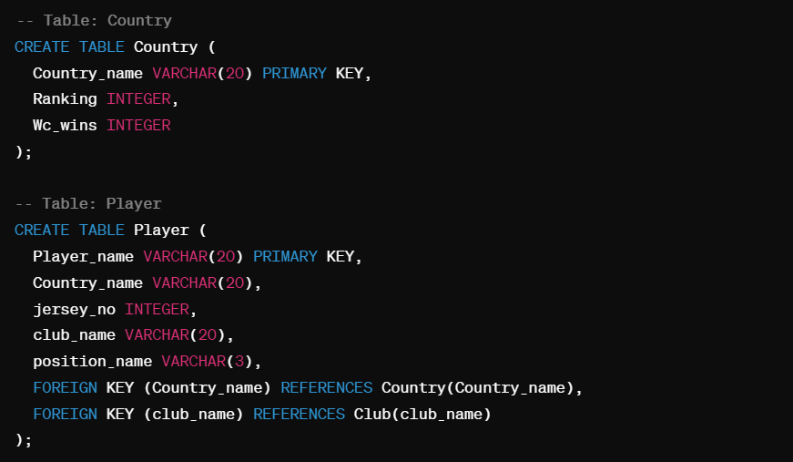

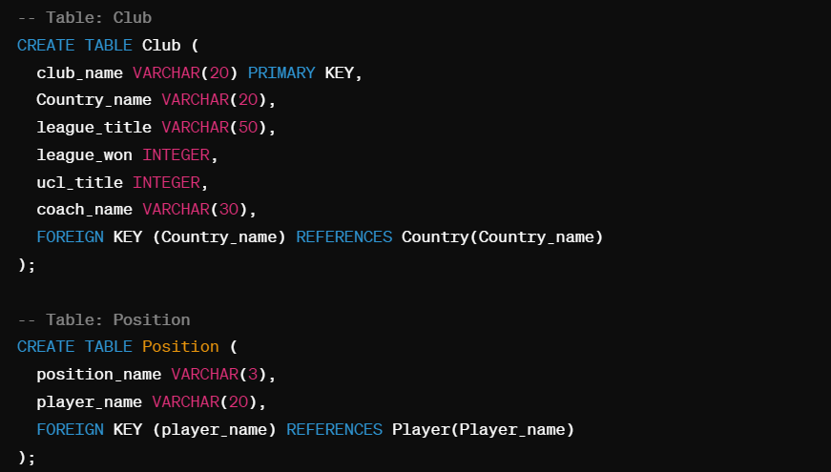

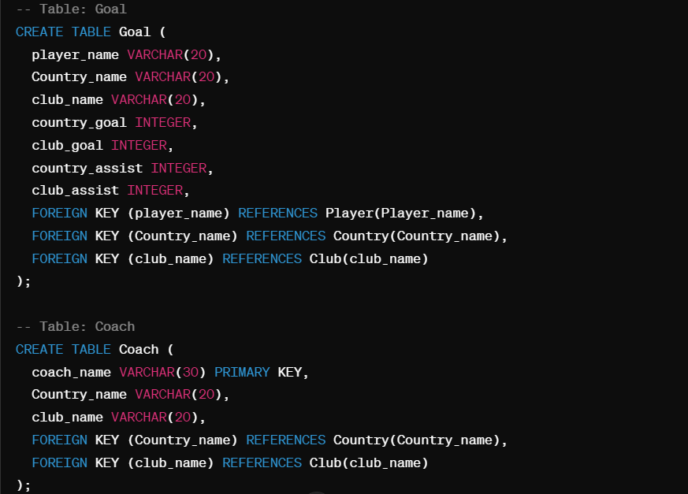

E-R Diagram (Entity Relationship Diagram):

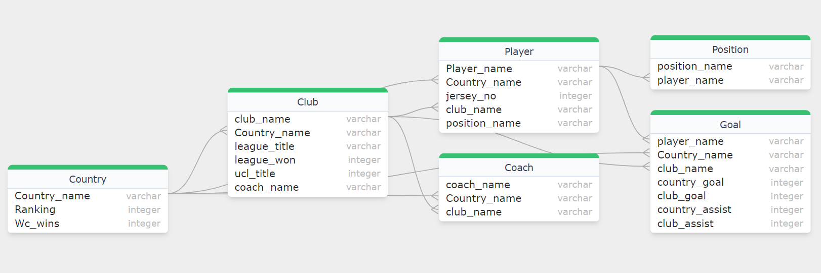

SQL Queries and Functionality:

1.Retrieve top goal scorers in a particular country:

SELECT Player_name, SUM(country_goal) AS Total_Country_Goals

FROM Goal

WHERE Country_name = 'Argentina'

GROUP BY Player_name

ORDER BY Total_Country_Goals DESC;

2.Calculate total goals scored by a player in both country and club competitions:

SELECT Player_name, SUM(country_goal + club_goal) AS Total_Goals

FROM Goal

WHERE Player_name = 'Lionel Messi'

GROUP BY Player_name;

3.Determine the most successful clubs based on league wins and UCL titles:

SELECT club_name, (league_won + ucl_title) AS Total_Titles

FROM Club

ORDER BY Total_Titles DESC;

4.Functionality to add a new player:

INSERT INTO Player (Player_name, Country_name, jersey_no, club_name, position_name)

VALUES ('Mohamed Salah', 'Egypt', 11, 'Liverpool', 'RW');

5.Functionality to update player information:

UPDATE Player

SET club_name = 'Real Madrid'

WHERE Player_name = 'Mohamed Salah';

6.Functionality to delete a player:

DELETE FROM Player

WHERE Player_name = 'Mohamed Salah';

Targeted Users:

1.Football Enthusiasts: Fans of the sport who are passionate about football and seek comprehensive insights into player performance, team statistics, and historical data. They can use the FootHub to stay updated on their favorite players, clubs, leagues, and international tournaments.

2.Coaches and Managers: Football coaches and managers can leverage the platform to analyze player statistics, track performance trends, and strategize for upcoming matches. They can access detailed reports and visualizations to make informed decisions about team selection, tactics, and training regimes.

3.Journalists and Analysts: Sports journalists, analysts, and commentators can utilize the Football Data Hub to gather valuable insights, statistics, and trends for their articles, reports, and broadcasts. They can explore data on player transfers, match results, injuries, and other relevant topics to enhance their coverage of the sport.

4.Scouts and Talent Managers: Scouts and talent managers looking to identify promising players and prospects can use the platform to scout talent from different countries, clubs, and leagues. They can analyze player performance metrics, scouting reports, and historical data to identify potential recruits for their teams.

5.Fantasy Football Players: Fantasy football enthusiasts who participate in fantasy leagues can benefit from the FootHub by accessing real-time player statistics, injury updates, and performance insights. They can make informed decisions about team selection, transfers, and captaincy based on the data available on the platform.

6.Sports Betting Professionals: Individuals involved in sports betting and gambling can utilize the platform to conduct in-depth analysis and research before placing bets on football matches. They can explore historical data, odds, and betting trends to make informed betting decisions and maximize their chances of success.

7.Academic Researchers: Academic researchers and scholars studying various aspects of football, including sports science, analytics, and sociology, can access the FootHub to gather data for their research projects, studies, and publications. They can analyze player performance, team dynamics, and other relevant factors to contribute to the academic discourse on the sport.

Overall, the FootHub caters to a diverse audience of football enthusiasts, professionals, and stakeholders, providing valuable insights and resources to enhance their understanding and engagement with the beautiful game.

Conclusion:

In conclusion, Foothub serves as a comprehensive platform for football enthusiasts, professionals, and stakeholders to access and analyze a wealth of football-related data. By providing detailed insights into player performance, team statistics, historical records, and more, FootHub empowers users to make informed decisions, whether they are coaches strategizing for matches, journalists covering the sport, or fans staying updated on their favorite teams and players.

With its user-friendly interface, robust database design, and extensive array of features, FootHub caters to a diverse range of users, including football enthusiasts, coaches, journalists, scouts, fantasy football players, sports betting professionals, and academic researchers. By centralizing and organizing football data from various sources, FootHub facilitates data-driven analysis, decision-making, and engagement within the football community.

As the world's most popular sport continues to evolve, FootHub remains committed to providing users with timely, accurate, and insightful information to deepen their understanding and appreciation of football. Whether it's tracking player statistics, analyzing match outcomes, or scouting talent, FootHub is the ultimate destination for all things football-related.

In essence, FootHub is not just a platform; it's a hub of knowledge, passion, and excitement for football enthusiasts around the globe. As the sport continues to capture hearts and minds worldwide, FootHub stands ready to be the premier destination for all football-related data and insights.