**Routing:** The process of selecting a path for traffic in a network or between or across multiple networks. The routing algorithms are used for routing the packets.

**Types of Routing:** Routing can be classified into three categories:

1. Static Routing
2. Default Routing
3. Dynamic Routing

**Static Routing:** A technique in which the administrator manually adds the routes in a routing table. *A.k.a.* Nonadaptive Routing.

**Default Routing:** A method where the router is configured to send all packets toward a single router (next hop). It doesn’t matter to which network the packet belongs, it is forwarded out to the router which is configured for default routing.

**Dynamic Routing:** A mechanism through which routing information is exchanged between routers to determine the optimal path between network devices. A routing protocol is used to identify and announce network paths. *A.k.a.* Adaptive Routing. RIP and OSPF are the protocols used to discover new routes.

 Two categories:

1. Interior Gateway Protocols (IGP): Algorithm Types: Distance Vector (RIP, EIGRP), Link State (OSPF, IS-IS).
2. Exterior Gateway Protocols (EGP): Algorithm Type: Path Vector (BGP).

IGP operates within a particular Autonomous System (AS) like a company, while EGP operates between ASes.

**Static Routing in Cisco Packet Tracer:**

* Let’s create a network. Assign the corresponding IP addresses similar to the following figure. At this moment, you cannot ping from PC0(192.168.10.3) to PC3(192.168.11.3). Because router0 doesn’t know the 192.168.11.0/24 network and vice versa.

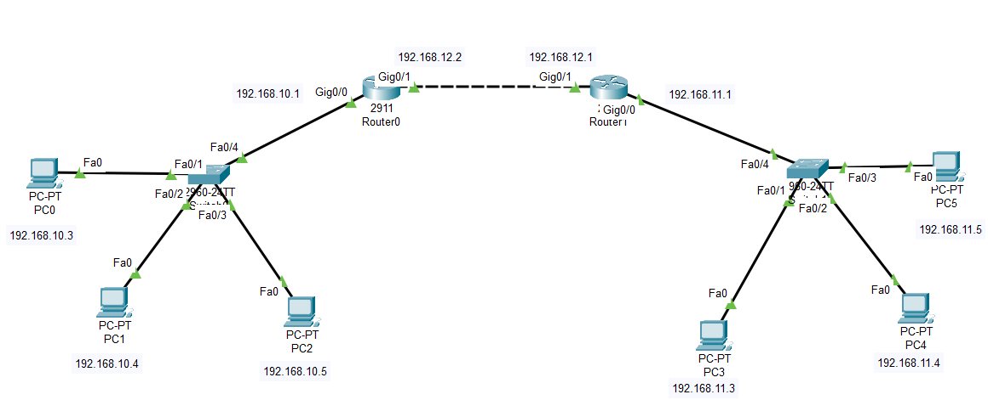

* There are three networks (192.168.10.0/24, 192.168.11.0/24, 192.168.12.0/24). Right?
* We have to manually add routes to the routing table.
* **In Router0:** We have to make familiarize the 192.168.11.0/24 network with the next hop of the **Router0**.

Router0(config)# ip route 192.168.11.0 255.255.255.0 192.168.12.1

* **In Router1:** We have to make familiarize the 192.168.10.0/24 network with the next hop of the **Router1**.

Router1(config)# ip route 192.168.10.0 255.255.255.0 192.168.12.2

* Run “do show ip route”. Now, you can ping from PC0(192.168.10.3) to PC3(192.168.11.3).
* What if there is added another router to the network like the following figure? Do you send packets from any PC to any PC? Absolutely not! What changes should you make? What do you think?

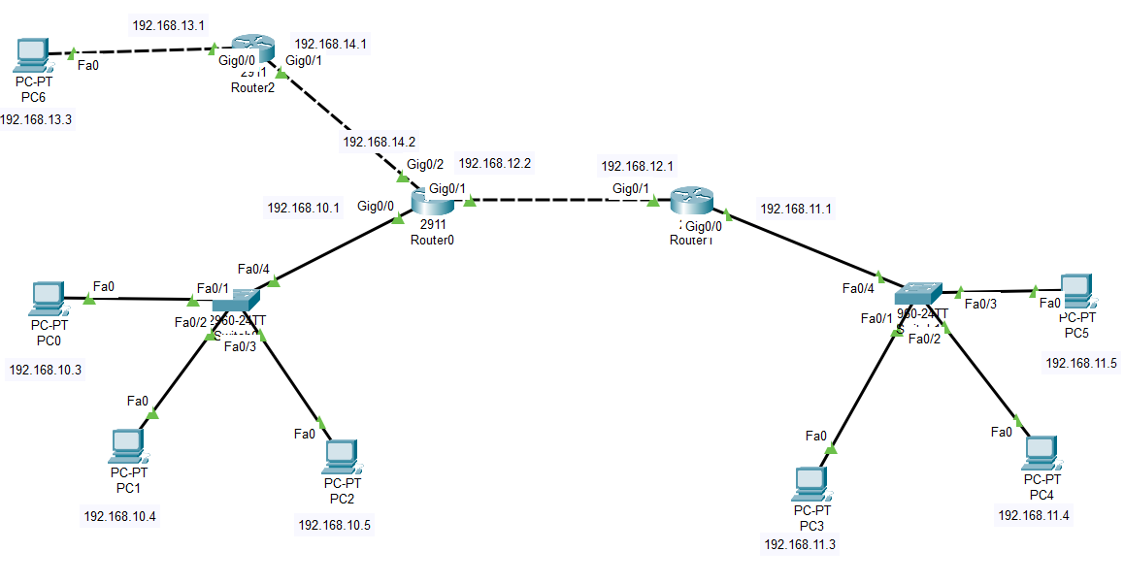

* We need to add the information of all networks on every router.
* **In Router0:** We have to make familiarize the new network 192.168.13.0/24 with the next hop of the **Router0**.

Router0(config)# ip route 192.168.13.0 255.255.255.0 192.168.14.1

* **In Router1:** We have to make familiarize the new networks 192.168.13.0/24 and 192.168.14.0/24 with the next hop of the **Router1**.

Router1(config)# ip route 192.168.13.0 255.255.255.0 192.168.12.2

Router1(config)# ip route 192.168.14.0 255.255.255.0 192.168.12.2

* **In Router2:** We have to make familiarize all the networks except the networks connected with **Router2** (192.168.13.0/24 and 192.168.14.0/24) with the next hop of the **Router2**.

Router2(config)# ip route 192.168.10.0 255.255.255.0 192.168.14.2

Router2(config)# ip route 192.168.12.0 255.255.255.0 192.168.14.2

Router2(config)# ip route 192.168.11.0 255.255.255.0 192.168.14.2

* Run “do show ip route”. Now, you can ping from any source to any destination.
* **N.B.** You can configure static routing from the router “config > routing > static” panel.

**Default Routing in Cisco Packet Tracer:**

* Let’s create a network. Assign the corresponding IP addresses similar to the following figure. At this moment, you cannot ping from PC0(192.168.10.3) to PC3(192.168.11.3).



* There are three networks (192.168.10.0/24, 192.168.11.0/24, 192.168.12.0/24).
* Every packet comes to Router0, if we want just to forward it towards Router1 (next hop), we can use default routing.
* **In Router0:** We have to forward all packet to the next hop (192.168.12.1).

Router0(config)# ip route 0.0.0.0 0.0.0.0 192.168.12.1

* **In Router1:** We have to forward all packet to the next hop (192.168.12.2).

Router1(config)# ip route 0.0.0.0 0.0.0.0 192.168.12.2

* Now, you can ping from PC0(192.168.10.3) to PC3(192.168.11.3).
* What if there is added another router to the network like the following figure?



* There are five networks (192.168.10.0/24, 192.168.11.0/24, 192.168.12.0/24, 192.168.13.0/24, 192.168.14.0/24).
* **Router2** needs to be updated because packet coming from PC6 to **Router2** needs to be forwarded to the next hop (192.168.14.2). So, in **Router2,** we have to forward all packet to the next hop (192.168.14.2).

Router2(config)# ip route 0.0.0.0 0.0.0.0 192.168.14.2

* And from **Router0**, all packets may need to be forwarded to **Router2** (otherwise the packets cannot be forwarded from **Router0** to **Router2**). So, in **Router0,** we have to forward all packet to the next hop (192.168.14.1).

Router0(config)# ip route 0.0.0.0 0.0.0.0 192.168.14.1

* Now, you can ping from PC6 (192.168.14.3) to PC3(192.168.11.3).
* **N.B.** You can configure static routing from the router “config > routing > static” panel.

**Dynamic Routing (RIP) in Cisco Packet Tracer:**

* Let’s create a network. Assign the corresponding IP addresses similar to the following figure. At this moment, you cannot ping from PC0(192.168.10.3) to PC3(192.168.11.3).



* **In Router0:** We need to make familiarize with two connected networks of it. But, before that we need to initialize RIP protocol in the router.

Router0(config)# router rip

Router0(config-router)# network 192.168.10.0

Router0(config-router)# network 192.168.12.0

* **In Router1:** We need to make familiar with two interfaced networks of it. But, before that we need to initialize RIP protocol in the router.

Router1(config)# router rip

Router1(config-router)# network 192.168.11.0

Router1(config-router)# network 192.168.12.0

* Now, you can ping from PC0(192.168.10.3) to PC3(192.168.11.3).
* What if there is added another router to the network like the following figure?



* **In Router0:** We need to make familiarize with the new connected network.

Router0(config-router)# network 192.168.14.0

* **In Router2:** We need to make familiarize with two connected networks. But, before that we need to initialize RIP protocol in the router.

Router0(config)# router rip

Router0(config-router)# network 192.168.13.0

Router0(config-router)# network 192.168.14.0

* Now, you can ping from any PC to any PC.
* **N.B.** You can configure RIP from the router “config > routing > RIP” panel.
* RIP v2 includes the "no auto-summary" command, which is used to disable automatic summarization of routes at network boundaries. When this command is used, RIP version 2 advertises subnets instead of just the network summary.
* In earlier versions of RIP, such as RIP version 1, automatic summarization of routes was enabled by default. This means that when a router advertised a network, it would advertise a summary route for the network instead of the individual subnets. This could lead to suboptimal routing, as the summary route may not accurately reflect the network topology.
* A passive interface is an interface that is not actively participating in the routing process. When an interface is set to passive, it will not send or receive routing updates, which can be useful in some scenarios.

**Dynamic Routing (OSPF) in Cisco Packet Tracer:**

* OSPF is a link-state routing protocol that uses Dijkstra's shortest path first (SPF) algorithm to calculate paths to destinations. OSPF was created for its use in large networks where RIP failed. OSPF improved the speed of convergence, provided for the use of VLSMs, and improved the path calculation. In OSPF, each router sends link-state advertisements about itself and its links to all other routers in the area. Note that it does not send routing tables but link-state information about its interfaces. Then, each router individually calculates the best routes to the destination by running the SPF algorithm.
* Let’s create a network. Assign the corresponding IP addresses similar to the following figure. At this moment, you cannot ping from PC0(192.168.10.3) to PC3(192.168.11.3).



* **In Router0:** We need to make familiarize with two connected networks of it. But, before that we need to initialize OSPF protocol in the router.

Router0(config)# router ospf 10

Router0(config-router)# network 192.168.10.0 0.0.0.255 area 1

Router0(config-router)# network 192.168.12.0 0 0.0.0.255 area 1

* **An "area number" in OSPF refers to a logical grouping of networks and routers within an OSPF domain, while "OSPF process number" refers to the identification number of a specific OSPF routing process that is running on a router.**
* **In Router1:** We need to make familiarize with two interfaced networks of it. But, before that we need to initialize OSPF protocol in the router.

Router1(config)# router ospf 11

Router1(config-router)# network 192.168.11.0 0 0.0.0.255 area 1

Router1(config-router)# network 192.168.12.0 0 0.0.0.255 area 1

* Now, you can ping from PC0(192.168.10.3) to PC3(192.168.11.3).
* What if there is added another router to the network like the following figure?



* **In Router0:** We need to make familiarize with the new connected network.

Router0(config-router)# network 192.168.14.0 0.0.0.255 area 1

* **In Router2:** We need to make familiarize with two connected networks. But, before that we need to initialize OSPF protocol in the router.

Router0(config)# router ospf 12

Router0(config-router)# network 192.168.13.0 0.0.0.255 area 1 Router0(config-router)# network 192.168.14.0 0.0.0.255 area 1

* Now, you can ping from any PC to any PC.
* **N.B.** You cannot configure OSPF from the router “config” panel.
* “area” must be same for all router.