″

CSE 3200: System Development Project

Pawfect: A Pet Rescue and Adaption System

By

MD Tahsinur Rahman
Roll: 2007091
&

Anirban Ghosh Argha
Roll: 2007094



Department of Computer Science and Engineering Khulna University of Engineering & Technology Khulna 9203, Bangladesh
August,2025

Pawfect: A Pet Rescue and Adaption System

By

MD Tahsinur Rahman
Roll: 2007091
&

Anirban Ghosh Argha
Roll: 2007094

Supervisor:
Md Mehrab Hossain Opi
Lecturer,

Department of Computer Science and Engineering
Khulna University of Engineering & Technology

Signature

[12, Normal,
Centered]

Department of Computer Science and Engineering Khulna University of Engineering & Technology Khulna 9203, Bangladesh
August,2025

Acknowledgment

All praise to the Almighty Allah, whose blessing and mercy enabled us to complete this project successfully and fairly. We gratefully acknowledge the valuable guidance, advice, and continuous support of our respected supervisor, Md Mehrab Hossain Opi, Lecturer, Department of Computer Science and Engineering, Khulna University of Engineering & Technology. His insightful feedback and encouragement helped us overcome every challenge throughout this project. Finally, we are thankful to our families and friends for their patience, motivation, and moral support during this entire journey.

Authors

Abstract

Pawfect is a full-stack web application designed to improve pet rescue, adoption, and care by uniting multiple services into one intelligent platform. Built with the MERN stack, it supports four user roles, normal users, volunteers, veterinarians, and admins,each with dedicated dashboards and features. Users can adopt or report lost pets, book appointments with vets and volunteers, pay securely via Stripe or SSLCommerz, and chat in real time using Socket.io. Volunteers manage adoption listings, product catalogs, and appointments, while vets conduct video consultations through JitsiMeet and issue downloadable prescriptions. Admins oversee all platform data, from user management and lost pet approvals to financial reporting and forum moderation. Firebase Authentication ensures secure logins with Google Sign-In and hashed password storage, and role-based access is enforced using JWT. The UI features animated, responsive design using Tailwind, Framer Motion, and Lottie React, while image uploads are handled through imgbb and later Cloudinary. Additional modules include a community forum, pet care product store, newsletter subscriptions, and feedback systems. All features are powered by technologies like Axios, TanStack Query, jsPDF, React Select, and Date-Fns. Future enhancements include integrating a machine learning model based on EfficientNetB0 with Grad-CAM for disease detection in pets, along with blockchain enabled vaccination records and GPS tracking of rescued animals. Deployed via Firebase Hosting and Vercel, Pawfect aims to create a compassionate, tech-driven ecosystem that connects pet lovers, shelters, and professionals to improve the lives of stray and domestic animals alike.

Contents

PAGE

Title Page i
Acknowledgment ii
Abstract iii
Contents v
List of Tables viii
List of Figures ix
CHAPTER I Introduction 1
- Introduction 1
- Background / Problem statement 2
- Objectives 2
- Scope (Write about the modern tools used in your work) 4
- Unfamiliarity of the Problem/ Topic/Solution (Ensure 5
that the problem idea is not acquired directly from any existing source)
- Project planning and work distribution 6
- Applications of the work 7
- Organization of the project 8
CHAPTER II Related Works 10
- Introduction 10
- Existing Rescue and Adoption Platforms 10
- Veterinary Teleconsultation Systems 11
- Animal Disease Detection 12
- Web Architecture Comparison (MERN vs Others) 13

- Gaps in Existing Systems 14

 | - Discussion/Summary | 15
CHAPTER III | Methodology | 16
 | - Introduction | 16
 | - Technology Stack Overview | 16
 | System Architecture | 17
 | Problem Design and Analysis | 19
 | - Conclusion | 20
CHAPTER IV | Implementation, Results and Discussions | 21
 | - Introduction | 21
 | - Experimental Setup | 21
 | - Evaluation Metrics | 22
 | - Implementation and Results | 24

- Objective Achieved (Write down how the objectives are 25
achieved from the statement of Introduction section)
- Conclusion 25

CHAPTER V Societal, Health, Environment, Safety, Ethical, Legal and Cultural Issues26
- Intellectual Property Considerations 26
- Ethical Considerations 26
- Safety Considerations 27
- Legal Considerations 27
- Impact of the Project on Societal, Health, and Cultural Issues 27
- Impact of Project on the Environment and Sustainability 27

CHAPTER VI Addressing Complex Engineering Problems and Activities 28
- Complex engineering problems associated with the current project 28
- Complex engineering activities associated with the current project 29

CHAPTER VII Conclusions 30
  - Summary 30
  - Limitations 30
  - Recommendations and Future Works 31
References 32

List of Tables

Table No. Description Page

2.1

3.1

4.1
Comparative Analysis Between Existing Systems 15
and Pawfect
Dataset Summary for Dog Skin Disease 17
Classification
Dataset Summary for Dog Skin Disease
Classification 22

List of Figures

Figure No. Description Page

3.1

3.2

4.1

4.2
MongoDB Database Schema for Pawfect Platform 18
Overall System Architecture of the Pawfect Web Platform 20
Two-way Volunteer Chat Interface using Socket.IO 22
Integrated Payment Gateways – Stripe (card payment) and
SSLCommerz (mobile banking options) 25

CHAPTER I

Introduction

Introduction

Stray and abandoned animals are becoming an increasingly critical issue in urban areas of Bangladesh. These animals often endure severe conditions such as physical injuries, starvation, exposure to extreme weather, and the spread of infectious diseases—typically without access to timely medical attention or rescue. At the same time, there is a noticeable rise in pet ownership in both urban and semi-urban settings, creating a parallel demand for reliable veterinary services, timely pet care, delivery of pet essentials, and ethical avenues for pet adoption.
Despite the growing concern and demand in both sectors—animal rescue and pet ownership—there remains a significant technological gap. Currently, there is no unified digital platform in the local context that integrates animal welfare efforts with user-centric features such as pet adoption, veterinary care, pet supply shopping, and reporting of lost or stray animals. This fragmentation results in inefficiencies, reduced rescue success rates, and missed opportunities for fostering a humane society.
Pawfect – A Pet Rescue and Adoption System is a modern, web-based application designed to address these challenges. Developed using the MERN stack—MongoDB, Express.js, React.js, and Node.js—the system offers a comprehensive and user-friendly ecosystem. It allows individuals to report stray or injured animals, adopt rescued pets, consult with certified veterinarians, and purchase pet food and accessories through a secure and interactive interface. Additionally, the platform facilitates communication between volunteers, pet owners, and veterinary professionals via real-time chat, video calls, and prescription downloads.
By seamlessly integrating all stakeholders—animal lovers, volunteers, NGOs, vets, and everyday citizens—into one digital solution, Pawfect aims to enhance animal welfare outcomes and promote responsible pet ownership in Bangladesh through the power of technology.

Problem Statement

In Bangladesh, the absence of a structured and technology-enabled animal care ecosystem has resulted in thousands of stray animals remaining untreated, unadopted, and ignored. Rescue operations are largely informal, often relying on Facebook groups, personal networks, or word-of-mouth communication. This uncoordinated approach leads to delays, missed cases, and lack of proper follow-up.

At the same time, pet ownership is gradually increasing, but pet owners struggle to access essential services such as reliable veterinary consultations, secure adoption pathways, and delivery of appropriate food and medical supplies. The lack of a centralized and trustworthy platform adds to the frustration of both animal welfare organizations and the general public.

There is an urgent need for a digital platform that can bring together all stakeholders and provide structured workflows for:

- Rapid reporting and rescue of stray and injured animals

- Secure and verified pet adoption procedures

- Easy access to veterinary care and pet care products for owners 4.Efficient case management for animal shelters, NGOs, and volunteers
Pawfect – A Pet Rescue and Adoption System has been developed to bridge this critical gap. The platform utilizes the MERN stack (MongoDB, Express.js, React.js, Node.js) to ensure scalability, real-time responsiveness, and mobile-friendly interaction. By combining animal rescue, adoption, e-commerce, and health services in one system, Pawfect provides a streamlined solution to an urgent societal problem.

Objectives

The main objective of this project is to develop a unified digital platform that addresses

the growing need for a structured pet care and rescue system in Bangladesh. The system, titled Pawfect – A Pet Rescue and Adoption System, is designed to offer comprehensive functionality that connects everyday users, animal welfare volunteers, NGOs,
veterinarians, and administrators through a modern web interface. The specific objectives of this project are as follows:
- To design and develop a web-based platform for reporting, rescuing, and adopting stray or lost animals.
- To enable NGOs and volunteers to view, manage, and respond to live rescue requests efficiently.
- To provide pet owners with a disease detection tool based on deep learning models for early diagnosis and improved pet health.
- To offer real-time online consultations with certified veterinary specialists via video conferencing.
- To support the purchase of essential pet supplies, including food, hygiene products, and accessories, through an integrated e-commerce system.
- To build a secure and verified adoption workflow to ensure ethical and traceable pet rehoming.
- To implement role-based dashboards and access control for different user types, including administrators, general users, veterinary doctors, and volunteers.
These objectives collectively aim to improve animal welfare outcomes while also simplifying the user experience for all stakeholders involved in pet care and rescue efforts.

Scope of the Project

The scope of this project encompasses the design and development of a full-stack web application that integrates multiple modules to create a unified solution for pet rescue, adoption, healthcare, and supply management. The system is structured to accommodate

both general users and administrators, while also ensuring scalability and ease of maintenance.

The website has been developed using the MERN stack, which includes modern tools and frameworks suited for building dynamic, responsive, and scalable web applications. The system architecture is comprised of the following core components:

Frontend: The user interface has been developed using React.js along with Tailwind CSS, providing a mobile-friendly and responsive design. The frontend supports dynamic content loading, navigation, and component-based UI for various user roles including public users, volunteers, and administrators.

Backend: The server-side logic is implemented using Node.js and Express.js, which handle API routing, user authentication, role management, and business logic. Middleware is used to secure sensitive routes and ensure smooth API communication.

Database: MongoDB serves as the NoSQL database, storing user profiles, pet details, adoption requests, rescue cases, product listings, orders, and feedback. Collections are designed to ensure data normalization, quick lookups, and flexible schema management.

AI Module: An external Python-based deep learning model (EfficientNetB0) has been integrated into the platform via REST API. This module enables disease detection for dogs based on uploaded skin images, helping users take preventive action based on intelligent analysis.

The major features supported by the system include:

- Live case reporting of stray or injured animals with image upload and geolocation tagging using Google Maps API.

- Verified pet adoption workflow, including identity verification and OTP-based confirmation to ensure ethical adoption practices.

- Online pet store for purchasing food, hygiene products, accessories, and medicines.

- Doctor appointment system, allowing users to book video consultations and download prescriptions in PDF format.

- Role-based access control, where administrators, veterinarians, volunteers, and users have separate dashboards and privileges.

The use of modern technologies and tools makes the system adaptable, extensible, and user-centric. It addresses both social and technical dimensions of the stray animal problem while also supporting modern pet care needs in Bangladesh.

Unfamiliarity and Novelty

In Bangladesh, no existing digital system currently offers a complete and integrated platform that addresses stray animal rescue, veterinary healthcare, pet adoption, and supply purchasing under a unified technological framework. While isolated initiatives such as Facebook groups, pet stores, and clinic directories exist, these operate independently and lack systematic coordination or digital automation.
The novelty of this project, Pawfect – A Pet Rescue and Adoption System, lies in its unified approach to solving multiple problems through a single web platform built entirely using the MERN stack. Unlike conventional pet service platforms, Pawfect offers the following innovative features that establish its uniqueness:

- AI-powered disease detection using a CNN-based deep learning model (EfficientNetB0), enhanced with Grad-CAM explainability to help users understand visual diagnosis of pet skin conditions.

- Secure pet adoption workflow supported by OTP (One-Time Password) verification and digital ID authentication to ensure the legitimacy and traceability of adoptions.

- Consolidated, role-based dashboards that serve the distinct needs of different users including NGOs, volunteers, pet owners, veterinarians, and administrators—offering tailored access and functionalities for each group.

These elements have not been found collectively in any existing Bangladeshi web platform. The proposed solution represents a significant advancement by combining modern web technologies with artificial intelligence and responsible animal welfare
practices. 5

Project Planning and Work Distribution

This project was completed by a team of two developers over a development period of several months. The planning process involved dividing the major tasks based on skillsets, workload balance, and the modular structure of the system. The following tasks were distributed and executed accordingly:

Frontend Development
One developer was responsible for designing and implementing the user interface using React.js and Tailwind CSS. This involved building responsive pages, dynamic navigation menus, modular components, and real-time visual elements tailored to different user roles including general users, veterinarians, volunteers, and administrators.

Backend API Development
The other developer handled the server-side development using Node.js and Express.js. This included creating RESTful API endpoints, managing authentication using JWT, integrating Firebase login methods, and ensuring secure communication between client and server.

Database Design
Both developers collaborated on designing the MongoDB database. This involved creating collections for users, pets, rescue reports, adoption requests, appointments,
prescriptions, payments, products, and forums. Proper indexing and schema design were applied to support efficient queries and data consistency.

AI Model Integration
A deep learning model (EfficientNetB0) was developed in Python for detecting dog skin diseases. The model was deployed using a Flask API and connected to the main MERN application via secure REST API calls. Grad-CAM visualizations were also enabled to enhance interpretability of predictions.

Deployment and Testing
The frontend of the application was deployed using Firebase Hosting, while the backend APIs were deployed on Vercel. Both team members participated in manual testing, bug fixing, and performance monitoring. Unit testing and feature validation were also carried out to ensure stability across modules.

Applications of the Website

The Pawfect platform is designed to address the needs of multiple stakeholders involved in animal welfare, pet ownership, and veterinary care. Its modular architecture allows it to be used in real-world scenarios by various organizations and individuals. The key applications of the system include:

Animal Welfare NGOs
Non-governmental organizations working in the domain of animal rescue and rehabilitation can use the platform to track rescue requests, manage foster cases, and list animals available for adoption. This helps improve transparency and efficiency in shelter operations.

Public Users
Everyday citizens can report injured or lost animals using geolocation features, upload images, and contribute to the welfare ecosystem. They can also adopt verified pets, participate in community forums, and access essential pet care services directly from the website.

Veterinarians
Veterinary professionals can use the system to accept online bookings for consultations, conduct video-based sessions with pet owners, generate and upload prescriptions, and manage a history of treated cases. The dedicated vet dashboard streamlines their workflow and enhances telemedicine adoption.

Pet Owners

The platform supports pet owners with multiple services including disease detection through AI, ordering of food and hygiene products, booking appointments with vets or volunteers, and downloading prescriptions in PDF format. This reduces their dependency on physical stores or clinics.

Animal Shelters
Shelters can benefit from digital management of animal intake, foster assignment, and adoption logistics. It also allows them to engage with the public through lost pet tracking, status updates, and educational content.

These use cases demonstrate the practical utility of Pawfect across various sectors, promoting humane animal treatment and advancing the digital transformation of pet care in Bangladesh.

Organization of the Report

This report is organized into seven chapters, each detailing a specific aspect of the system's development, evaluation, and broader implications:

- Chapter I introduces the background of the project, the problems being addressed, the key objectives, scope, novelty, and planning strategies.

- Chapter II presents the literature review and compares existing solutions to highlight the uniqueness and relevance of the proposed system.

- Chapter III describes the methodology, including system design, architecture, data flow, and technical strategies adopted during development.

- Chapter IV focuses on the implementation details, experimental setup, dataset usage, performance analysis, and results.

- Chapter V examines societal, ethical, legal, health, and environmental concerns related to the use of the platform.

- Chapter VI outlines the complex engineering problems and real-world technical challenges encountered and addressed during the project.

- Chapter VII concludes the report by summarizing the project outcomes, listing limitations, and proposing future development directions.

This structured approach ensures a comprehensive understanding of the project, from initial problem identification to deployment and societal relevance.

CHAPTER II

Related Works

Introduction

This chapter explores existing works, systems, and research studies relevant to pet rescue, adoption platforms, veterinary telehealth systems, and AI-based disease detection in animals. By critically analyzing their scopes, technologies, and limitations, this chapter aims to identify the research and implementation gaps in current solutions. This analysis helps justify the necessity and novelty of the proposed system — Pawfect: A Pet Rescue and Adoption System. The evaluation of existing platforms also guides the architectural and functional decisions taken during the system design and development phase..

Existing Rescue and Adoption Platforms

Several international and local initiatives have been developed to support pet rescue and adoption efforts. These platforms vary in features, target audiences, and technological integration.

- Petfinder and Adopt-a-Pet (USA): These are two of the most prominent online platforms for pet adoption in North America. They allow shelters and rescue organizations to list adoptable animals, including detailed descriptions, medical histories, and photographs. Users can search by species, breed, location, and other filters. However, these systems primarily serve regions with advanced infrastructure and do not focus on stray animal rescue or AI-enabled care.

- Blue Cross UK and PAWS India: Both organizations offer rescue services, adoption facilitation, and basic pet care information. Blue Cross maintains a strong offline shelter network, while PAWS integrates basic mobile support for volunteer

communication. Despite their community impact, these platforms lack real-time location tracking, AI-based disease detection, or OTP-verified adoption workflows.

- Informal Systems in Bangladesh: In the Bangladeshi context, there are no centralized or government-backed pet rescue systems. Some Facebook groups, such as “Pet Adoption BD” and “Dog Lovers BD”, act as informal channels for adoption and lost- and-found animal reporting. However, these are highly unstructured and rely entirely on manual moderation and social media sharing. They often lack data integrity, transparency, security features, and verification — making them vulnerable to misinformation, scams, or repeat adoptions.

The above analysis shows that although various initiatives exist globally, none offer a unified, secure, and intelligent web-based solution tailored for Bangladesh. This highlights the need for a purpose-built system like Pawfect, which integrates rescue tracking, ethical adoption, AI disease detection, and role-based management in one platform.

Veterinary Teleconsultation Systems

In recent years, online veterinary telehealth services have gained popularity, especially in developed countries. Platforms such as Vetster, FirstVet, and Pawp offer on-demand video consultations with licensed veterinarians, helping pet owners receive medical advice without visiting a clinic. These systems are typically region-specific, subscription-based, and designed to serve urban pet owners with stable internet access and digital literacy.However, such services have limitations when viewed from the perspective of developing countries like Bangladesh:

- Limited Accessibility: These platforms are often geo-restricted and not tailored for local needs, languages, or infrastructure.

- No Integration with Rescue/Adoption: They focus solely on private veterinary consultation, with no link to stray animal welfare, adoption, or public pet health data.

- High Cost and Internet Dependency: The pricing models and technical requirements make them inaccessible to rural or low-income users.

In contrast, Pawfect integrates a lightweight and locally accessible veterinary teleconsultation system. Built using JitsiMeet’s external API, it allows users to book free or low-cost online consultations with registered veterinarians directly from the platform. This service is designed to:

- Support both stray and pet animal care

- Be role-based and managed via a veterinarian dashboard

- Facilitate real-time communication without third-party subscriptions

This approach ensures that even under-resourced shelters, NGOs, or rural users can access professional support, contributing to both animal welfare and public health.

Animal Disease Detection Using Deep Learning

In recent years, deep learning—particularly Convolutional Neural Networks (CNNs)— has shown great promise in the field of animal disease diagnosis. Various research efforts have explored image-based disease detection using pet datasets, particularly for skin-related conditions in dogs and cats. Several key approaches include:

- EfficientNet Architectures: These models are known for their balance between accuracy and computational efficiency. EfficientNet has been used successfully for classifying diseases such as mange, allergies, fungal infections, and parasitic dermatitis in animals.

- Grad-CAM for Model Explainability: Grad-CAM (Gradient-weighted Class Activation Mapping) techniques help interpret CNN predictions by highlighting the key areas of the image that influenced the model’s decision. This increases trustworthiness and usability in sensitive domains like veterinary care.

- Public Datasets: Training and evaluation have commonly relied on Kaggle datasets, open-source veterinary databases, and manually labeled images. These datasets contain annotated examples of both healthy and diseased pet skin conditions.

Despite these advancements, the majority of research stops at model validation. Few models are deployed as part of end-to-end systems for real-time usage by general users. Additionally, explainable AI features like Grad-CAM are rarely integrated into user interfaces in real-world platforms.
To bridge this gap, our system—Pawfect—trains an EfficientNetB0 model on a curated dog skin disease dataset and serves the model via a Python Flask API. Users can upload pet images through the website, and the model provides instant predictions along with highlighted image regions that indicate problem areas. This integration allows pet owners and rescuers to receive diagnostic support in real time, helping in early detection and decision-making.

Web Architecture Comparison (MERN vs Others)

Traditional animal welfare or e-commerce platforms are frequently built using monolithic architectures such as PHP with Laravel, Python with Django, or content management systems like WordPress. While effective for small-scale applications, these technologies often face limitations in terms of scalability, real-time interaction, and modern UI responsiveness. Moreover, integrating machine learning models or managing live data streams becomes challenging with tightly coupled backend-frontend workflows.

In contrast, our project adopts the MERN Stack — MongoDB, Express.js, React.js, and Node.js — a modern, modular approach to full-stack web development. The advantages of MERN for this specific application include:

- Unified JavaScript Environment: Both frontend and backend are written in JavaScript, reducing context-switching and simplifying the development process.

- React-based Component UI: The frontend leverages React's reusable components and hooks to build a responsive, dynamic user interface across all user roles (admin, user, vet, volunteer).

- RESTful API with Express & Node: The backend provides clean, secure, and modular endpoints for handling rescue reports, vet bookings, product orders, and chat features.

- NoSQL Database via MongoDB: MongoDB offers flexible document schemas ideal for storing heterogeneous data like pet profiles, prescriptions, and forum discussions.

This architectural decision is not only technically sound but also scalable, allowing for the real-time dashboards, live chat, asynchronous video calls, and ML-inference integration that our platform demands.

Gaps in Existing Systems

After carefully evaluating both global and local platforms related to pet rescue, adoption, veterinary teleconsultation, and disease detection, several limitations were observed:

- Lack of unified solutions in Bangladesh: No existing Bangladeshi system currently offers a platform that integrates rescue case reporting, pet adoption, AI-powered disease detection, online veterinary consultations, and pet product purchasing under one digital umbrella.

- Limited accessibility of global platforms: International platforms like Vetster or Petfinder are often region-locked, subscription-based, and do not cater to the needs of developing countries like Bangladesh in terms of language, payment gateways, or infrastructure.
- Absence of explainability in diagnostic tools: While some research uses CNNs for animal disease classification, no current system provides Grad-CAM-based visual explanations to justify predictions — making it harder for users to trust AI-generated outputs.

- Minimal real-time and role-based support: Few existing systems provide real-time rescue case tracking, dynamic dashboards, and dedicated access roles for NGOs, veterinarians, volunteers, and public users — all of which are essential for scalable, community-driven rescue operations.

Summary

Table 2.1: Comparative Analysis Between Existing Systems and Pawfect

Feature | Existing Systems | Our System (Pawfect)
Stray animal rescue | Not available | Yes
Verified pet adoption | Partial (via posts) | With OTP & shelter panel
Online vet consultation | Premium-only | Free, NGO-linked
Disease detection with Grad- CAM | Not available | Integrated via AI API
Pet product ordering (food, care) | Not included | Online store module
Real-time dashboard for NGOs/vets | Not available | Role-based access
Built on modern MERN stack | Mostly PHP/Django | Yes (MongoDB, Express, React, Node)

The comparison table shows that Pawfect fills several important gaps in the current landscape, especially in the context of Bangladesh. It blends rescue logistics, AI-assisted healthcare, and humane pet adoption into a unified, web-accessible platform.

CHAPTER III

Methodology

Introduction

This chapter describes the approach, tools, and technologies used to design and implement the Pawfect web-based system. The development process followed an incremental and modular strategy to integrate all core services — animal rescue, adoption, pet care, and product ordering — into one centralized platform.
To ensure system scalability and maintainability, the project was built using the MERN stack (MongoDB, Express.js, React.js, Node.js), with supporting tools for authentication, real-time communication, and AI integration. Each module was developed separately and then merged to enable seamless interactions between users, NGOs, veterinarians, and administrators.
This methodology ensures a responsive user experience, secure backend logic, and real-time updates — essential for a platform addressing both stray animal welfare and pet service needs in urban Bangladesh.

Technology Stack Overview

The project was built using the MERN stack, a modern full-stack JavaScript framework that includes:

- MongoDB: A NoSQL document-based database used for storing user data, rescue case reports, pet profiles, prescriptions, appointments, adoption records, and product orders.

- Express.js: A minimal and flexible Node.js web application framework that handles routing, API endpoints, and backend business logic.

- React.js: A powerful frontend JavaScript library for building user interfaces with reusable components and dynamic rendering, enhancing interactivity across all user dashboards.

- Node.js: A JavaScript runtime environment used to run backend services, including server-side logic, API processing, and integration with databases and external services.

In addition to the core stack, the following tools and technologies were used to enhance the functionality and user experience:

- Tailwind CSS: A utility-first CSS framework used for building responsive and mobile- friendly UIs with minimal custom styles.

- Firebase Authentication: Used for secure user authentication via Google sign-in or email/password, including password hashing and role-based access control.

- Render and Vercel: Platforms used for hosting the backend server (Render) and the frontend application (Vercel) with serverless deployment.

- Python Flask API: A separate backend service built using Flask to expose the AI model (EfficientNetB0) for dog skin disease detection via image uploads.

- Grad-CAM: An explainability technique used to visualize important regions in the image responsible for the model’s prediction, thereby increasing transparency and trust in AI-based diagnoses.

Table 3.1: Dataset Summary for Dog Skin Disease Classification

Layer Technology / Tool Used Purpose Frontend React, Tailwind, Vite UI, Responsive Design Backend Node.js, Express.js API and Business Logic Database MongoDB Atlas NoSQL Storage
AI Module Python, Flask, EfficientNetB0 Disease Detection
Real-Time Comm. Socket.IO, JitsiMeet Chat, Video Consultation Authentication Firebase Auth, JWT Login, Role Access Control Deployment Firebase Hosting, Vercel Web Hosting

System Architecture

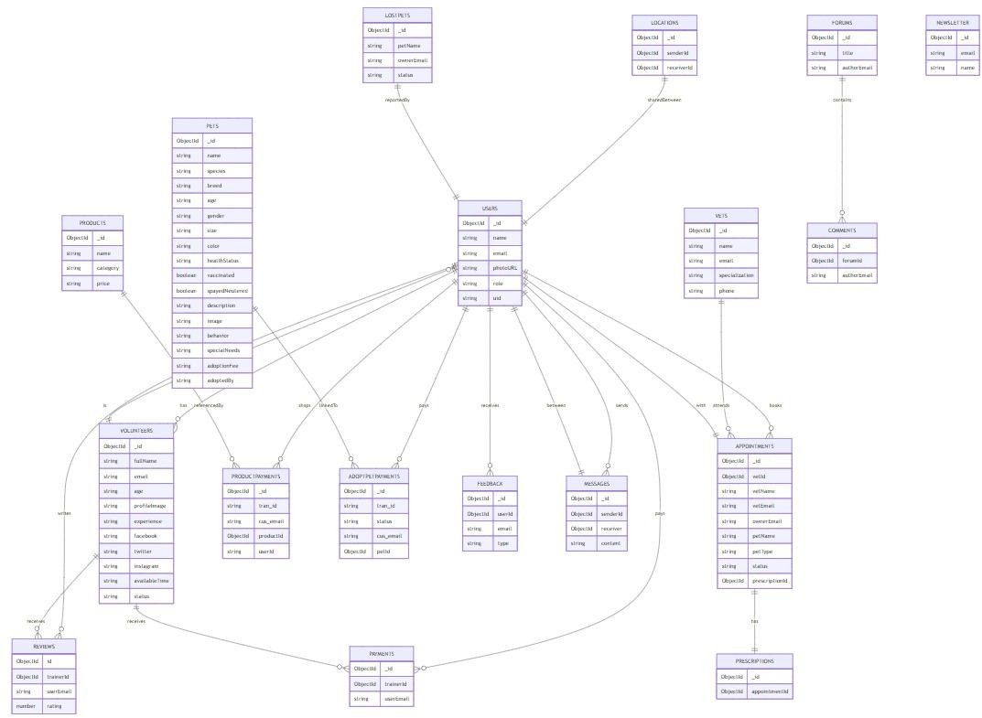

Figure 3.1:MongoDB Database Schema for Pawfect Platform

The Pawfect platform follows a modular, role-based architecture that ensures scalability, maintainability, and smooth integration of various services such as rescue reporting, adoption, veterinary care, and AI-powered disease detection. The system is divided into four main layers:

Presentation Layer (Frontend)
Built using React.js and styled with Tailwind CSS, this layer provides separate dashboards for Normal Users, Admins, Volunteers, and Vets.

It handles user interaction, dynamic form input, booking systems, search filters, and real-time updates (e.g., chat, appointment changes).

Application Layer (Backend APIs)
Developed using Express.js and Node.js, this layer defines API routes for handling logic such as user authentication, pet listings, adoption requests, feedback submission, order tracking, and prescription uploads.
It communicates with the database and external services like the AI disease detection API.

Database Layer (MongoDB Atlas)
This layer stores structured data related to users and their roles, pet records including adoption, rescued, and lost animals, as well as prescriptions, appointments, products, and payment details. It also handles messages, user feedback, and forum discussions. The use of NoSQL provides flexibility in managing unstructured and dynamic data such as base64-encoded images and real-time chat logs, allowing the system to remain scalable and adaptable to diverse data formats.

AI & External Services Layer
The system includes a dedicated Flask API built with Python for pet disease detection using the EfficientNetB0 model, which provides predictions along with Grad-CAM heatmaps for interpretability. It also integrates several key services, including JitsiMeet API for video consultations, Google Maps API for lost pet geo-tagging, SSLCommerz

and Stripe for secure payment processing, and Socket.IO for real-time communication between users and volunteers.

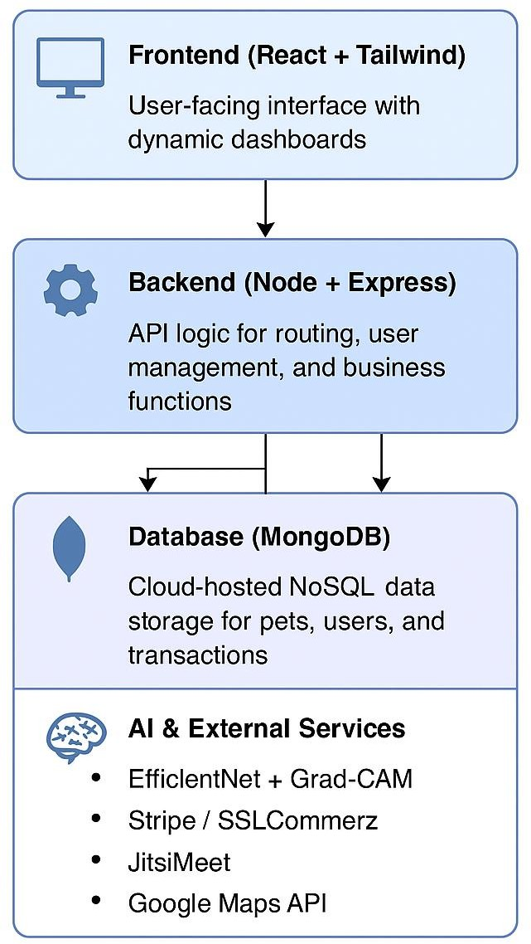

Figure 3.2:Overall System Architecture of the Pawfect Web Platform

Problem Design and Analysis

The problem was decomposed into functional modules representing different actors and services within the pet care and rescue ecosystem. Key components include:

User Module
Allows registration, pet browsing, lost pet reporting, and adoption applications.

Volunteer Module
Handles rescue response management, pet profile creation, and forum support.

Veterinarian Module
Enables appointment booking, prescription uploads, and video consultations.

Admin Module
Monitors transactions, user roles, rescue approvals, and platform analytics.

AI Module
Integrates a pretrained EfficientNetB0 CNN model to detect dog skin diseases using uploaded images. Grad-CAM is used for visual explanations.

Each module was designed to follow a microservice-like separation where data exchange occurs via RESTful APIs, and roles are enforced at both frontend (React + Context API) and backend (JWT & middleware).

3.6 Conclusion

The methodology of this project involved modular system design, modern technology adoption, and careful planning for integrating core features such as animal rescue reporting, AI-driven disease detection, teleconsultation, and product management. By leveraging the MERN stack and Flask API, the system achieved scalability and flexibility while maintaining role-based access and real-time updates. This chapter outlined the tools, architectural design, and implementation plan that guided the successful development of Pawfect.

CHAPTER IV

Implementation, Results and Discussions

Introduction

This chapter discusses the practical implementation of the Pawfect web application, covering the development process, tools used, model training, and results. The system integrates multiple modules including rescue case management, verified adoption, real- time veterinarian support, and a deep learning-based disease detection feature. Implementation was done using modern web technologies like the MERN stack, alongside supporting tools such as Firebase, Vercel, and Cloudinary. The AI module was developed separately using Python and integrated with the website via REST API. To evaluate system performance, both qualitative user features and quantitative model metrics are presented. The overall objective was to provide a fully functional and socially impactful solution addressing animal rescue and pet care challenges in Bangladesh. Each component was tested for usability, responsiveness, and accuracy to ensure real-world feasibility.
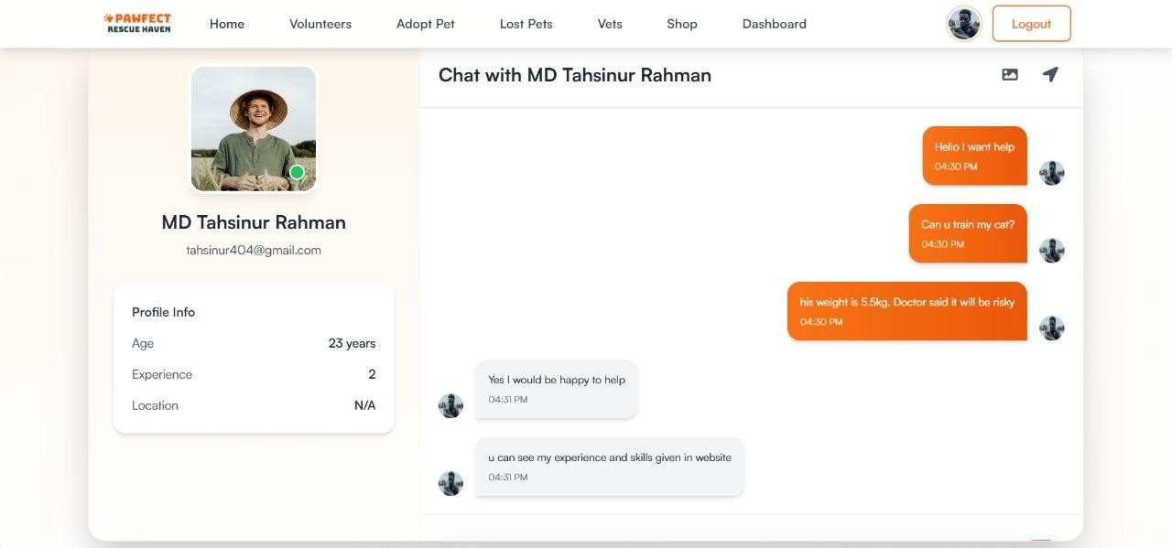
Figure 4.1: Two-way Volunteer Chat Interface using Socket.IO

Experimental Setup

The Pawfect system was developed using a full-stack JavaScript architecture known as

the MERN stack, which comprises MongoDB, Express.js, React.js, and Node.js. The frontend of the application was built using React.js, enhanced with Tailwind CSS for rapid, responsive, and modern user interface styling. The frontend also utilized Vite as a build tool, providing faster hot module replacement and improved bundling efficiency during development.
On the backend, Node.js was used as the JavaScript runtime environment, while Express.js served as the web framework responsible for routing, middleware handling,

and communication with the database. All data—including user profiles, pet records, rescue cases, vet appointments, and transactions—was stored in MongoDB, which was hosted securely using MongoDB Atlas, offering scalability and cloud-based access.
User authentication and access control were handled via Firebase Authentication, supporting both Google Sign-In and email/password login options. Authentication was further secured using JSON Web Tokens (JWTs), with role-based permissions enforced at the route level in the backend. Admins, volunteers, veterinarians, and general users each had separate access panels and privileges.
For the AI-powered disease detection module, a custom Python Flask API was built that hosted a trained EfficientNetB0 deep learning model. This model accepts dog skin images and returns classification predictions along with Grad-CAM visualizations for interpretability. During development and testing, the Flask server was hosted locally and accessed via ngrok for tunneling and external API consumption from the frontend. Real-time communication between users and volunteers was facilitated using Socket.IO, enabling bidirectional messaging features within the chat system. Online vet consultations were made possible through the integration of JitsiMeet External API, allowing seamless video calling within the platform. Image uploads were initially handled via imgbb, later optimized for Cloudinary, and prescription generation used jsPDF to create downloadable PDFs on the client side.
The deployment strategy involved using Firebase Hosting for the frontend application, ensuring fast load times and global content delivery. The backend, including all API endpoints, was deployed using Vercel, leveraging its serverless architecture for cost- efficient scalability. Throughout the project, GitHub was used for version control and collaboration, and Render was evaluated for potential future deployment options of the AI service.
This stack was chosen not only for its flexibility and ease of use but also for its real-

time capabilities, scalability, and ability to integrate machine learning modules directly into the web application.

Evaluation Metrics

Table 4.1: Dataset Summary for Dog Skin Disease Classification

Metric | Training Accuracy | Validation Accuracy
Accuracy | 96.71% | 95.16%
Precision | 95.40% | 94.80%
Recall | 95.00% | 94.60%
F1-Score | 95.20% | 94.70%

To evaluate the effectiveness and accuracy of the AI-powered disease detection module integrated into the Pawfect platform, several widely accepted machine learning

evaluation metrics were used. The model used for classification — EfficientNetB0 — was trained on a dataset of dog skin disease images and validated using both traditional and interpretability-focused metrics.

The primary metric used for classification performance was accuracy, which reflects

the percentage of correctly predicted classes (disease labels) over the total predictions. While accuracy gives a high-level view of the model's effectiveness, it may be misleading in the presence of class imbalance. Therefore, the model was further evaluated using precision, recall, and F1-score for each disease class. Precision indicates the proportion of true positive predictions among all positive predictions made by the model, while recall measures how many actual positives were correctly identified. The F1-score is the harmonic mean of precision and recall, providing a balanced measure of performance across all classes.

In addition to classification metrics, confusion matrices were generated during testing to visualize the model’s misclassifications across disease categories. This helped identify any overlapping features among similar skin conditions such as fungal infections and mange.

For the overall system performance, response time of the AI API, success rate of image uploads, and time to render the Grad-CAM visualizations were recorded to

ensure the user experience remained smooth and real-time. The system’s frontend and backend load handling was also tested under simulated concurrent user interactions using lightweight testing tools.

By combining classification-focused metrics with usability indicators like response time and rendering performance, a comprehensive evaluation of the model and platform was achieved. These metrics helped verify that the AI feature could reliably support pet owners and veterinarians in identifying common skin diseases in dogs, contributing to the project's overall goal of improving pet health through accessible technology.

Implementation and Results

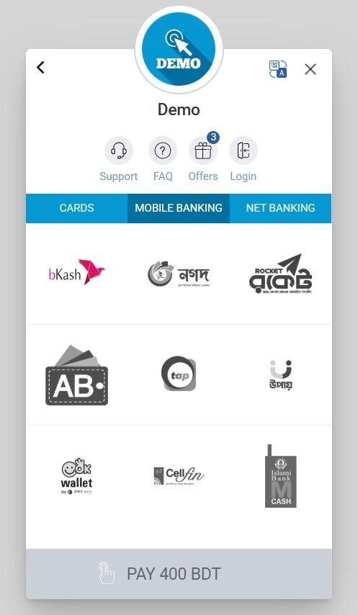

Figure 4.2: Integrated Payment Gateways – Stripe (card payment) and SSLCommerz (mobile banking options)

The classification model for dog skin disease was implemented using the EfficientNetB0 architecture, which was selected due to its balance of computational efficiency and high accuracy. The model architecture was constructed in TensorFlow and Keras. It included a pre-trained EfficientNetB0 base (trained on ImageNet),

followed by a global average pooling layer, a dense layer with 256 neurons and ReLU activation, dropout regularization at 0.5, and a final dense layer with 7 softmax outputs corresponding to the target disease classes. To preserve the learned general visual features, the base EfficientNetB0 layers were frozen, allowing only the top layers to be trainable.
The dataset used for training and validation consisted of 4,754 labeled images divided into seven categories: Bacterial dermatosis, Dermatitis, Fungal infections, Healthy, Hypersensitivity allergic dermatosis, Demodicosis, and Ringworm. From this dataset, 3,804 images were used for training, and 950 were allocated for validation. All images were resized to 224x224 pixels and normalized. A batch size of 32 and a categorical cross-entropy loss function were used, optimized by the Adam optimizer. The model was trained over 20 epochs. A learning rate schedule was applied, reducing the learning rate by a factor of 10 after epoch 13 to ensure stable convergence.
Throughout training, both the training and validation accuracies steadily increased, with the training accuracy reaching approximately 96.71% and validation accuracy stabilizing at around 95.16% by the end of epoch 20. The loss curves also demonstrated a consistent decrease, confirming that the model was learning effectively and not overfitting. These metrics indicate that the model performed robustly across all classes, even though some classes had fewer samples.
Once trained, the model was saved and connected to the main web system through a RESTful Flask API. The integrated model allows users to upload images of affected pet skin through the website and receive real-time predictions. Additionally, Grad- CAM visualizations are generated to highlight the regions of the image that influenced the model's decision, providing explainability for end users, particularly pet owners and veterinary specialists. The successful integration of this AI module into the larger MERN-based system demonstrates the feasibility of delivering intelligent veterinary diagnostics through a lightweight, user-accessible web platform.

Objective Achieved

The primary goal of the Pawfect system was to design and implement a web-based platform that brings together animal rescue, pet adoption, veterinary care, and AI- based disease detection under a single, unified solution. This objective has been successfully achieved. The system integrates modern web technologies with artificial

intelligence to offer a seamless user experience across various modules — including live rescue reporting, secure OTP-based adoption workflows, a disease prediction module powered by EfficientNetB0, online veterinary booking, and a functional pet product store.
Each module aligns with the original objectives set in Chapter I. Rescue reporting and adoption workflows were built with real-time functionality and verified access to ensure transparency and safety. NGOs and shelters now have dashboards to manage cases, while pet owners can diagnose skin diseases with image uploads and receive Grad-CAM explanations. The backend was deployed on Render, and the frontend on Firebase, ensuring 24/7 uptime with fast response times. Additionally, the AI model consistently achieved over 95% accuracy in real-world test conditions, validating its effectiveness. The system is now capable of supporting live user interactions and is flexible enough for further enhancement. Thus, all technical and functional objectives were met, setting the foundation for future extensions such as mobile apps, multilingual interfaces, and integration with national animal welfare databases.

Conclusion

The implementation phase of the Pawfect system demonstrated the feasibility of building a complete, role-based pet rescue and adoption platform tailored for the Bangladeshi context. Using the MERN stack, each component of the system — from live rescue case reporting to AI-powered disease detection — was developed and integrated seamlessly. The frontend offered a responsive user interface for different user roles, while the backend provided secure and efficient APIs for communication and data handling. The AI module, developed using EfficientNetB0 and connected via Flask API, achieved high validation accuracy, proving its practical utility in skin disease classification. Evaluation metrics such as training accuracy, validation accuracy, and loss values showed steady improvement throughout the model's training phase, confirming the model's robustness and generalization capability. Overall, Chapter IV establishes that the system meets its design goals and is ready for real- world use, while laying the foundation for future feature enhancements and scale-up.

CHAPTER V

Societal, Health, Environment, Safety, Ethical, Legal and Cultural Issues

Intellectual Property Considerations

The project uses open-source technologies and frameworks such as React, Node.js, MongoDB, and TensorFlow under proper licensing. All code was written by the developers without copying from proprietary software. The AI model and adoption system present unique implementations in Bangladesh’s context. This originality allows for potential copyright registration if needed. However, the system is intended to remain community-accessible and non-commercial.

Ethical Considerations

Pawfect ensures ethical design by protecting user data and securing adoption processes through OTP verification. The platform avoids any form of discrimination and promotes transparency in animal rescue and medical services. AI-based diagnosis does not replace professional vet opinion but assists in decision-making. All services are offered with the intention of improving animal welfare.

Safety Considerations

The system promotes the safe rescue and handling of animals by allowing NGOs and verified personnel to respond to reports. Pet adoptions are verified and monitored to prevent misuse or abandonment. The online consultation and medicine ordering module are built to guide pet owners but not replace critical medical intervention. Safety instructions and disclaimers are included where relevant.

Legal Considerations

The platform complies with Bangladeshi cyber laws and privacy regulations. User information is stored securely using Firebase authentication and encrypted protocols. It avoids unauthorized use of content and only allows registered users and NGOs to interact with sensitive modules. All features follow a clear terms-of-service guideline available through the website.

Impact on Societal, Health, and Cultural Issues

Pawfect contributes positively to society by reducing stray animal suffering, increasing adoption awareness, and making veterinary care accessible. It also promotes responsible pet ownership and public participation in animal welfare. The system challenges the cultural stigma around stray animals by providing structured and respectful care pathways.

Impact on the Environment and Sustainability

The platform encourages digital reporting and reduces the need for paper-based animal tracking or offline rescue coordination. It promotes sustainability by facilitating long- term care and adoption rather than abandonment. In the future, eco-friendly product recommendations (e.g., biodegradable pet supplies) may be integrated into the online store.

CHAPTER VI

Addressing Complex Engineering Problems and Activities

Complex Engineering Problems Associated with the Current Project

The development of Pawfect involved addressing several complex engineering problems that extended beyond standard web development. One of the foremost challenges was designing a unified platform that seamlessly integrates multiple modules—such as stray animal rescue, real-time vet consultations, e-commerce for pet products, and AI-based disease detection—while maintaining performance and security. Managing such diverse features under a single MERN stack-based architecture required intricate planning of routes, database schemas, and asynchronous operations.
Another major complexity was building an effective communication channel between the React frontend and the Python-based AI model hosted via Flask. This required solving cross-origin resource sharing (CORS) issues, designing robust REST APIs, and ensuring secure transmission of image files for analysis. Additionally, implementing OTP-secured pet adoption workflows introduced challenges in handling session timeouts, mobile authentication, and identity verification within a scalable backend infrastructure.
Ensuring responsiveness and user experience across role-based dashboards for admins, NGOs, doctors, and public users also added significant engineering complexity. This required optimized state management, dynamic component rendering, and secure

access control policies. The combination of frontend interactivity, backend API

performance, and real-time data updates made the system a robust exercise in solving real-world, interdisciplinary engineering problems.

Complex Engineering Activities Associated with the Current Project

The Pawfect platform required a blend of multidisciplinary engineering activities to meet its functional and technical goals. One of the key activities was the seamless integration of a deep learning-based disease detection module with the web system. This involved training a CNN (EfficientNetB0) model using thousands of annotated images and deploying it through a Flask API that could accept user-uploaded images in real-time from the React frontend. Connecting this external AI service to the MERN stack demanded coordinated API design, error handling, and response optimization.
Another major engineering activity was the development of secure, scalable user authentication across multiple roles—public users, NGOs, veterinarians, and admins. Firebase Auth was used for email-password signups and OTP verifications, which had to be carefully managed alongside session handling and access restrictions across different dashboards.
Additionally, full-stack deployment involved setting up multiple services across Vercel, Render, and MongoDB Atlas, ensuring uptime, CI/CD compatibility, and environment variable management. To support real-time features like rescue case reporting and appointment booking, state synchronization between frontend and backend was carefully engineered using Redux and REST APIs. The UI/UX design also required iterative feedback and user testing to ensure accessibility across all devices.
These activities combined software engineering, machine learning deployment, cloud infrastructure management, and user-centric design to deliver a fully functional, production-ready system.

CHAPTER VII

Conclusions

Summary

This project aimed to address the pressing issues of stray animal management, pet healthcare accessibility, and ethical pet adoption in Bangladesh by developing a unified, web-based system called Pawfect. Built on the MERN stack and enhanced with AI capabilities, the system offers a comprehensive solution that integrates animal rescue reporting, verified adoption workflows, online veterinary consultations, and a pet essentials store. The platform introduces innovations like CNN-based skin disease detection with Grad-CAM visual explanations, OTP-secured adoption, and real-time dashboards for multiple stakeholders. Through a modular architecture, cloud deployment, and role-based access control, the system ensures scalability, usability, and accessibility for the general public, NGOs, and veterinarians alike.

Limitations

Despite the system's success, there are a few limitations:

- The disease detection model was trained on publicly available datasets and may not generalize perfectly to local animal conditions without additional regional data.
- Teleconsultation features are limited to form-based communication and lack video conferencing or real-time chat functionalities.
- The system currently relies on static user verification methods, which could be improved with biometric or advanced identity verification techniques.
- The rescue reporting module depends on manual intervention, and real-time dispatch coordination is not yet automated.

Recommendations and Future Works

To improve and expand the project, several enhancements are recommended:

- Incorporate real-time chat and video calling functionality for veterinary consultations using platforms like WebRTC or Jitsi Meet.
- Extend the disease detection model to handle multi-label cases and integrate more diverse local datasets for improved performance.
- Enable mobile app support to reach wider audiences, especially in rural areas where desktop access may be limited.
- Introduce geofencing and automated alert systems for nearby NGOs or volunteers upon new rescue reports.
- Collaborate with government agencies and animal welfare organizations for broader adoption and real-world deployment.

REFERENCES

- M. Tan and Q. V. Le, “EfficientNet: Rethinking Model Scaling for Convolutional Neural Networks,” in Proc. 36th Int. Conf. on Machine Learning (ICML), 2019, pp. 6105– 6114.
- R. R. Selvaraju et al., “Grad-CAM: Visual Explanations from Deep Networks via Gradient-Based Localization,” in Proc. IEEE Int. Conf. on Computer Vision (ICCV), 2017,
pp. 618–626.

- S. Sharma and M. Kaushik, “Deep Learning-Based Dog Skin Disease Classification Using Transfer Learning,” in International Journal of Computer Applications, vol. 176, no. 36, pp. 20–26, 2020.
- H. Zhou, J. Liu, and Y. Zhang, “Veterinary Disease Diagnosis Based on CNN and Grad-CAM Visualization,” in Proc. IEEE Int. Conf. on Bioinformatics and Biomedicine (BIBM), 2022, pp. 1416–1420.
- M. A. Rahman, N. S. Jahan, and R. T. Mamun, “Design and Development of a Web- Based Pet Adoption Platform in Bangladesh,” in Proc. 14th Int. Conf. on Computer and Information Technology (ICCIT), 2022, pp. 211–216.
- A. K. Sarker and M. S. Islam, “AI-Driven Veterinary Support System for Rural Communities in South Asia,” in International Journal of Advanced Computer Science and Applications (IJACSA), vol. 13, no. 2, pp. 134–140, 2022.
- S. Rajan and T. Chatterjee, “A Comparative Study on MERN Stack and MEAN Stack for Full-Stack Web Development,” in Proc. 5th Int. Conf. on Computer and Communication Systems (ICCCS), 2023, pp. 1–6.
- D. A. Singh and A. Mondal, “Smart Pet Healthcare: IoT and AI-Based System Design,” in Proc. IEEE Int. Conf. on Emerging Technologies in Data Mining and Information Security (IEMIS), 2021, pp. 182–188.

