Assignment 1 – CAP680

Name – Aniket Kumar
Registration No – 12108348
Roll No – RD2112B62

Q1: Create an app in which user enter his NTS and F.Sc marks and your program will help student in selection of university. Based on these marks Student will be allocated a seat at different department of different university.
University Name Departments Criteria
Oxford University IT Above 70% in Fsc. and 70 % in NTS
Oxford University Engg Above 70% in Fsc. and 60 % in NTS
Oxford University Telecommunication Above 70% in Fsc. and 50 % in NTS
MIT IT 70% -60 % in Fsc. and 50 % in NTS
MIT Engg 59% – 50 % in Fsc. and 50 % in NTS
MIT Computer Above 40% and below 50 % in Fsc. and NTS
Code:
package CA1;

import java.util.Scanner;

class University{
public void SeatAllocation(double NTS, double Fsc){
//checking conditions for seat allocation
if(FSc>=70 && NTS>=70){
System.out.println("University: Oxford University");
System.out.println("Department: IT");
}
else if(FSc>=70 && NTS>=60 && NTS<70){
System.out.println("University: Oxford University");
System.out.println("Department: Engg");
}
else if(FSc>=70 && NTS>=50 && NTS<60){
System.out.println("University: Oxford University");
System.out.println("Department: Telecommunication");
}
else if(FSc>=60 && FSc<70 && NTS>50){
System.out.println("University: MIT");
System.out.println("Department: IT");
}
else if(FSc>=50 && FSc<60 && NTS>50){
System.out.println("University: MIT");
System.out.println("Department: Engg");
}
else if(FSc>=40 && FSc<50 && NTS>=40 && NTS<50){
System.out.println("University: MIT");
System.out.println("Department: Computer");
}
else{
System.out.println("Sorry!");
}
}
}

public class Set7Q1 {
public static void main(String[] args) {
Scanner sc = new Scanner(System.in);
System.out.println("University seat allocation");
System.out.print("Enter NTS marks(percentage): ");
double nts = sc.nextDouble();
System.out.print("Enter FSc marks(percentage): ");
double fsc = sc.nextDouble();
//creating an object of the University class and send marks //of NTS and Fsc to get the seat allocation result.
System.out.println("You have got a seat in:");
University u = new University();
u.SeatAllocation(nts, fsc);
}
}

Screenshot:

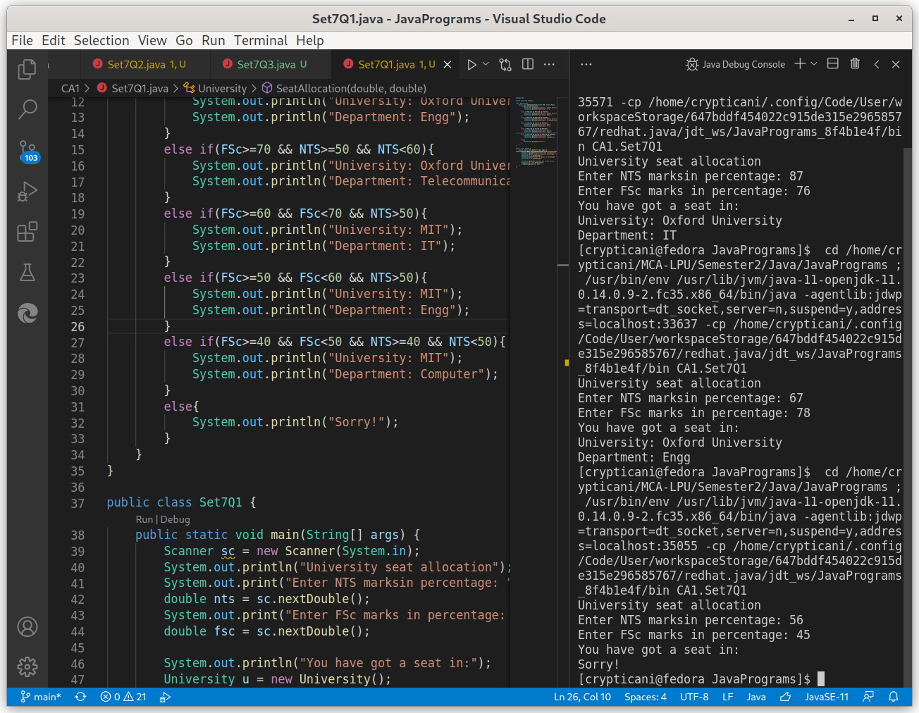
Q2: Create a class named 'Time' with data members (hours, mins, secs). Define methods in this class named 'hourConvertor', 'minConvertor' and 'secConvertor'. Calculate total hours, mins and secs for any integer value (in days).
For eg:
Input : 2 (days)
output: total_hours:48
total_mins:2880
total_secs:172800
Code:
package CA1;

import java.util.Scanner;

class Time{
int hours=24;
int minutes=24*60;
int seconds=24*60*60;
//function to convert days to hours
public void hourConvertor(int day){
int total_hours;
total_hours = day*hours;
System.out.println("total_hours:"+total_hours);
}
//function to convert days to minutes
public void minConvertor(int day){
int total_mins;
total_mins = day*minutes;
System.out.println("total_mins:"+total_mins);
}
//function to convert days to seconds
public void secConvertor(int day){
int total_secs;
total_secs = day*seconds;
System.out.println("total_secs:"+total_secs);
}
}

public class Set7Q2 {
public static int getDays(){
Scanner sc = new Scanner(System.in);
int d;
System.out.print("Days: ");
d = sc.nextInt();
return d;
}

public static void main(String[] args) {
System.out.println("A program to convert days into hours, minutes and seconds.");
//getting no of days as an input
int days = getDays();
//creating object of Time class and get the days converted
//into hours, minutes and seconds.
Time t = new Time();
t.hourConvertor(days);
t.minConvertor(days);
t.secConvertor(days);
}

}

Screenshot:

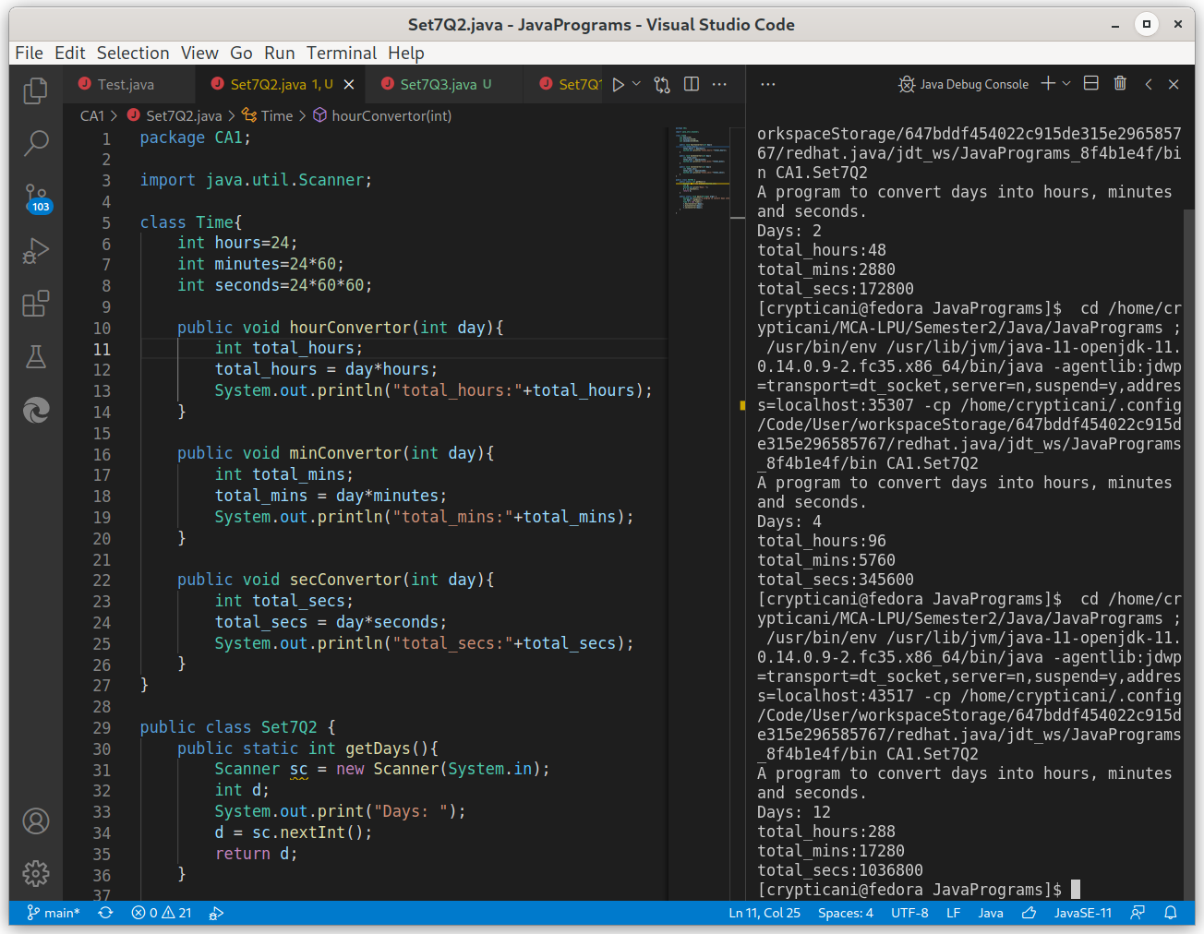
Q3: Suppose there is XYZ Company and there are different departments like production, marketing, finance, sales etc. Manager of the company want to know about the detail of the employees who are highly paid. Write a program using the concept of classes to implement the same.

Code:
package CA1;

import CA1.Company.Finance;
import CA1.Company.Marketing;
import CA1.Company.Production;
import CA1.Company.Sales;

class Company{
//function to get index of highest salary
public int getMaxIndex(double amount[]){
int N = 3;
int index=0;
double max = amount[0];
for(int i = 0; i < N; i++){
if(max < amount[i]){
max = amount[i];
index = i;
}
}
return index;
}
//different sub classes for each department with details of //some employees and their salary.
class Production{
String empName[] = {
"Ram",
"Shyam",
"Mohan"
};
double salary[] = {53453, 43534, 45445};
void getHighlyPaid(){
int a = getMaxIndex(salary);
System.out.println("Production Department: "+ empName[a]+" Rs."+salary[a]);
}
}

class Marketing{
String empName[] = {
"Lakshman",
"Bharat",
"Shatrughn"
};
double salary[] = {23432, 24343, 45326};
//function to get the highly paid employee
void getHighlyPaid(){
int a = getMaxIndex(salary);
System.out.println("Marketing Department: "+ empName[a]+" Rs."+salary[a]);
}
}

class Finance{
String empName[] = {
"Sohan",
"Hari",
"Murali"
};
double salary[] = {43243, 54656, 75678};
void getHighlyPaid(){
int a = getMaxIndex(salary);
System.out.println("Finance Department: "+ empName[a]+" Rs."+salary[a]);
}
}

class Sales{
String empName[] = {
"Murari",
"Govind",
"Narayan"
};
double salary[] = {34534, 45454, 34534};
void getHighlyPaid(){
int a = getMaxIndex(salary);
System.out.println("Sales Department: "+ empName[a]+" Rs."+salary[a]);
}
}
}

public class Set7Q3 {
public static void main(String[] args) {
Company c = new Company();
//creating objects of sub classes
Production cp = c.new Production();
Marketing cm = c.new Marketing();
Finance cf = c.new Finance();
Sales cs = c.new Sales();

System.out.println("Highly paid Employees of each department:");
//calling functions of each sub class to get the names of
//highly paid employee
cp.getHighlyPaid();
cm.getHighlyPaid();
cf.getHighlyPaid();
cs.getHighlyPaid();
}
}

Screenshot:

