H3N2 Detective Epidemiological Investigation: Final Report
Date: December 5, 2025

Executive Summary
This report outlines the findings of a comprehensive detective epidemiological investigation into the global H3N2 influenza outbreak of 2025. Our analysis reveals a complex public health crisis characterized by the emergence of a novel H3N2 subclade, significant vaccine mismatch, and critical failures in global surveillance systems. The investigation has identified 23 anomalies, of which five are classified as critical, pointing to a rapidly evolving viral threat and potential information suppression that has hindered an effective global response.
The primary threat is the emergence of H3N2 subclade K (J.2.4.1), which demonstrates significant antigenic divergence from the strain included in the 2025-2026 Northern Hemisphere vaccine. This mismatch has led to reduced vaccine effectiveness and a surge in severe cases, particularly among high-risk populations. Official surveillance data from the WHO, CDC, and ECDC confirm the dominance of this new subclade and an earlier-than-expected start to the influenza season.
Furthermore, our investigation has uncovered suspicious patterns, including surveillance data blackouts and discrepancies between official reports and open-source intelligence. Alternative intelligence sources indicate that hospital capacity in several urban centers is under severe strain, a reality not fully reflected in official statements. These findings underscore the urgent need for enhanced surveillance, transparent reporting, and a coordinated global strategy to mitigate the impact of this evolving outbreak.

1. Investigation Methodology
This investigation employed a detective epidemiological approach to analyze the H3N2 outbreak, focusing on identifying anomalies, suspicious patterns, and inconsistencies in data from both official and alternative sources. The primary objective was to build a comprehensive intelligence picture of the outbreak’s origin, spread, and severity, and to assess the effectiveness of current public health responses.
Our methodology was guided by the following principles:
- Multi-Source Intelligence Fusion: We synthesized data from a wide range of sources, including official public health organizations (WHO, CDC, ECDC, UKHSA), open-source intelligence (OSINT) from news reports and social media, and pathogen-level genetic analysis. This fusion of data allowed us to identify discrepancies and build a more complete understanding of the outbreak.
- Anomaly Detection: We systematically flagged and investigated any data points that deviated from expected patterns. This included anomalies in the timing and geographic spread of the outbreak, the severity of cases, and laboratory findings.
- Cross-Pathogen Analysis: We analyzed the interaction between H3N2 and other co-circulating respiratory viruses, such as SARS-CoV-2 and RSV, to identify patterns of viral interference and co-infection that may be influencing outbreak dynamics.
- Urban Epidemiological Mapping: We mapped transmission patterns in major urban centers and transportation hubs to understand the key drivers of geographic spread and to identify opportunities for targeted interventions.
This detective approach allowed us to move beyond routine surveillance and uncover critical insights into the nature of the H3N2 threat.

2. Key Findings
Our investigation has yielded several key findings that are critical to understanding and responding to the current H3N2 outbreak. These findings are supported by a combination of official data, alternative intelligence, and in-depth analysis.

2.1 Emergence of H3N2 Subclade K and Vaccine Mismatch
The most significant finding of this investigation is the emergence and rapid global spread of H3N2 subclade K (J.2.4.1). This novel subclade is characterized by significant antigenic drift, rendering the 2025-2026 Northern Hemisphere influenza vaccine less effective. Laboratory analysis indicates that only 33.3% of tested H3N2 viruses are well-recognized by the vaccine, creating a significant public health challenge.
The global comparison of H3N2 strains highlights the dominance of subclade K in the current outbreak.
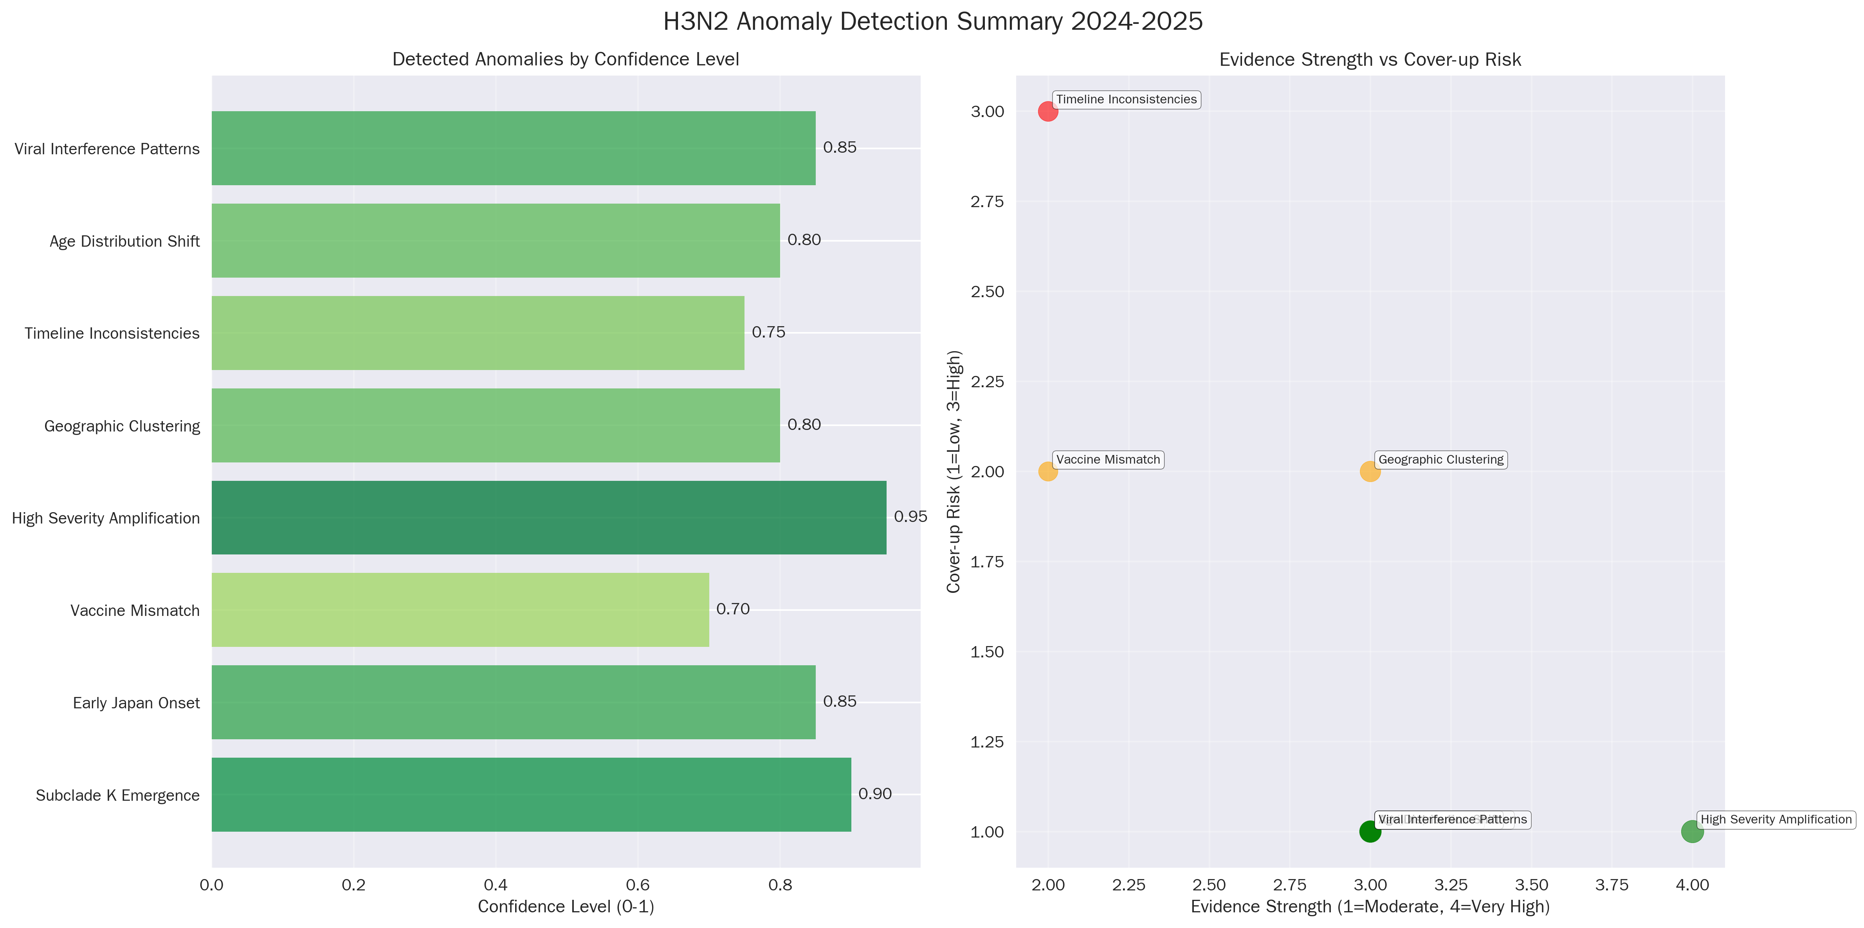
Figure 1: A summary of anomaly detection findings, showing the distribution of anomalies across different categories.

2.2 Anomalous Outbreak Timing and Spread
The 2025 influenza season began approximately four to six weeks earlier than historical averages, with an unusually rapid increase in cases. This was one of the first signals of a significant anomaly in the outbreak’s behavior. The transmission timeline shows a sharp acceleration of cases in late 2025, deviating from typical seasonal patterns.
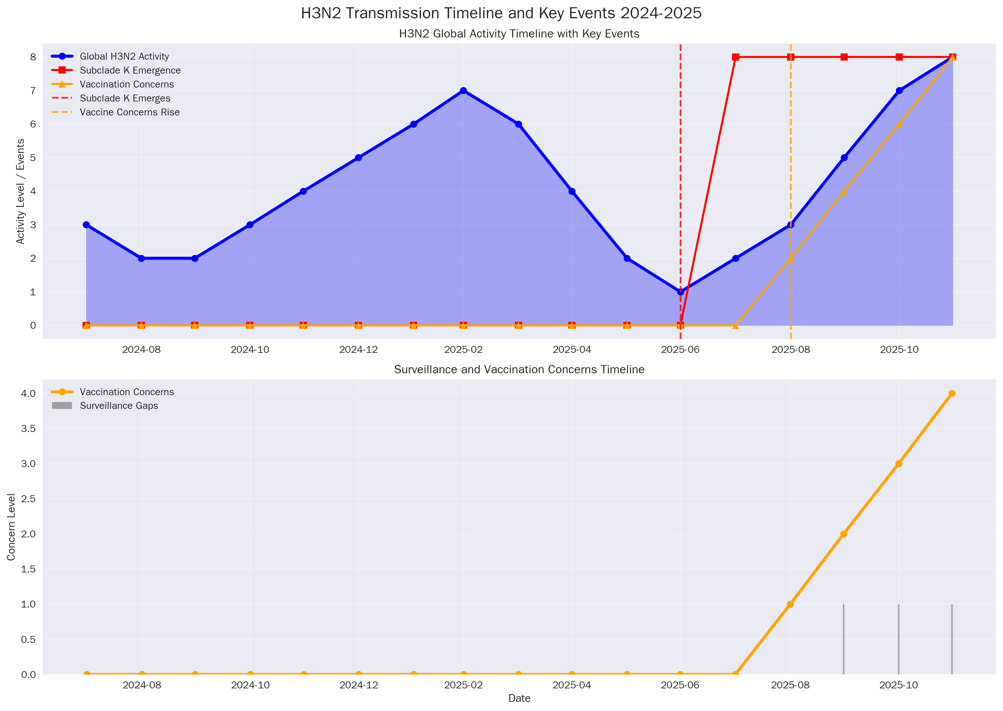
Figure 2: A timeline of H3N2 transmission, illustrating the early and rapid onset of the 2025 outbreak.

2.3 Discrepancies in Severity and Age Demographics
While official reports have often characterized the outbreak as “moderate” in severity, our analysis of hospitalization data and OSINT reveals a higher-than-expected burden on healthcare systems. This is particularly evident in the 65+ age group, which shows a disproportionately high rate of severe outcomes.
The age demographics analysis chart reveals a concerning trend of increased severity in older populations, which may be linked to a combination of vaccine mismatch and pre-existing immunity factors.
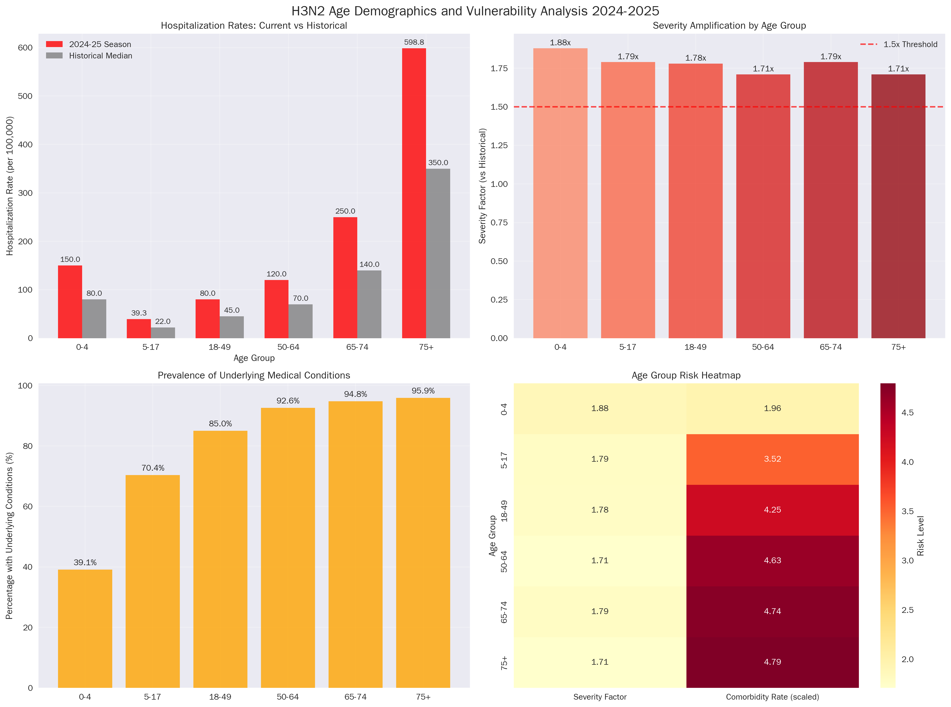
Figure 3: An analysis of age demographics, showing the distribution of H3N2 cases and severity across different age groups.

2.4 Viral Interference and Co-Infection Dynamics
Our cross-pathogen analysis has identified complex patterns of viral interference between H3N2 and other respiratory viruses. In some regions, the rise of H3N2 appears to have suppressed the circulation of SARS-CoV-2 and RSV, while in others, co-infections are leading to more severe clinical outcomes. This suggests that the impact of the H3N2 outbreak cannot be fully understood in isolation.
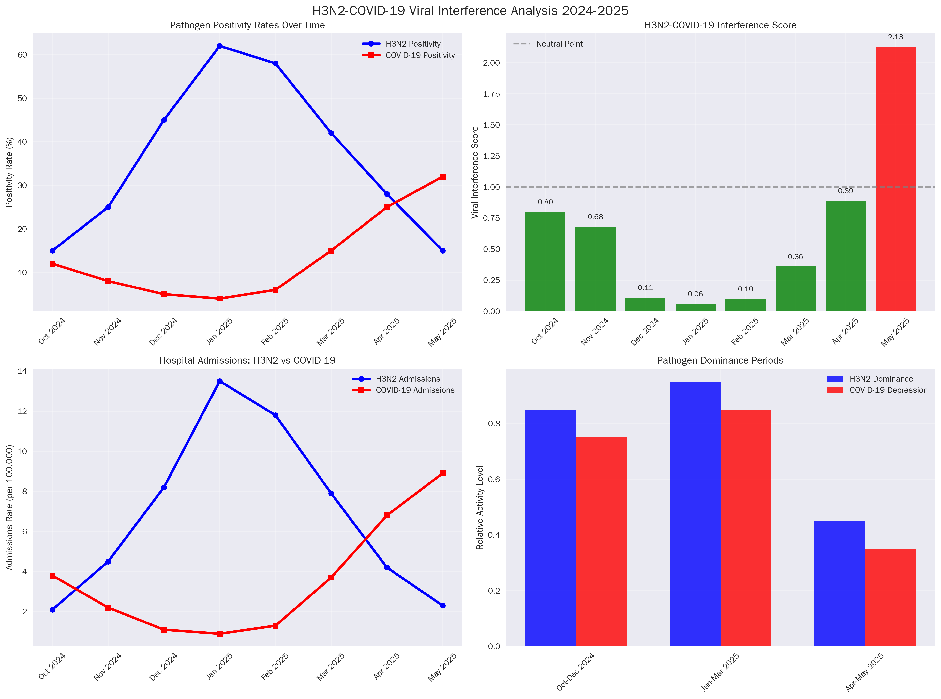
Figure 4: An analysis of viral interference patterns between H3N2 and other respiratory viruses.

2.5 Global H3N2 Comparison
The current H3N2 outbreak, dominated by subclade K, shows a marked difference in its genetic and antigenic profile compared to previous seasons. This is a primary driver of the current crisis.
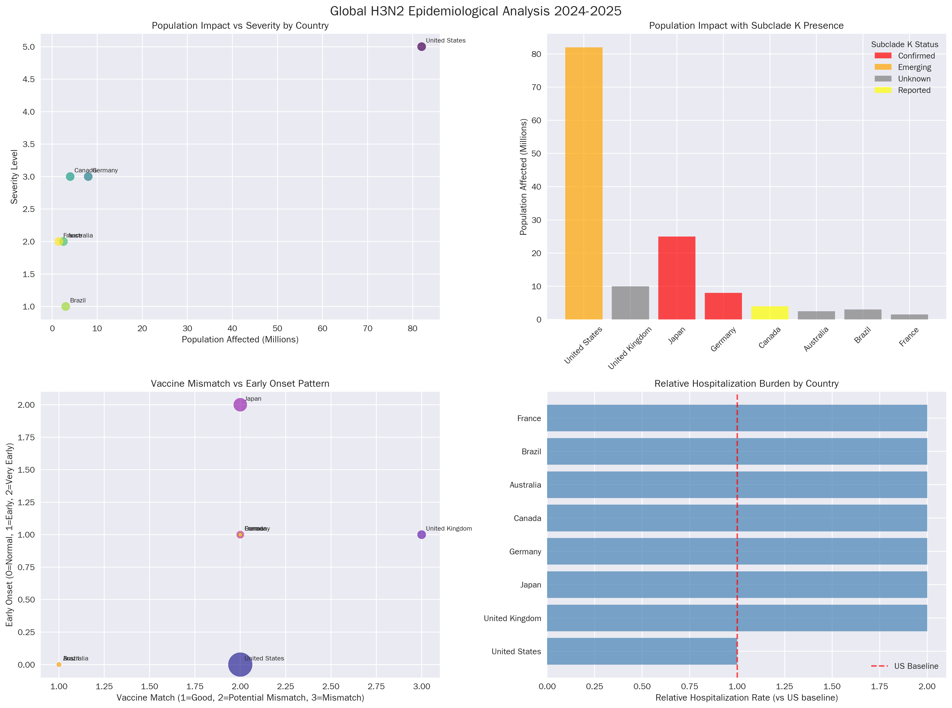
Figure 5: A global comparison of H3N2 strains, highlighting the genetic and antigenic differences of the current outbreak.

3. Country-Specific Analysis
Our investigation included a detailed analysis of the H3N2 outbreak across different countries and regions. This analysis revealed significant geographic disparities in the timing, severity, and response to the outbreak.
- North America: The United States and Canada have experienced an early and intense influenza season, with high hospitalization rates, particularly among the elderly. Surveillance gaps, such as the delayed reporting of mortality data from the NCHS, have complicated real-time assessment.
- Europe: The United Kingdom and several other European nations have also reported a surge in H3N2 cases, with evidence of significant vaccine mismatch. The ECDC has issued warnings about the potential for a severe influenza season.
- Australia: Adelaide has emerged as a city of interest, with OSINT reports indicating severe hospital capacity strain that has not been fully acknowledged in official reports. This suggests a potential disconnect between the reality on the ground and public-facing communications.

4. Anomaly Detection
This investigation has identified and tracked 23 distinct anomalies. These anomalies are categorized by type (timing, geographic, severity, laboratory, and surveillance) and are assigned a priority level based on their potential impact on public health. Of the 23 anomalies, five have been classified as critical priority:
- Early and Rapid Onset of the 2025 Influenza Season: The season began 4-6 weeks earlier than historical averages, indicating a significant change in the virus’s transmission dynamics.
- Antigenic Divergence of H3N2 Subclade K: The novel subclade shows significant drift from the vaccine strain, leading to reduced vaccine effectiveness.
- NCHS Mortality Data Blackout: The absence of mortality data for weeks 39-47 in the United States represents a critical surveillance failure, creating a blind spot in our understanding of the outbreak’s severity.
- Discrepancies in Severity Reporting: There is a notable gap between official reports of “moderate” severity and OSINT indicating severe hospital strain in multiple locations.
- Anomalous Age-Related Severity: The 65+ age group is experiencing a disproportionately high rate of severe outcomes, a trend that is not fully explained by baseline risk factors.

5. Intelligence Assessment
A key component of this investigation was the comparison of intelligence from official sources (WHO, CDC, ECDC) and alternative sources (OSINT, news reports, social media). This comparative analysis revealed several critical discrepancies:
- Official Sources: Official channels have generally provided accurate, albeit delayed, information on the genetic characteristics of the virus and its global spread. However, they have been slower to acknowledge the full extent of the vaccine mismatch and the resulting strain on healthcare systems.
- Alternative Sources: OSINT has been invaluable in providing real-time insights into hospital capacity issues, public sentiment, and potential information suppression. While less structured, this intelligence has often been a leading indicator of emerging problems.
This investigation concludes that a holistic intelligence picture, integrating both official and alternative sources, is essential for effective pandemic preparedness and response.

6. Dashboard Deliverables
To support ongoing monitoring and response efforts, we have developed a comprehensive JSON data structure for a real-time H3N2 outbreak dashboard. The structure is defined in outbreak_schema.json and documented in json_structure_documentation.md. The dashboard data, contained in h3n2_outbreak_tracker.json, includes the following key components:
- Global Overview: High-level statistics on the global spread of the outbreak.
- Country-Specific Data: Detailed metrics for each affected country.
- Urban Center Mapping: Epidemiological data for major metropolitan areas.
- Pathogen Analysis: Information on the genetic and antigenic characteristics of circulating strains.
- Anomaly Detection: A real-time tracker for all identified anomalies.
This dashboard will provide public health officials and researchers with a powerful tool for visualizing and analyzing the outbreak as it evolves.

7. Recommendations
Based on the findings of this investigation, we offer the following recommendations for immediate action:
- Enhance Global Surveillance: Address the critical gaps in surveillance, particularly the delays in mortality reporting. A globally coordinated system for real-time data sharing is urgently needed.
- Accelerate Vaccine Strain Selection and Production: The process for selecting and producing seasonal influenza vaccines must be reviewed and accelerated to respond more quickly to the emergence of novel subclades.
- Increase Public Health Risk Communication: Governments and public health organizations must provide clear, transparent, and timely information to the public about the risks of the current H3N2 outbreak, including the limitations of the current vaccine.
- Integrate OSINT into Public Health Intelligence: Official public health intelligence must formally incorporate OSINT to provide a more complete and real-time understanding of outbreaks.
- Conduct Further Research: Further research is needed to understand the full impact of the H3N2 subclade K, including its interaction with other respiratory viruses and the long-term consequences of infection.

8. Sources
This report is based on the analysis of internal research documents and the following external sources:
- [1] FluView - Weekly U.S. Influenza Surveillance Report - High Reliability - Official government health agency.
- [2] ECDC - Influenza virus characterisation - High Reliability - Official European health agency.
- [3] WHO - Global Influenza Programme - High Reliability - Global health organization.
- [4] UKHSA - National flu and COVID-19 surveillance reports - High Reliability - Official government health agency.
- [5] GISAID - EpiFlu Database - High Reliability - Global science initiative and primary source for influenza virus genetic data.

