

**Module Code & Module Title**

**CS6004NI – Application Development**

**Assessment Weightage & Type**

**30% Group Coursework**

**Year and Semester**

**2022 Spring**

|  |  |  |  |
| --- | --- | --- | --- |
| **L3C2** | | | |
| **Sn** | **Student Name** | **College ID** | **University ID** |
| **1** | **Animesh Singh Basnet** | **NP01CP4A190118** | **19030709** |
| **2** | **Abhishek Rokaya** | **NP01CP4A190164** | **19030695** |
| **3** | **Pranamya Sharma** | **NP01CP4A190001** | **19031360** |
| **4** | **Oshriya Manandhar** | **NP01CP4A190197** | **19031257** |
| **5** | **Ushaan Shrestha** | **NP01CP4A190074** | **19031825** |

**Assignment Due Date: 9th May 2022**

**Assignment Submission Date: 9th May 2022**

*I confirm that I understand my coursework needs to be submitted online via Google Classroom under the relevant module page before the deadline in order for my assignment to be accepted and marked. I am fully aware that late submissions will be treated as non-submission and a marks of zero will be awarded.*

Table of Content

1. Introduction 1

2. Detail Instruction to Run the Program 3

3. Logical solution of the implemented functions 4

4. Architecture of the System 7

5. Detailed Description of the Classes’ Properties and Method 8

6. Testing 9

6.1. Test 1 9

6.2. Test 2 11

6.3. Test 3 13

6.4. Test 4 14

6.5. Test 5 16

6.6. Test 6 18

6.7. Test 7 20

6.8. Test 8 22

6.9. Test 9 24

6.10. Test 10 25

6.11. Test 11 26

6.12. Test 12 27

6.13. Test 13 28

6.14. Test 14 29

6.15. Test 15 30

7. Individual Reflection 31

8. Conclusion 32

9. Bibliography 33

**Table of Figures**

Figure 1: Test 1 7

Figure 2: Test 1 7

Figure 3: Test 2 8

Figure 4: Test 2 9

Figure 5: Test 2 9

Figure 6: Test 3 10

Figure 7: Test 4 11

Figure 8: Test 4 12

Figure 9: Test 4 12

Figure 10: Test 5 13

Figure 11: Test 5 14

Figure 12: Test 5 14

Figure 13: Test 6 15

Figure 14: Test 6 16

Figure 15: Test 6 16

Figure 16: Test 7 17

Figure 17: Test 7 18

**Table of Tables**

Table 1: Test no.1 6

Table 2: Test no.2 7

Table 3: Test no.3 8

Table 4: Test no.4 9

Table 5: Test no.5 10

Table 6: Test no.6 11

Table 7: Test no.7 12

Table 8: Test no.8 13

Table 9: Test no.9 14

Table 10: Test no.10 15

# Introduction

The assigned project calls for the development of an application in a collaborative manner to support a company named Ropey DVDs. Ropey DVDs is a franchise DVD rental store chain in which several shops operate under a common name with shared purchasing and advertising yet function as distinct businesses.

Per the company's needs, the application in issue should provide a number of features. It should be able to manage the stock, loaning, and return of DVDs to its members who require such services. Moreover, each DVD should have the records of the main actors, as well as the studio and producer of the DVD.

There have also been some assumptions stated that must be followed during the development of this application. To begin, it is assumed that a single DVD can only have one producer and be linked with one studio. Aside from that, each DVD has been labeled with a genre and whether or not it is appropriate for audiences under the age of 18. Furthermore, each business maintains a list of members who are the only ones who are permitted to borrow DVDs. Each member, however, is assigned to a member category, which restricts how many DVDs they may loan at one time. Whenever a DVD is loaned, a record has to be created that includes information on the member who borrowed the DVD as well as how long they may retain the DVD without incurring any financial penalties.

A variety of tools were utilized in the development of this application. Visual Studio 2022 has been used for development.

Microsoft's Visual Studio is an Integrated Development Environment (IDE) used to create GUIs (Graphical User Interfaces), console, web applications, mobile apps, cloud and online services, and so on (Microsoft, 2022; geeksforgeeks, 2019).

As for version control of the development process, Git and GitHub have been used. Git is a free and open-source distributed version control system that can manage everything from modest to extremely large projects with efficiency and ease (Git, 2022). Likewise, GitHub provides Git-based Internet hosting for software development and version control. It provides Git's distributed version control and source code management (SCM) functions, as well as its own features. For each project, it provides access control as well as various collaboration tools such as bug tracking, feature requests, task management, continuous integration, and wikis (Williams, 2012).

Going further, the report documents the development process of the application from beginning to end, along with the tasks assigned to each individual member of the group.

# Detail Instruction to Run the Program

# Logical solution of the implemented functions

**Function - 1: To view the titles of all DVDs stocked by the shop User by entering or selecting an actor’s name (Last name) for which the Actor is a Cast Member.**

This function

**Function - 2: View the titles and the number of copies on the shelves of all DVDs by the user by entering or selecting an actor’s name (Last name) for which the Actor is a Cast Member and which have at least one copy on the shelves.**

This function

**Function - 3: View a member by MemberNumber or MemberLastName and view a list of all the DVDs (by title and copynumber) that they have been loaned in the last 31 days.**

This function

**Function – 4: List all producers, studio and cast lists of all DVDs in the shop with the DVDs in increasing order of Date Released, showing the title of each DVD and the names of all the cast members in alphabetic order of last name.**

This function

**Function – 5: Display customer/member detail by entering or selecting a Copy-by-Copy Number and find the details of the last loan for that copy (whether it is still on loan or has been returned), with the Name of the Member who borrowed it, the date out, due, and back (if any) and the title of the DVD.**

A search bar is placed to enter the copy number. When the copy number is entered, it then searches the row in the list and the data of that copy number is received. If the copy is loaned out, it displays the details of the members and when they loaned out with the option to return. But if, it was already returned, then the last loan that had been returned is shown with the details of the member along with when they took the DVD and when they returned it.

**Function – 6: To allow the User to issue a DVD Copy on loan to a member.**

This function

**Function – 7: To allow a user to record the return of a DVD copy.**

To return a DVD, the Return button is clicked for the selected DVD. When clicked, the IsOnLoan value is set to true. The ReturnedDate Value is set to Current DateTime. Then the ReturnedDate is checked whether is returned within the DueDate or not. If retuned within the DueDate, then the total cost is the StandardCost. If the ReturnDate is passed the DueDate then the total days late is counted. The PenaltyCharge is applied in multiply to the total late days and added with the StandardCharge to show the total cost.

**Function – 8: To produce an alphabetic list of all members with all their details and the total number of DVDs they currently have on loan.**

This function

**Function – 9: To allow the user to enter a new DVD Title into the system.**

This function

**Function – 10: To remove all data from stock all DVD copies which are more than 365 days old.**

This function

**Function – 11: To produce a list of all DVD copies currently on loan in date order of date out with the loans of a particular day ordered by the title.**

Here, first of all, a query is run to get details of all the DVD copies and then it is filtered by DVDs that are currently in loan. It is then ordered by the DateOut. Then a total loans is calculated according to the total loans taken in a particular DateOut.

**Function – 12: To Produce a list of all Members who have not borrowed any DVD in the last 31 days.**

This function

**Function – 13: To display a list of all DVD titles in the shop where no copy of the title has been loaned in the last 31 days.**

This function

**Function – 14: To allow Assistants to change their own passwords (on User) and Managers can change any detail on any row on User (including adding and deleting rows).**

This function

# Architecture of the System

The following system was made in MVC Architecture. The **Model-View-Controller (MVC)** is an architectural pattern that separates an application into three main logical components: the **model**, the view, and the controller. (TutorialsPoint, 2022) Each of these components is designed to handle particular development elements of an application. MVC is a popular industry-standard web development framework for building scalable and adaptable projects.

Web Pages, Web Forms, and MVC are the three major development formats supported by ASP.NET (Model View Controller). The ASP.NET MVC framework is a lightweight, highly testable presentation framework that integrates with existing ASP.NET capabilities like master pages, authentication, and so on. This framework is defined in the System class of.NET. Assembly of Web.Mvc.

# Detailed Description of the Classes’ Properties and Method

**1. ApplicationDbInitializer.cs**

This class contains the following methods:

**public static async Task SeedUsersAndRolesAsync(IApplicationBuilder applicationBuilder)**: In this method, the User data is seeded along with the User Roles.

**public static void Seed(IApplicationBuilder applicationBuilder)**: In this method, the Entire Data of the database is seeded.

**2. View Model**

The view models were created in order to retrieve data from more than one tables.

**DVDPreviewModel**: This class contains the property that is used to store the details of the DVD Titles to preview.

**DVDReturnModel**: This class contains the property that is used to store the details of the DVD Returns.

**FilteredLoan**: This class contains the property that is used to store the details of loans that are currently active.

**MemberDetailViewModel**: This class contains the property that is used to store the details of the members.

**RentModel**: This class contains the property that is used to store the details of the DVD Rent Transactions.

**UserDetailsViewModel**: This class contains the property that is used to store the details of the Users.

# Testing

Software Testing is a method to check whether the actual software product matches expected requirements and to ensure that software product is Defect free. (Hamilton, 2022) Any software developer's ultimate goal is to create apps that are fast, stable, and simple to use. Each application must be properly tested in order to achieve this goal.

The testing for the Ropey DVD Management System is given below:

## Test 1

|  |  |
| --- | --- |
| **Test No.1** | |
| Objective | To run the program. |
| Action | The run button in the Visual Studio 2022 was clicked. |
| Expected Output | The program would run successfully. |
| Actual Output | The program was successfully. |
| Result | The test was successful. |

Table 1: Test no.1

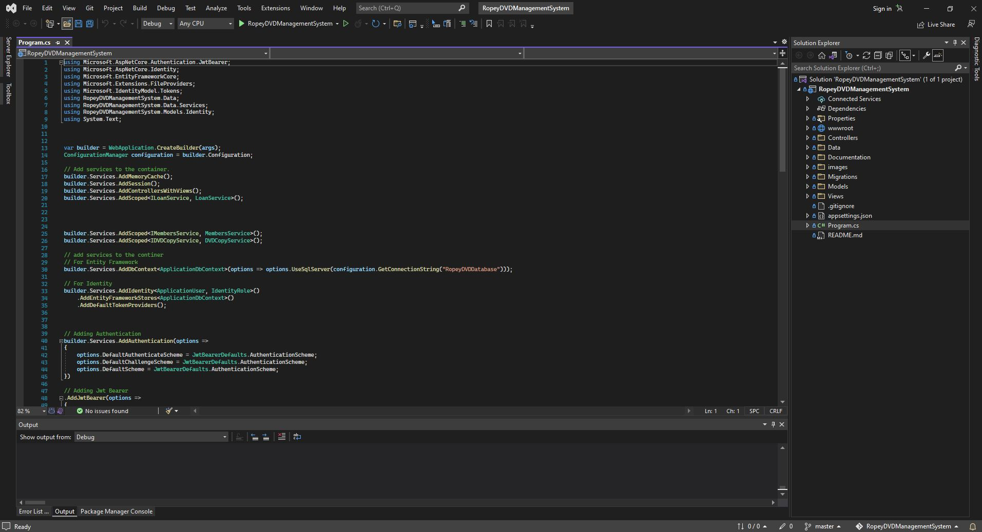

Figure 1: Test 1

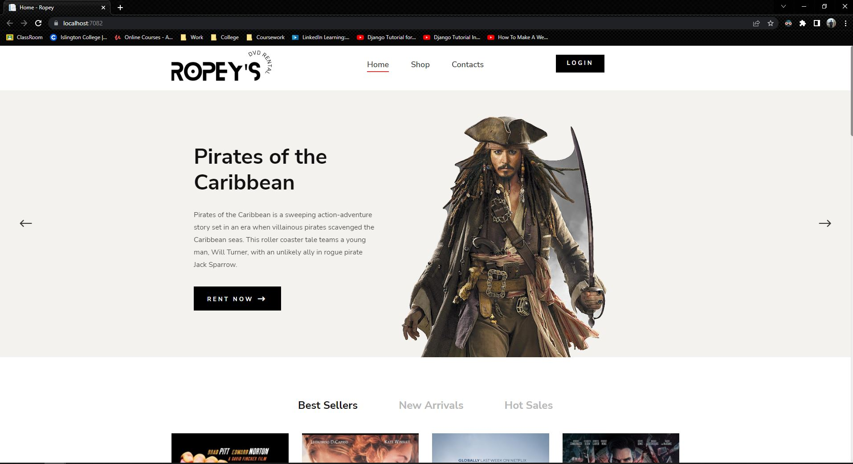

Figure 2: Test 1

## Test 2

|  |  |
| --- | --- |
| **Test No.2** | |
| Objective | To login the admin. |
| Action | The Login button was pressed and the valid credentials were entered. |
| Expected Output | The user would be logged in successfully. |
| Actual Output | The user was logged in successfully. |
| Result | The test was successful. |

Table 2: Test no.2

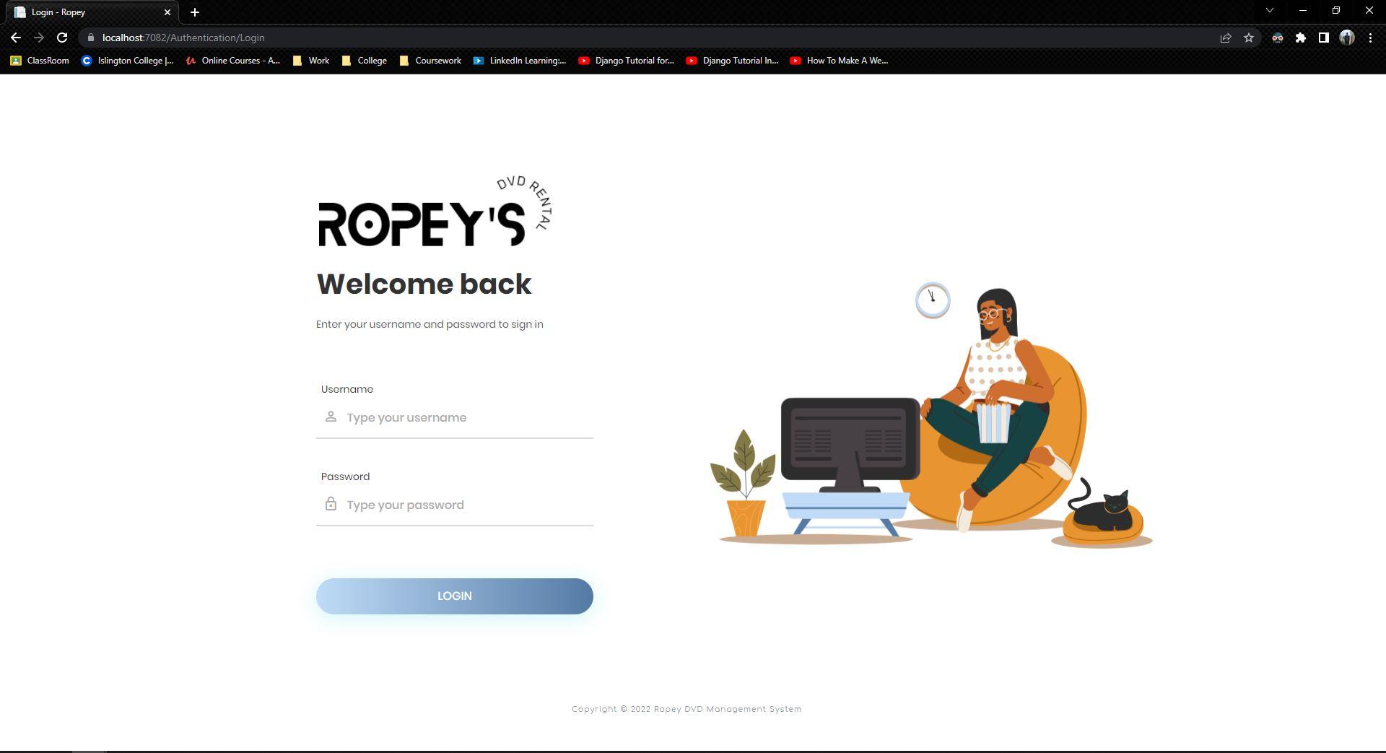

Figure 3: Test 2

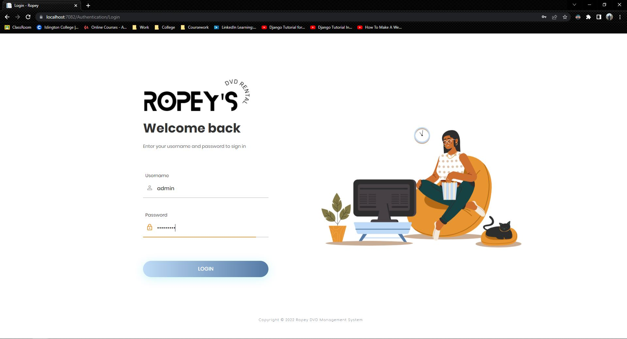

Figure 4: Test 2

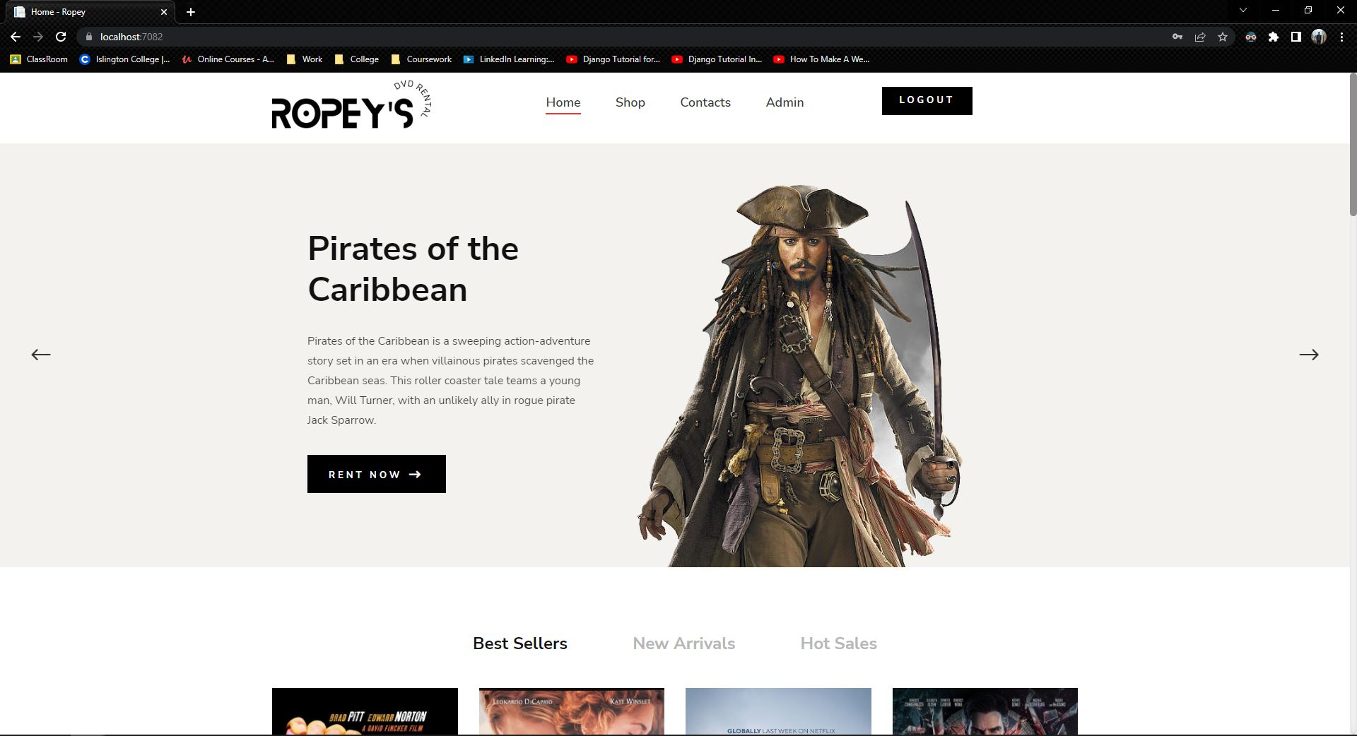

Figure 5: Test 2

## Test 3

|  |  |
| --- | --- |
| **Test No.3** | |
| Objective | To view list of DVD on Loan in order by date out. |
| Action | The 'Return' Button in the DVD section of the admin dashboard was clicked. |
| Expected Output | A list of DVD that are currently on loan and not returned would be shown in order by Date out. |
| Actual Output | A list of DVD that are currently on loan and not returned was shown in order by Date out. |
| Result | The test was successful. |

Table 3: Test no.3

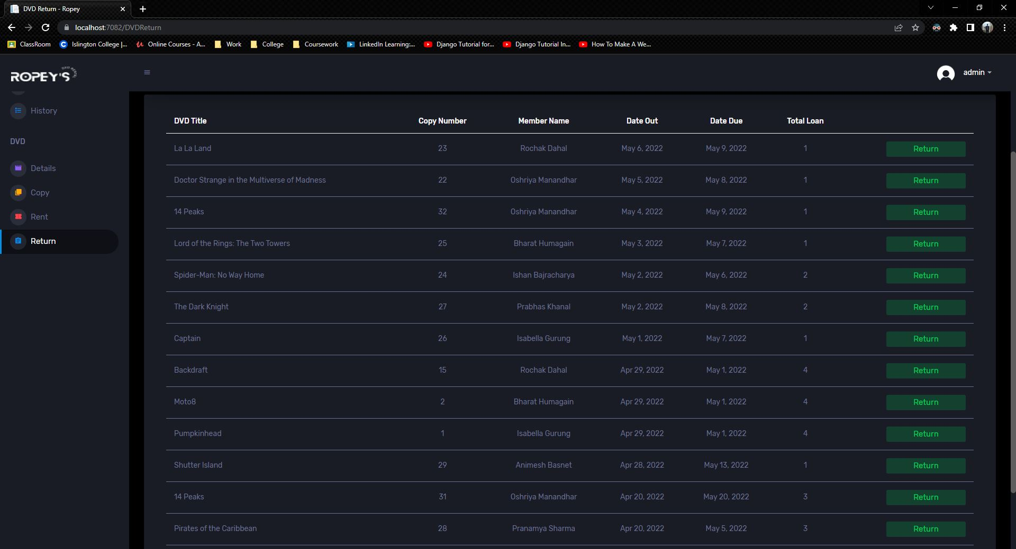

Figure 6: Test 3

## Test 4

|  |  |
| --- | --- |
| **Test No.4** | |
| Objective | To search details of the loan by copy number. |
| Action | The copy number was entered in the DVD Return page and the search button was clicked. |
| Expected Output | The details of the copy number would be shown. |
| Actual Output | The details of the copy number was shown. |
| Result | The test was successful. |

Table 4: Test no.4

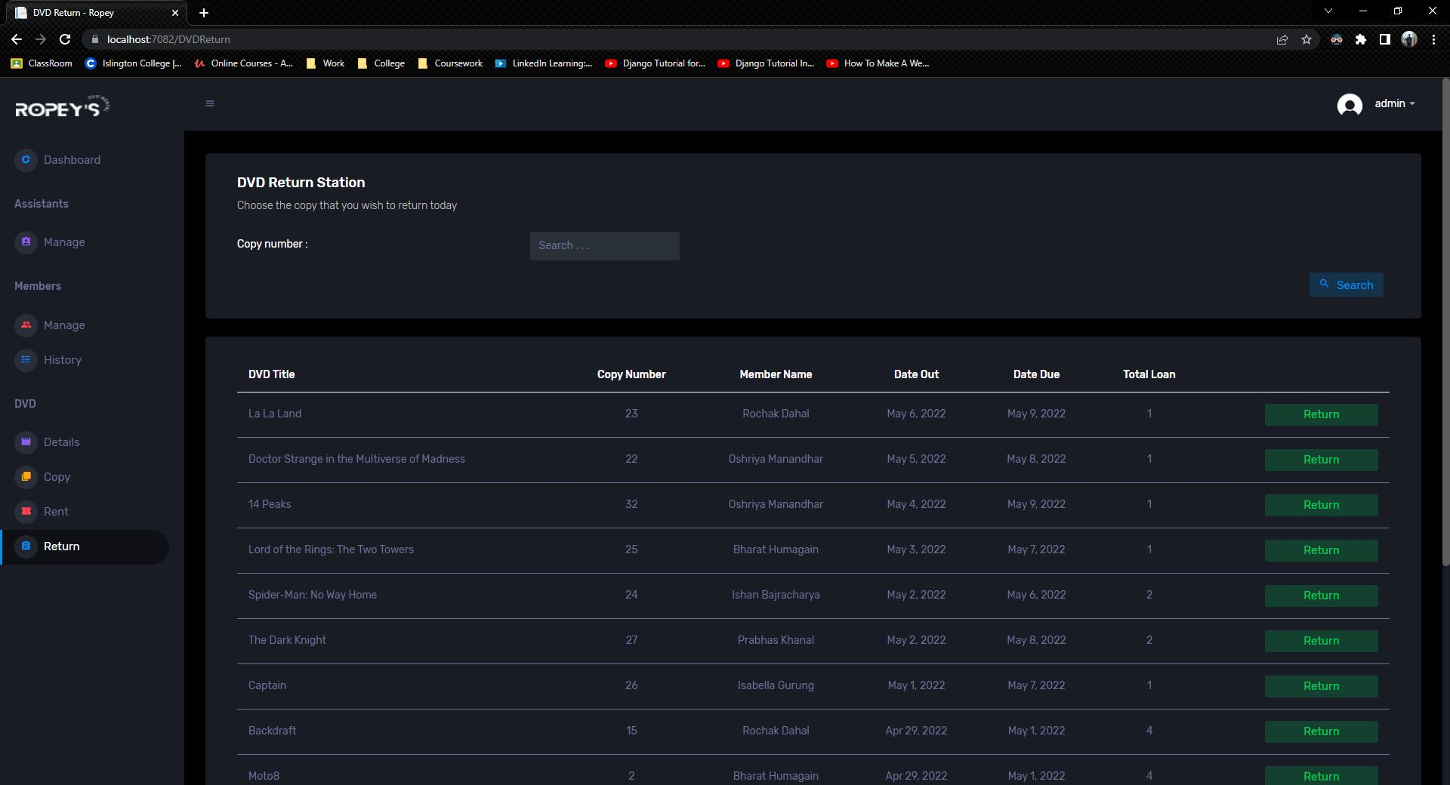

Figure 7: Test 4

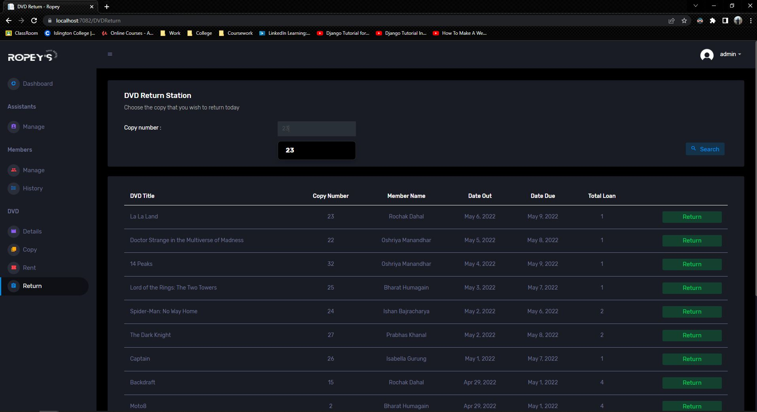

Figure 8: Test 4

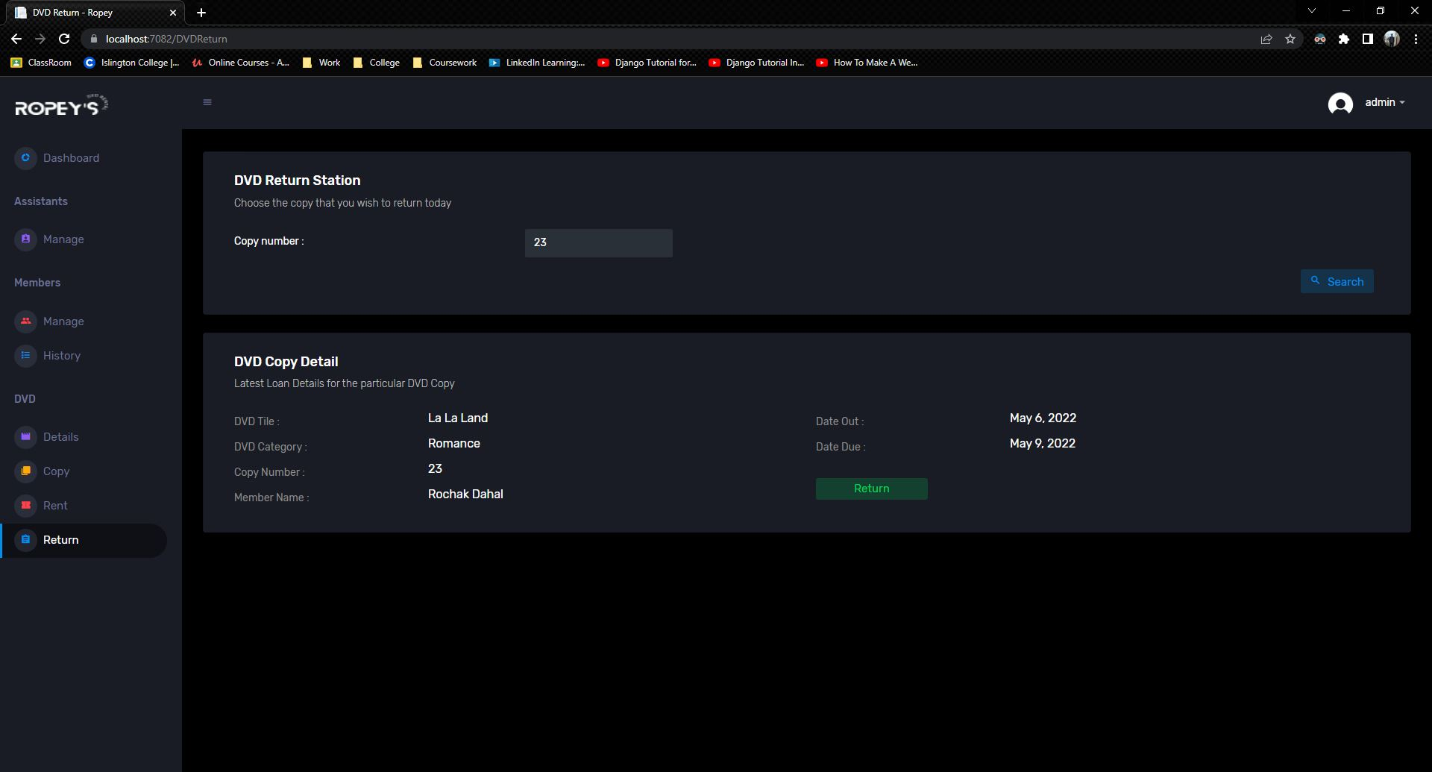

Figure 9: Test 4

## Test 5

|  |  |
| --- | --- |
| **Test No.5** | |
| Objective | To return the DVD with price calculation. |
| Action | The 'Return' button of the DVD to be returned was clicked and the 'Save' button was clicked. |
| Expected Output | The price would be calculated and the DVD would be returned. |
| Actual Output | The price was calculated and the DVD was returned. |
| Result | The test was successful. |

Table 5: Test no.5

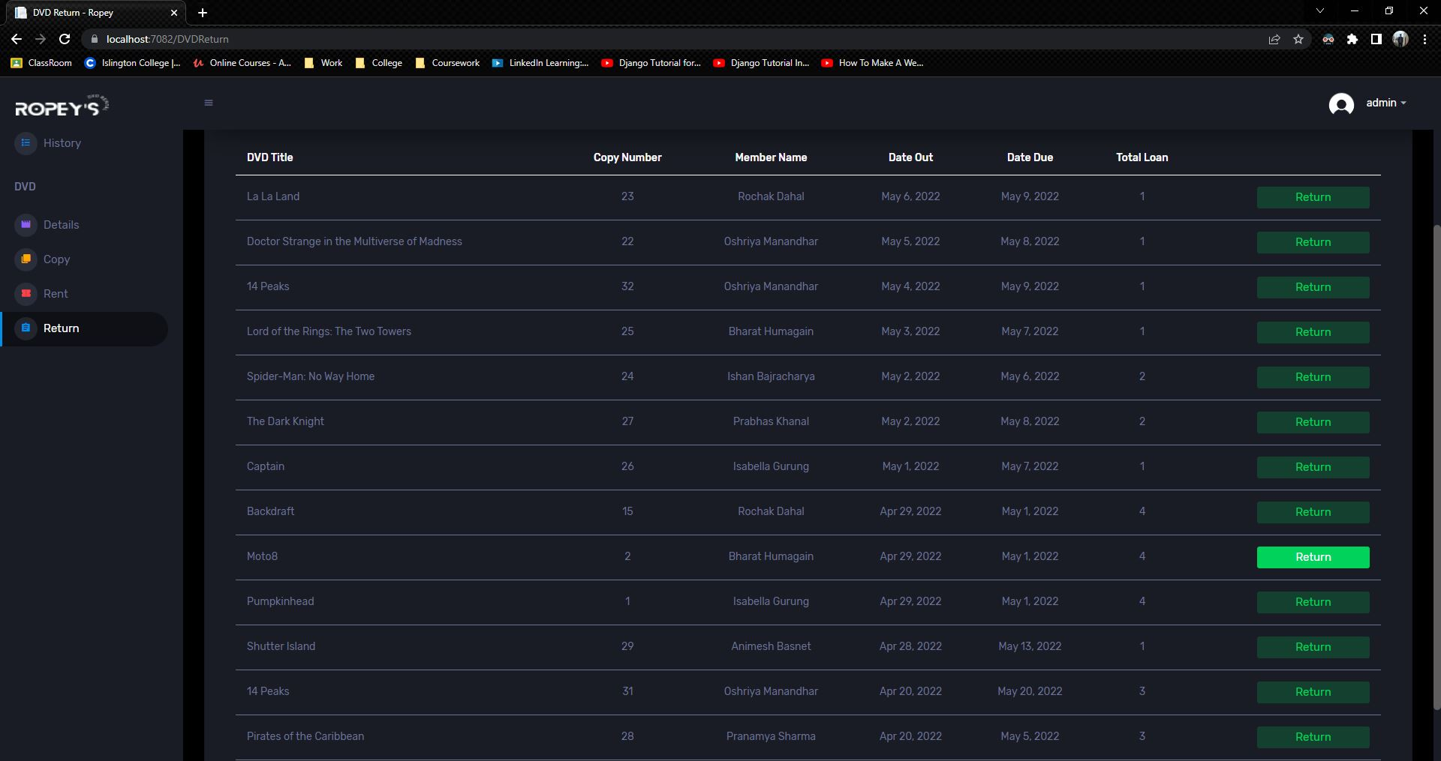

Figure 10: Test 5

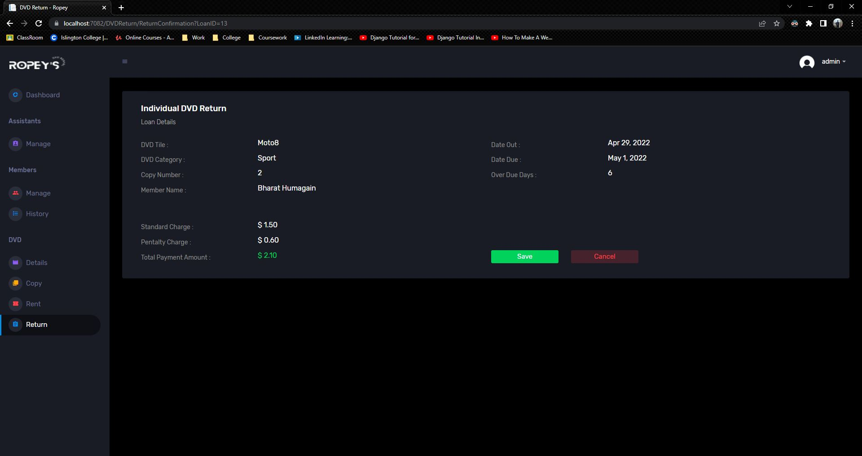

Figure 11: Test 5

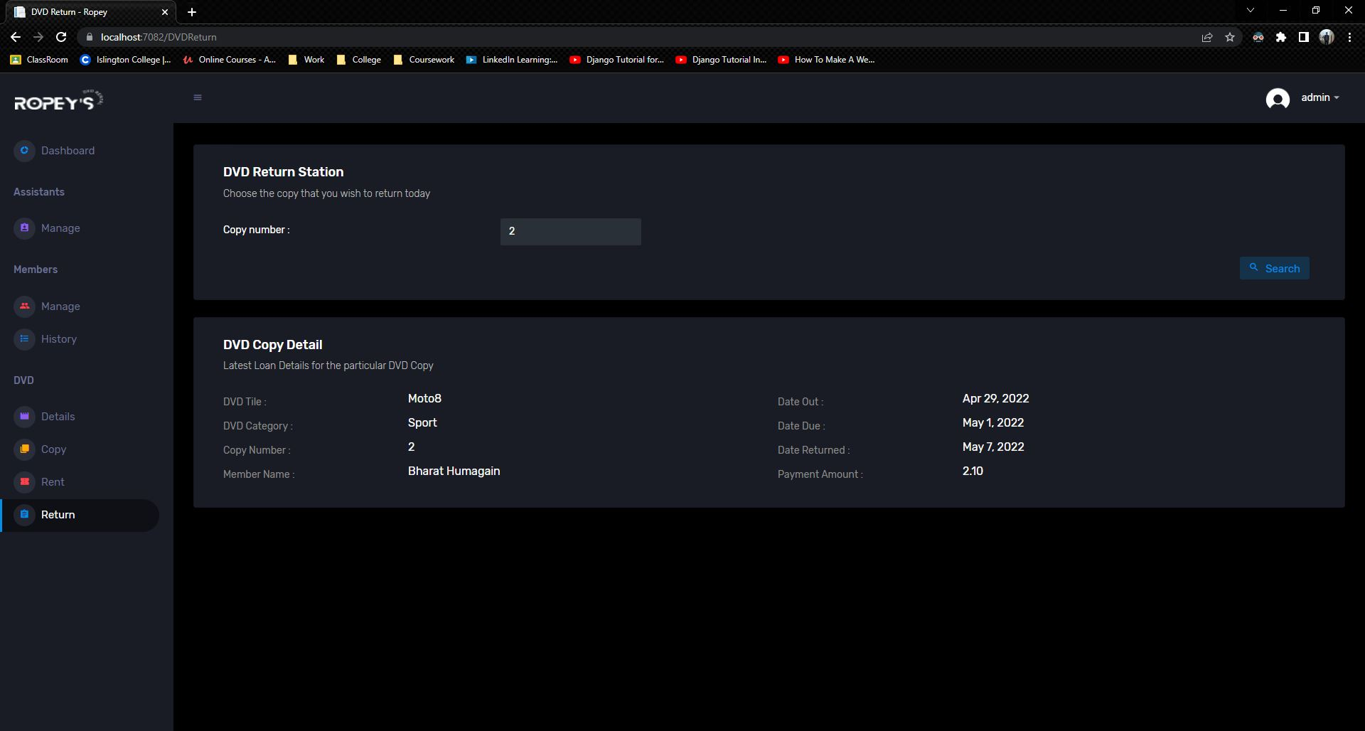

Figure 12: Test 5

## Test 6

|  |  |
| --- | --- |
| **Test No.6** | |
| Objective | To change password. |
| Action | The current password, new password and confirm new password were entered and the Update button was clicked, |
| Expected Output | The password would be updated. |
| Actual Output | The password was updated. |
| Result | The test was successful. |

Table 6: Test no.6

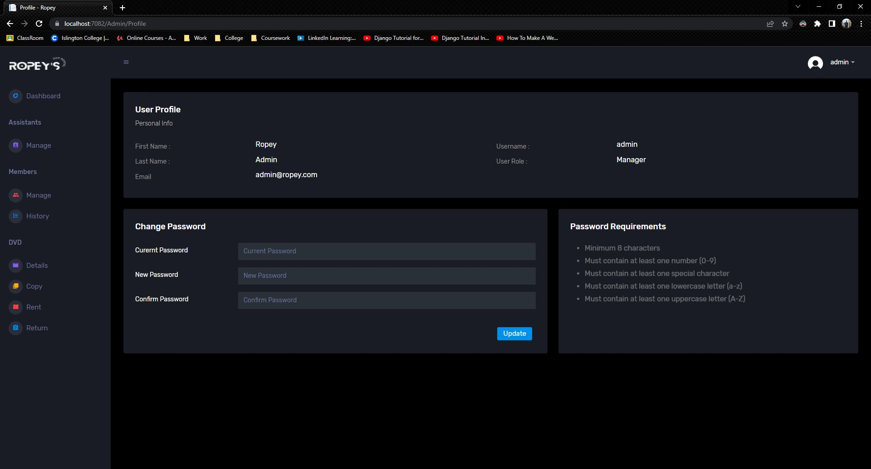

Figure 13: Test 6

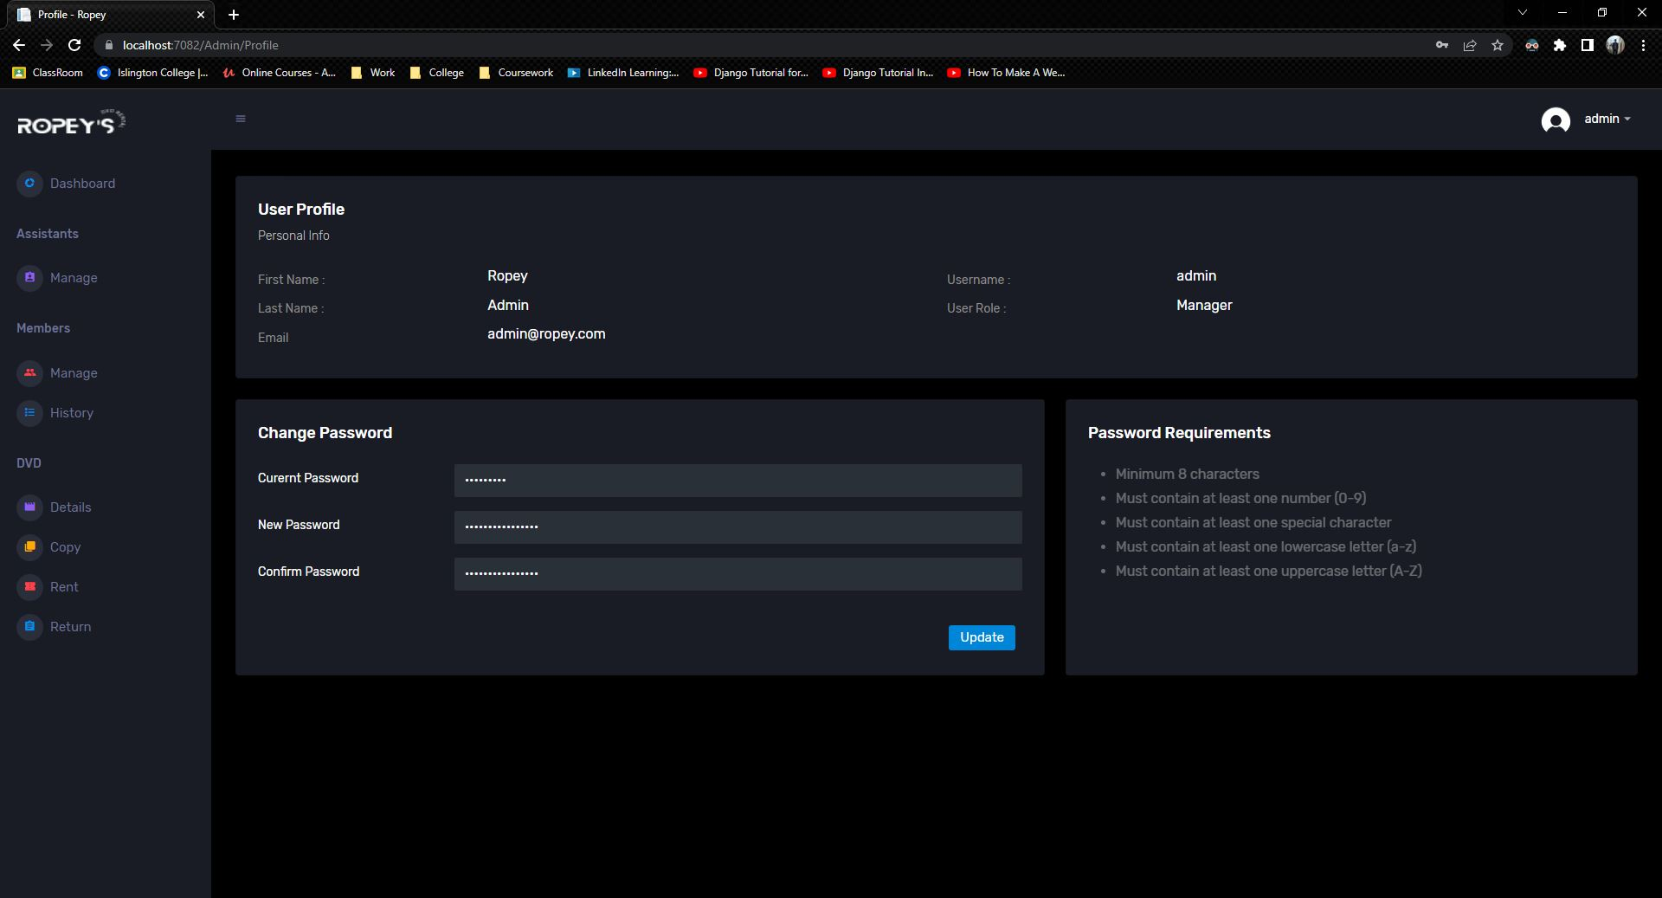

Figure 14: Test 6

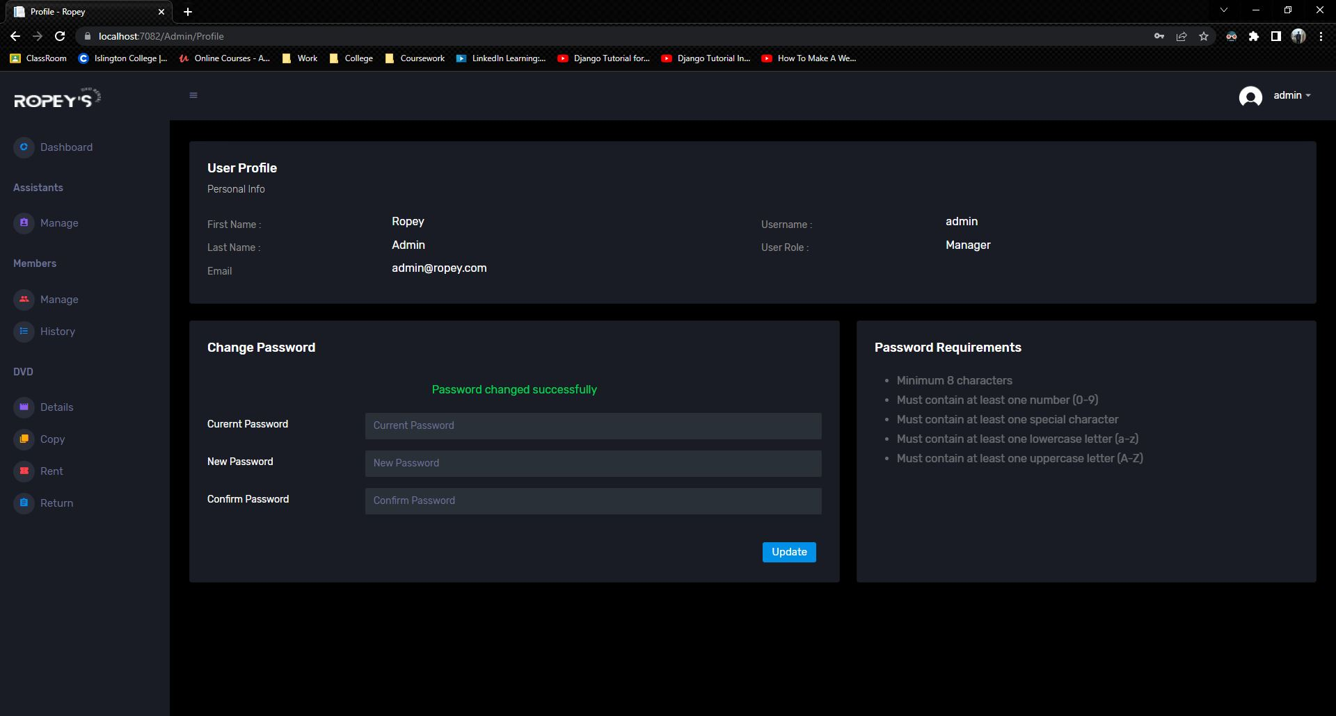

Figure 15: Test 6

## Test 7

|  |  |
| --- | --- |
| **Test No.7** | |
| Objective | To search DVD using Title Name. |
| Action | The Title Name was entered and the search button was clicked, |
| Expected Output | The user input DVD would be displayed. |
| Actual Output | The user input DVD was displayed. |
| Result | The test was successful. |

Table 7: Test no.7

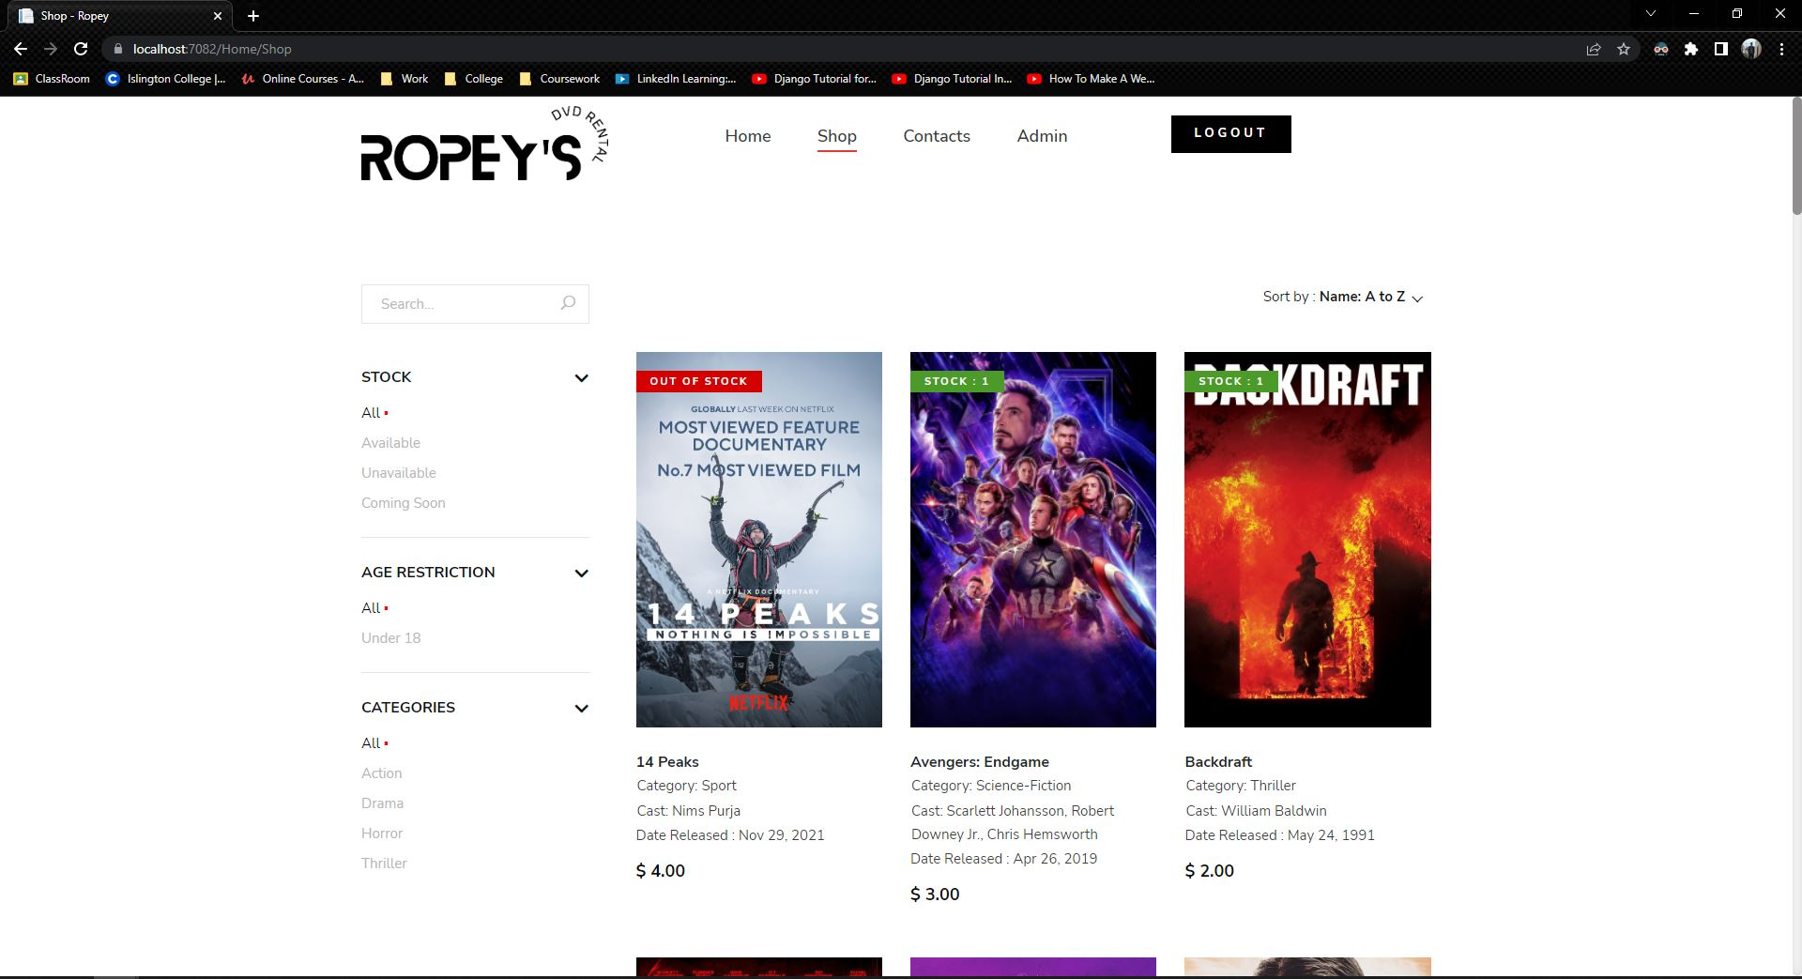

Figure 16: Test 7

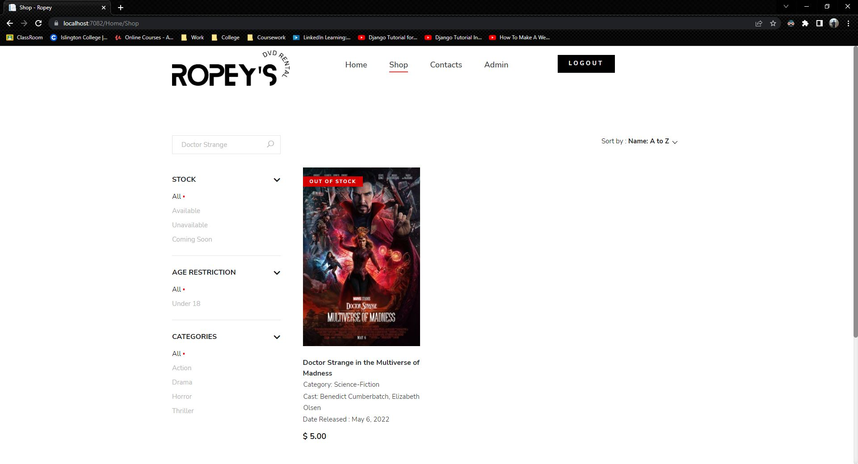

Figure 17: Test 7

## Test 8

|  |  |
| --- | --- |
| **Test No.8** | |
| Objective | To search DVD along with the number of copies by entering Actor's Last Name for which the Actor is a Cast Member. |
| Action | The Actor's Last Name was entered and the search button was clicked, |
| Expected Output | The user input Actor's DVD with number of copies would be displayed. |
| Actual Output | The user input Actor's DVD with number of copies was displayed. |
| Result | The test was successful. |

Table 8: Test no.8

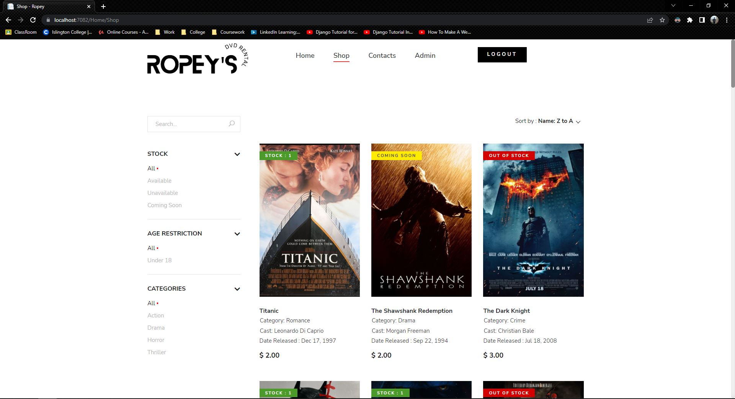

Figure 18: Test 8

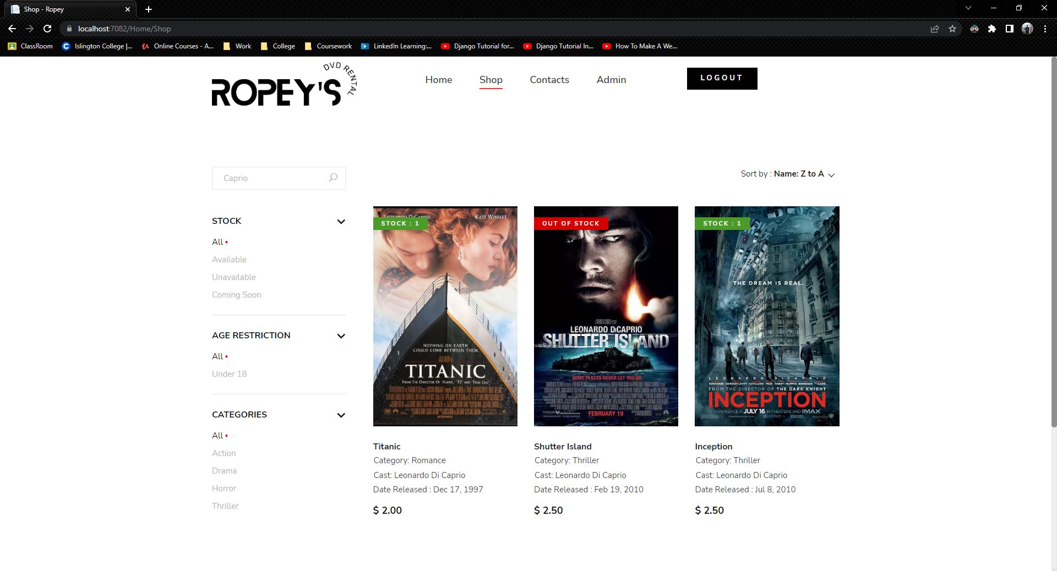

Figure 19: Test 8

## Test 9

|  |  |
| --- | --- |
| **Test No.9** | |
| Objective |  |
| Action |  |
| Expected Output |  |
| Actual Output |  |
| Result | The test was successful. |

Table 9: Test no.9

## Test 10

|  |  |
| --- | --- |
| **Test No.10** | |
| Objective |  |
| Action |  |
| Expected Output |  |
| Actual Output |  |
| Result | The test was successful. |

Table 10: Test no.10

## Test 11

|  |  |
| --- | --- |
| **Test No.11** | |
| Objective |  |
| Action |  |
| Expected Output |  |
| Actual Output |  |
| Result | The test was successful. |

Table 10: Test no.11

## Test 12

|  |  |
| --- | --- |
| **Test No.12** | |
| Objective |  |
| Action |  |
| Expected Output |  |
| Actual Output |  |
| Result | The test was successful. |

Table 10: Test no.12

## Test 13

|  |  |
| --- | --- |
| **Test No.13** | |
| Objective |  |
| Action |  |
| Expected Output |  |
| Actual Output |  |
| Result | The test was successful. |

Table 10: Test no.13

## Test 14

|  |  |
| --- | --- |
| **Test No.14** | |
| Objective |  |
| Action |  |
| Expected Output |  |
| Actual Output |  |
| Result | The test was successful. |

Table 10: Test no.14

## Test 15

|  |  |
| --- | --- |
| **Test No.15** | |
| Objective |  |
| Action |  |
| Expected Output |  |
| Actual Output |  |
| Result | The test was successful. |

Table 10: Test no.15

# Individual Reflection

**Member - 1 (Group Lead): Animesh Singh Basnet**

The

**Member - 2: Abhishek Rokaya**

All in all

**Member - 3: Pranamya Sharma**

The

**Member - 4: Oshriya Manandhar**

The

**Member - 5: Ushaan Shrestha**

The

# Conclusion

# Bibliography

Chand, M., 2020. *C# List Tutorial.* [Online]   
Available at: https://www.c-sharpcorner.com/article/c-sharp-list/

geeksforgeeks, 2019. *Introduction to Visual Studio.* [Online]   
Available at: https://www.geeksforgeeks.org/introduction-to-visual-studio/  
[Accessed 10 4 2022].

Geeksforgeeks, 2021. *Bubble Sort.* [Online]   
Available at: https://www.geeksforgeeks.org/bubble-sort/

Git, 2022. *git.* [Online]   
Available at: https://git-scm.com  
[Accessed 10 4 2022].

Microsoft, 2022. *Visual Studio.* [Online]   
Available at: https://visualstudio.microsoft.com/vs/  
[Accessed 10 4 2022].

Sayeed, A., 2019. *You Could Be The Winner.* Chhattisgarh: Sankalp Publications.

Shakya, S., 2019. *Information System.* s.l.:London Metripolitan.

Williams, A., 2012. *GitHub Pours Energies into Enterprise – Raises $100 Million From Power VC Andreessen Horowitz.* [Online]   
Available at: https://techcrunch.com/2012/07/09/github-pours-energies-into-enterprise-raises-100-million-from-power-vc-andreesen-horowitz/  
[Accessed 10 4 2022].

Yi, D., 2020. [Online]   
Available at: https://www.alibabacloud.com/blog/how-to-create-an-effective-technical-architectural-diagram_596100