# 依赖关系的解决

# 项目的内部依赖关系

项目的内部依赖关系表明的是：在coin-exchange该项目内部，我的那个模块需要依赖那个模块。

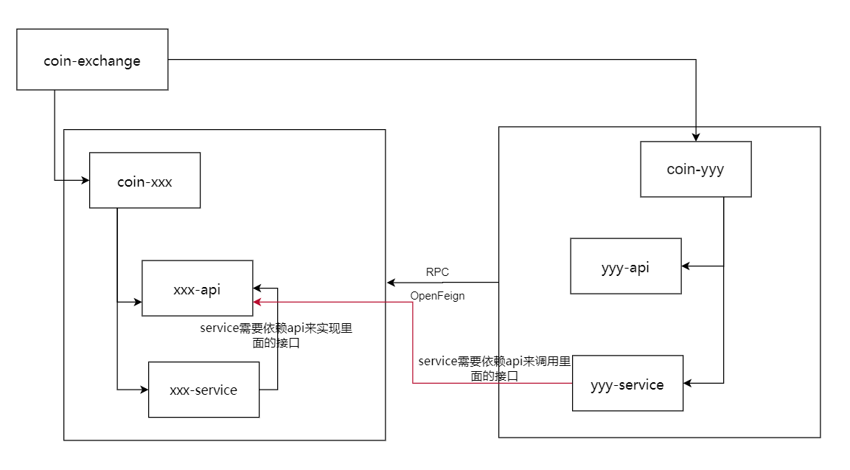

## 在所有service 里面添加自己项目api的依赖

涉及的项目包含：

* coin-admin
* coin-member
* coin-finance
* coin-chan
* coin-statistics
* match-engine
* exchange-engine

在这些项目的service 里面均需要添加api的依赖。

对于远程调用，我们暂时先不做依赖的管理

## 打包依赖后的项目

找到我们coin-exchange该父项目，点击install 即可打包所有的项目。

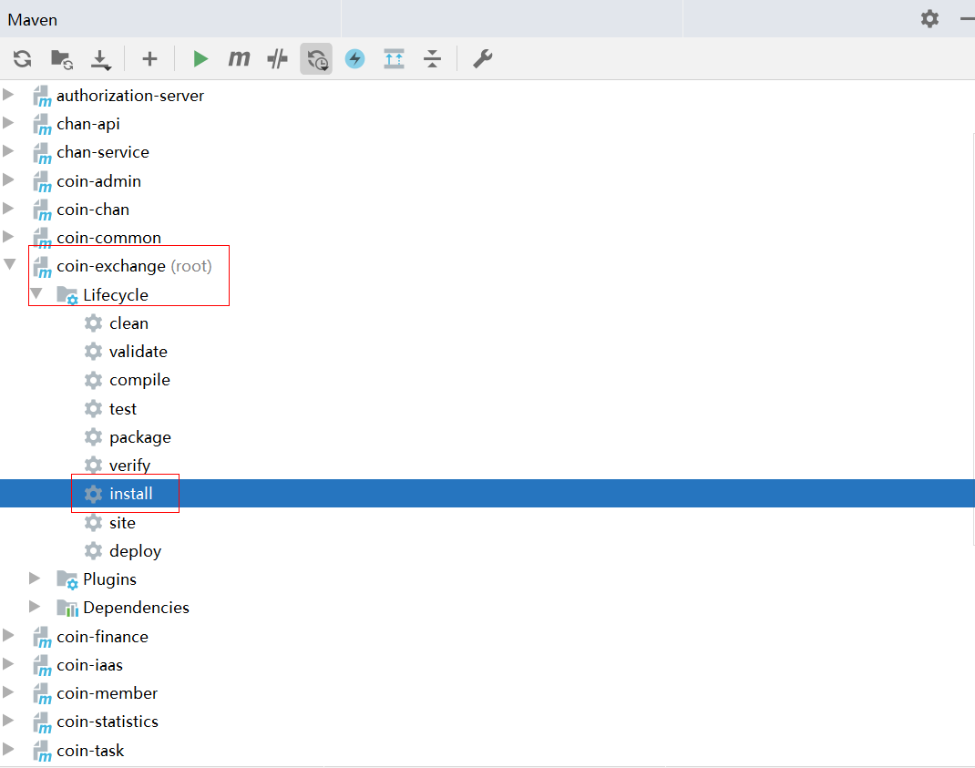

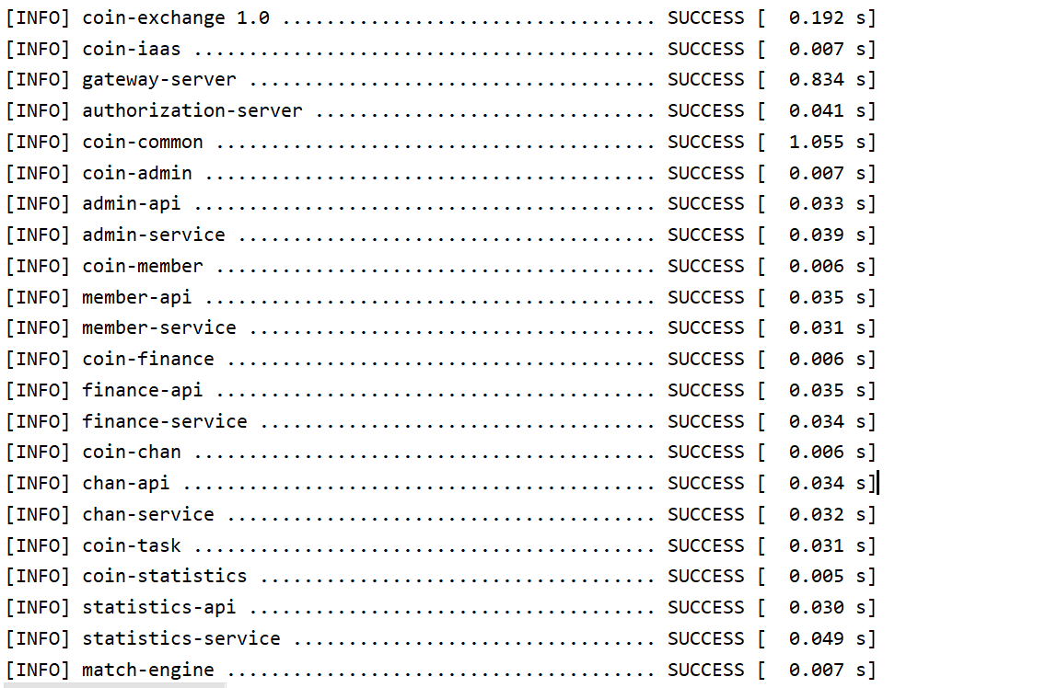

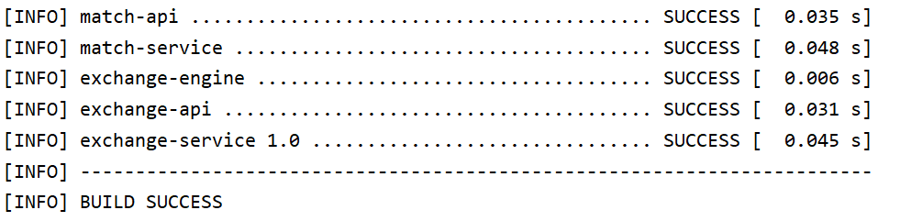

# 项目的外部依赖

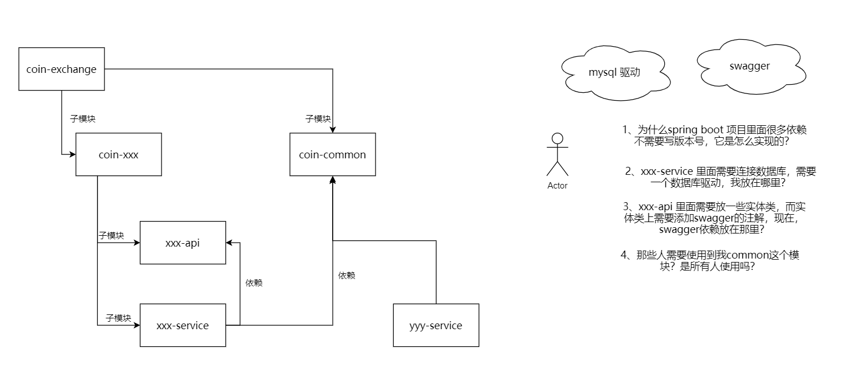

## 2.1 通过parent引入springboot

在coin-exchange项目里面，添加如下：

|  |
| --- |
| *<*parent*>  <*groupId*>*org.springframework.boot*</*groupId*>  <*artifactId*>*spring-boot-starter-parent*</*artifactId*>  <*version*>*2.2.3.RELEASE*</*version*>  <*relativePath*/> <!-- lookup parent from repository --> </*parent*>* |

## 2.2 通过依赖管理导入springcloud

### 2.2.1定义版本号

|  |
| --- |
| *<*properties*>  <*java.version*>*1.8*</*java.version*>  <*spring-cloud.version*>*Hoxton.SR3*</*spring-cloud.version*>*  *</*properties*>* |

### 2.2.2 依赖管理

|  |
| --- |
| *<*dependencyManagement*>  <*dependencies*>  <*dependency*>  <*groupId*>*org.springframework.cloud*</*groupId*>  <*artifactId*>*spring-cloud-dependencies*</*artifactId*>  <*version*>*${spring-cloud.version}*</*version*>  <*type*>*pom*</*type*>  <*scope*>*import*</*scope*>  </*dependency*>*  *<*dependencies*>*  *<*dependencyManagement*>* |

## 2.3 通过依赖管理导入spring-cloud-alibaba

### 2.3.1定义版本号

|  |
| --- |
| *<*properties*> <*java.version*>*1.8*</*java.version*> <*com-alibaba-cloud.version*>*2.2.0.RELEASE*</*com-alibaba-cloud.version*>*  *</*properties*>* |

### 2.3.2依赖管理

|  |
| --- |
| *<*dependencyManagement*>  <*dependencies*>  <*dependency*>*  *<*groupId*>*com.alibaba.cloud*</*groupId*>  <*artifactId*>*spring-cloud-alibaba-dependencies*</*artifactId*>  <*version*>*${com-alibaba-cloud.version}*</*version*>  <*type*>*pom*</*type*>  <*scope*>*import*</*scope*>  </*dependency*>*  *<*dependencies*>*  *<*dependencyManagement*>* |

## 2.4 其他依赖的导入

其他依赖我们均采用依赖管理的方式来导入

注意：其他依赖具体的作用，我们在使用到时，再给大家说明。

### 2.4.1 版本号的定义

|  |
| --- |
| *<*properties*>  <*java.version*>*1.8*</*java.version*>  <*spring-cloud.version*>*Hoxton.SR3*</*spring-cloud.version*>  <*com-alibaba-cloud.version*>*2.2.0.RELEASE*</*com-alibaba-cloud.version*>  <*mybatis-plus-boot-stater.version*>*3.3.2*</*mybatis-plus-boot-stater.version*>  <*druid-boot-stater.version*>*1.1.23*</*druid-boot-stater.version*>  <*redisson-spring-boot-starter.version*>*3.13.3*</*redisson-spring-boot-starter.version*>  <*jetcache-starter-redis.version*>*2.6.0*</*jetcache-starter-redis.version*>  <*disruptor.version*>*3.4.2*</*disruptor.version*>  <*org.mapstruct.version*>*1.4.0.Beta3*</*org.mapstruct.version*>  <*commons-beanutils.version*>*1.9.4*</*commons-beanutils.version*>  <*swagger-annotations.version*>*1.5.20*</*swagger-annotations.version*>  <*googleauth.version*>*1.1.5*</*googleauth.version*>  <*net.sf.supercsv.version*>*2.4.0*</*net.sf.supercsv.version*>  <*springside-utils.version*>*5.0.0-RC1*</*springside-utils.version*>  <*aliyun-sdk-oss.version*>*3.1.0*</*aliyun-sdk-oss.version*>  <*aliyun-java-sdk-core.version*>*4.0.3*</*aliyun-java-sdk-core.version*>  <*aliyun-java-sdk-dm.version*>*3.3.1*</*aliyun-java-sdk-dm.version*>  <*joda-time.version*>*2.10*</*joda-time.version*>  <*okhttp.version*>*3.11.0*</*okhttp.version*>  <*okio.version*>*1.15.0*</*okio.version*> </*properties*>* |

### 2.4.2 依赖管理

|  |
| --- |
| *<*dependencyManagement*>  <*dependencies*>  <*dependency*>  <*groupId*>*org.springframework.cloud*</*groupId*>  <*artifactId*>*spring-cloud-dependencies*</*artifactId*>  <*version*>*${spring-cloud.version}*</*version*>  <*type*>*pom*</*type*>  <*scope*>*import*</*scope*>  </*dependency*>  <*dependency*>  <*groupId*>*com.alibaba.cloud*</*groupId*>  <*artifactId*>*spring-cloud-alibaba-dependencies*</*artifactId*>  <*version*>*${com-alibaba-cloud.version}*</*version*>  <*type*>*pom*</*type*>  <*scope*>*import*</*scope*>  </*dependency*>  <*dependency*>  <*groupId*>*io.swagger*</*groupId*>  <*artifactId*>*swagger-annotations*</*artifactId*>  <*version*>*${swagger-annotations.version}*</*version*>  </*dependency*>  <*dependency*>  <*groupId*>*com.baomidou*</*groupId*>  <*artifactId*>*mybatis-plus-boot-starter*</*artifactId*>  <*version*>*${mybatis-plus-boot-stater.version}*</*version*>  </*dependency*>  <*dependency*>  <*groupId*>*com.baomidou*</*groupId*>  <*artifactId*>*mybatis-plus-annotation*</*artifactId*>  <*version*>*${mybatis-plus-boot-stater.version}*</*version*>  </*dependency*>  <!-- https://mvnrepository.com/artifact/com.alibaba/druid-spring-boot-starter -->  <*dependency*>  <*groupId*>*com.alibaba*</*groupId*>  <*artifactId*>*druid-spring-boot-starter*</*artifactId*>  <*version*>*${druid-boot-stater.version}*</*version*>  </*dependency*>   <*dependency*>  <*groupId*>*commons-beanutils*</*groupId*>  <*artifactId*>*commons-beanutils*</*artifactId*>  <*version*>*${commons-beanutils.version}*</*version*>  </*dependency*>  <!-- https://mvnrepository.com/artifact/org.redisson/redisson-spring-boot-starter -->  <*dependency*>  <*groupId*>*org.redisson*</*groupId*>  <*artifactId*>*redisson-spring-boot-starter*</*artifactId*>  <*version*>*${redisson-spring-boot-starter.version}*</*version*>  </*dependency*>   <!-- https://mvnrepository.com/artifact/com.alicp.jetcache/jetcache-starter-redis -->  <*dependency*>  <*groupId*>*com.alicp.jetcache*</*groupId*>  <*artifactId*>*jetcache-starter-redis*</*artifactId*>  <*version*>*${jetcache-starter-redis.version}*</*version*>  </*dependency*>  <!-- https://mvnrepository.com/artifact/com.lmax/disruptor -->  <*dependency*>  <*groupId*>*com.lmax*</*groupId*>  <*artifactId*>*disruptor*</*artifactId*>  <*version*>*${disruptor.version}*</*version*>  </*dependency*>  <*dependency*>  <*groupId*>*io.springfox*</*groupId*>  <*artifactId*>*springfox-swagger2*</*artifactId*>  <*version*>*${swagger2.version}*</*version*>  </*dependency*>  <*dependency*>  <*groupId*>*io.springfox*</*groupId*>  <*artifactId*>*springfox-swagger-ui*</*artifactId*>  <*version*>*${swagger2.version}*</*version*>  </*dependency*>   <!--mapStruct依赖-->  <*dependency*>  <*groupId*>*org.mapstruct*</*groupId*>  <*artifactId*>*mapstruct-jdk8*</*artifactId*>  <*version*>*${org.mapstruct.version}*</*version*>  </*dependency*>  <*dependency*>  <*groupId*>*org.mapstruct*</*groupId*>  <*artifactId*>*mapstruct-processor*</*artifactId*>  <*version*>*${org.mapstruct.version}*</*version*>  <*scope*>*provided*</*scope*>  </*dependency*>   <*dependency*>  <*groupId*>*net.sf.supercsv*</*groupId*>  <*artifactId*>*super-csv*</*artifactId*>  <*version*>*${net.sf.supercsv.version}*</*version*>  </*dependency*>   <*dependency*>  <*groupId*>*io.springside*</*groupId*>  <*artifactId*>*springside-utils*</*artifactId*>  <*version*>*${springside-utils.version}*</*version*>  </*dependency*>   <*dependency*>  <*groupId*>*org.flywaydb*</*groupId*>  <*artifactId*>*flyway-core*</*artifactId*>  <*version*>*${flyway.version}*</*version*>  </*dependency*>  <*dependency*>  <*groupId*>*joda-time*</*groupId*>  <*artifactId*>*joda-time*</*artifactId*>  <*version*>*${joda-time.version}*</*version*>  </*dependency*>  <*dependency*>  <*groupId*>*com.squareup.okhttp3*</*groupId*>  <*artifactId*>*okhttp*</*artifactId*>  <*version*>*${okhttp.version}*</*version*>  </*dependency*>  <*dependency*>  <*groupId*>*com.squareup.okio*</*groupId*>  <*artifactId*>*okio*</*artifactId*>  <*version*>*${okio.version}*</*version*>  </*dependency*>  <*dependency*>  <*groupId*>*com.aliyun.oss*</*groupId*>  <*artifactId*>*aliyun-sdk-oss*</*artifactId*>  <*version*>*${aliyun-sdk-oss.version}*</*version*>  </*dependency*>  <*dependency*>  <*groupId*>*com.aliyun*</*groupId*>  <*artifactId*>*aliyun-java-sdk-core*</*artifactId*>  <*version*>*${aliyun-java-sdk-core.version}*</*version*>  </*dependency*>  <*dependency*>  <*groupId*>*com.aliyun*</*groupId*>  <*artifactId*>*aliyun-java-sdk-dm*</*artifactId*>  <*version*>*${aliyun-java-sdk-dm.version}*</*version*>  </*dependency*>  </*dependencies*> </*dependencyManagement*>* |

# coin-exchange 依赖

coin-exchang 是所有项目的父项目，在它里面添加依赖时需要谨慎，因为它的依赖会传递到我们所有的子项目里面。

我们在coin-exchange里面依赖：

|  |
| --- |
| *<*dependencies*>  <*dependency*>  <*groupId*>*org.projectlombok*</*groupId*>  <*artifactId*>*lombok*</*artifactId*>  </*dependency*>  <!-- https://mvnrepository.com/artifact/io.swagger/swagger-annotations -->  <*dependency*>  <*groupId*>*io.swagger*</*groupId*>  <*artifactId*>*swagger-annotations*</*artifactId*>  </*dependency*>  <*dependency*>  <*groupId*>*com.baomidou*</*groupId*>  <*artifactId*>*mybatis-plus-annotation*</*artifactId*>  </*dependency*>  <!-- https://mvnrepository.com/artifact/com.fasterxml.jackson.core/jackson-annotations -->  <*dependency*>  <*groupId*>*com.fasterxml.jackson.core*</*groupId*>  <*artifactId*>*jackson-annotations*</*artifactId*>  </*dependency*> </*dependencies*>* |

大家不难发现，我们仅仅依赖了一些注解而已。

# coin-common的依赖

coin-common 以后将会让所有的xxx-service依赖，因此我们需要提取xxx-service里面所有的公共依赖。现在我们来思考一下，作为一个微服务或中台服务，都需要那些依赖：

* 服务注册

|  |
| --- |
| *<*dependency*>  <*groupId*>*com.alibaba.cloud*</*groupId*>  <*artifactId*>*spring-cloud-starter-alibaba-nacos-discovery*</*artifactId*> </*dependency*>* |

* 配置文件拉取

|  |
| --- |
| *<*dependency*>  <*groupId*>*com.alibaba.cloud*</*groupId*>  <*artifactId*>*spring-cloud-starter-alibaba-nacos-config*</*artifactId*> </*dependency*>* |

* 服务保护（限流、熔断）

|  |
| --- |
| *<*dependency*>  <*groupId*>*com.alibaba.cloud*</*groupId*>  <*artifactId*>*spring-cloud-starter-alibaba-sentinel*</*artifactId*> </*dependency*>* |

* 服务保护（鉴权）

|  |
| --- |
| *<*dependency*>  <*groupId*>*org.springframework.cloud*</*groupId*>  <*artifactId*>*spring-cloud-starter-oauth2*</*artifactId*> </*dependency*>* |

* 数据库的访问

|  |
| --- |
| *<*dependency*>  <*groupId*>*com.baomidou*</*groupId*>  <*artifactId*>*mybatis-plus-boot-starter*</*artifactId*> </*dependency*> <*dependency*>  <*groupId*>*mysql*</*groupId*>  <*artifactId*>*mysql-connector-java*</*artifactId*> </*dependency*>* |

* 缓存的使用

|  |
| --- |
| *<*dependency*>  <*groupId*>*com.alicp.jetcache*</*groupId*>  <*artifactId*>*jetcache-starter-redis*</*artifactId*> </*dependency*>* |

* 工具类

|  |
| --- |
| *<*dependency*>  <*groupId*>*io.springside*</*groupId*>  <*artifactId*>*springside-utils*</*artifactId*> </*dependency*>* |

* 远程调用

|  |
| --- |
| *<*dependency*>  <*groupId*>*org.springframework.cloud*</*groupId*>  <*artifactId*>*spring-cloud-starter-openfeign*</*artifactId*> </*dependency*>* |

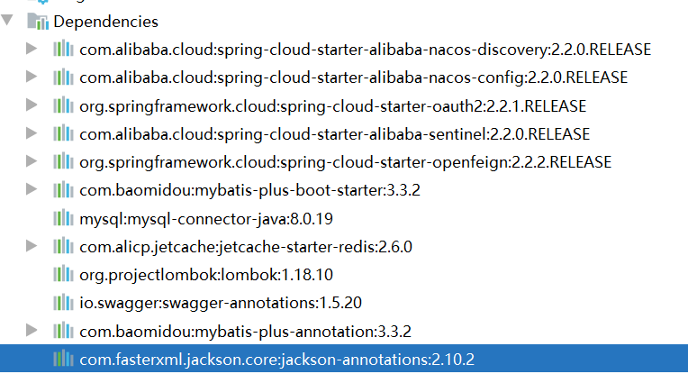

# xxx-service的依赖

在所有的xxx-service 里面依赖coin-common

# 打包插件

我们的模块以后需要单独的运行起来，因此我们还需要添加一个打包插件：

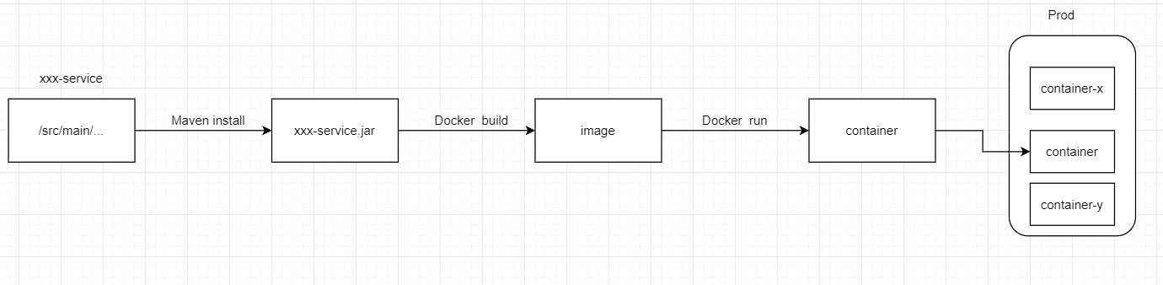

|  |
| --- |
| *<*build*>  <*plugins*>  <*plugin*>  <*groupId*>*org.springframework.boot*</*groupId*>  <*artifactId*>*spring-boot-maven-plugin*</*artifactId*>  </*plugin*>  </*plugins*> </*build*>* |