# 推送系统的实现

# 任务系统的简介

从上游(Match-engine\Exchange-engin)会获取数据,对数据做一定的加工后,将该数据推送给下游服务里面.

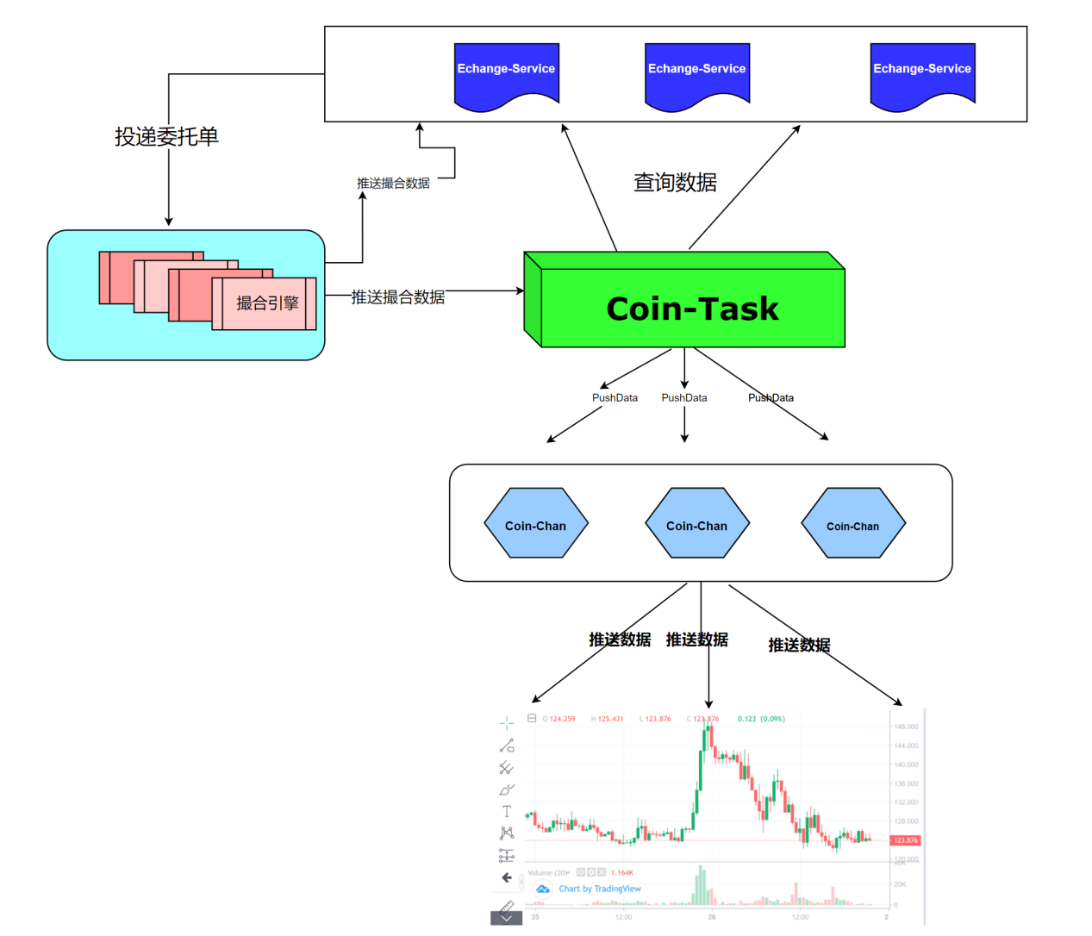

# 任务系统的启动

## 2.1 事件

事件是某种动作的载体,我们认为发送了某种事件后,肯定会触发该动作。

## 2.2 定时任务

使用定时任务触发事件,从而引发事件里面的处理器处理它

## 2.3 添加依赖

|  |
| --- |
| <dependency>  <groupId>com.bjsxt</groupId>  <artifactId>coin-common</artifactId>  <version>1.0</version> </dependency> <dependency>  <groupId>joda-time</groupId>  <artifactId>joda-time</artifactId> </dependency> <dependency>  <groupId>com.bjsxt</groupId>  <artifactId>exchange-api</artifactId>  <version>1.0</version> </dependency> |

## 2.4 添加配置文件

|  |
| --- |
| spring:  application:  name: task-service  cloud: *# nacos地址* nacos:  server-addr: nacos-server:8848  config:  file-extension: yaml  stream:  bindings:  subscribe_event_out: {destination: tio_group, content-type: application/plain, group: order-group, consumer.maxAttempts: 1}  rocketmq:  binder:  name-server: rocket-server:9876  profiles:  active: dev *# 拉取的配置文件的dataID = task-service-dev.yaml* |

## 2.5 添加启动类

|  |
| --- |
| @SpringBootApplication @EnableScheduling @EnableDiscoveryClient public class TaskServiceApplication {   public static void main(String[] args) {  SpringApplication.*run*(TaskServiceApplication.class,args) ;  } } |

# 事件定义

## 3.1 定义事件的接口

|  |
| --- |
| */**  * 事件的接口  */* public interface Event {   */**  * 事件触发处理机制  */* void handle(); } |

## 3.2 盘口深度事件

|  |
| --- |
| */**  * 深度盘口数据事件  */* @Component @Slf4j public class DepthEvent implements Event {  */**  * 推送市场合并深度  */* @Override  public void handle() {    } } |

## 3.3 K线推送事件

|  |
| --- |
| */**  * K 线推送事件  */* @Component @Slf4j public class KlineEvent implements Runnable,Event {   */**  * 交易对标识符  */* private String symbol;   */**  * 通道  */* private String channel;   */**  * redis key 前缀  */* private String keyPrefix;   public KlineEvent() {  }   public KlineEvent(String symbol, String channel, String keyPrefix) {  this.symbol = symbol;  this.channel = channel;  this.keyPrefix = keyPrefix;  }   */**  * 事件触发处理机制  */* @Override  public void handle() {    }   */**  * 让线程池调度  */* @Override  public void run() {  handle();  }  } |

## 3.4 实时成交订单事件

|  |
| --- |
| */**  * 成交记录事件  */* @Component @Slf4j public class TradeEvent implements Event {   @Override  public void handle() {    } |

## 3.5 币币交易数据事件

|  |
| --- |
| */**  * 行情数据的K线  */* @Component @Slf4j public class TradeKLineEvent implements Event {   @Override  public void handle() {  }  } |

## 3.6 行情市场的事件

|  |
| --- |
| */**  * 行情市场的K 线  */* @Component @Slf4j public class MarketEvent implements Event {  @Override  public void handle() {  }    } |

# 事件触发

## 4.1 关于行情事件的触发

|  |
| --- |
| */**  * 行情的任务触发  */* @Component public class MarketTickerTask {   @Autowired  private MarketEvent marketEvent;   @Autowired  private TradeEvent tradeEvent;   @Autowired  private DepthEvent depthEvent;    */**  * 推送交易对信息  */* @Scheduled(fixedRate = 1000)  public void pushMarkets() {  marketEvent.handle();  }   */**  * 推送市场深度  */* @Scheduled(fixedRate = 500)  public void pushDepths() {  depthEvent.handle();  }   */**  * 推送实时成交订单数据  */* @Scheduled(fixedRate = 500)  public void pushTrades() {  tradeEvent.handle();  }  } |

## 4.2 关于K线事件的触发

|  |
| --- |
| */**  * K 线数据的推送  */* @Component @Slf4j public class TopicKLineTask{    private ExecutorService executor = null;   {  executor = new ThreadPoolExecutor(  5,  10,  100L, TimeUnit.*MILLISECONDS*,  new LinkedBlockingQueue<>(30),  new ThreadPoolExecutor.CallerRunsPolicy());  }   */**  * 每3秒推送K线数据  */* @Scheduled(fixedRate = 3000)  public void pushKline() {   String channel = "market.%s.kline.%s";  executor.submit(new KlineEvent())  } } |

## 4.3 关于交易事件的触发

|  |
| --- |
| @Component @Slf4j public class TradeKLineTask {   @Autowired  private TradeKLineEvent tradeKLineEvent;   */**  * 币币交易生成一次K线  */* @Scheduled(fixedRate = 25000)  public void generateKLine() {  tradeKLineEvent.handle();  } } |

# 整合MQ 向下游发送数据

## 5.1 添加依赖

|  |
| --- |
| <dependency>  <groupId>com.alibaba.cloud</groupId>  <artifactId>spring-cloud-stream-binder-rocketmq</artifactId> </dependency> |

## 5.2 添加Source

|  |
| --- |
| public interface Source {    */**  * 向指定的output 里面输出信息  * @return  */* @Output("subscribe_event_out")  MessageChannel subscribeEventOutput() ; } |

## 5.3 开启Stream

|  |
| --- |
| */**  * 开启Stream  */* @Configuration @EnableBinding(value = Source.class) public class RocketMqConfig { } |

## 5.3 添加配置文件

|  |
| --- |
| spring:  application:  name: task-service  cloud: *# nacos地址* nacos:  server-addr: nacos-server:8848  config:  file-extension: yaml  stream:  bindings:  subscribe_event_out: {destination: tio_group, content-type: application/plain, group: order-group, consumer.maxAttempts: 1}  rocketmq:  binder:  name-server: rocket-server:9876  profiles:  active: dev *# 拉取的配置文件的dataID = task-service-dev.yaml* |

## 5.4 添加常用的工具类/枚举类

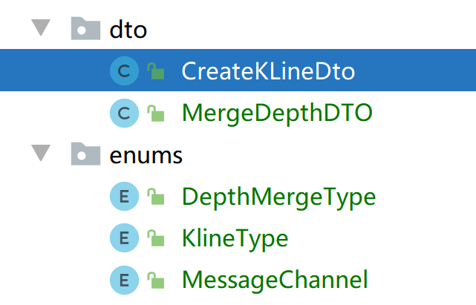

### CreateKLineDto : common里面

|  |
| --- |
| @Data @EqualsAndHashCode public class CreateKLineDto {   */**  * 交易对名称  */* private String symbol;   */**  * 交易的价格  */* private BigDecimal price;   */**  * 交易的数量  */* private BigDecimal volume;  } |

### MergeDepthDTO :

|  |
| --- |
| @Data @NoArgsConstructor @Accessors(chain = true) public class MergeDepthDTO {   */**  * 合并类型  */* private String mergeType;   */**  * 合并精度  */* private BigDecimal value; } |

### DepthMergeType :

|  |
| --- |
| public enum DepthMergeType {   *DEFAULT*("step0", 0),  *LOW*("step1", 1),  *HIGH*("step2", 2);   */**  * 代码  */* private String code;   */**  * 值  */* private int value;   public String getCode() {  return code;  }   public void setCode(String code) {  this.code = code;  }   public int getValue() {  return value;  }   public void setValue(int value) {  this.value = value;  }   DepthMergeType(String code, int value) {  this.code = code;  this.value = value;  }   public static DepthMergeType getByCode(String code) {  if (StringUtils.*isEmpty*(code)) {  return null;  }  for (DepthMergeType depthMergeType : DepthMergeType.*values*()) {  if (depthMergeType.getCode().equals(code)) {  return depthMergeType;  }  }  return null;  }   public static DepthMergeType getByValue(int value) {  for (DepthMergeType depthMergeType : DepthMergeType.*values*()) {  if (depthMergeType.getValue() == value) {  return depthMergeType;  }  }  return null;  } } |

### KlineType:

|  |
| --- |
| */**  * K线类型  */* public enum KlineType {    *ONE_MINUTES*("1min"),  *FIVE_MINUTES*("5min"),  *FIFTEEN_MINUTES*("15min"),  *THIRTY_MINUTES*("30min"),  *ONE_HOUR*("1hour"),  *TWO_HOURS*("2hour"),  *FOUR_HOURS*("4hour"),  *SIX_HOURS*("6hour"),  *TWELVE_HOURS*("12hour"),  *ONE_DAY*("1day"),  *ONE_WEEK*("1week"),  *ONE_MONTH*("1mon"),  *ONE_YEAR*("1year");   private String value;   KlineType(final String value) {  this.value = value;  }   public String getValue(){  return this.value;  }   public static KlineType getByValue(String value) {  for (KlineType klineType : KlineType.*values*()) {  if (klineType.getValue().equals(value)) {  return klineType;  }  }  return null;  } } |

### MessageChannel :

|  |
| --- |
| */**  * 订阅的频道名称  */* public enum MessageChannel {    *ORDER_TX*("order.tx"),  *ORDER_CANCEL*("order.cancel"),  *ORDER_IN*("order.in"),  *MATCH_IN*("match.in"),  *ORDER_DELAY_NOTIFY*("order.delay.notify"),  *SYNC_ACCOUNT*("sync.account"),  *MARKET_REFRESH*("market.refresh"),  *BONUS*("bonus"),  *REGISTER_REWARD*("register.reward"),  *FINANCE_RECHARGE_SUCCESS*("finance.recharge.success"),  *FINANCE_WITHDRAW_RESULT*("finance.withdraw.result"),  *RECHARGE_ADDRESS*("plant.user.address");   private String channel;   MessageChannel(String channel) {  this.channel = channel;  }   public String getChannel() {  return channel;  }   public void setChannel(String channel) {  this.channel = channel;  } } |

### 常量Constants :

|  |
| --- |
| */**  * 常用的常量  */* public interface Constants {  */**  * UTF-8 字符集  */* public static final String *UTF8* = "UTF-8";   */**  * GBK 字符集  */* public static final String *GBK* = "GBK";   */**  * http请求  */* public static final String *HTTP* = "http://";   */**  * https请求  */* public static final String *HTTPS* = "https://";   */**  * 成功标记  */* public static final Integer *SUCCESS* = 200;   */**  * 失败标记  */* public static final Integer *FAIL* = 500;    */**  * 验证码 redis key  */* public static final String *CAPTCHA_CODE_KEY* = "captcha_codes:";   */**  * 验证码有效期（分钟）  */* public static final long *CAPTCHA_EXPIRATION* = 2;    */**  * 数值类型精度  */* public static final int *SCALE* = 8;   public static final int *AGENT_TYPE* = 2;   public static final String *BCRYPT_SALT* = "!waihui!_+waihui+-";   */**  * 首页Banner图  */* public static final String *CONFIG_WEB_BANNER* = "WEB_BANNER";   public static final String *TOKEN* = "token";   */*********************************** MATCH ********************************/* public static final String *MATCH_RESULT_DEAL_ORDER* = "dealOrder";  public static final String *MATCH_RESULT_BUY_ORDER* = "buyOrder";  public static final String *MATCH_RESULT_SELL_ORDER* = "sellOrder";  public static final String *MATCH_RESULT_NEW_BUY_LOCK* = "buyLock";  public static final String *MATCH_RESULT_NEW_SELL_LOCK* = "sellLock";  public static final String *MATCH_RESULT_PART_MATCH* = "partMatch";  */*********************************** MATCH ********************************/    /*********************************** CONFIG TABLE CODE ********************************/* public static final String *CONFIG_TYPE_SYSTEM* = "SYSTEM";  public static final String *CONFIG_TYPE_CNY* = "CNY";  public static final String *CONFIG_TYPE_SMS* = "SMS";  public static final String *CONFIG_TYPE_REGISTER* = "REGISTER_REWARD";  public static final String *CONFIG_TYPE_REWARD* = "INVITE_REWARD";   */**  * 最小提现额度（USDT）  */* public static final String *CONFIG_WITHDRAW_MIN_AMOUNT* = "WITHDRAW_MIN_AMOUNT";   */**  * 最大提现额度（USDT）  */* public static final String *CONFIG_WITHDRAW_MAX_AMOUNT* = "WITHDRAW_MAX_AMOUNT";   */**  * 最小取现手续费（USDT）  */* public static final String *CONFIG_WITHDRAW_MIN_POUNDAGE* = "WITHDRAW_MIN_POUNDAGE";   */**  * 取现手续费率（USDT）  */* public static final String *CONFIG_WITHDRAW_POUNDAGE_RATE* = "WITHDRAW_POUNDAGE_RATE";   */**  * 取现基数（USDT），取现值必须是基数的倍数，基数如果是100，那么取现值只能是100的倍数，例如：200, 300等  */* public static final String *CONFIG_WITHDRAW_BASEAMOUNT* = "CONFIG_WITHDRAW_BASEAMOUNT";   */**  * 每日最大提现额（USDT）  */* public static final String *CONFIG_WITHDRAW_DAY_MAX_AMOUNT* = "WITHDRAW_DAY_MAX_AMOUNT";   */**  * 提现状态（USDT）  */* String *CONFIG_WITHDRAW_STATUS* = "WITHDRAW_STATUS";   */**  * 币币交易状态  */* String *CONFIG_TRADE_STATUS* = "TRADE_STATUS";   */**  * 人民币充值USDT换算费率  */* String *CONFIG_CNY2USDT* = "CNY2USDT";   */**  * 人民币提现USDT换算费率  */* String *CONFIG_USDT2CNY* = "USDT2CNY";   */**  * 提现审核级数  */* String *CONFIG_CASH_WITHDRAW_AUDIT_STEPS* = "CASH_WITHDRAW_AUDIT_STEPS";   */**  * 充值审核级数  */* String *CONFIG_CASH_RECHARGE_AUDIT_STEPS* = "CASH_RECHARGE_AUDIT_STEPS";   */**  * 提币审核级数  */* String *CONFIG_COIN_WITHDRAW_AUDIT_STEPS* = "COIN_WITHDRAW_AUDIT_STEPS";   String *C2C_ADMIN_USER_ID* = "C2C_ADMIN_USER_ID";  */*********************************** CONFIG TABLE CODE ********************************/    /************************************* CACHE KEY ************************************/  /**  * 交易区域  */* String *CACHE_KEY_TRADE_AREA* = "tradeArea:";   */**  * 交易区域  */* String *CACHE_KEY_TRADE_AREAS* = "tradeAreas:";   */**  * 币种  */* String *CACHE_KEY_COIN* = "coin:";   */**  * 交易对列表  */* String *CACHE_KEY_MARKETS* = "markets:";   */**  * 交易对列表  */* String *CACHE_KEY_AREA_MARKETS* = "areaMarkets:";   */**  * 交易对  */* String *CACHE_KEY_MARKET* = "market:";   */**  * 基础配置  */* String *CACHE_KEY_CONFIG* = "config:";   */**  * 系统配置列表  */* String *CACHE_KEY_CONFIG_LIST* = "config_list:";   */**  * 管理员  */* String *CACHE_KEY_ADMIN_USER* = "user_admin";  String *CACHE_KEY_C2C_ADMIN_USER* = "user_c2c_admin";  String *CACHE_KEY_AGENT_ADMIN_USER* = "user_agent_admin";  */************************************* CACHE KEY ************************************/    /**  * 币币市场行情Socket推送  */* String *CH_MARKETS_TICKER* = "market.ticker";  */**  * 未成交委托订阅通道  */* String *CH_ORDER_PENDING* = "order.pending.update";  */**  * 历史委托订阅通道  */* String *CH_ORDER_FINISHED* = "order.finished.update";  */**  * 持仓汇总订阅通道  */* String *CH_POSITION_SUMMARY_UPDATE* = "position.summary.update";  */**  * 今日平仓订阅通道  */* String *CH_CLOSEPOSITION_ORDERS_UPDATE* = "closeposition.orders.update";  */**  * 今日委托订阅通道  */* String *CH_ENTRUST_ORDERS_UPDATE* = "entrust.orders.update";  */**  * 今日成交订阅通道  */* String *CH_TURNOVER_ORDERS_UPDATE* = "turnover.orders.update";    */************************************* REDIS KEY ************************************/  /**  * 验证码redis存储Key  */* String *REDIS_KEY_CAPTCHA_KEY* = "CAPTCHA:";   */**  * 短信验证码redis存储Key  */* String *REDIS_KEY_SMS_CODE_KEY* = "SMSCODE:";   */**  * 登录设备存储key  */* String *REDIS_KEY_DEVICES_KEY* = "DEVICES";   */**  * 最大缓存数据量  */* long *REDIS_MAX_CACHE_KLINE_SIZE* = 10000L;   */**  * 币币交易K线 redis存储Key  */* String *REDIS_KEY_TRADE_KLINE* = "TRADE_KLINE:";    */**  * 币币交易撮合队列 redis存储Key  */* String *REDIS_KEY_TRADE_MATCH* = "TRADE_MATCH:";   */**  * 币币交易对  */* String *REDIS_KEY_TRADE_MARKET* = "TRADE_MARKET";   */**  * 法币充值审核锁  */* String *REDIS_KEY_CASH_RECHARGE_AUDIT_LOCK* = "CASH_RECHARGE_AUDIT_LOCK:";   */**  * 法币提现审核锁  */* String *REDIS_KEY_CASH_WITHDRAW_AUDIT_LOCK* = "CASH_WITHDRAW_AUDIT_LOCK:";   */**  * 数字货币提现审核锁  */* String *REDIS_KEY_COIN_WITHDRAW_AUDIT_LOCK* = "COIN_WITHDRAW_AUDIT_LOCK:";   */**  * 币币交易撤单锁  */* String *REDIS_KEY_TRADE_ORDER_CANCEL_LOCK* = "TRADE_ORDER_CANCEL_LOCK:";   */**  * 币币交易撮合锁  */* String *REDIS_KEY_TRADE_ORDER_MATCH_LOCK* = "TRADE_ORDER_MATCH_LOCK:";   */**  * 创新交易资金账户锁  */* String *REDIS_KEY_TRADE_ACCOUNT_LOCK* = "TRADE_ACCOUNT_LOCK:";  */************************************* REDIS KEY ************************************/    /************OAUTH*********************/* String *AUTHORIZATION_HEADER* = "Authorization";   String *BEARER* = "Bearer ";  */************OAUTH*********************/   /************STREAM*********************/* String *CHANNEL_SENDTO_USER* = "user";  String *CHANNEL_SENDTO_GROUP* = "group";  String *CHANNEL_TICKER_UPDATE* = "ticker";      */**  * 钱包币  */* String *COIN_TYPE_QBB* = "qbb";  */**  * 认购币  */* String *COIN_TYPE_RGB* = "rgb";  } |

# 盘口深度事件触发机制的处理

## 6.1 远程调用市场数据

在 **MarketServiceFeign** 里面添加:

|  |
| --- |
| */**  * 获取所有的市场  *  * @return  */* **@GetMapping(value = "/all")  List<MarketDto> tradeMarkets();** |

## 6.2 远程调用该市场里面的盘口深度数据

在 **MarketServiceFeign** 里面添加:

|  |
| --- |
| */**  * 币币交易市场深度  *  * @param symbol 交易对标识符  * @param mergeType 合并深度类型  * @return  */* **@GetMapping("/depth/{symbol}/{mergeType}") String depth(@PathVariable("symbol") String symbol,@PathVariable("mergeType") String mergeType);** |

## 6.3 向下游订阅的队列里面推送该数据

订阅组: **market.%s.depth.step%s**

|  |
| --- |
| */**  * 深度盘口数据事件  */* @Component @Slf4j public class DepthEvent implements Event {    @Autowired  private ObjectMapper objectMapper;   @Autowired  private MarketServiceFeign marketServiceClient ;   @Autowired  private Source source ;   */**  * 推送市场合并深度  */* @Override  public void handle() {  marketServiceClient.tradeMarkets().forEach(market -> {  try {  for (DepthMergeType mergeType : DepthMergeType.*values*()) {  String groupName = String.*format*("market.%s.depth.step%s", market.getSymbol(), mergeType.getValue()).toLowerCase();  JSONObject body = new JSONObject();  String data = marketServiceClient.depth(market.getSymbol(), mergeType.getCode());  body.put("tick", data);   MessagePayload messagePayload = new MessagePayload();  messagePayload.setChannel(groupName);  messagePayload.setBody(objectMapper.writeValueAsString(body));  source.subscribeEventOutput().send(  MessageBuilder  .*withPayload*(messagePayload)  .setHeader(MessageHeaders.*CONTENT_TYPE*, MimeTypeUtils.*APPLICATION_JSON*)  .build()  );  }  } catch (JsonProcessingException e) {  e.printStackTrace();  }  });  } } |

# K线事件的处理

## 7.1 数据流向图

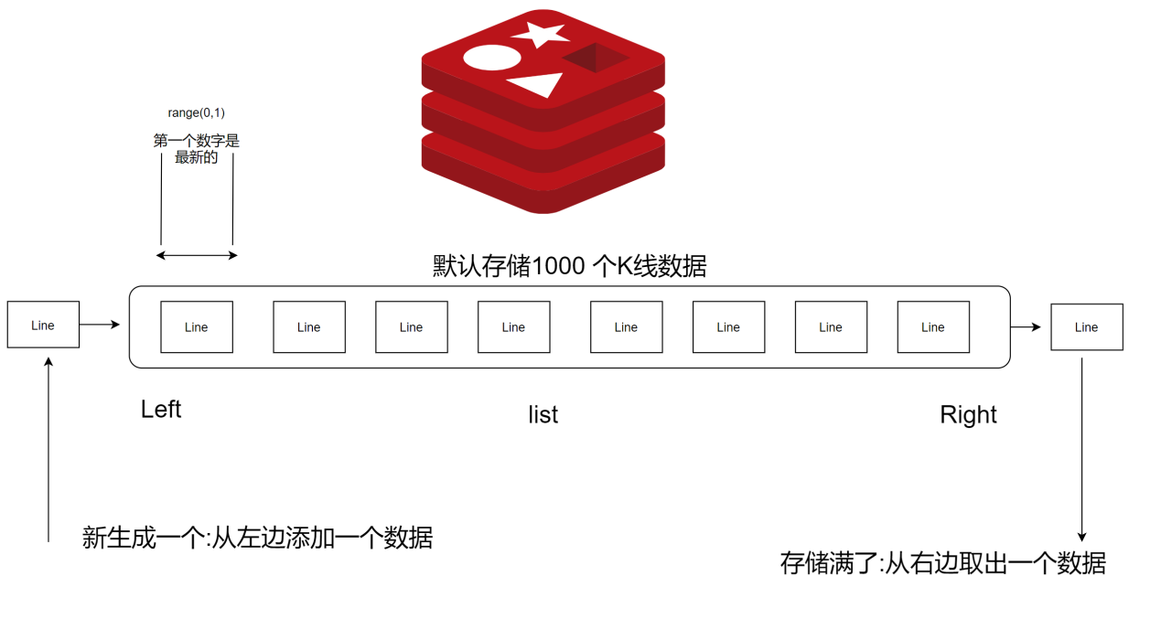

## 7.2 K线的模型

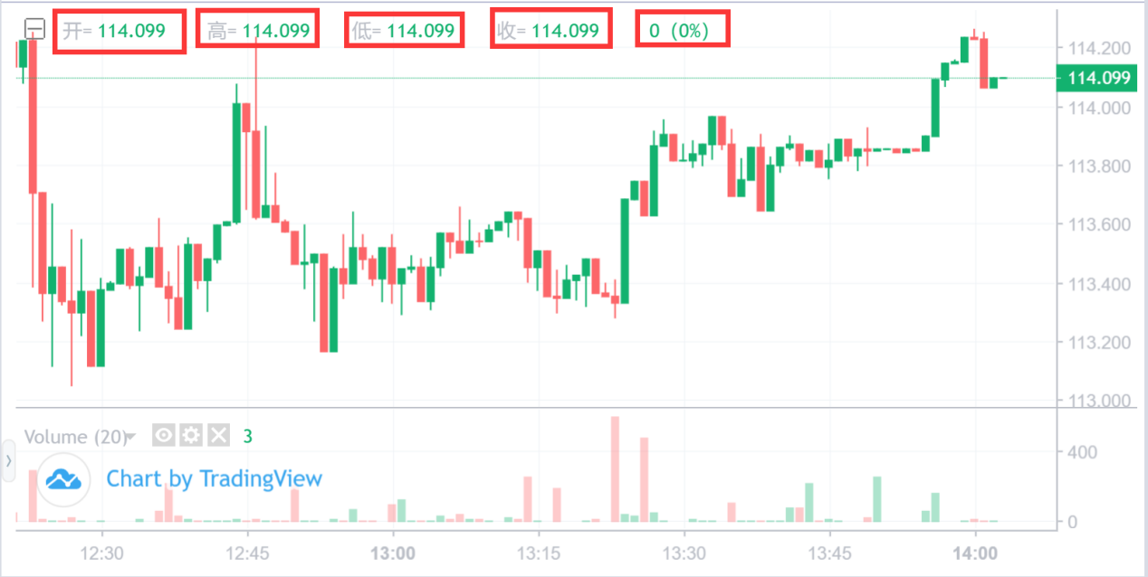

|  |
| --- |
| @Data public class Line {   */**  * 时间  */* private DateTime time;   */**  * 开盘价  */* private BigDecimal open;   */**  * 最高价  */* private BigDecimal high;   */**  * 最低价  */* private BigDecimal low;   */**  * 收盘价  */* private BigDecimal close;   */**  * 总交易量  */* private BigDecimal volume;   public Line() {}   */**  * 通过价格构造  * @param time 时间  * @param price 成交价  * @param volume 成交量  */* public Line(DateTime time, BigDecimal price, BigDecimal volume) {  this.time = time;  this.open = price;  this.high = price;  this.low = price;  this.close = price;  this.volume = volume;  }   */**  * 通过K线构造  * @param line k线  */* public Line(String line) {  }   */**  * 格式化称kline  * @return  */* public String toKline() {  *// 时间，开，高，低，收，量* JSONArray array = new JSONArray();  array.add(time.getMillis());  array.add(open);  array.add(high);  array.add(low);  array.add(close);  array.add(volume);  return array.toJSONString();  } } |

## 7.3 K线的推送

|  |
| --- |
| */**  * K 线推送事件  */* @Component @Slf4j public class KlineEvent implements Runnable, Event {   */**  * 交易对标识符  */* private String symbol;   */**  * 通道  */* private String channel;   */**  * redis key 前缀  */* private String keyPrefix;   @Autowired  private static RedisTemplate<String, Object> *redisTemplate*;    @Autowired  private Source source;   public KlineEvent() {  }   public KlineEvent(String symbol, String channel, String keyPrefix) {  this.symbol = symbol;  this.channel = channel;  this.keyPrefix = keyPrefix;  }   */**  * 事件触发处理机制  */* @Override  public void handle() {  for (KlineType klineType : KlineType.*values*()) {  String groupName = String.*format*(channel, symbol.toLowerCase(), klineType.getValue()).toLowerCase();  String key = new StringBuffer(keyPrefix).append(symbol).append(":").append(klineType.getValue()).toString();  List<Object> klines = *redisTemplate*.opsForList().range(key, 0, 1);  if (!CollectionUtils.*isEmpty*(klines)) {  MessagePayload messagePayload = new MessagePayload();  messagePayload.setChannel(groupName);  JSONObject body = new JSONObject();  body.put("tick", klines.get(0));  messagePayload.setBody(body.toJSONString());  source.subscribeEventOutput().send(  MessageBuilder  .*withPayload*(messagePayload)  .setHeader(MessageHeaders.*CONTENT_TYPE*, MimeTypeUtils.*APPLICATION_JSON*)  .build()  );  }  }  }   @Override  public void run() {  handle();  } } |

## 7.4 K 线事件的触发

|  |
| --- |
| */**  * K 线推送事件  */* @Component @Slf4j public class KlineEvent implements Runnable,Event {   */**  * 交易对标识符  */* private String symbol;   */**  * 通道  */* private String channel;   */**  * redis key 前缀  */* private String keyPrefix;   private static final String *KLINE_GROUP* = "market.%s.kline.%s" ; *// 1%s: 交易对 2%s: k 线类型* @Autowired  private RedisTemplate<String,Object> redisTemplate ;   @Autowired  private Source source ;   public KlineEvent() {  }   public KlineEvent(String symbol, String channel, String keyPrefix) {  this.symbol = symbol;  this.channel = channel;  this.keyPrefix = keyPrefix;  }   */**  * 事件触发处理机制  */* @Override  public void handle() {  *// 1 循环所有的K 线类型* for (KlineType klineType : KlineType.*values*()) {  *// 2 获取特定的K 线类型 keyPrefix:etcgcn:1min* String key = new StringBuilder(keyPrefix).append(symbol).append(":").append(klineType.getValue().toLowerCase()).toString() ;  List<Object> lines = redisTemplate.opsForList().range(key, 0, 1);  if(!CollectionUtils.*isEmpty*(lines)){  Object lineData = lines.get(0);  MessagePayload messagePayload = new MessagePayload();  JSONObject jsonObject = new JSONObject();  jsonObject.put("tick",lineData) ;  *// market.%s.kline.%s* messagePayload.setChannel(String.*format*(*KLINE_GROUP*,symbol,klineType.getValue().toLowerCase()));  messagePayload.setBody(jsonObject.toString());  }   }   }   */**  * 让线程池调度  */* @Override  public void run() {  handle();  } } |

## 7.5 K 线的生成

|  |
| --- |
| @Component public class TradeKlineService implements CommandLineRunner {   *// 当我们的交易完成(撮合)之后,就会触发k 线的生成* public static BlockingQueue<CreateKLineDto> *queue* = new LinkedBlockingDeque<>();   @Autowired  private StringRedisTemplate redisTemplate;   @Override  public void run(String... args) throws Exception {   while (true) {  CreateKLineDto createKLineDto = *queue*.poll(); *// 从里面获取一个数据,若没有数据,则会阻塞* if (createKLineDto != null) {  for (KlineType klineType : KlineType.*values*()) {  this.generateKLine(createKLineDto, klineType);  }  }  }   }   */**  * 为当前的交易数据生成K 线  *  * @param klineData  * @param klineType  */* private void generateKLine(CreateKLineDto klineData, KlineType klineType) {  *// 1 获取之前该K 线的数据* String redisKey = new StringBuilder(Constants.*REDIS_KEY_TRADE_KLINE*)  .append(klineData.getSymbol().toLowerCase())  .append(":")  .append(klineType.getValue().toLowerCase()).toString();  Long size = redisTemplate.opsForList().size(redisKey);  DateTime dateTime = KlineTimeUtil.*getKLineTime*(klineType);  *// 2 之前没有该K 线的数据* if (size == 0) {  Line line = new Line(dateTime, klineData.getPrice(), klineData.getVolume());  *// 放在Redis 里面* redisTemplate.opsForList().leftPush(redisKey, line.toKline());  return;  }   *// 3 之前有数据 ,获取最近的一个数据* String historyKlineData = redisTemplate.opsForList().range(redisKey, 0, 1).get(0);  Line historyKline = new Line(historyKlineData);  *// 4 若当前的时间: 是否还在上一个时间的区间内* if (dateTime.compareTo(historyKline.getTime()) == 1) {   *// redis的容量是否超* if (size > Constants.*REDIS_MAX_CACHE_KLINE_SIZE*) {  redisTemplate.opsForList().rightPop(redisKey);  }   Line line = new Line();  line.setTime(dateTime);  *// 如果我们当前的交易量为 0* if (klineData.getVolume().compareTo(BigDecimal.*ZERO*) == 0) {  line.setHigh(historyKline.getClose());  line.setLow(historyKline.getClose());  line.setOpen(historyKline.getClose());  line.setClose(historyKline.getClose());  line.setVolume(BigDecimal.*ZERO*) ;  *// 放在Redis 里面* redisTemplate.opsForList().leftPush(redisKey, line.toKline());  return;  }  line.setOpen(klineData.getPrice());  line.setClose(klineData.getPrice());   *// 最高价 ,最低价* if (klineData.getPrice().compareTo(historyKline.getHigh()) == 1) {  line.setHigh(klineData.getPrice());  line.setLow(historyKline.getClose());  }  if (klineData.getPrice().compareTo(historyKline.getLow()) == 1) {  line.setLow(klineData.getPrice());  line.setHigh(historyKline.getClose());  }   historyKline.setClose(klineData.getPrice());  redisTemplate.opsForList().set(redisKey, 0, historyKline.toKline());  *// 放最新的进入  // 放在Redis 里面* redisTemplate.opsForList().leftPush(redisKey, line.toKline());  return;  }   if (klineData.getVolume().compareTo(BigDecimal.*ZERO*) == 0) {  return;  }   historyKline.setClose(klineData.getPrice());   if (klineData.getPrice().compareTo(historyKline.getHigh()) == 1) {  historyKline.setHigh(klineData.getPrice());  }   if (klineData.getPrice().compareTo(historyKline.getLow()) == 1) {  historyKline.setLow(klineData.getPrice());  }  historyKline.setVolume(historyKline.getVolume().add(klineData.getVolume()));  redisTemplate.opsForList().set(redisKey, 0, historyKline.toKline());  }   } |

## 7.6 监听撮合的数据

### 7.6.1 添加Sink

|  |
| --- |
| public interface Sink {   */**  * 交易记录的输入  * @return  */* @Input("exchange_trades_in")  MessageChannel exchangeTradesIn() ; } |

### 7.6.2 添加配置信息

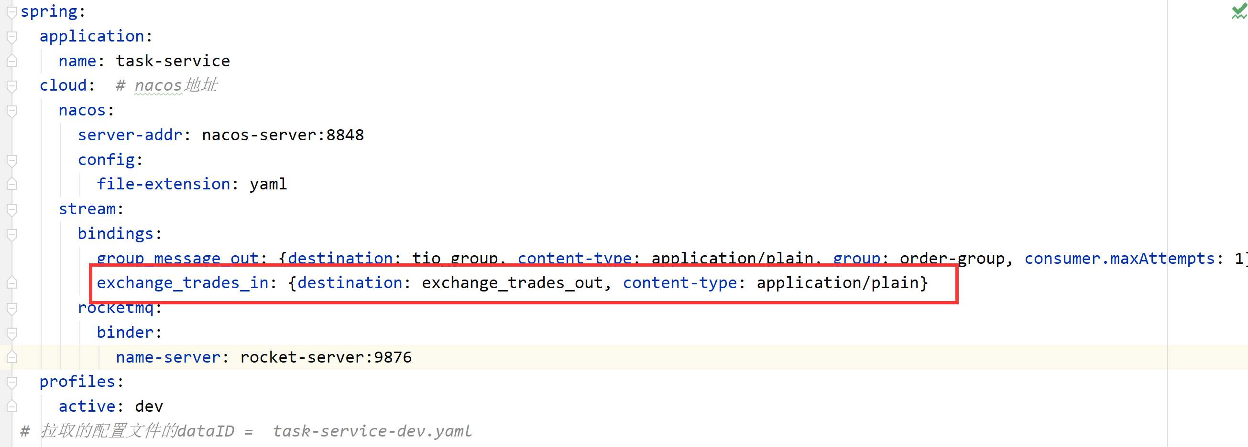

### 7.6.3 监听器

|  |
| --- |
| @Component @Slf4j public class ExchangeTradesListener {    @StreamListener("exchange_trades_in")  public void handlerExchangeTrades(List<ExchangeTrade> exchangeTrades) {  *log*.info("接收到撮合引擎的数据===>{}", exchangeTrades);  if (!CollectionUtils.*isEmpty*(exchangeTrades)) {  for (ExchangeTrade exchangeTrade : exchangeTrades) {  CreateKLineDto createKLineDto = exchangeTrade2CreateKLineDto(exchangeTrade);  TradeKlineService.*queue*.offer(createKLineDto);  }  }  }   private CreateKLineDto exchangeTrade2CreateKLineDto(ExchangeTrade exchangeTrade) {  CreateKLineDto createKLineDto = new CreateKLineDto();  createKLineDto.setPrice(exchangeTrade.getPrice());  createKLineDto.setSymbol(exchangeTrade.getSymbol());  createKLineDto.setVolume(exchangeTrade.getAmount());  return createKLineDto;  }  } |

记得把撮合引擎的对象复制过来:

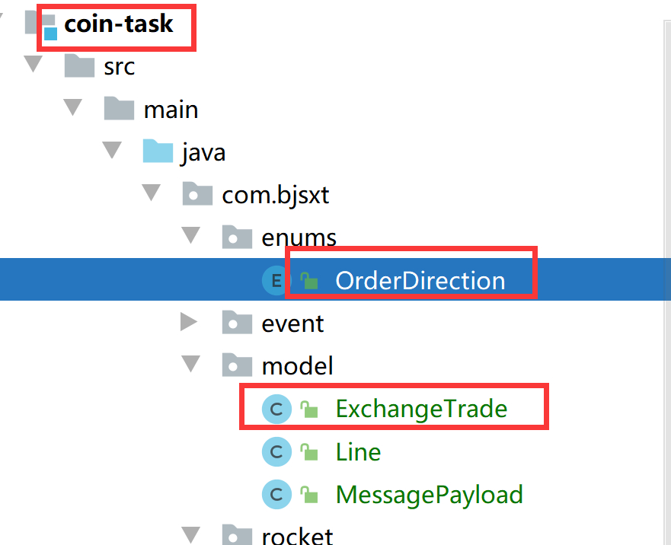

# 市场行情事件的处理

## 8.1 远程调用交易区域

### 8.1.1 创建TradeAreaDto对象

|  |
| --- |
| @Data public class TradeAreaDto implements java.io.Serializable {   */**  * 主键  */* private Long id;  */**  * 交易区名称  */* private String name;  */**  * 交易区代码  */* private String code;  */**  * 类型：1-数字货币交易；2-创新交易使用；  */* private Integer type;  */**  * 结算币种（仅创新交易需要使用）  */* private Long coinId;  */**  * 结算币种名称（仅创新交易需要使用）  */* private String coinName;  */**  * 排序  */* private int sort;  */**  * 状态  */* private Integer status;  */**  * 创建时间  */* private Date createTime;  */**  * 修改时间  */* private Date lastUpdateTime;   */**  * 交易区内所在市场Id(逗号分隔)  */* private String marketIds; } |

### 8.1.2 创建TradingAreaServiceClient

|  |
| --- |
| @FeignClient(name = "exchange-service",contextId = "tradingAreaServiceClient" ,configuration = OAuth2FeignConfig.class ,path = "/tradeArea" ) public interface TradingAreaServiceClient {   */**  * 查询所有的交易区域  * @return  */* @GetMapping("/list")  List<TradeAreaDto> tradingAreaList(); } |

### 8.1.3 创建TradeMarketDto

|  |
| --- |
| @Data public class TradeMarketDto implements Comparable<TradeMarketDto> {   */**  * 交易对  */* private String symbol;   */**  * 市场名称  */* private String name;   */**  * 图片  */* private String image;   */**  * 买入手续费  */* private BigDecimal buyFeeRate;   */**  * 卖出手续费  */* private BigDecimal sellFeeRate;   */**  * 价格小数位数  */* private int priceScale;   */**  * 数量小数位数  */* private int numScale;   */**  * 最小委托数量  */* private BigDecimal numMin;   */**  * 最大小数位数  */* private BigDecimal numMax;   */**  * 最小成交额  */* private BigDecimal tradeMin;   */**  * 最大成交额  */* private BigDecimal tradeMax;   */**  * 当前价  */* private BigDecimal price;   */**  * 价格单位  */* private String priceUnit;   */**  * 当前价（人民币）  */* private BigDecimal cnyPrice;   */**  * 报价货币人民币价格  */* private BigDecimal coinCnyPrice;   */**  * 合并深度  */* private List<MergeDepthDto> mergeDepth;   */**  * 最高价  */* private BigDecimal high;   */**  * 最低价  */* private BigDecimal low;   */**  * 日总交易量  */* private BigDecimal volume = BigDecimal.*ZERO*;   */**  * 日总成交额  */* private BigDecimal amount = BigDecimal.*ZERO*;   */**  * 涨幅  */* private double change;   */**  * 排序  */* private int sort;   @Override  public int compareTo(TradeMarketDto object) {  if (this.sort >= object.getSort()) {  return 1;  } else {  return -1;  }  } } |

## 8.2 处理该事件

|  |
| --- |
| */**  * 行情市场的K 线  */* @Component @Slf4j public class MarketEvent implements Event {   @Autowired  private Source source;   @Autowired  private TradingAreaServiceClient tradingAreaServiceClient;    @Autowired  private MarketServiceFeign marketServiceFeign;   private static final String *MARKET_GROUP* = "market.%s.ticker"; *// %s代表交易区域* private static final String *MARKET_DETAIL_GROUP* = "markets.%s.detail" ; *// 交易区域的详情交易数据* @Override  public void handle() {  *// 1 交易区域的查询* List<TradeAreaDto> tradeAreaDtoList = tradingAreaServiceClient.tradeAreas();  if (CollectionUtils.*isEmpty*(tradeAreaDtoList)) {  return;  }  for (TradeAreaDto tradeAreaDto : tradeAreaDtoList) {  *// 2 差该交易区域下的交易数据 , 使用的是交易区域里面市场的id("id1,id2")* List<TradeMarketDto> tradeMarketDtos = marketServiceFeign.queryMarkesByIds(tradeAreaDto.getMarketIds());  if (CollectionUtils.*isEmpty*(tradeMarketDtos)) {  return;  }   JSONObject jsonObject = new JSONObject();  jsonObject.put("markets", tradeMarketDtos);  MessagePayload messagePayload = new MessagePayload();  messagePayload.setChannel(String.*format*(*MARKET_GROUP*, tradeAreaDto.getCode().toLowerCase()));  messagePayload.setBody(jsonObject.toJSONString());  source.subscribeGroupOutput()  .send(  MessageBuilder  .*withPayload*(messagePayload)  .setHeader(MessageHeaders.*CONTENT_TYPE*, MimeTypeUtils.*APPLICATION_JSON*).build()  );  }    *// 获取所有的交易市场* List<MarketDto> marketDtos = marketServiceFeign.tradeMarkets();  if(CollectionUtils.*isEmpty*(marketDtos)){  return;  }  for (MarketDto marketDto : marketDtos) {  List<TradeMarketDto> tradeMarketDtos = marketServiceFeign.queryMarkesByIds(marketDto.getId().toString());   JSONObject jsonObject = new JSONObject();  jsonObject.put("tick",tradeMarketDtos) ;   MessagePayload messagePayload = new MessagePayload();  messagePayload.setChannel(String.*format*(*MARKET_DETAIL_GROUP*,marketDto.getSymbol()));  messagePayload.setBody(jsonObject.toJSONString());  source.subscribeGroupOutput()  .send(  MessageBuilder  .*withPayload*(messagePayload)  .setHeader(MessageHeaders.*CONTENT_TYPE*, MimeTypeUtils.*APPLICATION_JSON*).build()  );  }   } } |

# 成交记录事件的处理

## 9.1 远程调用数据

在**MarketServiceFeign**里面添加:

|  |
| --- |
| */**  * 获取最新成交列表  *  * @param symbol 交易对标识符  * @return  */* @GetMapping("/trades/{symbol}") String trades(@PathVariable("symbol") String symbol); |

## 9.2 处理该事件

|  |
| --- |
| */**  * 成交记录事件  */* @Component @Slf4j public class TradeEvent implements Event {   @Autowired  private MarketServiceFeign marketServiceClient;    @Autowired  private Source source;   @Override  public void handle() {  try {  marketServiceClient.tradeMarkets().forEach(market -> {  String groupName = String.*format*("market.%s.trade.detail", market.getSymbol()).toLowerCase();  String data = marketServiceClient.trades(market.getSymbol());  JSONObject orders = new JSONObject();  orders.put("data", data);   MessagePayload messagePayload = new MessagePayload();  messagePayload.setChannel(groupName);  messagePayload.setBody(orders.toJSONString());  source.subscribeEventOutput().send(  MessageBuilder  .*withPayload*(messagePayload)  .setHeader(MessageHeaders.*CONTENT_TYPE*, MimeTypeUtils.*APPLICATION_JSON*)  .build()  );  });  } catch (Exception e) {  *log*.error("推送最新成交订单异常");  e.printStackTrace();  }  } } |

# 行情数据事件

## 10.1 处理该事件

|  |
| --- |
| */**  * 行情数据的K线  */* @Component @Slf4j public class TradeKLineEvent implements Event {   @Autowired  private MarketServiceFeign marketServiceClient;   @Override  public void handle() {  List<MarketDto> markets = marketServiceClient.tradeMarkets();  if (!CollectionUtils.*isEmpty*(markets)) {  for (MarketDto market : markets) {  CreateKLineDto createKLineDTO = new CreateKLineDto();  createKLineDTO.setSymbol(market.getSymbol()) ;  createKLineDTO.setPrice(market.getOpenPrice());  createKLineDTO.setVolume(BigDecimal.*ZERO*);  TradeKLineService.*queue*.offer(createKLineDTO);  }  }  } } |

# 定时任务完善

## 11.1 刷新24小时的成交记录

### 11.1.1 远程调用

在**MarketServiceFeign**里面添加:

|  |
| --- |
| */**  * 刷新24小时成交数据  *  * @param symbol 交易对  * @return  */* @GetMapping(value = "/refresh_24hour") void refresh24hour(@RequestParam("symbol") String symbol); |

### 11.1.2 添加任务

在: MarketTickerTask 里面添加

|  |
| --- |
| */**  * 刷新24小时成交数据  */* @Scheduled(fixedRate = 1000) public void refresh24HDeal() {  marketServiceClient.tradeMarkets().forEach(market -> {  if (market.getStatus() == 1) {  marketServiceClient.refresh24hour(market.getSymbol());  }  }); } |

## 11.2 关于前端订阅的channel

前端订阅数据时:它的所有的交易对都是小写,因次,我们在使用source发送数据之前,需要将所有的symbol都转化为小写.



# 定时任务的启动

## 12.1 MarketServiceFeign 的处理

|  |
| --- |
| @FeignClient(name = "exchange-service", contextId = "marketServiceFeign", configuration = OAuth2FeignConfig.class, path = "/markets") public interface MarketServiceFeign {   */**  * 使用报价货币 以及 出售的货币的iD  *  * @param buyCoinId  * @return  */* @GetMapping("/getMarket")  MarketDto findByCoinId(@RequestParam("buyCoinId") Long buyCoinId, @RequestParam("sellCoinId") Long sellCoinId);    @GetMapping("/getMarket/symbol")  MarketDto findBySymbol(@RequestParam("symbol") String symbol);   */**  * 查询所有的交易市场  *  * @return  */* @GetMapping("/tradeMarkets")  List<MarketDto> tradeMarkets();   */**  * 查询该交易对下的盘口数据  *  * @param symbol  * @param value  * @return  */* @GetMapping("/tradeMarkets/{symbol}/{type}")  String depthData(@PathVariable("symbol") String symbol, @PathVariable("type") int value);   */**  * 使用市场的ids 查询该市场的交易趋势  *  * @param marketIds  * @return  */* @GetMapping("/queryMarketsByIds")  List<TradeMarketDto> queryMarkesByIds(@RequestParam("marketIds") String marketIds);   */**  * 通过交易对查询所有的交易数据  *  * @param symbol  * @return  */* @GetMapping("/trades")  String trades(String symbol);    */**  * 刷新24小时成交数据  *  * @param symbol 交易对  * @return  */* @GetMapping(value = "/refresh_24hour")  void refresh24hour(@RequestParam("symbol") String symbol);   } |

## 12.2 TradingAreaServiceClient的处理

|  |
| --- |
| @FeignClient(name = "exchange-service",contextId = "tradingAreaServiceClient" ,configuration = OAuth2FeignConfig.class,path = "/tradeArea" ) public interface TradingAreaServiceClient {    */**  * 查询所有的交易区域  * @return  */* @GetMapping("/all")  List<TradeAreaDto> tradeAreas(); } |

## 12.3 Token 传递问题

### 12.3.1 修改AuthorizationServerConfig

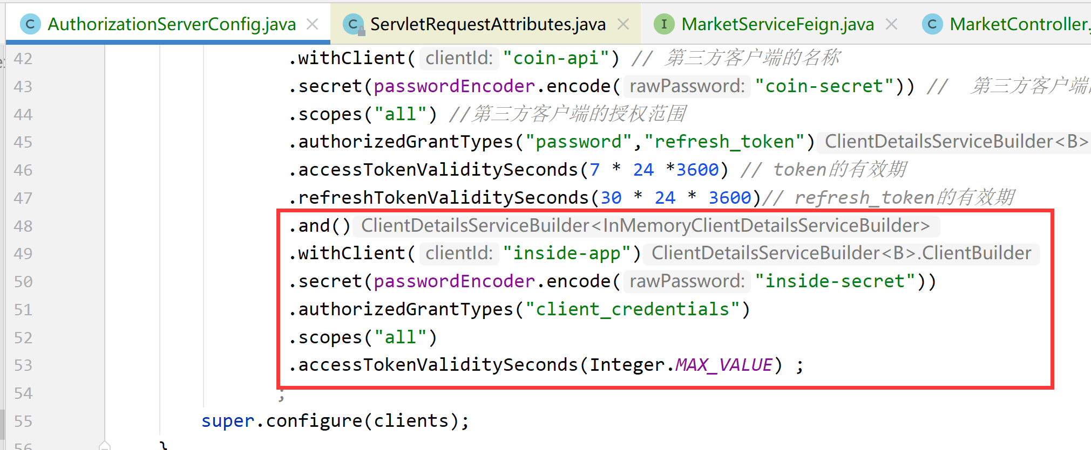

### 12.3.2 获取Token 并放在Constants 里面

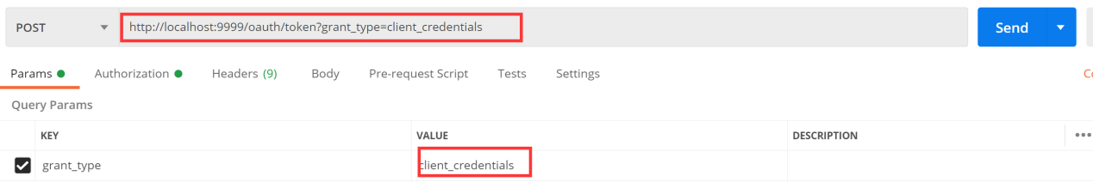

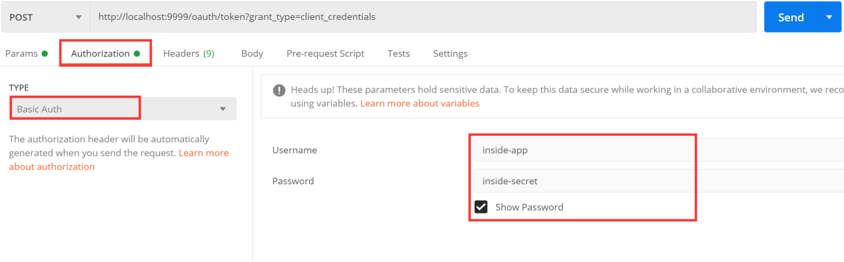

获取到Token:

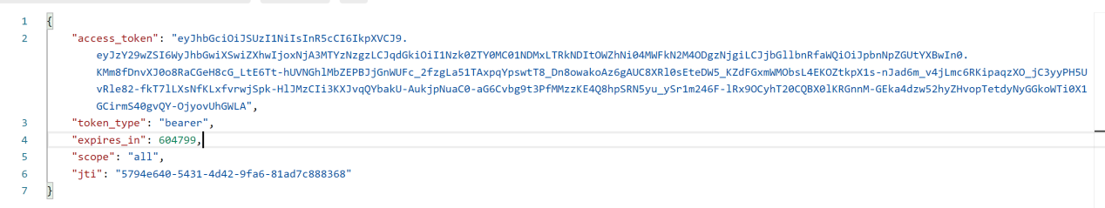

放在常量里面:

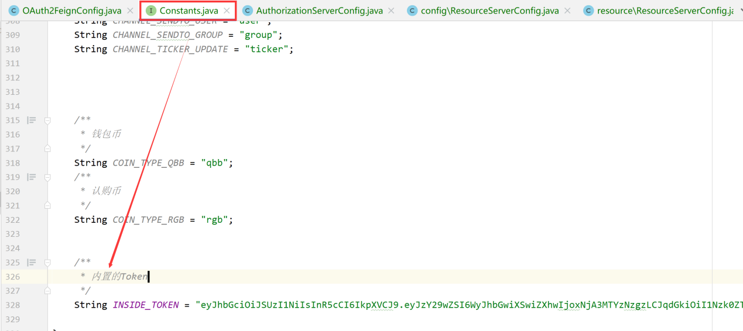

### 12.3.3 传递获取到的内置的Token

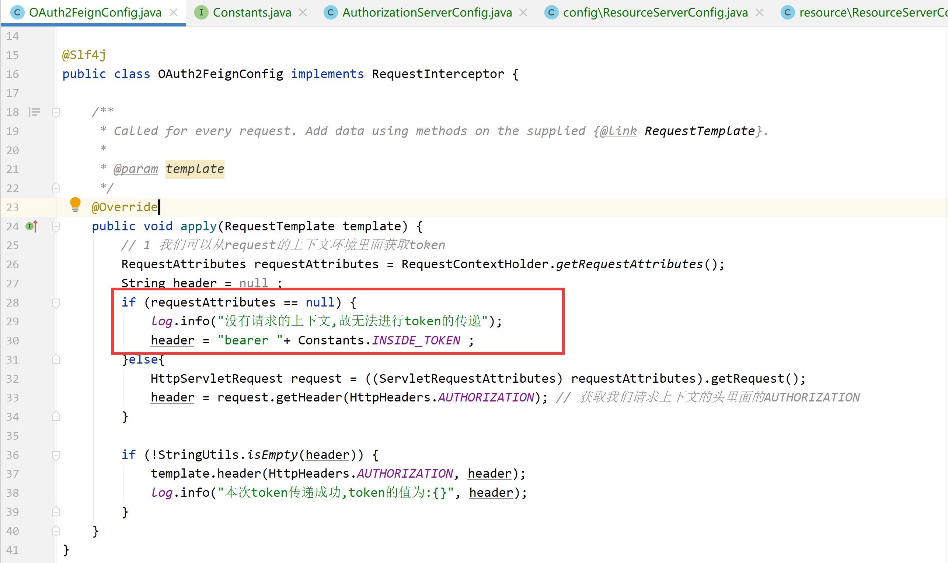

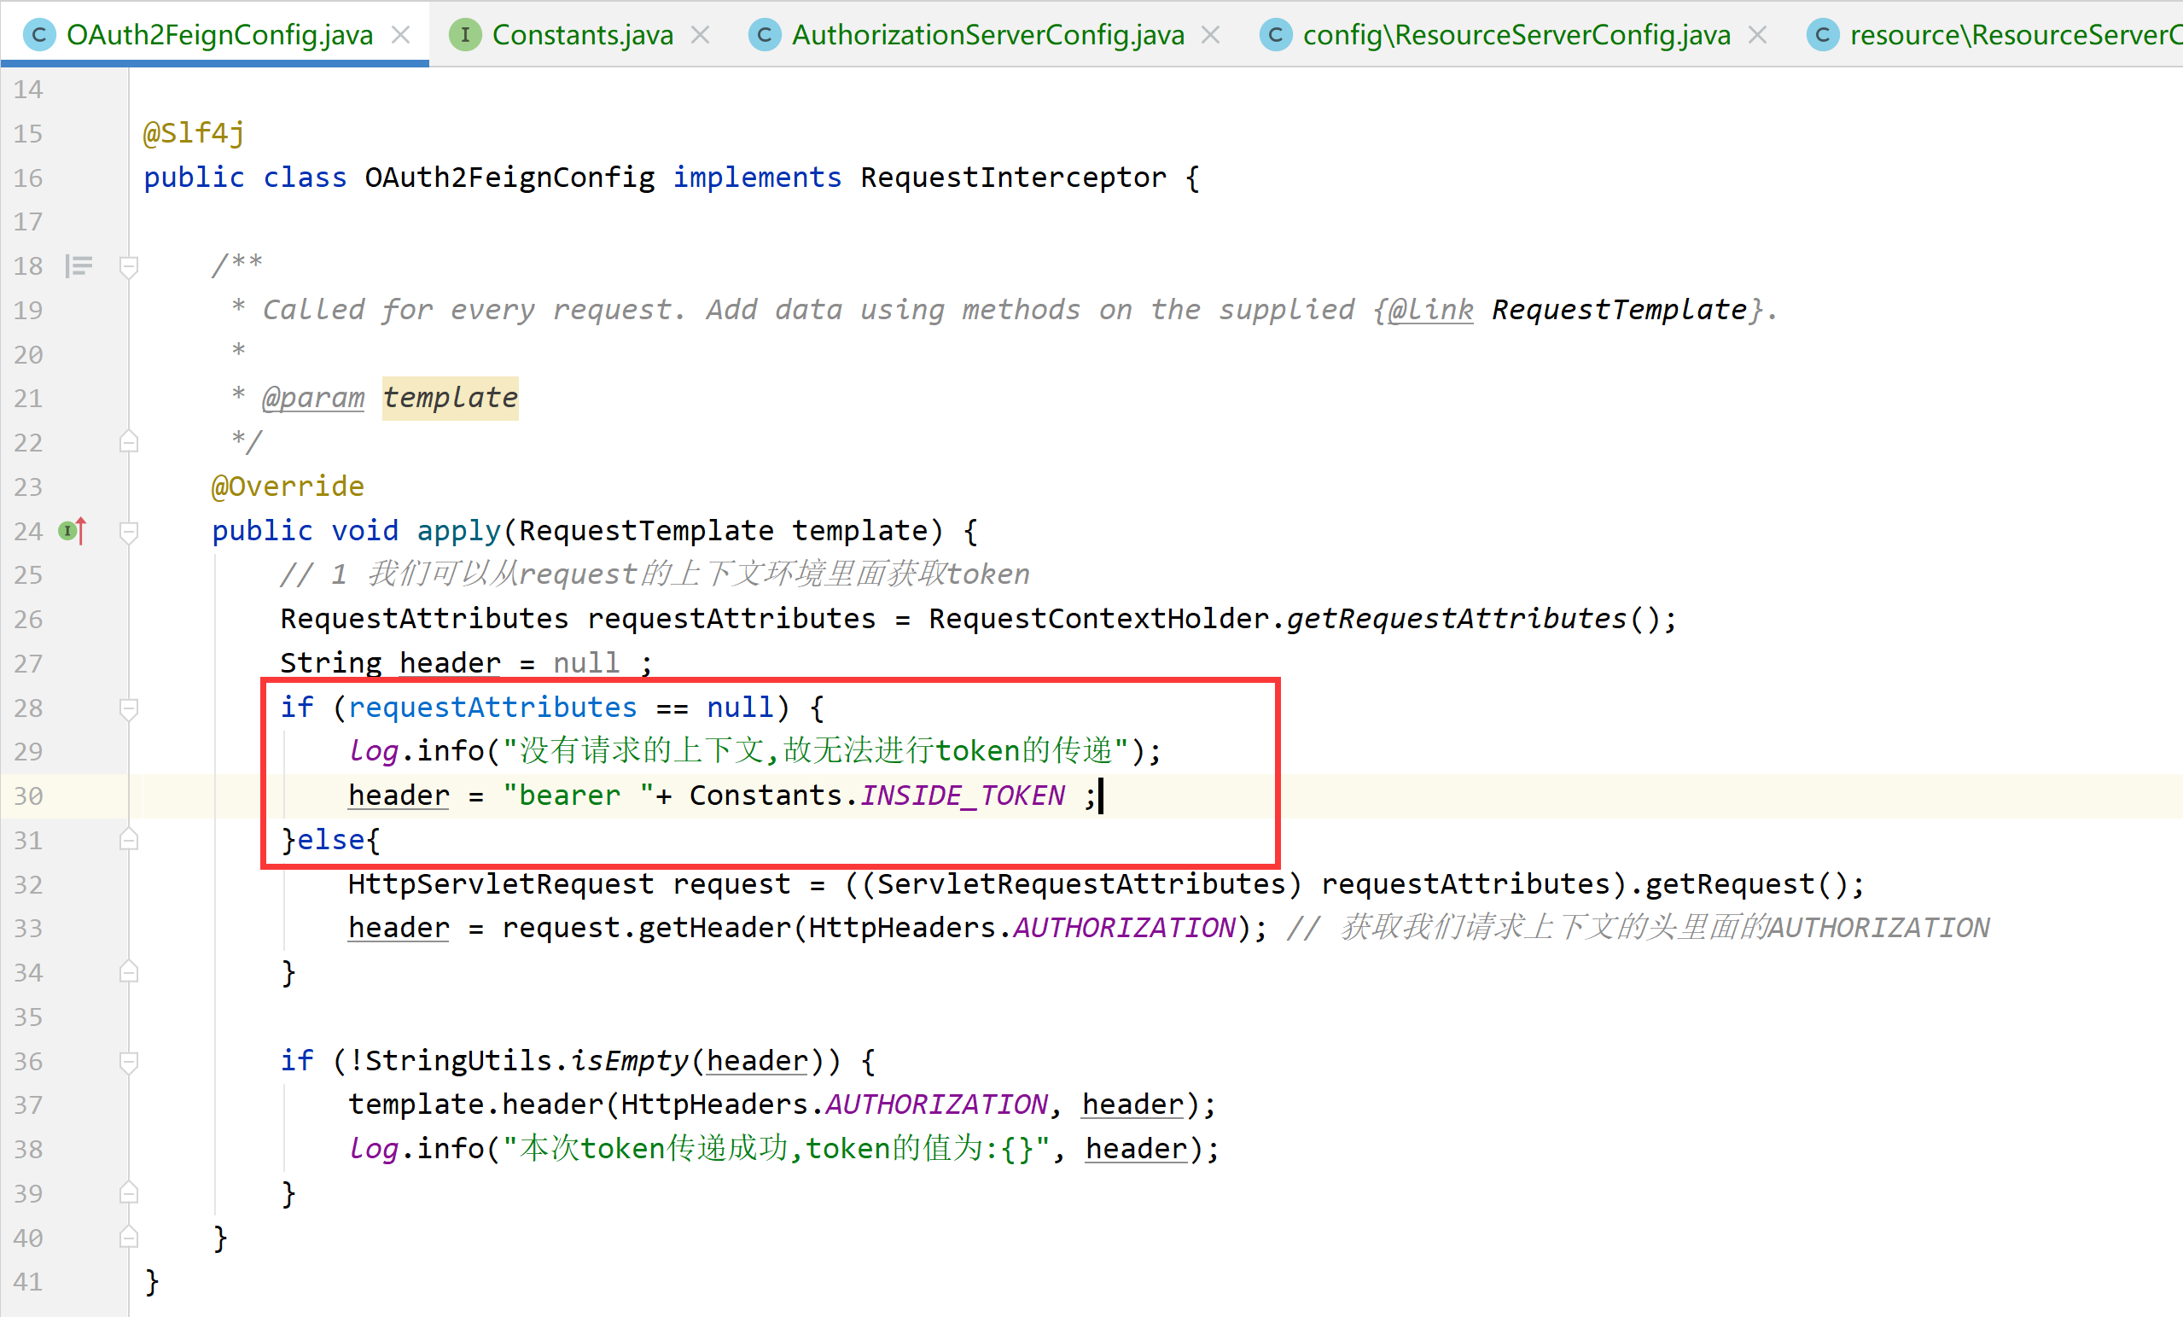

# 盘口数据的推送测试

## 13.1 实现MarketServiceFeign 里面的方法

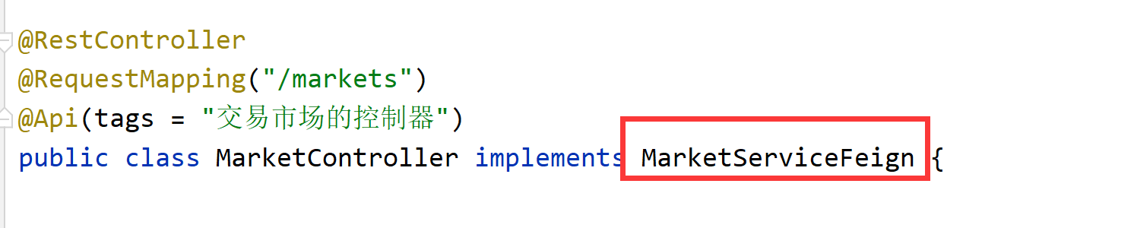

### 13.1.1 MarketController

|  |
| --- |
| */**  * 查询所有的交易市场  *  * @return  */* @Override public List<MarketDto> tradeMarkets() {  return marketService.queryAllMarkets() ; }  */**  * 查询该交易对下的盘口数据  *  * @param symbol  * @param value  * @return  */* @Override public String depthData(String symbol, int value) {  R<DepthsVo> deptVosSymbol = findDeptVosSymbol(symbol, value + "");  DepthsVo data = deptVosSymbol.getData();  return JSON.*toJSONString*(data); } |

### 13.1.2 MarketService

|  |
| --- |
| */**  * 查询所有的市场数据  * @return  */* List<MarketDto> queryAllMarkets(); |

### 13.1.3 MarketServiceImpl

|  |
| --- |
| */**  * 查询所有的市场数据  *  * @return  */* @Override public List<MarketDto> queryAllMarkets() {  List<Market> list = list(new LambdaQueryWrapper<Market>().eq(Market::getStatus, 1));  return MarketDtoMappers.*INSTANCE*.toConvertDto(list); } |

## 13.2 测试盘口数据的推送

### 13.2.1因为计算机性能较差,我们需要先将部分数据修改

:将交易市场设置为 关闭,只剩第三个启用

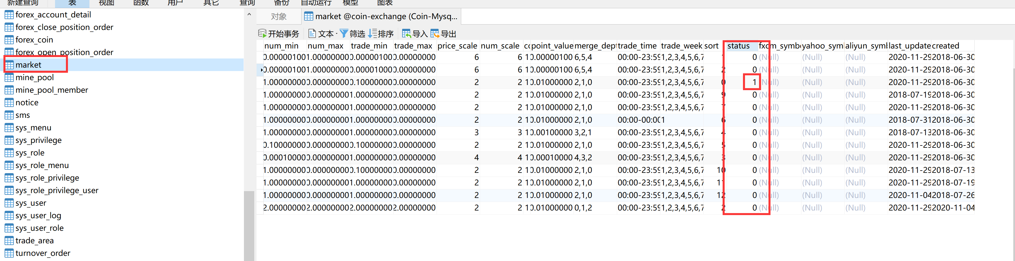

修改exchange-chan的配置文件,修改为单机推送:

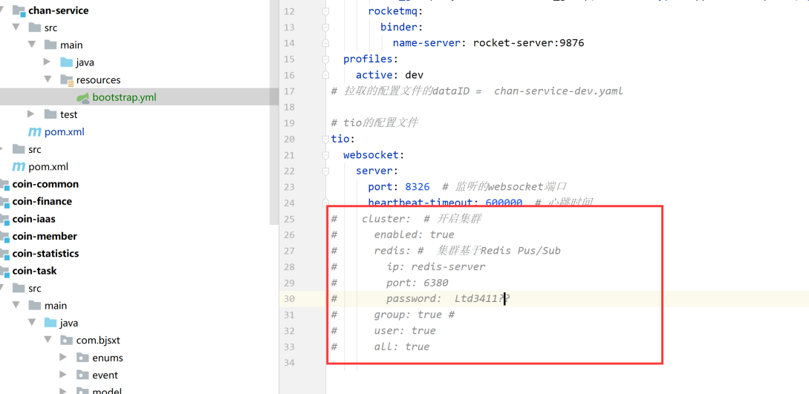

### 13.2.2 关闭多余的定时任务

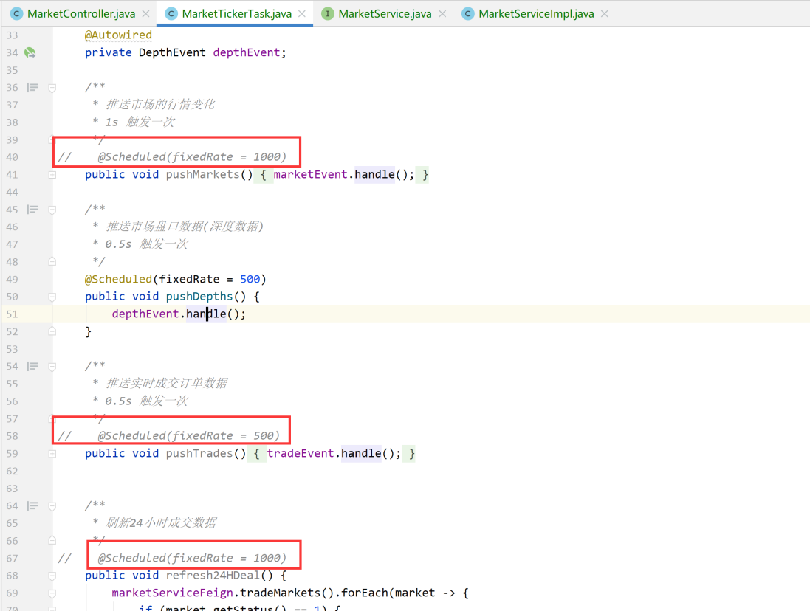

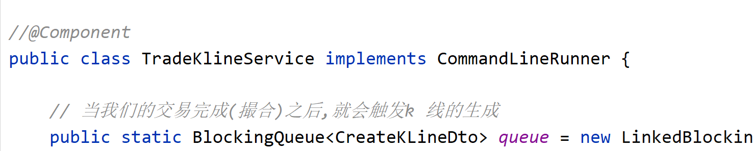

### 13.2.3 测试推送

新增数据后,观察数据的变化就可以了

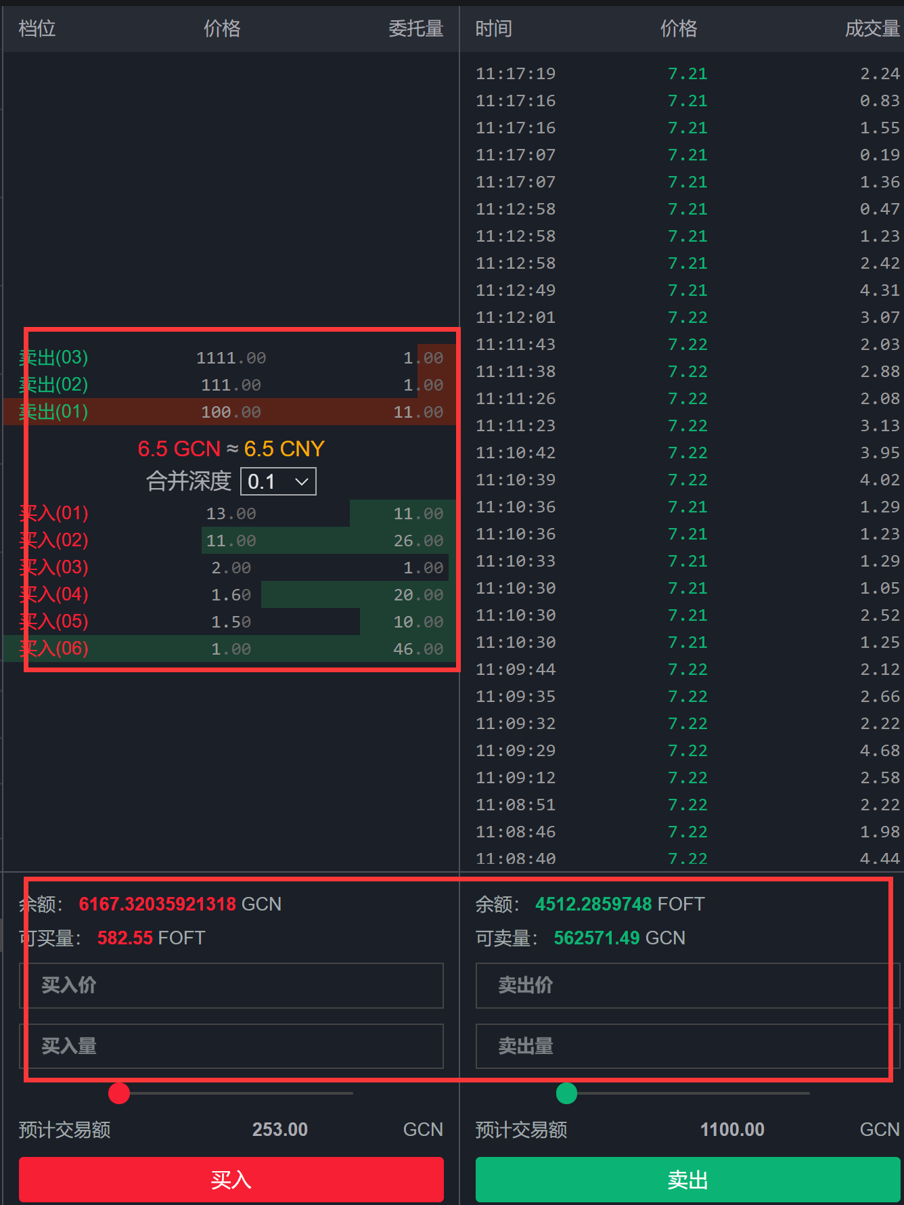

# KLine的推送

## 14.1 完成MarketController 里面的K线查询方法

|  |
| --- |
| */**  * K 线的查询  *  * @param symbol 交易对  * @param type K 线类型  * @return  */* @GetMapping("/kline/{symbol}/{type}") public R<List<JSONArray>> queryKLine(@PathVariable("symbol") String symbol, @PathVariable("type") String type) {  *// 我们的K 线放在Redis 里面* String redisKey = new StringBuilder(Constants.*REDIS_KEY_TRADE_KLINE*).append(symbol.toLowerCase()).append(":").append(type).toString();  List<String> klines = redisTemplate.opsForList().range(redisKey, 0, Constants.*REDIS_MAX_CACHE_KLINE_SIZE* - 1);  List<JSONArray> result = new ArrayList<>(klines.size()) ;  if (!CollectionUtils.*isEmpty*(klines)) {  for (String kline : klines) {  JSONArray objects = JSON.*parseArray*(kline);  result.add(objects) ;  }  return R.*ok*(result);  }   return null; } |

## 14.2 放行该请求

ResourceServerConfig 里面:

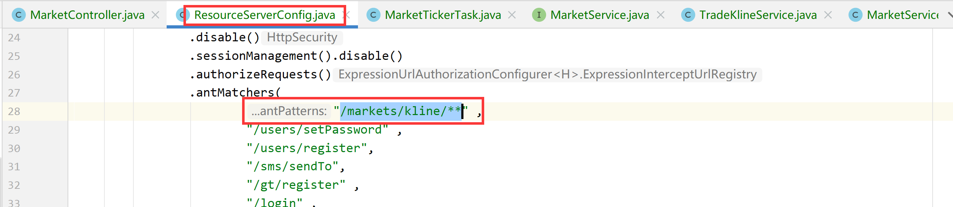

网关里面:JwtCheckFilter:

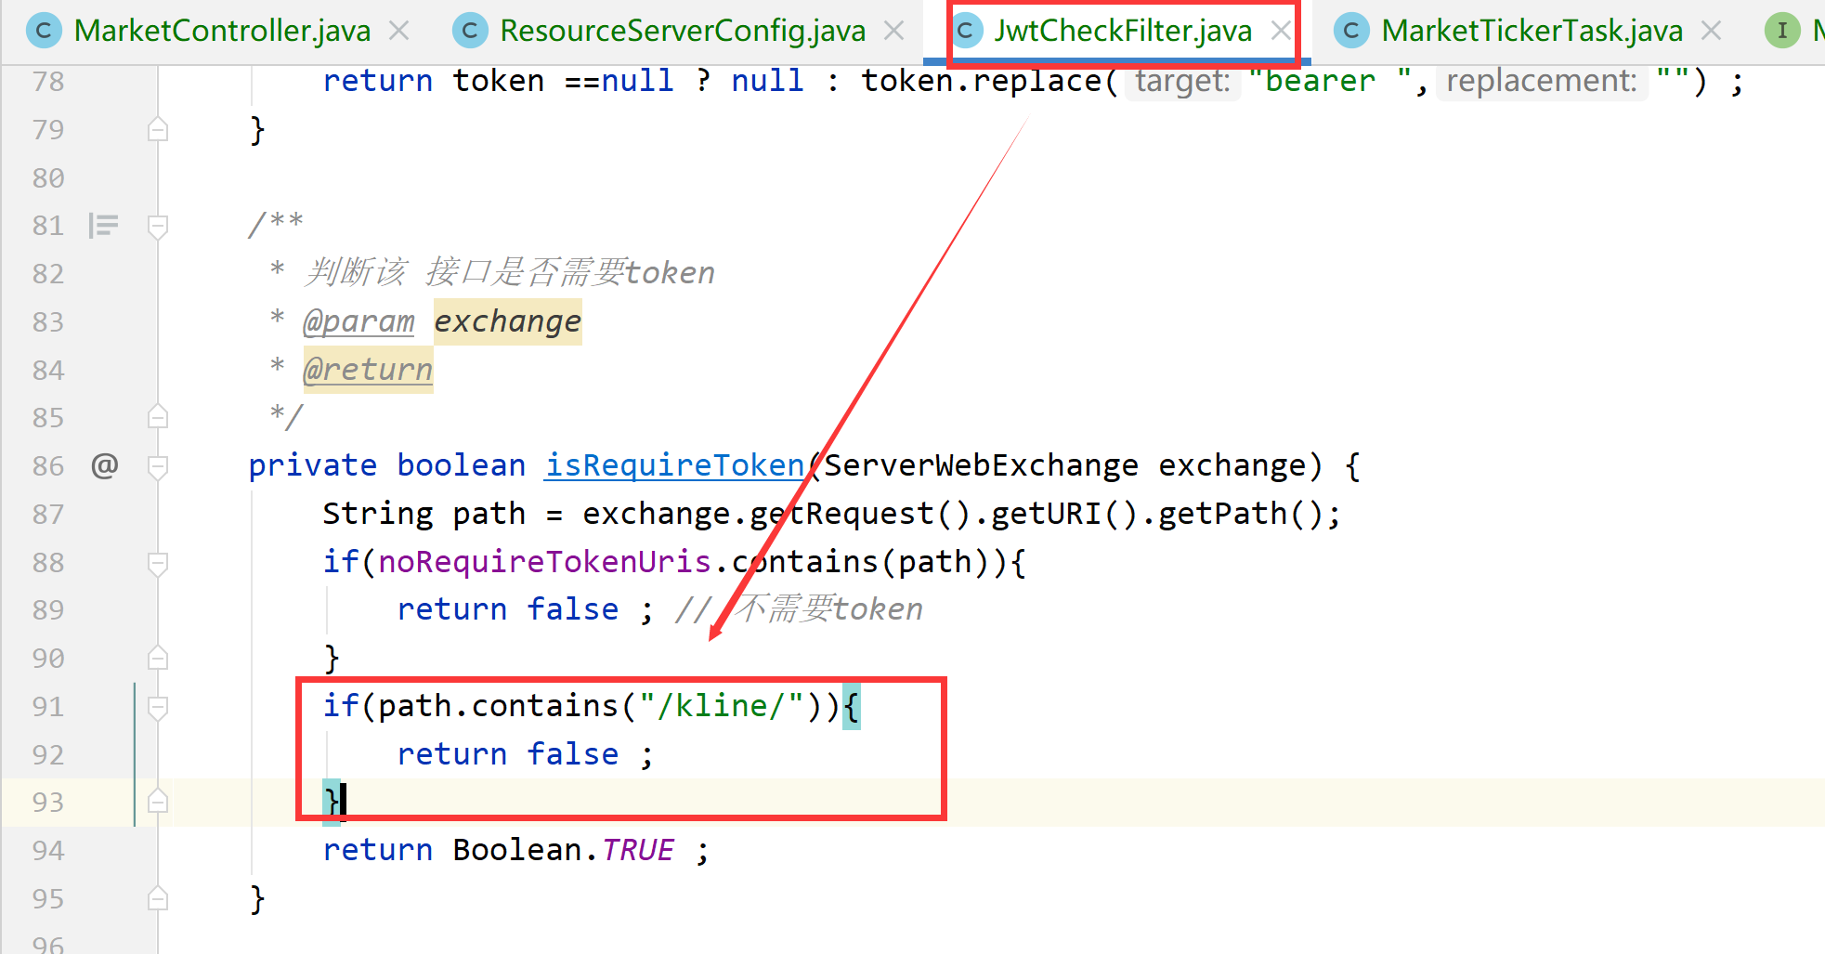

## 14.3 关闭其他的定时任务,只推K 线

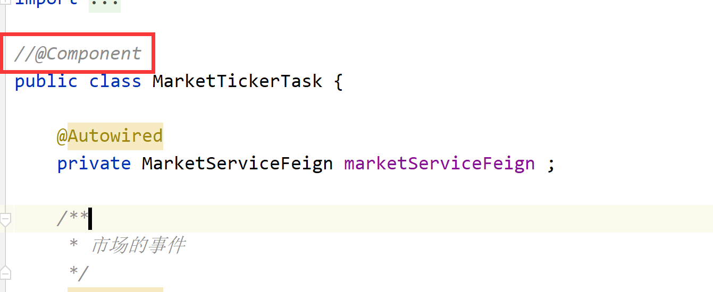

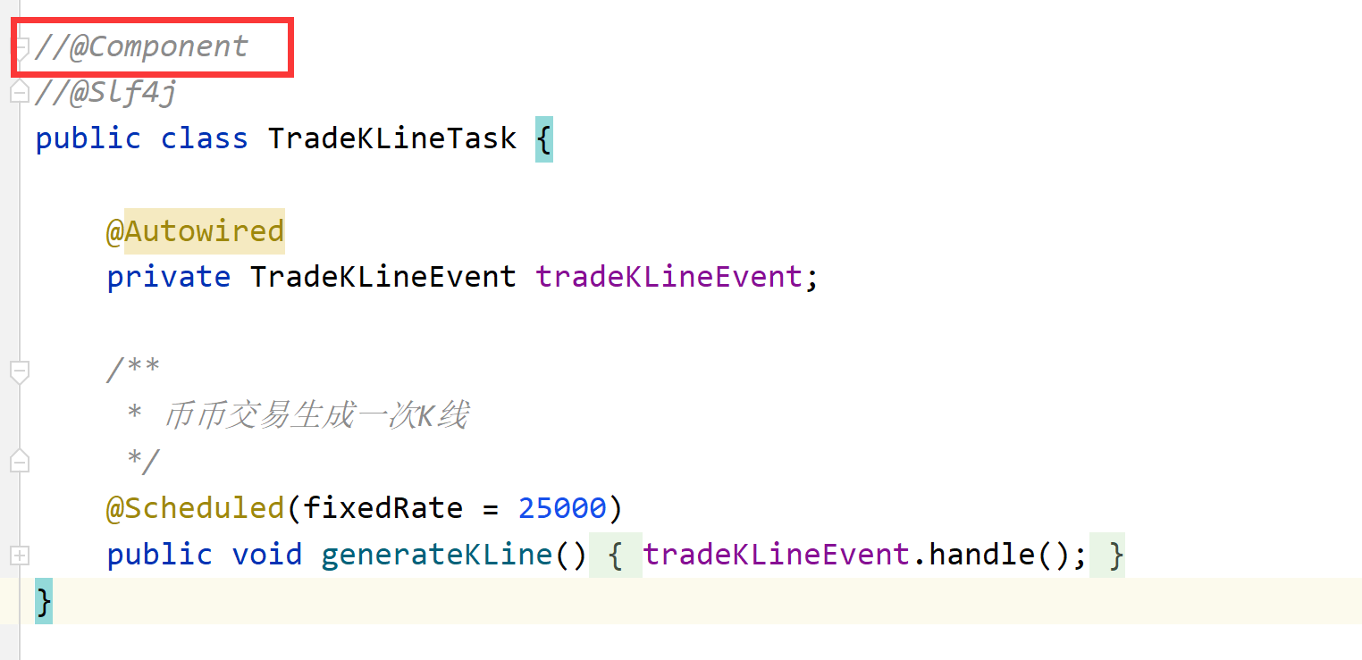

## 14.4 打开 K 线推送

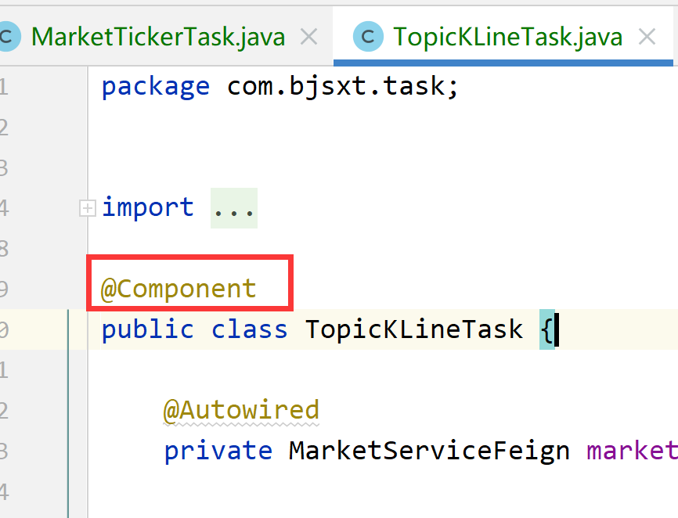

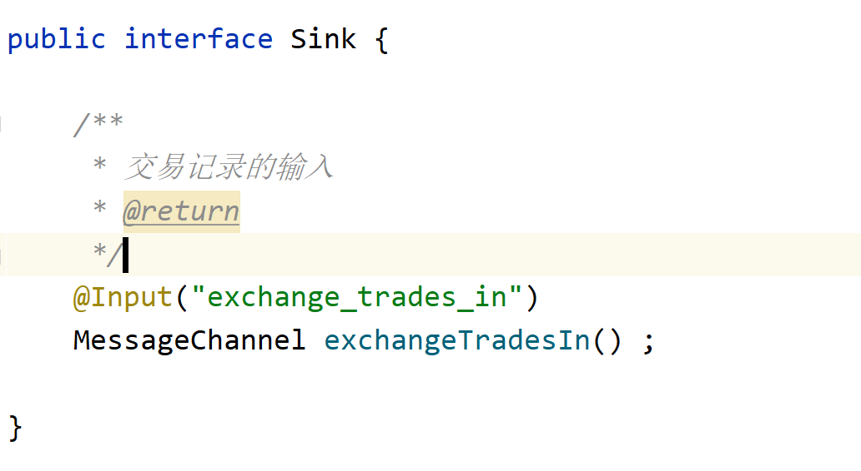

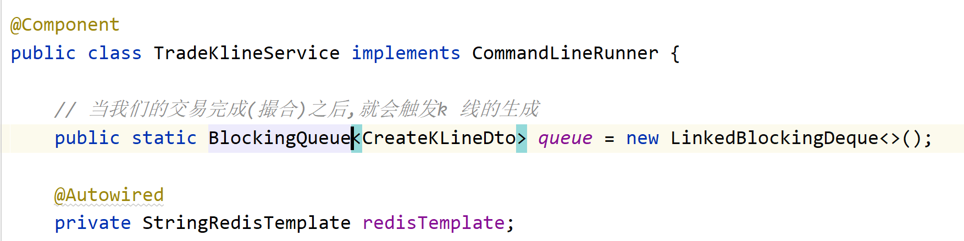

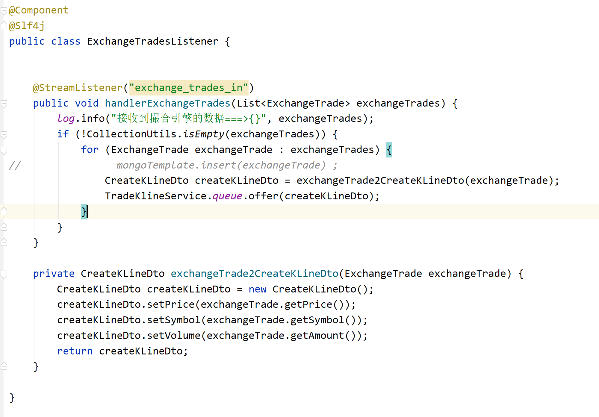

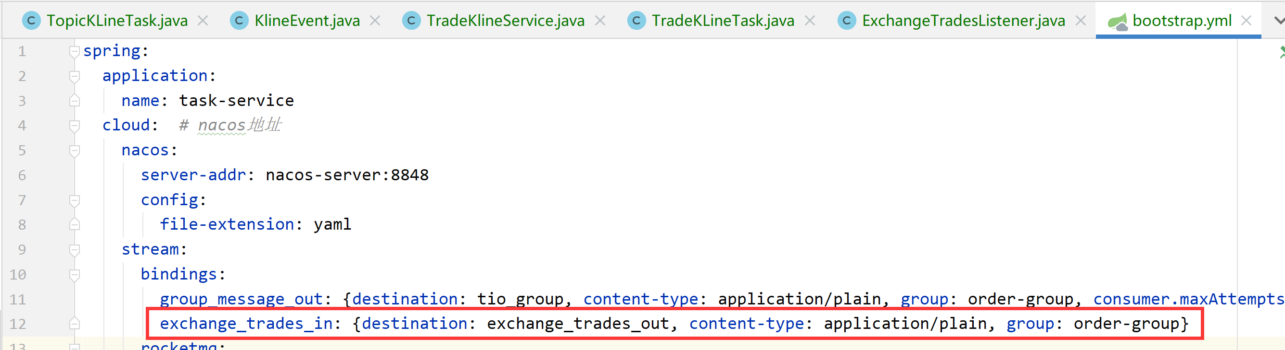

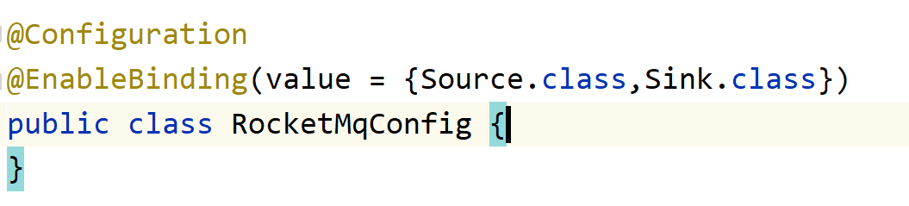

## 14.5 清除Redis 里面的所有K 线

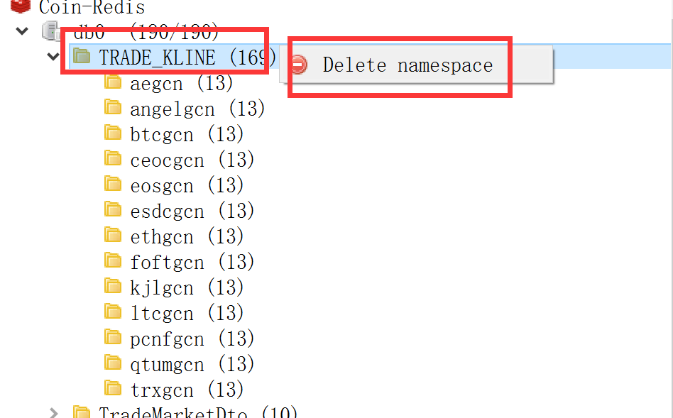

## 14.6 撮合交易测试

在买入和售出选择合适的价格,即可进行撮合,撮合成功后,数据会推送过来

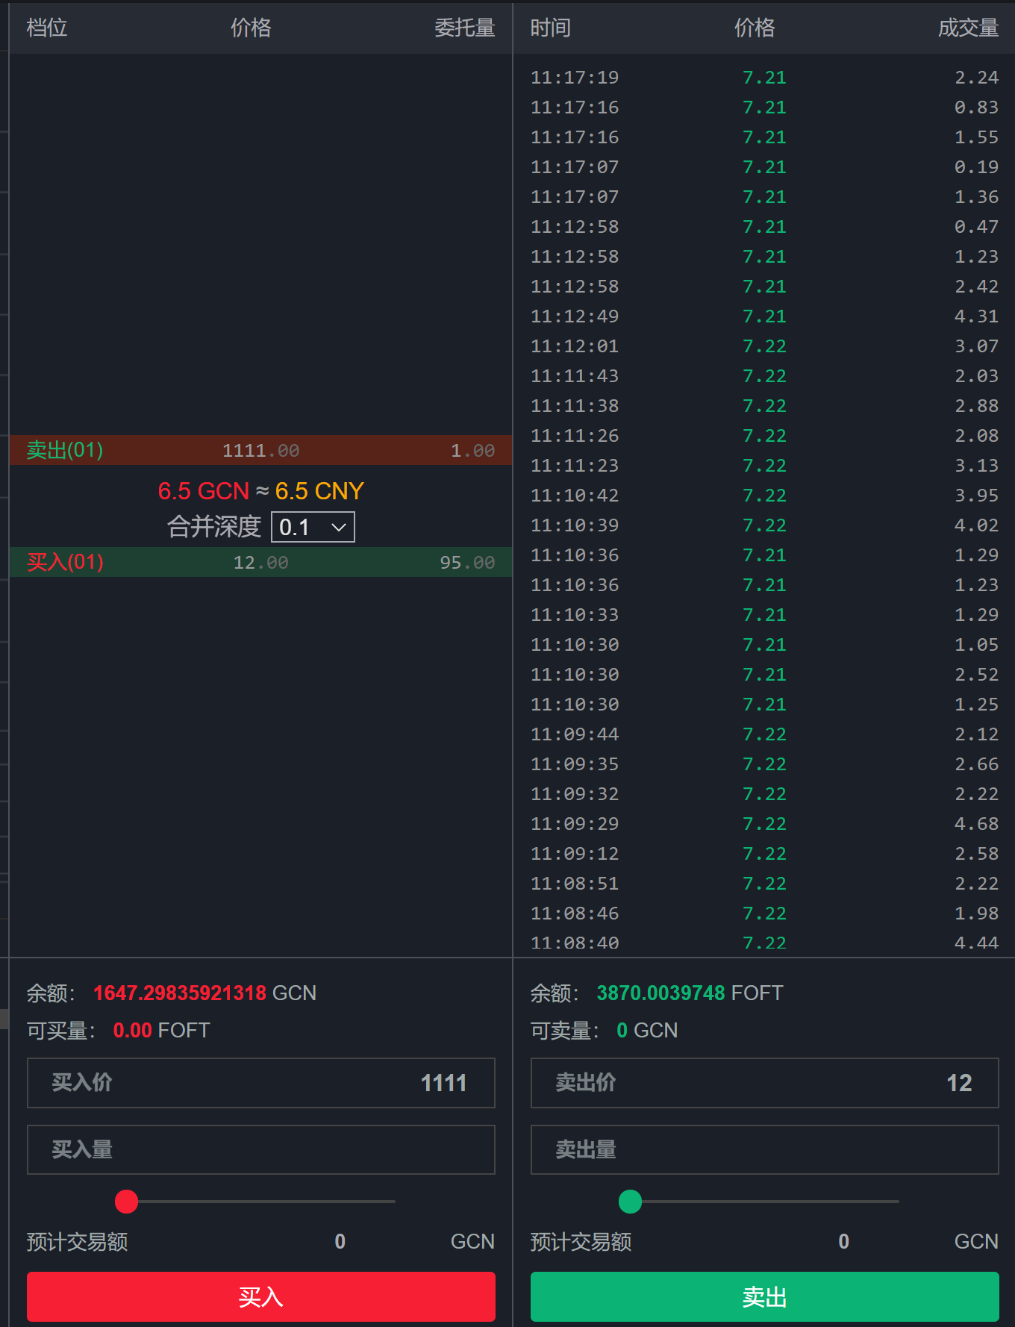

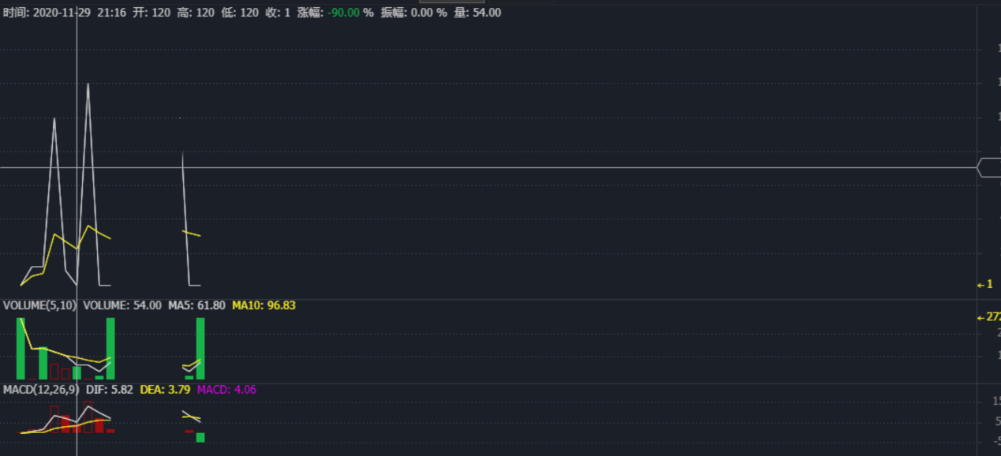

## 14.7 延迟太高的同学

因为运行了9个微服务,导致线程的调度非常慢,因此,K 线的推送速度会很慢.大家一定要关闭电脑上无用的软件,以及关闭多余的服务.

最后,如果实在推送不过来,或者是电脑死机了,可以在这个地方只推一种K 线类型:

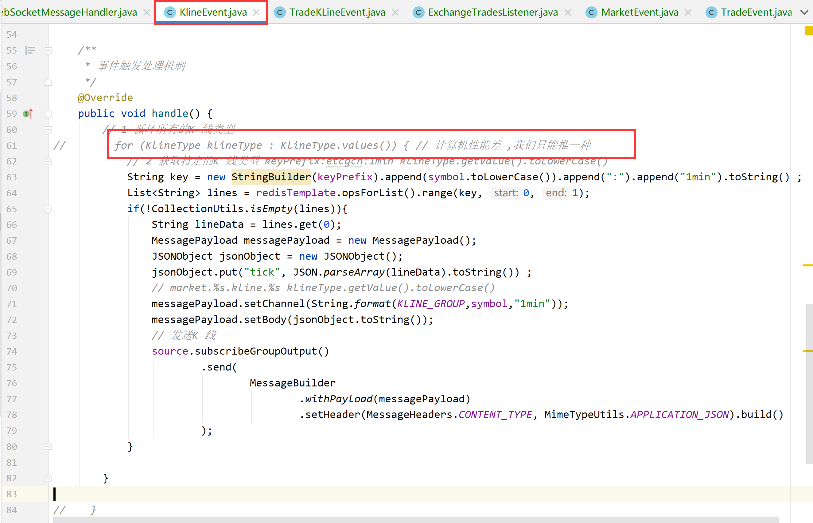

# 关于其他的推送服务

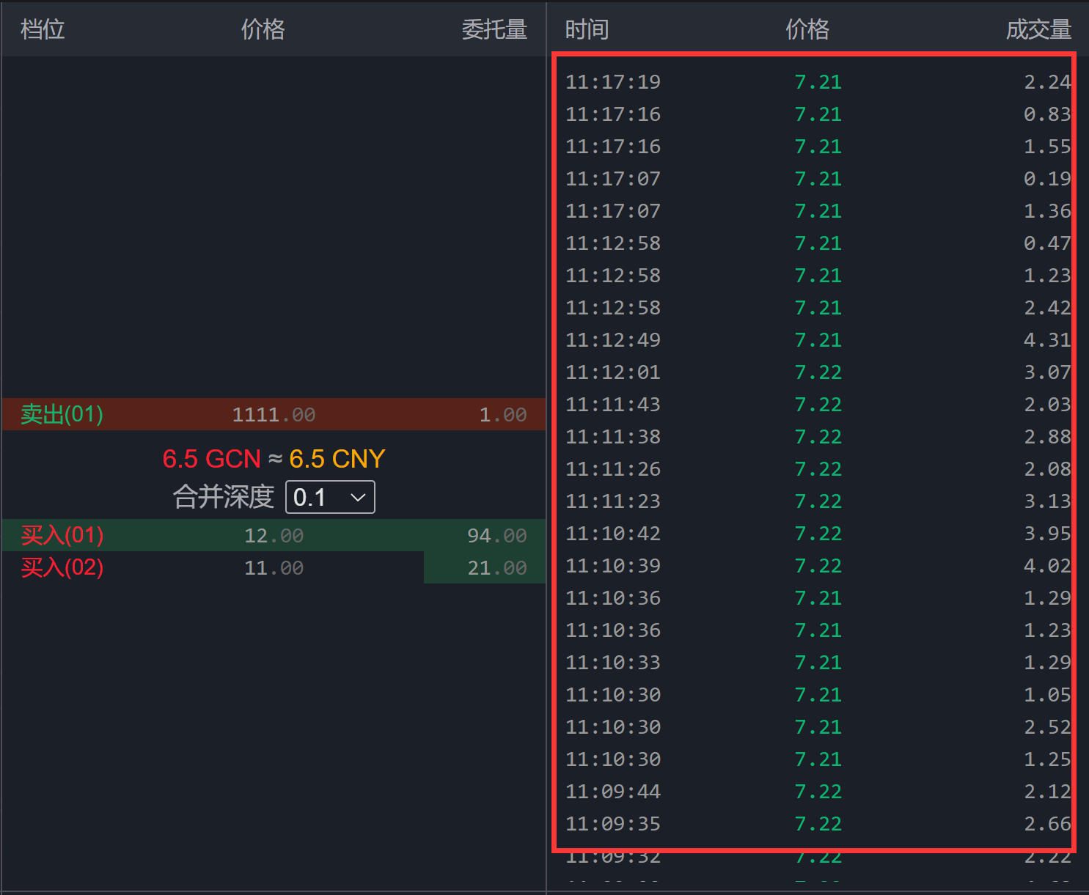



## 15.1 市场行情K 线的推送

|  |
| --- |
| */**  * 行情市场的K 线  */* @Component @Slf4j public class MarketEvent implements Event {   @Autowired  private Source source;   @Autowired  private TradingAreaServiceClient tradingAreaServiceClient;    @Autowired  private MarketServiceFeign marketServiceFeign;   private static final String *MARKET_GROUP* = "market.%s.ticker"; *// %s代表交易区域* private static final String *MARKET_DETAIL_GROUP* = "markets.%s.detail" ; *// 交易区域的详情交易数据* @Override  public void handle() {  *// 1 交易区域的查询* List<TradeAreaDto> tradeAreaDtoList = tradingAreaServiceClient.tradeAreas();  if (CollectionUtils.*isEmpty*(tradeAreaDtoList)) {  return;  }  for (TradeAreaDto tradeAreaDto : tradeAreaDtoList) {  *// 2 差该交易区域下的交易数据 , 使用的是交易区域里面市场的id("id1,id2")* List<TradeMarketDto> tradeMarketDtos = marketServiceFeign.queryMarkesByIds(tradeAreaDto.getMarketIds());  if (CollectionUtils.*isEmpty*(tradeMarketDtos)) {  return;  }   JSONObject jsonObject = new JSONObject();  jsonObject.put("markets", tradeMarketDtos);  MessagePayload messagePayload = new MessagePayload();  messagePayload.setChannel(String.*format*(*MARKET_GROUP*, tradeAreaDto.getCode().toLowerCase()));  messagePayload.setBody(jsonObject.toJSONString());  source.subscribeGroupOutput()  .send(  MessageBuilder  .*withPayload*(messagePayload)  .setHeader(MessageHeaders.*CONTENT_TYPE*, MimeTypeUtils.*APPLICATION_JSON*).build()  );  }    *// 获取所有的交易市场* List<MarketDto> marketDtos = marketServiceFeign.tradeMarkets();  if(CollectionUtils.*isEmpty*(marketDtos)){  return;  }  for (MarketDto marketDto : marketDtos) {  List<TradeMarketDto> tradeMarketDtos = marketServiceFeign.queryMarkesByIds(marketDto.getId().toString());   JSONObject jsonObject = new JSONObject();  jsonObject.put("tick",tradeMarketDtos) ;   MessagePayload messagePayload = new MessagePayload();  messagePayload.setChannel(String.*format*(*MARKET_DETAIL_GROUP*,marketDto.getSymbol().toLowerCase()));  messagePayload.setBody(jsonObject.toJSONString());  source.subscribeGroupOutput()  .send(  MessageBuilder  .*withPayload*(messagePayload)  .setHeader(MessageHeaders.*CONTENT_TYPE*, MimeTypeUtils.*APPLICATION_JSON*).build()  );  }   } } |

## 15.2 成交记录的推送

|  |
| --- |
| */**  * 成交记录事件  */* @Component @Slf4j public class TradeEvent implements Event {   @Autowired  private Source source;   private static final String *TRADE_GROUP* = "market.%s.trade.detail"; *// %s 代表交易对* @Autowired  private MarketServiceFeign marketServiceFeign;   @Override  public void handle() {  *// 1 获取所有的交易市场* List<MarketDto> marketDtos = marketServiceFeign.tradeMarkets();  if (CollectionUtils.*isEmpty*(marketDtos)) {  return;  }  for (MarketDto marketDto : marketDtos) {  *// 2 查询该交易对下的交易数据* String data = marketServiceFeign.trades(marketDto.getSymbol());   JSONObject jsonObject = new JSONObject();  jsonObject.put("data", data);  MessagePayload messagePayload = new MessagePayload();  messagePayload.setChannel(String.*format*(*TRADE_GROUP*, marketDto.getSymbol().toLowerCase()));  messagePayload.setBody(jsonObject.toString());  source.subscribeGroupOutput()  .send(  MessageBuilder  .*withPayload*(messagePayload)  .setHeader(MessageHeaders.*CONTENT_TYPE*, MimeTypeUtils.*APPLICATION_JSON*).build()  );  }   } } |