Staking Contract Address : 0xab6ef2576afcD7598E4DCfCA01215fEeA2a07C91

RTT Address for staking contract : [0x30ba2db859e2f998a82cb9485b0b288aea48651a](https://testnet.bscscan.com/address/0x30ba2db859e2f998a82cb9485b0b288aea48651a)

Airdrop Contract Address: 0x71E8ec88826A47f24631Dc2f01085e98b76685Da

RTT Address for airdrop contract: [0x8ce9bd698cf17200918379d06d85c01c1f12f1ab](https://testnet.bscscan.com/address/0x8ce9bd698cf17200918379d06d85c01c1f12f1ab)

Note: Now RTT address for airdrop and RTT address for staking is different. It is temporary. Once these contracts pass your testing and when these contracts deploy on the mainnet, I will use the same address of RTT for staking and airdrop.

Note: RTT token has 18 decimals. So you should consider the decimals when enter the RTT amount. 1000000000000000000 = 1RTT

How to confirm your balance exactly?

1. Go to the token address.

When you test the airdrop, RTT address: [0x8ce9bd698cf17200918379d06d85c01c1f12f1ab](https://testnet.bscscan.com/address/0x8ce9bd698cf17200918379d06d85c01c1f12f1ab)

When you test the staking, RTT address: [0x30ba2db859e2f998a82cb9485b0b288aea48651a](https://testnet.bscscan.com/address/0x30ba2db859e2f998a82cb9485b0b288aea48651a)

1. Click “Read Contract” button.

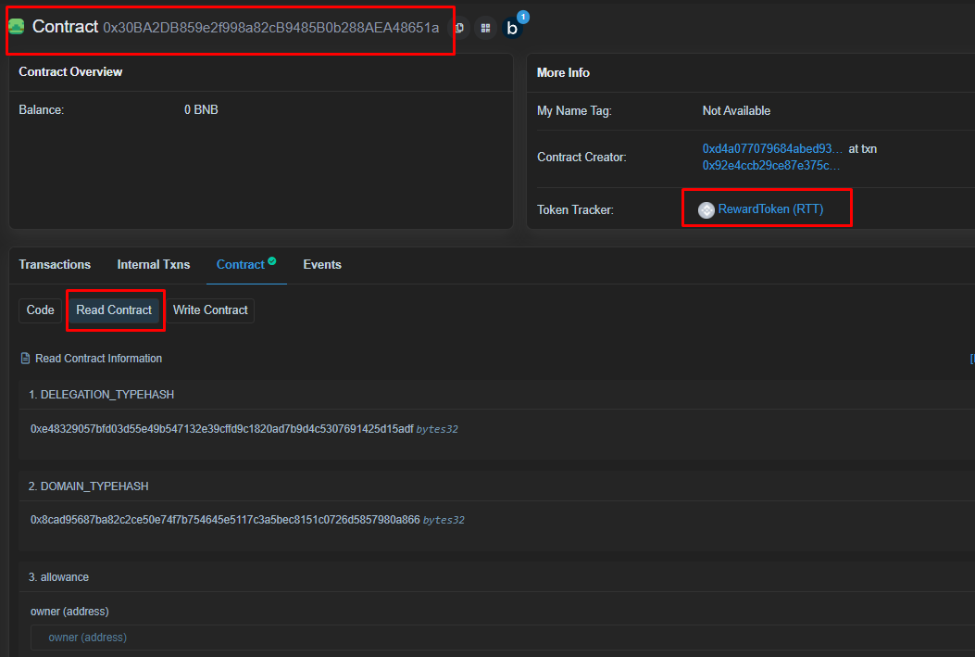

1. Go to the balanceOf function
2. Put your address in the address field
3. Click the “Query” button.
4. You can see your RTT balance.

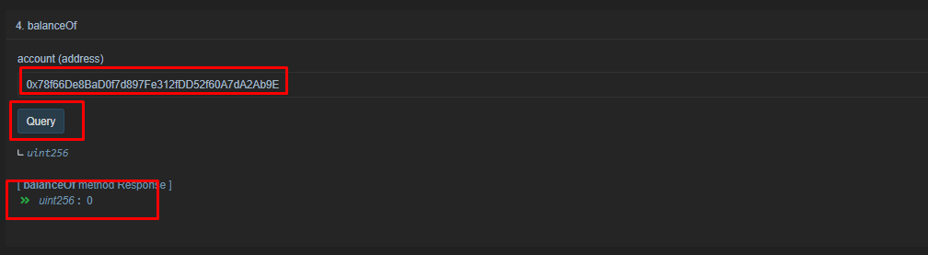

**Guide for airdrop :**

dropTokens(No 2) function will send presetted RTT amount to all putted addresses.

You can preset the airdrop amount.

Following below:

1. connect your metamask to the BSC testnet.

2. Go to the updateDropAmount function(No 8).

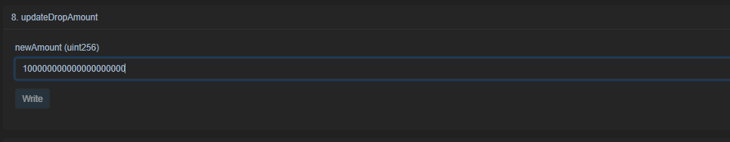

100000000000000000000 = 100RTT

3. go to the dropTokens function and put the addresses in the input field.

[0xDF465C98bB8dDC6eBb7F9c1086120FD01eEF70AD, 0x7656da7821e1eC8cA663995523037Ce00372a8d8]

Note: Your balance should be above 100*2 = 200RTT. You should check your balance before airdrop.

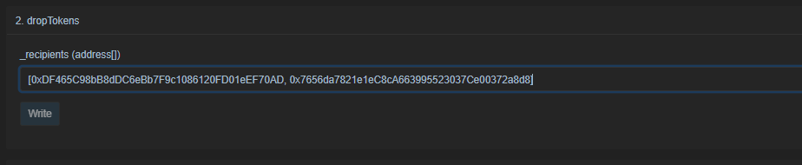

These two addresses will get the 100RTT tokens.

4. click the write button

5. confirm.

If the airdrop success, the 0xDF465C98bB8dDC6eBb7F9c1086120FD01eEF70AD address and 0x7656da7821e1eC8cA663995523037Ce00372a8d8 address will add 100RTT tokens.

**Guide for staking :**

1. Go to the RTT token address on the bscscan

Rtt address: [0x30ba2db859e2f998a82cb9485b0b288aea48651a](https://testnet.bscscan.com/address/0x30ba2db859e2f998a82cb9485b0b288aea48651a)

1. Confirm your RTT balance
2. Approve your RTT tokens

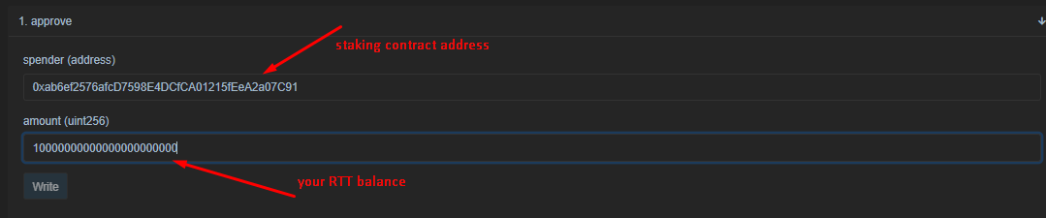

1. Go to the staking contract on the bsc

Staking address: 0xab6ef2576afcD7598E4DCfCA01215fEeA2a07C91

1. Call deposit function

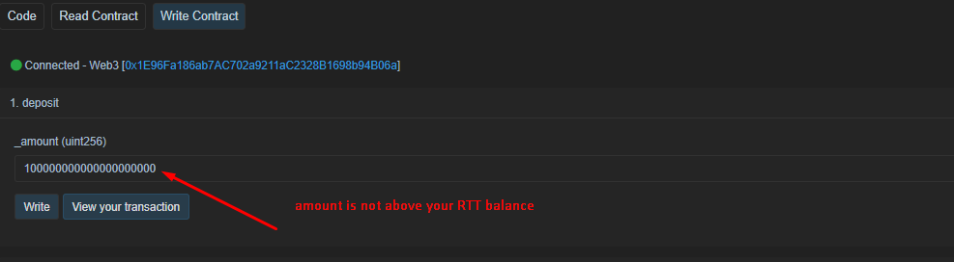

1. Check your reward amount.

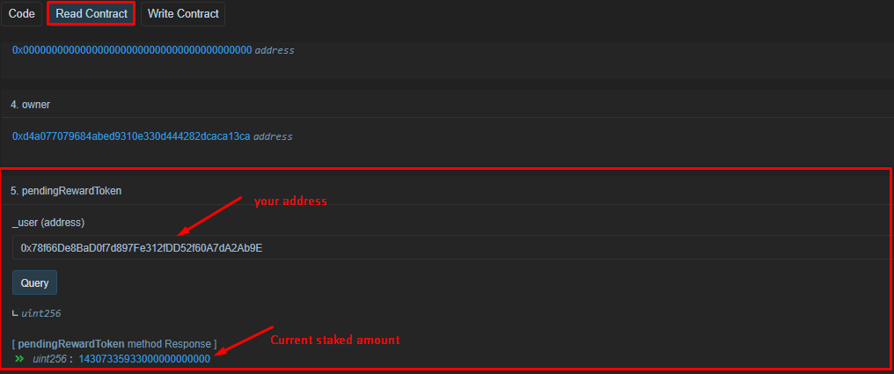

1. Call emergencyWithdraw function

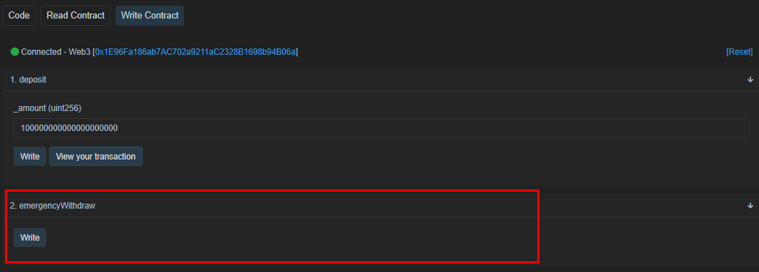

1. Confirm your balance

Your balance will be initial balance+reward amount