Amrita Vishwa Vidyapeetham

Amrita School of Computing , Coimbatore

Mobile Application Development

**Submitted To**

Dr. Guruprakash J

|  |  |
| --- | --- |
| **Name** | **Rollno** |
| Hidesh Balaji C U | CB.EN.U4CSE21320 |

Badges and Certificate

Badges

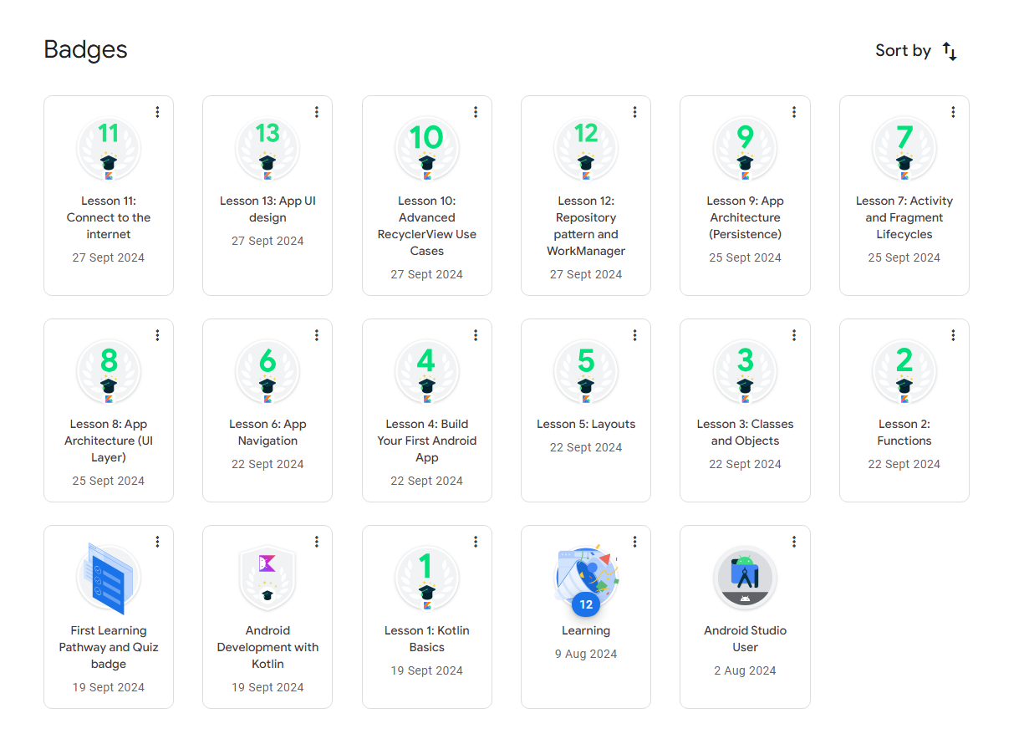

Coursera

