**Amrita Vishwa Vidyapeetham**

**Amrita School of Computing , Coimbatore**

19CSE463-Mobile Application Development

Plant Disease Detection

**Project Report**

**Submitted to**

**Dr.J.Guruprakash**

**Team – 03**

Hidesh Balaji C U – CB.EN.U4CSE21320

Sivaraj Kumar S – CB.EN.U4CSE21457

**Introduction:**

In the field of dermatology, accurate and timely skin disease detection is critical for effective treatment and improved patient outcomes. To meet this need, we have developed a custom ensemble model for skin disease detection that utilizes the HAM10000 dataset and combines the strengths of four advanced neural network architectures: ResNet50, DenseNetV2, MobileNetV2, and a custom CNN. This ensemble approach aims to enhance classification accuracy and provide a reliable solution for identifying various types of skin diseases.

**Model Architectures:**

**ResNet50**

ResNet50 is a deep residual network designed to handle complex feature extraction by utilizing skip connections, which facilitate gradient flow and help avoid vanishing gradients during training. With its 50-layer depth, ResNet50 is capable of capturing intricate features, making it a powerful choice for skin disease classification tasks.

**DenseNetV2**

DenseNetV2 is a densely connected network that promotes feature reuse across layers. Each layer has direct connections to all subsequent layers, which improves parameter efficiency and enhances feature propagation. This architecture is particularly useful for tasks where detailed feature extraction is needed, such as distinguishing between various types of skin lesions.

**MobileNetV2**

MobileNetV2 is an efficient and lightweight model, specifically optimized for mobile and embedded devices. It uses depthwise separable convolutions to reduce computation and memory requirements while maintaining high classification accuracy. MobileNetV2's efficiency makes it a valuable addition to the ensemble, ensuring that the model can be deployed effectively on resource-constrained devices.

**Custom CNN**

The custom CNN model is tailored for skin disease detection, featuring a simplified architecture with fewer parameters, which enables faster training. This model captures essential features of skin lesions, providing additional robustness to the ensemble.

**Ensemble Approach**

By combining predictions from ResNet50, DenseNetV2, MobileNetV2, and the custom CNN, we create an ensemble model that leverages the unique strengths of each individual architecture. This ensemble approach promotes better generalization and improved accuracy, as each model may excel in identifying different aspects of skin disease patterns.

**Training and Evaluation**

The ensemble model was trained and fine-tuned on the HAM10000 dataset, which includes a wide range of skin disease classes. Each model in the ensemble was trained independently, and their predictions were averaged to produce the final output. This approach not only improves classification accuracy but also enhances the model's resilience to overfitting.

**Performance**

The custom ensemble model has demonstrated a significant improvement in classification accuracy over individual models. By integrating multiple architectures, the model provides comprehensive feature extraction and is capable of accurately distinguishing between diverse skin diseases.

**Conclusion**

This custom ensemble model represents a substantial advancement in skin disease detection. By combining ResNet50, DenseNetV2, MobileNetV2, and a custom CNN, we have developed a robust solution that surpasses traditional single-model approaches. This model is expected to aid dermatologists and healthcare professionals in providing accurate and timely diagnostics, ultimately supporting improved patient care and more effective treatment strategies**.**

**Resnet50 Model Architecture**

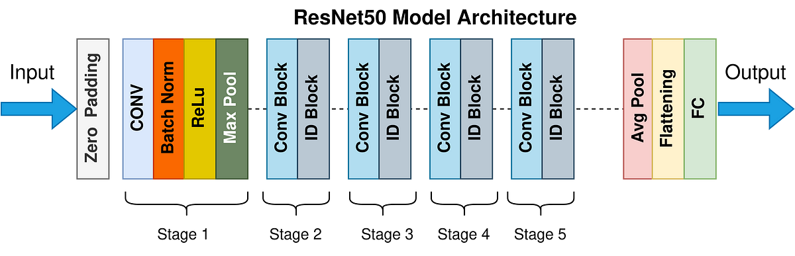

**DenseNETV2 Model Architecture**

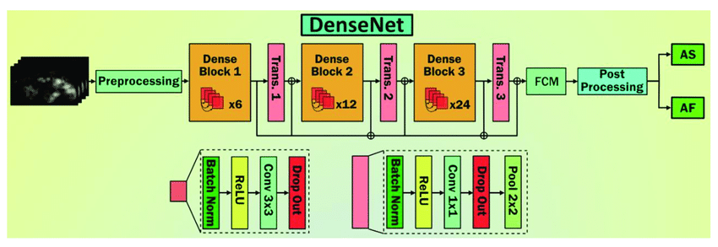

**MobilenetV2 Model architecture:** 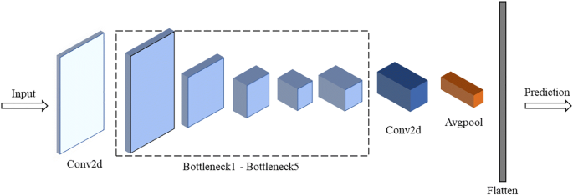

**Evaluation Metrics :**

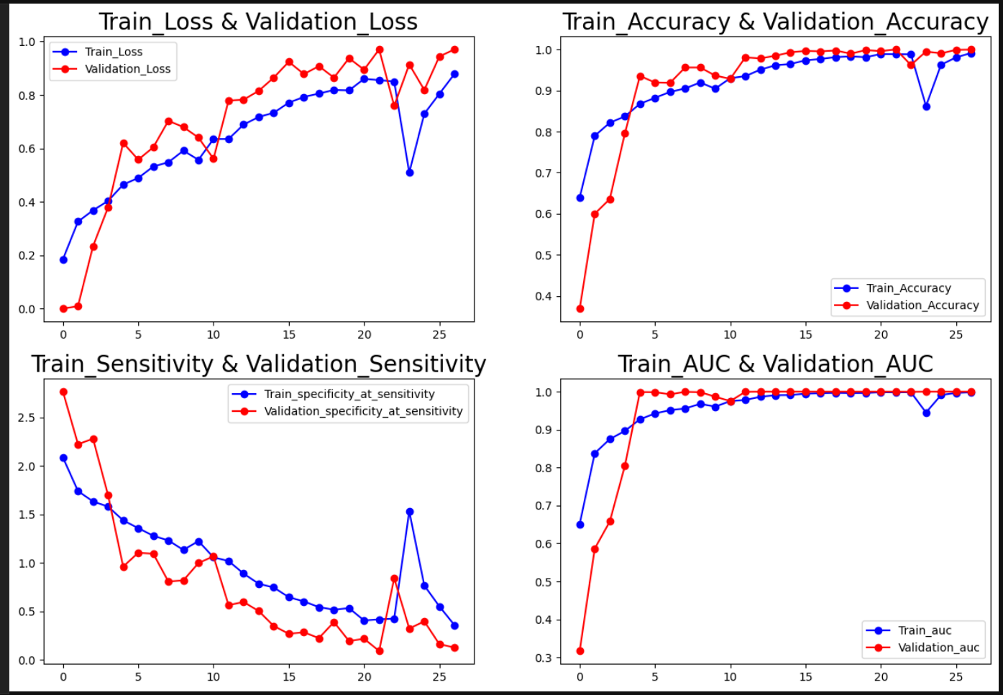

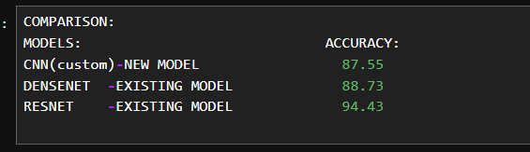

**Confusion Matrix**

