**Amrita Vishwa Vidyapeetham**

**Amrita School of Computing , Coimbatore**

19CSE463-Mobile Application Development

Plant Disease Detection

Review – 02

Submitted To :

**Dr.J.Guruprakash**

**Team No – 03**

Hidesh Balaji – CB.EN.U4CSE21320

Sivaraj Kumar S – CB.EN.U4CSE21457

**Model Name :** Custom CNN

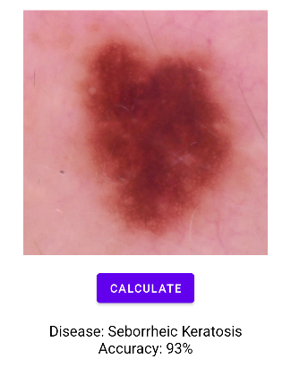

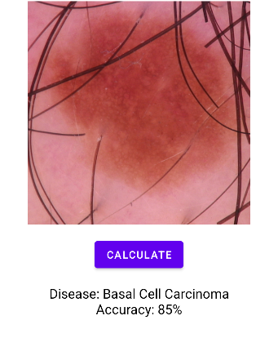

**Accuracy:**

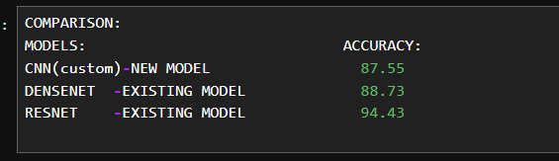

**Confusion Matrix :**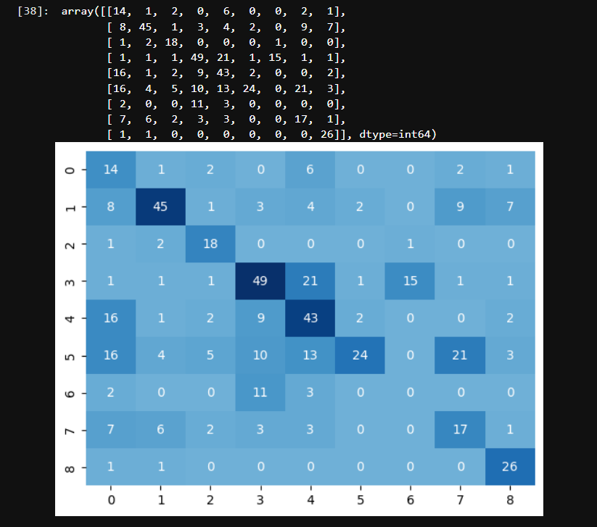

**UI :**

