Key Engineering Materials Vols. 326-328 (2006) pp 1217-1220
Online available since 2006/Dec/01 at www.scientific.net
© (2006) Trans Tech Publications, Switzerland doi:10.4028/www.scientific.net/KEM.326-328.1217
TOPOLOGY OPTIMIZATION OF A VEHICLE’S HOOD USING EVOLUTIONARY STRUCTURAL OPTIMIZATION
S. H. Choi^{1,a}, J. Y. Park^{1,b}, I. S. Shin^{1,c}, S. Y. Han ^{2,d}
1
Dept. of Automotive Engineering, Hanyang Graduate School, 17 Haengdang-Dong, Sungdong-
Ku, Seoul 133-791, Korea 2
School of Mechanical Engineering, Hanyang University, 17 Haengdang-Dong, Sungdong-Ku, Seoul 133-791, Korea
a b csh4866101@hanmail.net, bimmer@ihanyang.ac.kr,
c d
Formonatra@hanmail.net, syhan@hanyang.ac.kr
Keywords: Topology, Vehicle’s hood, ESO, Multiobjective Optimum Design
Abstract Topology optimization of the inner reinforcement for a vehicle’s hood has been performed by evolutionary structural optimization (ESO) method. The purpose of this study is to obtain optimal topology of the inner reinforcement for a vehicle’s hood considering static stiffness and natural frequency simultaneously. To do this, the multiobjective design optimization technique was implemented. From several combinations of weighting factors, a Pareto-optimal solution was obtained. Optimal topologies were obtained by the ESO method, i.e., by eliminating the elements having the lowest efficiency from the structural domain. As the weighting factor of the elastic strain efficiency goes from 1 to zero, it is found that the optimal topologies transmits from the optimal topology of static stiffness problem to that of natural frequency problem. Therefore, it was concluded that ESO method is effectively applied to topology optimization of the inner reinforcement of a vehicle’s hood.

Introduction
Shell and plate structures, of which the areas are relatively very wide compared to their thickness, are very weak in both transverse loading and transverse vibration. Therefore they have been used with inner reinforcement attached beneath the structures. In order to obtain an optimum design under the given boundary conditions, the concept of optimum design such as design sensitivity analysis should be implemented in addition to the estimations of static and dynamic stiffness [1].
Topology optimization obtains an optimal topology by determining which elements should remain inside the structure. An important recent development in this area was made by Bendsoe and Kikuchi [2] who proposed the homogenization method, where the structure was represented by a model with microvoids and the objective was to seek the optimal porosity of the porous medium using an optimality criterion. Recently, ESO has been proposed by Xie and Steven [3-5], based on the concept of gradually removing redundant elements to obtain an optimal design. Some important characteristics of ESO are that it involves no mathematical programming technique such as design sensitivity analysis and there is no ambiguity for determining the redundant elements to be removed.
In this study, the multiobjective method was performed in order to estimate whether ESO method can effectively be applied to topology optimization of inner reinforcement of a vehicle’s hood or not. For this purpose the multiobjective sensitivity number was defined by combining each sensitivity number for static stiffness and natural frequency as a criterion for removing redundant elements. Also, two models with different curvature were chosen in order to investigate the effect of sizes of curvature on the static stiffness and natural frequency of the inner reinforcement.
All rights reserved. No part of contents of this paper may be reproduced or transmitted in any form or by any means without the written permission of TTP, www.ttp.net. (ID: 140.116.207.86, National Cheng Kung University, Tainan, Taiwan-03/12/13,08:40:57)

1218 Experimental Mechanics in Nano and Biotechnology

ESO For Static Stiffness Problem [3] and Natural Frequency Problem [4]
Sensitivity number α_{si}^{e} for maximizing static stiffness of a structure can be defined by the change in strain energy due to the removal of the ith element.

α_{si}^{e} = ¹{u^{i} }^{T} [K ^{i} ]{u^{i}} (i =1, n) (1)
2
where [K ^{i} ] is the stiffness matrix of the ith element, and {u^{i}} is the displacement vector of the ith element. In order to increase the static stiffness, it would be most effective to remove the elements having the smallest sensitivity number.
To determine which elements should be removed from the structure so that the frequency will be shifted towards a desired value, the sensitivity number α_{di}^{e} for natural frequency can be defined by an indicator of the frequency change due to the removal of the element.

α_{di}^{e} = ¹ {u_{i}^{e}}^{T} (ω_{i}²[M ^{e} ]−[K ^{e} ]){u_{i}^{e}} (2)
m_{i}

where, m_{i} is the modal mass, [M ^{e} ] is the mass matrix of the removed element, [K ^{e} ] is the stiffness matrix of the removed element, {u_{i}^{e}} is the element eigenvector which are related to the removed element. In order to increase the natural frequency ω_{i} , it would be most effective to remove the elements having the maximum sensitivity number.

Multiobjective Design Optimization
Multiobjective Design optimization is a design method used to simultaneously maximize the objective functions when there is more than one. In this case, the weighting factors can be introduced to reflect the importance of the different design criteria such as static stiffness and natural frequency. From several combinations of weighting factors, different trade-off strategies result in different topologies. Each of these topologies represents a Pareto-optimal solution [5]. Therefore, a designer can select one optimal solution from the Pareto-optimal solution dependent on the level of importance.
Multiobjective sensitivity number In order to find an optimal topology which is to maximize the static stiffness and natural frequency simultaneously, a definition of the multiobjective sensitivity number is needed in order to determine which elements should be removed. Therefore, in this paper the multiobjective sensitivity number α_{mi}^{e} is defined by the following Eq. (3), which combines both the normalized sensitivity numbers for static stiffness and natural frequency, and introduces the weighting factors λ₁ and λ₂ in order to reflect the importance of static stiffness and natural frequency, respectively.
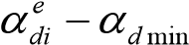

αmie = λ1^{ αsmax −αsie P} +λ₂_{α}d max _{−α}d min ^{P}  (3)
 _{α}smax _{−α}smin  

where, α_{si}^{e} and α_{di}^{e} are the sensitivity numbers for static stiffness and natural frequency, respectively. α_{smax} and α_{smin} are the maximum and minimum sensitivity numbers for static stiffness, respectively. α_{d max} and α_{d min} are the maximum and minimum sensitivity numbers for natural frequency. P is the penalty factor, which is used as 2 in this study.
Key Engineering Materials Vols. 326-328 1219

Removal Line In order to overcome this difficulty, α_{mi}^{e} is normalized again by the following Eq.
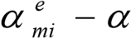
(4), so that α_{mmin} and α_{mmax} are equal to zero, and one, respectively. α_{N}^{e} _{mi} = ^{m min} (4) αm max −αm min

where, α_{Nmi}^{e} is the normalized multiobjective sensitivity number. The elements for which the normalized multiobjective sensitivity number α_{Nmi}^{e} are less than or equal to RL are to be removed. It can be expressed by the following Eq. (5).
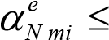 RL (5)

Application Examples
Multiobjective topology optimization In order to investigate the effect of curvature of a vehicle’s hood on an optimal topology, multiobjective topology optimizations were performed for two cases;
- the severe curvature part in front of a vehicle’s hood was included in design domain (Model 1),
- the severe curvature part in front of a vehicle’s hood was not included in design region (Model 2). And as mentioned before, five kinds of weighting factors λ₁ and λ₂ were considered 0, 0.25,
0.5, 0.75 and 1 in order to reflect the importance of static stiffness and natural frequency, respectively. The dimensions and material properties of a vehicle’s hood shown in Fig. 1(a) are as follows; length (x-axis) 1.122 m, width (z-axis) 1.4 m, Young’s modulus E = 210 GPa, Poisson’s ratio ν=0.3, density ρ=7800 kg/m³, and thickness t=3 mm. Final mass was restricted as 50% of the initial design (original model). The dimensions and the finite element modeling for Model 1 are shown in Fig. 1. The overall design region of Model 1 is shown in Fig. 1(a), and finite element modeling in x-y plane and y-z plane are shown in Fig. 1(b) and Fig. 1(c), respectively. The dimensions and the finite element modeling for Model 2 are basically the same as Fig. 1. But the only different thing is that the severe curvature part in front of a vehicle’s hood is not included in design region. Hence, the dimensions of Model 2 are length (x-axis) 1 m and width (z-axis) 1.4 m.

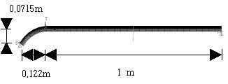
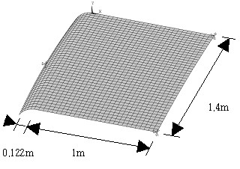
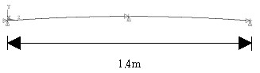
(b) Finite element modeling in the x-y plane

(a) Oblique view of finite element modeling
(c) Finite element modeling in the y-z plane

Fig. 1 Finite element modeling of Model 1

Pareto-optimal solution of multiobjective topology optimization A Pareto-optimal solution for Model 1 and Model 2 due to several combinations of weighting factors is shown in from Fig. 2 to Fig. 3. Also the first natural frequency and the maximum displacement at the center of the hood of a Pareto-optimal solution due to several combinations of weighting factors are listed in Table 1. It was verified that as the weighting factor λ₂ for natural frequency goes from 0 to 1 for Model 1 and

1220 Experimental Mechanics in Nano and Biotechnology

Model 2, the optimal topologies transitions from the optimal topology of the static stiffness problem to that of the natural frequency problem.
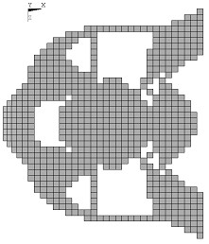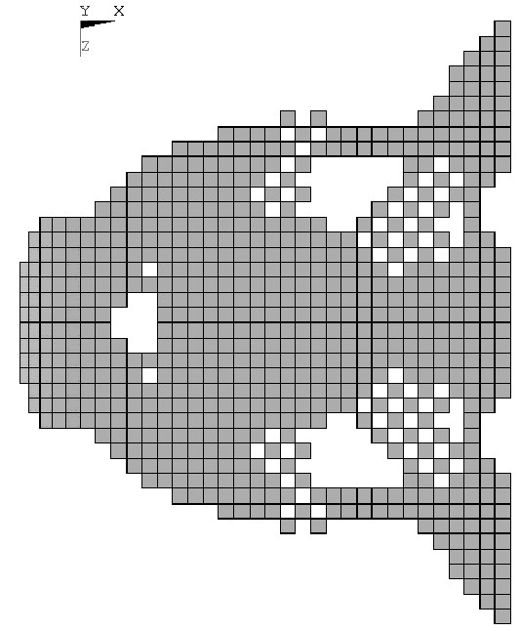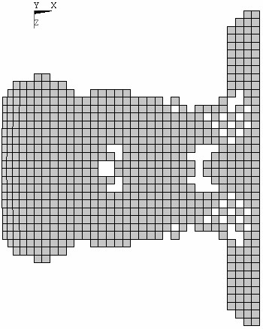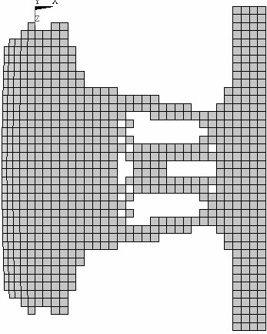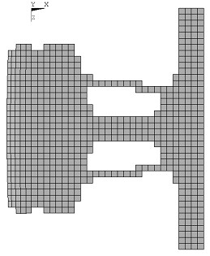 (a) λ₁ =1 (b) λ₁ =0.75 (c) λ₁ =0.5 (d) λ₁ =0.25 (e) λ₁ =0.

Fig. 2 Pareto-Optimal topologies for Model 1

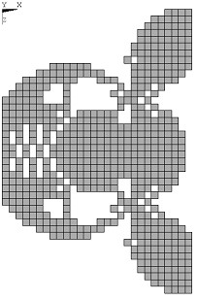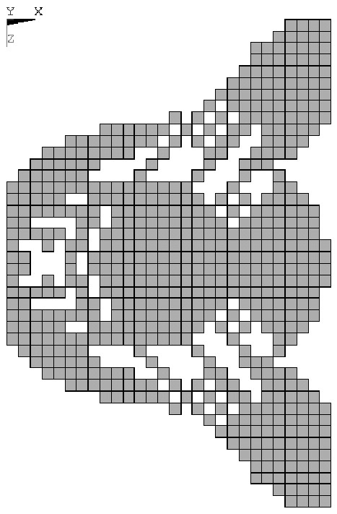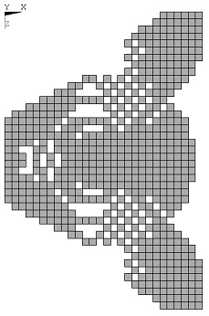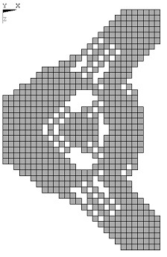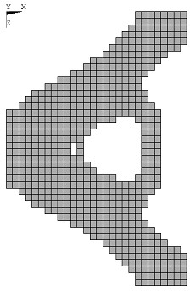 (a) λ₁ =1 (b) λ₁ =0.75 (c) λ₁ =0.5 (d) λ₁ =0.25 (e) λ₁ =0.

Fig. 3 Pareto-Optimal topologies for Model 2

Table 1 Comparisons of the 1st natural frequency (Hz) and the max. displacement (m)
Weighting Factor |  | Model 1 |  | Model 2
λ₁ | λ₂ | 1st. natural freq. | Max. Displ. | 1st. natural freq. | Max. Displ.
1 | 0 | 9.65 | 0.119E-03 | 8.52 | 0.157E-03
0.75 | 0.25 | 11.09 | 0.132E-03 | 12.48 | 0.160E-03
0.5 | 0.5 | 13.09 | 0.213E-03 | 13.51 | 0.162E-03
0.25 | 0.75 | 13.67 | 0.316E-03 | 17.15 | 0.173E-03
0 | 1 | 13.88 | - | 17.50 | -
Original model |  | 12.35 | 0.658E-04 | 7.00 | 0.901E-04

Summary
From the results of multiobjective topology optimization for inner reinforcement of a vehicle’s hood, the conclusions are as follows; (1) It was verified that the ESO method can effectively be applied to multiobjective topology optimization of inner reinforcement of a vehicle’s hood, (2) It was shown that the static stiffness and the increase of natural frequency for a hood with large curvature are the larger and the smaller, respectively, compared with a hood with small curvature.

References
[1] T. H. Lee, D. Lee, J. Koo, S. Y. Han and J. K. Lim, Trans. KSME Ser. A, 24(2000), p.62 [2] M. P. Bendsoe and N. Kikuchi, Comput. Methods Appl. Mech. Eng. Vol. 71(1988), p.197
- D. Nha Chu, Y. M. Xie, A. Hira and G. P. Steven, Finite Elements in Analysis and Design Vol. 21(1996), pp.239
- Y. M. Xie and G. P. Steven, Computers & Structures Vol. 58(1996), p.1067
- Q. Li, G. P. Steven, O. M. Querin and Y. M. Xie, Engr. Computations Vol. 11(2000), p.295
Experimental Mechanics in Nano and Biotechnology
10.4028/www.scientific.net/KEM.326-328

Topology Optimization of a Vehicle’s Hood Using Evolutionary Structural Optimization 10.4028/www.scientific.net/KEM.326-328.1217

