**REST API Documentation**

1. Customer

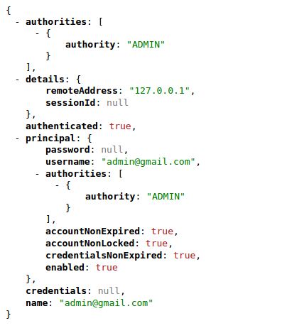- api/user Return-Type: Principal

- api/customer Return-Type: Customer

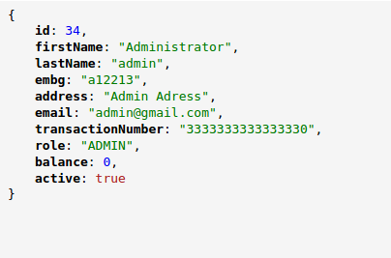

- api/customer/register,customer/Method=POST Return-Type:Customer

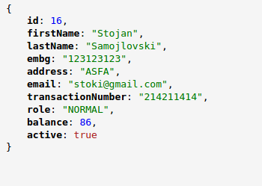

-(api/admin/customer + id) Return-Type:Customer



-/api/admin/customers Return-Type: List<Customer>

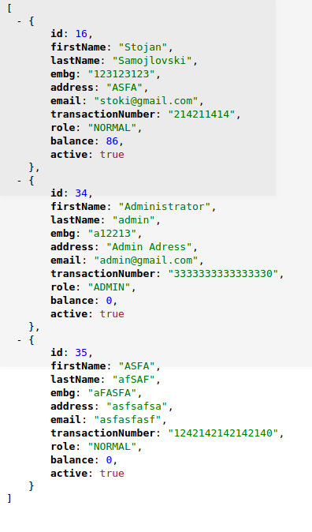

-api/admin/customer/edit , customer , Method = PUT

Return-Type:Customer



2.Creditor

- api/admin/creditor + id Return-Type:Creditor

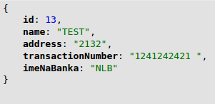

3.Role

-api/admin/role + id Return-Type:String



4.Order

- api/order/create,order/Method=POST Return-Type:Order

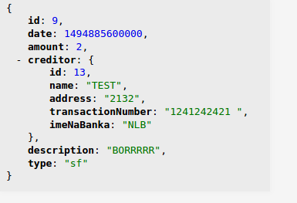

- (api/admin/order + id) Return-Type:Order



-/api/admin/orders Return-Type: List<Order>

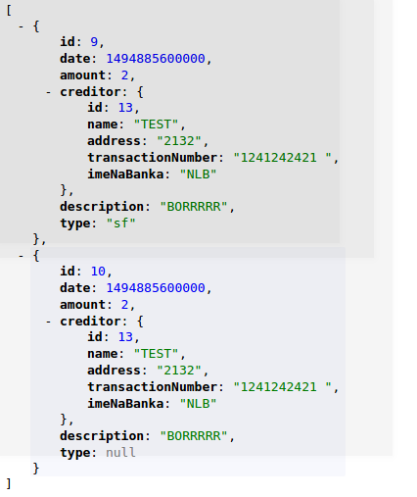

-api/admin/order/edit , customer , Method = PUT

Return-Type:Order



-api/orders/customer , Method = PUT Return-Type:List<Order>

