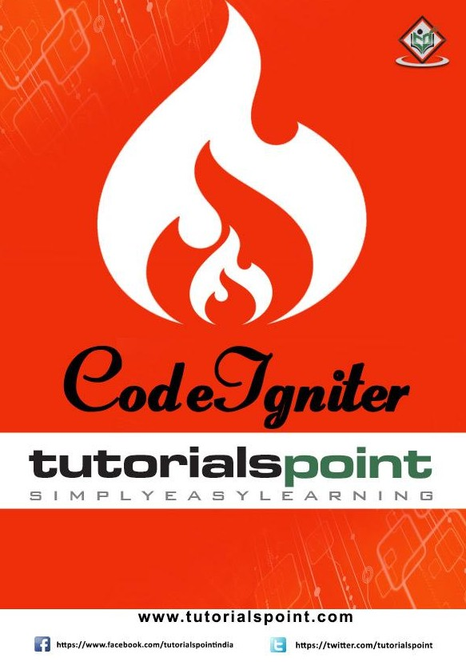

CodeIgniter

# About the Tutorial

CodeIgniter is a powerful PHP framework with a very small footprint, built for developers who need a simple and elegant toolkit to create full-featured web applications. CodeIgniter was created by EllisLab, and is now a project of the British Columbia Institute of Technology.

# Audience

This tutorial has been prepared for developers who would like to learn the art of developing websites using CodeIgniter. It provides a complete understanding of this framework.

# Prerequisites

Before you start proceeding with this tutorial, we assume that you are already exposed to HTML, Core PHP, and Advance PHP. We have used CodeIgniter version 3.0.1 in all the examples.

# Copyright & Disclaimer

Copyright 2015 by Tutorials Point (I) Pvt. Ltd.

All the content and graphics published in this e-book are the property of Tutorials Point

(I) Pvt. Ltd. The user of this e-book is prohibited to reuse, retain, copy, distribute or republish any contents or a part of contents of this e-book in any manner without written consent of the publisher.

We strive to update the contents of our website and tutorials as timely and as precisely as possible, however, the contents may contain inaccuracies or errors. Tutorials Point (I) Pvt. Ltd. provides no guarantee regarding the accuracy, timeliness or completeness of our website or its contents including this tutorial. If you discover any errors on our website or in this tutorial, please notify us at [contact@tutorialspoint.com](mailto:contact@tutorialspoint.com)

i



Thank you for using [www.freepdfconvert.com](http://www.freepdfconvert.com/) service!

Only two pages are converted. Please Sign Up to convert all pages. <https://www.freepdfconvert.com/membership>