A Brief Aboriginal History
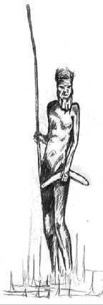
“The very ink with which all history is written is merely fluid prejudice.”
Mark Twain
Since the European invasion of Australia in 1788, the Aboriginal people have been oppressed into a world unnatural to their existence, a way of life that had continued for thousands of years. First came the influx of the strangers who carried with them diseases, which decimated the immediate population of the Sydney tribes. It is estimated that over 750,000 Aboriginal people inhabited the island continent in 1788. The colonists were led to believe that the land was terra nullius (‘no one’s land’), despite what Lt James Cook saw in 1770 during his voyage up the east coast of Australia.
“… they were so ignorant they thought there was only one race on the earth and that was the white race. So when Captain Cook first came, when Lieutenant James Cook first set foot on Wangal land over at Kundul which is now called Kurnell, he said oh lets put a flag up somewhere, because these people are illiterate, they’ve got no fences. They didn’t understand that we didn’t need fences … that we stayed here for six to eight weeks, then moved somewhere else where there was plenty of tucker and bush medicine and we kept moving and then come back in twelve months’ time when the food was all refreshed …”1
the late Aunty Beryl Timbery Beller
It would not be an exaggeration to claim that the Island continent was owned by over 400 different nations at the time of this claim by Cook. When the first fleet arrived in Sydney Cove it is said that Captain Philip was astounded with the theory of Cook’s terra nullius, saying “Sailing up into Sydney cove we could see natives lining the shore shaking spears and yelling.”
The Occupants of the Land
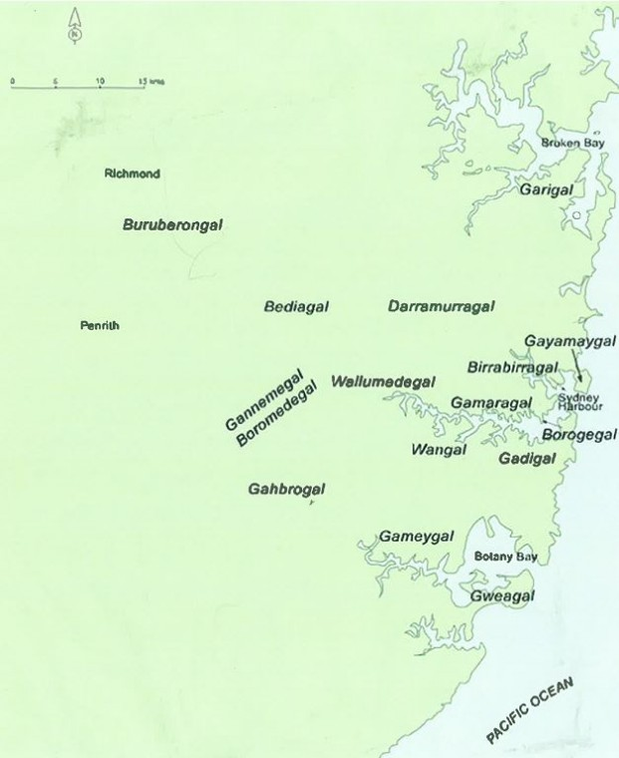Clans in the Sydney Region – courtesy of Dr Val Attenbrow, 2010
For thousands of years prior to the arrival of Europeans, northern Sydney was occupied by different Aboriginal clans. Living primarily along the foreshores of the harbour, they fished and hunted in the waters and hinterlands of the area, and harvested food from the surrounding bush. Self-sufficient and harmonious, they had no need to travel far from their lands, since the resources about them were so abundant, and trade with other tribal groups was well established. Moving throughout their country in accordance with the seasons, people only needed to spend about 4-5 hours per day working to ensure their survival. With such a large amount of leisure time available, they developed a rich and complex ritual life – language, customs, spirituality and the law – the heart of which was connection to the land.
European Discovery and Arrival
The arrival of Lt James Cook in 1770 marked the beginning of the end for this ancient way of life. Cook’s voyage of exploration had sailed under instructions to take possession of the Southern Continent if it was uninhabited, or with the consent of the natives if it was occupied. Either way, it was to be taken. Upon his arrival, Lt Cook declared the land he called New South Wales to be the property of Britain’s King George III, and ignored the inconvenient fact that the land was already well populated. His failure to even attempt to gain the consent of the natives began the legal fiction that Australia was waste and unoccupied (terra nullius: learn more).
Cook was followed soon enough by the arrival of the First Fleet, in January of 1788, under the command of Captain Arthur Phillip, whose mission was to establish a penal colony and take control of Terra Australia for settlement.
We found the natives tolerably numerous as we advanced up the river, and even at the harbour’s mouth we had reason to conclude the country more populous than Mr Cook thought it. For on the Supply’s arrival in the [Botany] bay on the 18th of the month they assembled on the beach of the south shore to the number of not less than forty persons, shouting and making many uncouth signs and gestures. This appearance whetted curiosity to its utmost, but as prudence forbade a few people to venture wantonly among so great a number, and a party of only six men was observed on the north shore, the governor immediately proceeded to land on that side in order to take possession of this new territory and bring about an intercourse between its new and old masters.
Watkin Tench, January 1788
The first act of land ownership by Europeans came within four days of arrival when a group of men from the HMS Sirius went ashore to clear land to gain access to fresh water. By 26 January, the First Fleet had found its way to Sydney Cove and landed there on the harbour.
Aboriginal Life Through European Eyes
The early Europeans took a dim view of the Aboriginal way of life when first they encountered it.
This excerpt is taken from the diary of Watkin Tench, an officer in the First Fleet:
It does not appear that these poor creatures have any fixed Habitation; sometimes sleeping in a Cavern of Rock, which they make as warm as a Oven by lighting a Fire in the middle of it, they will take up their abode here, for one Night perhaps, then in another the next Night. At other times (and we believe mostly in Summer) they take up their lodgings for a Day or two in a Miserable Wigwam, which they made from Bark of a Tree. There are dispersed about the woods near the water, 2, 3, 4 together; some Oyster, Cockle and Muscle (sic) Shells lie about the Entrance of them, but not in any Quantity to indicate they make these huts their constant Habitation. We met with some that seemed entirely deserted indeed it seems pretty evident that their Habitation, whether Caverns or Wigwams, are common to all, and Alternatively inhabited by different Tribes.
Kinship with the Land
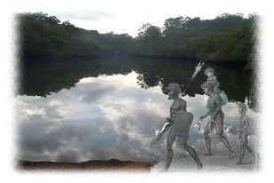For Aboriginal people and, in this instance, the clans living on the northern shores of Sydney, nothing could have been further from the truth. What the early colonists never understood, and perhaps what many Australians are only now beginning to grasp, was that the Aboriginal lifestyle was based on total kinship with the natural environment. Wisdom and skills obtained over the millennia enabled them to use their environment to the maximum. For the Aboriginal people, acts such as killing animals for food or building a shelter were steeped in ritual and spirituality, and carried out in perfect balance with their surroundings.
… from time immemorial, we believe as Aboriginal people, Australia has been here from the first sunrise, our people have been here along with the continent, with the first sunrise. We know our land was given to us by Baiami, we have a sacred duty to protect that land, we have a sacred duty to protect all the animals that we have an affiliation with through our totem system …1
Jenny Munro, Wiradjuri nation
Food was abundant, as was fresh water and shelter. Everything needed for a fruitful, healthy life was readily available. It was not to remain so. The British arrival brought armed conflict and a lack of understanding, which heralded the demise of the northern Sydney clans, along with the other peoples of the Sydney basin – the Dharawal to the south and the Dharug to the west. Food shortages soon became a problem. The large white population depleted the fish by netting huge catches, reduced the kangaroo population with unsustainable hunting, cleared the land, and polluted the water. As a result, the Aboriginal people throughout the Sydney Basin were soon close to starvation.
Disease and Devastation
Disease struck a fatal and extensive blow to the Aboriginal people, who until that point had been isolated for thousands of years from the diseases that had raged through Europe and Asia. They had no resistance to the deadly viruses carried by the sailors and convicts such as smallpox, syphilis and influenza. In less than a year, over half the indigenous population living in the Sydney Basin had died from smallpox. The region, once alive with a vibrant mix of Aboriginal clans, now fell silent.
Every boat that went down the harbour found them lying dead on the beaches and in the caverns of the rocks… They were generally found with the remains of a small fire on each side of them and some water left within their reach.
Lieutenant Fowell, 1789
It is difficult to comprehend how devastating this event was to the Aboriginal clans of the Sydney area. Bennelong told Judge Advocat David Collins that his friend Colebee’s tribe had been reduced to only three people. Those witnessing could not remain unmoved.
At that time a native was living with us; and on our taking him down to the harbour to look for his former companions, those who witnessed his expression and agony can never forget either. He looked anxiously around him in the different coves we visited; not a vestige on the sand was to be found of human foot; the excavations in the rocks were filled with the putrid bodies of those who had fallen victims to the disorder; not a living person was any where to be met with. It seemed as if, flying from the contagion, they had left the dead to bury the dead. He lifted up his hands and eyes in silent agony for some time; at last he exclaimed, ‘All dead! all dead!’ and then hung his head in mournful silence, which he preserved during the remainder of our excursion. Some days after he learned that the few of his companions who survived had fled up the harbour to avoid the pestilence that so dreadfully raged. His fate has been already mentioned. He fell a victim to his own humanity when Boo-roong, Nan-bar-ray, and others were brought into the town covered with the eruptions of the disorder. On visiting Broken Bay, we found that it had not confined its effects to Port Jackson, for in many places our path was covered with skeletons, and the same spectacles were to be met with in the hollows of most of the rocks of that harbour.
Judge Advocate David Collins, 1798
The colonists had destroyed within months a way of life that had outlasted British history by tens of thousands of years, and the people soon realised that the trespassers were committed to nothing less than total occupation of the land.
To most settlers, the Aboriginal people were considered akin to kangaroos, dingoes and emus, strange fauna to be eradicated to make way for the development of farming and grazing.
I have myself heard a man, educated, and a large proprietor of sheep and cattle, maintain that there was no more harm in shooting a native, than in shooting a wild dog. I have heard it maintained by others that it is the course of Providence, that blacks should disappear before the white, and the sooner the process was carried out the better, for all parties. I fear such opinions prevail to a great extent. Very recently in the presence of two clergymen, a man of education narrated, as a good thing, that he had been one of a party who had pursued the blacks, in consequence of cattle being rushed by them, and that he was sure that they shot upwards of a hundred. When expostulated with, he maintained that there was nothing wrong in it, that it was preposterous to suppose they had souls. In this opinion he was joined by another educated person present.
Bishop Polding, 1845
Despite these impacts, Aboriginal people fought a guerrilla war for many years. In a place renamed Woodford Bay by the settlers, now in Longueville in Lane Cove Council, a stockade was built in 1790 to protect timber and grass cutters from attacks by local clans. Attacks had been mounted against the British elsewhere (learn more), however, the ‘eradication’, for the most part, had been easy. Smallpox had destroyed more than half the population and those not ravaged by disease were displaced when land was cleared for settlements and farms. Dispossessed of the land that had nourished them for so long, the Aboriginal people became dependent on white food and clothing. Alcohol, used as a means of trade by the British, served to further shatter traditional social and family structures.
European civilisation devastated, in what amounts to the blink of an eye, an incomparable and ancient people. Because the vast majority of clans living in the Sydney Basin were killed as a result of the 1788 invasion, the stories of the land have been lost forever. Much of what we do know about the northern Sydney clans must be gleaned from their archaeological remains. Middens, shelters, engravings and art remnants of indigenous life are prolific throughout the region, but no one remains to reveal their particular meanings or ancient significance. There are no first hand witness accounts giving the Aboriginal perspective to what was happening.
Rediscovering History
Aboriginal history has been handed down in ways of stories, dances, myths and legends. The dreaming is history. A history of how the world, which was featureless, was transformed into mountains, hills, valleys and waterways. The dreaming tells about how the stars were formed and how the sun came to be.
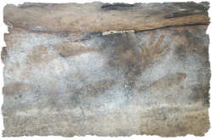In the metropolitan area of Sydney there are thousands of Aboriginal sites, over 1000 just in the AHO partner Council areas. These sites are under threat every day from development, vandalism and natural erosion. The sites cannot be replaced and once they are destroyed, they are gone forever. The sites that are located in Lane Cove, North Sydney, Willoughby, Ku-ring-gai and Northern Beaches Council areas are still in reasonable condition and hold an important part in our history. The Aboriginal people, who once occupied this area, left important evidence of their past and way of life before colonisation. All Aboriginal sites are significant to Aboriginal people because they are evidence of the past Aboriginal occupation of Australia and are valued as a link with their traditional culture. An emphasis is placed on the scientific investigation into stone technology for a great deal of insight is obtained by studying the manufacture techniques and animals associated with them that tells us about daily traditional life. Clues to what these sites were used for can also be surmised by talking with Elders from other parts of Australia where traditional knowledge has not been lost to the same degree. Every part of Australia has a different story.
“No culture on this planet stagnates. Cultures across the globe adapt every day to the climate, impacts from neighbouring cultures, technology and even invasion by hostile groups far from their borders.
Aboriginal people over the past 24 decades have simply adapted to the changes of the land. An Aboriginal person is no longer living as they were 240 years ago. Some old ways are practiced to this day but not without having some changes added or subtracted to the practice…
The history and heritage in [this] area is a large part of all the residents of the area and also extends to the entire community of Australia”.
2 David Watts, 2008
1. quotation from interview in 2007, printed in Currie J (2008) Bo-ra-ne Ya-goo-na Par-ry-boo-go Yesterday Today Tomorrow: An Aboriginal History of Willoughby Willoughby City Council.
2. In Currie J (2008) Bo-ra-ne Ya-goo-na Par-ry-boo-go Yesterday Today Tomorrow: An Aboriginal History of Willoughby Willoughby City Council
in Currie J (2008) Bo-ra-ne Ya-goo-na Par-ry-boo-go Yesterday Today Tomorrow: An Aboriginal History of Willoughby Willoughby City Council.

