
Guidelines for conducting and reporting on Aboriginal cultural heritage investigations
(other than cultural heritage management plans)

March 2012
(Updated November 2018)


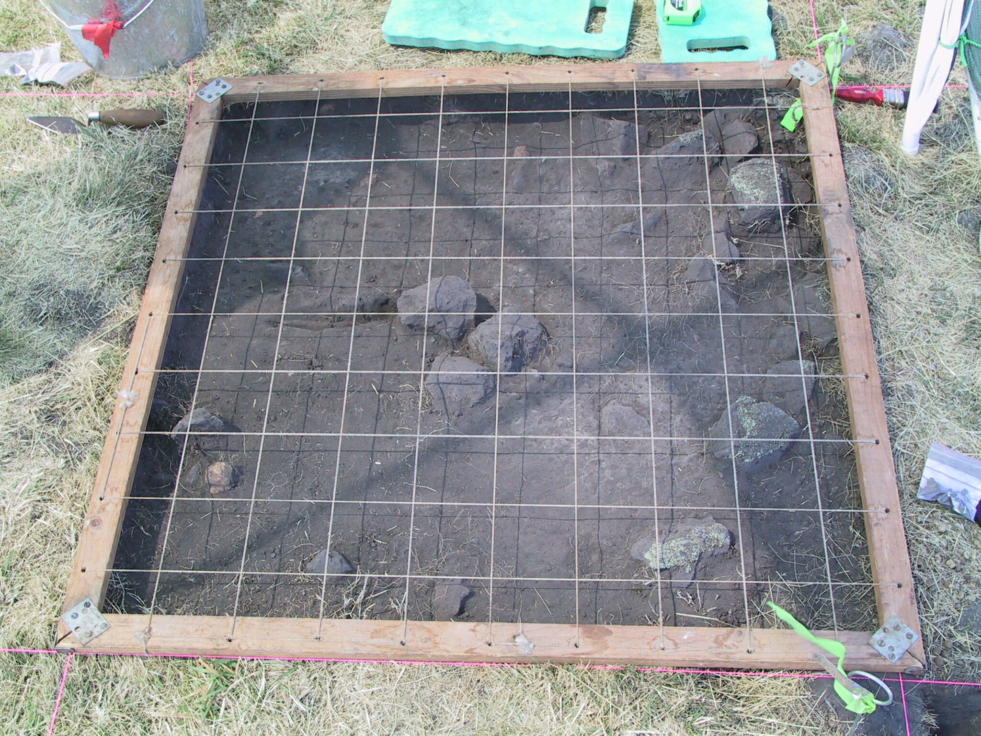

Authorised and published by Aboriginal Victoria
Department of Premier and Cabinet
1 Treasury Place, Melbourne Victoria 3000
Telephone: 1800 762 003
March 2012 (Updated November 2018)

© Copyright State Government of Victoria 2007
This publication is copyright. No part may be reproduced by any process except in accordance with the provisions of the Copyright Act 1968.

ISBN 978-1-921940-35-4

This publication may be of assistance to you but the State of Victoria and its employees do not guarantee that the publication is without flaw of any kind or is wholly appropriate for your particular purposes and therefore disclaims all liability for any error, loss or other consequence which may arise from you relying on any information in this publication.

Contents
1. Introduction 4
1.1 Preliminary matters 4
1.2 Cultural Heritage Permits 6
1.3 Surveys for Aboriginal cultural heritage 6
2. Involving Registered Aboriginal Parties 7
3. Aboriginal cultural heritage management standards 8
3.1 The Aboriginal Heritage Act 2006 8
3.2 Conducting an investigation 9
3.3 Interpreting the results 10
3.4 Assessing significance 10
3.5 Managing Aboriginal Cultural Heritage 10
4. Documenting and lodging results in the Victorian Aboriginal Heritage Register 12
Content and Format Guide for Aboriginal Cultural Heritage Reports 13

1. Introduction
These guidelines have been prepared to assist in carrying out Aboriginal cultural heritage investigations and preparing Aboriginal cultural heritage reports (other than Cultural Heritage Management Plans (CHMPs), such as:

general heritage studies; regional surveys; salvage excavations and systematic surface collections; research projects; conservation and management plans; due diligence reports, heritage impact assessments, preliminary Aboriginal heritage tests (PAHTs), Aboriginal cultural heritage land management agreements and surveys for Aboriginal cultural heritage (as defined under section 4 of the Aboriginal Heritage Act 2006 (the Act)).

1.1 Preliminary matters
These guidelines have been prepared to assist in carrying out and reporting on Aboriginal cultural heritage investigations; other than CHMPs. These guidelines provide advice on conducting and reporting on these projects. The various reports are referred to as Aboriginal cultural heritage reports (reports), the activities or assessments undertaken to prepare the reports as ‘investigations’, and the investigation and report together as ‘projects’.
For project sponsors these guidelines assist in understanding what standards a heritage advisor should meet in the investigation and reporting process. For heritage advisors they provide guidance on meeting the standards and professional obligations they have to their sponsor, a Registered Aboriginal Party (RAP) and to Aboriginal Victoria (AV). This includes any requirements to lodge information with the Victorian Aboriginal Heritage Register (VAHR).
Given the variety of projects that these guidelines cover, the content of reports will vary considerably. All reports should provide sufficient detail about a particular project, documenting what was investigated, what was found, what actions were taken and/or what recommendations or advice was given, address any legal obligations, and be in sufficient detail to enable those managing land to make good management decisions.
Large and/ or complex investigations will clearly require appropriate contextual information, documentation of the investigation methodology, analysis and results. This is necessary to provide an adequate basis for the formulation of interpretations, advice or recommendations. Comparatively smaller and/ or simpler projects will not require the same level of detail, and reports on an investigation which provide advice and/or recommendations may only encompass a few pages. Nevertheless, all Aboriginal cultural heritage projects should consider the issues outlined below and meet relevant reporting standards.
A Content and Format Guide for Aboriginal Cultural Heritage Reports is included, following discussion of issues that should be considered when conducting investigations.

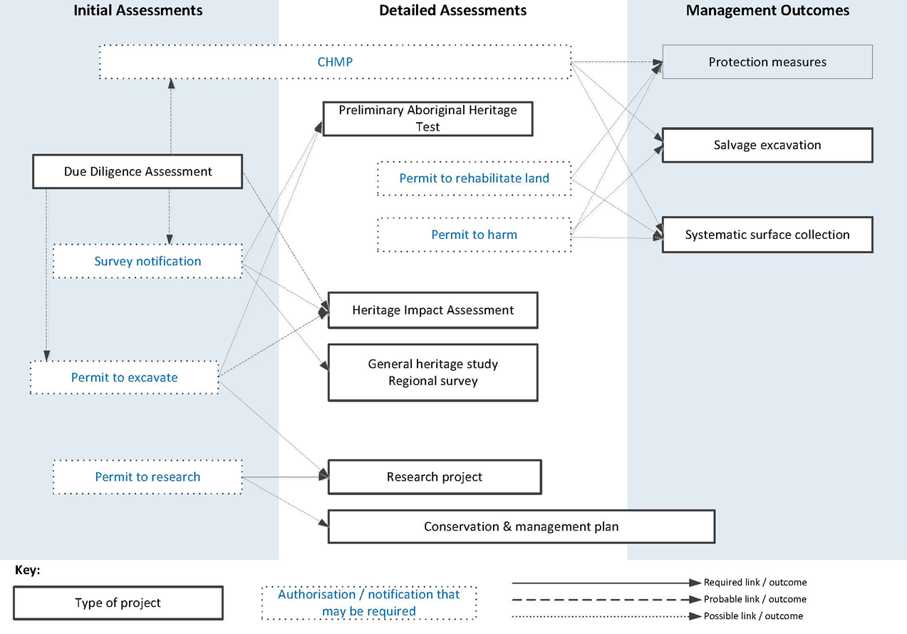
Figure 1: Types of heritage investigations that can result in written reports

1.2 Cultural Heritage Permits
Cultural Heritage Permits (permits) are required for four types of activities relating to investigating Aboriginal cultural heritage (section 36 of the Aboriginal Heritage Act 2006 (the Act)). A permit is needed to:
- disturb or excavate any land for the purpose of uncovering or discovering Aboriginal cultural heritage (Excavation Permit)
- carry out research on an Aboriginal place or Aboriginal object, including the removal of an Aboriginal object from Victoria for the purposes of that research (Research Permit)
- carry out an activity that will, or is likely to, harm Aboriginal cultural heritage (Permit to Harm)
- rehabilitate land at an Aboriginal place, including land containing burial grounds for Aboriginal Ancestral Remains (Permit to Rehabilitate).
A permit must be obtained prior to undertaking any activity listed under the Act. A permit holder must comply with any conditions of a granted permit (see the AV website for further information about permits).
A permit is not required if the activity is part of carrying out conditions of an approved CHMP.
It is the responsibility of the person carrying out the investigation to ensure that all necessary permission is obtained for entry to any land.

1.3 Surveys for Aboriginal cultural heritage
A ‘survey for Aboriginal cultural heritage’ is defined under section 4 of the Act, as follows:
- a survey of land, other than by disturbing or excavating the land, to discover Aboriginal cultural heritage; or
- a survey of land for the purposes of a Preliminary Aboriginal Heritage Test.
The term ‘survey’ is intended to be understood in the generally applied archaeological sense. A person intending to carry out a survey of land for the purpose of discovering Aboriginal cultural heritage, must comply with the requirements set out in section 34A of the Act.
A person intending to carry out a survey for Aboriginal cultural heritage must give written notice of their intention to carry out the survey to each RAP, the Secretary and the owner/ occupier of the land. On receiving a notice of intention to carry out a survey for Aboriginal cultural heritage, a RAP has 14 days in which to respond if they wish to participate in the survey.
Importantly, a person who carries out a survey for Aboriginal cultural heritage MUST give a copy of the relevant documentation (as defined under the Act) to the Secretary (VAHR) within 30 days of producing the report; or within 12 months of giving notice of their intention to undertake the survey. Penalties are associated with non-compliance of this provision.
Note:
- Separate consent or permission from Heritage Victoria may be required under the provisions of the Heritage Act 2017 for works or activities affecting historical archaeological sites or archaeological artefacts (see Heritage Victoria’s website at www.heritage.vic.gov.au for further information).
- The discovery of any historical archaeological sites, as defined under the Heritage Act 2017, must be recorded and reported to Heritage Victoria (see Heritage Victoria’s website for requirements).
- A separate research permit may be required from the Department of Environment, Land, Water and Planning or Parks Victoria for any fieldwork carried out on land managed by these agencies.

2. Involving Registered Aboriginal Parties
The Act recognises Aboriginal people as the primary guardians, keepers and knowledge holders of Aboriginal cultural heritage. The Act includes provisions for the establishment of a network of Registered Aboriginal Parties (RAPs) and gives these RAPs responsibility for protection and management of Aboriginal cultural heritage at the local level. RAPs therefore have a crucial role at all stages of investigations relating to Aboriginal cultural heritage within their areas.
While many of the Aboriginal cultural heritage investigations discussed in these guidelines do not require a formal notification to be given to the RAP and the RAP is not required to evaluate the report (as is required for CHMPs, cultural heritage permit applications, or suverys for Aboriginal cultural heritage), good practice involves consulting with the relevant RAP early on in the project, and, depending upon the nature of investigation, involving the RAP in the project if they choose.
The RAP should be notified, as a courtesy, when the Victorian Aboriginal Heritage Register (VAHR) is accessed for information about land in their area of responsibility. This also provides an opportunity to begin discussions with the RAP about values that may not be reflected in the VAHR, such as oral history associated with an area, and build on their invaluable local knowledge.
A RAP will also have endorsed proposed investigations, such as a salvage excavation, resulting from a CHMP that they have evaluated and approved. A cultural heritage permit or CHMP may incorporate specific conditions and/or recommendations about the level of RAP involvement in the proposed project.
When an Aboriginal cultural heritage project relates largely to advice on the legislative system or is a preliminary assessment, RAP involvement may be limited to consultation. A RAP may however elect to have greater involvement in field investigations or projects that focus on protection and management works. This may include employment of RAP representatives.
The Fees and Conduct Guidelines for Registered Aboriginal Parties prepared by the Department of Premier and Cabinet, with advice from the Victorian Aboriginal Heritage Council, provide some initial guidance on RAP involvement. Direct discussions with the RAP will elicit more detailed information.
Possible order of events
- Contact RAP to begin discussions and notify the RAP that the VAHR will be examined
- Notify RAP of intention to carry out a survey
- Access VAHR
- Arrange RAP participation in field investigation, and discuss the proposed methodology for the field investigation
- Undertake field investigations
- Discuss the outcomes of the investigations with the RAP
- Draft report
- Discuss any proposed recommendations with the RAP
- Finalise report
- Provide a copy of the final report to the RAP and VAHR
The RAP may choose to participate, or not, at any stage.
3. Aboriginal cultural heritage management standards

3.1 The Aboriginal Heritage Act 2006
Most clients do not work regularly with Aboriginal cultural heritage and require information about the legislation in Victoria. For this reason, a heritage advisor should:
- inform clients that the Act provides protection for all Aboriginal cultural heritage places, objects and Aboriginal Ancestral Remains; regardless of their inclusion on the VAHR or their location on public or private land
- provide advice about the relevant RAP for the area and the role of RAPs
- if a RAP is not appointed for the area, provide advice about other Traditional Owners that have interests in the Aboriginal cultural heritage of the area
- inform the client about whether a CHMP is required
- provide advice about the preparation of a voluntary CHMP (voluntary CHMPs provide the same legislative protection, follow the process for preparing a CHMP, and must be approved)
- advise on whether any permit applications may need to be submitted
- advise on whether the project classifies as a survey for Aboriginal cultural heritage (see section 1.3 above).

Advice provided by a heritage advisor should be documented, and may be included in a report. Other matters relating to the legislation require advice to be provided in a report or on relevant forms, depending on the circumstances. Projects may need to:
- notify any relevant RAP, the Secretary to the Department of Premier and Cabinet, and any relevant landowner of the intent to carry out a survey for Aboriginal cultural heritage (see section 1.3 above)
- report the discovery of Aboriginal cultural heritage on relevant VAHR forms or through the Aboriginal Cultural Heritage Information System
- detail whether further investigations are necessary such as a detailed ground survey or subsurface testing
- provide information about the legal requirements to report the discovery of Aboriginal cultural heritage
- provide contingency plans for the discovery of Aboriginal Ancestral remains
- give information about Cultural Heritage Audits and Stop Orders
- outline arrangements for the preparation of a Cultural Heritage Agreement or Protection Declarations
detail actions to be undertaken to ensure harm to known Aboriginal cultural heritage is avoided (e.g. fencing, cultural heritage induction).

3.2 Conducting an investigation
Background (Desktop) Assessment
All investigations require a background assessment to collect contextual information. A background assessment needs to:
    - search the VAHR for information relating to the investigation (following an application to access the VAHR, made to the Heritage Registrar at Aboriginal Victoria)
    - review reports on the VAHR and other published works about Aboriginal cultural heritage in the region
    - review historical and ethno-historical accounts of Aboriginal occupation of the region
    - review the landforms or geomorphology of the area
    - review the land use history of the study area
    - collect and review oral history relating to the area.

Field assessment – surface survey
Following the appropriate notification process (see section 1.3 above), field investigation usually commences with a surface survey of the study area. A surface survey needs to:
    - make arrangements for the appropriate level of RAP involvement
    - undertake preliminary ground survey of all or part of the area to detect the presence of Aboriginal cultural heritage
    - undertake systematic or possibly sample survey of the area
    - inspect mature indigenous trees, caves and rock shelters.

A surface survey may also include:
    - the use of specialised subsurface investigation techniques that do not disturb the ground
    - soil and sediment testing (e.g. use of a hand auger)
    - pH and Munsell testing of soil or lithic surfaces.

Field assessment – excavation
Where subsurface testing or excavation is undertaken, the investigation will need to:
    - notify the relevant RAP, or the Secretary, where required
    - make arrangements for the appropriate level of RAP involvement
    - either:
- ensure permit conditions are met; or
- comply with the salvage excavation strategy in the CHMP (see also the practice note on salvage excavation on AV website).
    - be supervised by a person appropriately qualified in archaeology and be carried out in accordance with proper archaeological practice
    - develop a subsurface testing strategy and adhere to relevant subsurface testing standards when undertaking any subsurface testing (see practice note on AV website)
    - adhere to the relevant standards developed for salvage excavations when undertaking any salvage excavation (see practice note on AV website)
    - obtain dates when suitable dating methods are available
    - report results to the RAP and the Secretary.

Analysis of findings
After field assessment, analysis is needed to understand the findings. This should include:
    - intra and inter-site distribution taking account of survey coverage, surface visibility and sampling strategy
    - intra and inter-site distribution of subsurface deposits taking account of stratigraphic context, site formation, discrete cultural deposits or features, and sampling strategy
    - analysis of artefacts, flora and fauna based on the appropriate spatial context.

3.3 Interpreting the results
Based on previous investigations in the region, consideration should be given to what cultural heritage places might reasonably be present in the study area.
Reports should discuss the findings of the investigation with reference to the contextual information, project aims and / or research objectives, and assess how the results of the project add to the existing understanding about the region’s Aboriginal cultural heritage.
Discussion of the implications of the results of the project on any proposed activity and any management requirements may also be necessary. This may involve developing predictions about the nature and extent of Aboriginal cultural heritage in areas not subject to detailed investigations.

3.4 Assessing significance
In some cases the significance of the Aboriginal cultural heritage present in the study area should be assessed. This may be particularly relevant when developing appropriate management and protection strategies.
Cultural heritage significance should be assessed in accordance with section 4 of the Act. Significance here is defined as including:
a) archaeological, anthropological, contemporary, historical, scientific, social, or spiritual significance and;
b) significance in accordance with Aboriginal tradition.
Assessing the significance of Aboriginal cultural heritage values requires consultation with the relevant RAP or, where there is no RAP, the relevant Traditional Owners.

3.5 Managing Aboriginal Cultural Heritage
In some cases specific conservation and management actions need to be outlined in a report. The following matters may need to be considered:
- Conservation and management strategies should be developed in consultation with the relevant RAP.
- The Burra Charter defines the basic principles, processes and practices to be observed in the conservation of important historic and cultural heritage places. These are widely accepted and adopted as the standards for heritage conservation in Australia. Where relevant and appropriate the Burra Charter should guide the management and protection of significant Aboriginal cultural heritage places.
- Be specific about any management actions required: what needs to be done, when, by whom and how.
- If appropriate, obtain advice from relevant experts (e.g. arborists, art conservators, botanists, geomorphologists, heritage architects).
- If the appropriate management strategy is to restrict information about a place, or if signage or information boards are an appropriate management tool.
- Management strategies should not cause harm to Aboriginal cultural heritage. A permit will be required if this is unavoidable.
- Whether monitoring the ongoing condition of the Aboriginal cultural heritage is necessary and whether formal monitoring points should be established.

4. Documenting and lodging results in the Victorian Aboriginal Heritage Register
Preparing and lodging reports and forms in the VAHR fulfils legal obligations. It is also good cultural heritage management practice.
Reports provide a record that contributes to our understanding of Victoria’s Aboriginal history and promotes the protection and management of Aboriginal cultural heritage around the State.
One electronic version in Portable Document Format (PDF) of any final report should be lodged with the VAHR.
Any relevant VAHR forms must also be completed and lodged with the VAHR. VAHR forms must comply with AV’s Standards for Recording Victorian Aboriginal Heritage Places and Objects.

Guidelines prepared under section 143 of the Aboriginal Heritage Act 2006

Content and Format Guide for Aboriginal Cultural Heritage Reports
This content and format guide has been developed to assist in the preparation of Aboriginal cultural heritage investigation reports. The content of this guide is not necessarily comprehensive; some investigations may require additional details in the final report.
The sections below are relevant to any report. The boxed sections may only be relevant to some reports.
- Presentation
An Aboriginal cultural heritage report should be presented as follows:
- pages must be typed and numbered
- references must be given to any reports, articles, primary sources, maps or books cited in the report
- where appropriate include photographs, maps, figures and tables in relevant sections.
- Cover and Title Page
The cover and/or title page should set out
- the name of the project, including a general study location (i.e. suburb)
- the type of assessment (e.g. desktop, regional survey, salvage excavation, conservation and management plan)
- the name(s) of the author
- date of completion.
It may be relevant to include:
- reference to any Cultural Heritage Permit, Cultural Heritage Management Plan, or survey for Aboriginal cultural heritage notification directly relating to this report
- the name of the sponsor/proponent
- the name of the heritage advisor
- the name of consultancy company, organisation or other body responsible for producing the report .
- Executive Summary
The report should start with an executive summary that briefly describes the reason for the project, when and where the project took place, any key findings, and recommendations.
- Table of Contents
The table of contents should list the following items (as appropriate), giving page numbers for each item:
- headings
- sub-headings
- maps
- references
Where the report includes these things, the table of contents should also include:
- tables
- photographs
- figures
- appendices (including any Gazetteer)
- Introduction
The introduction should contain the following information:
- the reasons for the study, and aims of the project
- a brief description of the location of the study area
- the name of the any heritage advisor involved and their role
- the name(s) of the owner(s) (and/or occupier(s)) of the land where the study area is located
- the RAP(s) with responsibility for the study area
- when the investigation took place.
It may be relevant to include:
- a reference to any Cultural Heritage Permit, Cultural Heritage Management Plan, or survey for Aboriginal cultural heritage notification directly relevant to this report
- the name of the sponsor / proponent.
- Project Description
Provide a clear description of the study. This should include the reason for the study for example, the impact assessment, subsurface testing, salvage excavation, due diligence report, regional heritage study or conservation management plan. Summarise the project and outline any research aims.
It may be relevant to describe and provide specific reference to any Cultural Heritage Permit, Cultural Heritage Management Plan or survey for Aboriginal cultural heritage notification directly relating to this report.
- Extent of Study Area
The extent of the study area should be described with reference to a map(s) indicating:
- the location of the study area in the regional context
- the salient prominent natural features and structures, and include geographic place names such as roads and towns
- reference to Victorian Government standard MGA94 coordinates (soon to superseded by the GDA 2020) and zone for Easting and Northing along the map margins
- legend explaining symbols used on the map
- scale and North arrow
- a small diagram showing the location of the area depicted on map in relation to the nearest major town.
It may be relevant to include photographs to provide a visual aid to understanding the study area.
- Documentation of Consultation
Document the extent of Aboriginal community involvement with the study. This may include correspondence and meetings with RAP representatives, and/or any other relevant Aboriginal organisation. Summarise relevant outcomes of the consultation.
Identify any RAP representative and/or other Aboriginal community members who participated in field work.
Discuss any consultation with individuals or agencies such as land owners, historical societies and land management agencies relevant to the study. Summarise relevant outcomes.
- Reporting the Results of the Project
The report must use VAHR numbers to identify all Aboriginal cultural heritage located, relocated and/or the subject of this project.
An Aboriginal Cultural Heritage Report should include:
Contextual or Background Information
Details of the contextual or background information relating to the Aboriginal cultural heritage in or associated with the investigation:
  - results of a search of the VAHR for information relating to the study area, including the date(s) the Register was accessed
  - review of registered Aboriginal places in the region or surrounding area
  - review of reports, published works and any other relevant information about the heritage in the region
  - review of the landforms or geomorphology of the area
  - review of the history of the use of the study area, including discussion of prior disturbance of ground surfaces and soil deposits if available.
It may be relevant to include:
- identification and discussion of the geographic region relevant to the heritage that may be present
- review of historical and ethno-historical accounts of Aboriginal occupation of the region
- summary of information, if any, provided by a member of the relevant RAP or other person about Aboriginal cultural heritage of the area
- transcript of any oral information provided by a representative of the relevant RAP or other person who may possess information about the Aboriginal heritage of the area, if consent is given (this may also be included as an appendix)
- conclusions surmising where Aboriginal cultural heritage may be located in the study area.
Field Investigation Methods
Specify if this project included no field investigation.
Where field investigation is undertaken, include:
- the method by which Aboriginal cultural heritage present in the study area was assessed, including ground survey strategies and techniques, discuss survey conditions and provide estimates of effective survey coverage
- subsurface testing or excavation strategies, including aims, methodology and techniques used
- a concise map or maps of the study area showing the ground survey areas, the location of any controlled subsurface testing and/or areas excavated (clearly indicate the location of any Aboriginal cultural heritage places within the areas investigated)
- scaled section drawing and/or scaled photographs of the profile of each of the controlled subsurface testing or excavation units (or representative samples, for example, of the landforms being investigated)
- co-ordinates for the location of subsurface testing and/or excavation units, including spatial data for each excavation
- names of those involved in the fieldwork including the name and qualifications of the person responsible for supervising any subsurface testing or excavation
- details of any obstacles encountered to carrying out the ground survey, subsurface testing or excavation (e.g. surface visibility, weather, access restrictions, competency of participants)
- results and conclusions of the ground survey, considered in light of the background information, including the identification of areas likely to contain Aboriginal cultural heritage (if any)
- results and conclusions of the subsurface testing and/or excavation considered in light of the background information, ground survey, and the results of any radiometric or other dating samples.
Aboriginal Cultural Heritage
Specify if there is no Aboriginal cultural heritage.
Where the subject land contains Aboriginal cultural heritage, include:
    - a detailed description of all Aboriginal cultural heritage found, discovered and/or subject to the investigation
    - a concise map(s) of the study area which locates all Aboriginal cultural heritage places found, discovered and/or subject to investigation with reference to VAHR numbers
    - a description of the stratigraphic context with a clear indication of the location and extent of any subsurface cultural deposits on section drawings and/or photographs
    - a full cadastral description of the land on which Aboriginal cultural heritage is located
    - a detailed plan of each Aboriginal place found, discovered and/or subject to investigation including spatial data
    - photographs or digital images of the Aboriginal cultural heritage found, discovered and/or subject to investigation
    - discussion of the Aboriginal cultural heritage found, discovered and/or subject to the investigation (this should include links to relevant background and contextual information, relevant dates, any spatial analyses and aims of the investigation) (see also analysis section below).
If the results of the cultural heritage assessment are used to develop a predictive model about areas likely to contain Aboriginal cultural heritage, include:
    - the reasoning behind the development of the predictive model
    - definition and description of areas likely to contain Aboriginal heritage.
Analyses
Include the detail of any analyses associated with the investigation, including analysis of:
    - site formation processes and geomorphology
    - artefacts within appropriate spatial context
    - shell and other faunal remains within appropriate spatial context.
The analysis should be linked to relevant background and contextual information and the aims of the project.
Provide data in tables and include relevant figures. Supporting material, such as tabulations of raw data or reports on specialist studies associated with the project should be contained in separate appendices.
- Aboriginal Cultural Heritage Significance
Where the subject land contains Aboriginal cultural heritage, include an assessment and statement of the significance of the Aboriginal cultural heritage located, relocated and/or subject to investigation.
- Conservation and Management
It may be relevant to include details of any conservation and protection measures carried out, including:
  - the VAHR number and names of places subject to management actions
  - details of works and any treatment carried out (e.g. arborist treatment, erosion and rabbit control, fencing, graffiti removal)
  - who carried out the works, and any specialist qualifications
  - when works were carried out
  - include photographic record of works
  - detail requirements for monitoring or follow up works.
Note: a full description of individual cultural heritage places may not be relevant to include in the main body of the report, particularly for projects dealing with numerous cultural heritage places. Such information may be presented in an appendix.
It may also be relevant to include:
- Recommendations and Considerations
- Outline actions and provide advice on the implications of the Act:
  - use VAHR numbers and names of places subject to any specific recommendations
  - outline requirements to prepare a mandatory CHMP or advice about preparing a voluntary one
  - identify whether any applications for cultural heritage permit(s) will need to be made
  - if the area has been subject to significant ground disturbance provide relevant evidence to support this
  - provide advice about how to avoid harm to Aboriginal cultural heritage
  - provide advice about the likely impact of the proposed activity on cultural heritage
  - include advice about the possible discovery of Aboriginal cultural heritage
  - include advice about the possible discovery of Aboriginal human remains
  - provide advice about entering into a Cultural Heritage Agreement.
- Outline actions and provide advice on the implications of the Act:
  - use VAHR numbers and names of places subject to any specific recommendations
  - outline requirements to prepare a mandatory Cultural Heritage Management Plan or advice about preparing a voluntary one
  - identify whether any applications for permit(s) will need to be made
  - if the area has been subject to significant ground disturbance provide relevant evidence to support this
  - provide advice about how to avoid harm to Aboriginal cultural heritage
  - provide advice about the likely impact of the proposed activity on cultural heritage
  - include advice about the possible discovery of Aboriginal cultural heritage
  - include advice about the possible discovery of Aboriginal human remains
  - provide advice about entering into a Cultural Heritage Agreement.
- Details for follow-up heritage investigation:
  - outline required or recommended further investigation, including ground survey, subsurface testing or excavation strategies
  - specify whether there is a need to obtain specialist expertise.
- Detail conservation and management recommendations:
  - use VAHR numbers and names of places to be subject to management actions
  - outline actions to be followed for the protection and management of Aboriginal cultural heritage (e.g. training, fencing, signage)
  - specify whether there is a need for specialist expertise
  - detail proposed works and any necessary treatments (e.g. arborist treatment, erosion and rabbit control, graffiti removal)
  - who will carry out the works, and any necessary expertise or qualifications
  - outline requirements relating to the custody and management of Aboriginal cultural heritage
  - detail requirements for monitoring the on-going condition or follow up works.
Include a map(s) clearly showing the location of actions advised on in the recommendations (e.g. extent of Aboriginal cultural heritage place, areas likely to contain Aboriginal cultural heritage, location of proposed fences, where track building should not occur).
- References
The references section should list all reports, books, articles or maps referred to in the report and should be presented in accordance with standard referencing convention, such as those set out in the Australian Style Manual.
- Appendices
The following documents may be appended to the report:
- glossary listing simple explanations for any technical terms used
- catalogues or tables (e.g. data recorded about Aboriginal cultural heritage, such as detailed recording of stone artefacts, shell, features, soil/sediment descriptions and analyses)
- relevant figures, tables, photographs not required in the body of the text
- any relevant correspondence
- gazetteer of all Aboriginal cultural heritage found, discovered and/or subject to investigation indexed by VAHR numbers
- copy of any cultural heritage permit.
Maps
Include one or more map(s) of sufficient quality to clearly identify the investigation area and the Aboriginal cultural heritage of the area. All maps must provide a minimum of:
- either geo-referencing or at least three readily identifiable features, such as road intersections, river crossings, prominent features, within the vicinity
- a prominent North arrow
- a scale bar using standard cartographic formats
- the area covered by the report clearly shown, and
- any other salient prominent natural features, structures and works.
The following information must be provided to AV as projected spatial data (e.g. Polygon or Shape file):
- the investigation area
Where field investigation is undertaken, include:
- ground survey areas (if any)
- subsurface testing or excavation pits or transects (if any), and
- the extent of each Aboriginal place found, discovered or subject to investigation, normally provided when the Victorian Aboriginal Heritage Register form is lodged.
Lodgement of reports
Lodge an electronic copy in portable document format (PDF) of the report with the VAHR, AV. Provide a copy of the report to the RAP and other relevant persons or organisations.

A Survey for Aboriginal cultural heritage is the exception to this rule. See section 1.3 above, and Part 3. Aboriginal Cultural Heritage Management Standards, below.
2002 Australian Style Manual for Authors, Editors and Printers, Department of Information, Communication Technology and the Arts, Wiley Australia.

