Aboriginal stone structures

in southwestern Victoria

report to Aboriginal Affairs Victoria

Sharon Lane
Revised December 2009

Quality control: Alyssa Gilchrist

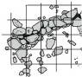
Qu.A.C.
Quality Archaeological Consulting
PO Box 1230
Collingwood VIC 3066
quac.com.au
ph 0425 323 965
ABN 99713807067
Acknowledgements

Thanks are due to the following people for their assistance with various aspects of this project:

Matt Butt - Winda-Mara Aboriginal Corporation
Joey Chatfield - then of SWWCHP
John Clarke - Parks Victoria
Greg Edwards - Lake Corangamite Catchment Authority
Alyssa Gilchrist - field assistant
Herb Harridine - then of the SWWCHP
Denise Lovett - then of the SWWCHP
Wendy Luke - AAV
Alan Murphy - Wathaurong Aboriginal Co-op
Geoff Sharrock - Ranger, Mt Eccles National Park
The Thomas family of Bessiebelle
Betty Tucker - Colac and District Historical Society
Harry Webber - AAV
Winda-Mara Aboriginal Corporation
And AAV staff in the site registry office and those in the Barwon southwestern/Grampians region who commented on the draft of this report.

Permission to reproduce figures 30 and 32(A) was granted by the State Library of Victoria and the Keeper of Public Records, Public Records Office, Victoria, respectively.

Contents

1 Introduction – aims of this report 1

2 Aboriginal stone structures in southwestern Victoria 2

3 Types of Aboriginal stone structures known to be present in western Victoria 4

3.1 Utilitarian Stone Structures Associated with Water and Fishing 4

3.1.1 Estuarine/littoral or tidal zone fishtraps 4
3.1.2 Fishtraps on rivers/creeks 7
3.1.3 Inland fishtrap complexes 10

3.2 Terrestrial Utilitarian Structures 14

3.2.1 Shelters (stone-based huts) 14
3.2.2 Stone hunting hides 19
3.2.3 Ovens/hearths 21

3.3 Other Stone Arrangements – purpose unknown and probably unknowable 23

4 Aboriginal stone structure identification 28

4.1 Distinguishing between natural and cultural features 28

4.2 Distinguishing between Aboriginal and European 31

4.3 Conclusion – Identifying Aboriginal stone structures 38

References 39

Introduction – aims of this report

The following report was written in response to the project brief Investigating Stone Structures in South-West Victoria produced by Aboriginal Affairs Victoria. In the main the intended purpose of the report is to “provide a…reference document for…AAV staff in identifying and assessing stone structures in South-West Victoria” (project brief).

It should be stated from the outset that there is no failsafe method for the accurate surface identification of Aboriginal stone structures. As the discussion in this report hopefully makes clear such identification is likely to be dependent, for the most part, on a balance of probabilities. In many cases the identification of an apparent Aboriginal arrangement of stones will be dependent on ascertaining that it is unlikely to be a natural occurrence and, if its anthropogenic origin established, that it is not a structure built by non-Aboriginal people. Admittedly, this process is imprecise, being an approach that reduces Aboriginal stone structures to things which are not any of the above, but this is simply the result of the potential range and variety of such structures – both functional and physical.

This report is set out in four main sections. Following this introduction, sections 2 and 3 discuss types of Aboriginal stone structures known to be found in south-west Victoria, providing ethnohistorical or early descriptions (where available), some known archaeological examples, and a short discussion of the characteristics of each identified type. The 4th section of the report focuses on Aboriginal stone structure identification and provides some examples of natural (section 4.1) and non-Aboriginal (section 4.2) structures which might be confused with them.

There exists a relatively large body of literature relating to Aboriginal stone structures or arrangements in Australia. Much of it is purely descriptive, and simply provides a report of an arrangement of stones ‘discovered’ by the author. Some papers draw on information provided by Aboriginal or, in some cases, European informants and describe how the stone arrangement was or is used, or what function it had/has. Some more recent theorise on the possible economic and social implications of the arrangements for pre-contact Aboriginal societies. These theories are not discussed here, as this would go beyond the scope of this report. A list of references is provided in the final part of this report. The reader is directed to these for more detailed discussions of those aspects of Aboriginal stone structures than could be addressed in this short report.

Aboriginal stone structures in southwestern Victoria

In reading Chamber’s tract on ‘the Monuments of unrecorded Ages,’ I was startled by the assertion that ‘stone circles’ were numerous in Victoria. I made what enquiries I could here, and all replies confirmed my own impression that no Australian tribe had ever been known to raise such a structure, or any other of monumental character. But I myself not infrequently found the ‘native ovens’ crowned with the ring of small stones wherein the fires had formerly been lighted, and it seems to me that an unpractised observer…might have called these ‘stone circles’…I then asked enlightenment from the…Secretary for Mines [R.B. Smyth], who, I thought, might as Secretary to the Aborigines Protection Board, be able to obtain some positive information. Instead of giving that, he suggested that the ‘stone circles’ are natural piles of basaltic rock, which appears to me an eminently unsatisfactory theory (R.E. Johns to P. Chauncy 6/2/1873 in Phillip Chauncy Papers SLV MS 9287/72, Box 1036; See also Griffith 1996: 40-41 and Russell and McNiven 1998 for a discussion of these letters).

Contrary to the opinions of Smyth and Johns, various types of arrangements of stone are known from Victoria and from Aboriginal Australia in general. While many of these arrangements are not ‘monumental’ or ‘megalithic’ in character, others, such as the Wurdi Youang/Mt Rothwell stone arrangement are large arrangements containing stones of considerable size, weighing up to 500kg (Lane and Fullagar 1980: 135; Marshall and Webb 1999: 9). Smyth’s response to Johns’ inquiry, however, and Johns’ own thoughts on the matter do highlight some of the problems inherent in identifying Aboriginal arrangements of stone – namely problems of distinguishing between stone arrangements constructed by humans and natural features, and, when a natural origin can be discounted, between types of Aboriginal stone arrangement, or between those built by Aboriginal and non-Aboriginal people.

Hundreds of confirmed and probable Aboriginal stone structures exist in western Victoria – the number and density of such structures in this region is unusual. To a large extent this density of stone structures may be attributed to the geology of the region. Being an extensive volcanic plain, southwestern Victoria has an abundant supply of basalt stone, which has been exploited by both the pre and post contact populations of the region.

In a discussion of Victorian stone arrangements Lane and Fullagar (1980:146) identified four categories of stone arrangement by function, these are:

Technological – relating to food gathering
Technological – relating to shelter
Demographic – relating to various religious and mythical rites
Demographic – relating to boundaries of tribal areas

In the following report, stone arrangements are broadly divided into two categories: those with an identifiable utilitarian function, and those of unknown purpose. Those in the latter category are generally presumed to have some sort of ceremonial or ritual purpose, although it must be recognised both that they may have had a utilitarian function which is not obvious to modern observers (e.g. see Kimber 1981), and that lines between the utilitarian and the ceremonial may not be clear (e.g. see McNiven 2003:337; O’Connor et al 2007:20). Nevertheless, for ease of discussion, this portion of the report is divided into the following sections:

• Utilitarian stone structures or arrangements associated with water and fishing (section 3.1)

• Terrestrial utilitarian stone structures or arrangements (section 3.2); and

• Terrestrial stone arrangements, structures and complexes of uncertain (presumed ceremonial/ritual) purpose (section 3.3)

The more utilitarian types of arrangement discussed in the first two sections are somewhat easier to identify because their physical suitability to perform the assumed function can be assessed. These are also the types of arrangement for which directly relevant (originating from western Victoria) ethnohistorical information is available. This information generally provides both an indication of the physical appearance of these structures and a description of how they functioned.

The third category of arrangement is, in terms of identification, the most difficult - in the sense that it is more difficult to positively identify something when its purpose is unknown and, for the most part, unknowable. Such arrangements generally are assumed to be of ritual/ceremonial importance, and their purpose may include such functions as “totem-centres, initiation grounds…and places associated with culture heroes and magic”(McCarthy 1940: 188-189, see also Palmer 1977). For the most part, and in common with other parts of Australia, reference to these arrangements is absent from the ethnohistorical sources of western Victoria. In general it is assumed that Aboriginal people avoided disclosing information about these sites and structures to non-Aboriginal people because of their sacred nature (McBryde 1974: 50).

Types of Aboriginal stone structures known to be present in western Victoria

Utilitarian stone structures associated with water and fishing

Three main types of fishtraps are known from Australia – these consist of coastal or tidal traps (little known in Victoria) traps found along rivers and creeks (common along the Hopkins River and elsewhere in western Victoria) and fishtrapping complexes, such as at Lake Condah or Toolondo, located in swamps, marshes or lakes.

Estuarine/littoral or tidal zone fishtraps

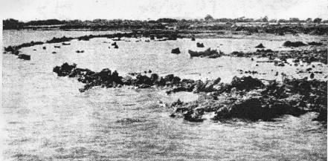
Figure 1 Example of an estuarine/tidal fishtrap from Mt Dutton Bay, South Australia
(after Mountford 1939b: 197).

Ethnohistorical or early descriptions

William Buckley’s fishtrap
One day, whilst watching the fish, I saw a great shoal of bream come into the mouth of the river, making their way up a long distance…When the tide turned, they came down with it again, and it occurred to me that if I could by any means stop them in their retreat by a sort of wear [weir], I should have a great supply of food…After examining the river, I found a spot suited to the purpose, where the tide did not rise above two feet…I set to work making faggots with rushes and boughs of trees, - carrying them down to the bank of the river; and, at the same time, preparing long stakes, sharpened at one end, to make them fast in the sand…taking advantage of the tide when it receded, I set about my undertaking, and completed a wear (Morgan 1852: 88-89).

In the above passage, William Buckley, the escaped convict who spent over thirty years with the Wathaurong people, appears to be taking credit for the invention of the estuarine fishtrap. Aboriginal estuarine or tidal stone fishtraps are, however, known to exist in a number of locations around Australia – several have been recorded on the north coast of NSW and in Queensland (eg Bowen 1998; Campbell 1982; Coleman 1982: 5-6; Walters 1985, but see also Godwin 1988), in southern (Dortch 1997; Dortch et al 2006) and northern (Smith 1983; Vinnicombe 1987:34) Western Australia, and in South Australia (Welz 2002). Evidence for tidal fishtraps in Victoria is less common, although two possible examples are known from Port Phillip Bay – these are both located in the Corio Bay/Point Lillias area.

Smith has described the process of the use of a tidal weir as follows:

This type of trap functions by movement of the tide…Fish, feeding on the advancing and high tides, swim over the wall. As the tide recedes, water runs out through the loosely packed and gradually exposed walls stranding fish on the sand or in small pools of water which remain (Smith 1983: 30).

Archaeological examples

Buckley’s description is of a tidal weir built of organic materials. Most archaeologically-known fishtraps are, for obvious reasons of preservation, built of stone. As with their river/creek counterparts (see section 2.1.2), the choice of material used for their construction probably depended upon availability, although it might be expected that coastal traps required more substantial construction to withstand tidal currents. In some cases at least, it is probable that stone tidal fishtraps had superstructures of organic material (Dortch 1997: 21).

Stone tidal fishtraps known from other parts of Australia tend to consist of arced or semi-circular alignments of stone, arranged with the concave side facing to the shore that simply hold back fish (generally schooling types) as the tide recedes. Horseshoe-shaped, box-like and maze-like arrangements have also, however, been recorded (Godwin 1988: table 3), as have combinations of the above (e.g. the Scraggy Point complex on Hinchinbrook Island, see Campbell 1982: figure 2).

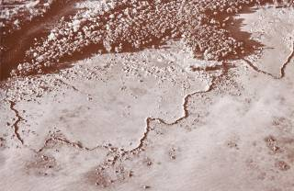
Figure 2 Aerial photo of a stone tidal fishtrap at Bayley Island in the Gulf of Carpentaria
(after Memmott 2007: 69).

Two examples of possible tidal fishtraps have been recorded in Victoria on the western side of Port Phillip Bay. The Corio Bay fishtrap (VAHR 7721/505) has been described as “lines of basalt in intertidal zone” for which there exists oral tradition of it being “a known fish trap which worked prior to coastal works along Avalon coastline” (VAHR 7721/505 sitecard).

The recording of the second known tidal fishtrap (VAHR 7721/761), located at Point Lillias, as an Aboriginal archaeological site may be regarded as somewhat contentious. There are historical remains at the location of the Point Lillias fishtrap that suggest that it was associated with the oyster industry known to have operated in the area in the late nineteenth century (figure 3). In 1995 the site was recorded as historical site HV7721/012. Ten years later it was recorded as an Aboriginal archaeological site, with the recorders noting that “it is likely that the site was originally used by Aboriginal people as a fishtrap” (VAHR 7721/761 sitecard).

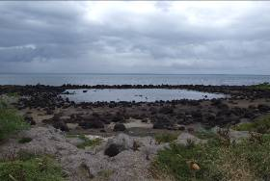 | 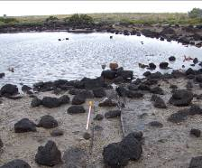
Figure 3 The Point Lillias fishtrap (VAHR 7721/761). A) General view facing east B) Detail of the north side of the site, showing remains of oyster racks. Photos by author.

Location and Identification

For the most part known estuarine/coastal fishtraps are located on low-energy shorelines (Welz 2002: 110). Dortch has noted that tidal weirs in Western Australia are generally located on “the nearly level shores of estuarine basins” (Dortch 1997: 16). Generally they consist of low walls of piled stone, which might be of various shapes (see above) but which are designed to be immersed at high tide, and to hold fish in at low tide. The main difficulties that have been encountered in accurately identifying Aboriginal estuarine coastal fishtraps have been:

• The similarities between non-Aboriginal/European and Aboriginal fishtraps.
Coastal fishtraps are known from various parts of the world, including Britain where “relicts of fisheries form one of the most ubiquitous features of the coast”. The earliest are thought to date from at least the Mesolithic, but construction and use of coastal traps probably continued up until the 1860s (Bannerman and Jones 1999: 70, 79). It is not unlikely, then, that early British settlers might have constructed coastal fishtraps. Certainly coastal traps thought to be of European construction have been recorded in Tasmania – they were described of having walls of “loosely piled boulders” and would be difficult to differentiate from Aboriginal structures without historical evidence (Stockton 1982).

• Confusion of non-fishtrap structures with fishtraps.
Randolph (2004) has documented an instance in Western Australia where a modern structure built in the period between the 1960s and the 1980s has been mistakenly recorded as a fishtrap. Likewise Walshe has re-assessed a previously recorded South Australian fishtrap as “debris from grading activity” (Welz 2002: 45).

It should be noted here that there also exists evidence of Aboriginal people using natural tidal pools as fishtraps (for example the ‘Champagne Pools’ at Fraser Island, QLD) – these would not, of course, consist of a built structure but may be evidenced by other archaeological material.

Fishtraps on rivers/creeks

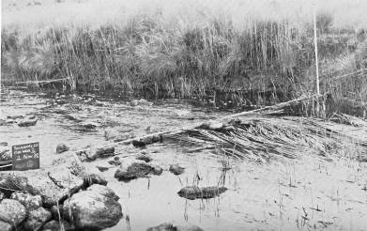
Figure 4 Photo of fishtrap site VAHR 7422/414 on the Hopkins River
(after Hotchin 1980: plate 4).

Ethnohistorical or early descriptions

George Augustus Robinson – first hand description
The country at Kilgower is but slightly elevated above the sea. Kilgower is on the [blank] or Port Fairy River…He…took me to a very fine and large weir and went through, with several other of the natives, the process of taking eels and the particular spot where he himself stood and took them. I measured this weir with a tape, 200 feet; five feet high. It was turned back at each end. The eel pots are placed over the holes and the fisher stands behind the yere.roc or weir and lays hold of the small end of the arrabine or eel pot. And when the eel makes its appearance he bites it on the head and puts it on the lingeer or small stick with a knob at the end, thus or, if near the bank, he throws them out. The fishing is carried on in the rainy season. Arrabine or eel pot made of bark or plaited rushes with a…round mouth and having a small end to prevent the eel from rapidly getting away.

These yere.roc or wiers are built with some attention to the principles of mechanics. Those erected on a rocky bottom have the stocks inserted in a grove made by removing the small stones so as to form a grove. The wier is kept in a straightline. The small stones are laid against the bottom of the stick. The upright sticks are supported by transverse sticks, resting on forked sticks as shown above. These sticks are three, four or five inches in diameter. Some of the smaller wiers are in the form of a segment or circle. The convex side against the current (Robinson 30/4/1841 in Clark 2000b: 157-158).

James Dawson – possible first hand desciption
The small fish, ‘tarropatt,’ and others of a similar description, are caught in a rivulet which runs into Lake Colangulac, near Camperdown, by damming it up with stones, and placing a basket in a gap in the dam. The women and children go up the stream and drive the fish down…Eels are prized by the Aborigines as an article of food above all other fish. They are captured in great numbers by building stone barriers across rapid streams, and diverting the current through an opening into a funnel-mouthed basket pipe, three or four feet long, two inches in diameter, and closed at the lower end. When the streams extend over marshes in time of flood, clay embankments, two to three feet high, and sometimes three to four hundred yards in length, are built across them, and the current is confined to narrow openings in which the pipe baskets were placed…Lake Boloke is the most celebrated place in the Western District for the fine quality and abundance of its eels; and, when the autumn rains induce these fish to leave the lake and to go down the river to the sea, the aborigines gather there from great distances. Each tribe has allotted to it a portion of the stream, now known as Salt Creek; and the usual stone barrier is built by each family…For a month or two the banks of the Salt Creek presented the appearance of a village all the way from Tuureen Tuureen, the outlet of the lake, to its junction with the Hopkins (Dawson 1881: 94).

According to the ethnohistorical sources, fishtraps or weirs across rivers and creeks were widespread in western Victoria. Descriptions generally indicate that the stone in these traps (where there is stone) formed only part of their structure with, as Robinson’s description makes clear, the rest being made up of organic materials – stick and/or brush barriers and eel pots or baskets. In other regions Robinson described fishtraps which, according to his descriptions, seem to have been made primarily of organic material, or possibly of organic material alone. For example in the Twofold Bay region Robinson noted “an old weir for taking fish, i.e. fence of brush cross river” (Robinson 30/8/1844 in Clark 2000d: 166). The comparatively high number of stone fishtraps in western Victoria can probably, at least in part, be attributed to the ready availability of stone on the basalt plains.

In general, it would seem that the purpose of such traps in western Victoria was to catch eels during their annual downstream migration. Schell has, however, pointed out that the upstream migration of elvers may have also been exploited (Schell 1995: 12). Dawson’s description, given above, also makes clear that in areas where eels were probably not available, such as in the internal Corangamite drainage basin (see McNiven 1994: 62), fish other that eels were caught through the use of stone traps.

Archaeological examples

A number of stone river or creek fishtraps are known to exist in southwestern Victoria. Both Hotchin (1980) and Schell (1995) have recorded examples along the Hopkins River. Figure 5 below is an example recorded and planned by Hotchin.

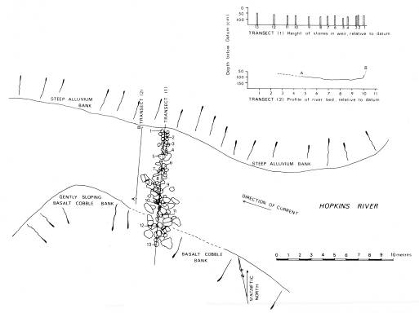
Figure 5 Plan of a stone fishtrap on the Hopkins River (after Hotchin 1980: figure 29).

While the example shown in figure 5 is a straight line, Robinson’s observations (see above) suggests that V-shaped alignments were also common.

Identification and Location

The main difficulties that have been noted regarding the identification of river/creek fishtraps are:

• Confusion of non-fishtrap structures with fishtraps.
The structures most likely to be confused with fishtraps are historical or contemporary fording places. In some instances there is evidence that fords were created using the stone from a pre-existing fishtrap, for example:

The fording place at Bolden’s are the remains of an old stone were [weir] called by the natives yere.roc, but now destroyed by Bolden’s people (Robinson 25/4/1841 in Clark 2000b:144).

• Confusion of natural features with fishtraps
Schell has noted the difficulty in differentiating between naturally occurring rock scatters in the river and fishtraps – a difficulty exacerbated by the natural deterioration of fishtrap alignments caused by river currents.

Hotchin noted that the fishtraps recorded on the Hopkins River by him were all located both “where the river narrows and can be dammed with relatively little effort” and adjacent to apparently natural outcrops of basalt which were incorporated into the fishtrap alignment (Hotchin 1980: 128). The fishtraps recorded by Schell on the Hopkins were “always located in shallow sections of the river and usually, but not always, in areas where the river narrowed” (Schell 1995: 18).

Schell applied the following criteria to identify probable fishtrap structures in the Hopkins River:

To be defined as eel traps the stone alignment must:

1. Consist of at least 30 stones.
2. Have a minimum of ten stones which are aligned.
3. Consist of stones which are partially placed across the river.
4. Occur in an area where stone does not naturally outcrop across the river
(Schell 1995: 18).

While the majority of eel associated fishtraps in the western district could be expected to be found on river or creek lines or systems which drain to the ocean, fishtraps associated with the capture of other types of fish can be found in internal drainage basins such as the lakes and streams of the Corangamite basin. Fishtraps in this region are more likely to be located “at the mouths of a number of freshwater creeks entering larger lakes” (McNiven 1994: 62).

The distribution of stone fishtraps is determined by both the presence of suitable fish populations and suitable raw materials, i.e. outcropping and moveable stone.

Inland fishtrap complexes

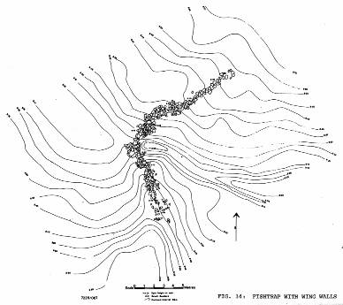
Figure 6 V-shaped fishtrap at Lake Condah (from Coutts et al 1978: figure 14).

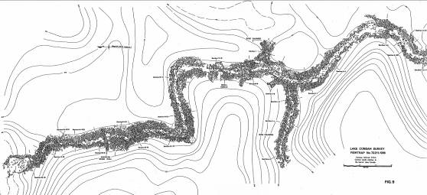
Figure 7 Part of a Lake Condah fishtrap system (from Coutts et al 1978: figure 9).

Ethnohistorical or early descriptions

George Augustus Robinson – early site descriptions
[Mt William region]
passed several dieks dug by the natives for draining small lagoons into the large ones for the purpose of catching eels, etc. These channels were from a foot to 18 inches deep and from one to 300 yards in length (Robinson 8/7/1841 in Clark 2000b: 299).

[near Mt William]
At the confluence of this creek with the marsh observed an immense piece of ground trenched and banked…which on inspection I found to be the work of the Aboriginal natives, purposefully constructed for catching eels… These trenches are hundreds of yards in length. I measured at one place in one continuous trepple line for the distance of 500 yards. These treble watercourses led to other ramified and extensive trenches of a most tortuous form. An area of at least 15 acres was thus traced over...These works must have been executed at great cost of labor…the only means of artificial power being the lever...This lever is a stick chisel, sharpened at one end. by which force they threw up clods of soil and thus formed the trenches, smoothing the water channel with their hands. The soil displaced went to form the embankment…This description of work is called by the natives cro.cup.per, i.e. Bennewongham [said so].

The plan or design of these ramifications was extremely perplexing and I found it difficult to commit it [to] paper, in the way I could have wished, all its varied form and curious curvilinear windings and angles of every size and shape and parallels, etc. At intervals small apertures left and where they placed their arabine or eel pots. These gaps were supported by pieces of the bark of trees and sticks. In single measurement there must have been some thousands of yards of this trenching and banking. The whole of the water from the mountain rivulet is made to pass through this trenching ere it reaches the marsh; it is hardly possible for a single fish to escape. I observed at short distance higher up, minor trenching was done through which part of the water ran its course to the more extensive works. Some of these banks were two feet in height, the most of them a foot and the hollow a foot deep by 10 or 11 inches wide. The main branches were wider.

Around these entrenchments was a number of large ovens or mounds for baking, there were at least a dozen in the immediate neighbourhood (Robinson 9/7/1841 in Clark 2000b: 302).

Alexander Ingram – early site description
At the south-western portion of Lake Condah is situated one of the largest and most remarkable aboriginal fisheries in the western district of Victoria. The position has been very well chosen, as the small bay is the lowest point on the western side of the lake. Owing to the peculiar formation (open trap scoriae) along the eastern, southern, and part of the western sides of the lake, the water sinks very rapidly and becomes very low during summer months, but as it receives the drainage of a large extent of country the water rises very quickly during winter, and first flows into the scoriae at the point named, which has been facilitated to some extent by the channels formed by the aborigines for trapping eels, trout, etc. These channels have been made by removing loose stones and portions of the more solid rocks between the ridges and lowest places, also by constructing low wing walls to concentrate the streams. At suitable places are erected stone barricades with timber built in to as to form openings from 1ft. to 2ft. wide; behind these openings were secured long narrow bag nets made of strong rushes…There are also numerous smaller fisheries constructed in suitable places in small bays and outlets where the water sinks into the trap scoriae down along the margin of the valley of Darlot’s Creek. Across this valley, at suitable places, were erected large barricades constructed with strong forked stakes, horizontal spars, and vertical stakes strengthened with piles of stones; openings were also left in these (Ingram in Worsnop 1897: 104-105).

Less common in Australia than either tidal traps or traps constructed over freshwater streams are the large fishtrap complexes known to exist in southwestern Victoria. Robinson happened upon two such complexes in the region of Mt William in 1841 (see above).

Archaeological examples

The archaeological example most like the complex described by Robinson is the Toolondo site noted first by Massola (1962) and later investigated by Lourandos (1976: 183-187; 1980: 353-396). Lourandos interpreted the complex of earthen drains at Toolondo as creating an extension of the “territorial range of the [eel]” which would result in “an increase in the eel biomass in this area” (Lourandos 1980: 389).

Although the Toolondo site, and those described by Robinson were clearly built of drains and banks of earth, the fish or eel trapping complexes at Lake Condah and on the Tyrendarra lava flow (Coutts et al 1978, Builth 2002) might be seen as stony versions of such sites – with drains made through the process of removing and piling alignments of stone (see figure 7) rather than of earthen ditches and banks. The results of Coutts et al’s study of the Lake Condah fishtraps suggest that the trap system located there was constructed in order to take advantage of the natural fluctuation of water levels in the lake, with traps being activated at both the rising and falling of lake levels. These fluctuations occurred in the late autumn to late spring period “when the water level…would always have been comparatively high.” As water levels receded with drier weather “water was trapped in pools…fish would have been captured in these pools and eels could have been taken in traps if they attempted to escape overland along the artificial structures towards the main body of the lake” (Coutts et al 1978: 28).

Coutts et al i(1978:12) identified three main components of the Lake Condah fishtrap complex: stone races, canals and traps. During a re-assessment of the Lake Condah Aboriginal archaeological sites, Clarke undertook a re-classification of site types, with the following types pertaining to the fishtrapping complex:

Stone Traps [figure 6]
…were defined as stone features which had been constructed across a range of depression features in the landscape. Some traps occurred on slightly elevated land surface, between two areas of lower ground…Stone traps were also constructed across the channel types described below, across natural drainage lines, and across the edges of depression features, particularly lava sinkholes.

Stone traps were differentiated from stone alignments, which also occur in similar positions in the landscape, by the presence of one or more gaps in the stone structure. Stone traps do not just consist of freestanding stone walls…but occur in a range of forms. There are structures which do consist of low (50cm-75cm), free-standing, stone walls, but there are also traps which make use of natural basalt outcrops by adding short sections of piled stones to the existing geological formations. Other traps combine short sections of low walls with natural outcrops and small (up to 1m in diameter and 75cm high) stone piles.

The traps occur across landscape features which contain and direct water flow..

Channels
There are a number of distinct channels in the depressions around the lake. Channels were defined as drainage lines whose edges were not defined by blocks of basalt. They were only recorded as sites where they were clearly in association with a stone trap or stone alignment. It is likely, given the topography, that these features are simply natural drainage lines running along the bottoms of the depressions. However, it is also possible that some may have been defined, or accentuated by some form of cultural modification. It was not possible to ascertain this from the ground survey.

Stone-lined channels
…are…channels whose edges have been defined by lines of basalt blocks. Again, given their location within the depressions, they appear to be natural drainage lines which have been modified by the addition of rocks.

Modified channels [figure 7]
Steep-sided, rocky gullies have formed between the lobes of the lava flow throughout the stony rises. The bottoms of these gullies form natural channels along which water could flow at times of high lake levels. In some places, on the edges of the lava flow adjacent to the lake, these gullies have been culturally modified. Loose rocks from the gully floors and from the fractured surface of the basalt flow have been picked up and placed along the gully edges to form a modified channel. The placed basalt blocks appear to accentuate the channel, and would most likely act to direct and contain the flow of water…It was not clear from the evidence observed on the ground that these features were excavated as described by Coutts et al. (1978:12). The construction process seems to be more one of landscape modification through both the removal and placement of rocks.

Stone alignments
…were defined as low (25cm-75cm high) contiguous lines of stones. They were differentiated from stone traps on the basis that they did not have clear gaps in the lines of stones. They occurred across drainage lines in similar positions to the stone traps. They were also found in between basalt outcrops, possibly functioning as some sort of blocking or holding construction in relation to water flow. The stone alignments could be differentiated from European stone alignments, such as stone fence footings. The European stone fence structures have a distinct design and method of construction…(Clarke 1991: 16-17).

Identification

As Coutts et al. (1978: 6-8) observed, the natural drainage system of Lake Condah has been radically altered by the construction of artificial drains. As a result, the various components of the fishtrap complex do not now regularly operate as they would have prior to drain construction. Such changes to pre-European drainage regimes can make the accurate identification of these complexes and their various components difficult. Added to this is the prevalence of small drains created by European pastoralists in swampy areas which, in addition to altering the natural drainage, can be confused with Aboriginal stone-lined and modified channels. This presented a problem during the surface survey of the Tyrendarra IPA property where such features were recorded simply as ‘channels’ but were not registered as either Aboriginal or historical sites as their origin could not be determined (see Lane 2001: 56).

This difficultly has been overcome to an extent by Van Waarden and Wilson (1993) and Builth (2002) who have used GIS and water-level modelling to study how water would, in the past, have flowed through identified channels and traps, and thus see how the components of fishtrap complexes functioned. This cannot, however, assist with the initial ‘on-the-ground’ identification of these components.

Terrestrial utilitarian structures

Ethnohistorical sources and/or archaeological evidence exists for three main types of small generally circular stone structures in Victoria. These are circular stone arrangements associated with stone-based huts, small arrangements believed to be hunting hides, and arrangements of stone which surrounded hearths or ovens. Each of these is discussed below.

Shelters (stone-based huts)

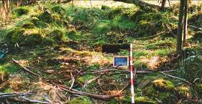 | 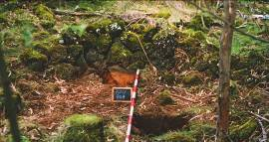
Figure 8 Showing hut base structures VAHR 7221/882 (left) and
VAHR 7221/883 (right) prior to vegetation clearing and excavation. Photos by author.

Ethnohistorical or early descriptions

George Augustus Robinson – first-hand description
In March of 1842 Chief Protector of Aborigines George Augustus Robinson and Assistant Protector Sievewright ventured on to the stony rises to the south of Mt. Eccles. Part of Robinson’s journal entry from that day reads:

Led our horses into the stony rises: masses of larve, steep stone - horse could barely walk - plenty ash hills, round sharp layrs, plenty huts of dirt and others built of stones…At the native camp they had oven baking roots…Stone houses, stone weirs…Mt Napier bore north and Mt Eels WNW (Robinson 20/3/1842 in Clark 2000c: 42).

Peter Manifold – first-hand description
Stone-circles are made by the natives, and are always found in exposed situations where timber is difficult to obtain. The natives there formed their break-winds of stones, placed on edge in circular form, some of them very perfect, leaving the opening generally towards the east, the prevailing winds coming from the north-west and south-west. These circles are common on the plains…where branches of trees could not be procured for giving shelter. When we first occupied this country, it was quite common for the natives to use these circles as camping-places, always having fires in the centre…The circles are generally formed of large stones set on their edges, and bedded in the ground close together, without any other stones on top…The stones are of the common basalt…The situation selected was generally where water was convenient, or in some favourable place for game. The circles were about the size of the ordinary mia-mys, that is from ten to twenty feet in diameter. (Manifold quoted in Chauncy, in Smyth 1878 vol 2: 235).

James Dawson – first-hand description?
In some parts of the country where it is easier to get stones than wood and bark for dwellings, the walls are built of flat stones, and roofed with limbs and thatch. A stony point of land on the south side of a lake near Camperdown is called ‘karm karm,’ which means ‘building of stones,’ but no marks or remains are now to be seen indicating the former existence of a building there (Dawson 1881: 10).

Alexander Ingram/R.E. Johns – early site description, with Aboriginal informant
Near a large waterhole in a fine permanent stream known as ‘The River’ are the remains of an old aboriginal camping-place, the name of which is Narrarrabeen, consisting of about twenty stone foundations, of horseshoe form, from 4ft to 7ft in diameter, and opening towards the east, a point from which the wind rarely blows. They are built among the loose blocks of cellular basalt, and appear to have been made by piling the stones removed to level the floor into a dry-stone wall about 1ft high on the western or windward side. On this foundation – Mr Ingram learned from Tommy White, a civilised aboriginal, who had been born at a similar camping place (called by the blacks Allumyung, about a quarter of a mile higher up the river, near the point at which it issued from beneath the basalt) – the ordinary mia mia of bark was erected. In the forest, not far distant, is another old camping ground, called Eullameet. Similar stone foundations are found among the rough basalt around Mount Eccles and Lake Gorrie (Johns quoted in Worsnap 1897: 105-106).

Robinson’s journal entry provides a record of one of the few contemporary observations of the western district stone-based huts made while they were in use. Unfortunately, however, Robinson did not record a detailed description of these ‘huts…built of stones’ despite elsewhere in his journal providing a relatively detailed discussion of southwestern Victorian Aboriginal hut types (eg Robinson 10/5/1841 in Clark 2000b: 190-191).

Peter Manifold, a squatter who took up land surrounding Lake Purrumbeet, no doubt also saw the structures described during the early years on his squatting run. James Dawson provided a similar description in his publication Aborigines of Australia, but while Dawson is known to have received much of his information from local Aboriginal people (Corris 1968: 19, Critchett 1981), it is not certain that he would have observed such structures in use. The description given by Alexander Ingram to R.E. Johns appears to have been the only one informed by an Aboriginal person (Tommy White) who lived in and, presumably, built these shelters.

The above descriptions would also seem to be of two slightly differing types of stone-based huts: unroofed stone wind-breaks (as described by Manifold) and huts roofed with “limbs and thatch” or “the ordinary mia-mia of bark”. Note that in this description the removal of stone to form a level internal area appears to have been as important to the building of the structure as the piling of stone to form the surrounding low wall.

Archaeological examples

Since their ‘discovery’ by archaeologists in the 1970s, hundreds of stone huts (or, following Clarke 1994) ‘stone circles’ have been recorded in western Victoria. The majority of these are located in the region of the Mt Eccles or Mt Napier lava flows, although a small number of examples have been recorded in the Corangamite region. Generally in western Victoria, they are restricted to the landform known as the ‘stony rises’ although the descriptions given by both Manifold and Dawson suggest that they may also have been common on the more open plains. Some examples of Aboriginal stone or stone based huts/shelters are also known from elsewhere in Australia, for example in Western Australia (O’Conner 1987), and Queensland (Ferrier 2002: 32).

Generally the stone-based huts of the Mt Eccles region have been described as:

low stone walls built by piling unmodified blocks of basalt on top of one another, [they] are semi-circular to U-shaped and usually 2-4m, across. The insides of the structures are relatively clear of rocks, although walls have partially collapsed (Wesson 1981: 31).

The surface identification of the stone-based huts has been acknowledged to be problematic. Clarke (1991, 1994) has pointed out that natural features of the stony rises may mimic the form of the stone-based huts. The examples given here are therefore confined to huts confirmed as such through excavation. The PAL/20 site, located on the Allambie property was excavated in the early 1980s (Wesson 1981), and more recently two circular stone-based hut structures have been excavated on the southern edge of the Mt Eccles lava flow, near Bessiebelle, on a property, which for the sake of convenience will be here referred to as the ‘Thomas’ property’ (Lane 2008) (see figures 8 and 9).

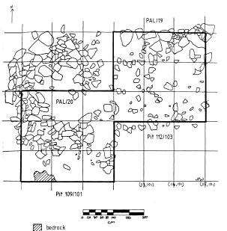
Figure 9 Plan of the PAL/20 stone-based hut site (VAHR 7221/358)
(after Wesson 1981: figure 11).

Both the PAL/20 and the Thomas’ property stone circle sites appeared, on the ground surface, to consist of low walls of piled stone arranged in ‘C’ or arc shapes. The Thomas’ property structures, however, though only a few metres apart contrast in both their shapes and in the height of their walls (see section drawings in figures 11 and 12). Results of the excavation of the Thomas’ property structures suggests both that they had been constructed atop the current ground surface (contrasting with the interpretation of the PAL/20 site that its walls had been built on bedrock) and that naturally-occurring stone had been removed from the centre of the structures (prised from the ground) when they were built. Figure 10, for instance shows a plan of structures VAHR 7221/882 and 883 (located on the Thomas’ property) both prior to excavation and after roughly 10cm of soil and stone had been removed. Figures 11 and 12 show the section drawings of these two structures after excavation was completed. The results of this excavation (as demonstrated by these figures) confirm that, as Tommy White described, the huts were formed by the removal of internal surface stone (some of which must have been prised out of the ground) which was then piled up to form the low walls which border the cleared area.

No stone windbreaks of the type described by Manifold (in the Corangamite region) have been excavated.

Relatively stone-free area
(see figure 12 for a section drawing of this structure)

Stone hut base VAHR 7221/883
(only half of the arc of the structure is shown on this plan)

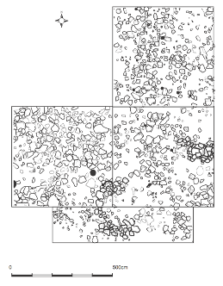  Stone hut base VAHR 7221/882  A | 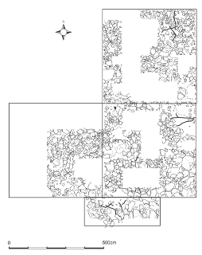  wall  Relatively stone-free area  (see figure 11 for a section drawing of this structure)  B
A) Surface plan of excavation area showing stone hut bases VAHR 7221/882 and (part of) 883. Stones thought to be part of huts are highlighted.  B) Same area after the excavation of about 10cm of soil and stone showing relatively stone-free areas inside huts (hut walls and rectangular black areas were not excavated).  C) Inset showing VAHR 7221/882 after 10cm of soil/stone removed. Note that the natural subsurface stone (lighter grey) appears to have been removed from the internal area of the hut. | 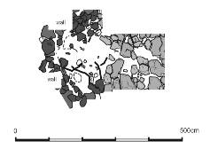  C
Figure 10 Excavation plans of the stone-based hut structures VAHR 7221/882 and 883. Figures by author (Lane 2008).

Low wall, which appears to be comprised of stone removed from centre
Centre of circle/hut
(relatively little stone)
Edge of natural stone (which seems to have been removed from inside the circle/hut)

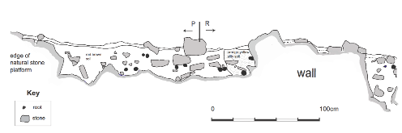
Figure 11 North-facing section of structure VAHR 7221/882 showing relatively stone-free space between the back wall of the structure and the edge of a natural stone platform.
Figures by author (Lane 2008).

Wall appears to be built on top of natural stone
Stone appears to have been removed from the inside of the circle/hut

Natural stone
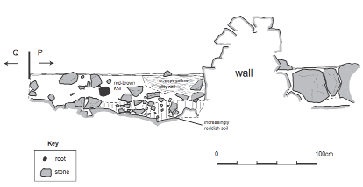
Figure 12 West-facing section of structure VAHR 7221/883 showing structure wall built on edge of natural stone platform, and the relatively stone-free space in front of the wall (inside the structure). Figure by author (Lane 2008).

Excavation of these features also confirmed that they contained flaked stone, and in the case of structure VAHR 7221/883, flaked glass artefacts. As figure 13 shows, stone and glass artefacts were found to be most densely concentrated within the two structures, but artefacts were also found outside of/away from the structures. Analysis of this distribution suggests that outside the structures, a slightly higher density of artefacts is associated with a relative lack of surface stone. This considered alongside the description recorded by Ingram leads to questions regarding the reasons behind the building of the stone hut bases – are they as much the result of a need to clear an area as to build a wall? Could areas on the stony rises that were naturally relatively clear of surface stone have been the location of ‘ordinary mia mia of bark’ (to use Ingram’s words)? And finally, is there a continuum of hut locations on the stony rises that progress from naturally clear areas (with no accompanying stone arrangement) to cleared areas (with surrounding low stone walls)? (see Lane 2008 for a more complete discussion of this).

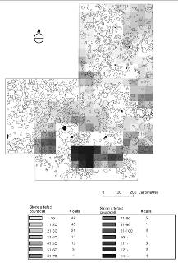  A | 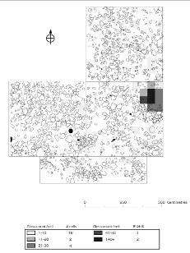  B
Figure 13 Showing distribution of A) stone artefacts and B) flaked glass artefacts (excavated and plotted by 50cm cells) around and inside structures VAHR 7221/882 and 883 (artefact counts from all excavation units). Figures from Lane (2008)

Identification and probable locations

Aboriginal stone hut bases in western Victoria are found, for the most part, only on the stony rises of the region, although some of the early descriptions (e.g. Manifold’s, above) suggest that stone break-winds might once have been common on the more open plains. The archaeological identification of the stone-based huts of the western Victorian stony rises has been a matter of some debate amongst archaeologists.

Again the main difficulties that may occur in trying to accurately identify stone-based huts from the ground surface are

• confusion with non-Aboriginal structures
There are a relatively large number of non-Aboriginal structures built from basalt blocks on the stony rises, particularly in the Lake Condah area. Both Wesson (1981) and Clarke (1991, 1994) have noted that while most non-Aboriginal or European structures existing in the region of the Mt Eccles stony rises can relatively easily be distinguished from Aboriginal sites on the bases of their method of construction, there do exist a small number of European site types which could be confused with Aboriginal structures.

• confusion with natural features
Clarke identified three main processes which might result in the creation of small circular arrangements of stone on the stony rises. They are:

Geological formation processes
The surface of the basalt appeared to contain circular features which were thought to have originated during the geological formation of the lava flow…a number of surface circular features were thought to be the direct result of flow behaviour rather than cultural construction…

Post-flow landscape processes
Post-flow alteration of the landscape also appeared to contribute circular features to the basalt ridges…Trees, in particular, were observed to be contributing circular features to the landscape…(Clarke 1991: 24-25).

See sections 4.1 and 4.2 for examples of natural features and European constructions which may pose problems for the accurate identification of Aboriginal stone-based huts.

Stone hunting hides

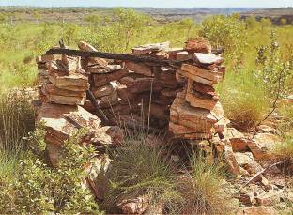
Figure 14 Example of a stone-walled bird hide from Victoria River District
(after Mulvaney and Kamminga 1999: plate 1).

Ethnohistorical or early descriptions

I am not aware of any ethnohistorical descriptions of stone hunting hides from western Victoria, but Robinson’s description below makes clear that small hides were constructed in Victoria for the purposes of hunting.

George Augustus Robinson – first-hand description
The holes with the water are then selected by the natives for catching birds. The method resorted to is by sticking boughs in the bank on the edge of the pond, the boughs overhanging the water, as shewn in sketch book. This is done to prevent the birds getting at the water. One end of the hole is left open and at this place two sticks, bent in cimicircle [sic] or form of a segment of a circle, is then placed in front of this opening - for the birds to perch on. The bird catcher then builds himself a hut of boughs of the smallest size in which he can crouch; the one I saw was two feet by three. The sportsman then crouches ain and watches the bird perch on the stick. When he snares them with his [blank], thus, a stick with a noose. This mode of catching birds indicates much ingenuity and I should think patience also (Robinson 9/5/1841 in Clark 2000b:189).

Stone hunting hides are known to exist elsewhere in Australia, such as in the Victoria River District (Kimber 1981: 13; Mulvaney 1992; see also figure 14), the Olary region of South Australia (Smith 1982) and possible hunting hides have been identified on the Burrup Peninsula (Vinnicombe 1987: 33). Generally Aboriginal stone hunting hides are described as small circular or semi-circular dry stone wall constructions (eg see Smith 1982: 25).

Archaeological examples

As hides of a sort were used in western Victoria (according to Robinson’s description, above), there is the possibility that stone hides were built in places in which stone was more readily available than timber, such as on the stony rises. On this landform they may, however, be difficult to distinguish from stone-based huts as their morphology in very similar. Van Waarden has identified one possible hide on the Tyrendarra property based, however, upon its dissimilarities to both stone-based huts and European dry stone walls:

One of the sites was not a stone circle but roughly formed a small straight stone wall parallel to the Fitzroy River. The stone wall is not as well constructed as other definitely European built walls and is therefore identified as an Aboriginal hunting hide (Van Waarden 1990: 9).

Identification and probable location

In a discussion of the use of hunting hides in Australia Smith noted:

It is clear that hides act to conceal a hunter in a location where the movements of game are predictable i.e. movement along well-defined pads, areas where movement is tied to localised resources such as water. Hides allow the game to be ambushed and function to decrease the striking distance between hunter and quarry (Smith 1982: 25).

As Smith’s discussion suggests, hides could be expected to occur in particular locations according to the species of prey being targeted. Smith has noted, for example, that the South Australian examples studied by him were “located in areas where the movement of game is restricted or channelled” (Smith 1982: 22), while the example recorded by Van Waarden at Tyrendarra was found in a location that overlooked the Fitzroy River.

The accurate identification of Aboriginal stone hunting hides would likely be hampered by the same difficulties inherent in the identification of stone-based huts, namely:

• Confusion with natural features

• Confusion with non-Aboriginal structures.

• Confusion with other types of Aboriginal stone structure.

Ovens/hearths

Ethnohistorical or early descriptions

George Augustus Robinson – first-hand description
Passed several fireplaces of the natives or ovens, thus [ref to fig]. In these ovens or fireplaces, the natives bake their murnong and emue and other animals. The round dots are stone, the intermediate is earth, that is, the stones are placed to keep up the earth (Robinson 27/1/1840 in Clark 2000a).

Peter MacPherson – early site description
In the district of Meredith…there is a considerable number of mounds, locally known as Blackfellows ovens…The collection of ashes, charcoal and stones may be 20 or 30 feet in diameter, and 1 or 2 feet thick in the centre. But the real oven, formed of stones, is much smaller than what the foregoing figures indicate. The stone oven itself varies in size from 4 to 9 feet in diameter; 6 feet, however, may be taken as a common size in the whole of the Meredith district. The stone oven is usually concave, or crater-like, with a central stone larger than those otherwise employed in the oven…The stone oven, of course, will remain till disturbed by the white man, but it is otherwise with the loose ashes and charcoal.

…Besides the stones which are used for making the cooking oven, there are sometimes other which present all the appearance of having been designedly placed as circles about the mound (MacPherson 1884: 49-53).

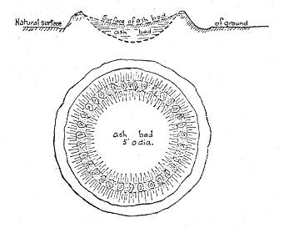
Figure 15 Plan of a stone-ringed mound drawn by Alexander Ingram 1895
(from Kenyon 1912: 102).

Alexander Ingram – early site description
The above diagrams represent a remarkable artificial formation, visited by me on the 24th of March, 1895. It is situated on the Congbool Estate, near Balmoral, and is presumed to be an aboriginal oven. I have never seen anything like it in this district (Hamilton)…The above formation is circular, about 5 feet in diameter, with a rim of stones around the raised outer edge. It is dished to the depth of about 6 inches, below which is a bed of ashes about 12 inches deep. It is surrounded by a shallow trench, probably made when forming the outer rim (Ingram in Kenyon 1912: 102).

George Robinson noted the existence of small circles of stone around Aboriginal “ovens or fireplaces” in several places in central and western Victoria. Both MacPherson and Ingram later described what appear to be similar structures (mounds containing rings of stone). While MacPherson noted examples near Meredith, Ingram seemed to have been of the opinion that these sorts of mounds were rare, and Kenyon stated that the “stone circle oven” was found “only west of the Grampians and along the Upper Glenelg”(Kenyon 1912: 102). Coutts et al (1977: 2) have suggested that the concave depressions described by MacPherson may be similar to the hut-base hollows described in western Victoria by Robinson (Robinson journal 7/6/1841 in Clark 2000b: 247), but concede that “it is not possible to be certain”.

Archaeological examples

Excavations of mound sites in the Hopkins River region have revealed some small ‘arrangements’ of stone within the mounds which were described by the excavators as being probable “fireplace” or hearth remains (Coutts et al 1977: 22, 25; Williams 1988: 88). Mounds excavated near Bessiebelle likewise were found to contain a number of burnt basalt rocks interpreted as heat retainers (Williams 1988: 155) while balls of baked clay used as heat retainers have been found in mounds in the Murray River region (see Frankel 1991: figure 6.11).

As far as I am aware, no western Victorian mound excavations have revealed either an internal regular circle of stone, or an external stone circle as described by MacPherson.

Identification and Location

Presumably these circles would be of limited size and height and might be found within or associated with mounds. They may now appear less as arrangements of stone, and more as scatters of stone associated with deflated or eroded mounds.

Other stone arrangements – purpose unknown and probably unknowable

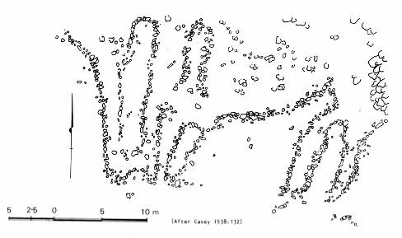
Figure 16 Plan of the Lake Wongan stone arrangement
(after Lane and Fullagar 1980:figure 35)

Phillip Chauncy – early description

On a little basalt islet in Lake Wongan, about seven miles north-east from Streatham, I observed an ancient Aboriginal work consisting of extensive rows of large stones, forming passages up and down, like a maze, at the foot of a little hill. A semicircular walk, ten feet wide, has been made by clearing and smoothing the rough rocky surface up the hill and down again leading into the maze. This work was possibly executed for the purpose of carrying on some mystic rites, or probably only for the amusement of running between the rows of stones and up the hill and down again.

Also, Mr. A.C. Allan, Inspector-General of Surveys, has informed me that during a recent journey in the Tattiara country, near the South Australian border, he noticed a number of stone walls, two or three feet high, which had been constructed by the natives, radiating from a little cave in the ground, and forming irregular passages.

I can only conjecture that these and other similar works have been used by the Aborigines, in times past, for the purposes of incantation (Chauncy in Smyth 1878 vol 2: 235-236).

There exists a relatively large literature regarding presumed non-utilitarian Aboriginal stone arrangements in Australia. Such arrangements may consist of alignments of stone in straight, curving or circular lines or shapes, standing stones, piles or cairns of stone, or complexes consisting of combinations of the above (McCarthy 1940). Many of the published sources discuss the physical phenomena of the arrangements, but offer little in the way of interpretation regarding their use. Generally, it has been assumed that the stone arrangements without a clear ‘utilitarian’ purpose have a ritual or ceremonial function.

This category of stone arrangement is necessarily broad, and as a result is possibly the most difficult to define or identify. Unlike the ‘utilitarian’ arrangement types discussed above, which have a purpose both identifiable and readily understood by people from outside the creating culture, these are arrangements for which the purpose is unclear. Like Chauncy (above) those who have recorded or described these structures have generally assumed that they had a ritual function. It should be noted, however, that not every stone arrangement without an immediately obvious function was necessarily related to ritual or ceremony. Kimber (1981), for example, has described a number of non-ritual/ceremonial stone arrangements found in Central Australia, many of which would not have an obvious utilitarian function to an uninformed observer.

There do also, however, exist a number of descriptions of ceremony and ritual connected with arrangements of stone. Daniel (1990) has described the ritual associated with a number of thalu or increase sites in the western Pilbara. Palmer (1977) has reported on the “mythology” and meaning connected with complex stone arrangements, as revealed by Aboriginal informants, in northern Western Australia. McBryde has recorded available ethno and oral history connected with Aboriginal arrangements of stone in the New England region of New South Wales (1974: 29-64). More recently Tulloch has recorded that oral tradition links some stone arrangements in north-west New South Wales to ceremonies of birth, death, marriage and initiation, with different sites (of different shape) being linked to different ceremonies (Tulloch 2003: 24).

Archaeological examples

A number of possible ‘ceremonial’ stone arrangements are known from western Victoria. These include the large sites at Lake Bolac, Carisbrook, Mount Rothwell/Wurdi Youang (figures 17 and 18) and the arrangement at Lake Wongan described by Chauncy (figure 16). Some smaller possible Aboriginal stone arrangements have also been recorded in the region - for example in the Werribee district, du Cros recorded small arrangements at Lollypop Creek and Bulban Road (du Cros 1991). These, and more recently recorded stone alignments including that at Mt Bealiba (figure 19), and the Marpeang stone arrangement might be considered to be ‘unconfirmed’ arrangements simply because to date little research into alternative explanations for these structures has yet been carried out (see below).

The better-known arrangements at Wurdi Youang, Lake Bolac and Carisbrook are broadly similar in that their structures consist, in the main, of lines of single stone arranged into various shapes. At Wurdi Youang some of the stones were supported by smaller rocks wedged beneath them (Marshall and Webb 1999: 8) and at Lake Bolac there is evidence that some stones in the arrangement may have been embedded in holes in the ground so as to make them stand upright (Long and Schell 1999: 20-21). The more recently recorded probable stone arrangement at Mt Bealiba (figure 19) consists, in places of lines of piled stone, possibly similar to the low stone walls described to Chauncy by Mr Allen.

Each of the best-known stone arrangements are situated in relatively secluded locations (Long and Schell 1999; Marshall and Webb 1999; du Cros and Associates 1998). In each instance it would appear that the stone used in the alignments was locally available. Individual stone sizes vary within and between arrangements. At Lake Bolac stone sizes vary from about 30cm to 150cm (Long and Schell 1999: 20), at Carisbrook stones of between 5cm and 80cm were used in various parts of the arrangement (du Cros and Associates 1998: 34) and at the Wurdi Youang/Mt Rothwell arrangement stones in the alignment have been recorded as having weights varying between 30kg and 500kg with most weighing “nearer to 90kg” (Lane and Fullagar 1980: 135).

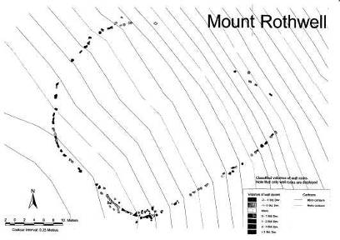
Figure 17 Plan of the Mt Rothwell/Wurdi Youang stone arrangement
(after Marshall and Webb 1999: map 9).

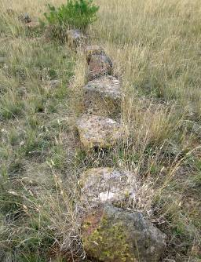
Figure 18 Photo showing a portion of the alignment of the Mt Rothwell/Wurdi Youang stone arrangement. Photo by author.

It would appear that there exist no ethnohistorical or oral histories relating to these sites and their use by Aboriginal people. This absence is a common characteristic of this site type, and has generally been attributed to the reluctance of Aboriginal people to disclose to non-Aboriginal people information regarding sacred sites (McBryde 1974: 50).

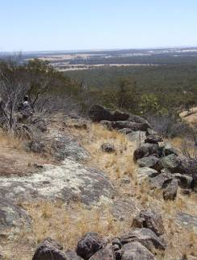  A | 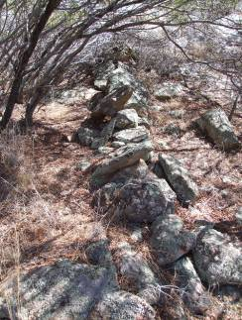  B
Figure 19 Two views of portions of the Mt Bealiba stone arrangement A) Curving line running along the upper slope of the valley B) Straight line running downslope. Photo by author.

Identification and location

The Wurdi Youang and Lake Bolac stone arrangement sites were originally identified as Aboriginal structures on the basis of their lack of “counterpart among colonial structures” and lack of evidence that they “ever formed part of any type of fence or building”. In addition, in both instances the land on which the arrangements stand had been owned by a single European family “since first settlement” and there existed no tradition within those families of the arrangements having been built by Europeans (Lane and Fullagar 1980: 139-140). Massola utilized similar criteria to identify the Mount Franklin stone arrangement as a potential Aboriginal stone alignment (Massola 1968).

Probably the most detailed investigation of this site type in Victoria is that undertaken by Frankel at the Sunbury earth rings. While not strictly a stone arrangement, consisting of mainly of circular earthen banks, but also containing cairns of stone, the Sunbury rings have been interpreted as a ceremonial site. Frankel’s discussion of the investigation of the Sunbury earth rings site provides a relatively detailed account of the process of the identification of a potential ceremonial site (1982; 1991: 106-112). In their form the Sunbury rings resemble the Aboriginal ‘bora’ ring sites of NSW. Like other probable ceremonial sites in Victoria, however, no known oral or ethnohistorical history existed to link these rings to Aboriginal people. On the other hand, the structures bore no resemblance to common non-Aboriginal or historical sites such as those created by the construction of dams, buildings or animal pens. One of the rings was then partially excavated to reveal two small stone cairns (one in the centre of the ring, and one outside it). In addition a number of stone artefacts were recovered during the excavation with the main concentration of these artefacts being near the centre of the ring (figure 20). This spatial distribution of stone artefacts was taken as supporting evidence of the probable Aboriginal origin of the earth ring structure (Frankel 1982: 95). The identification of the Sunbury rings as Aboriginal ceremonial sites was therefore based on their similarity to known Aboriginal ceremonial sites located elsewhere, their dissimilarity to known European structures and the lack of evidence to support a post-contact construction, and finally, on archaeological evidence which showed a concentration of stone artefacts near the centre of the partially excavated ring.

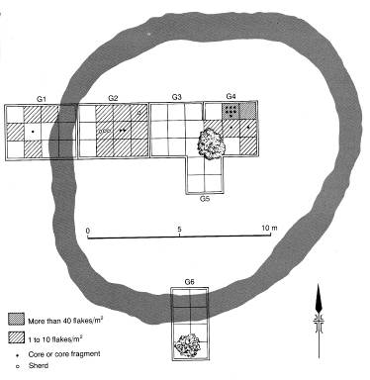
earth bank
stone cairns
excavation trenches
Figure 20 Partially excavated earth ring at Sunbury, Victoria (after Frankel 1991: figure 9.11).

While identified probable ceremonial stone arrangements located western Victoria tend to consist of relatively large arrangements of stone it is not necessarily the case that all such places were marked in this way. Arrangement may be much smaller or more subtle in their appearance. McCarthy has noted that in some instances the distinction between built arrangements of stone and natural features may be irrelevant in the view of living or past Aboriginal groups for whom these arrangements and features all form, or formed, part of a landscape created by supernatural beings:

clumps of bushes, trees, rocks in situ, waterholes, and other features of the landscape are just as important as the megaliths (McCarthy 1940: 189).

Archaeologically detectable remains of such sites, such as arrangements of stone, may therefore be just one part of a spectrum of such places of importance. Certainly some of the thalu or increase sites and rituals of the Pilbara described by Daniel (1990) involve little or no human modification of the natural environment, while others are centred upon visible and obvious arrangements of stone.

Aboriginal stone structure identification

Distinguishing between natural and cultural features

A large portion of southwestern Victoria consists of extensive New Volcanic plains, which take up a surface area of about 15,000km² . Ollier has noted that while “some lava plains may be produced by extensive fissure eruptions…the Victorian one was made by lava from many distinct points” (Ollier 1988: 71-72). The volcanic plains of southwestern Victoria have supplied an abundance of basalt blocks and boulders which have been used by its human population for the building of various structures. In some instances the surface features of the volcanic plains, and of the stony rises in particular can resemble man-made structures. Ollier has described the surface of stony rises as generally consisting of “hummocks and depressions, ridges and blind channels [which] make a completely confused topography” (1988: 87). Or as Rosengren puts it “cracked ridges, arched blocks, confused bouldery surfaces, intersecting ridges and numerous depressions form the chaotic rubbly surfaces of stony rises (1994: 22).

As Clarke has pointed out (see section 3.2.1) there exist both lava flow and post-flow processes which may create structures which mimic those built by people. The following figures provide some illustrations of lava flow features:

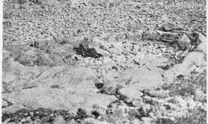
Figure 21 Small circular lava flow surface feature (after Hills 1951: figure 251).

Figure 21 is a photo of the eroded base of a “small lava blister…with its summit removed by marine abrasion” (Hills 1951: 251).

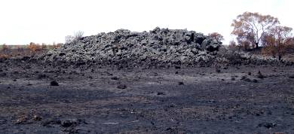
Figure 22 Lava tumulus on the Tyrendarra property. Photo by author.

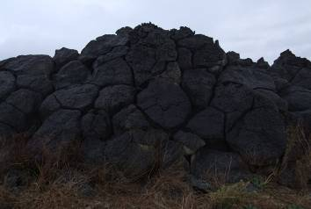
Figure 23 Jointed blocks of lava forming a ridge near the southern edge of Lake Corangamite. Photo by author.

The Aboriginal stone structures most likely to be mimicked by natural lava flow features are stone hut bases (figure 21) stone cairns (which can resemble small natural tumuli) and possibly channels. In discussing the possibility that natural features could be mistaken for man-made structures, Rosengren emphasised the need to determine whether the apparent structure have “disjunct surfaces with the underlying lava – i.e. they lie on the surface rather than show any structural continuity with it” (1990: 5). This may, of course be difficult in the more densely grassed/vegetated areas of the stony rises or volcanic plains.

Clarke has noted that tree growth, death and decay may be responsible for the creation of circles and piles of stone which may mimic man-made structures, this is particularly true on the stone-strewn surfaces of the stony rises. Figure 24 is an example of the result of a ‘tree hole’ from the Tyrendarra property. Figure 25 is an example of stone still held by the roots of an upturned tree – when this tree decays this may produce a small pile of stone adjacent to a roughly circular stone-free hollow.

Burnt tree stump

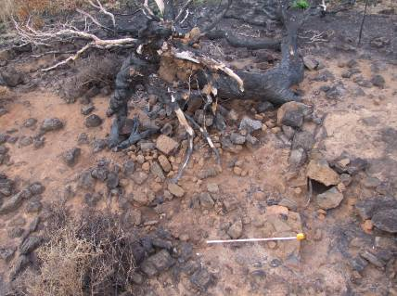
Semi-circle of stone rubble (indicated by white dashed lines)
Depression containing smaller stone
Figure 24 Uprooted tree stump on the Tyrendarra property, photographed after the bushfires of early 2006. Photo by author.

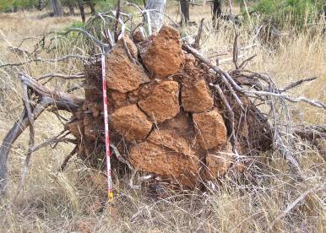
Figure 25 Root-bound stone in an uprooted tree on the Kurtonitj property. Photo by author.

Distinguishing between Aboriginal and European structures

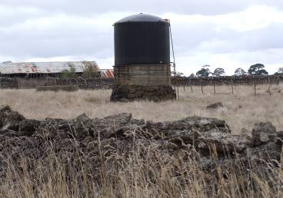
Figure 26 European dry stone structures near Purrumbete
(dry stone walls and tank stand). Photo by author.

Just as the Aboriginal population of the region used the ubiquitous basalt stone of the district to build various structures, so too did the Europeans. The district’s earliest dry stone walls were built in the 1840s or 1850s(McLellan 1989: 28, Vines 1990: 17), and such walls became increasingly more common in the 1860s after land sales and the Selection Acts (Vines 1990: 17).

Apart from walls, small structures of stone appear to have been built by the western district squatters from about the time of their initial claiming of their runs. Rolf Boldrewood described , for example, the first hut at Squattlesea mere, constructed in about 1844, as being of sod construction but with a chimney of basalt blocks (Boldrewood 1969: 39). As McLellan has noted, stone walls are commonly marked on pre-emptive right survey plans, and are often listed as ‘improvements’ on land files (McLellan 1989: 28). Stone stock yards, tank stands, fords and buildings are amongst the nineteenth-century stone structures commonly found in the south-west of Victoria (Rhodes 1990, Lane 2006: 9).

The construction of these European buildings and structures had and has a two-part impact on the survival and identification of Aboriginal stone structures in the region. On one hand the use of stone by Europeans has contributed to the destruction of the Aboriginal structures, on the other there are a number of European-built structures which may easily be confused with pre-contact Aboriginal sites. These two situations are discussed below.

Substitution and destruction of Aboriginal stone structures

The stone circles found by the early settlers in different parts of the Colac district – on the Mt Gellibrand Plains, in the Stoney Rises, and other places…were erected as break-winds, or mia-mias…Many of these stones were removed and made use of in the erection of stone wall fences (Hebb 1970: 223).

One of the largest threats to the survival of Aboriginal stone arrangements in south-western Victoria was the tendency for early European squatters and settlers in the region to use Aboriginal structures as a ready source of stone for their own stone structures. Considering the generally high density of natural surface stone in the region, which McLellan cites as one reason for the building of European dry stone walls (i.e. as a place to put the cleared surface stone) (McLellan 1989: 29) the ‘mining’ of these structures, in some cases, at least, must be considered to be deliberate destruction. Certainly Robinson’s comment would seem to suggest that this was the case at ‘Bolden’s place’ (see section 3.1.2). Other squatters recorded having deliberately destroyed Aboriginal huts and property with the intention of letting people know that they were no longer welcome on land that had once been their own. Harrison and McIntyre-Tamwoy (2004) have described a modern parallel – the apparently deliberate substitution of Aboriginal for European stone cairns at Evans Bay, Cape York. While the cases cited above involve the complete destruction of the earlier Aboriginal site, there may also be instances where an Aboriginal site was only slightly modified, or not modified at all, prior to re-use by Europeans.

In many instances Aboriginal stone structures have probably been destroyed by the land-clearing process, making way from crops and grazing animals:

It has been reported by Mr. N. O. Mack that lines of stones made by the aborigines existed many years ago, on his father’s property, ‘Berrybank,’ north of Lake Corangamite, but that they were removed when the land was cleared for cultivation (Casey 1938: 133).

It would seem that surviving stone structures for the most part remain because they are situated in an area that by either accident of history, or as a result of topography, has remained uncleared or undeveloped (e.g. see Massola 1968: 39).

Aboriginal-like structures

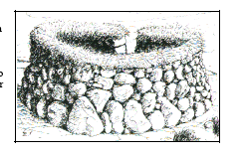
Figure 27 A British dry-stone butt (generally used as a hunting hide)
(after Dry Stone Walling Association of Great Britain 1997)

Both Wesson and Clarke have discussed the problems of distinguishing between Aboriginal and non-Aboriginal structures that exist in the region of the Mts Eccles and Napiers stony rises. In commenting on the differences between structures of different origins, Wesson stated that most of the non-Aboriginal structures have

square corners, but a few are circular or semi-circular. In general the latter are unlike Aboriginal semi-circular structures because the walls tend to be much higher (as much as 1.5m) or much lower (only one rock high). Some were also constructed in the same way as many of the stone fences in the district. However, a very small number of sites could be confused with or identified as Aboriginal sites (Wesson 1981: 12).

Clarke (1991:25) noted two main types of European dry stone structures located in the vicinity of Lake Condah: hunting sites and farm structures, the latter generally being associated with sheep. The former type was assessed as being “the most likely to be confused with Aboriginal structures” and consists of a range circular stone features used as hunting hides or blinds. In the main they can be distinguished from Aboriginal stone circles by their high walls, some of which have triangular holes used as gun sights, although Clarke suggested that some Aboriginal structures may have been used or modified by European hunters. Many of the farming or pastoral structures are more clearly European, being built using “a distinctive dry stone walling technique” although Clarke indicated that less permanent European structures might be more difficult to distinguish from Aboriginal structures “without material evidence” (Clarke 1991: 25).

The dry stone walling technique referred to by Clarke (also the method used to construct ‘many of the stone fences in the district, as noted by Wesson) is illustrated in figures 28 and 29.

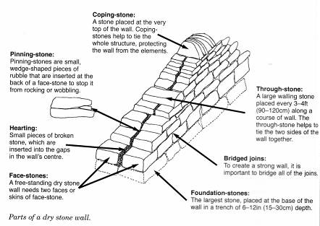
Figure 28 Main features of a European dry stone wall (from Radford 2001: 14).

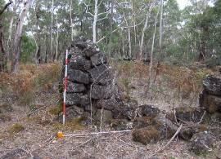 | 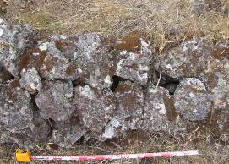
Figure 29 Examples of historical dry stone walls, Foote Track, Mt Eccles National Park. Photo by author.

Structures built in this manner can be easily distinguished from Aboriginal stone structures. There do exist, as both Wesson and Clarke have commented, less easily identifiable European structures. Surveyor Phillip Chauncy, for example, noted that nineteenth century shepherds of the western district built structures very similar to Aboriginal stone-based huts:

the European shepherds have been in the habit of constructing rubble-walls in circles for the same purpose of protection from the winds (Chauncy in Smyth 1878 vol 2: 235).

It would be near-impossible to distinguish these structures from Aboriginal stone-based huts without the aid of evidence from archaeological excavation.

Stone markers and cairns erected by surveyors (figure 30 and 31), or as land boundary markers have also long been recognised as structures which could be confused with Aboriginal stone cairns:

After receiving your letter and noting your remarks about a possible trig. station on Mount Forster, I wrote to the Surveyor General and asked him to advise me. I have his reply which, I think, places the matter beyond doubt. He states that there is no trig. station on or in the vicinity of Mount Forster...I think there is little doubt that the aborigines built the piles (C.C. Towle to A.S. Kenyon 17/3/1938, Kenyon papers, SLV MS 12173).

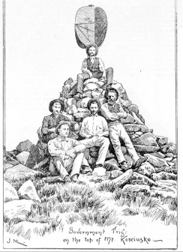
Figure 30 ‘Government trig on the top of Mt Kosciusko’ (1892)
(Pictures Collection, State Library of Victoria)

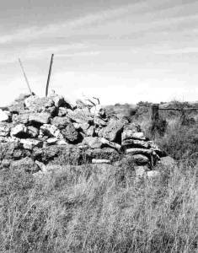
Figure 31 Stone cairn erected on the line of the Victoria/SouthAustralia border in the late 1840s (from Middleton 2001)

In addition to these, early surveyors used markers such as trenches cut in the ground. Surveyor Tyers, for example is known to have marked a 4 mile line going north from the mount of the Glenelg River “marking the line at frequent intervals with stakes and limestone trenches” (Chappel 2001).

An interesting example of small surveyor’s markers can be seen at Lake Gorrie. These appear to have been placed at each change in alignment of the boundary of the Lake Gorrie reserve. They consist of short, linear to V-shaped alignments of basalt blocks and bear some resemblance to the arc-shaped types of stone-based huts (such as VAHR 7221/883 – see section 3.2.1).

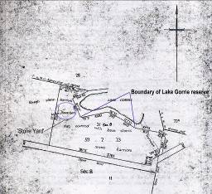  A | 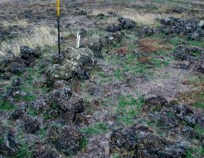  B
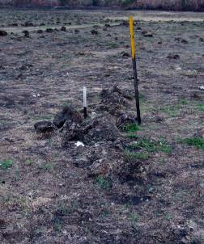  C | A) 1923 plan showing the then new boundaries of the Lake Gorrie reserve (PROV, VPRS 5357, unit 3023, file Hamilton 511/46).  B and C) Surveyor’s small stone alignments showing ‘corners’ or changes  in direction of Lake Gorrie reserve boundary.
Figure 32 Surveyor’s stone alignments at Lake Gorrie.
Figure A is reproduced with the permission of the Keeper of Public Records, Public Record Office Victoria. Photos by the author.

Farm clearing and paddock boundaries can have the result of creating less formal stone structures (figures 33 to 35).

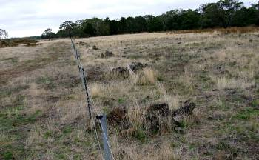
Figure 33 Line of small stone piles along a fenceline on the Kurtonitj property. Photo by author.

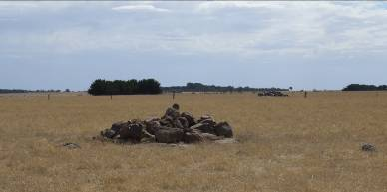
Figure 34 Stone pile formed by paddock clearing, western Victoria. Photo by author.

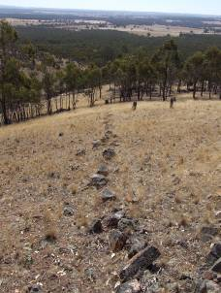
Figure 35 Line of stone formed along an old fenceline. The fenceline is still marked in a few places by decaying wooden posts. Near Bealiba, Victoria. Photo by author.

In some instances the origin of these non-Aboriginal structures can be ascertained through historical research, particularly by looking at maps which may show old property boundaries, surveyor’s trig points, river and creek fording places, etc.

Aboriginal historical structures

Having discussed Aboriginal and historical structures as two different categories, mention here should be made of Aboriginal historical stone structures. By this is meant stone structures built by Aboriginal people using the style of, or for a similar purpose to non-Aboriginal or European historical structures.

Two examples illustrate this point:

Historical research in the Mt Eccles/Lake Condah region by historian Carlotta Kellaway has revealed evidence of Aboriginal men working on dry stone walls surrounding the Lake Condah Mission lands in the nineteenth century.

There is evidence in Lands Department Selection files (held at the PROV) that Blacks’ Wall to the south of the Serpentine Wall was constructed in c1875 by a team of Aboriginal workers from the Lake Condah Mission, supervised by the Rev. Henry Stahle, the Mission’s superintendent (Kellaway 2005: 6)

The serpentine wall was also, according to Kellaway, kept in repair by local Aboriginal men (Kellaway 2005: 5). That Aboriginal people were building and maintaining structures on the mission lands is not surprising considering that residents of the mission/board stations were generally required to work on them (Christie 1979: 175; Rhodes 1986: 35). It is also likely, however, that Aboriginal people played a part in the construction of ‘European’ stone structures on land unconnected with mission or board stations through both being employed on squatting runs and farms (for example Aboriginal people were employed on the Learmonth family’s Ettrick run from at least the 1850s, see Lane 2001: 18), and through cases like that of Tommy White:

Tommy White…was recently found dead in his tent adjacent to ‘Allumyung,’ where he had lived for some years getting a living by catching eels…The hut Tommy occupied was of a very primitive nature, but he had a number of stones roughly dressed ready to build a better house, fully expecting the Government would grant him a small piece of his native ground when the swamp was drained (Hamilton Spectator 31/12/1892).

Tommy White was the man who showed surveyor Alexander Ingram a number of stone-based hut remains on the Mt Eccles stony rises (section 3.2.1). He told Ingram that he was born at one of these hut groups at ‘Allumyung.’ By the 1890s, however, having survived the squatting invasion White was preparing to build a stone hut in the European style with dressed stone. Just as Europeans built Aboriginal-style structures, Aboriginal people built European-style structures (see also Lane, forthcoming). Again without historical evidence to the contrary a hut built of dressed stone by someone like Tommy White would be generally recorded as a non-Aboriginal site.

Conclusion – identifying Aboriginal stone structures

The foregoing report has provided examples of known Aboriginal stone structure types, as well as some discussion of both natural and non-Aboriginal structures which bear some resemblance to, and could therefore be mistaken for such Aboriginal stone structures. The process of identifying Aboriginal stone structures is basically as outlined below.

 | Possible stone structure encountered | Questions to consider
1 | Determine whether this is natural or cultural | Does it bear resemblance to other more obviously natural stone features located in the immediate area?  Is there a discontinuity between the structure and natural underlying lava surface. That is, is there a clear break between the structure and the natural surface beneath it?  Do the stones in the structure show jointing i.e. have the individual stones been placed, or do they appear to have fractured apart into their current position?
2 | If cultural, is it Aboriginal or European | Are the stones in the structure dressed? Are they arranged in the ‘classic’ European dry stone style?  Do historical maps or land files for the area show any kind of European structure there, or do local landowners or historical societies have any information?  Do Aboriginal community members have any knowledge of this as an Aboriginal structure or significant place?
3 | If Aboriginal, what type? | If it is a suspected Aboriginal ‘utilitarian’ structure, could it have functioned as required in this location?

In many instances, of course, distinguishing between natural/cultural and Aboriginal/European will not be possible on first inspection in the field. Research into local landforms, or consultation with, for example geologists (eg Clark 1994: appendix 3) may be necessary, as might research into historical land use and/or land boundaries.

In some instances further archaeological research, in the form of excavation, might also be employed as it was at the Sunbury earth rings (section 3.3) and more recently in investigating stone-based huts in the Mt Eccles region (section 3.2.1). Excavation, or the apparent association (or not) of stone artefacts with a structure may not, however, always provide a reliable indication of the origins of the structure. The possible stone arrangement at Rokewood, for example, was excavated by the VAS in the early 1980s with little result. The arrangement was described as ‘ovate’ in shape and about 8.5m x 3m in size. The 1980/81 VAS activity report notes that “an excavation was undertaken…to expose the stone arrangement and establish its ethnicity. However, although stone artefacts were located, its origin remains uncertain” (Coutts 1981: 41). Considering that it is generally unlikely that large stone structures could be archaeologically tied to stone artefacts within on near them through stratigraphic association, it may be difficult, in many instances, to prove that any seeming spatial association is not simply fortuitous. It is also likely that many types of Aboriginal stone structure were not locations in which people made or used stone artefacts.

References

Key to references:
CFT = coastal fish trap
G = general reference used in the text, not necessarily related to sone structures
HH = stone hunting hide
HS = historical or ethnohistorical source used in the text
IFT = inland fish trap
M = mounds
N = discusses natural landforms/features
PC = post contact stone structures
SA = stone arrangement
SBH = stone-based hut
U = reference discusses stone arrangement of uncertain type

Bannerman N. and C. Jones 1999 Fish-trap types: a component of the maritime cultural landscape The International Journal of Nautical Archaeology 28: 70-84. CFT

Black, J. and A. Miller (eds) 1995 If These Walls Could Talk Corangamite Arts Council Inc. PC

Boldrewood, R. 1969 Old Melbourne Memories: with an introduction and editorial commentary by C.E. Sayers William Heinemann, Melbourne. HS

Bowen, G. 1998 Towards a generic technique for dating stone fish traps and weirs Australian Archaeology 47: 39-43. CFT

Brown, P. (ed) 1986 Memoirs Recorded at Geelong, Victoria, Australia by Captain Foster Fyans (1790-1870) The Geelong Advertiser Pty. Ltd., Geelong. HS

Builth, H. 2002 The archaeology and socioeconomy of the Gunditjmara: a landscape analysis from southwest Victoria, Australia, unpublished PhD thesis, Department of Archaeology, Faculty of Education, Humanities, Law and Theology, Flinders University of South Australia. IFT, SBH

Builth, H. 2004 Mt Eccles lava flow and the Gunditjmara connection: a landform for all seasons Proceedings of the Royal Society of Victoria 116(1): 163-182. IFT, SBH

Campbell, T.D. and C.P. Mountford 1939 Aboriginal arrangements of stone in Central Australia Royal Society of South Australia 63(1): 17-21. SA

Campbell, T.D. and P.S. Hossfeld 1964 Aboriginal stone circles Mankind 6(4): 181-183. SA

Campbell. J.B. 1982 Automatic seafood retrieval systems: the evidence from Hinchinbrook Island and its implications, in S. Bowdler (ed) Coastal Archaeology in Eastern Australia: proceedings of the 1980 Valla conference on Australian Prehistory Department of Prehistory, Research School of Pacific Studies, ANU. CFT

Casey, D.A. 1938 An Aboriginal ceremonial ground at Lake Wongan, near Streatham, Victoria The Victorian Naturalist 54: 130-133. SA

Chappel, K. 1966 Surveying for land settlement in Victoria, 1836-1960, available on the CD Surveying Victoria - Celebration of 150 Years of Victorian Surveyors General Victorian Surveyor General. PC

Chauncy, P., papers MS 9287/72, State Library of Victoria, Australian Manuscripts Collection.

Chauncy, P. 1878 Notes and Anecdotes of the Aborigines of Australia, in R Brough Smyth The Aborigines of Victoria with Notes Relating to the Habits of the Natives of Other Parts of Australia and Tasmania vol 2 Government Printer, Melbourne. HS

Clark, I. D. 2000a The Journals of George Augustus Robinson, Chief Protector, Port Phillip Aboriginal Protectorate, Volume One: 1 January 1839 - 30 September 1840 Clarendon and Heritage Matters. HS

Clark, I. D. 2000d The Journals of George Augustus Robinson, Chief Protector, Port Phillip Aboriginal Protectorate, Volume Four: 1 January 1844 - 24 October 1845 Clarendon and Heritage Matters. HS

Clark, I. D. 2000b The Journals of George Augustus Robinson, Chief Protector, Port Phillip District, Volume Two: 1 October 1840-31 August 1841 Clarendon and Heritage Matters. HS

Clark, I. D. 2000c The Journals of George Augustus Robinson, Chief Protector, Port Phillip Aboriginal Protectorate, Volume Three: 1 September 1841 - 31 December 1843 Clarendon and Heritage Matters. HS

Clarke, A. 1991 Lake Condah project: Aboriginal archaeology resource inventory Victoria Archaeological Survey Occasional Report 36. IFT, SBH, HH

Clarke, A. 1994a Romancing the Stones: The cultural construction of an archaeological landscape in the Western District of Victoria Archaeology in Oceania 29: 1-15. IFT, SBH

Coleman, J. 1982 A new look at the North Coast: fish traps and ‘villages’, in S. Bowdler (ed) Coastal Archaeology in Eastern Australia: proceedings of the 1980 Valla conference on Australian Prehistory Department of Prehistory, Research School of Pacific Studies, ANU. CFT

Corris, P. 1968 Aborigines and Europeans in Western Victoria Occasional Papers in Aboriginal Studies No 12, Ethnohistory Series No 1, Australian Institute of Aboriginal Studies. G

Coutts, P.J.F., D. Witter, M. McIlwraith, R. Frank 1977a The Mound People of Western Victoria Records of the Victorian Archaeological Survey 1. M

Coutts, P.J.F., R.K. Frank and P. Hughes 1978 Aboriginal Engineers of the Western District, Victoria Records of the Victorian Archaeological Survey 7. IFT

Critchett, J. 1981 Introduction to the Facsimile Edition in J. Dawson Australian Aborigines: the Language and Customs of Several Tribes of Aborigines in the Western District of Victoria, Australia Australian Institute of Aboriginal Studies, Canberra. G

Daniel, D. 1990 Thalu sites of the west Pilbara Department of Aboriginal sites, Western Australian Museum. SA

Dawson, J. 1881 Australian Aborigines: the Language and Customs of Several Tribes of Aborigines in the Western District of Victoria, Australia Australian Institute of Aboriginal Studies (facsimile edition published 1981). HS

Dortch, C.E. 1997 New perceptions of the chronology and development of Aboriginal fishing in south-western Australia World Archaeology 29(1): 15-35. CFT

Dortch, J., C. Dortch and R. Reynolds 2006 Test excavation at the Oyster Harbour stone fish traps, King George Sound, Western Australia: an investigation aimed at determining the construction method and maximum age of the structures Australian Archaeology 62: 38-43. CFT

Dow, E. 1939a Aboriginal cairns near Broken Hill Oceania 9: 30-36. SA

Dow, E. 1939b Rock carvings and ceremonial mounds, Noonthorungee Ranges, Koonawarra, N.S.W. Mankind 2: 210-221. SA

Dry Stone Wall Association of Great Britain 1997 Butts for shelter, shooting or watching Milnthorpe, Cumbria.

Du Cros and Associates 1998 Carisbrook declared archaeological area management plan, unpublished report to Aboriginal Affairs Victoria. SA

Enright, W.J. 1937 Notes on the Aborigines of the North Coast of New South Wales Mankind 2: 88-91. SA

Ferrier, A. 2002 The Mjöberg collection and contact period Aboriginal material culture from north-east Queensland's rainforest region, in R. Harrison and C. Williamson (eds) After Captain Cook: the archaeology of the recent indigenous past in Australia Sydney University Archaeological Methods series 8. SBH

Frankel, D. 1982 Earth rings at Sunbury, Victoria Archaeology in Oceania 17: 83-89. G

Frankel, D 1991 Remains to be Seen: archaeological insights into Australian prehistory Longman Cheshire, Melbourne. G

Frost, L. 1992 A Face in the Glass: the journal and life of Annie Baxter Dawbin William Heinemann, Port Melbourne. HS

Godwin, L. 1988 Around the traps: a reappraisal of stone fishing weirs in northern New South Wales Archaeology in Oceania 23: 49-59. CFT

Griffiths, T. 1996 Hunters and Collectors: the antiquarian imagination in Australia Cambridge University Press. G

Head, L. 1989 Using Palaeocology to date Aboriginal fishtraps at Lake Condah, Victoria Archaeology in Oceania 24: 110-115. IFT

Hills, E.S. 1951 The Physiography of Victoria; an introduction to geomorphology Whitcombe and Tombs, Melbourne.

Hebb, I. 1970 The History of Colac and District The Hawthorn Press, Melbourne. HS

Hotchin, K. 1980 Three previously unrecorded Aboriginal stone alignments on the Hopkins River, Western District Records of the Victorian Archaeological Survey 10: 119-. IFT

Jones, Rhys 1965 Excavations of a stone arrangement in Tasmania Man 65: 78-79. SA

Kellaway, C. 2005 The remarkable Serpentine and Black’s Wall at Lake Condah The Dry Stone Wall Association of Australia Newsletter 4: 5-6. PC

Kelly, J. 1968 Hut sites, rock engravings, stone arrangements and Tjurunga. Mulligan River, Queensland Mankind 1968: 563-566. SA

Kenyon, A.S. papers, MS 12173, Box 2773, State Library of Victoria, Australian manuscripts collection.

Kenyon, A.S. 1912 Camping places of the Aborigines of south-east Australia The Victorian Historical Magazine 2: 97-110. M

Kenyon, A.S. 1930 Stone structures of the Australian Aboriginal The Victorian Naturalist 47: 71-75. SBH

Kenyon, A.S., D.J. Mahony and S.F. Mann 1926 Evidence of outside culture inoculations Reports of the 17th meeting of the Australasian Association for the Advancement of Science, Australia and New Zealand pp 464-466. G

Kimber, R.G. 1981 Some thoughts on stone arrangements The Artefact pp10-18. G

Lane, L. and R.L.K. Fullagar 1980 Previously unrecorded Aboriginal stone alignments in Victoria Records of the Victorian Archaeological Survey 10:134-151. SA

Lane, S. 2001 Tyrendarra cultural heritage assessment project, unpublished report to Winda Mara Aboriginal Corporation and Aboriginal Affairs Victoria. SBH, IFT

Lane, S. 2006a Preliminary survey of the Kurtontij property, unpublished report to the Winda Mara Aboriginal Corporation and Aboriginal Affairs Victoria. SBH, IFT

Lane, S. 2009 Shifting stones: the archaeology of the stone-based huts of the Mt Eccles stony rises, southwestern Victoria, unpublished PhD thesis, Deptartment of Archaeology, University of Sydney. SBH

Long, A, and P. Schell 1999 Lake Bolac stone arrangement (AAV 7422-394); management plan, unpublished report to Aboriginal Affairs Victoria. SA

Lourandos, H. 1976 Aboriginal settlement and land use in south western Victoria: a report on current field work, The Artefact 1 (14): 174-193. IFT

Lourandos, H. 1980 Forces of change: Aboriginal technology and population in south western Victoria, unpublished PhD thesis, Department of Anthropology, University of Sydney. IFT

Lutz, H.J. 1969 Movement of rocks by uprooting of forest trees American Journal of Science 258: 752-756. N

MacPherson, P. 1884 The oven-mounds of the Aborigines of Victoria Journal and Proceedings of the Royal Society of New South Wales 18: 49-59.

Marshall, B. and C. Webb 1999 Mount Rothwell archaeological area cultural heritage management plan, unpublished report to Aboriginal Affairs Victoria. SA

Massiola, A. 1968 A probable Native stone arrangement at Franklinford Victorian Naturalist 85: 33-40. SA

Massola, A. 1963 Native stone arrangement in Carisbrook Victorian Naturalist 80: 177-180. SA

Massola, A. 1966 Notes on Aboriginal antiquities of the Colac district The Victorian Naturalist 83: 125-136. G
Massola, A. 1968 The Aboriginal fish-traps at Homerton Victorian Naturalist 85: 197-200. IFT

McBryde, I. 1963 An unusual series of stone arrangements near the Serpentine River, Ebor District New South Wales Oceania 34(2):137-146. SA

McBryde, I. 1973 Stone arrangements and a quartzite quarry site at Brewarrina Mankind 9(2): 118-121. SA

McBryde, I. 1974 Aboriginal Prehistory in New England: An Archaeological Survey of Northeastern New South Wales Sydney University Press, Sydney. SA

McCarthy, F.D. 1940 Aboriginal stone arrangements in Australia The Australian Museum Magazine pp 184-189. SA

McIntyre-Tamwoy, S. and R. Harrison 2004 Monuments to colonialism? Stone arrangements, tourist cairns and turtle magic at Evans Bay, Cape York Australian Archaeology 59: 31-42. SA, PC

McLellan, R. The dry stone walls of Victoria’s western district Historic environment 7:28-32. PC

McNiven, I. 1994 Archaeological survey of Corangamite Basin, south central Victoria: Land-use patterns, sites and management recommendations, unpublished report to Heritage Services Branch, Aboriginal Affairs Victoria. IFT

McNiven, I. 2003 Saltwater people: spiritscapes, maritime rituals and the archaeology of Australian indigenous seascapes World Archaeology 35(3):329-349. SA

Memmott, P. 2007 Gunyah goondie and wurley: the Aboriginal architecture of Australia University of Queensland Press, St Lucia. CFT, SBH

Middleton, A. 2001 Victorian/South Australian Border, available on the CD Surveying Victoria - Celebration of 150 Years of Victorian Surveyors General Victorian Surveyor General. PC

Morgan, J. 1852 The life and adventures of William Buckley, thirty-two years a wanderer amongst the Aborigines (facsimile edition published 1996 by Ares Books, Sydney). HS

Mountford, C.P. 1927 Aboriginal stone structures in South Australia Transactions and Proceedings of the Royal Society of South Australia 51: 169-172. SA

Mountford, C.P. 1939A Aboriginal arrangement of stones at Moana, South Australia Royal Society of South Australia 63: 119-287. SA

Mountford, C.P. 1939B Aboriginal methods of fishing and cooking as used on the southern coast of Eyre’s Peninsula, South Australia Mankind 2: 196-200. CFT

Mulvaney, D.J. and J. Kamminga, J. 1999 The Prehistory of Australia Allen and Unwin, St Leonards. G

Mulvaney, K.J. 1992 Hunting with hides: ethno-historical reflections on Victoria River stone structures Records of the South Australian Museum 26: 111-120. HH

O’Connor, S. 1987 The stone house structures of High Cliffy Island, North West Kimberley, W.A. Australian Archaeology 25: 30-39. SBH

O’Connor, S., L. Zell and A. Barham 2007 Stone constructions on Rankin Island, Kimberley, Western Australia Australian Archaeology 64: 15-22. SA

Ollier, C.D. 1964 Tumuli and Lava Blisters of Victoria, Australia Nature 202 (4939): 1284-1286. N

Ollier, C.D. 1967 Landforms of the newer volcanic province of Victoria, in J.N. Jennings and J.A. Mabbutt (eds) Landform Studies from Australia and New Guinea Australian National University Press, Canberra. N

Ollier, C.D., and E.B. Joyce 1964 Volcanic Physiography of the Western Plains of Victoria Proceedings of the Royal Society of Victoria 77: 357-376 N

Palmer, K. 1977 Stone arrangements and mythology Mankind 11: 33-38. SA

Radford, A. 2001 A Guide to Dry Stone Walling The Crowood Press, Marlborough. PC

Randolph, P. 2004 Lake Richmond ‘fish-traps’? World Archaeology 36(4): 502-506. CFT, PC

Rhodes, D. 1990 Part Two: A Survey of Post-Contact Archaeological Sites at Lake Condah Lake Condah Project Post-Contact Archaeological Component Victoria Archaeology Survey Occasional Report 35. PC

Rhodes, D. and S. Lane 1995 Point Lillias bulk liquid storage and port facility, archaeological survey report, unpublished report to Maunsell Pty Ltd. PC

Ross, A. 2001 The Aboriginal Moreton Bay fishery: using archaeological evidence to reply to Walters Australian Aboriginal Studies 2001/2: 63-65. CFT

Rowlands, R. and J. Rowlands 1966 Aboriginal stone arrangements in the Western Desert of Australia, part 1 Mankind 6(8): 355-358. SA

Russell, L. and I. McNiven 1998 Monumental colonialism: megaliths and appropriation of Australia’s Aboriginal past Journal of Material Culture 3: 283-299. G

Schell, P. 1995 An Archaeological Survey of the Hopkins River. Unpublished report to the Framlingham Aboriginal Trust and Aboriginal Affairs Victoria. IFT

Schell, P. 1996 An Archaeological Survey at Tyrendarra: Field Report, unpublished report to Aboriginal Affairs Victoria. IFT, SBH

Schell, P. 1998 The Archaeology of the Stony Rises, unpublished draft report to Aboriginal Affairs Victoria. SBH

Smith, A. 1998 Preliminary results of a midden excavation at Arrawarra Beach, mid-north coast, NSW Australian Archaeology 47: 61-62.CFT

Smith, M. 1983 Joules from Pools: social and techno-economic aspects of Bardi stone fish traps Archaeology at ANZAAS Western Australian Museum, pp 29-45. CFT

Smith, M.A. 1982 Stone hunting hides in the Olary region, S.A. The Artefact 7: 19-27. HH

Smyth, R.B. 1878 The Aborigines of Victoria: with notes relating to the habits of the natives of other parts of Australia and Tasmania vols 1 and 2 Government Printer, Melbourne. HS

Stockton, J. 1982 Stone wall fish-traps in Tasmania Australian Archaeology 14: 107-114. CFT, PC

Tacon, P. 1989 Gurig National Park: an archaeologically significant region of the Northern Territory Australian Archaeology 29: 28-38. SA

Towle, C.C. 1939 Stone arrangements and other relics of the Aborigines found on the lower Macquarie River, N.S.W., at and near Mount Foster and Mount Harris Mankind 2: 200-209. SA

Tulloch, J. 2003 Rearranging the landscape: an archaeological investigation of Aboriginal stone arrangements in north-west New South Wales, unpublished Master of Arts thesis, School of Historical and European Studies, La Trobe University. SA

Vale, D. 1999 Go Fish!: using archaeological fishbone to investigate the enigmatic stone structure at Arrawarra Beach, NSW Australian Archaeology 48: 57.CFT

Vale, D. 2000 The Arrawarra Beach stone structures: another perspective Australian Archaeology 51: 67-68. CFT

Van Waarden, N. 1990 An archaeological survey at Tyrendarra, western Victoria, unpublished report to the Victoria Archaeological Survey. IFT, SBH, HH

Van Waarden, N. and B. Wilson 1994 Developing a Hydrological Model of the Lake Condah Fish Traps in Western Victoria using GIS, in I. Johnson (ed) Methods in the Mountains: Proceedings of UISPP Commission IV Meeting Mount Victoria, Australia. August 1993 Sydney University Archaeological Methods Series 2. IFT

VAS 1992 Lake Condah: Review and Assessment Victoria Archaeological Survey. IFT, SBH

Vines, G. 1990 Built to Last: an historical and archaeological survey of dry stone walls in Melbourne’s western region Melbourne’s Living Museum of the West. PC

Vinnicombe, P. 1987 Dampier Archaeological Project: resource document, survey and salvage of Aboriginal sites, Burrup Peninsula, Western Australia Department of Aboriginal sites, Western Australian Museum. IFT, HH

Walters, I. 1986 The Toorbul Point Aboriginal fish trap Queensland Archaeological Research 2: 38-49. CFT

Welz, A. 2002 Fish trap placement: the environmental and cultural influences in fish trap placement along the Australian coastline, unpublished Honours thesis, Department of Archaeology, Flinders University. CFT

Wesson, J. 1981 Excavations of Stone Structures in the Condah Area, Western Victoria, unpublished Masters Preliminary Thesis, Division of Prehistory, La Trobe University. SBH

Westaway, M. and J. Tunn 1999 Report on an Archaeological Investigation of Eight Stone Structures at Pomborneit, South-western Victoria, AAV No 7521-106, unpublished report to Aboriginal Affairs Victoria. U

Westgarth, W. 1848 Australia Felix; or, a Historical and Descriptive Account of the Settlement of Port Phillip, NSW: Including Full Particulars of the Manners and Condition of the Aboriginal Natives, with Observations on Emigration, on the System of Transportation, and on Colonial Policy Oliver and Boyd, Edinburgh. HS

Williams, E. 1988 Complex Hunter-Gatherers: a Late Holocene Example from Temperate Australia BAR International Series 423. SBH, M

Willingham, A. 1995 The Dry Stone Walls in the Corangamite Region: a Brief History in J. Black and A. Miller If These Walls Could Talk Corangamite Arts Council Inc. PC

Winterbotham, L. 1951 Stone arrangements, Western Queensland Mankind 4(7): 296-297. SA

Wood Jones, F. 1925 The ordered arrangement of stones present in certain parts of Australia The journal of the Royal Anthropological Institute of Great Britain and Ireland 55: 124-128. SA

Worsnop, T. 1897 The prehistoric arts, manufactures, works, weapons, etc., of the Aborigines of Australia Government Printer, Adelaide. HS

Definitions of these terms are somewhat subjective. Kenyon et al (1926), aware of some Australian stone arrangements, asserted that they could not be classed as ‘megalithic’ because the individual stones that made them up were too small – megalithic, in their terms requires the “use of stones of such dimensions as could not readily be moved by a few men only” (Kenyon et al 1926: 469).
Or possibly John Morgan, who recorded Buckley’s story for publication in 1852, is the one who gave him credit for this invention.
Coutts et al (1978: 12) also mentioned “stone walls” which “were occasionally built between rocky outcrops forming the perimeters of the small embayment in which the fishtraps are located.” These do not appear, however, to be a functional part of the trapping complex.
Stone size information for this arrangement is not available.
Examples of earthen ‘arrangements’ also exist in western Victoria – Massola described an earthen ring near Deans Creek, just west of Colac (1966).
Builth (2002: 150-151) has rejected the idea that ‘tree holes’ may be responsible for the creation of stone formations that mimic those of the stone-based huts suggesting both that stones built into hut walls were selected by the building and were therefore of a relatively regular size, and that those bound in tree roots stone will be of more variable size. The results of more recent excavation, however, suggests that the walls stones of these structures are largely derived from surface and subsurface stone from the immediate area of the hut, particularly from its centre (section 3.2.1, see also Lane 2008). In addition basalt tends to fracture in a way that produces relatively evenly sized stones within limited areas. As a result tree roots can collect and deposit clusters of relatively same-sized stones (see figure 25).
Neil Black’s journal records such an incident (though not involving a stone structure). On coming across what he described as “a native chief’s Myoh Myoh” on his newly-claimed squatting run, he: …ordered it to be tumbled to the ground, and a piece of paper folded up containing a small quantity of powder put into the end of a split stick…and the other end stuck in the ground among the ruins of their hut to show them…that it was done by whites and that we did not want them near us (Neil Black journal 13/3/1840, SLV MS 11519). Annie Baxter who squatted at Yambuck recorded similar events (Frost 1992).
Thanks to Geoff Sharrock, then Ranger at Mt Eccles National Park for drawing my attention to these.
This information was originally drawn to my attention by Denise Lovett.
I am indebted to Thomas Richards of AAV for providing me with a copy of this newspaper article.

