

**- - Proposal For “Cricket game” - -**

**Content:**

1. **Introduction**
2. **Statement of Work**
3. **Project Description**

**4.1) Non-Functional Requirement**

1. **Roles and Skills**
2. **Our Development Model / Process**
3. **Test Objectives**
4. **Support Methodology**
5. **QA Methodology**
6. **Technical Documentation**
7. **Delivery Time**
8. **Cost estimation**
9. **Payment terms & conditions**
10. **Company Informations**

**1. INTRODUCTION:**

Infograins is a metropolitan area-based web and Mobile application development agency that specializes in the design, development, and search engine optimization (SEO) of government and non-profit Organization websites, easy-to-use (user-friendly) content management systems (CMS) and Mobile application (Iphone & android). Our goal is to help organizations cost-effectively meet and exceed their website and mobile application goals and objectives. Founded in 2012, Infograins Software Solutions was created to offer innovative web solutions, mobile applications development and internet marketing services to growing and mid-sized business. Since the beginning, the company successfully serving to our UAE, USA, India, Australia and UK clients.

* **Our Corporate Capabilities:**

**Web Design, Development, Usability:**

Perhaps our greatest strength is identifying, understanding, and cultivating the target web visitor segments. Our approach to user interface (UI) design incorporates human factors engineering, ergonomics, accessibility, Section 508compliance and web usability. We believe that user-focused design is extremely important to a successful interface. It takes quite a bit of thinking and effort to make complicated things simple, easy, intuitive, and meaningful. We take an outside-in perspective to create excellent user experiences for both web and mobile visitors.

**Content Management System (CMS):**

We believe that database-driven content management systems (CMS) represent one of the greatest breakthroughs in the development and proliferation of the World Wide Web. We focus on designing and delivering easy-to-use, search engine friendly content management systems that empower our clients to take control of their content and outreach programs.

**Mobile Design, Development (Android & iOS)**

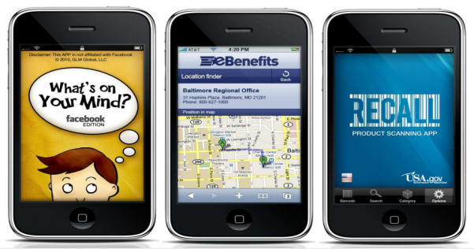

**Search Engine Optimization (SEO)**

**Social Media Integration**

**Support & Services**

**Full List of Corporate Capabilities**

* Web design ,development
* Mobile Design, development
* Search engine optimization (SEO)
* Web usability testing, analysis, implementation
* Dynamic database applications (My-SQL) development
* Website optimization (including photo, image, animation, graphics optimization)
* E-commerce solutions (shopping carts, secure checkout, payment gateways)
* SSL Integration and authentication
* Dashboard design and implementation
* Content management system design, development, customization, implementation
* Web content development, copy writing, editing, content management, archival
* Systems training and support (via telephone, e-mail, web conference, and in-person)
* Intra-net design, development, implementation, support
* Social media integration and platform development
* Multimedia library implementation and integration
* Drupal/Magneto/Joomla/WordPress/X- Cart/OsCommerce/etc..development, implementation, modification, and maintenance
* PHP
* Android/Android
* MySQL
* Javascript
* jQuery
* HTML/CSS
* C#
* VB
* ASP.NET
* SharePoint
* Site Core
* Visual Studio
* .NET
* SQL Server
* 3D animation
* WordPress
* Photography, photo editing, photo manipulation
* Videography, video editing, video production
* Illustration
* Web analytics

**2. STATEMENT OF WORK**:Global marketing platform for leisure companies which enables them to use high end marketing and management technology at a guaranteed low cost, gaining more control over their companies processes and commercial activities, and supporting them to actively grow their own businesses first online platform that charges low prices for her services and guarantees through a smart contract,Many platforms, moreover most platforms increase their prices dramatically once they are successful, and the majority of professional users are “hooked “ to the service when a large portion of their business is generated by the platform. And this happens always, while the success primarely has come by the support from it’s users and their smart use of the platform.wants to do fair and transparant business, where the leisure market can rely on us and the users can have maximum benefit of their own success.

**Scope**:The scope of the decentralized find engine that enables consumers to find new, surprising and inspiring leisure activities by using state of the art blockchain technology.

**3. PROJECT DESCRIPTION :-**

**Unique device:**

**Music Regonization:**

**Music**

**Video**

**Auto**

**Sports**

**Company**

**CRM:**

* CRM en Dossiers
* CRM en dossiers
* CRM en financieel
* CRM en HRM

Offer:

**Professional editie:**

Venaf 25-p/m

**Team editie:**

Venaf 50-p/m

**Enterprise editie:**

Venaf 150-p/m

**Dashboard:**

* Incentive program with customers
* Ticket service/reservation
* Planning staff
* Own Website with e-mail marketing application
* Juke box
* Review from customers appilcation
* Financial overview
* Find engine
* Customer database

**5. OUR DEVELOPMENT MODEL / PROCESS:**

Our process is very client interactive. At each phase we interact with client for the betterment of the project. Our Process has 5 phases:--

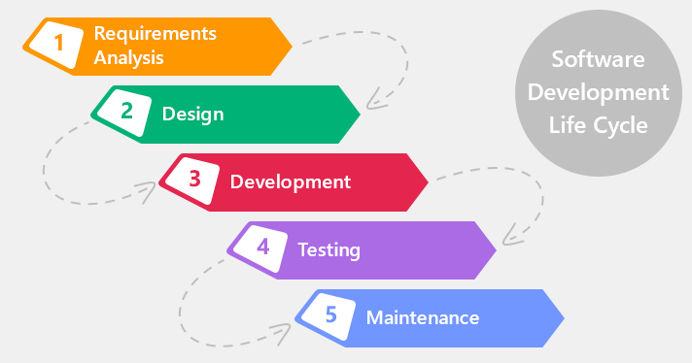

* Analysis
* Designing
* Developing
* Testing
* Deployment and Maintenance

**Analysis:--**

We start the process with analysis , In this we analyses and understand the client's problem and perspective. In these we send a document of Project Planning to client for his approval. This document describe the project as per our understanding and if client want any changes in the document they can correct and suggest us.

**Designing:--**In designing phase , We create the UI / UX design in PSD(Photoshop document) and UI flow. We also send these designs to client for their approval and any changes to this are also invited.

**Development:--**

In these phase we do coding and develop application. In these phase also we interact with client on weekly basis to give the status of development.

**Testing:--**

In testing we test the developed application according to user's perspective. After assuring the quality of software , It is ready for deployment.

**Deployment / Maintenance:--**

In these phase , we deploy the application on server. We also provide Maintenance to the application for a particular time period after the deployment.

**7. TEST OBJECTIVES:**

Installation Testing

System Integration Test (SIT)

Network testing

User Acceptance Test (UAT)

Test Approach

There are 2 categories of testing, **Functional Testing and Technical Testing.**

* Functional Testing
* Technical Testing

**Types of Testing:** Detail description of testing are as follows.

* **Functional Testing:**

|  |  |  |
| --- | --- | --- |
| Testing Type | Descriptions | |
| UR – User Requirements and Procedures | | Checking the Functional requirement and procedures and process |
| ER – Error Response | | Check every error and do proper validation and verification |
| FN – Function | | INFOGRAINS will done all functional testing to determine the effectiveness of every function |
| II – Interface & Inter system | | Checking the all interface and Inter system functionality |
| RN – Regression Testing | | Will be properly done for all functionality |
| TR – Transaction Flow | | Will do proper transaction flow of every flow of the function within the project. |

* **Technical Testing:** The following testing types are part of Technical Testing and those applicable in the SIT are marked as “Yes”.

|  |  |
| --- | --- |
| Testing Type | Descriptions |
| IN – Installation Verification | YES |
| BO- Batch Cycle and Operations | YES |
| SA – Security Acceptance | YES |

**8.SUPPORT METHODOLOGY:**

**Scope of Support:**

Our Support services include:

* Bug fixes
* Technical, Functional and Operational support
* Root cause analysis
* Enhancements
* MIS Reports
* Support Documentation

All these services are effectively delivered remotely through continuous interactions with the customer to get an insight into the problem space. Internal processes for providing support services to meet stringent service levels.

Mode of communication:

* IM
* Phone Call
* Email

**Support Process:**

The Support Process will start after the delivery of the Source code of the project to Customer for the Time period of three month. INFOGRAINS will assign the Support task for the every team member of Support Team. (Mention Below). Process we follow:

* Assigned Team for Support.
* Mentioning the task for Every Team members.
* Analysis of Task done for Every Team member.
* Setting up the priority for every Task.
* INFOGRAINS will properly looking for the every milestone delivery.
* We will use Project Management System for tracking of every project.

**Critical Issues(Show Stoppers):**INFOGRAINS help Customer to solve out any critical issue raised by the customer at any point. Any of the Critical Issues arise than client has to inform INFOGRAINS by Call or by the Email.

**Support Hours:**

INFOGRAINS provide 2-3 hours per day (Monday – Friday) support services. give time period will be change as per the issue raised.

**Support Options:**

* On call Support
* Off-site using INTERNET and network facilities
* Direct login to client environment through VNC or team viewer client
* Easy to maintain and provide application support

**Warranty Support:**

Warranty Support would be of three month only for the bug fixing.

**9. QA METHODOLOGY:**

Our singular focus on quality management and testing combined with our expertise in the development life cycle enables us to deliver practical services that drive improvement to the way you build and manage your enterprise applications and IT infrastructure. We engage QA team right from the start of the project to ensure the quality of the solutions we offer. It helps us to identify the variation from the specification at the initial stage that eventually save efforts and cost. We offer all Quality Assurance and Testing services with help of our experience and expertise by understanding the client and investment Planning, prepare quality standard, test scenario.

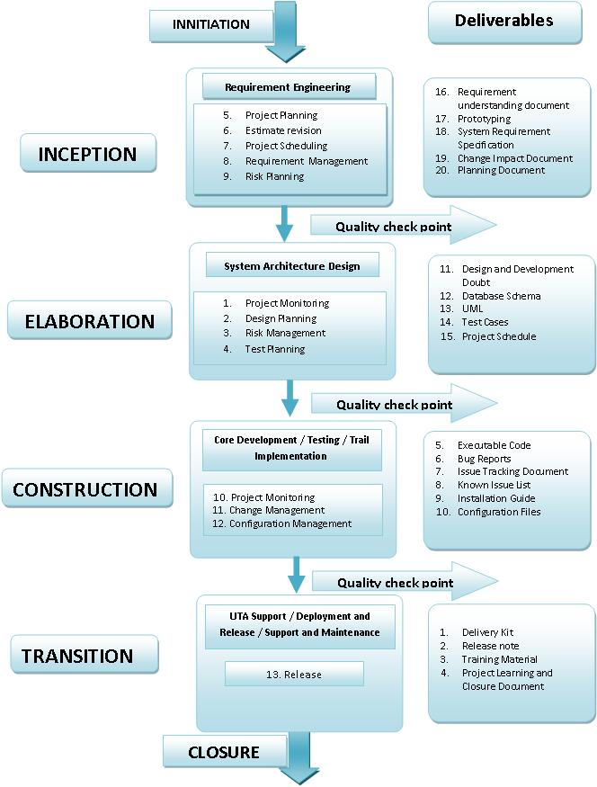

**10. TECHNICAL DOCUMENTATION:**-

* System design documents
* Class diagram
* Test Cases document
* User Manual & Help documents

**11. DELIVERY TIME** :-With the agreed upon Scope for the above Proposal For “  **Game**”we will completethe project in  **– working days ( need to discuss more). Infograins software solutions Pvt. Ltd.** agrees to deliver the complete project in working days from the date of start.

**12. COST ESTIMATION:-** Based on the nature of the project and above solutions the estimated cost to develop this website will be**: --**

**Maintenance: -** We will decide in final discussion.

**13. PAYMENT TERMS & CONDITION:-**

We shall change the terms if required in any condition.

* 30% as an upfront
* 50% will be break down in two different milestones
* 20% once application will successfully upload to Play store

**14. Company Informations:-** For more details you can contact us to our contact number.

|  |  |
| --- | --- |
| **Company Name** | Infograins Software Solutions Pvt. Ltd. |
| **Address** | Tower 61,302, 3rd Floor, opposite mata Gujri, Girls College, bhawarkua, AB Road, Indore, Madhya Pradesh, India |
| **Contact Number** | 0731-4258071 |
| **Contact Email** | info@infograins.com |