

**- - Proposal For “****SehatEnak” - -**

**Content:**

1. **Introduction**
2. **Statement of Work**

1. **Scope**
2. **Project Description**

**5)**Technical Description****

1. **Roles and Skills**
2. **Our Development Model / Process**
3. **Test Objectives**

1. **Support Methodology**

1. **QA Methodology**
2. **Technical Documentation**
3. **Delivery Time**
4. **Cost estimation**
5. **Payment terms & conditions**
6. **Company Information**

**1. INTRODUCTION:**

Infograins is a metropolitan area-based web and Mobile application development agency that specializes in the design, development, and search engine optimization (SEO) of government and non-profit Organization websites, easy-to-use (user-friendly) content management systems (CMS) and Mobile application (Iphone & android). Our goal is to help organizations cost-effectively meet and exceed their website and mobile application goals and objectives. Founded in 2012, Infograins Software Solutions was created to offer innovative web solutions, mobile applications development and internet marketing services to growing and mid-sized business. Since the beginning, the company successfully serving to our UAE, USA, India, Australia and UK clients.

* **Our Corporate Capabilities:**

**Web Design, Development, Usability:**

Perhaps our greatest strength is identifying, understanding, and cultivating the target web visitor segments. Our approach to user interface (UI) design incorporates human factors engineering, ergonomics, accessibility, Section 508compliance and web usability. We believe that user-focused design is extremely important to a successful interface. It takes quite a bit of thinking and effort to make complicated things simple, easy, intuitive, and meaningful. We take an outside-in perspective to create excellent user experiences for both web and mobile visitors.

**Content Management System (CMS):**

We believe that database-driven content management systems (CMS) represent one of the greatest breakthroughs in the development and proliferation of the World Wide Web. We focus on designing and delivering easy-to-use, search engine friendly content management systems that empower our clients to take control of their content and outreach programs.

**Mobile Design, Development (Android & iOS)**

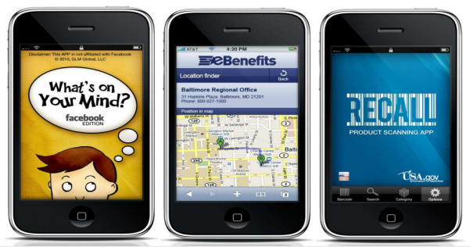

**Search Engine Optimization (SEO)**

**Social Media Integration**

**Support & Services**

**Full List of Corporate Capabilities**

* Web design ,development
* Mobile Design, development
* Search engine optimization (SEO)
* Web usability testing, analysis, implementation
* Dynamic database applications (My-SQL) development
* Website optimization (including photo, image, animation, graphics optimization)
* E-commerce solutions (shopping carts, secure checkout, payment gateways)
* SSL Integration and authentication
* Dashboard design and implementation
* Content management system design, development, customization, implementation
* Web content development, copy writing, editing, content management, archival
* Systems training and support (via telephone, e-mail, web conference, and in-person)
* Intra-net design, development, implementation, support
* Social media integration and platform development
* Multimedia library implementation and integration
* Drupal/Magneto/Joomla/WordPress/X- Cart/OsCommerce/etc..development, implementation, modification, and maintenance
* PHP
* Android/Android
* MySQL
* JavaScript
* j Query
* HTML/CSS
* C#
* VB
* ASP.NET
* SharePoint
* Site Core
* Visual Studio
* .NET
* SQL Server
* 3D animation
* WordPress
* Photography, photo editing, photo manipulation
* Videography, video editing, video production
* Illustration
* Web analytics

**2. STATEMENT OF WORK:**we will make online platform for kitchen organization. This will be web and mobile application.

**3. SCOPE:**Customer order for food and get it delivered Accordingly and also reduce the long queues of customer at the counter ordering for food.

**4. PROJECT DESCRIPTION :-** There will be 4 user in this application.

* **User**
* **Manager(kitchen)**
* **Driver**
* **Admin**

Login:login with registered email and password.

Login:login with social media account(Facebook,email,Google)

Sign-up:

* Patient name
* Email
* Contact number
* Address
* Password

user profile:

* View Profile
* Edit profile
* change profile image
* Change address
* Change mobile number

Search: location or city

* Food type
* Restaurant

view order history

* Order details
* Pre order list

Track Driver

* Location

On call

Payment:

* Cash on Delivery
* Credit Card
* Debit Card
* I-Banking
* ATM

Notification:

Confirmation order

Received order

* Sms
* Email
* whats app number
* Review/Ratings
* contact us
* Logout

**Manager Account:**

Login:Login with Regitered email and password and social media account(facebook,Email,Google+)

Signup:

* First name
* Last name
* kitchen name
* Address
* Email
* Contact number
* password

Manager Profile:manager can Edit Profile

Change mobile number

change address

view order:

* pre order
* confirm order
* Create order
* food type
* food
* Drinks

Driver Details:

* Driver name
* Driver mobile number

Notiication:Recevied new order notification.

Manage order

* Accept order
* Reject order

history

* Order history
* Payment history
* about us
* Contact us
* Logout

**Driver Account:**

Login:login with Registered email and password and social media account(facebook,Email,Google+)

Sign up:

* First name
* Last name
* contact number
* Email
* Password

Driver Profiles:Driver can edit Profile

* change profile image
* change mobile number
* change vechicle number

Notification:new order notification

* New order details:
* Accept
* Reject
* kitchen name
* order title
* order id
* Pick up address
* dropping address

Order Delivery Status:

* Pickup order
* Dropping order
* complete order
* Pending order
* contact us
* Logout

**Admin Account:**

login:login with registered email id and password.

Sign-up:

* Name
* Email id
* mobile number
* Password

admin Profile:

* edit profile

admin:manage the user manger and driver account.

* View all registered user profile
* View all registered manger profile
* View all registered driver profile
* Delete user profile
* Delete manager profile
* Delete driver profile
* Manage food items
* Manage all food product
* Manage each kitchen
* Delete kitchen
* About us
* Contact us
* FAQ
* Logout

**5.Technical Description:**We will use Client-side and server-side technology to make this project more productive and user friendly.

**1. Web:-** Admin Back end technology arelisting below

**Server Side (Back end )** :- We use server side technology which produce a response for client side request to the website. We use server side like **Apache Server, MySQL, PHP.**

**Client Side (Front end) :-** We use client side technology which request to the server for specific action perform using **HTML, CSS, JavaScript, J Query, Bootstrap etc.**

**2. Android:-** we will use Java technology for back end technology, screens will be designed and send for the approval before working on it.Both Front-end and Back-end developers collaborate parallel for the development of application. Android code standard will be used with the latest version of Android Studio IDE 3.0.1. Application will support all the resolutions Small, Medium, Large and Extra Large and will be developed for Android OS 4.4 Kit-kat and above.

3.**iOS:-** Application will be developed using NATIVE Application Development for iOS. iOS Coding standards will be followed with the code written Swift 4 (Latest version), will be developed in Swift 4 on Xcode tool. Application will be developed for i Phone iOS 10.0 version(s) and above and it will support all the resolutions Small, Medium, Large and Extra Large.

**6. Roles and Skills:-** This project will be develop under the experienced resources, they are

|  |  |  |  |  |
| --- | --- | --- | --- | --- |
| **Roles** | **Name** | **Year of Experience** | **Skills** | **Contact Email** |
| Project Manager | Ajay Shukla | 8 Years | PHP, Java, Swift, Ionic | ajay@infograins.com |
| Web Designer | Hukum Khede | 4 Years | Html5, CSS3, Bootstrap, JavaScript | hukum@infograins.com |
| Hybrid Developer | Archana Jaiswal | 4 years | Ionic, Javascript,HTML, CSS, | archana@infograins.com |
| Web Developer | Hemant Anjana | 4 Years | PHP, WordPress, Codeignitor | hemantanjana@infograins.com |
| Q.A | Krishna Thakur | 5 Years | Manual and Automation | krishna@infograins.com |

**7. OUR DEVELOPMENT MODEL / PROCESS:**

Our process is very client interactive. At each phase we interact with client for the betterment of the project. Our Process has 5 phases:--

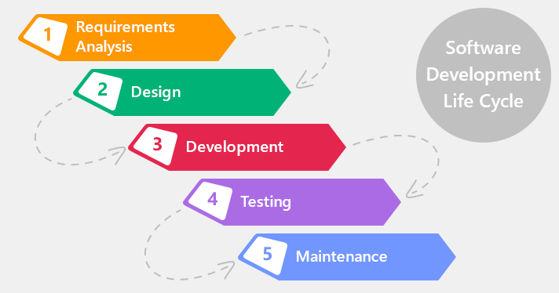

* Analysis
* Designing
* Developing
* Testing
* Deployment and Maintenance

**Analysis:--**

We start the process with analysis , In this we analyses and understand the client's problem and perspective. In these we send a document of Project Planning to client for his approval. This document describe the project as per our understanding and if client want any changes in the document they can correct and suggest us.

**Designing:--**In designing phase , We create the UI / UX design in PSD(Photoshop document) and UI flow. We also send these designs to client for their approval and any changes to this are also invited.

**Development:--**

In these phase we do coding and develop application. In these phase also we interact with client on weekly basis to give the status of development.

**Testing:--**

In testing we test the developed application according to user's perspective. After assuring the quality of software , It is ready for deployment.

**Deployment / Maintenance:--**

In these phase , we deploy the application on server. We also provide Maintenance to the application for a particular time period after the deployment.

**8. TEST OBJECTIVES:**

Installation Testing

System Integration Test (SIT)

Network testing

User Acceptance Test (UAT)

Test Approach

There are 2 categories of testing, **Functional Testing and Technical Testing.**

* Functional Testing
* Technical Testing

**Types of Testing:** Detail description of testing are as follows.

* **Functional Testing:**

|  |  |  |
| --- | --- | --- |
| Testing Type | Descriptions | |
| UR – User Requirements and Procedures | | Checking the Functional requirement and procedures and process |
| ER – Error Response | | Check every error and do proper validation and verification |
| FN – Function | | INFOGRAINS will done all functional testing to determine the effectiveness of every function |
| II – Interface & Inter system | | Checking the all interface and Inter system functionality |
| RN – Regression Testing | | Will be properly done for all functionality |
| TR – Transaction Flow | | Will do proper transaction flow of every flow of the function within the project. |

* **Technical Testing:** The following testing types are part of Technical Testing and those applicable in the SIT are marked as “Yes”.

|  |  |
| --- | --- |
| Testing Type | Descriptions |
| IN – Installation Verification | YES |
| BO- Batch Cycle and Operations | YES |
| SA – Security Acceptance | YES |

**9.SUPPORT METHODOLOGY:**

**Scope of Support:**

Our Support services include:

* Bug fixes
* Technical, Functional and Operational support
* Root cause analysis
* Enhancements
* MIS Reports
* Support Documentation

All these services are effectively delivered remotely through continuous interactions with the customer to get an insight into the problem space. Internal processes for providing support services to meet stringent service levels.

Mode of communication:

* IM
* Phone Call
* Email

**Support Process:**

The Support Process will start after the delivery of the Source code of the project to Customer for the Time period of three month. INFOGRAINS will assign the Support task for the every team member of Support Team. (Mention Below). Process we follow:

* Assigned Team for Support.
* Mentioning the task for Every Team members.
* Analysis of Task done for Every Team member.
* Setting up the priority for every Task.
* INFOGRAINS will properly looking for the every milestone delivery.
* We will use Project Management System for tracking of every project.

**Critical Issues(Show Stoppers):**INFOGRAINS help Customer to solve out any critical issue raised by the customer at any point. Any of the Critical Issues arise than client has to inform INFOGRAINS by Call or by the Email.

**Support Hours:**

INFOGRAINS provide 2-3 hours per day (Monday – Friday) support services. give time period will be change as per the issue raised.

**Support Options:**

* On call Support
* Off-site using INTERNET and network facilities
* Direct login to client environment through VNC or team viewer client
* Easy to maintain and provide application support

**Warranty Support:**

Warranty Support would be of three month only for the bug fixing.

**10. QA METHODOLOGY:**

Our singular focus on quality management and testing combined with our expertise in the development life cycle enables us to deliver practical services that drive improvement to the way you build and manage your enterprise applications and IT infrastructure. We engage QA team right from the start of the project to ensure the quality of the solutions we offer. It helps us to identify the variation from the specification at the initial stage that eventually save efforts and cost. We offer all Quality Assurance and Testing services with help of our experience and expertise by understanding the client and investment Planning, prepare quality standard, test scenario.

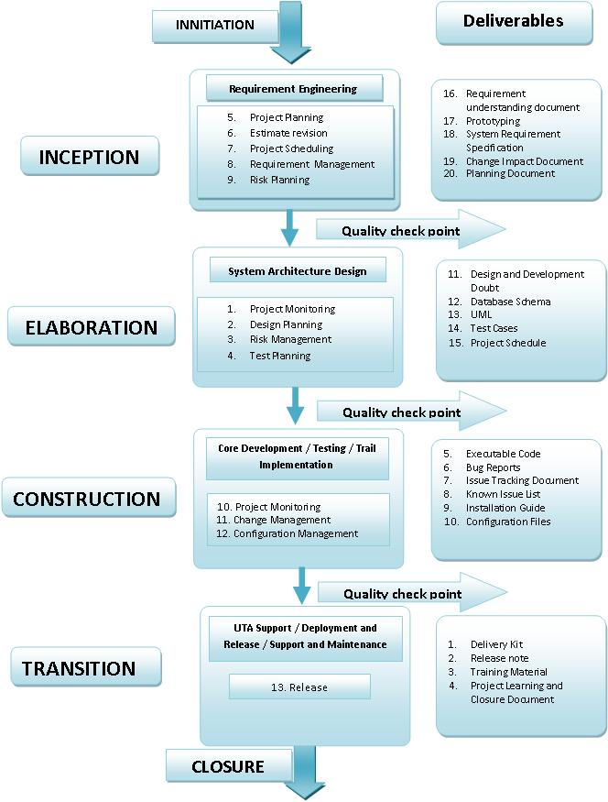

**11. TECHNICAL DOCUMENTATION:**-

* System design documents
* Class diagram
* Test Cases document
* User Manual & Help documents

**12. DELIVERY TIME** :-With the agreed upon Scope for the above Proposal For **“sehat enak”.Infograins software solutions Pvt. Ltd. agrees to deliver the complete project in working days from the date of start.**

**13. COST ESTIMATION:-** Based on the nature of the project and above solutions the estimated cost to develop this website will be**: --**

**Maintenance: -** We will decide in final discussion.

**14. PAYMENT TERMS & CONDITION:-**

We shall change the terms if required in any condition.

* 30% as an upfront
* 50% will be break down in two different milestones
* 20% once application will successfully upload to Play store

**15. Company Informations:-** For more details you can contact us to our contact number.

|  |  |
| --- | --- |
| **Company Name** | Infograins Software Solutions Pvt. Ltd. |
| **Address** | Tower 61,302, 3rd Floor, opposite mata Gujri, Girls College, bhawarkua, AB Road, Indore, Madhya Pradesh, India |
| **Contact Number** | 0731-4258071 |
| **Contact Email** | info@infograins.com |