The instructions below show how to create the menu tree PDF files from the HTML files generated using make based on the receipt in Makefile.

The PDF files can be generated using Adobe Acrobat or Firefox. The resulting PDFs differ regarding the font size.

The last section shows how to remove the white margin.

Acrobat Instructions
http://mnemonic.de.db.com/menu/cryptool-menu-en.html
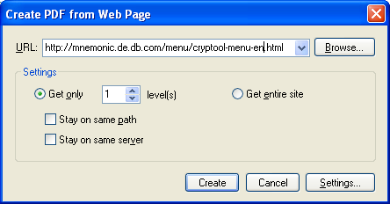
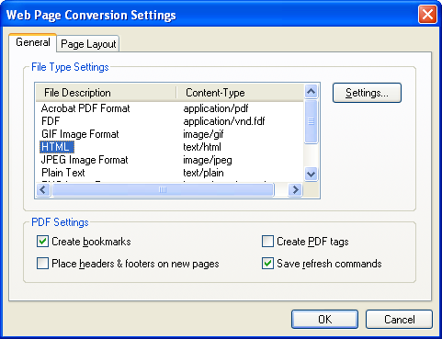
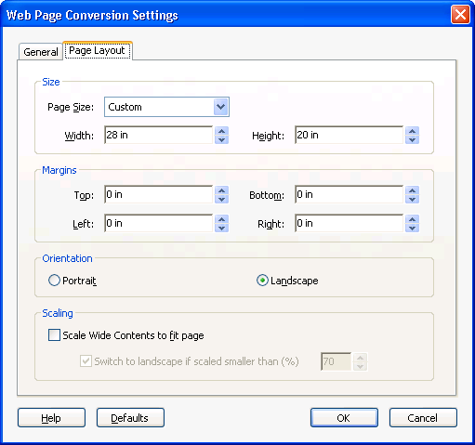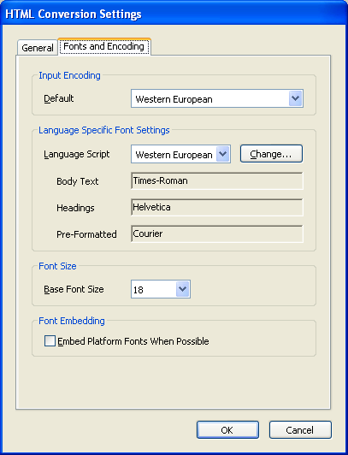

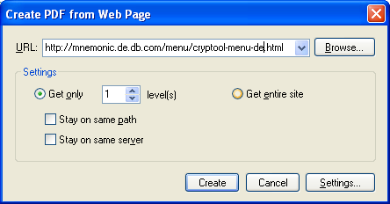
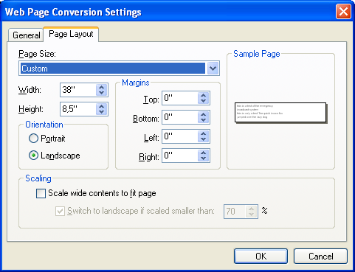

Firefox Instructions
firefox *.html
^P (Print), Print to File
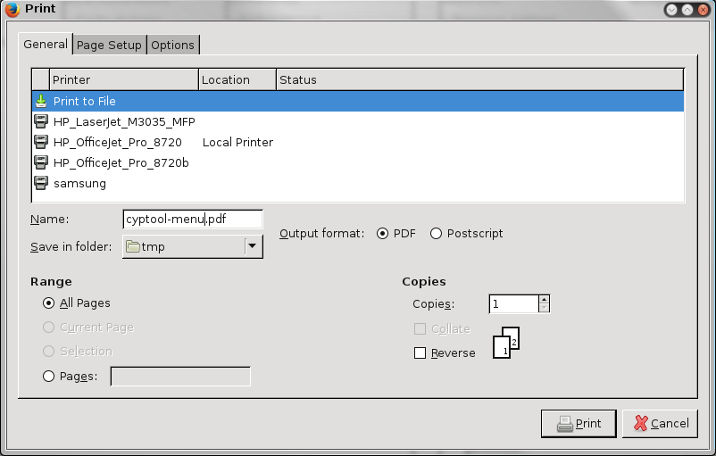
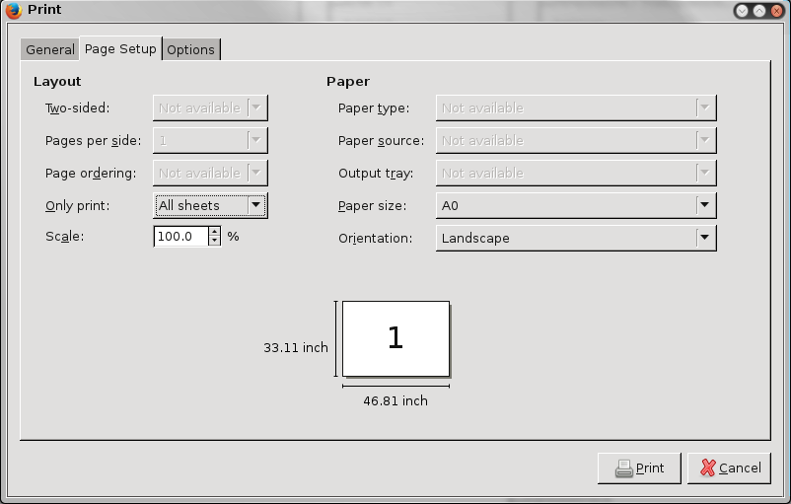
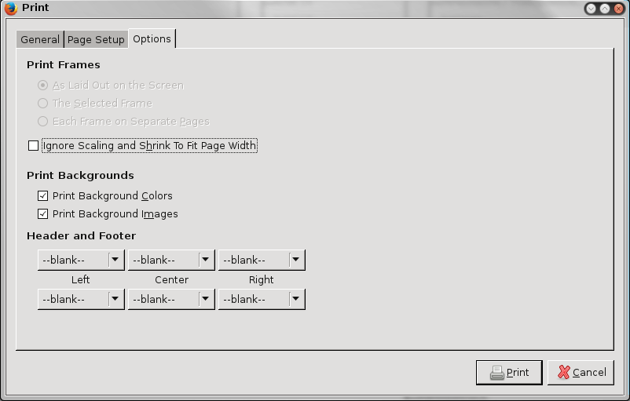
Repeat for all languages

Removing the Margin
pdfcrop --clip cryptool-menu-en.pdf figures/cryptool-menu-en.pdf
pdfcrop --clip cryptool-menu-de.pdf figures/cryptool-menu-de.pdf

