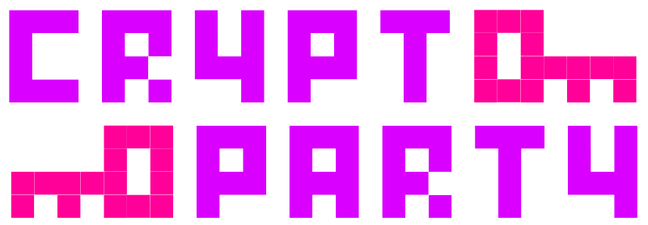

Assembly

Come talk to us at the about:freedom Cluster

Sessions


Day 1 -- 27th
“How To Survive 35C3” CryptoParty
16 – 19 @ Lecture Room M3

Day 4 -- 30th
Nextcloud Install Party
11.30 – 13.30 @ Lecture Room M2


Mastodon CryptoParty@mastodon.earth
Twitter @CryptoParty_
Web https://cryptoparty.in/35c3

