# Exam: DevOps #2 2022.04 (2022.05.29)

### Main Goal

You are expected to utilize all or most of the studied products and technologies and create an infrastructure with **three** hosts. Their parameters and distributions are up to you to decide *(considering your free resources and the actual distribution of components)*

The **emphasis** should be on **features** usage **demonstration** versus optimal solution

The goal is to have the whole **infrastructure** as a **file** or **set** of **files**

Your solution should look and follow this structure:

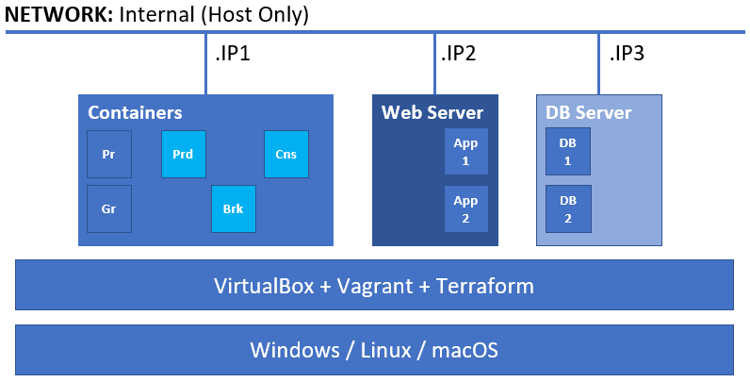

### Rules and Guidelines

Be sure to **follow** the **naming** **conventions** specified in the checklist and in project source files

The tasks execution order should not be derived from the order in which they are listed below. Please note that there are tasks that depend on the successful completion of one or more other tasks

### Tasks

#### Infrastructure as Code (19 pts)

*You are expected to demonstrate knowledge working with* ***Terraform****,* ***Vagrant*** *and* ***VirtualBox***

##### Level #1

*Depending on the platform you use you are expected to create the following:*

* (T101, 3 pts) Create a set of **three** machines *(the distribution is up to you)*. Most of the provisioning is expected to be done with the help of configuration management tools *(there is a separate set of tasks)*

##### Level #2

*Using* ***Terraform*** *(either on the host or inside the* ***Containers*** *machine) you are expected to implement the following:*

* (T102, 4 pts) Spin up an **Apache Kafka** or **RabbitMQ** *(it is up to you to decide)* single-node cluster
* (T103, 2 pts) Enable the monitoring of the single-node cluster *(either by enabling a plugin or by running additional container)*
* (T104, 2 pts) Spin up a producer container for the **exam** topic/exchange by using the appropriate repository
  + for Apache Kafka – <https://hub.docker.com/repository/docker/shekeriev/kafka-prod>
  + for RabbitMQ – <https://hub.docker.com/repository/docker/shekeriev/rabbit-prod>
* (T105, 2 pts) Spin up a consumer container for the **exam** topic/exchange by using the appropriate repository
  + for Apache Kafka – <https://hub.docker.com/repository/docker/shekeriev/kafka-cons>
  + for RabbitMQ – <https://hub.docker.com/repository/docker/shekeriev/rabbit-cons>
* (T106, 3 pts) Spin up a **Prometheus** instance and set it to collect data from the single-node cluster
* (T107, 3 pts) Spin up a **Grafana** instance and set it to use the **Prometheus** instance as a data source

*The number and structure of the configurations to spin up the above is up to you to determine*

#### Configuration Management (27 pts)

*You are expected to demonstrate knowledge working with two of the studied configuration management solutions. It is up to you to select which two*

##### Configuration Management #1

* (T201, 3 pts) Do a basic (installed and running) installation of **Docker** on **VM1**
* (T202, 1 pts) The **user in use** (**vagrant** or another one) must be a member of the **docker** group

##### Configuration Management #2

* (T203, 4 pts) Do a basic (installed and running) installation of **Apache** (+PHP +libraries) on **VM2**
* (T204, 3 pts) Add two virtual hosts by port – **8081** and **8082**
* (T205, 4 pts) Deploy both applications (**app1** and **app2**) files to the corresponding folders of the virtual hosts
* (T206, 3 pts) Do a basic (installed and running) installation of **MariaDB** on **VM3**
* (T208, 3 pts) Make sure the service is listening on all interfaces (should be accessible from **VM2**)
* (T207, 4 pts) Deploy applications’ databases
* (T209, 2 pts) Make sure that **VM2** and **VM3** can reach each other by name

*Applications can be found here:* [*https://github.com/shekeriev/do2-app-pack*](https://github.com/shekeriev/do2-app-pack)

*Deploy the not as containers but following the classical approach*

#### Monitoring (3 pts)

*You are expected to demonstrate basic knowledge working with both* ***Prometheus*** *and* ***Grafana***

* (T301, 3 pts) Create a simple visualization of a metric of the selected middleware

#### Applications (11 pts)

*You are expected to manage to do a successful deployment of the three applications*

* (T401, 5 pts) Working pair of producer and consumer
* (T402, 3 pts) Working web application #1
* (T403, 3 pts) Working web application #2

### Proof

Prepare a compressed archive with the files of your solution and any supporting files and upload it on the site

Make sure that you include at least all configuration files, a brief description of the workflow and pictures of important moments/achievements (at least the state of the applications). If there are any manual steps, you must describe them in free form (including commands if any) in an additional document

Make sure that all temporary (created by applications like vagrant, terraform, etc.) files are not included

In general, any hint (in written and/or with pictures) on what you do and why will be more than welcome