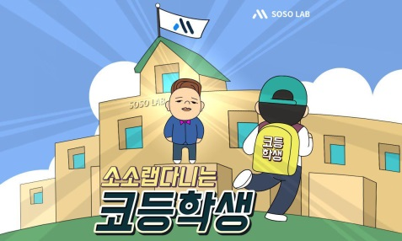**코등학생**

**HWANG JUN HEON**  
Seoul, Korea

Telephone: +82 10-8107-1111

Email: [hwangmc88@gmail.com](mailto:hwangmc88@gmail.com)

Homepage: [**https://coinairdrop.io**](https://coinairdrop.io)

**Cryptocurrency Influencer in Korea**

**EDUCATIONS:**

**Yonsei University** (Bachelor's degree) March 2007 – February 2014  
50, Yonsei-ro, Seodaemun-gu, Seoul, Korea  
Major: Computer Science

**WORK EXPERIENCES:**

**Samsung Electronics** August 2014 - Present  
IT & Mobile Communications

Next Generation Communications Business Team

Assistant Engineer

**LANGUAGES:**

**Korean**: Maternal

**English**: Intermediate

**COMPUTER SKILL:**

**Microsoft Word** ●●●●●●●●●●●●

**Microsoft PowerPoint** ●●●●●●●●●●●●

**Microsoft Excel** ●●●●●●●●●●●●

**Hangeul** ●●●●●●●●●●●●

**Online Research** ●●●●●●●●●●●●

**ACTIVITIES:**

* Rating ICO, ALTs (Korea Influencer group)

<https://t.me/r>ating_kr

* Becent Community Manager in one month (in Korea, 4219名)

<https://Becent.com>

* OpenKakaoTalk Manager (613名)

<https://open.kakao.com/o/gxwn9aJ>

* Telegram channel Manager (730名)

<https://t.me/blockschool>

https://t.me/coinstudent

* Steemit (218 followers)

<https://steemit.com/@junheony>

* Cryptoleaders news

<http://www.cryptoleaders.net/?site=zone&no=802>

* Naver Blog

<https://blog.naver.com/hwangmc88>

* Telegram Joint manager

<https://t.me/sosocrypto> (5731名)

<https://t.me/tsar77> (1633名)

<https://t.me/GolampN> (987名)

<https://t.me/socialsaveNR> (531名)

<https://t.me/lovejudylee> (2048名)

* SOSO Media Lab press [corps](javascript:endicAutoLink('corps');)

<https://www.sosolab.co.kr/1627/>

<https://www.sosolab.co.kr/1608>

<https://www.sosolab.co.kr/1464>

<https://www.sosolab.co.kr/1152>

<https://www.sosolab.co.kr/2290>

<https://www.sosolab.co.kr/1890>

<https://www.sosolab.co.kr/2344>

(SOSO - Korean Famous Youtuber)

<https://www.youtube.com/channel/UC7PcPe3We3JCtjPYdwtCoSg>

* CoinView Crypto Application column

<https://itunes.apple.com/kr/app/%EC%BD%94%EC%9D%B8%EB%B7%B0-%EB%B9%84%ED%8A%B8%EC%BD%94%EC%9D%B8-%EC%95%94%ED%98%B8%ED%99%94%ED%8F%90-%EC%95%B1/id1293681262?mt=8>

**ETC**

Networking is active in the Korea Crypto Community, so it has a lot of connections.

Influencer, Exchange manager, Development company, Developer, Trader, etc.