

**Lab Report- 1**

**Course Code: CSE415**

**Course Title: Web Engineering Lab**

**Submitted to:**

Mr. Hasanuzzaman Dipu Assistant Professor Department of CSE

Daffodil International university

**Submitted by:**

Abu Hanzala

ID: 211-15-4022

Section: 60_B2 Department of CSE

Daffodil International University

**Submission Date: 27**.01.2025

INDEX

|  |  |  |
| --- | --- | --- |
| **Index** | **Topic Name** | **Page No** |
| 1 | HTML Introduction | 1 |
| 2 | HTML Title | 1,2 |
| 3 | HTML Headings | 2 |
| 4 | HTML Paragraphs | 3 ,4 |
| 5 | HTML Elements | 4 |
| 6 | HTML Attributes | 5 |
| 7 | HTML Styles, HTML Links | 6 |
| 8 | HTML Images | 7 |
| 9 | HTML Formatting Elements | 8 |
| 10 | HTML Quotation | 9 |
| 11 | HTML Comment | 10 |
| 12 | CSS | 11 |
| 13 | HTML Links | 1 |
| 14 | HTML Image | 12 |
| 15 | HTML Favicon and title | 13 |
| 16 | HTML Table | 15 |
| 17 | HTML List | 16 |
| 18 | HTML Block and Inline element | 17 |
| 19 | HTML Classes | 18 |
| 20 | HTML ID | 18 |

|  |  |
| --- | --- |
| 21 iframes | 19 |
| 22 Semantic Elements for layout | 21 |
| 23 Responsiveness | 22 |
| 24 HTML Forms | 22,23 |
| 25 Html Colors | 10 |
| 26 HTML Div | 16 |
| 27 HTML Filepath | 17 |
| 28 HTML Emoji | 19 |
| 29 HTML Symbol | 19 |
| 30 HTML Vedio | 21 |

HTML Introduction

HTML is the standard markup language for creating Web pages.

**Simple HTML Document**

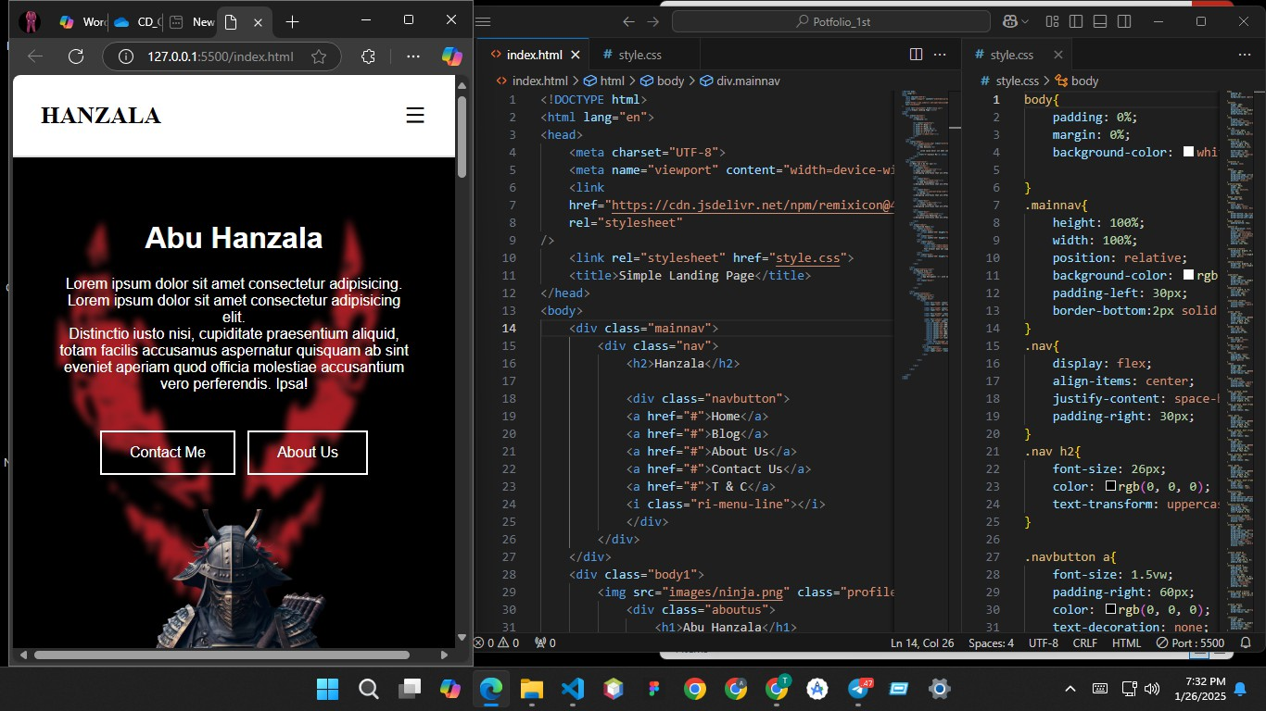

**Page Title:**

The <title> element specifies a title for the HTML page (which is shown in the browser's title bar or in the page's tab)

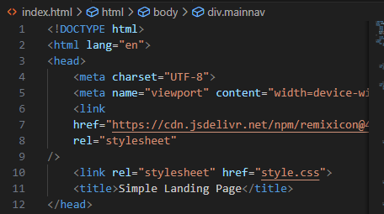

**Output:**

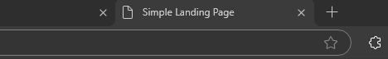

**HTML Heading**

HTML headings are defined with the <h1> to <h6> tags. <h1> defines the most important heading. <h6> defines the least important heading.

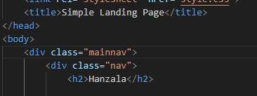

**Output:**



**HTML Paragraph**

The HTML <p> tag represents a paragraph. Every paragraph begins on a new line, and web browsers automatically insert some white space (a margin) both above and below a paragraph.

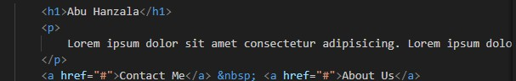

**Output:**

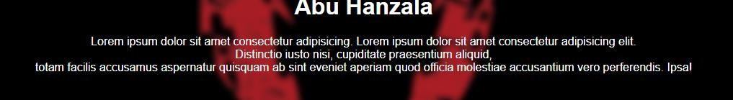

**HTML Elements**

An HTML element is defined by a start tag, some content, and an end tag.

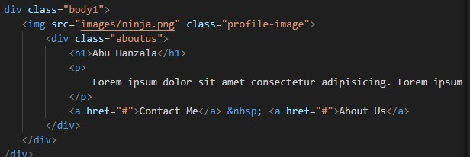

**Output:**

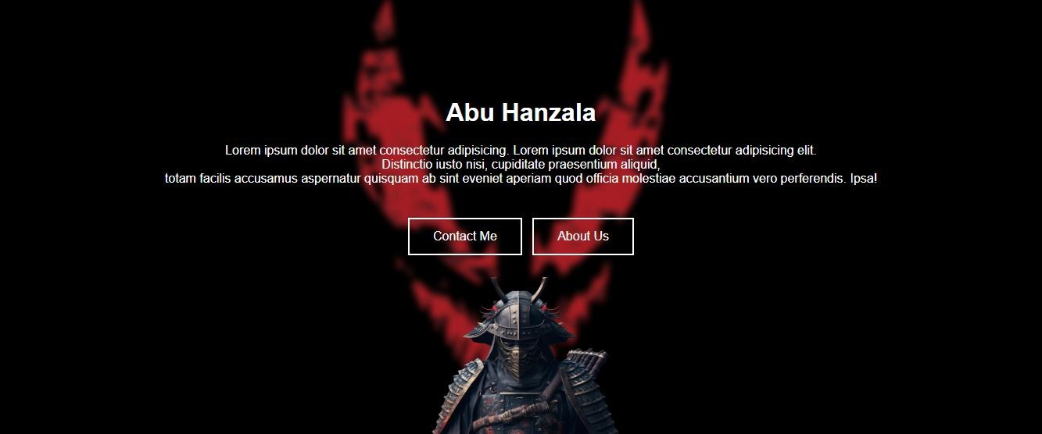

**HTML Styles**

The HTML style attribute is used to add styles to an element, such as color, font, size, and more.

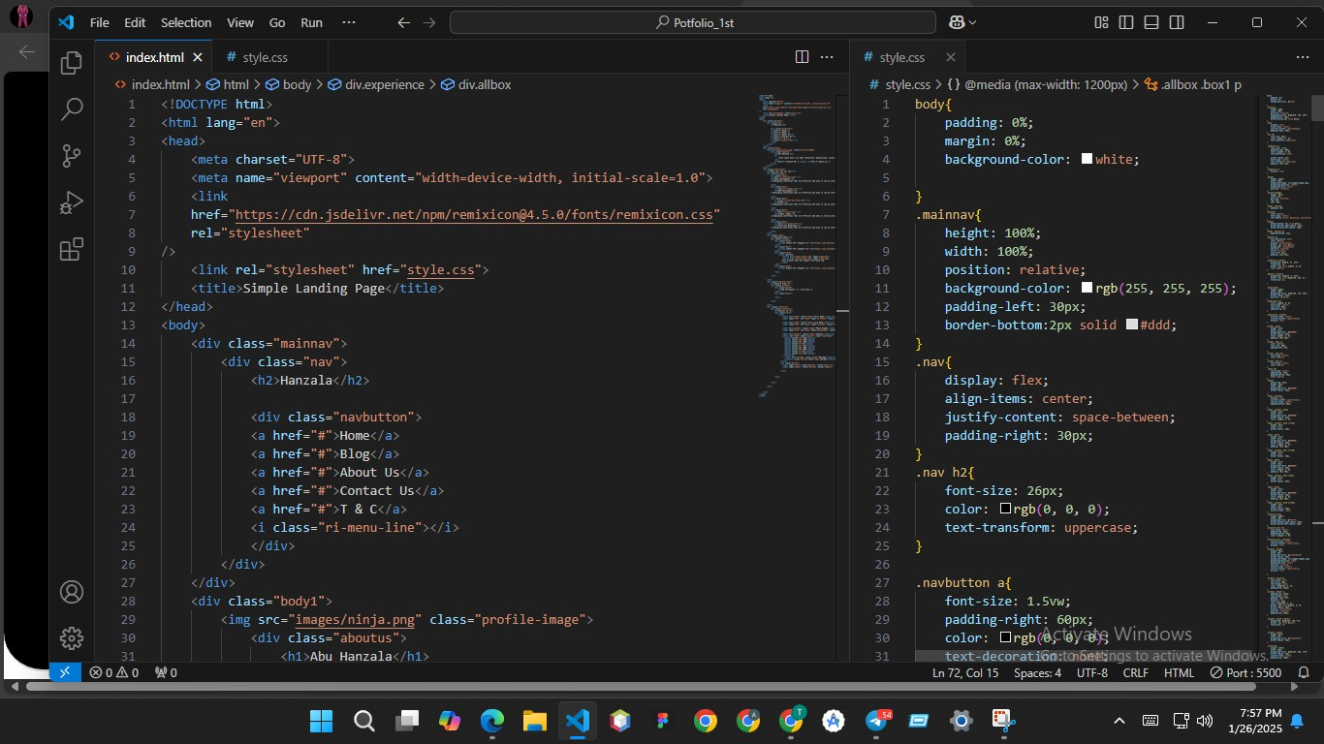

**Output:**

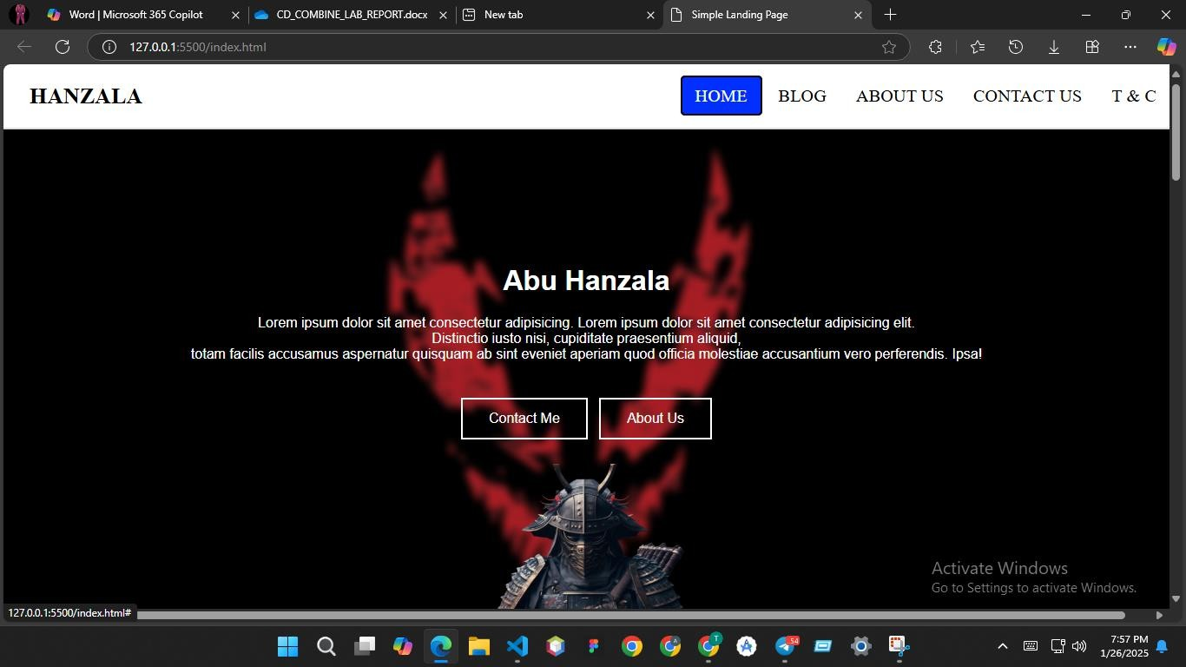

**HTML Text Formatting**

HTML contains several elements for defining text with a special meaning.

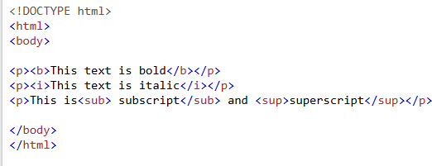

**Output:**

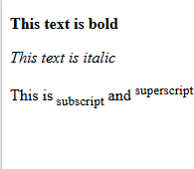

**HTML Colors**

HTML colors are specified with predefined color names, or with RGB, HEX, HSL, RGBA, or HSLA values.

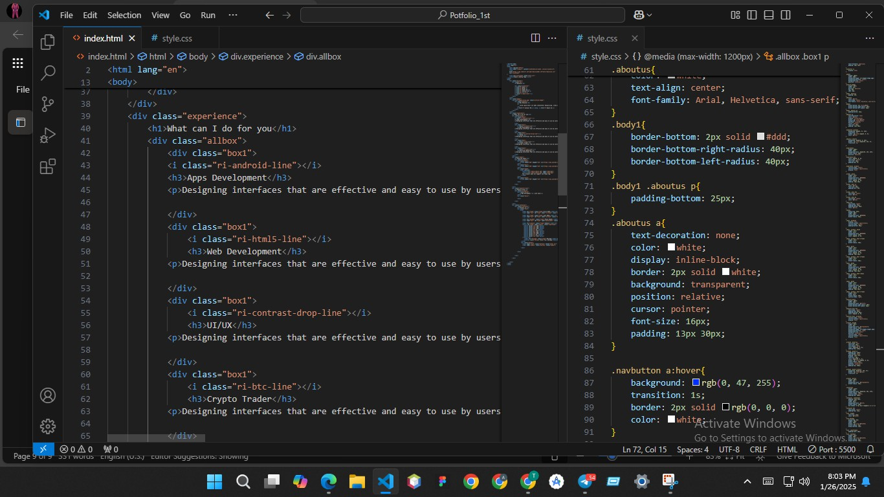

**Output:**

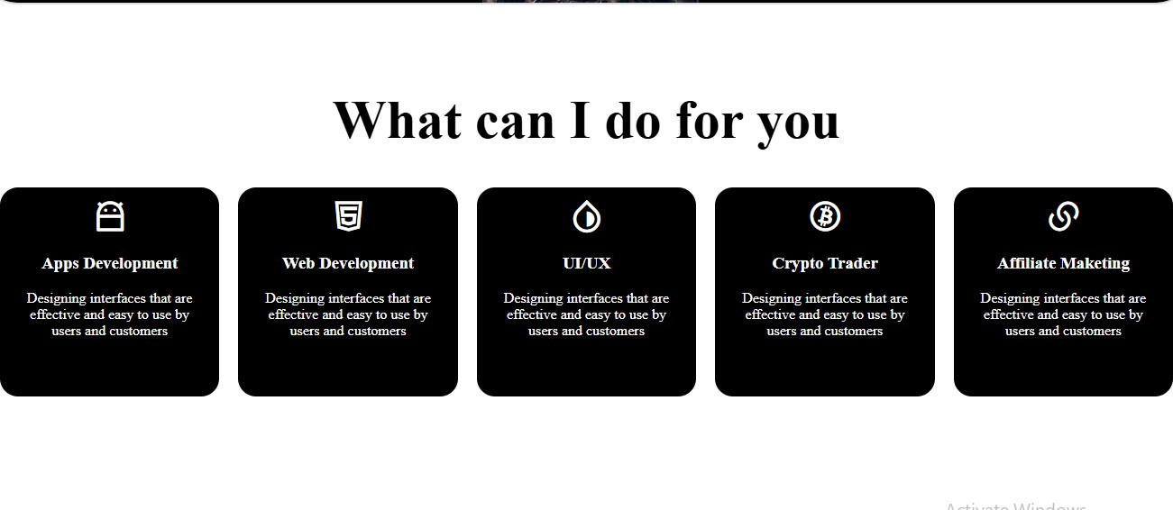

**HTML Styles – CSS**

CSS stands for Cascading Style Sheets. CSS saves a lot of work. It can control the layout of multiple web pages all at once

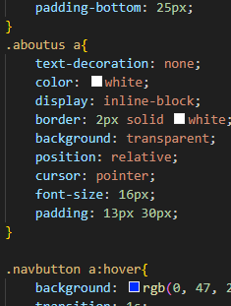

**Output:**

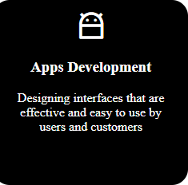

**HTML Links**

Links are found in nearly all web pages. Links allow users to click their way from page to page.

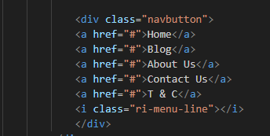

**Output:**



**HTML Images**

Images can improve the design and the appearance of a web page.

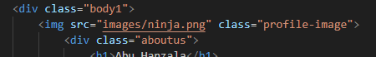

Output:



**HTML Background Images**

A background image can be specified for almost any HTML element.

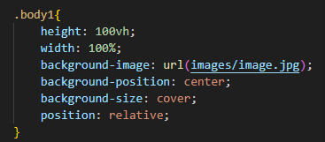

**Output:**

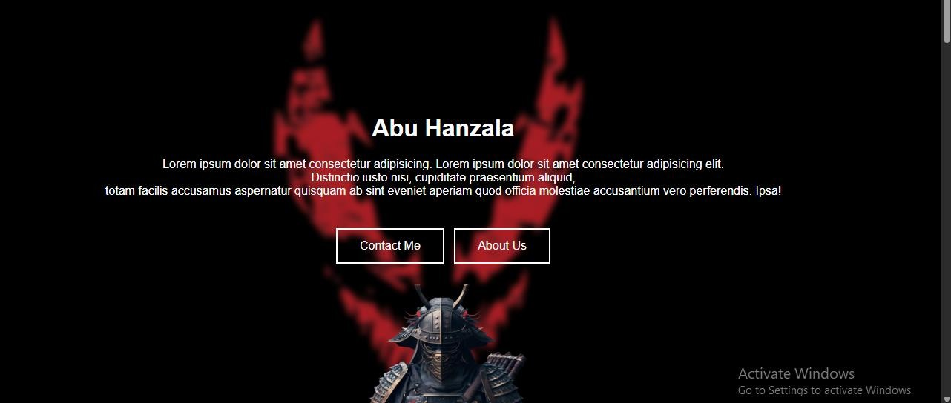

**HTML Tables**

HTML tables allow web developers to arrange data into rows and columns.

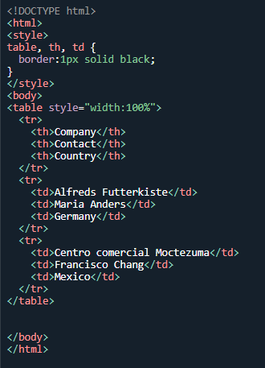

**Output:**

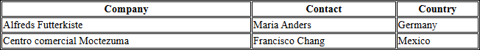

**HTML Lists**

HTML lists allow web developers to group a set of related items in lists.

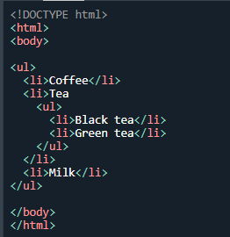

**Output:**

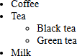

**HTML Block and Inline Elements**

Every HTML element has a default display value, depending on what type of element it is. The two most common display values are block and inline.

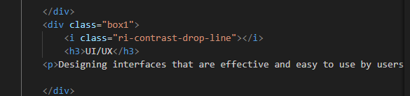

**Output:**

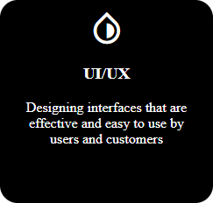

**HTML class Attribute**

The HTML class attribute is used to specify a class for an HTML element. Multiple HTML elements can share the same class.

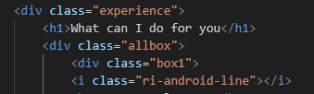

**HTML id Attribute**

**The HTML id attribute is used to specify a unique id for an HTML element. Cannot have more than one element with the same id in an HTML document.**

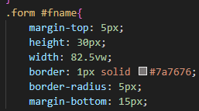

**HTML Iframes**

**An HTML iframe is used to display a web page within a web page.**

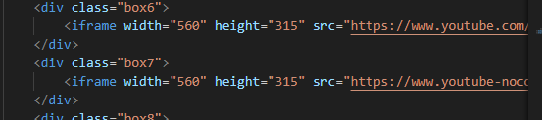

**Output:**

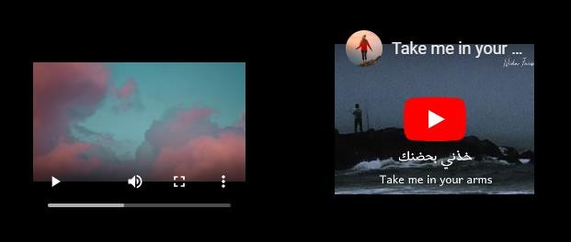

**HTML JavaScript**

JavaScript makes HTML pages more dynamic and interactive.

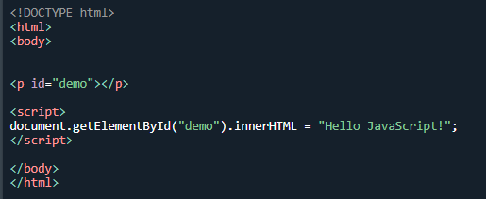

**Output:**



**HTML File Paths**

A file path describes the location of a file in a web site's folder structure.

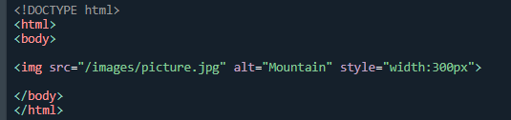

**Output:**



**HTML Responsive Web Design**

Responsive web design is about creating web pages that look good on all devices! A responsive web design will automatically adjust for different screen sizes and viewports.

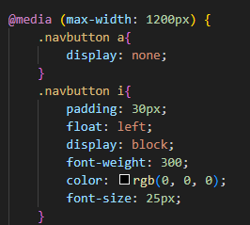

Output:

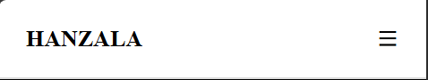

**HTML Computer Code Elements**

HTML contains several elements for defining user input and computer code.

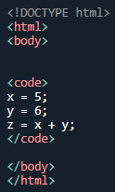

**Output:**



**HTML Symbols**

Symbols or letters that are not present on your keyboard can be added to HTML using entities.

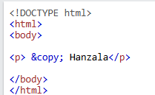

**Output:**



**Using Emojis in HTML**

Emojis are characters from the UTF-8 character set: v^-● ●v-˘ ♥y

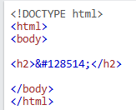

**Output:**



**HTML Video**

The HTML <video> element is used to show a video on a web page.

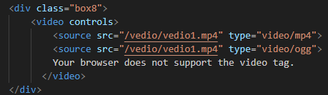

**Output:**



**HTML YouTube Videos**

The easiest way to play videos in HTML, is to use YouTube.

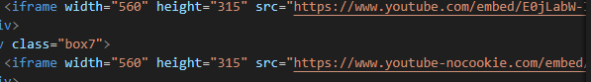

**Output:**



**HTML Forms**

An HTML form is used to collect user input. The user input is most often sent to a server for processing.

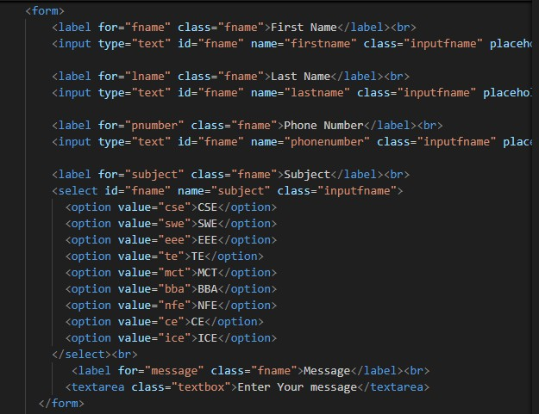

**Output:**

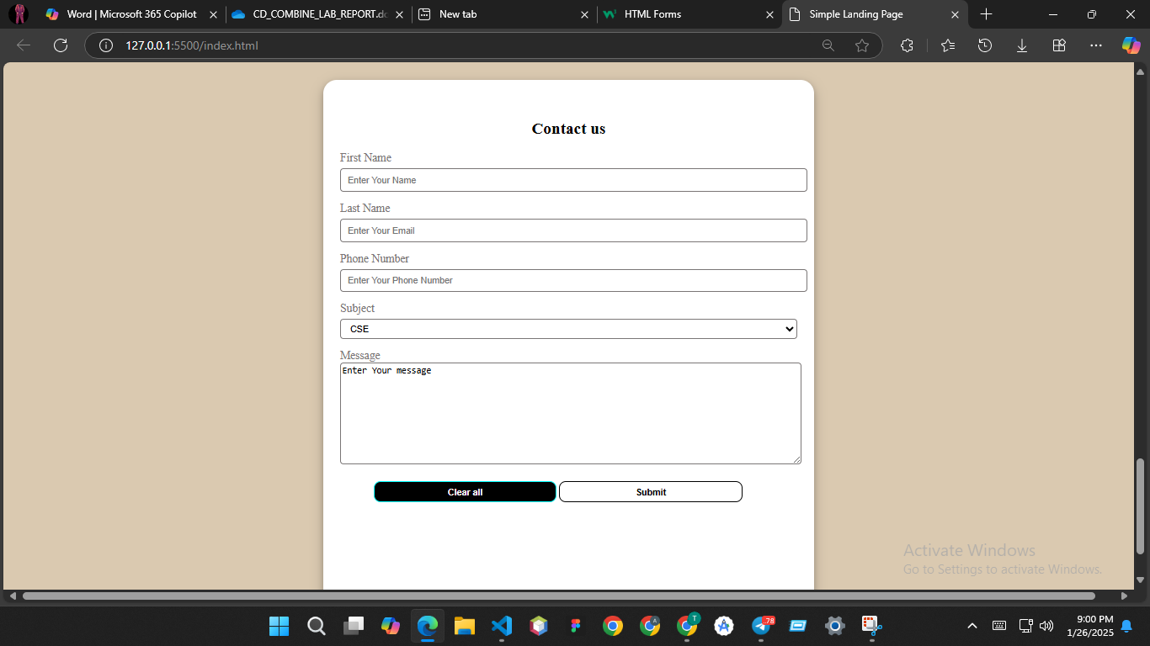

**Thank You**