**Documentation of ChaCha IP**

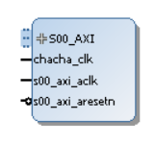

The Chacha IP communicates via AXI-lite interface with 32 bits data bus. It allows only unidirectional communication as of now.

**The addresses of registers are as follows:**

* ADDR_CTRL = 8'h08;
* CTRL_INIT_BIT = 0;
* CTRL_NEXT_BIT = 1;
* ADDR_STATUS = 8'h09;
* STATUS_READY_BIT = 0;
* ADDR_KEYLEN = 8'h0a;
* KEYLEN_BIT = 0;
* ADDR_ROUNDS = 8'h0b;
* ROUNDS_HIGH_BIT = 4;
* ROUNDS_LOW_BIT = 0;
* ADDR_KEY0 = 8'h10;
* ADDR_KEY1 = 8'h11;
* ADDR_KEY2 = 8'h12;
* ADDR_KEY3 = 8'h13;
* ADDR_KEY4 = 8'h14;
* ADDR_KEY5 = 8'h15;
* ADDR_KEY6 = 8'h16;
* ADDR_KEY7 = 8'h17;
* ADDR_IV0 = 8'h20;
* ADDR_IV1 = 8'h21;
* ADDR_DATA_IN0 = 8'h40;
* ADDR_DATA_IN1 = 8'h41;
* ADDR_DATA_IN2 = 8'h42;
* ADDR_DATA_IN3 = 8'h43;
* ADDR_DATA_IN4 = 8'h44;
* ADDR_DATA_IN5 = 8'h45;
* ADDR_DATA_IN6 = 8'h46;
* ADDR_DATA_IN7 = 8'h47;
* ADDR_DATA_IN8 = 8'h48;
* ADDR_DATA_IN9 = 8'h49;
* ADDR_DATA_IN10 = 8'h4a;
* ADDR_DATA_IN11 = 8'h4b;
* ADDR_DATA_IN12 = 8'h4c;
* ADDR_DATA_IN13 = 8'h4d;
* ADDR_DATA_IN14 = 8'h4e;
* ADDR_DATA_IN15 = 8'h4f;
* ADDR_DATA_OUT0 = 8'h80;
* ADDR_DATA_OUT1 = 8'h81;
* ADDR_DATA_OUT2 = 8'h82;
* ADDR_DATA_OUT3 = 8'h83;
* ADDR_DATA_OUT4 = 8'h84;
* ADDR_DATA_OUT5 = 8'h85;
* ADDR_DATA_OUT6 = 8'h86;
* ADDR_DATA_OUT7 = 8'h87;
* ADDR_DATA_OUT8 = 8'h88;
* ADDR_DATA_OUT9 = 8'h89;
* ADDR_DATA_OUT10 = 8'h8a;
* ADDR_DATA_OUT11 = 8'h8b;
* ADDR_DATA_OUT12 = 8'h8c;
* ADDR_DATA_OUT13 = 8'h8d;
* ADDR_DATA_OUT14 = 8'h8e;
* ADDR_DATA_OUT15 = 8'h8f;

The ip has been tested with core-clk of 50Mhz and axi-clk of 250Mhz.

**Example design:**

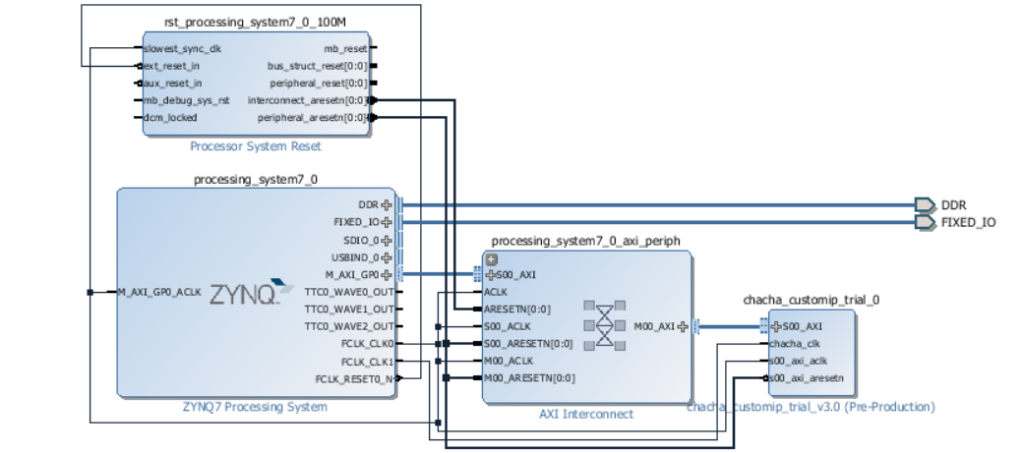

**Test Code:**

#include <stdio.h>

#include "platform.h"

#include "xil_printf.h"

#include "xparameters.h"

#include "sleep.h"

#include "xuartps_hw.h"

#include "addr.h"

int main()

{

init_platform();

// u32 r0,r1,addr1,addr2;

u32 ready,out_temp, i;

print("Hello World\n\r");

//write parameters

Xil_Out32(XPAR_CHACHA_CUSTOMIP_TRIAL_0_S00_AXI_BASEADDR+(ADDR_KEY0<<2), 0X00000000);

Xil_Out32(XPAR_CHACHA_CUSTOMIP_TRIAL_0_S00_AXI_BASEADDR+(ADDR_KEY1<<2), 0X00000000);

Xil_Out32(XPAR_CHACHA_CUSTOMIP_TRIAL_0_S00_AXI_BASEADDR+(ADDR_KEY2<<2), 0X00000000);

Xil_Out32(XPAR_CHACHA_CUSTOMIP_TRIAL_0_S00_AXI_BASEADDR+(ADDR_KEY3<<2), 0X00000000);

Xil_Out32(XPAR_CHACHA_CUSTOMIP_TRIAL_0_S00_AXI_BASEADDR+(ADDR_KEY4<<2), 0X00000000);

Xil_Out32(XPAR_CHACHA_CUSTOMIP_TRIAL_0_S00_AXI_BASEADDR+(ADDR_KEY5<<2), 0X00000000);

Xil_Out32(XPAR_CHACHA_CUSTOMIP_TRIAL_0_S00_AXI_BASEADDR+(ADDR_KEY6<<2), 0X00000000);

Xil_Out32(XPAR_CHACHA_CUSTOMIP_TRIAL_0_S00_AXI_BASEADDR+(ADDR_KEY7<<2), 0X00000000);

Xil_Out32(XPAR_CHACHA_CUSTOMIP_TRIAL_0_S00_AXI_BASEADDR+(ADDR_IV0<<2), 0X00);

Xil_Out32(XPAR_CHACHA_CUSTOMIP_TRIAL_0_S00_AXI_BASEADDR+(ADDR_IV1<<2), 0X00);

Xil_Out32(XPAR_CHACHA_CUSTOMIP_TRIAL_0_S00_AXI_BASEADDR+(ADDR_KEYLEN<<2), 0X00);

Xil_Out32(XPAR_CHACHA_CUSTOMIP_TRIAL_0_S00_AXI_BASEADDR+(ADDR_ROUNDS<<2), 0X08);

Xil_Out32(XPAR_CHACHA_CUSTOMIP_TRIAL_0_S00_AXI_BASEADDR+(ADDR_CTRL<<2), 0X01);

//reset and init// wait 4 core clks

usleep(10);

Xil_Out32(XPAR_CHACHA_CUSTOMIP_TRIAL_0_S00_AXI_BASEADDR+(ADDR_CTRL<<2), 0X00);

do{

ready = (Xil_In32(XPAR_CHACHA_CUSTOMIP_TRIAL_0_S00_AXI_BASEADDR+(ADDR_STATUS<<2))) & 0X00000001;

}while(!ready);

for(i=0;i<16;i++){

out_temp = Xil_In32(XPAR_CHACHA_CUSTOMIP_TRIAL_0_S00_AXI_BASEADDR+((ADDR_DATA_OUT0 + i)<<2));

// XUartPs_SendByte(STDOUT_BASEADDRESS,out_temp);

xil_printf("%08x",out_temp);

}

print("\n\rHello World\n\r");

//write parameters

Xil_Out32(XPAR_CHACHA_CUSTOMIP_TRIAL_0_S00_AXI_BASEADDR+(ADDR_KEY0<<2), 0X00112233);

Xil_Out32(XPAR_CHACHA_CUSTOMIP_TRIAL_0_S00_AXI_BASEADDR+(ADDR_KEY1<<2), 0X44556677);

Xil_Out32(XPAR_CHACHA_CUSTOMIP_TRIAL_0_S00_AXI_BASEADDR+(ADDR_KEY2<<2), 0X8899aabb);

Xil_Out32(XPAR_CHACHA_CUSTOMIP_TRIAL_0_S00_AXI_BASEADDR+(ADDR_KEY3<<2), 0Xccddeeff);

Xil_Out32(XPAR_CHACHA_CUSTOMIP_TRIAL_0_S00_AXI_BASEADDR+(ADDR_KEY4<<2), 0Xffeeddcc);

Xil_Out32(XPAR_CHACHA_CUSTOMIP_TRIAL_0_S00_AXI_BASEADDR+(ADDR_KEY5<<2), 0Xbbaa9988);

Xil_Out32(XPAR_CHACHA_CUSTOMIP_TRIAL_0_S00_AXI_BASEADDR+(ADDR_KEY6<<2), 0X77665544);

Xil_Out32(XPAR_CHACHA_CUSTOMIP_TRIAL_0_S00_AXI_BASEADDR+(ADDR_KEY7<<2), 0X33221100);

Xil_Out32(XPAR_CHACHA_CUSTOMIP_TRIAL_0_S00_AXI_BASEADDR+(ADDR_IV0<<2), 0X0f1e2d3c);

Xil_Out32(XPAR_CHACHA_CUSTOMIP_TRIAL_0_S00_AXI_BASEADDR+(ADDR_IV1<<2), 0X4b596877);

Xil_Out32(XPAR_CHACHA_CUSTOMIP_TRIAL_0_S00_AXI_BASEADDR+(ADDR_KEYLEN<<2), 0X01);

Xil_Out32(XPAR_CHACHA_CUSTOMIP_TRIAL_0_S00_AXI_BASEADDR+(ADDR_ROUNDS<<2), 0X08);

Xil_Out32(XPAR_CHACHA_CUSTOMIP_TRIAL_0_S00_AXI_BASEADDR+(ADDR_CTRL<<2), 0X01);

usleep(10);

Xil_Out32(XPAR_CHACHA_CUSTOMIP_TRIAL_0_S00_AXI_BASEADDR+(ADDR_CTRL<<2), 0X00);

do{

ready = (Xil_In32(XPAR_CHACHA_CUSTOMIP_TRIAL_0_S00_AXI_BASEADDR+(ADDR_STATUS<<2))) & 0X00000001;

}while(!ready);

for(i=0;i<16;i++){

out_temp = Xil_In32(XPAR_CHACHA_CUSTOMIP_TRIAL_0_S00_AXI_BASEADDR+((ADDR_DATA_OUT0 + i)<<2));

// XUartPs_SendByte(STDOUT_BASEADDRESS,out_temp);

xil_printf("%08x",out_temp);

}

cleanup_platform();

return 0;

}

**Result of Testcode:**

* he28a5fa4a67f8c5defed3e6fb7303486aa8427d31419a729572d777953491120b64ab8e72b8deb85cd6aea7cb6089a101824beeb08814a428aab1fa2c816081b
* h60fdedbd1a280cb741d0593b6ea0309010acf18e1471f68968f4c9e311dca149b8e027b47c81e0353db013891aa5f68ea3b13dd2f3b8dd0873bf3746e7d6c567

**Note:** When encrypting next block without initializing again, use CTRL_REG value as 2