**Documentation of SHA256 IP**

The SHA256 IP communicates via AXI-lite interface with 32 bits data bus. It allows only unidirectional communication as of now.

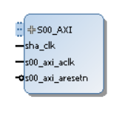

**The addresses of registers are as follows:**

* ADDR_CTRL = 8’h08
* CTRL_INIT_BIT = 0
* CTRL_NEXT_BIT = 1
* CTRL_MODE_BIT = 2
* ADDR_STATUS = 8’h09
* STATUS_READY_BIT = 0
* STATUS_VALID_BIT = 1
* ADDR_BLOCK0 = 8’h10
* ADDR_BLOCK1 = 8’h11
* ADDR_BLOCK2 = 8’h12
* ADDR_BLOCK3 = 8’h13
* ADDR_BLOCK4 = 8’h14
* ADDR_BLOCK5 = 8’h15
* ADDR_BLOCK6 = 8’h16
* ADDR_BLOCK7 = 8’h17
* ADDR_BLOCK8 = 8’h18
* ADDR_BLOCK9 = 8’h19
* ADDR_BLOCK10 = 8’h1a
* ADDR_BLOCK11 = 8’h1b
* ADDR_BLOCK12 = 8’h1c
* ADDR_BLOCK13 = 8’h1d
* ADDR_BLOCK14 = 8’h1e
* ADDR_BLOCK15 = 8’h1f
* ADDR_DIGEST0 = 8’h20
* ADDR_DIGEST1 = 8’h21
* ADDR_DIGEST2 = 8’h22
* ADDR_DIGEST3 = 8’h23
* ADDR_DIGEST4 = 8’h24
* ADDR_DIGEST5 = 8’h25
* ADDR_DIGEST6 = 8’h26
* ADDR_DIGEST7 = 8’h27
* CORE_NAME0 = 32’h73686132 // "sha2"
* CORE_NAME1 = 32’hd323536 // "-256"
* CORE_VERSION = 32’h312e3830 // "1.80"
* MODE_SHA_224 = 1’h0
* MODE_SHA_256 = 1’h1

The ip has been tested with core-clk of 70Mhz and axi-clk of 70Mhz.

**Note:** As of now, both core and axi clocks should be same. Future updates may allow using different clocks

**Example design:**

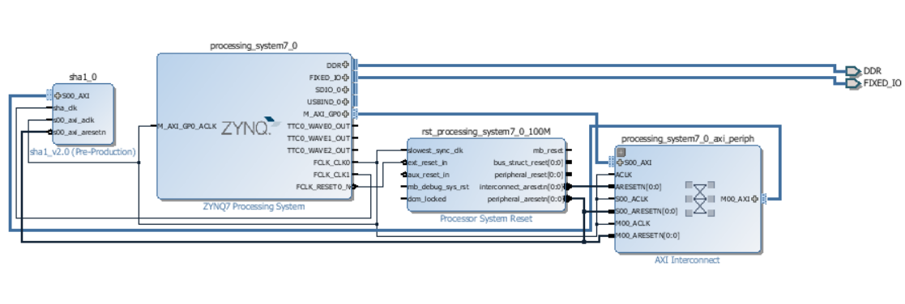

**Test Code:**

**#include** <stdio.h>

**#include** "platform.h"

**#include** "xil_printf.h"

**#include** "address.h"

**#include** "xil_io.h"

**#include** "sleep.h"

**int** **main**()

{

**int** ready,i,out_temp;

init_platform();

print("Hello World SHA224\n\r");

Xil_Out32(XPAR_SHA256_0_S00_AXI_BASEADDR+(ADDR_BLOCK0<<2), 0X61626380);

Xil_Out32(XPAR_SHA256_0_S00_AXI_BASEADDR+(ADDR_BLOCK1<<2), 0X00000000);

Xil_Out32(XPAR_SHA256_0_S00_AXI_BASEADDR+(ADDR_BLOCK2<<2), 0X00000000);

Xil_Out32(XPAR_SHA256_0_S00_AXI_BASEADDR+(ADDR_BLOCK3<<2), 0X00000000);

Xil_Out32(XPAR_SHA256_0_S00_AXI_BASEADDR+(ADDR_BLOCK4<<2), 0X00000000);

Xil_Out32(XPAR_SHA256_0_S00_AXI_BASEADDR+(ADDR_BLOCK5<<2), 0X00000000);

Xil_Out32(XPAR_SHA256_0_S00_AXI_BASEADDR+(ADDR_BLOCK6<<2), 0X00000000);

Xil_Out32(XPAR_SHA256_0_S00_AXI_BASEADDR+(ADDR_BLOCK7<<2), 0X00000000);

Xil_Out32(XPAR_SHA256_0_S00_AXI_BASEADDR+(ADDR_BLOCK8<<2), 0X00000000);

Xil_Out32(XPAR_SHA256_0_S00_AXI_BASEADDR+(ADDR_BLOCK9<<2), 0X00000000);

Xil_Out32(XPAR_SHA256_0_S00_AXI_BASEADDR+(ADDR_BLOCK10<<2), 0X00000000);

Xil_Out32(XPAR_SHA256_0_S00_AXI_BASEADDR+(ADDR_BLOCK11<<2), 0X00000000);

Xil_Out32(XPAR_SHA256_0_S00_AXI_BASEADDR+(ADDR_BLOCK12<<2), 0X00000000);

Xil_Out32(XPAR_SHA256_0_S00_AXI_BASEADDR+(ADDR_BLOCK13<<2), 0X00000000);

Xil_Out32(XPAR_SHA256_0_S00_AXI_BASEADDR+(ADDR_BLOCK14<<2), 0X00000000);

Xil_Out32(XPAR_SHA256_0_S00_AXI_BASEADDR+(ADDR_BLOCK15<<2), 0X00000018);

Xil_Out32(XPAR_SHA256_0_S00_AXI_BASEADDR+(ADDR_CTRL<<2), 0X01);// init+mode sha224

**do**{

ready = (Xil_In32(XPAR_SHA256_0_S00_AXI_BASEADDR+(ADDR_STATUS<<2))) & 0X00000001;

}**while**(!ready);

**for**(i=0;i<7;i++){

out_temp = Xil_In32(XPAR_SHA256_0_S00_AXI_BASEADDR+((ADDR_DIGEST0 + i)<<2));

xil_printf("%08x",out_temp);

}

print("\nHello World SHA256\n\r");

Xil_Out32(XPAR_SHA256_0_S00_AXI_BASEADDR+(ADDR_BLOCK0<<2), 0X61626380);

Xil_Out32(XPAR_SHA256_0_S00_AXI_BASEADDR+(ADDR_BLOCK1<<2), 0X00000000);

Xil_Out32(XPAR_SHA256_0_S00_AXI_BASEADDR+(ADDR_BLOCK2<<2), 0X00000000);

Xil_Out32(XPAR_SHA256_0_S00_AXI_BASEADDR+(ADDR_BLOCK3<<2), 0X00000000);

Xil_Out32(XPAR_SHA256_0_S00_AXI_BASEADDR+(ADDR_BLOCK4<<2), 0X00000000);

Xil_Out32(XPAR_SHA256_0_S00_AXI_BASEADDR+(ADDR_BLOCK5<<2), 0X00000000);

Xil_Out32(XPAR_SHA256_0_S00_AXI_BASEADDR+(ADDR_BLOCK6<<2), 0X00000000);

Xil_Out32(XPAR_SHA256_0_S00_AXI_BASEADDR+(ADDR_BLOCK7<<2), 0X00000000);

Xil_Out32(XPAR_SHA256_0_S00_AXI_BASEADDR+(ADDR_BLOCK8<<2), 0X00000000);

Xil_Out32(XPAR_SHA256_0_S00_AXI_BASEADDR+(ADDR_BLOCK9<<2), 0X00000000);

Xil_Out32(XPAR_SHA256_0_S00_AXI_BASEADDR+(ADDR_BLOCK10<<2), 0X00000000);

Xil_Out32(XPAR_SHA256_0_S00_AXI_BASEADDR+(ADDR_BLOCK11<<2), 0X00000000);

Xil_Out32(XPAR_SHA256_0_S00_AXI_BASEADDR+(ADDR_BLOCK12<<2), 0X00000000);

Xil_Out32(XPAR_SHA256_0_S00_AXI_BASEADDR+(ADDR_BLOCK13<<2), 0X00000000);

Xil_Out32(XPAR_SHA256_0_S00_AXI_BASEADDR+(ADDR_BLOCK14<<2), 0X00000000);

Xil_Out32(XPAR_SHA256_0_S00_AXI_BASEADDR+(ADDR_BLOCK15<<2), 0X00000018);

Xil_Out32(XPAR_SHA256_0_S00_AXI_BASEADDR+(ADDR_CTRL<<2), 0X04 + 0X01);// init+mode sha256

**do**{

ready = (Xil_In32(XPAR_SHA256_0_S00_AXI_BASEADDR+(ADDR_STATUS<<2))) & 0X00000001;

}**while**(!ready);

**for**(i=0;i<8;i++){

out_temp = Xil_In32(XPAR_SHA256_0_S00_AXI_BASEADDR+((ADDR_DIGEST0 + i)<<2));

xil_printf("%08x",out_temp);

}

cleanup_platform();

**return** 0;

}

**Result of Testcode:**

Hello World SHA224

23097D223405D8228642A477BDA255B32AADBCE4BDA0B3F7E36C9DA7

Hello World SHA256

hBA7816BF8F01CFEA414140DE5DAE2223B00361A396177A9CB410FF61F20015AD

**Note:** When encrypting next block without initializing again, use CTRL_REG value as 2