**Documentation of SHA512 IP**

The SHA512 IP communicates via AXI-lite interface with 32 bits data bus. It allows only unidirectional communication as of now.

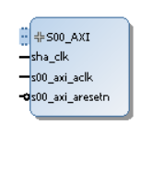

**The addresses of registers are as follows:**

* ADDR_NAME0 = 8’h00
* ADDR_NAME1 = 8’h01
* ADDR_VERSION = 8’h02
* ADDR_CTRL = 8’h08
* CTRL_INIT_BIT = 0
* CTRL_NEXT_BIT = 1
* CTRL_MODE_LOW_BIT = 2
* CTRL_MODE_HIGH_BIT = 3
* CTRL_WORK_FACTOR_BIT = 7
* ADDR_STATUS = 8’h09
* STATUS_READY_BIT = 0
* STATUS_VALID_BIT = 1
* ADDR_WORK_FACTOR_NUM = 8’h0a
* ADDR_BLOCK0 = 8’h10
* ADDR_BLOCK1 = 8’h11
* ADDR_BLOCK2 = 8’h12
* ADDR_BLOCK3 = 8’h13
* ADDR_BLOCK4 = 8’h14
* ADDR_BLOCK5 = 8’h15
* ADDR_BLOCK6 = 8’h16
* ADDR_BLOCK7 = 8’h17
* ADDR_BLOCK8 = 8’h18
* ADDR_BLOCK9 = 8’h19
* ADDR_BLOCK10 = 8’h1a
* ADDR_BLOCK11 = 8’h1b
* ADDR_BLOCK12 = 8’h1c
* ADDR_BLOCK13 = 8’h1d
* ADDR_BLOCK14 = 8’h1e
* ADDR_BLOCK15 = 8’h1f
* ADDR_BLOCK16 = 8’h20
* ADDR_BLOCK17 = 8’h21
* ADDR_BLOCK18 = 8’h22
* ADDR_BLOCK19 = 8’h23
* ADDR_BLOCK20 = 8’h24
* ADDR_BLOCK21 = 8’h25
* ADDR_BLOCK22 = 8’h26
* ADDR_BLOCK23 = 8’h27
* ADDR_BLOCK24 = 8’h28
* ADDR_BLOCK25 = 8’h29
* ADDR_BLOCK26 = 8’h2a
* ADDR_BLOCK27 = 8’h2b
* ADDR_BLOCK28 = 8’h2c
* ADDR_BLOCK29 = 8’h2d
* ADDR_BLOCK30 = 8’h2e
* ADDR_BLOCK31 = 8’h2f
* ADDR_DIGEST0 = 8’h40
* ADDR_DIGEST1 = 8’h41
* ADDR_DIGEST2 = 8’h42
* ADDR_DIGEST3 = 8’h43
* ADDR_DIGEST4 = 8’h44
* ADDR_DIGEST5 = 8’h45
* ADDR_DIGEST6 = 8’h46
* ADDR_DIGEST7 = 8’h47
* ADDR_DIGEST8 = 8’h48
* ADDR_DIGEST9 = 8’h49
* ADDR_DIGEST10 = 8’h4a
* ADDR_DIGEST11 = 8’h4b
* ADDR_DIGEST12 = 8’h4c
* ADDR_DIGEST13 = 8’h4d
* ADDR_DIGEST14 = 8’h4e
* ADDR_DIGEST15 = 8’h4f
* MODE_SHA_512_224 = 2’h0
* MODE_SHA_512_256 = 2’h1
* MODE_SHA_384 = 2’h2
* MODE_SHA_512 = 2’h3
* CTRL_INIT_VALUE = 2’h1
* CTRL_NEXT_VALUE = 2’h2
* CTRL_WORK_FACTOR_VALUE = 1’h1

The ip has been tested with core-clk of 60Mhz and axi-clk of 60Mhz.

**Note:** As of now, both core and axi clocks should be same. Future updates may allow using different clocks

**Example design:**

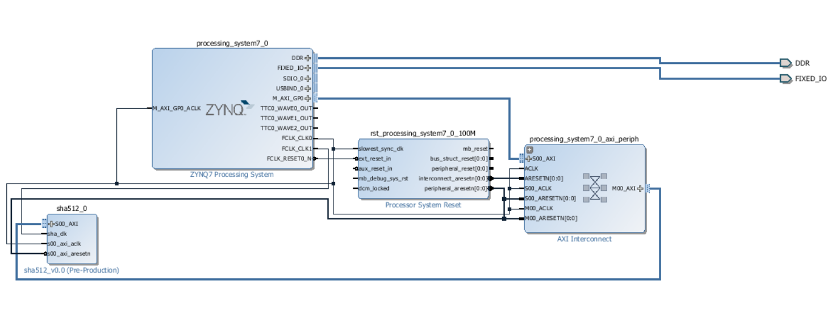

**Test Code:**

**#include** <stdio.h>

**#include** "platform.h"

**#include** "xil_printf.h"

**#include** "addr.h"

**#include** "xil_io.h"

**int** **main**()

{

init_platform();

**int** i, ready, out_temp;

print("Hello World\n\r");

Xil_Out32(XPAR_SHA512_0_S00_AXI_BASEADDR+(ADDR_BLOCK0<<2), 0X61626380);

Xil_Out32(XPAR_SHA512_0_S00_AXI_BASEADDR+(ADDR_BLOCK1<<2), 0X00000000);

Xil_Out32(XPAR_SHA512_0_S00_AXI_BASEADDR+(ADDR_BLOCK2<<2), 0X00000000);

Xil_Out32(XPAR_SHA512_0_S00_AXI_BASEADDR+(ADDR_BLOCK3<<2), 0X00000000);

Xil_Out32(XPAR_SHA512_0_S00_AXI_BASEADDR+(ADDR_BLOCK4<<2), 0X00000000);

Xil_Out32(XPAR_SHA512_0_S00_AXI_BASEADDR+(ADDR_BLOCK5<<2), 0X00000000);

Xil_Out32(XPAR_SHA512_0_S00_AXI_BASEADDR+(ADDR_BLOCK6<<2), 0X00000000);

Xil_Out32(XPAR_SHA512_0_S00_AXI_BASEADDR+(ADDR_BLOCK7<<2), 0X00000000);

Xil_Out32(XPAR_SHA512_0_S00_AXI_BASEADDR+(ADDR_BLOCK8<<2), 0X00000000);

Xil_Out32(XPAR_SHA512_0_S00_AXI_BASEADDR+(ADDR_BLOCK9<<2), 0X00000000);

Xil_Out32(XPAR_SHA512_0_S00_AXI_BASEADDR+(ADDR_BLOCK10<<2), 0X00000000);

Xil_Out32(XPAR_SHA512_0_S00_AXI_BASEADDR+(ADDR_BLOCK11<<2), 0X00000000);

Xil_Out32(XPAR_SHA512_0_S00_AXI_BASEADDR+(ADDR_BLOCK12<<2), 0X00000000);

Xil_Out32(XPAR_SHA512_0_S00_AXI_BASEADDR+(ADDR_BLOCK13<<2), 0X00000000);

Xil_Out32(XPAR_SHA512_0_S00_AXI_BASEADDR+(ADDR_BLOCK14<<2), 0X00000000);

Xil_Out32(XPAR_SHA512_0_S00_AXI_BASEADDR+(ADDR_BLOCK15<<2), 0X00000000);

Xil_Out32(XPAR_SHA512_0_S00_AXI_BASEADDR+(ADDR_BLOCK16<<2), 0X00000000);

Xil_Out32(XPAR_SHA512_0_S00_AXI_BASEADDR+(ADDR_BLOCK17<<2), 0X00000000);

Xil_Out32(XPAR_SHA512_0_S00_AXI_BASEADDR+(ADDR_BLOCK18<<2), 0X00000000);

Xil_Out32(XPAR_SHA512_0_S00_AXI_BASEADDR+(ADDR_BLOCK19<<2), 0X00000000);

Xil_Out32(XPAR_SHA512_0_S00_AXI_BASEADDR+(ADDR_BLOCK20<<2), 0X00000000);

Xil_Out32(XPAR_SHA512_0_S00_AXI_BASEADDR+(ADDR_BLOCK21<<2), 0X00000000);

Xil_Out32(XPAR_SHA512_0_S00_AXI_BASEADDR+(ADDR_BLOCK22<<2), 0X00000000);

Xil_Out32(XPAR_SHA512_0_S00_AXI_BASEADDR+(ADDR_BLOCK23<<2), 0X00000000);

Xil_Out32(XPAR_SHA512_0_S00_AXI_BASEADDR+(ADDR_BLOCK24<<2), 0X00000000);

Xil_Out32(XPAR_SHA512_0_S00_AXI_BASEADDR+(ADDR_BLOCK25<<2), 0X00000000);

Xil_Out32(XPAR_SHA512_0_S00_AXI_BASEADDR+(ADDR_BLOCK26<<2), 0X00000000);

Xil_Out32(XPAR_SHA512_0_S00_AXI_BASEADDR+(ADDR_BLOCK27<<2), 0X00000000);

Xil_Out32(XPAR_SHA512_0_S00_AXI_BASEADDR+(ADDR_BLOCK28<<2), 0X00000000);

Xil_Out32(XPAR_SHA512_0_S00_AXI_BASEADDR+(ADDR_BLOCK29<<2), 0X00000000);

Xil_Out32(XPAR_SHA512_0_S00_AXI_BASEADDR+(ADDR_BLOCK30<<2), 0X00000000);

Xil_Out32(XPAR_SHA512_0_S00_AXI_BASEADDR+(ADDR_BLOCK31<<2), 0X00000018);Xil_Out32(XPAR_SHA512_0_S00_AXI_BASEADDR+(ADDR_CTRL<<2), 0X00000000+(MODE_SHA_512<<2)+CTRL_INIT_VALUE);

**do**{

ready = (Xil_In32(XPAR_SHA512_0_S00_AXI_BASEADDR+(ADDR_STATUS<<2))) & 0X00000001;

}**while**(!ready);

**for**(i=0;i<16;i++){

out_temp = Xil_In32(XPAR_SHA512_0_S00_AXI_BASEADDR+((ADDR_DIGEST0 + i)<<2));

xil_printf("%08x",out_temp);

}

cleanup_platform();

**return** 0;

}

**Result of Testcode:**

Hello World

DDAF35A193617ABACC417349AE20413112E6FA4E89A97EA20A9EEEE64B55D39A2192992A274FC1A836BA3C23A3FEEBBD454D4423643CE80E2A9AC94FA54CA49F

**Note:**

For MODE_SHA_512_224, the output will be

4634270F707B6A54DAAE7530460842E20E37ED265CEEE9A43E8924AA (followed by zeros)

For MODE_SHA_512_256, the output will be

53048E2681941EF99B2E29B76B4C7DABE4C2D0C634FC6D46E0E2F13107E7AF23 (followed by zeros)

For MODE_SHA_384, the output will be

CB00753F45A35E8BB5A03D699AC65007272C32AB0EDED1631A8B605A43FF5BED8086072BA1E7CC2358BAECA134C825A7 (followed by zeros)

**Note:** When encrypting next block without initializing again, use CTRL_REG value as 2