Ultra-Wideband Radar Signal Generation and Analysis Using SystemVue Integrated Test Solution
A Quick Demo Guide (Agilent Restricted)

Introduction

With unique advantages of high accuracy for target detection, high fidelity for precision with penetration and low cost for combining radar and communication systems, the Ultra Wideband (UWB) Radar is very popular in both commercial and defense industries. To design and test the new UWB radar systems, different signal sources, target environment setup, signal processing and measurements are needed. A platform is proposed for designing and testing UWB Radar. In the platform, SystemVue Integreted Test Solution (ITS) is used with Agilent Wideband Signal Source (81180A/81190A, M9390), Vector Signal Source PSG, Wideband Vector Signal Analyzer and High Performance Scope (90000/90000X series) and form a UWB component tester in which different UWB signals can be generated in SystemVue, send to wideband arbitrary waveform generator as hardware component test signal. Also, different measurements are available in the platform. Examples show that this platform can be used not only for UWB transmitter but also for receiver troubleshooting and test purpose.

Test Setup Overview

- Software Installation

- A Windows platform with 4 G RAM required.
- Agilent 89600 VSA software version 11.0 or up.
- Agilent IO library version 15 or up.
- SystemVue 2010.07 0r up.
- SystemVue Workspace, WidebandGen.wsv with 81180 Signaldownloadedr and setup files.

- The recommended equipment list with options

- DSOX93204A 32 GHz Digital Signal Oscilloscope with Options:
  - 02G 2Gpts/ch memory
  - 062 MATLAB Standard Digital Package
  - 010 User Defined Function

- 81180A Arbitrary Waveform Generator with Options:
  - 264 Two channel 64M points memory
  - (2) F4G Reconstruction filter set for 4Gsa/s, 1 channel

- 89600 A/AN VSA Software with Options:
  - 200 Basic Vector Signal Analysis
  - 300 Hardware Connectivity
  - AYA Vector Modulation Analysis

- E8267D PSG Vector Signal Generator with Options:
  - 520 or 532 Frequency range from 250 kHz to 20 GHz or 31.8 GHz
  - 016 Wideband differential external I/Q inputs
  - H18 Wideband modulation less than 3.2 GHz

- PXA, MXA, or PSA for flatness corrections (optional)

- Hardware Setup

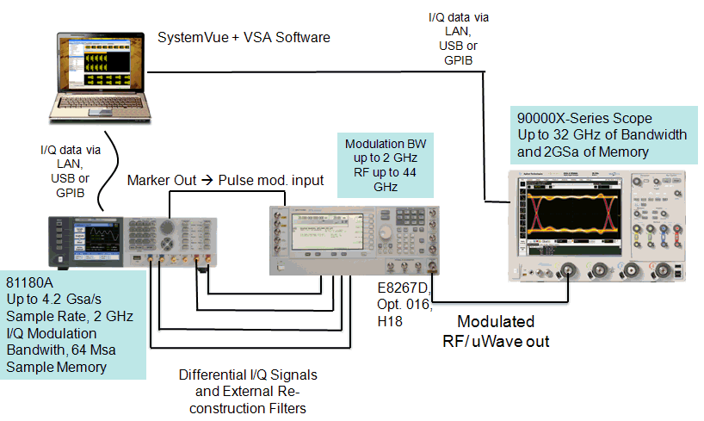
Figure 1: Test Setup Diagram for UWB Radar Signal Generation and Measuring

In the test, as seen in Figure 1 a UWB signal is generated in SystemVue first and then downloaded to the 81180A. The 81180 IQ outputs are modulated onto a microwave carrier using a PSG with external wideband IQ inputs. The UWB signal is then analyzed using a 90000 or 90000X scope through VSA software that can be installed either in your PC or in the 90000/90000X Scope. In Figure 2, the test platform in Agilent Santa Rosa MCD office is shown.

- Connect instruments based on Figure 1.
- Run Agilent IO library using connection expert to connect the PC with 81180A, 90000/90000X and PSG.
- Run Agilent 89600 VSA software. In the VSA menu select Utilities->Hardware; make sure the Scope has been connected to the PC.

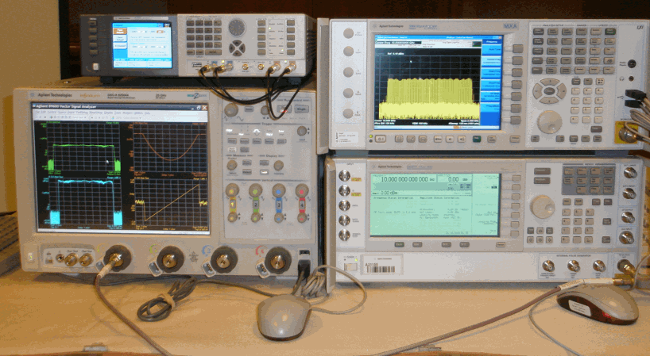
Figure 2: UWB Radar Signal Test Platform in Agilent Santa Rosa Office

- Run SystemVue to generate UWB signals and then download data to 81180A .

- Start SystemVue by double clicking on the workspace WidebandGen.wsv and you will see the LFM design in the design window.
- Modify parameters as needed for your test. To do this, click on Equation in the design window and view key parameters. By default, the bandwidth has been set to 1GHz, SamplingRate=2.4 GHz, PulseWidth=1e-6 Sec and Repeatition Pulse Interval, PRI=10e-6 Sec. It is OK to use the default setting at the beginning to run the UWB LFM signal.
- In the LFM design shown in Figure 4, for the SignalDownloader_81180, parameters must be reset to specify instrument ip address (for example, 141.121.148.5) for connection of your 81180A.
- Execute the signal generation design. You can see data from SV is downloaded to 81180A.
- Setup the VSA to display and measure the results as shown below. For your convinience, you can select “File> Recall Setup…” and select prestored .set file in the SV workspace direction. As seen from Figure 4, the generated LFM UWB signal is measured.

Figure 4: Design for generate UWB Signal

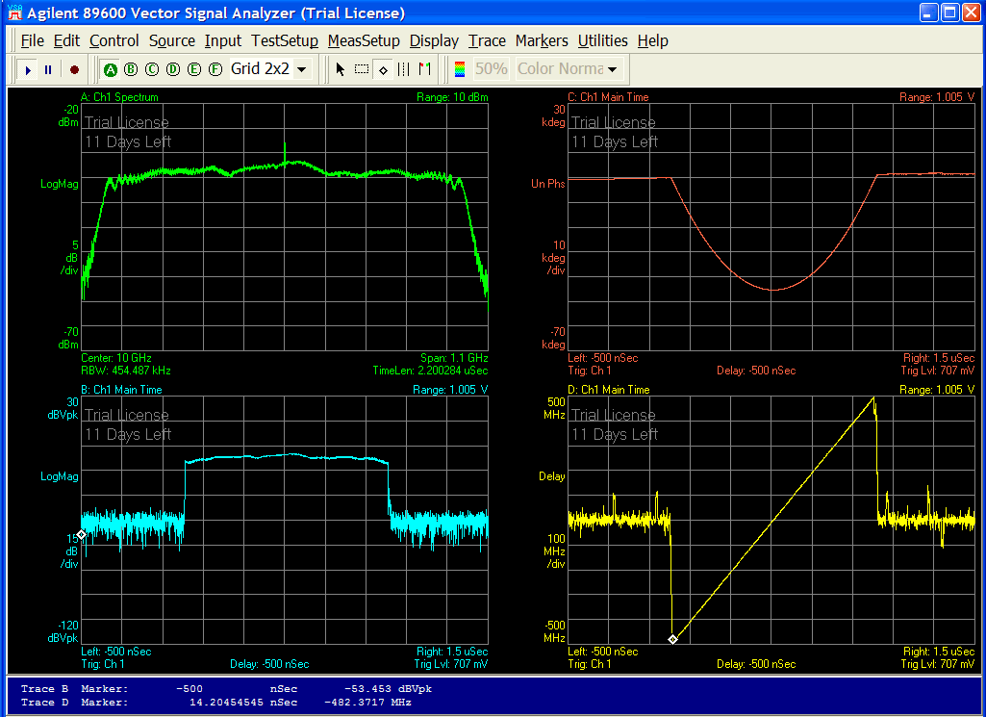

Figure 5: 1GHz BW LFM UWB Signal

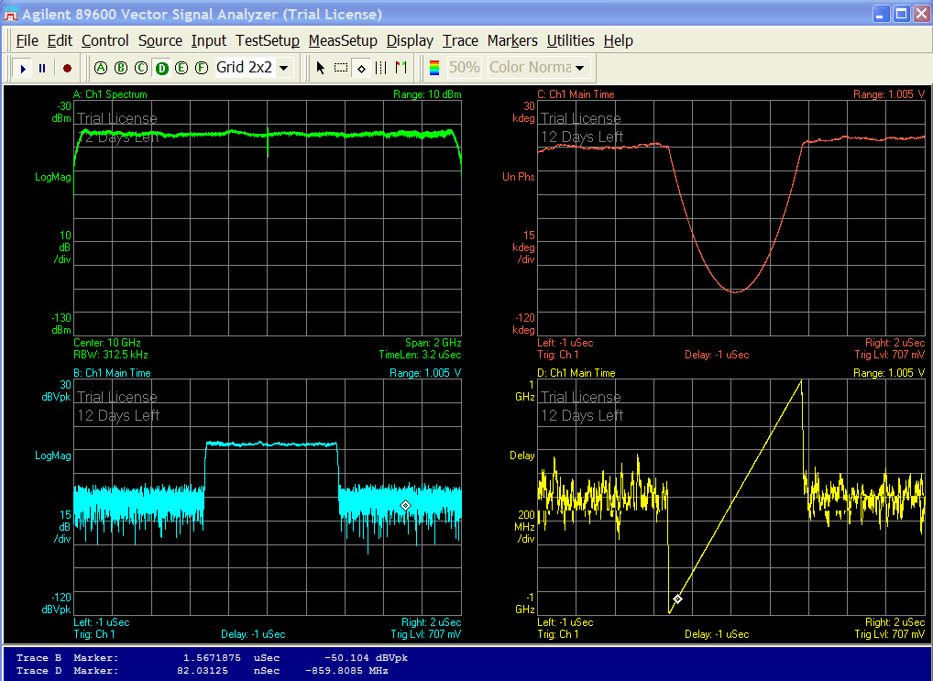

Figure 6: 2GHz BW LFM UWB Signal
Summary

We have showed how UWB Radar waveforms can be created by using SystemVue and downloaded to the 81180 arb, PSG with wideband IQ inputs, and analyzed by using 90000/90000X oscilloscope. A WidebanGen.zip has been created to include SystemVue demo workspace with 81180 link model, and VSA setup file. Based on the instruction from this doc, the demo can be performed easily.

