**RESULTS (Test Dataset)**

1. Accuracy: 97.87%
2. Precision: 0.8499
   1. True Positives: 23192
   2. Total Predicted Positives: 27289
3. Recall: 0.9398
   1. True Positives: 23192
   2. 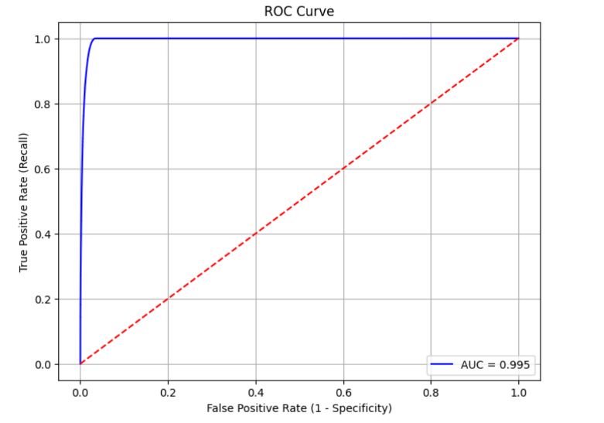Actual Positives: 24678
4. AUC-ROC: 0.995
5. F1 Score: 0.8926
6. Log Loss: 0.04869
7. Confusion Matrix:

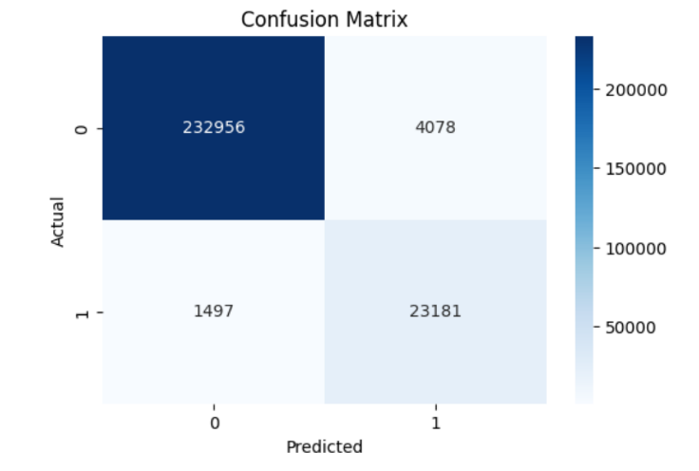

**CITATIONS**

1. Breiman, L. Random Forests. *Machine Learning* **45**, 5–32 (2001)

<https://link.springer.com/article/10.1023/A:1010933404324#citeas>

2. XGBoost: A Scalable Tree Boosting System

<https://doi.org/10.48550/arXiv.1603.02754>

**Libraries Used**: pandas, numpy, scikit-learn, XGBoost, matplotlib, seaborn, pickle