1、使用摄像头和GPU
1、进入makefile :
修改Makefile：
GPU=1
CUDNN=1
OPENCV=1
OPENMP=0
DEBUG=0

ARCH= -gencode arch=compute_53,code=[sm_53,compute_53]
-gencode arch=compute_62,code=[sm_62,compute_62]
# -gencode arch=compute_20,code=[sm_20,sm_21] This one is deprecated?
# This is what I use, uncomment if you know your arch and want to specify
# ARCH= -gencode arch=compute_52,code=compute_52
同时修改对应的cuda版本
- make -j4
- 运行：./darknet detector demo cfg/coco.data cfg/yolov3.cfg yolov3.weights -c 1
4、读取摄像头
./darknet detector demo cfg/coco.data cfg/yolov3-tiny.cfg yolov3-tiny.weights -c 1 使用usb摄像头
./darknet detector demo cfg/coco.data cfg/yolov3-tiny.cfg yolov3-tiny.weights 使用本地摄像头

2、输出指定类别：
./darknet/src/修改image.c或detect.c里的draw_detection函数
更改源码：https://blog.csdn.net/weixin_42183449/article/details/80472069
（https://blog.csdn.net/Limbos/article/details/81949591）
（https://blog.csdn.net/zhangxinyu11021130/article/details/76473193）
data/coco.names中修改：
不需要显示的物体前，加上dont_show
注：如果是自己的数据集，在自己的数据集名字文件中修改
修改image.c中的两句：
dont_show person
bicycle
car
motorbike
aeroplane
bus
train
truck
boat
traffic light
fire hydrant
stop sign
parking meter
bench
bird
cat
dog
horse
sheep
void draw_detections(image im, detection *dets, int num, float thresh, char
**names, image **alphabet, int classes)
{
int i,j;
for(i = 0; i < num; ++i){
char labelstr[4096] = {0};
int class = -1;
for(j = 0; j < classes; ++j){
int show = strncmp(names[j], "dont_show", 9);
if (dets[i].prob[j] > thresh && show){
if (class < 0) {
strcat(labelstr, names[j]);
class = j;
} else {
strcat(labelstr, ", ");
strcat(labelstr, names[j]);
}
printf("%s: %.0f%%\n", names[j], dets[i].prob[j]*100);
}
}
if(class >= 0){
int width = im.h * .006;/*
if(0){
width = pow(prob, 1./2.)*10+1;
alphabet = 0;
}
*/
//printf("%d %s: %.0f%%\n", i, names[class], prob*100);
int offset = class*123457 % classes;
float red = get_color(2,offset,classes);
float green = get_color(1,offset,classes);
float blue = get_color(0,offset,classes);
float rgb[3];
//width = prob*20+2;
rgb[0] = red;
rgb[1] = green;
rgb[2] = blue;
box b = dets[i].bbox;
//printf("%f %f %f %f\n", b.x, b.y, b.w, b.h);
int left = (b.x-b.w/2.)*im.w;
int right = (b.x+b.w/2.)*im.w;
int top = (b.y-b.h/2.)*im.h;
int bot = (b.y+b.h/2.)*im.h;
if(left < 0) left = 0;
if(right > im.w-1) right = im.w-1;
if(top < 0) top = 0;
if(bot > im.h-1) bot = im.h-1;
draw_box_width(im, left, top, right, bot, width, red, green, blue);
if (alphabet) {
image label = get_label(alphabet, labelstr, (im.h*.03));
draw_label(im, top + width, left, label, rgb);
free_image(label);
}
if (dets[i].mask){
image mask = float_to_image(14, 14, 1, dets[i].mask);
image resized_mask = resize_image(mask, b.w*im.w, b.h*im.h);
image tmask = threshold_image(resized_mask, .5);
embed_image(tmask, im, left, top);
free_image(mask);
free_image(resized_mask);
free_image(tmask);
}
}
}
}
修改之后make clean
make
重新编译即可

3、实时保存处理视频
1、第一种方式：只要在demo命令行后面加上"-out_filename output.mp4"即输出保存视频。不用修改源码
2、第二种方式：改源码。修改image.c文件中添加save_video函数
https://blog.csdn.net/sinat_33718563/article/details/79964758

4、图片上添加置信度
https://blog.csdn.net/gaoyu1253401563/article/details/89388043
打开src/image.c文件
找到draw_detections函数然后更改代码如下
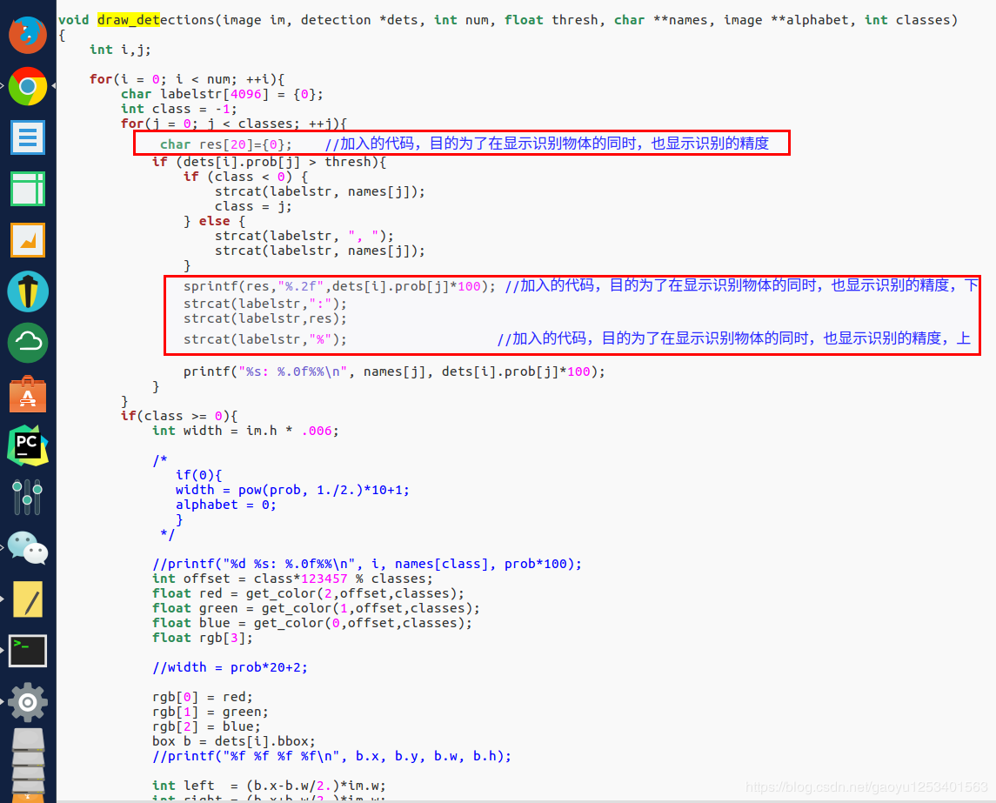

5、批量处理图片并保存
1.用下面代码替换detector.c文件（example文件夹下）的void test_detector函数（注意有3处要改成自己的路径）
void test_detector(char *datacfg, char *cfgfile, char *weightfile, char *filename, float thresh, float hier_thresh, char *outfile, int fullscreen)
{
list *options = read_data_cfg(datacfg);
char *name_list = option_find_str(options, "names", "data/names.list");
char **names = get_labels(name_list);

image **alphabet = load_alphabet();
network *net = load_network(cfgfile, weightfile, 0);
set_batch_network(net, 1);
srand(2222222);
double time;
char buff[256];
char *input = buff;
float nms=.45;
int i=0;
while(1){
if(filename){
strncpy(input, filename, 256);
image im = load_image_color(input,0,0);
image sized = letterbox_image(im, net->w, net->h);
//image sized = resize_image(im, net->w, net->h);
//image sized2 = resize_max(im, net->w);
//image sized = crop_image(sized2, -((net->w - sized2.w)/2), -((net->h - sized2.h)/2), net->w, net->h);
//resize_network(net, sized.w, sized.h);
layer l = net->layers[net->n-1];

float *X = sized.data;
time=what_time_is_it_now();
network_predict(net, X);
printf("%s: Predicted in %f seconds.\n", input, what_time_is_it_now()-time);
int nboxes = 0;
detection *dets = get_network_boxes(net, im.w, im.h, thresh, hier_thresh, 0, 1, &nboxes);
//printf("%d\n", nboxes);
//if (nms) do_nms_obj(boxes, probs, l.w*l.h*l.n, l.classes, nms);
if (nms) do_nms_sort(dets, nboxes, l.classes, nms);
draw_detections(im, dets, nboxes, thresh, names, alphabet, l.classes);
free_detections(dets, nboxes);
if(outfile)
{
save_image(im, outfile);
}
else{
save_image(im, "predictions");
#ifdef OPENCV
cvNamedWindow("predictions", CV_WINDOW_NORMAL);
if(fullscreen){
cvSetWindowProperty("predictions", CV_WND_PROP_FULLSCREEN, CV_WINDOW_FULLSCREEN);
}
show_image(im, "predictions");
cvWaitKey(0);
cvDestroyAllWindows();
#endif
}
free_image(im);
free_image(sized);
if (filename) break;
}
else {
printf("Enter Image Path: ");
fflush(stdout);
input = fgets(input, 256, stdin);
if(!input) return;
strtok(input, "\n");

list *plist = get_paths(input);
char **paths = (char **)list_to_array(plist);
printf("Start Testing!\n");
int m = plist->size;
if(access("/home/FENGsl/darknet/data/out",0)==-1)//"/home/FENGsl/darknet/data"修改成自己的路径
{
if (mkdir("/home/FENGsl/darknet/data/out",0777))//"/home/FENGsl/darknet/data"修改成自己的路径
{
printf("creat file bag failed!!!");
}
}
for(i = 0; i < m; ++i){
char *path = paths[i];
image im = load_image_color(path,0,0);
image sized = letterbox_image(im, net->w, net->h);
//image sized = resize_image(im, net->w, net->h);
//image sized2 = resize_max(im, net->w);
//image sized = crop_image(sized2, -((net->w - sized2.w)/2), -((net->h - sized2.h)/2), net->w, net->h);
//resize_network(net, sized.w, sized.h);
layer l = net->layers[net->n-1];

float *X = sized.data;
time=what_time_is_it_now();
network_predict(net, X);
printf("Try Very Hard:");
printf("%s: Predicted in %f seconds.\n", path, what_time_is_it_now()-time);
int nboxes = 0;
detection *dets = get_network_boxes(net, im.w, im.h, thresh, hier_thresh, 0, 1, &nboxes);
//printf("%d\n", nboxes);
//if (nms) do_nms_obj(boxes, probs, l.w*l.h*l.n, l.classes, nms);
if (nms) do_nms_sort(dets, nboxes, l.classes, nms);
draw_detections(im, dets, nboxes, thresh, names, alphabet, l.classes);
free_detections(dets, nboxes);
if(outfile){
save_image(im, outfile);
}
else{

char b[2048];
sprintf(b,"/home/FENGsl/darknet/data/out/%s",GetFilename(path));//"/home/FENGsl/darknet/data"修改成自己的路径

save_image(im, b);
printf("save %s successfully!\n",GetFilename(path));
#ifdef OPENCV
cvNamedWindow("predictions", CV_WINDOW_NORMAL);
if(fullscreen){
cvSetWindowProperty("predictions", CV_WND_PROP_FULLSCREEN, CV_WINDOW_FULLSCREEN);
}
show_image(im, "predictions");
cvWaitKey(0);
cvDestroyAllWindows();
#endif
}

free_image(im);
free_image(sized);
if (filename) break;
}
}
}
}
- 在前面添加*GetFilename(char *p)函数（注意后面的注释）
#include "darknet.h"
#include <sys/stat.h>
#include<stdio.h>
#include<time.h>
#include<sys/types.h>
static int coco_ids[] = {1,2,3,4,5,6,7,8,9,10,11,13,14,15,16,17,18,19,20,21,22,23,24,25,27,28,31,32,33,34,35,36,37,38,39,40,41,42,43,44,46,47,48,49,50,51,52,53,54,55,56,57,58,59,60,61,62,63,64,65,67,70,72,73,74,75,76,77,78,79,80,81,82,84,85,86,87,88,89,90};

char *GetFilename(char *p)
{
static char name[20]={""};
char *q = strrchr(p,'/') + 1;
strcpy(name,q)
strncpy(name,q,strlen(q)-4);
#strncpy(name,q,6);//注意后面的6，如果你的测试集的图片的名字字符（不包括后缀）是其他长度，请改为你需要的长度（官方的默认的长度是6）
return name;
}

6、更改测试label，box线条粗细及标签大小
/src/image.c
在draw_detections()函数中，get_label函数调用的参数,修改成合适的大小
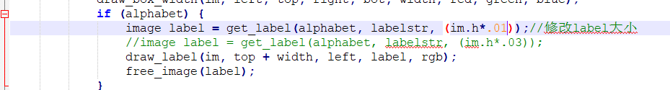

7、更改终端界面输出内容
/src/image.c
printf("%s:%.0f%%\n", names[j], dets[i].prob[j]*100);
8、更改更改训练分辨率大小
/examples/detector.c
- 什么时候保存模型，又要如何更改呢？
迭代次数小于1000时，每100次保存一次，大于1000时，每10000次保存一次。
自己可以根据需求进行更改，然后重新编译即可[ 先 make clean ,然后再 make]
代码位置： examples/detector.c line 138
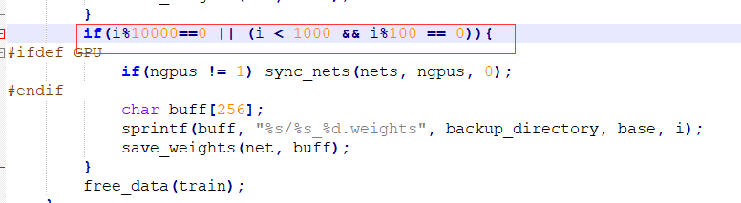

优化：
- 在.cfg文件中设置random=1，可以增加检测精度。此时训练不适用cfg中的分辨率，使用代码src/image.c中的分辨率。
2. 增加input图像尺寸，在.cfg文件中设置（height=608，heigh=608）以上，可以增加检测精度
3. 对.cfg文件中的anchors重新进行聚类
4. 确保数据集中所有的class都有对应的label，检测你的数据集可以使用https://github.com/AlexeyAB/Yolo_mark
5. 所使用的数据集包括同一物体在不同角度、光照、背景、大小下的图片，并且确保训练2000**classes个iterations以上。类别数*每类张数。
6. 确保生成的txt文档不为空
- 数据集最好有没有标注的对象，即负样本，对应空的txt文件，最好有多少图片就设计多少负样本。
- 在训练完成后，进行目标检测的时候，可以提高网络的分辨率，以便刚好检测小目标：
- 不需要重新训练，需要先试用低分辨率的权重，测试使用更高的分辨率，测试时调高cfg中w h的 值。
- 为了得到更高的检测结果，就可以提升分辨率608*608至832*832
- 损失函数调优（https://blog.csdn.net/qwedsaewq/article/details/89137126）
- 使用专门针对背景的focal loss
- 使用senet通道加权层
- 使用GIOU loss
- GHMC loss

