### Python installation.

- Open the downloaded installer file.

<https://www.python.org/ftp/python/3.13.1/python-3.13.1-amd64.exe>

- In the installer, check the box that says Add Python to PATH (important for running Python from the command line).

- Click "**Install Now**” or “ **Customize Installation**” if you want to choose specific features.

- Wait for the installation to complete and then click Close.

- Verify Python Installation.

Open the terminal (or Command Prompt).

Type : “**python --version**”

You should see a version number (e.g., **Python 3.13.0**), confirming that Python is installed.

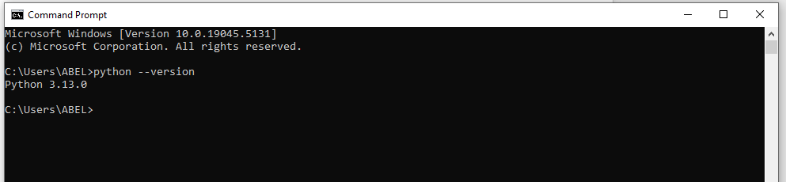

#### Getting the credentials.json file to access the Google Calendar API.

1. **Enable the Google Calendar API**

- Go to the Google Cloud Console. <https://console.cloud.google.com/>

- Log in with your Google account.

- Create a new project.

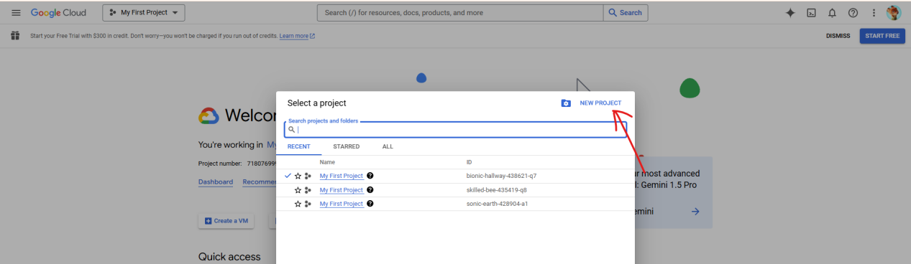

Enter a project name (e.g., "Calendar API Project") and click Create.

- Enable the API.

In the Google Cloud Console, go to the APIs & Services > Library.

Search for "Google Calendar API."

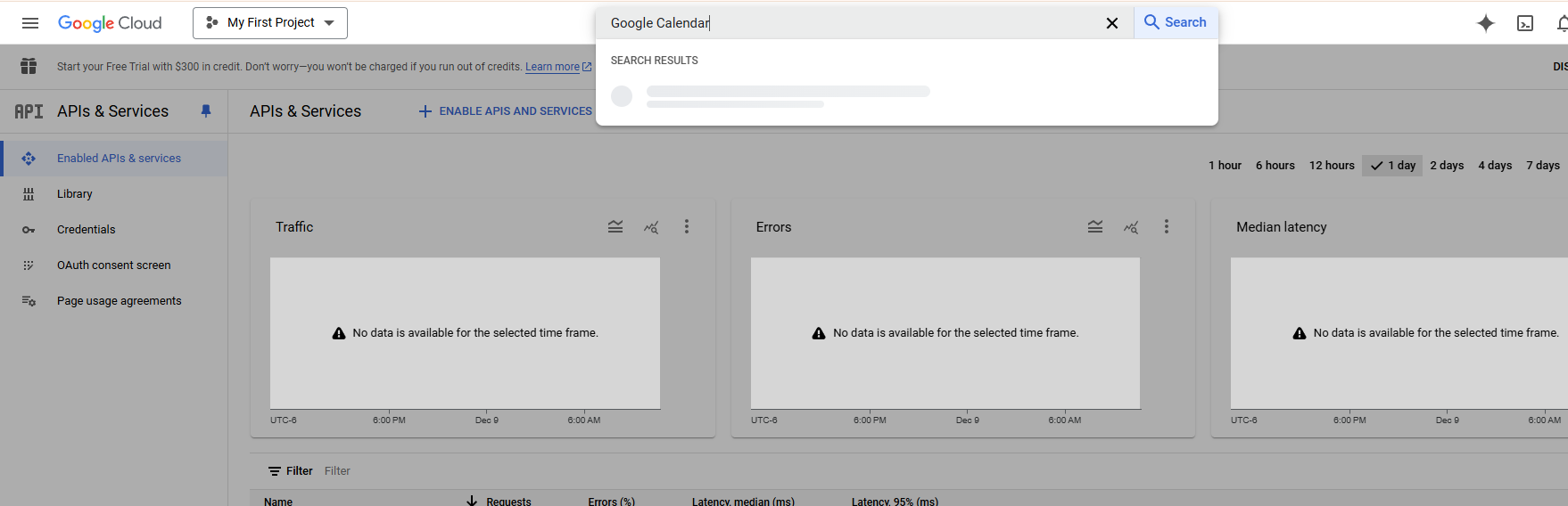

Click on it and then click the Enable button.

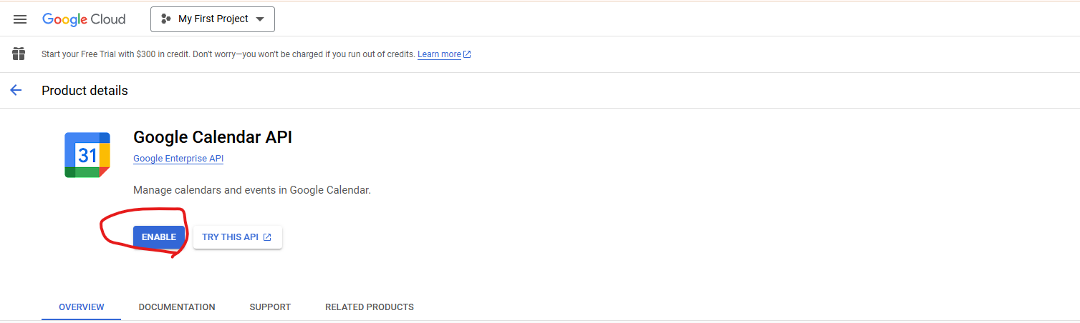

1. **Set Up OAuth 2.0 Credentials**

- Go to APIs & Services > Credentials in the Google Cloud Console.

- Click Create Credentials > OAuth Client ID.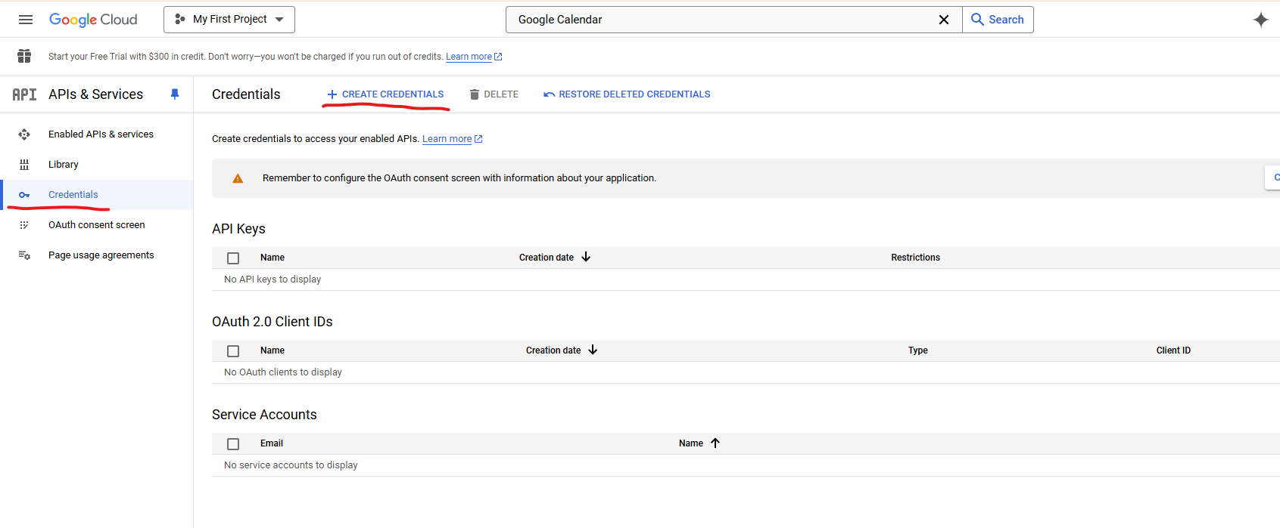

- Configure the consent screen (if prompted):

Choose "**External**" as the user type.

Fill in the required fields (e.g., app name, user support email).

Add a developer email and save.

- Select Application type as **Desktop App.**

- Give it a name (e.g., "Calendar API Client") and click Create.

- A dialog will appear with your Client ID and Client Secret. Click Download JSON to save the credentials.json file.

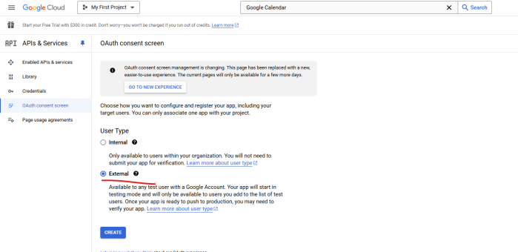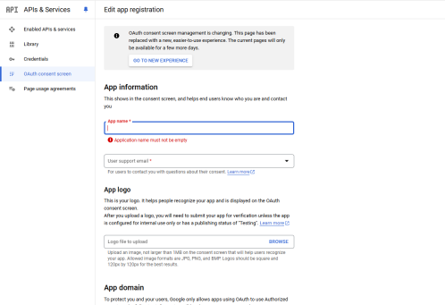

### Installing Python packages.

1. Copy “**credentials.json**” file and Paste to “auto-open-meeting” folder.
2. Go to “**auto-open-meetings**” folder and Run “**package_install.bat**”.
3. Run “run.bat”, You will see the Chrome browser running and need to sign in with your google account.
4. And you will see a new file, “token.pickle”

#### Installing your browser with your google account and zoom account

1. Run “chrome_install.bat” file.

- You will see the new chrome brower. You need to sign in with your google account in this browser.

If you can’t sign in with your google account, you can cancle the browser and run “chrome_install.bat” file again.

- From that time if you run “chrome_install.bat” file, you can see the browser with your google account and you need to login with **zoom** account in this broswer.

1. Installing Zoom account in your google browser.

- Run “chrome_install.bat” file. You will see the browser with your google account.

In this browser, you can sign in with your Zoom account. For example, in this browser, you can join the test Zoom meeting manually. If you installed zoom app in your pc, you can see following alert message. You can click “cancel” and join the meeting manually.

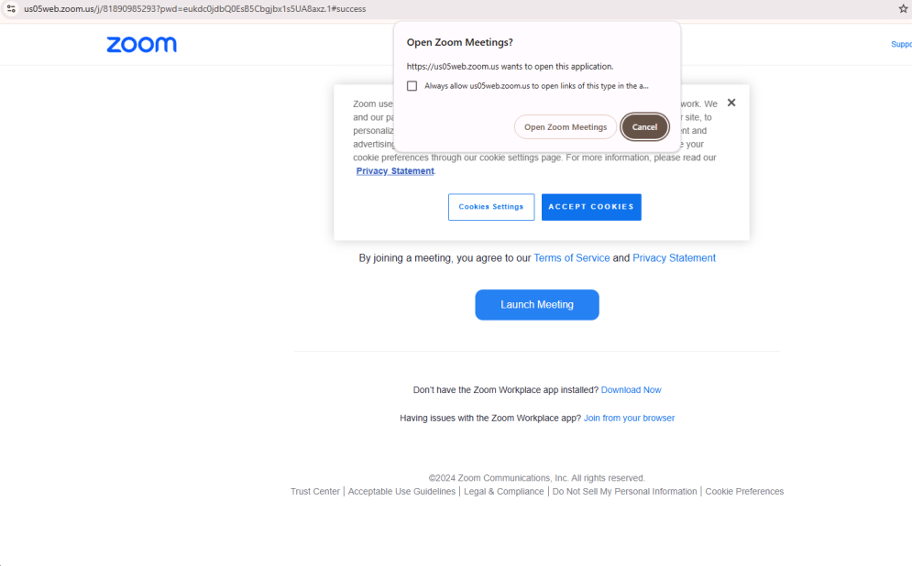

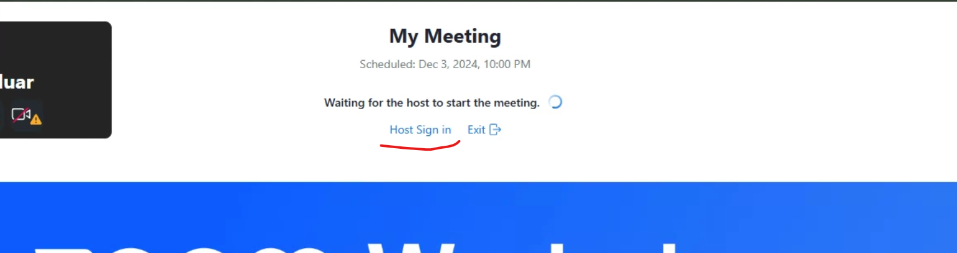

You need to click “Host Sign in” button and you can sign in with your zoom account to store zoom session into this browser.

In this browser, you should pass the whole zoom meeting join process to store session.

After that, this manual action will not be needed.

#### Run “run.bat” file.

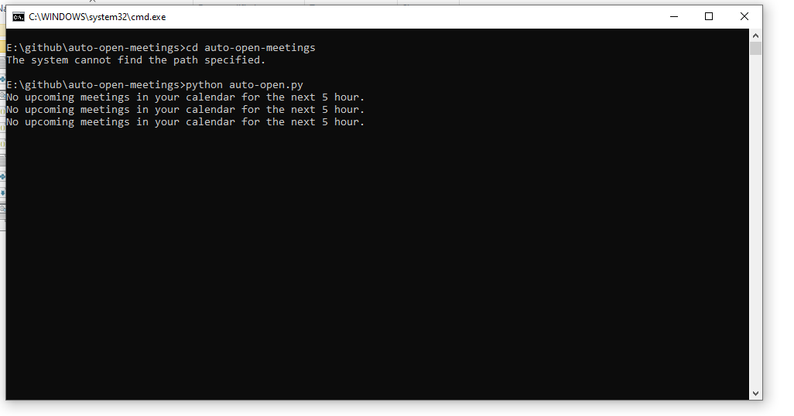

You will see this window.

If you want to make the bot disactive, you can cancel this window manually.

#### Running this bot automatically everyday.

- Copy the “auto-open-meetings” folder and Paste to “C:\Windows\System32”.

- Click “win+R” and Type “shell:startup” and Click OK

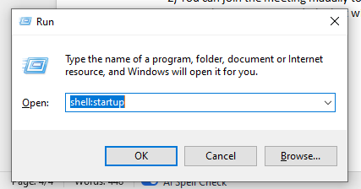

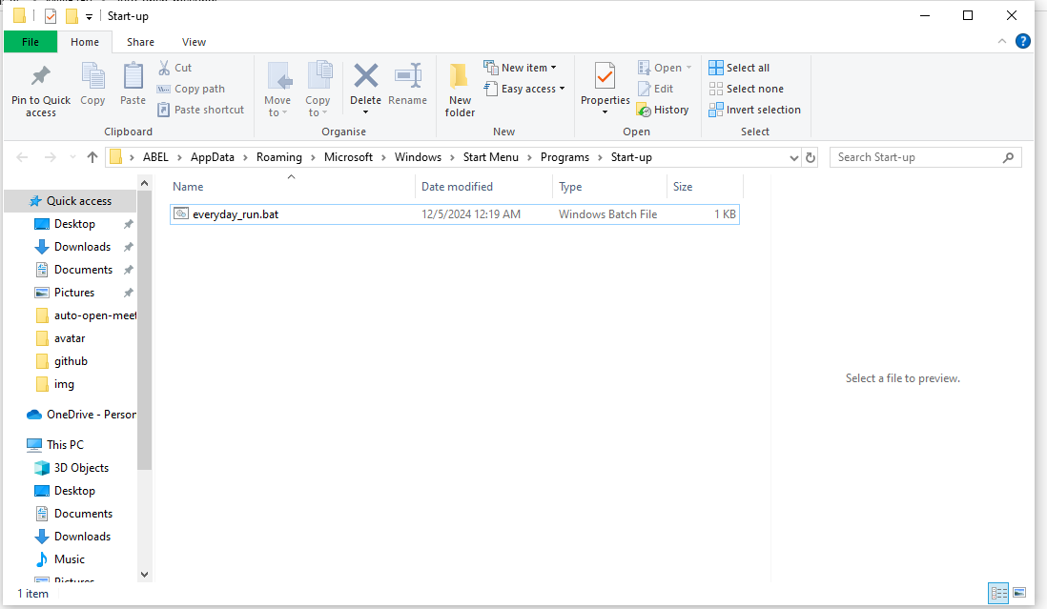

You will see this folder “C:\Users\ABEL\AppData\Roaming\Microsoft\Windows\Start Menu\Programs\Startup”

- Copy “everyday_run.bat” file and Paste to this folder.

If you restart the pc, the bot will open automatically.