Databricks Exam Guide for Databricks Certified Data Engineer Associate

Audience Description
The Databricks Certified Data Engineer Associate certification exam assesses an individual’s ability
to use the Databricks Data Intelligence Platform to complete introductory data engineering tasks.
This includes an
- understanding of the Data Intelligence Platform, and its workspace, its
architecture, and its capabilities
- ability to perform ETL tasks using Apache Spark SQL or PySpark, covering extraction, complex data handling, and user-defined functions.
- ability to deploy and orchestrate workloads with Databricks workflows, configuring and scheduling jobs effectively.
Individuals who pass this certification exam can be expected to complete basic data engineering tasks using Databricks and its associated tools.

About the Exam
● Number of scored items: 45 scored multiple-choice questions.
● Time limit: 90 minutes.
● Registration fee: USD 200
● Delivery method: Online or test center
● Test aides: None allowed
● Prerequisite: None required; course attendance and six months of hands-on experience in
Databricks are highly recommended.
● Validity: 2 years.
● Recertification: Recertification is required every two years to maintain your certified status.
To recertify, you must take the full exam that is currently live. Please review the “Getting
Ready for the Exam” section on the exam webpage to prepare for retaking the exam.
● Unscored Content: Exams may include unscored items to gather statistical information for
future use. These items are not identified on the form and do not impact your score.
Additional time is factored into account for this content.
Recommended Training
● Instructor-led: Data Engineering with Databricks
● Self-paced (available in Databricks Academy):
○ Data Ingestion with Lakeflow Connect
○ Deploy Workloads with Lakeflow Jobs
○ Build Data Pipelines with Lakeflow Spark Declarative pipeline.
○ DevOps Essentials for Data Engineering.

Exam outline

Section 1: Databricks Intelligence Platform
● Enable features that simplify data layout decisions and optimize query performance.
● Explain the value of the Data Intelligence Platform.
● Identify the applicable compute to use for a specific use case.

Section 2: Development and Ingestion
● Use Databricks Connect in a data engineering workflow.
● Determine the capabilities of the Notebooks functionality.
● Classify valid Auto Loader sources and use cases.
● Demonstrate knowledge of Auto Loader syntax.
● Use Databricks' built-in debugging tools to troubleshoot a given issue.

Section 3: Data Processing & Transformations
● Describe the three layers of the Medallion Architecture and explain the purpose of each
layer in a data processing pipeline.
● Classify the type of cluster and configuration for optimal performance based on the
scenario in which the cluster is used.
● Emphasize the advantages of Lakeflow Spark Declarative Pipelines (for ETL process in
Databricks).
● Implement data pipelines using Lakeflow Spark Declarative Pipelines.
● Identify DDL (Data Definition Language)/DML features.
● Compute complex aggregations and Metrics with PySpark Dataframes.

Section 4: Productionizing Data Pipelines
● Identify the difference between DAB and traditional deployment methods.
● Identify the structure of Asset Bundles.
● Deploy a workflow, repair, and rerun a task in case of failure.
● Use serverless for a hands-off, auto-optimized compute managed by Databricks.
● Analyzing the Spark UI to optimize the query.

Section 5: Data Governance & Quality
● Explain the difference between managed and external tables.
● Identify the grant of permissions to users and groups within UC.
● Identify key roles in UC.
● Identify how audit logs are stored.
● Use lineage features in Unity Catalog.
● Use the Delta Sharing feature available with Unity Catalog to share data.
● Identify the advantages and limitations of Delta sharing.
● Identify the types of delta sharing: Databricks vs. external systems.
● Analyze the cost considerations of data sharing across clouds.
● Identify Use cases of Lakehouse Federation when connected to external sources.

Sample Questions
These questions are retired from a previous version of the exam. The purpose is to show you the
objectives as they are stated on the exam guide, and give you a sample question that aligns with
the objective. The exam guide lists the objectives that could be covered on an exam. The best way
to prepare for a certification exam is to review the exam outline in the exam guide.

Question 1
Objective: Compute complex aggregations and Metrics with PySpark Dataframes
A data engineer is curating data in the silver layer of a hospital management data warehouse
system. The data engineer is trying to aggregate hospital billing data from a table
patient_billing to generate a daily revenue fact table daily_revenue

Assume this as a sample of the dataframe billing_df:
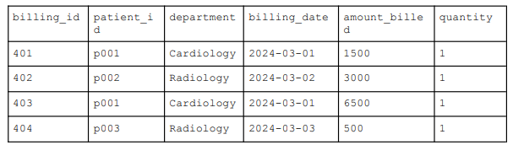
Which code snippet aggregates the amount billed per day with the unique invoices from a
Dataframe billing_df?

A. daily_revenue_df = billing_df.groupBy("billing_date").agg(
sum("amount_billed").alias("total_revenue"),
sum("billing_id").alias("total_invoices")
)
B. daily_revenue_df = billing_df.groupBy("billing_date").agg(
col("amount_billed").alias("total_revenue"),
count("billing_id").alias("total_invoices")
)
C. daily_revenue_df = billing_df.groupBy("billing_date").agg(
sum("amount_billed").alias("total_revenue"),
count_distinct("patient_id").alias("total_invoices")
)
D. daily_revenue_df = billing_df.groupBy("billing_date").agg(
sum("amount_billed").alias("total_revenue"),
count_distinct("billing_id").alias("total_invoices")
)

Question 2
Objective: Identify grant of permissions to users and groups within UC
A data engineer is working on a Databricks project with a schema named sales_data that stores
transactional sales information. The analyst group, responsible for analyzing this data, needs
read-only access to the sales_data schema.

Which SQL command should the data engineer use to grant the analyst group read-only access to
the sales_data schema, assuming that the analyst group already has USE CATALOG and USE
SCHEMA permissions?

A. GRANT ALL PRIVILEGES ON SCHEMA sales_data TO analysts;
B. GRANT SELECT ON SCHEMA sales_data TO analysts;
C. GRANT INSERT ON SCHEMA sales_data TO analysts;
D. GRANT SELECT ON ALL TABLES IN SCHEMA sales_data TO analysts;

Question 3
Objective: Use the Delta Sharing feature available with Unity Catalog to share data
A data engineer is configuring Delta Sharing for a multi-team project where teams
from different departments will need to access shared data. The data engineer has
successfully created a Unity Catalog metastore and is now setting up the Delta
Share. The goal is to ensure that internal teams can access the data with full
permissions, while external partners can only read the shared data.

Which action should the Data Engineer take to configure the sharing?
A. Grant READ permissions to external partners through the Delta Share and
READ/WRITE permissions to internal teams on Unity Catalog.
B. Create a Delta Share, add the internal team's tables and views, and assign
READ/WRITE permissions to both external partners and internal teams.
C. Create READ permissions to external partners and READ/WRITE permissions
to internal teams through Delta Share.
D. Create a Delta Share, set up a secure access URL for internal teams and
external partners, and distribute the URL to provide them access to the
shared data.
Question 4
Objective: Identify DDL (Data Definition Language)/DML features
A data engineer has determined that a table of the following format is necessary:
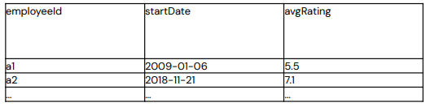

Which code block is used by SQL DDL command to create an empty Delta table in the above
format, regardless of whether a table already exists with this name?

A. CREATE OR REPLACE TABLE table_name ( employeeId STRING, startDate
DATE, avgRating FLOAT )
B. CREATE TABLE IF NOT EXISTS table_name ( employeeId STRING,
startDate DATE, avgRating FLOAT )
C. CREATE TABLE table_name AS SELECT employeeId STRING, startDate
DATE, avgRating FLOAT
D. CREATE OR REPLACE TABLE table_name WITH COLUMNS ( employeeId
STRING, startDate DATE, avgRating FLOAT ) USING DELTA

Question 5
Objective: Identify DDL (Data Definition Language)/DML features.
A data engineer has been given a new record of data:
id STRING = 'a1'
rank INTEGER = 6
rating FLOAT = 9.4

Which SQL command can be used to append the new record to an existing Delta table my_table?

A. UPDATE VALUES ('a1', 6, 9.4) my_table
B. UPDATE my_table VALUES ('a1', 6, 9.4)
C. INSERT VALUES ('a1', 6, 9.4) INTO my_table
D. INSERT INTO my_table VALUES ('a1', 6, 9.4)

Crystal Answer

Section 1: Databricks Intelligence Platform

● Enable features that simplify data layout decisions and optimize query performance.

This typically involves enabling two core technologies: Liquid Clustering and Predictive Optimization.

1. Liquid Clustering (Replacing Partitioning)
Traditionally, data engineers had to decide how to "partition" a table (e.g., by date or country). If they chose the wrong column, query performance suffered.
- Simplification: You use the CLUSTER BY command on up to four columns. You don’t need to worry about the order of columns or their cardinality (how many unique values they have).

- In Databricks, the CLUSTER BY command is used to enable Liquid Clustering, a modern data layout technique that replaces traditional partitioning and Z-ordering. It allows you to specify up to four columns to optimize data skipping and improve query performance without manual tuning.
- 1. Basic SQL Syntax
  - Creating a new table or by altering an existing unpartitioned table:

CREATE TABLE table_name (
col0 INT,
col1 STRING,
col2 DATE
)
CLUSTER BY (col0, col2); -- Specify up to 4 clustering keys
```
  - Creating from existing data (CTAS)

CREATE TABLE new_table
CLUSTER BY (col0)
AS SELECT * FROM source_table;
```
  - Altering an existing table

ALTER TABLE table_name
CLUSTER BY (new_col1, new_col2);
```
- 2. Python (PySpark) Syntax
  - In Databricks Runtime 14.2 and above, you can use the DataFrame API or DeltaTable API.

  - Writing a DataFrame to a clustered table
df.write.clusterBy("col0").saveAsTable("table_name")
```

  - Using the DeltaTable API (Create):
from delta.tables import *
(DeltaTable.create()
.tableName("table_name")
.addColumn("col0", "INT")
.clusterBy("col0")
.execute())
```

- 3. Automatic Liquid Clustering
  - In Databricks Runtime 15.4 LTS and above, you can use CLUSTER BY AUTO to let Databricks intelligently select clustering keys based on your actual query patterns.

ALTER TABLE table_name CLUSTER BY AUTO;
```

### 4. Triggering the Optimization
Simply setting the clustering keys does not immediately reorganize existing data. You must run the `OPTIMIZE` command to physically group the data according to the keys.
* **Run incremental optimization:** `OPTIMIZE table_name;`
* **Force full reclustering (DBR 16.0+):** `OPTIMIZE table_name FULL;`

### Best Practices for Selecting Keys
* **Frequency**: Choose columns most frequently used in your query `WHERE` filters.
* **Correlation**: If two columns are highly correlated (like `Date` and `Timestamp`), only pick one as a clustering key.
* **Limitations**: `CLUSTER BY` is incompatible with Hive-style partitioning and `ZORDER BY`. If a table is already partitioned, you cannot enable liquid clustering on it.

- Optimization: Databricks automatically organizes data into "clusters." If your query patterns change, you can redefine the clustering keys without rewriting the entire table.

2. Predictive Optimization (AI-Driven Maintenance)
This feature uses AI to learn from your query patterns and automatically perform background maintenance tasks.
- Automatic OPTIMIZE: It compacts small files into larger ones to reduce overhead and triggers incremental clustering for tables using Liquid Clustering.
- Automatic ANALYZE: It gathers table statistics so the query optimizer can choose the fastest way to run your code (e.g., picking the best join strategy).
- Automatic VACUUM: It removes old, unreferenced data files to save on storage costs.

Key Benefits
- No Manual Tuning: Removes the need to manually schedule maintenance jobs or guess the best partitioning strategy.
- Performance: Can result in queries running up to 20x faster.
- Cost Efficiency: Reduces storage costs by up to 50% by cleaning up unused files.

● Explain the value of the Data Intelligence Platform.

1. AI-Driven Automation (Predictive Optimization)
- Instead of data engineers manually tuning tables, the platform uses AI to automatically optimize storage. It looks at your query patterns and applies techniques like Z-Ordering or indexing on its own. This reduces manual labor and lowers cloud costs.
- DatabricksIQ/ Databricks Assistant acts as a "self-driving" mechanism for your data storage. Instead of engineers manually running maintenance tasks, the platform uses AI to observe how you use your data and tunes it automatically.
- Example:
  - In a standard database, an engineer might have to manually run a command to Z-Order a sales table by customer_id to speed up searches.
- Databricks Value:
  - The platform identifies that you frequently filter by customer_id and performs this optimization in the background. This reduces manual labor and ensures your queries stay fast and cost-effective without human intervention.

2. Natural Language for Everyone (AI/BI Genie)
- It bridges the gap between technical and business teams. Through tools like Databricks Assistant or AI Functions, a user can ask, "Which customers are at risk of churning?" The platform understands the underlying schemas and generates the SQL or Python needed to find the answer.
- This feature democratizes data by allowing anyone to interact with datasets using plain English instead of SQL.
- Example:
  - A marketing manager wants to know "Which region had the highest growth in organic web traffic last month?"
- Databricks Value:
  - Through AI/BI Genie, the manager types that exact question into a chat interface. The platform translates it into a complex SQL join, retrieves the data, and can even suggest a visualization (like a bar chart) to show the trend.

3. Unified Governance with Unity Catalog
- The "Intelligence" layer acts as a brain for your entire data estate. It tracks lineage (where data came from and where it went) across files, tables, and Machine Learning models in one place. This makes compliance and security much easier than managing separate silos.
- Unity Catalog provides a single "pane of glass" to manage security and permissions for all your assets, including tables, files, and AI models.
- Example:
  - A health insurance company needs to ensure that only authorized doctors can see "Patient Records" while masking sensitive ID numbers for researchers.
- Databricks Value:
  - With Unity Catalog, an admin sets a single "Data Masking" policy. This policy follows the data everywhere—whether it's being used in a dashboard, a Python notebook, or an AI model—ensuring consistent compliance across the entire organization.

4. Better Machine Learning (LLM-Ready)
- Because the platform is "data-aware," it makes it easier to build custom AI. You can use your own private company data to "teach" an LLM (using RAG or fine-tuning) without the data ever leaving your secure environment.
- The platform integrates AI development directly into the data layer, making it easier to build "company-aware" AI.
- Example:
  - A company wants to build a customer support chatbot that knows their specific product manuals and return policies.
- Databricks Value:
  - Using Mosaic AI, the team can connect an LLM (like Llama 3) to their governed PDF manuals stored in Unity Catalog. Because the AI "lives" where the data is, it can provide accurate answers (via RAG) while following all the security rules already set up in the platform.

● Identify the applicable compute to use for a specific use case.

1. SQL Analytics & BI (Dashboards)
- Applicable Compute: Serverless SQL Warehouse.
- Why: Specifically optimized for SQL performance with nearly instant startup (2–6 seconds) and rapid scaling to handle multiple concurrent users.
- Best For: Power BI/Tableau connections, ad-hoc SQL queries, and the AI/BI Genie natural language interface.

2. Automated Production Pipelines (ETL)
- Applicable Compute: Serverless Jobs Compute or Classic Jobs Compute.
- Why:
  - Serverless Jobs: Recommended for most automated workloads because it removes the need for infrastructure configuration and scales automatically based on the task's complexity.
  - Classic Jobs: Use this for long-running, stable ETL (over 30 minutes) where you need precise control over Spark configurations or specific instance types to keep costs predictable.

3. Interactive Data Science & Prototyping
- Applicable Compute: Serverless Compute for Notebooks or All-Purpose Compute.
- Why:
  - Serverless: Ideal for ad-hoc Python/SQL analysis; it starts instantly so data scientists don't wait for clusters to spin up.
  - All-Purpose (Classic): Necessary when you require specific legacy features, custom libraries not in serverless, or R language support.

4. Machine Learning & Model Development
- Applicable Compute: Databricks Runtime for ML (on Single-Node or Multi-Node clusters).
- Why: These clusters come pre-configured with ML libraries (TensorFlow, PyTorch, Scikit-learn) and GPU support.
- Best For: Training models, deep learning, and initial experimentation using the Personal Compute policy.

Summary Recommendation Table
Use Case | Recommended Compute Type | Primary Benefit
BI & SQL Queries | Serverless SQL Warehouse | High concurrency & fast startup
Scheduled ETL | Serverless Jobs | No management & auto-scaling
Exploratory DS | Serverless for Notebooks | Instant availability for Python/SQL
ML Training | ML Runtime (GPU/Memory Opt) | Pre-built AI infrastructure
Real-time Scoring | Model Serving | Low-latency REST API endpoints

Choose compute for your interactive notebooks
Compute type | When to use
Serverless compute | Generally recommended. Offers faster start-up, automatic scaling, and lower cost.
Serverless SQL warehouse | For SQL-based analytics and reporting. Optimized for SQL query performance.
Classic all-purpose compute | When you need RDD APIs, GPU instances, or R language support.

Section 2: Development and Ingestion

● Use Databricks Connect in a data engineering workflow.
Databricks Connect is a client library for the Databricks Runtime that allows you to connect to Azure Databricks compute from IDEs such as Visual Studio Code, PyCharm, and IntelliJ IDEA, notebooks and any custom application, to enable new interactive user experiences based on your Azure Databricks Lakehouse.
Databricks Connect is available for the following languages:
- Databricks Connect for Python
- Databricks Connect for R
- Databricks Connect for Scala

What can I do with Databricks Connect?
Using Databricks Connect, you can write code using Spark APIs and run them remotely on Azure Databricks compute instead of in the local Spark session.
- Interactively develop and debug from any IDE. Databricks Connect enables developers to develop and debug their code on Databricks compute using any IDE's native running and debugging functionality. The Databricks Visual Studio Code extension uses Databricks Connect to provide built-in debugging of user code on Databricks.
- Build interactive data apps. Just like a JDBC driver, the Databricks Connect library can be embedded in any application to interact with Databricks. Databricks Connect provides the full expressiveness of Python through PySpark, eliminating SQL programming language impedance mismatch and enabling you to run all data transformations with Spark on Databricks serverless scalable compute.

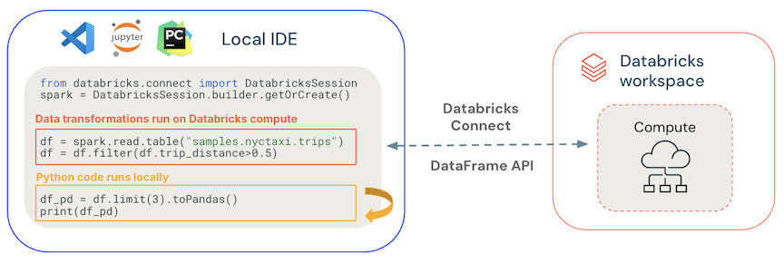
How does it work?
Databricks Connect is built on open-source Spark Connect, which has a decoupled client-server architecture for Apache Spark that allows remote connectivity to Spark clusters using the DataFrame API. The underlying protocol uses Spark unresolved logical plans and Apache Arrow on top of gRPC. The client API is designed to be thin, so that it can be embedded everywhere: in application servers, IDEs, notebooks, and programming languages.
- General code runs locally: Python and Scala code runs on the client side, enabling interactive debugging. All code is executed locally, while all Spark code continues to run on the remote cluster.
- DataFrame APIs are executed on Databricks compute. All the data transformations are converted to Spark plans and run on the Databricks compute through the remote Spark session. They are materialized on your local client when you use commands such as collect(), show(), toPandas().
- UDF code runs on Databricks compute: UDFs(user-defined functions) defined locally are serialized and transmitted to the cluster where it runs. APIs that run user code on Databricks include: UDFs, foreach, foreachBatch, and transformWithState.
- For dependencies management:
  - Install application dependencies on your local machine. These run locally and need to be installed as part of your project, such as part of your Python virtual environment.
  - Install UDF dependencies on Databricks. See Manage UDF dependencies.

● Determine the capabilities of the Notebooks functionality.
● Classify valid Auto Loader sources and use cases.
● Demonstrate knowledge of Auto Loader syntax.
● Use Databricks' built-in debugging tools to troubleshoot a given issue.

sample code in spark to ingest data on another server in text raw file:

To ingest a raw text file from another server into Spark, the method depends on how that server is accessible. Since Spark executors need to read the data, you generally cannot use a local file path (like C:/ or /home/user/) unless the file is on a shared network drive.

Option 1: SFTP (Secure File Transfer)
This is the most common way to pull data from a remote Linux/Unix server. You can use the Databricks SFTP Connector or a third-party library like com.springml.spark.sftp.

# Using the Databricks SFTP Connector (Runtime 17.3+)
df = (spark.read
.format("sftp")
.option("host", "remote-server.com")
.option("port", "22")
.option("username", "my_user")
.option("password", "my_password") # Or use a key file
.load("/path/to/remote/file.txt"))

df.show()

Option 2: Cloud Storage (S3, ADLS, GCS)
If "another server" refers to cloud storage, Spark can read these natively using URI protocols like s3a://, abfss://, or gs://.

# Example for Azure Data Lake Storage (ADLS Gen2)
path = "abfss://container@account.dfs.core.windows.net/folder/data.txt"

df = spark.read.text(path)
df.show()

Option 3: Shared Network Mount (NFS/SMB)
If the remote server's drive is mounted to your Spark cluster's nodes (e.g., via NFS), you can treat it like a local file.

# Ensure the mount point exists on all cluster nodes
df = spark.read.text("file:///mnt/network_share/data.txt")

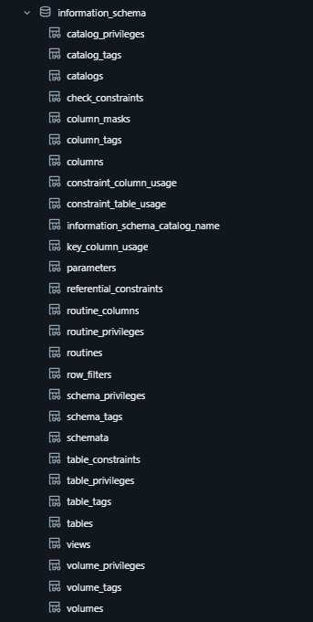 | 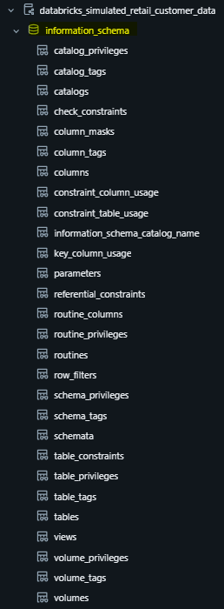

Index
- cardinality - Data with high cardinality refers to data columns or sets containing a large proportion of unique, distinct values relative to the total number of rows. (High Uniqueness: Columns have very few, if any, duplicate values ). Common examples include IDs, timestamps, or email addresses. While useful for detailed analysis, this data often causes, slow queries, poor compression, and increased storage costs.

- z-order - Normally, when data is saved in a data lake, it is written randomly. If you try to query for specific customers (e.g., WHERE customer_id = 123), the system might have to read thousands of files scattered across the storage. Z-Ordering organizes data by multiple columns at once (e.g., ZORDER BY (city, date)). It rearranges data so that rows with similar values in those columns end up in the same physical file. When you query, the system uses "data skipping" to ignore files that don't contain your data.

