Marketplace - Simulated Retail Customer Data
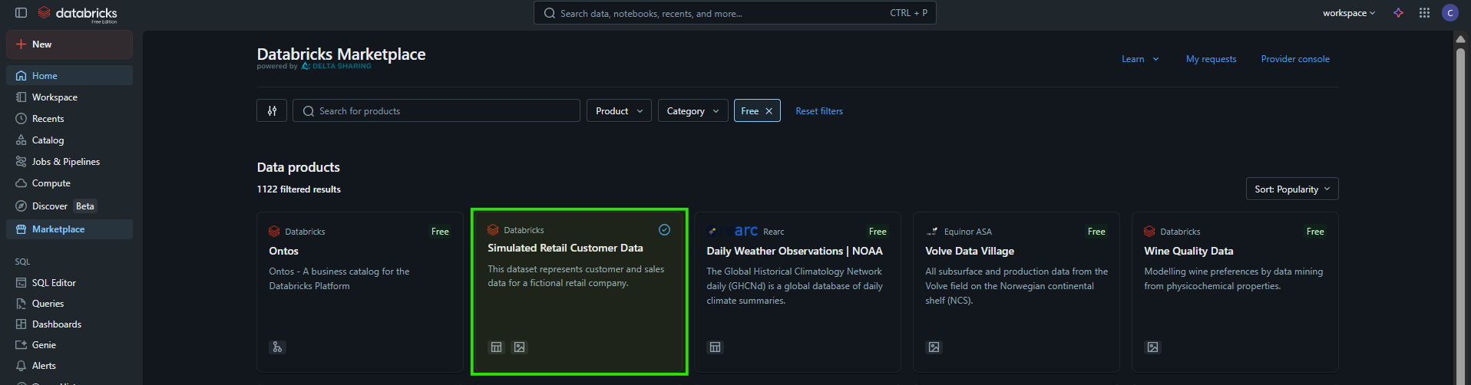
Simulated Retail Customer Data

Overview
This collection provides a comprehensive set of synthetic retail datasets designed for hands-on training with Lakeflow Spark Declarative Pipelines and general data ingestion patterns. All data is fully fictional and formatted as CSV or JSON files to mirror common real-world retail ingestion scenarios.
This share contains two schemas with tables and volumes:
- v01
- v02
NOTE: All data is synthetically generated and does not represent real customers or transactions.

v01 - Schema
This schema contains three tables: customers, sales, and sales_orders. Each representing core records of a fictional retail company.
These datasets accompany the Get Started with Databricks for Data Analysis course on Databricks Academy.

Tables
- customers – Customers located in the US who purchase finished goods.
- sales – Individual item-level sales transactions.
- sales_orders – The originating purchase orders associated with each customer transaction.

Volumes
source_files
Contains the raw CSV files used to build the three core tables.
- customers.csv
- sales.csv
- sales_orders.csv
retail-pipeline
Simulates a streaming data landing zone with three subdirectories:
- customers – JSON files representing new, updated, or deleted customers.
- orders – JSON files representing order activity.
- status – JSON files representing order status updates.

v02 - Schema
This schema contains seven days of order drops for three fictional retail subsidiaries, spanning 2025-11-01 through 2025-11-07. Each subsidiary contributes one file per day, using its own format and structure.
The dataset is designed for workshops using Lakeflow Spark Declarative Pipelines (SDP) to demonstrate ingestion with Auto Loader, schema normalization, and other core SDP features. It is also suitable for general ingestion and processing from cloud storage.

Volumes
subsidiary_daily_orders
This volume contains three directories, each simulating daily order drops:
- bright_home_orders – Daily CSV files with home goods order activity.
- lumina_sports_orders – Daily CSV files for outdoor and athletic gear purchases.
- northstar_outfitters_orders – Daily JSON files for camping and travel product orders.
business_daily_events
Simulates a unified business event stream used across subsidiaries. Each day contains a mixed set of operational events stored as a single JSON file. These files are intended for showcasing multiplex routing in Lakeflow Spark Declarative Pipelines and include three distinct event groups:
- Store operations
- Marketing campaign activity
- Logistics and fulfillment events
customer_changes_daily
Contains seven days of customer change events in JSON format, including new signups, profile updates, and deletions. Customers first appear on the day they are observed in real subsidiary orders, providing a CDC feed aligned with downstream SCD Type 2 processing and analytics.

Structure in Catalog
Delta Shares Received  databricks_simulated_retail_customer_data  1. information_schema  2. v01  > Tables(3)  >> customers  >> sales  >> sales_orders  > Volumes(2)  >> retail-pipeline  >>> README.md  >>> customers  >>>> stream_json  >>>>> 00.json  >>>>> 01.json  >>>>> 02.json  >>>>> ...  >>>>> 30.json  >>> orders  >>>> stream_json  >>>>> 00.json  >>>>> 01.json  >>>>> 02.json  >>>>> ...  >>>>> 30.json  >>> status  >>>> stream_json  >>>>> 00.json  >>>>> 01.json  >>>>> 02.json  >>>>> ...  >>>>> 30.json  >> source_files  >>> customers.csv  >>> sales.csv  >>> sales_orders.csv  3. v02  > business_daily_events  >> retail_business_events_2025-11-01.json  >> retail_business_events_2025-11-02.json  >> ...  >> retail_business_events_2025-11-07.json  > customer_changes_daily  >> customer_changes_2025-11-01.json  >> customer_changes_2025-11-02.json  >> ...  >> customer_changes_2025-11-07.json  > subsidiary_daily_orders  >> bright_home_orders  >>> bsh_orders_2025-11-01.csv  >>> bsh_orders_2025-11-02.csv  >>> ...  >>> bsh_orders_2025-11-07.csv  >> lumina_sports_orders  >>> lms_orders_2025-11-01.csv  >>> lms_orders_2025-11-02.csv  >>> ...  >>> lms_orders_2025-11-07.csv  >> northstar_outfitters_orders  >>> nso_orders_2025-11-01.json  >>> nso_orders_2025-11-02.json  >>> ...  >>> nso_orders_2025-11-07.json | 