1、Exercise 1 - ls, cd, pwd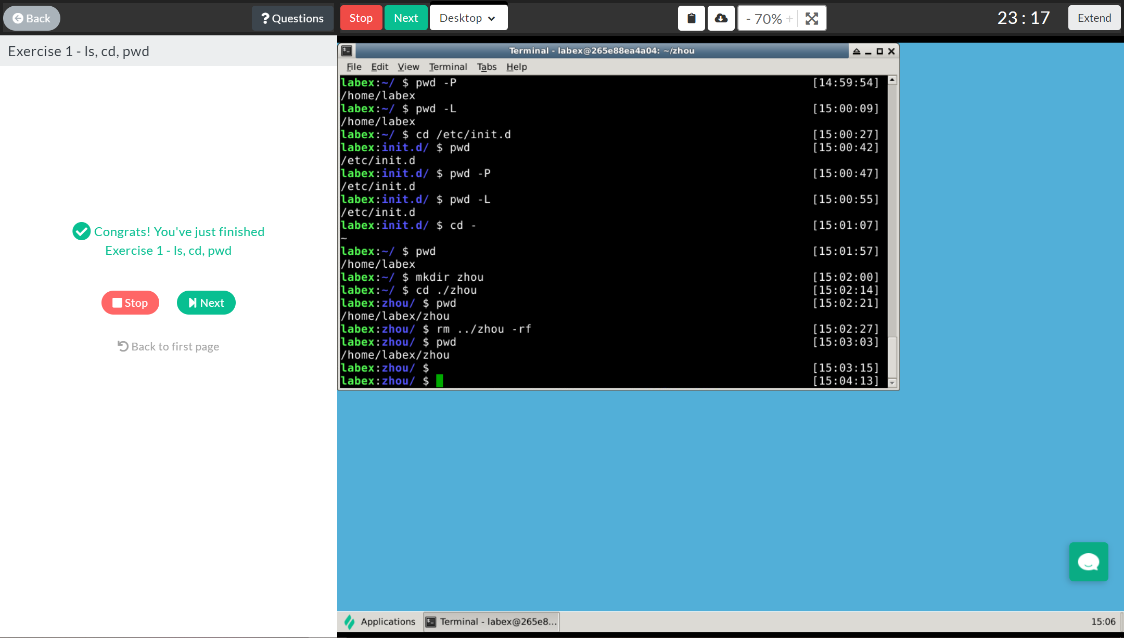

2、Exercise 2 - mkdir, rm, mv, cp, cat, nl

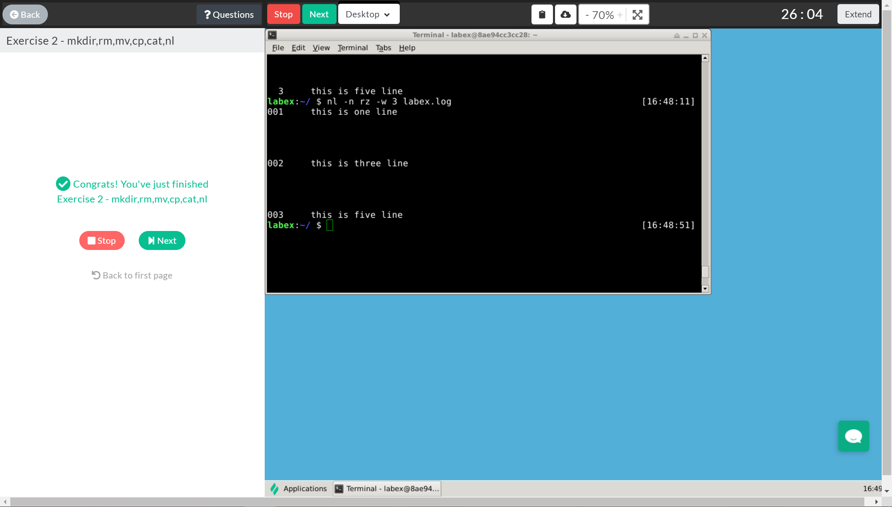

3、Exercise 3 – more, less, head, tail

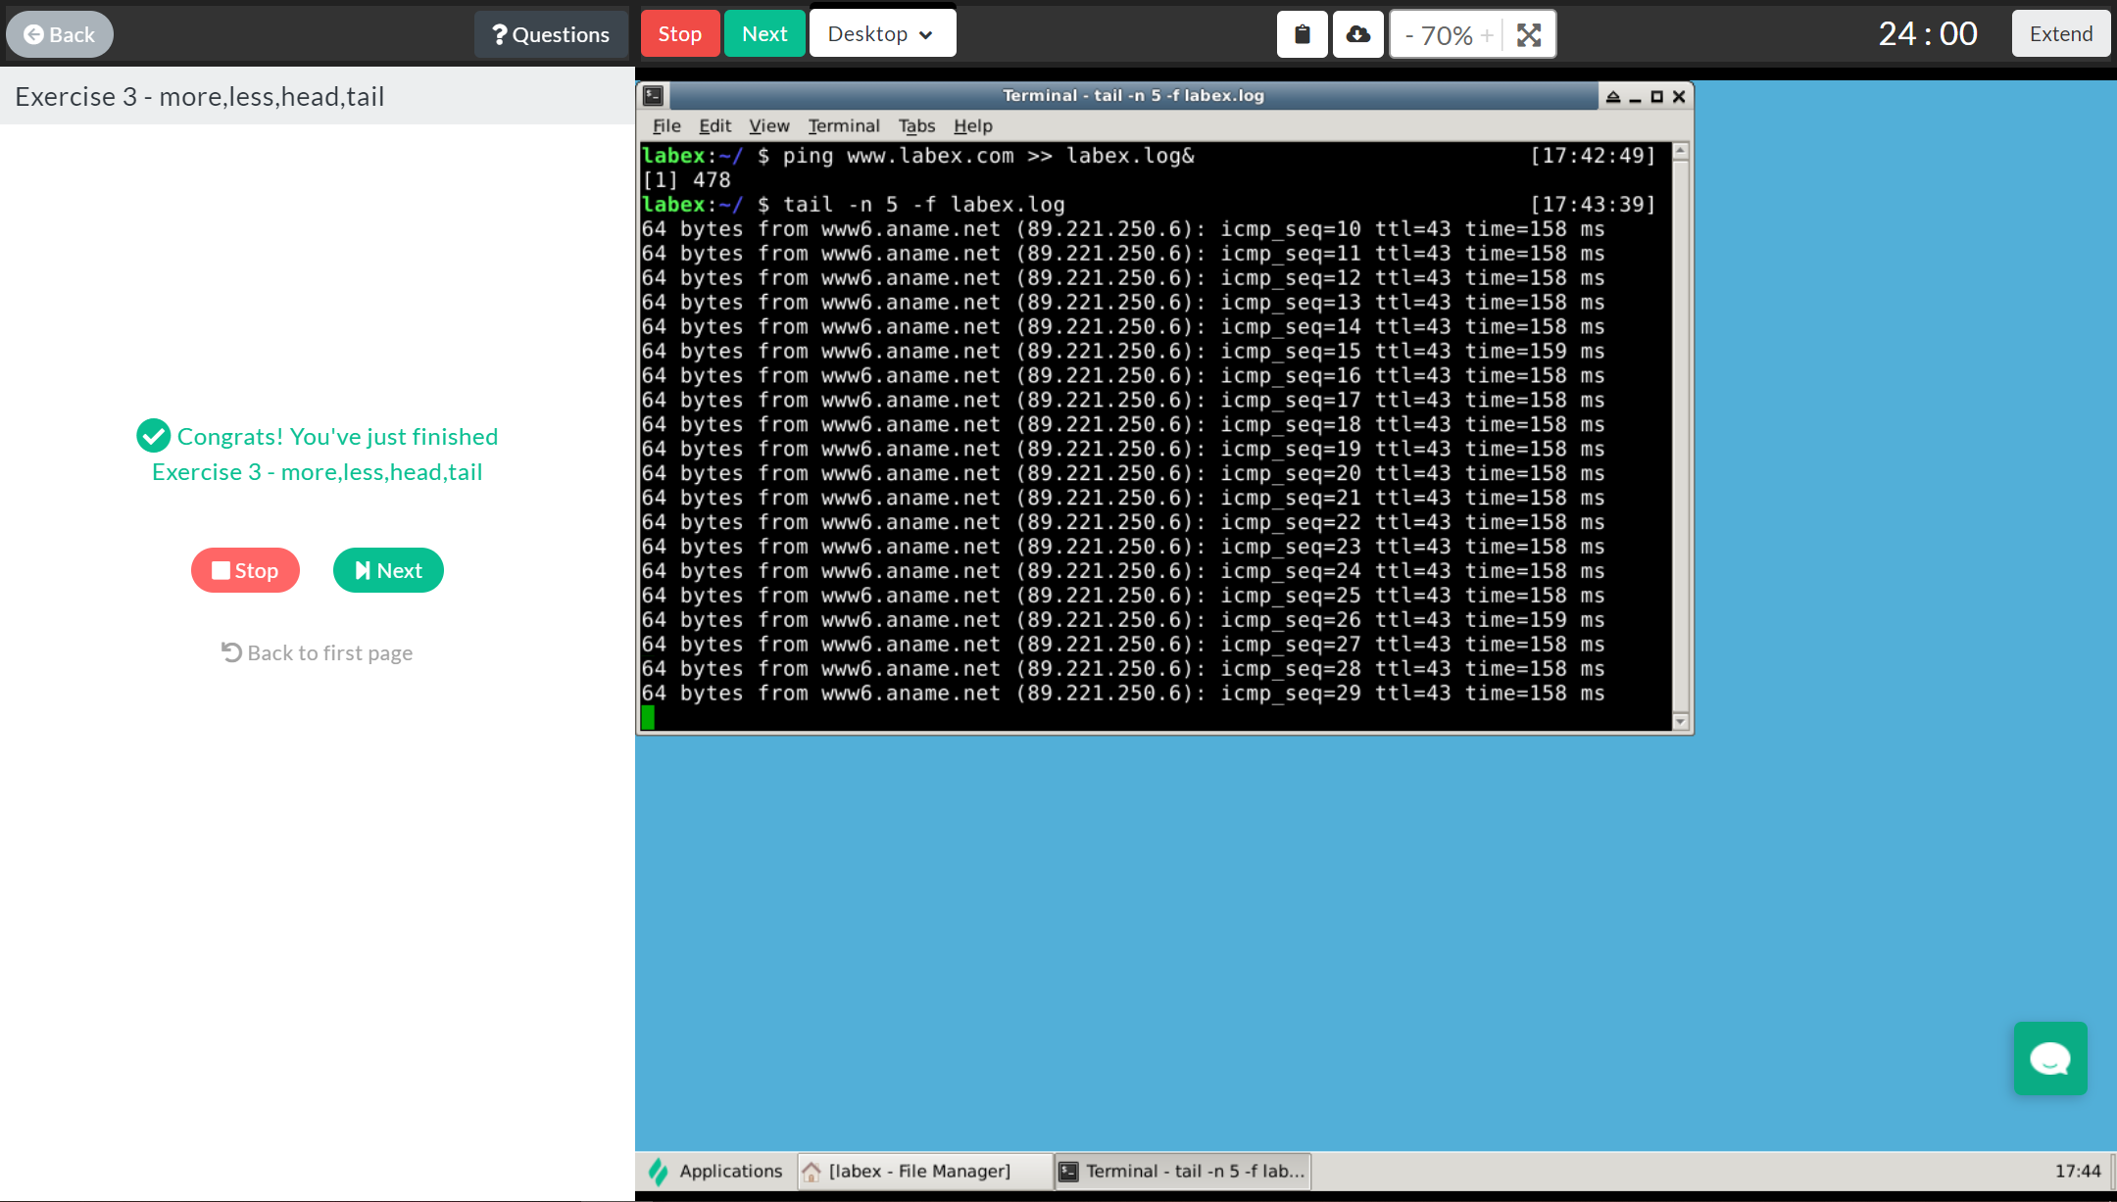

4、Exercise 4 – which, whereis, locate

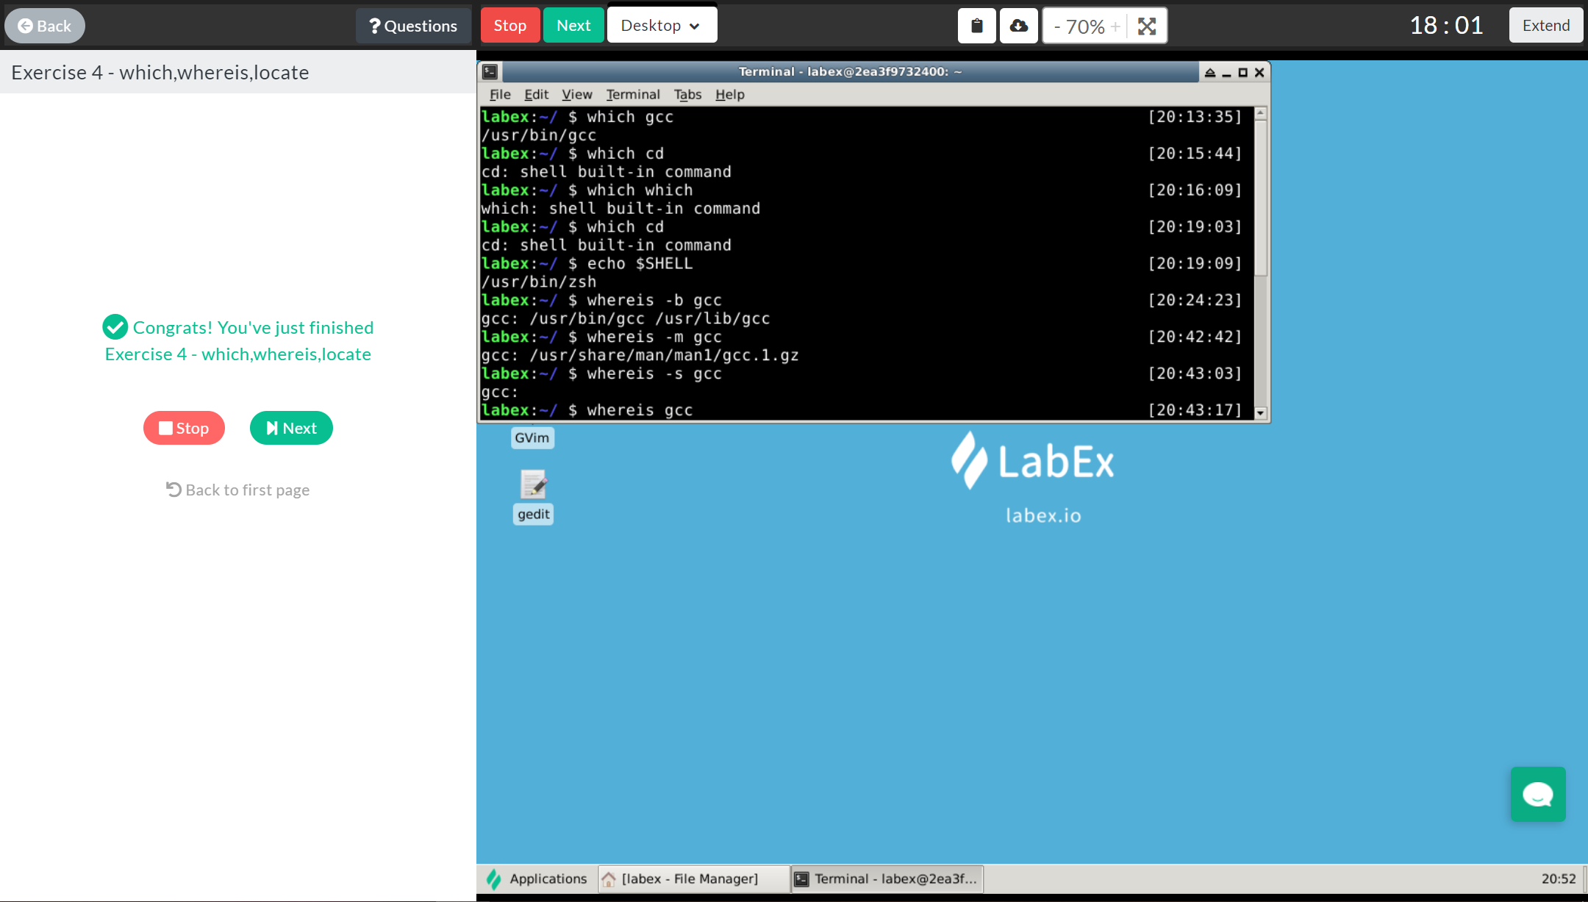

5、Exercise 5 – find, xargs

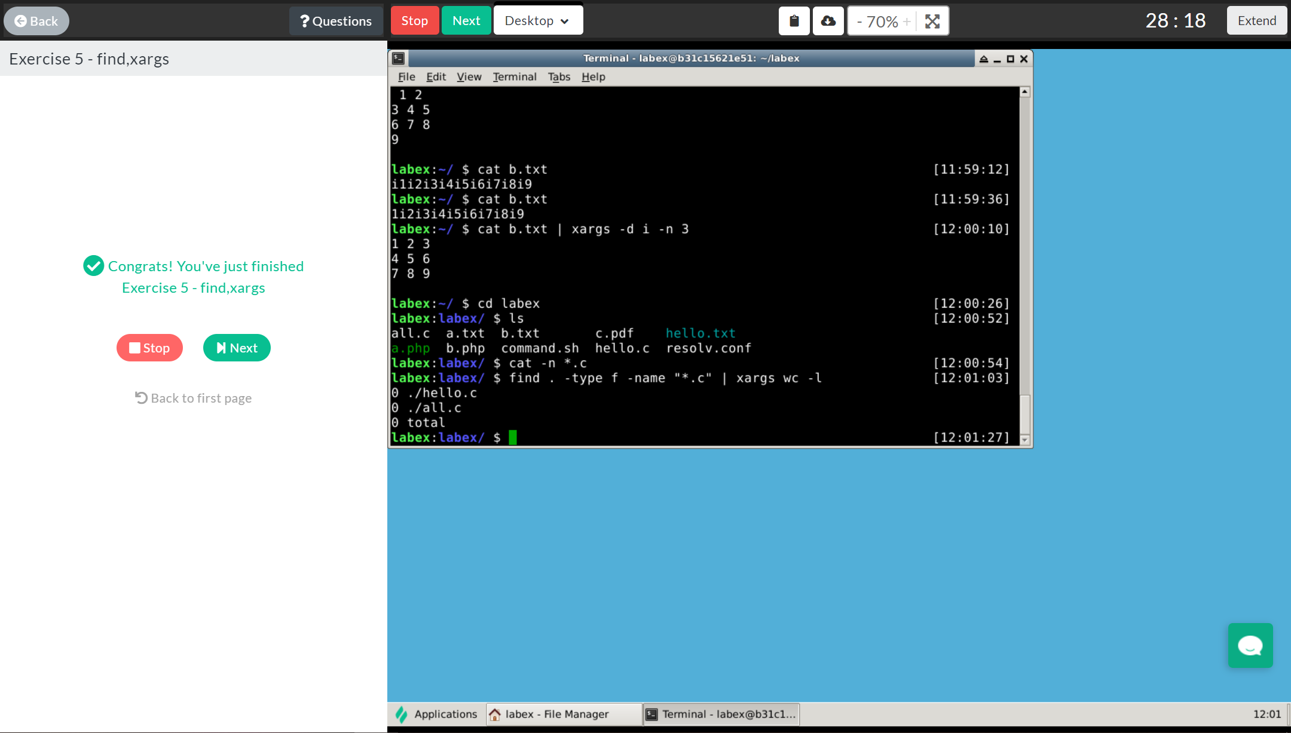

6、Exercise 6 – wc, grep, Regular expression

