Honeywell Hackathon Proposal BA

Topic:
Innovating Automation System using Arduino UNO R3 CH340 and Bitmi 10171 kit
Project scope:
This project aims to develop a comprehensive automation system using the given resources.
The system will integrate various sensors and modules included in the kit to provide intelligent control over appliances, enhance security, and improve energy efficiency. The proposed solution will utilize IoT principles, allowing users to control and monitor their environment remotely via a mobile app or web interface.

Given Resources:
No. | Qt. | Material | Link
1 | 1 | Arduino UNO R3 CH340 | https://www.bitmi.ro/electronica/kit-arduino-uno-r3-ch340-10171.html
2 | 1 | USB Cable
3 | 1 | Prototype Expantion
4 | 1 | Remote
5 | 1 | 65 Jump Wire
6 | 1 | Stepper Motor
7 | 1 | Power Supply Module
8 | 10 | Resistor 0.25W 100R
9 | 10 | Resistor 0.25W 220R
10 | 10 | Resistor 0.25W 560R
11 | 10 | Resistor 0.25W 1K
12 | 10 | Resistor 0.25W 4.7K
13 | 10 | Resistor 0.25W 10K
14 | 10 | Resistor 0.25W 47K
15 | 10 | Resistor 0.25W 100K
16 | 10 | Resistor 0.25W 10M
17 | 1 | ULN2003 Stepper Motor Drive Board
18 | 1 | Ulstrasonic Sensor
19 | 1 | Joystick Module
20 | 1 | Membrance Switch Module
21 | 1 | Water Level Detection Sensor Module
22 | 1 | Fan Blade
23 | 1 | 3V DC Motor
24 | 1 | 4 digit 7 Segment Display
25 | 1 | 1 digit 7 Segment Display
26 | 1 | DHT11 Temperature and Humidity Module
27 | 1 | Potentiometer (10K)
28 | 1 | IR Receiver Module
29 | 1 | Sound Sensor Module
30 | 1 | Servomotor (SG90)
31 | 1 | LCD 1602 Module
32 | 1 | 5V Relay
33 | 1 | F-M Dupont Wire
34 | 1 | 9V Battery Connector
35 | 1 | Electrolytic Capacitor (100UF 50V)
36 | 1 | L293D
37 | 1 | 74HC595N
38 | 1 | Passive Buzzer
39 | 1 | Active Buzzer
40 | 5 | Small Button
41 | 1 | RGB LED
42 | 5 | Red LED
43 | 5 | Yellow LED
44 | 5 | Green LED
45 | 5 | Blue LED
46 | 5 | White LED
47 | 2 | Diode Rectifier (1N4007)
48 | 2 | PN2222
49 | 1 | Thermistor
50 | 2 | Photoresistor
51 | 1 | 830 Tie-Point Breadboard
52 | 1 | MQ4 Gas Sensor | Modul senzor de gaze naturale si metan MQ4 | Bitmi.ro✅
53 | 1 | Air Quality Sensor | Modul senzor calitate aer MQ135 | Bitmi.ro✅
54 | 1 | Motion Detection Sensor | Modul senzor calitate aer MQ135 | Bitmi.ro✅
55 | 1 | Fire Detection Sensor | Modul senzor IR, detectare flacara KY-026 | Bitmi.ro✅
56 | 1 | Tilt Sensor KY-020 | Modul senzor de inclinare, KY-020 | Bitmi.ro✅
57 | - | Arduino IDE 2.32. | https://www.arduino.cc/en/software
58 | - | CH340 Driver | https://www.youtube.com/watch?v=8S7AfFQlamM
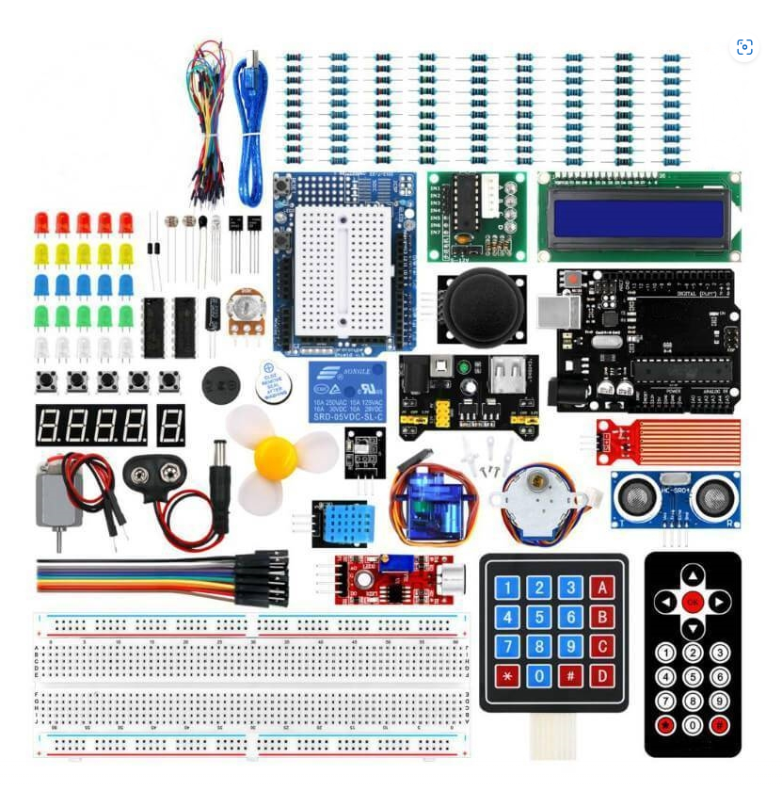
Fig1. Kit Components

Objectives
1. Develop a centralized control system to manage appliances and devices.
2. Enhance security with motion detection and alerts.
3. Improve energy efficiency through automated control of lighting and HVAC systems.
4. Enhance Cyber Security elements in the technical solution and develop a cyber-secure design. Recommended topics to be explored related to cyber security:
- Authentication and access control (including different layers of access, e.g. admin, power user, user)
- Data encryption
- Secure firmware updates
- Data privacy
- Device hardening
- Resilience against physical tampering (physical security)
- Compliance with IoT OWASP security guidelines

For additional points:
A. For additional points, provide remote monitoring and control via a user-friendly mobile application.

Key Features
1. Smart Lighting System: Automated lighting control using light sensors and timers.
2. Building Security: Motion sensors and door/window sensors to detect unauthorized access and send alerts.
3. Climate Control: Temperature and humidity sensors to regulate HVAC systems.
For additional points:
A. Energy Monitoring: Real-time energy consumption tracking to optimize usage.
B. Centralized Dashboard: A web-based interface to control and monitor all connected devices.

Mandatory requirements:
- Microcontroller Integration: Connect the microcontroller with various sensors and relay modules.
- Sensor Placement: Strategically place sensors around the prototype for optimal coverage.
- Power Supply: Ensure a stable power supply for all components.
- Use at least 3 different input data sources (sensors, sound, motion etc.).
- Provide at least 3 different output data type (LED, motors, notifications, alarms).
- Cyber Enhancements.
Scoring system:
- Innovation.
- Creativity.
- Functionality.
- Practicality.

Deliverables
- A functional prototype
- Concept Presentation:
The presentation can consist of:
      - Live demo,
- Highlights of the optional features,
- The steps to reach success,
- Challenges,
- Development,
- Highlights of the experience,
- Lessons learned.
10-15 minutes presentation time

