MEMBER

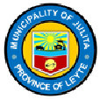

Julita Public Library

Membership Date: